THE COUNCIL OF THE CITY OF NEW YORK
RESOLUTION NO. 1056

Resolution approving with modifications the decision of the City Planning Commission on Application No. N 180165 ZRK, for an amendment of the text of the Zoning Resolution (Preconsidered L.U. No. 480).

By Council Members Salamanca and Moya

WHEREAS, Ciarafour Realty, LLC, pursuant to Section 201 of the New York City Charter, for an amendment of the text of the Zoning Resolution of the City of New York, modifying Appendix F for the purpose of establishing a Mandatory Inclusionary Housing area utilizing Option 2, which in conjunction with the related action would facilitate the construction of a new four-story, approximately 16,930-square-foot, mixed-use building with nine apartments and ground floor commercial space at 273 Avenue U in the Gravesend neighborhood of Brooklyn, Community District 11 (Application No. N 180165 ZRK), (the "Application");

WHEREAS, the City Planning Commission filed with the Council on July 12, 2019 its decision dated June 19, 2019 (the "Decision"), on the Application;

WHEREAS, the Application is related to application C 180164 ZMK (Pre. L.U. No. 479), a zoning map amendment to change R5B/C2-3 district to R6A/C2-3 district;

WHEREAS, the Decision is subject to review and action by the Council pursuant to Section 197-d of the City Charter;
WHEREAS, upon due notice, the Council held a public hearing on the Decision and Application on July 16, 2019;

WHEREAS, the Council has considered the land use implications and other policy issues relating to the Decision and Application; and

WHEREAS, the Council has considered the relevant environmental issues, including the negative declaration issued February 11th, 2019 (CEQR No. 18DCP104K), which includes an (E) designations to avoid the potential for significant adverse impacts related to hazardous materials and air quality (E-525) (the “Negative Declaration”).

RESOLVED:

The Council finds that the action described herein will have no significant impact on the environment as set forth in the (E) Designation (E-525) and Negative Declaration.

Pursuant to Sections 197-d and 200 of the City Charter and on the basis of the Decision and Application, and based on the environmental determination and consideration described in the report, N 180165 ZRK, incorporated by reference herein, and the record before the Council, the Council approves the Decision of the City Planning Commission with the following modifications:

Matter underlined is new, to be added;
Matter struck out is to be deleted;
Matter within # # is defined in Section 12-10;
Matter double struck out is old, deleted by the City Council;
Matter double-underlined is new, added by the City Council
* * * indicates where unchanged text appears in the Zoning Resolution.

* * *

APPENDIX F
Inclusionary Housing Designated Areas and Mandatory Inclusionary Housing Areas

* * *

BROOKLYN

* * *

Brooklyn Community District 11

* * *
Map [_] – (date of adoption)

[PROPOSED MAP]

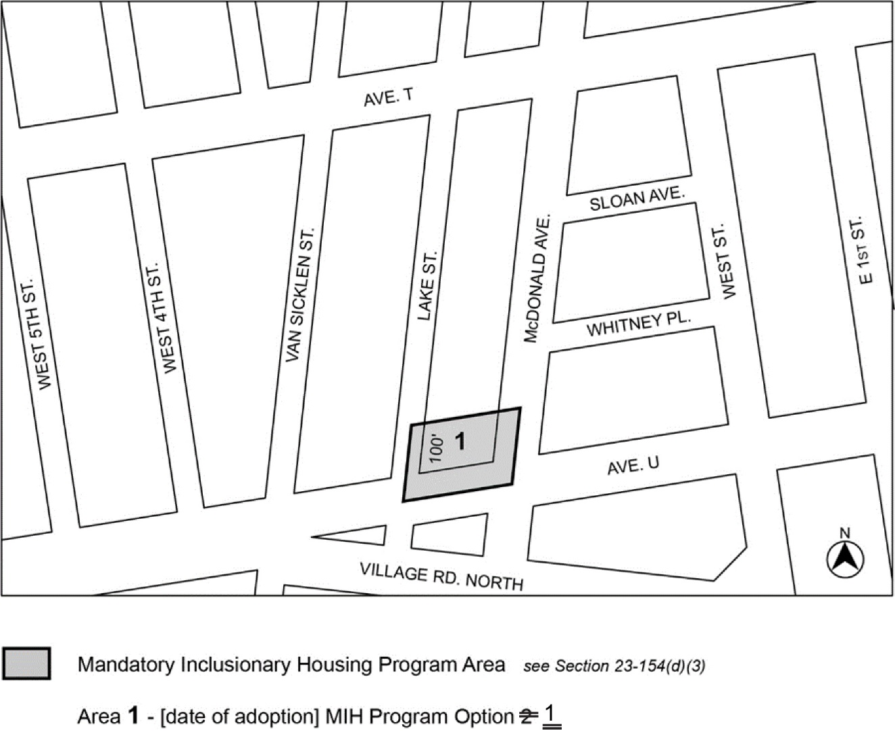

Portion of Community District 11, Brooklyn

* * *

Adopted.

Office of the City Clerk, }
The City of New York, } ss.:

I hereby certify that the foregoing is a true copy of a Resolution passed by The Council of The City of New York on September 12, 2019, on file in this office.

.....……......................................... City Clerk, Clerk of The Council

