Committee on Hospitals Staff  Rie Ogasawara, Legislative Counsel  Mahnoor Butt, Legislative Policy Analyst  Melissa Nuñez, Senior Data Scientist  James Wu, Data Scientist  Reese Hirota, Data Scientist  Danielle Glants, Financial Analyst  Florentine Kabore, Finance Unit Head | Committee on Health Staff  Christopher Pepe, Senior Legislative Counsel  Sara Sucher, Legislative Counsel  Mahnoor Butt, Legislative Policy Analyst  Melissa Nuñez, Senior Data Scientist  James Wu, Data Scientist  Reese Hirota, Data Scientist  Danielle Glants, Financial Analyst
Committee on Education Staff  Nadia Jean-François, Legislative Counsel  Jan Atwell, Senior Policy Analyst  Chloë Rivera, Senior Policy Analyst  Monica Saladi, Principal Financial Analyst  Andrew Lane-Lawless, Legislative Financial Analyst | Committee on Mental Health, Disabilities & Addiction Staff  Sara Sucher, Legislative Counsel  Cristy Dwyer, Senior Legislative Policy Analyst  Rose Martinez, Assistant Deputy Director of Data  Danielle Glants, Financial Analyst
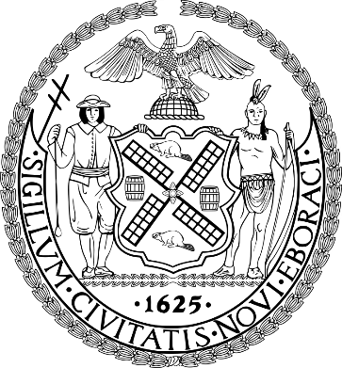
The Council of the City of New York

Briefing Paper and Committee Report of the Legislative Division
Andrea Vazquez, Director
Smita Deshmukh, Deputy Director, Human Services

Committee on Hospitals
Hon. Mercedes Narcisse, Chair

Committee on Health
Hon. Lynn Schulman, Chair

Committee on Mental Health, Disabilities and Addiction
Hon. Linda Lee, Chair

Committee on Education

Hon. Rita Joseph, Chair

April 17, 2024

Oversight: School-Based Health Centers and School-Based Mental Health Clinics

Introduction No. 341: | By Council Members Narcisse, Brooks-Powers, Joseph, Riley, Hanif, Gennaro, Louis and Hudson
Title: | A Local Law to amend the administrative code of the city of New York, in relation to requiring the New York city department of education to report the number of students reported to the office of school health as having a diagnosis of sickle cell disease or trait
Administrative Code: | Amends section 21-965
Resolution No. 13: | By Council Members Joseph, Lee, Avilés, Farías, Cabán, Stevens, Gennaro, Louis, Rivera, Schulman, Gutiérrez, Hudson, Nurse, Hanks, Salaam, Marte, Riley, Banks, Bottcher, Williams, Feliz, Hanif, Brewer and De La Rosa
Title: | Resolution designating the second Friday in March annually as Social and Emotional Learning Day in the City of New York and recognizing the importance of ensuring that prekindergarten through twelfth grade public school students acquire the social-emotional competencies needed to succeed in life

- Introduction

On Wednesday, April 17, 2024, the Committee on Hospitals, chaired by Council Member Mercedes Narcisse, the Committee on Health, chaired by Council Member Lynn Schulman, the Committee on Mental Health, Disabilities, and Addiction, chaired by Council Member Linda Lee, and the Committee on Education, chaired by Council Member Rita Joseph, will conduct a joint oversight hearing on School-Based Health Centers and School-Based Mental Health Clinics. Additionally, the Committees will hear Introduction Number (“Int. No.”) 341, sponsored by Council Member Narcisse, a Local Law to amend the administrative code of the city of New York, in relation to requiring the New York city department of education to report the number of students reported to the office of school health as having a diagnosis of sickle cell disease or trait. The Committees will also hear Resolution Number (“Res. No.”) 13, sponsored by Council Member Joseph, a Resolution designating the second Friday in March annually as Social and Emotional Learning Day in the City of New York and recognizing the importance of ensuring that prekindergarten through twelfth grade public school students acquire the social-emotional competencies needed to succeed in life. Witnesses invited to testify include representatives from the New York City (NYC) Health + Hospitals (H+H), the NYC Department of Health and Mental Hygiene (DOHMH), and the NYC Department of Education (DOE), as well as other interested stakeholders.
- Background
  - School-Based Health Centers
School-Based Health Centers (SBHCs) are medical health centers located inside school buildings operated by local hospitals, medical centers, and community organizations. All SBHCs are overseen by the New York State (NYS) Department of Health (DOH) and DOHMH. Because of their on-site location at schools, SBHCs are an important source of healthcare for many students in DOE public schools –especially those who lack access to primary care – and have been proven to reduce school absences and parents’ time away from work. SBHCs are staffed with a team of healthcare professionals, which may include a physician, nurse practitioner, physician assistant, mental health professional, social worker, medical assistant, and health educators.
In addition to offering scheduled and walk-in student health services when schools are open, SBHCs also have a 24-hour telephone service to respond when schools are closed. Among the services SBHCs provide for students are the following:
- Primary care and preventive health services, including:
  - Physical exams for sports, working papers, and new admissions;
  - Required school health services, such as vaccines, and tests for vision, hearing, asthma, obesity, scoliosis, tuberculosis and other medical conditions;
  - Medical care for chronic illness and disease, including prescribing and giving out medicines; and
  - Referrals to specialty care outside of the SBHC for conditions that the SBHC cannot care for.
- First aid care to all students attending school in the building.
- Emergency care to anyone in need in the school building.
- Mental health services on site or by referral, including crisis intervention.
- Health education, as well as working with schools on their health education programs.
- Counseling to prevent drug and alcohol abuse and smoking.
- Dental Services at select School-Based Health Center sites.
- Age-appropriate teen reproductive health services. This includes health education on safe sex practices, pregnancy prevention, and sexually transmitted infections (STIs) and HIV. SBHC staff offer counseling and access to pregnancy testing, birth control methods, and tests and treatment for STIs. Staff also provide referrals for conditions needing further evaluation.

SBHCs can only provide full healthcare services for students who have enrolled with a signed Parental Consent Form; otherwise, the SBHC can only provide first aid and emergency care and those services for which minors can consent to their own treatment. Per NYS law, minors are allowed to consent to their own care for: reproductive health services, such as birth control, care during pregnancy, and testing for and treatment of STIs, including HIV; mental health counseling and treatment; and substance abuse treatment.
SBHCs provide medical care to students regardless of insurance or immigration status, and do not bill students or parents for services. SBHCs do bill Medicaid and private insurance companies and accordingly ask parents to provide insurance information when they enroll their child. According to DOE’s website, as of January 2024, over 387 schools in NYC have access to SBHCs, but stipulates that, in most cases, SBHCs are not allowed to provide care to any student not registered at the school in which the SBHC is located. It is important to note that many of the SBHCs serve multiple co-located schools in a school building.
For the 2023-24 School Year (“SY”), there are 138 SBHCs operating throughout the 5 boroughs, with 64 centers located in the Bronx; 39 in Manhattan; 21 in Brooklyn; 10 in Queens; and 4 in Staten Island. In addition, DOE is required to report to the Council on student health services and this reporting includes information on the total number of students enrolled in schools with SBHCs. The most recent report submitted to the Council indicates that 171,062 students were enrolled in schools with SBHCs in SY 2021-22, including 70,297 students in the Bronx; 41,834 in Manhattan; 33,949 in Brooklyn; 15,824 in Queens; and 10,058 in Staten Island. The report for the 2023-24 school year is due on April 30, 2024.
  - School-Based Mental Health Clinics

According to the DOE, tier 3 mental health services offered in schools include School-Based Mental Health Clinics (SBMHCs) as well as SBHCs that offer concurrent mental health services, as described above. SBMHCs are clinics licensed and overseen by the NYS Office of Mental Health (OMH) pursuant to § 31 of the State’s Mental Hygiene Law. Such clinics can be part of a larger health clinic or a stand-alone model, including a satellite clinic. SBMHCs provide individual, family, and group therapies, as well as psychiatric assessments, case management, school community outreach, and 24-hour crisis coverage for students. According to the DOE, although many mental health services are provided at no cost to students and families, some services may require a fee.
In November 2023, NYS Governor Kathy Hochul announced that more than $5.1 million had been awarded to support 137 SBMHC satellites throughout NYS, including 82 high-need schools. In the city, 52 high-need schools in 21 districts have received such funding awards:
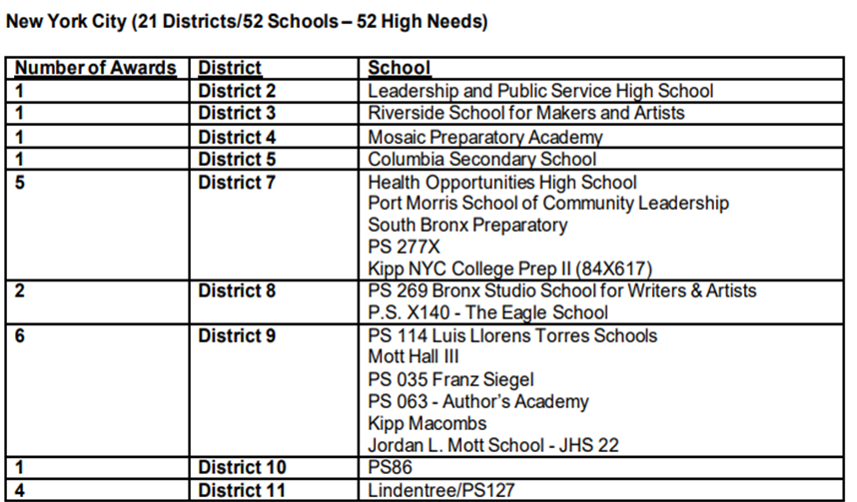
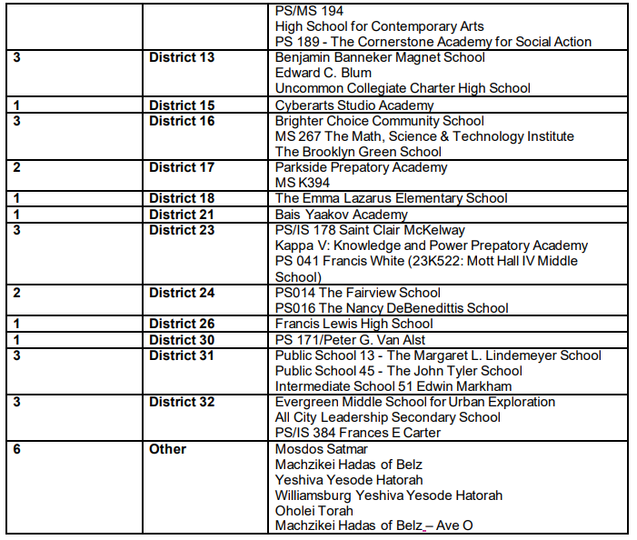
Source: School-Based Mental Health Clinic Satellite Awards https://www.governor.ny.gov/sites/default/files/2023-11/School_Award_List.pdf

OMH-licensed providers were awarded $25,000 per clinic to establish services at 137 schools throughout the state. An additional $20,000 per school was awarded to providers establishing services at high-need schools, where more than 50 percent of the students are classified as coming from economically disadvantaged households. The SBMHC satellite clinics operate at each school’s main location and are staffed by mental health practitioners “regularly throughout the week.” Funding will help schools and providers develop physical locations within the schools, shift part-time program supervisors to full-time roles, provide additional training to staff, and help providers connect students and families with services and provide case management for those in need of intensive care. The Governor’s plan also provided a 25 percent increase in Medicaid rates for full-day school-based programs for young people with significant mental health challenges and for school-based mental health services provided by Article 31 licensed clinics serving children in pre-K, elementary and secondary schools.
In February 2024, the Governor announced an additional $20 million in start-up funding for SBMHCs and launched a rolling application to make it easier for interested schools to access state funding. With support from a school wanting to establish a clinic satellite, OMH-licensed providers can apply for start-up funding on a rolling basis rather than through the state procurement process that previously used. Licensed OMH providers can submit an application to establish a school-based satellite clinic through the Mental Health Provider Data Exchange. Every new school satellite clinic will automatically be eligible for $25,000 in start-up funding. As mentioned, high-need schools, or those where more than 50 percent of students classified as coming from an economically disadvantaged household, are eligible for an additional $20,000.
- Common Pediatric Health Conditions
  - Physical Health Conditions

In NYC, DOHMH identifies asthma as a leading cause of emergency room visits, hospitalizations and missed school days among children in the city’s poorest neighborhoods. The onset of asthma in children is often caused by environmental health factors, such as tree pollen, tobacco smoke, pet dander, mold, dust mites, pests, proximity to highways, gas and diesel emissions, and other pollutants. Asthma is more common among low-income Black and Latinx children in NYC. In 2020, 57 out of 10,000 NYC children ages 5 to 17 visited an emergency department due to an asthma-related health event; in the Bronx, that number climbed to 100 out of 10,000, which is the highest percentage of any borough. The top four Community Districts with the greatest percentages of asthma-related emergency department visits among children ages 5 to 17 were Mott Haven and Melrose in the Bronx (CD1, 182 visits per 10,000 children); Brownville in Brooklyn (CD16, 166 per 10,000); Central Harlem (CD10, 159.3 per 10,000); and Belmont and East Tremont in the Bronx (CD6, 131 per 10,000). A 2022 report found that poverty is highly correlated with asthma prevalence, citing disrepair, mold, and pests as asthma attack triggers, which are largely a result of disinvestment in neighborhoods of color.
Diabetes is also an ongoing health issue for NYC children. Per the NYSDOH, diabetes is one of the most common chronic diseases of childhood, affecting over 13,000 children in NYS. Research has demonstrated that type 2 diabetes is more common in certain racial and ethnic groups such as Black Americans, American Indians, Hispanic/Latinx Americans, and some Asian and Pacific Islander Americans, while type 1 diabetes is more common in the non-Hispanic White population. According to NYSDOH, the increasing incidence of type 2 diabetes in youth is a “first consequence” of the obesity epidemic among young people. Overweight children are at increased risk for developing type 2 diabetes during childhood, adolescence, and later in life.
Finally, lead exposure remains a concern for children in NYC. While the percentage of children with elevated blood lead levels has decreased steadily since the passage of Local Law 1 in 2004, sharp disparities persist: as of 2019, 82 percent of NYC children under the age of six with elevated blood lead levels were Black, Latinx, or Asian. As of 2019, about 1 percent of children under six in NYC exhibited elevated blood lead levels, an 11 percent decrease from 2005.
  - Mental Health Conditions

On March 16, 2023, Governor Hochul began a series of statewide listening sessions aimed at discovering the mental health issues affecting youth in NYS. The Governor’s initiative was in response to the “alarming” mental health trends uncovered by the U.S. Centers for Disease Control (CDC) Youth Risk Behavior Survey, conducted from 2011 to 2021. The focus areas of the survey included substance use, threat of experiencing sexual violence or violence due to prevalence of weapons at school, feeling safe, effects of electronic bullying; experiencing sadness, hopelessness, or issues of mental health and suicidality; housing instability, and the efficacy of protective factors such as school connectedness and parental support.
According to the report, nearly one third of teenage girls had seriously considered attempting suicide in 2021—an increase of 19 percent from the previous decade. Additionally, three in five school aged girls reported feeling “persistently sad or hopeless” in 2021, a 60 percent increase over the rates as recorded in 2011. Significantly, girls who reported experiencing feelings of persistent sadness did so at twice the rate of their teenage male counterparts. Additionally, more than half of LGBTQ+ youth surveyed reported having poor mental health, with one in five having experienced a suicide attempt in the past year.
While key findings of trends from the 2011 to 2021 report observed an overall reduction of school bullying among female adolescents, conversely, male students reported an increase of electronic bullying. Female students reported an increase of sexual violence in school, causing some youth to avoid going to school due to safety concerns.
The report cited substance use as being associated with high-risk behaviors and suggested preventing substance use can reduce the future risk of substance use disorders, high-risk sexual behaviors, violence, poor mental health and suicidality. In 2021, the report found female students and LGBTQ+ students to be more likely than their peers to use alcohol, cannabis and illicit and prescription drugs. Significantly, the reported 24 percent of students using vapor products has not increased since 2015.
In 2021, the report cited nearly 30 percent of female students had used alcohol within 30 days of being surveyed for the report; 20 percent of LGBTQ+ students had used some form of illicit drugs, with 20 percent reportedly never having misused prescription opioids. The report noted Asian and Black students were less likely than every other racial and ethnic group to have ever used select illicit drugs, and reportedly, Black students used cannabis more often than Asian, Hispanic/Latinx, and White students did.
According to the report, nearly all groups and percentages of students who had considered suicide had increased. Notably, while less likely to report mental health issues, Black students were more likely than Asian, Hispanic/Latinx or White students to have attempted suicide. Even prior to the pandemic, overall mental health among students continued to worsen between 2011 and 2021. According to the report, 40 percent of students surveyed in 2021 reported feeling so hopeless and so sad they could not and did not engage in their regularly scheduled activities.
In 2021, the CDC added questions to their data set exploring the social determinants of health to assess youth’s access to environmental protective factors. Protective factors include conditions, behaviors and characteristics that help to mitigate and successfully manage the effects of stress and negative events. These protective factors include school connectedness to ensure students feel protected and that they are cared for, understood, and listened to. Additionally, parental monitoring was assessed and going forward, students will report on how their home and school environments affect their overall well-being.
- Operation of School-Based Health Centers and School-Based Mental Health Clinics

The school-based health system is a collaborative effort between schools, hospitals, healthcare centers, insurance companies, and various other interested parties who strive to provide care for the city’s student population. SBHC and SBMHC facilities may serve many co-located schools simultaneously, and each is sponsored by an external health institute. Ryan Health, Institute for Family Health, Community Healthcare Network, Mount Sinai (Adolescent Health Center), Mount Sinai (Pediatrics), New York-Presbyterian, Montefiore Medical Center, Children’s Aid Society, Morris Heights Health Center, Urban Plan Health, and NYU Langone FHC appear to be the most common sponsors.
Due to the sheer number of clinics in operation, as well as the variable resources that are provided to and by each facility, the operational organization is inconsistent. The number of services provided by each SBHC is varied, with some offering primary care and preventive health services, while others offer a wider range of services, such as dental care options. Due to the lack of uniformity in the administration of the SBHC services, the Committees have not been able to access a standardized assessment of all SBHC and SBMHC facilities in the city. The Committees will use this hearing as an opportunity to learn about the structure of the SBHC and SBMHC system, for which there is very limited publicly-available information. In particular, there are outstanding questions regarding: the funding of each health center; who is responsible for staffing; how many healthcare providers are placed at each facility; who decides the sponsorship of each center or clinic; who conducts oversight on the provision and quality of care offered to students; and other relevant questions pertaining to the operation of such school-based healthcare.
- Financial analysis

School-Based Health Centers

According to DOHMH, there are 138 SBHCs across 334 public schools in NYC serving over 150,000 students. This differs somewhat from the 387 schools that DOE claims have an SBHC for the 2023-2024 school year on their website. NYC currently funds 35 SBHCs held in DOHMH’s budget. At adoption, NYC dedicated $7.3 million to SBHCs in the Fiscal 2024 Adopted budget; however, this number has grown to $8 million, where it stands currently in DOHMH’s budget. Additionally, $7.6 million has been dedicated for Fiscal 2025 and in the Fiscal 2025 Preliminary Plan, $848,959 was budgeted within DOE Fiscal 2024 budget in intra-city funds for DOHMH for SBHCs.
- Issues and Concerns

There have been a number of SBHC closures over the past few years. During the summer of 2022, Chalkbeat reported that five SUNY Downstate-run SBHCs serving 10 schools in Brooklyn closed due to budget constraints. In a letter to the superintendents and principals, a group of eight nurse practitioners, social workers, and other health professionals who had staffed the SBHCs blamed SUNY Downstate for mismanagement, claiming “[t]he abrupt announcement of the closure is shocking, irresponsible, and wrong, abandoning chances for problem solving and leaving our communities with a huge deficit in care”. Then, in mid-August 2023, Politico Pro reported that H+H was planning to close its network of eight SBHCs located in Brooklyn, Queens and Manhattan on August 31, 2023, pending State approval. H+H claimed its centers were “scarcely used due to the overlap in services with school services, with an average daily number of visits in the single digits.” While there was no reporting on the closures, a review of data from year to year show that they did, in fact, close.
In January 2024, the Queens Daily Eagle reported that at the H+H-run Gotham Health clinic located at I.S. 145 in Jackson Heights, Queens, which had been in service for 25 years, closed with little explanation to the school community. H+H purported that they had too few patients to justify remaining open, a claim which parents and teachers disputed, saying that “the vast majority of the school’s children [elected] to utilize the clinic in lieu of a primary care doctor.” In addition to parents lamenting that they have been left with limited and inconvenient healthcare options for their children, the closure has had an impact on the more acute medical needs of the students. School nurses have a limited scope of care, which prevents them from rendering aid “beyond bags of ice or bandaids,” meaning students must now wait for paramedics for significant care.
Consistent with concerns over closures due to budget constraints are concerns over the precarious nature in which SBHCs could be reimbursed. Since their inception in 1985, SBHCs have been “carved-out” of Medicaid Managed Care (MMC) and paid under fee-for-service. However, since 2014, NYS DOH has repeatedly attempted then delayed ending the carve-out. Transitioning SBHCs from fee-for-service to MMC would require them to negotiate terms and conditions of payment through managed care plans, with prior authorization and utilization review, which would both increase administrative burdens and costs. The MMC model in NYS has created barrier to care for other sectors, including behavioral health and home care, such as persistent plan denials, delays, and red tape. In 2021, 2022, and 2023, Governor Hochul vetoed legislation that would make the care-out permanent and provide stability to SBHCs. This is concerning since SBHCs have already suffered over $7 million in funding cuts since 2008, despite growth in patient population.
- Legislative Analysis
  - Int. No. 341

This bill would require the DOE to provide, in its annual report on student health and student health services to the Council, the total number of students reported to the Office of School Health as having a diagnosis of sickle cell disease or sickle cell trait.
- Conclusion

The Committees on Hospitals, Education, Health, and Mental Health, Disabilities and Addiction look forward to learning more about the operation and utilization of SBHCs and SBMHCs. This includes, but is not limited to, where and how they are sited and maintained, as well as scope of services offered. The Committees are also interested in related data, including rates of utilization and any other types of data that may be collected. Additionally, the Committees are interested in what kind of outreach is conducted to inform students and their families about the existence of SBHCs and SBMHCs, any plans to expand access to their services, and whether continuity of care is ensured for students who graduate or transfer.
Providing holistic, quality care to students is of utmost importance, and the Committees look forward to greater understanding of the vital role played by SBHCs and SBMHCs in providing such care.

Int. No. 341

By Council Members Narcisse, Brooks-Powers, Joseph, Riley, Hanif, Gennaro, Louis, Hudson, Banks, Ossé, Schulman, Brannan and Avilés

A Local Law to amend the administrative code of the city of New York, in relation to requiring the New York city department of education to report the number of students reported to the office of school health as having a diagnosis of sickle cell disease or trait

Be it enacted by the Council as follows:
Section 1. Subdivision b of section 21-965 of the administrative code of the city of New York, as amended by local law number 156 for the year 2021, is amended to read as follows:
b. Not later than [April 30, 2022] October 31, 2024, and no later than [April 30th] October 31 annually thereafter, the department shall submit to the speaker of the council a report regarding information on health services provided to students for the preceding school year. Such report shall include, but not be limited to:
1. The number of school buildings where full time nurses are employed by the office of school health and the number of school buildings where part time nurses are employed by such office; the ratio of students to nurses in such school buildings; and the average number of student health encounters per nurse in such school buildings;
2. The total number of student health encounters;
3. The total number of NYC FITNESSGRAMS performed, and the percentage of students assessed who had a body mass index: (i) below the 5th percentile; (ii) in the 5th to 84th percentile; (iii) in the 85th to 94th percentile; and (iv) equal to or above the 95th percentile, to the extent such information is collected by the department;
4. The total number of medication orders reviewed by the office of school health and recorded in the automated student health record database;
5. The total number of students reported to the office of school health as having a diagnosis of allergies, asthma, diabetes type 1, [or] diabetes type 2, sickle cell disease, or sickle cell trait; and
6. The total number of school based health centers disaggregated by the type of provider including, but not limited to, hospital and federally qualified health centers; and the total number of students enrolled in the school or schools served by each school based health center.
§ 2. This local law takes effect immediately.
Session13
LS #14159
01/10/2024

Session12
NJF
LS #14159
10/19/23 12:03 pm

Res. No. 13

Resolution designating the second Friday in March annually as Social and Emotional Learning Day in the City of New York and recognizing the importance of ensuring that prekindergarten through twelfth grade public school students acquire the social-emotional competencies needed to succeed in life.

By Council Members Joseph, Lee, Avilés, Farías, Cabán, Stevens, Gennaro, Louis, Rivera, Schulman, Gutiérrez, Hudson, Nurse, Hanks, Salaam, Marte, Riley, Banks, Bottcher, Williams, Feliz, Hanif, Brewer and De La Rosa

Whereas, The New York State Education Department (NYSED) has described Social Emotional Learning (SEL) as “the process through which children, youth, and adults acquire and effectively apply the knowledge, attitudes, and skills necessary to understand and mange emotions, set and achieve positive goals, feel and show empathy for others, establish and maintain positive relationships, and make responsible decisions”; and
Whereas, The NYSED has pointed to studies showing that, compared to students who do not receive SEL instruction, students who do receive it have higher achievement scores; better attitudes, including motivation to learn; fewer disruptive classroom behaviors; and less emotional stress, including depression and anxiety; and
Whereas, The NYSED has stated that SEL instruction can also “decrease implicit bias, increase cultural responsiveness, and result in greater equity” among young New Yorkers; and
Whereas, The NYSED has established three SEL goals for students: “Develop self-awareness and self-management skills essential to success in school and in life”; “Use social awareness and interpersonal skills to establish and maintain positive relationships”; and “Demonstrate ethical decision-making skills and responsible behaviors in personal, school, and community contexts”; and
Whereas, The Center for Benefit-Cost Studies of Education at Teachers College, Columbia University, claimed in The Economic Value of Social and Emotional Learning in 2015 that, for every dollar spent on SEL programming with proven results, there is a return on investment of 11 dollars; and
Whereas, SEL Day on March 10, 2023, was celebrated and acknowledged by commitments to advocate for and engage in SEL activities from students and educators in all 50 United States (U.S.) states and in 88 countries; and
Whereas, U.S. President Joseph R. Biden, Jr. issued a statement on March 10, 2023, stating that “children are the kite strings that keep our national ambitions aloft” and that, through SEL, “our students get the resources and support they need to learn, make good decisions, build community, and achieve their goals”; and
Whereas, President Biden pledged that his Administration would “continue to work with educators, schools, and organizations to ensure that the best practices of social and emotional learning are being promoted nationwide”; and
Whereas, New York State (NYS) Governor Kathy Hochul issued a citation on March 10, 2023, recognizing SEL as a “valued program within our state’s schools and a beneficial resource in the lives of all New Yorkers”; and
Whereas, Governor Hochul further noted that SEL is “essential to our success in school, the workplace, at home, and in our communities-allowing us to participate in and contribute to society in meaningful ways”; and
Whereas, NYS Assembly bill A.3087, introduced on February 2, 2023, by Assembly Member Vivian Cook, of Assembly District 32 in Queens, would require the NYS Commissioner of Education to establish a pilot program to improve the delivery of SEL instruction statewide, including in at least one school in each NYS school district, and to administer the pilot program under contract with an outside community-based organization with a proven track record in SEL instructional delivery for students in prekindergarten through twelfth grade, among other relevant qualifications; and
Whereas, March 8, 2024, has been designated as the fifth annual international SEL Day; now, therefore, be it
Resolved, That the Council of the City of New York designates the second Friday in March annually as Social and Emotional Learning Day in the City of New York and recognizes the importance of ensuring that prekindergarten through twelfth grade public school students acquire the social-emotional competencies needed to succeed in life.

LS #15248
1/11/2024
RHP

Appendix I
The Council’s Data Team has created a webpage to display its findings for the public, including the datasets below. The webpage can be accessed at https://council.nyc.gov/data/school-based-health-center-closures.
Appendix II
The following pages contain scatter plots and accompanying maps prepared by the Council’s Data Team showing the number of SBHCs by the prevalence of a certain factor (poverty, asthma, diabetes type 1, diabetes type 2, and anaphylaxis) within a NYC school district. The size of each point on the scatter plot is based on total enrollment; a larger dot means there are more students in that school district. The legend to the right of the map details the color scaling for both the scatter plot and the map.
School districts 9 and 10 in the Bronx stand out as the districts with the highest number of SBHCs. There seems to be no strong relationship between prevalence measures, like asthma and diabetes type 1 or type 2, and socioeconomic indicators like poverty. When comparing the student asthma rate, the citywide rate (14.10 percent) is slightly lower than those of school districts with SBHCs (14.28 percent) and those without (12.48 percent), where the rates are nearly the same.

Total Number of SBHCs vs. Prevalence of Anaphylaxis
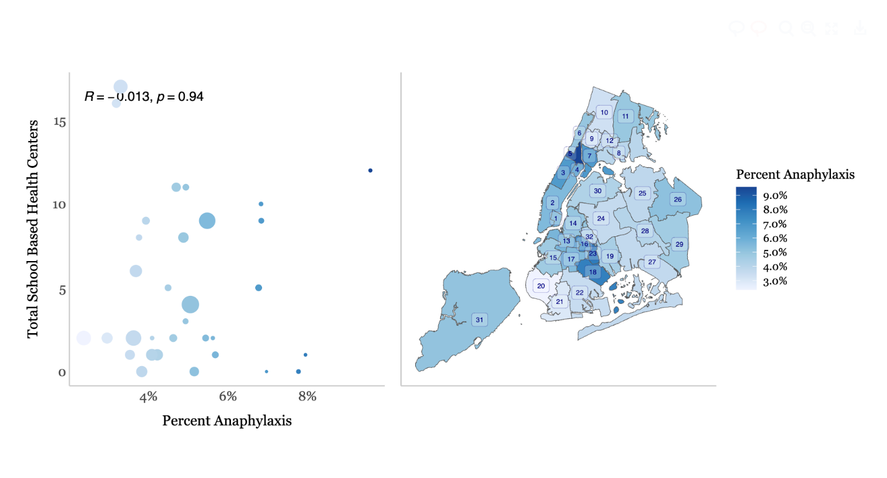
Total Number of SBHCs vs. Prevalence of Asthma
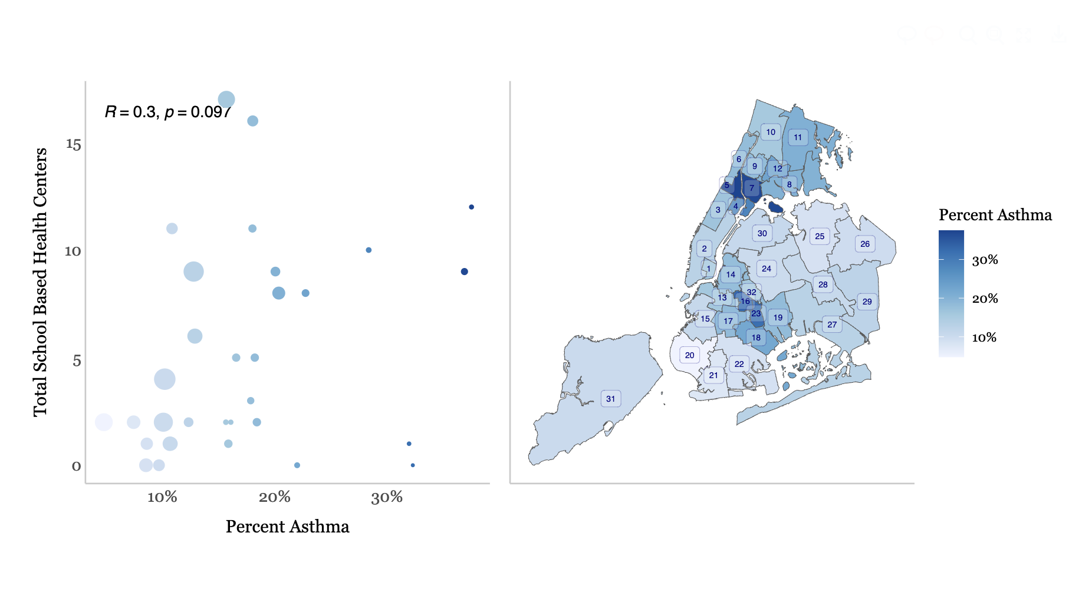

Total Number of SBHCs vs. Prevalence of Diabetes 2
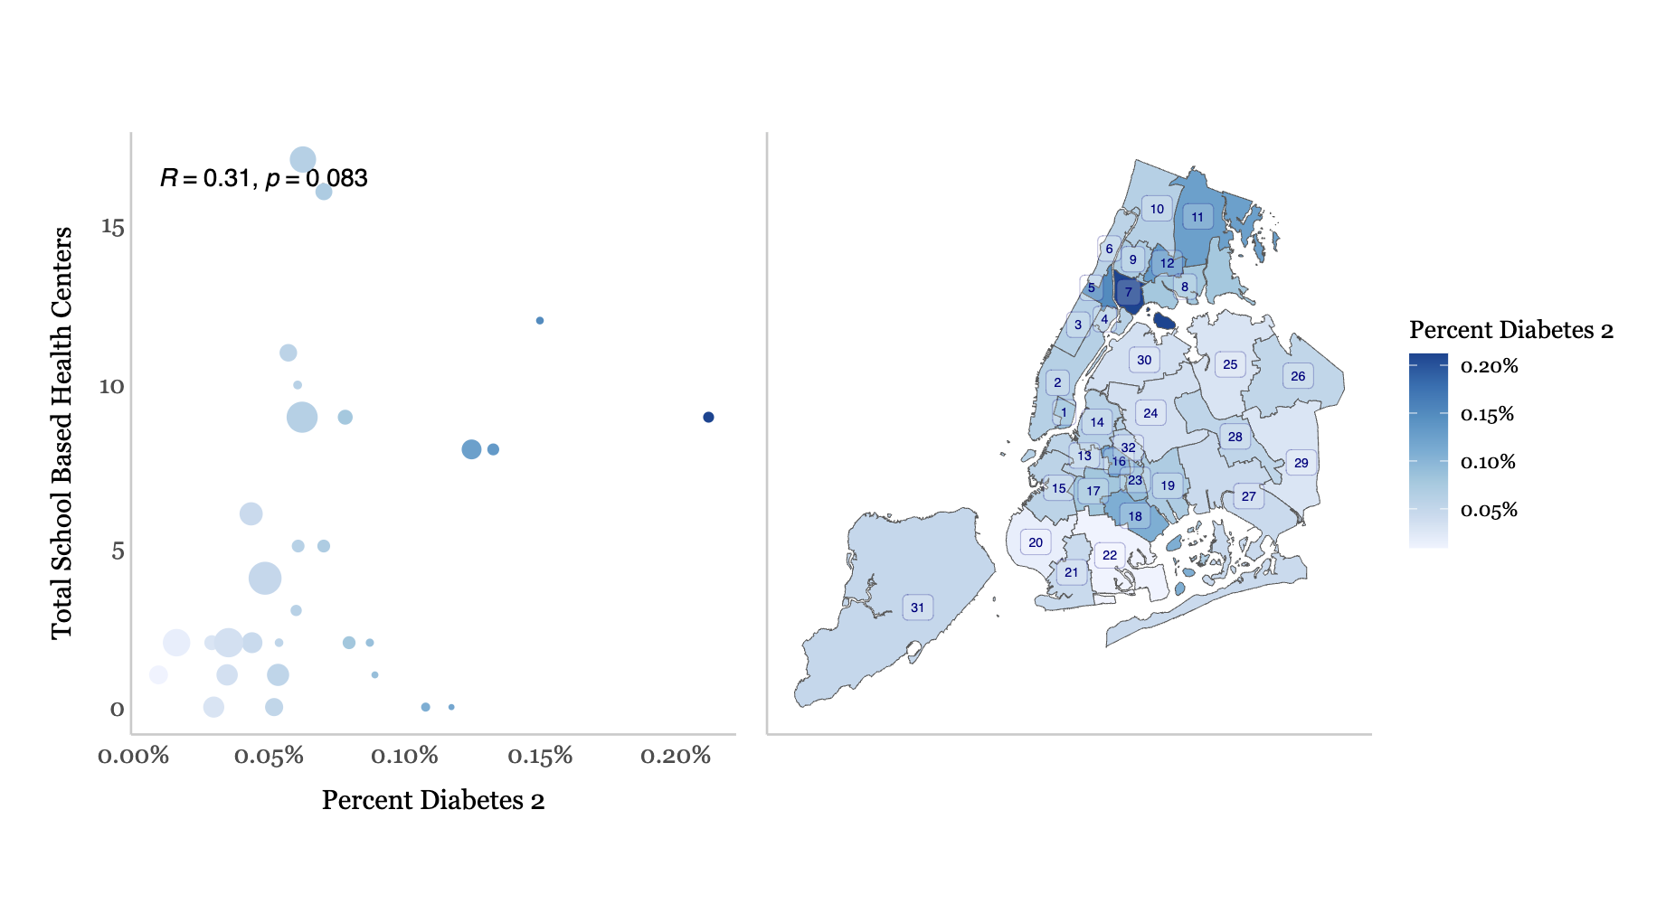
Total Number of SBHCs vs. Prevalence of Diabetes 1
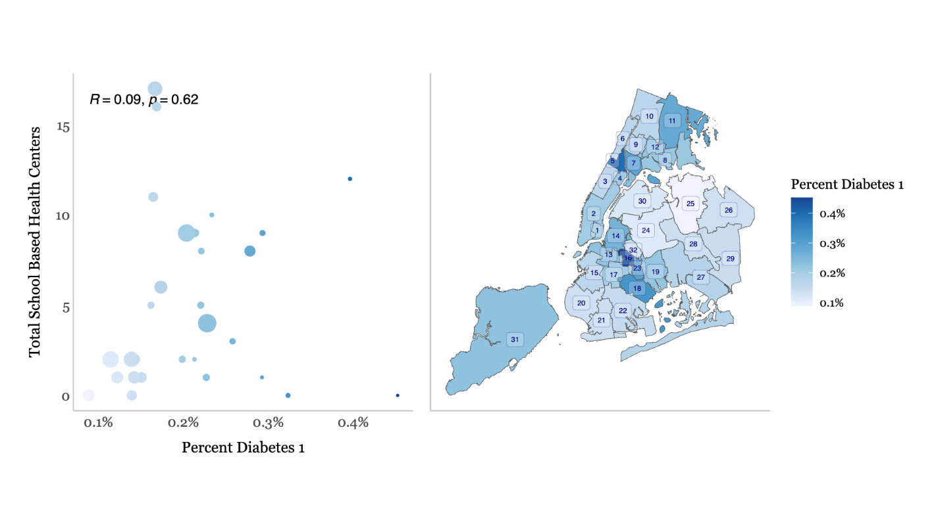

Total Number of SBHCs vs. Percentage of Population Living in Poverty
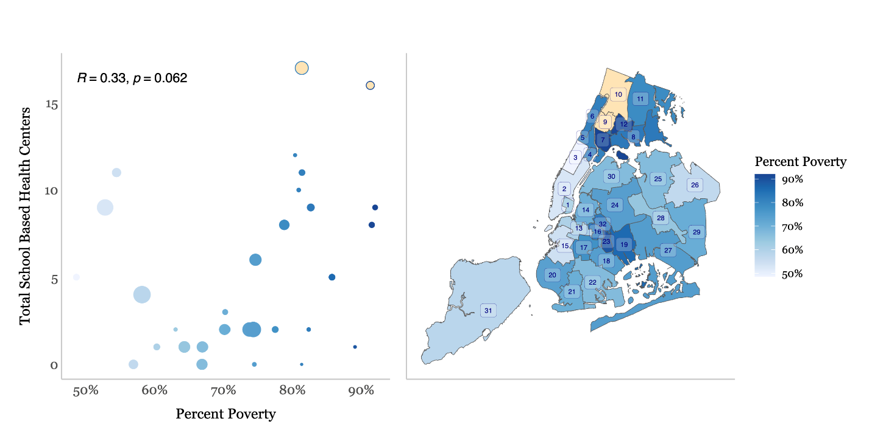

Appendix III
Over time, there have been minor variations in the count of SBHCs. The numbers had been steadily rising since the 2015-2016 period, reaching their highest point during the post-pandemic school year of 2020-2021. However, there has been a decline since then, with the 2023-2024 school year marking the lowest count of operational centers. Notably, between the academic years of 2022-2023 and 2023-2024, nine centers were closed, with eight of them previously sponsored by H&H Gotham. School buildings, along with all SBHCs, were closed during the 2019-2020 school year.
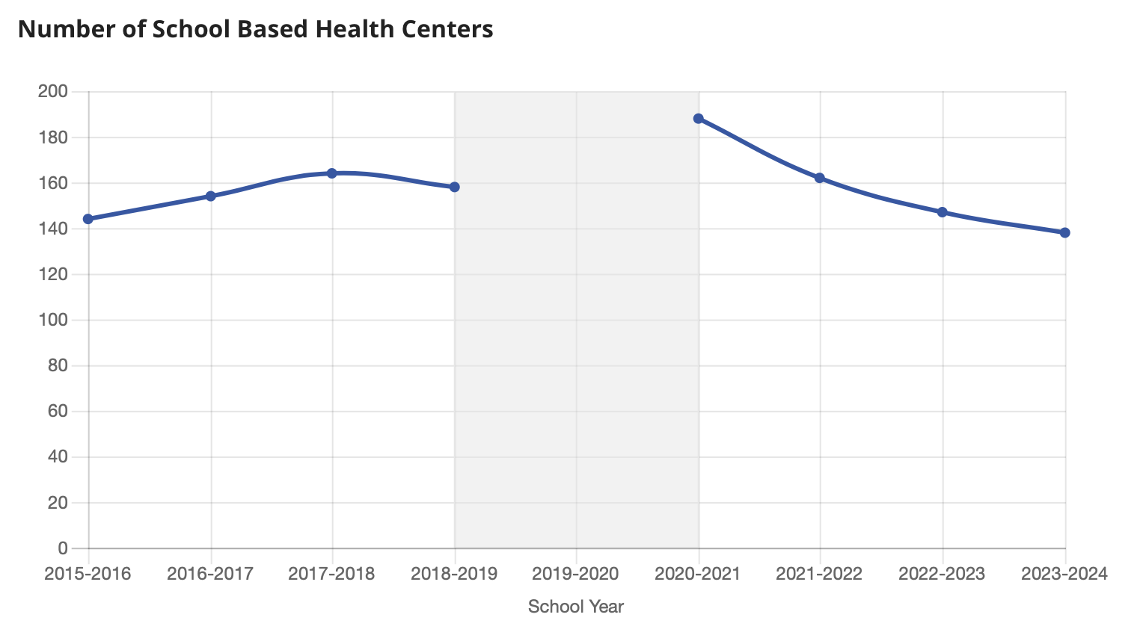

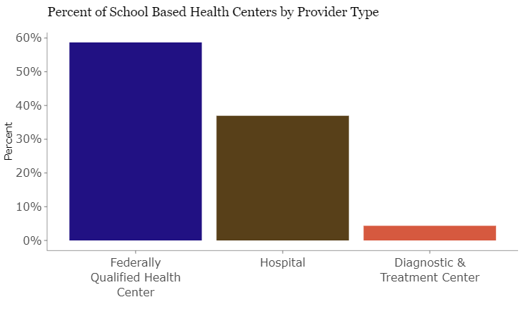
Montefiore Medical Center, Morris Heights Health Center, and NYU Langone FHC lead as sponsors with the highest number of SBHCs. Combined, these 3 medical facilities accommodate close to half of the city’s SBHCs, catering to 76,648 students, which constitutes 50 percent of all students with access to such facilities.
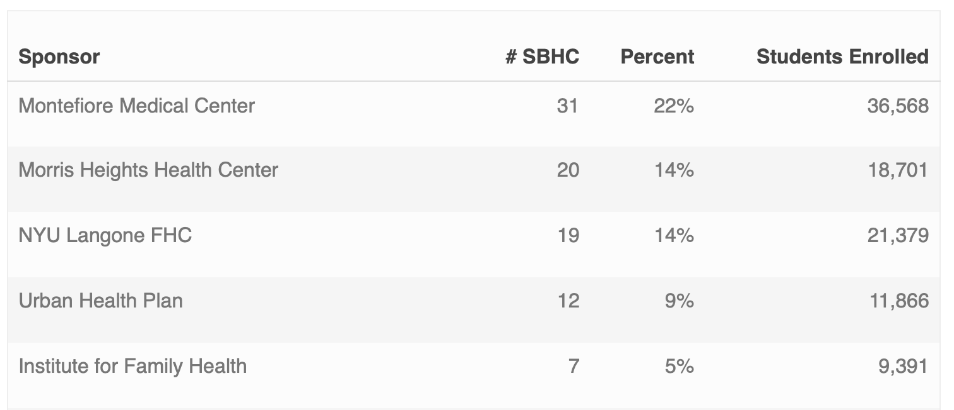
Appendix IV
The following maps depict the rates of enrollment, poverty, and asthma as they relate to the location of SBHCs. An interactive version of this map is available at the Data Team’s webpage, linked in Appendix I.
- Enrollment
The top 3 largest school districts are 31, 2, and 24 with 61,838, 57,900, 54,197 people enrolled respectively. Of these, only district 24 has a poverty percentage of greater than 70 percent and the others have less than 60 percent in poverty. District 2 has the largest number of open schools of all districts and has 8 SBHCs serving 34 schools. District 31 and 24 have 4 and 2 SBHCs respectively, both serving only 7 schools out of 87 and 69 respectively. 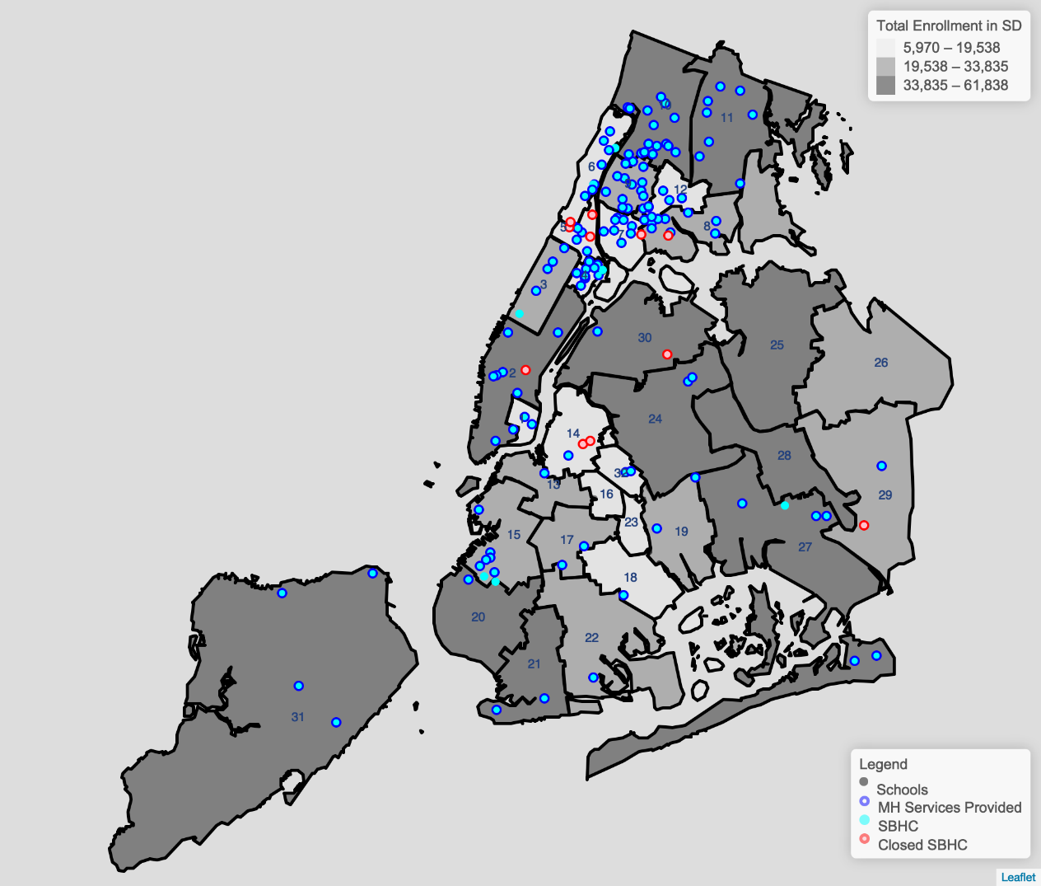
- Poverty
The top 3 school districts with the highest poverty percentage are 7, 12, and 9 with more than 91 percent of their students in poverty. These districts have 8, 7, and 13 SBHCs serving 20, 29, and 37 schools out of 74, 60, and 88 respectively. 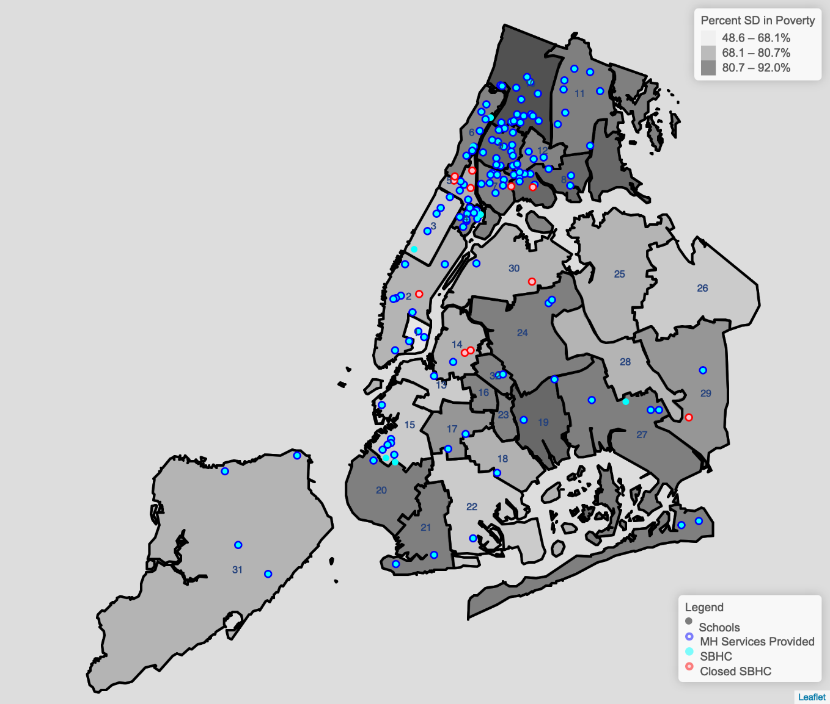

- Asthma
The top 3 school districts with the highest percentage of people with asthma are 5, 7, and 16 with more than 32 percent of their students with asthma. These districts have 2, 8, and 0 SBHCs serving 3, 20, and 0 schools out of 45, 74, and 33 respectively. District 16 may not have an SBHC as it is the lowest enrolled district with only 5,970 people. District 7 makes the top 3 in both poverty and asthma metrics.
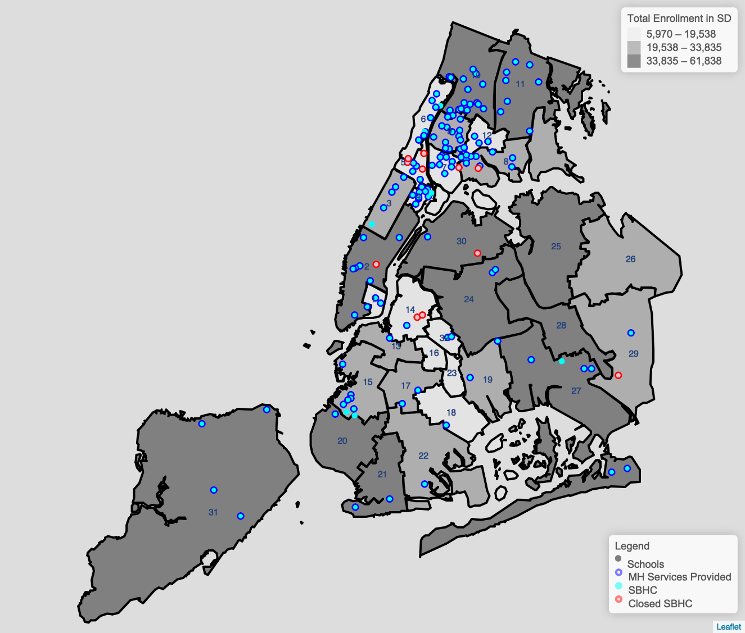

NYC DOE, “School-Based Health Centers”, available at: https://www.schools.nyc.gov/school-life/health-and-wellness/school-based-health-centers.
Id.
Id.
Id.
Id.
Id.
Id.
Id.
Id.
Id.
Id.
NYC DOE, “NYC School-Based Health Centers (SBHCs) 2023-2024,” (Jan. 2024), available at: https://www.schools.nyc.gov/docs/default-source/default-document-library/list-of-nyc-school-based-health-centers-english.pdf. See, e.g. Manhattan, District 2, Julia Richman Campus, BLDG M480, which contains 6 schools.
Note: This number includes 3 SBHCs in the Bronx that are temporarily closed. NYC DOE, “NYC School-Based Health Centers (SBHCs) 2023-2024,” (Jan. 2024), available at: https://www.schools.nyc.gov/docs/default-source/default-document-library/list-of-nyc-school-based-health-centers-english.pdf.
NYC Administrative Code §21-965.
NYC DOHMH, “Local Law 12 School Year 2021-22,”excel sheet, (Oct. 5, 2023), (On file with Council).
New York Mental Hygiene Law § 31; NYC Public Schools, “Mental Health,” available at: https://www.schools.nyc.gov/school-life/health-and-wellness/mental-health.
NYC Public Schools, “Mental Health,” available at: https://www.schools.nyc.gov/school-life/health-and-wellness/mental-health.
NYC Public Schools, “Mental Health”, available at: https://www.schools.nyc.gov/school-life/health-and-wellness/mental-health.
“Governor Hochul Announces $5.1 Million to Establish School-Based Mental Health Clinics,” (Nov. 30, 2023), available at: https://www.governor.ny.gov/news/governor-hochul-announces-51-million-establish-school-based-mental-health-clinics.
Id.
Id.
Id.
Id.
Id.
Id. As part of her plan, Governor Hochul increased insurance reimbursement rates for school based mental health services, ensuring the care provided by SBMHC satellites are covered by commercial insurance plans and at the same rates as Medicaid. Id. This change was adopted as part of the FY 2024 State Budget in May and took effect in January. Id.
“Governor Hochul Launches Expansion of School-Based Mental Health Clinics to Combat Youth Mental health Crisis” (Feb. 27, 2024), available at: https://www.governor.ny.gov/news/governor-hochul-launches-expansion-school-based-mental-health-clinics-combat-youth-mental.
Id.
Id.
Id.
Id.
NYC.gov, “Environment and Health Data Portal: Data Explorer: Asthma Emergency Department Visits (age 5 to 17)” (last accessed Apr. 10, 2024), available at: https://a816-dohbesp.nyc.gov/IndicatorPublic/data-explorer/asthma/?id=2380#display=summary.
Id.
Id.
Id.
Id.
Citizens’ Committee for Children, “Keeping Track of New York City’s Children: 2022,” (2022), available at: https://s3.amazonaws.com/media.cccnewyork.org/2022/11/CCC+Keeping+Track+2022_Small+PDF+Low+Res_corrected_20221021.pdf.
New York State Department of Health, “Children with Diabetes,” (2012), available at: https://www.health.ny.gov/publications/0944.pdf.
Id.
Id.
Id.
Jenny Veloz and Julie Kronick, “Environmental Justice is Health Equity for Many Children,” Citizens’ Committee for Children, (Apr. 25, 2023), available at: https://cccnewyork.org/environmental-justice-is-health-equity-for-many-children/.
Id.
Citizens’ Committee for Children, “Keeping Track of New York City’s Children: 2022,” (2022), available at: https://s3.amazonaws.com/media.cccnewyork.org/2022/11/CCC+Keeping+Track+2022_Small+PDF+Low+Res_corrected_20221021.pdf.
“Governor Hochul Launches Statewide Listening Tour on Youth Mental Health,” (Mar. 2023), available at: https://www.governor.ny.gov/news/governor-hochul-launches-statewide-listening-tour-youth-mental-health.
CDC, “2011-2021 Youth Risk Behavior Survey,” (2023), available at: https://www.cdc.gov/healthyyouth/data/yrbs/pdf/YRBS_Data-Summary-Trends_Report2023_508.pdf.
Id.
Id.
Id.
Id.
Id.
Id.
Id.
Id.
Id.
Id.
Id.
Id.
Id.
Id.
Id.
Id.
Id.
Id.
Id.
Id.
NYC DOE, “NYC School-Based Health Centers (SBHCs) 2023-2024,” (Jan. 2024), available at: https://www.schools.nyc.gov/docs/default-source/default-document-library/list-of-nyc-school-based-health-centers-english.pdf.
Id.
Id.
NYC DOE, “School-Based Health Centers”, available at: https://www.schools.nyc.gov/school-life/health-and-wellness/school-based-health-centers.
Id.
Id.
Financial Management Systems
Id.
January 2024 Monitor’s Packet on Department of Education from the Mayor’s Office of Management and Budget
Amy Zimmer, “5 school-based health clinics shuttered due to SUNY Downstate budget woes,” Chalkbeat (Aug. 3, 2022), available at: https://www.chalkbeat.org/newyork/2022/8/3/23290800/nyc-school-based-health-clinics-brooklyn-suny-downstate/.
Id.
Maya Kaufman, “Health + Hospitals to shutter all its school clinics,” POLITICO Pro (Aug. 15, 2023), available at: https://subscriber.politicopro.com/article/2023/08/health-hospitals-to-shutter-all-its-school-clinics-00111274.
Id.
See NYC Department of Education, NYC School-Based Health Centers (SBHCs) 2023-2024, available at: https://www.schools.nyc.gov/docs/default-source/default-document-library/list-of-nyc-school-based-health-centers-english.pdf and NYC School-Based Health Centers (SBHC) 2022-23, available at: https://web.archive.org/web/20230811024348/https://www.schools.nyc.gov/docs/default-source/default-document-library/list-of-nyc-school-based-health-centers-english.
Max Rivera, “Jackson Heights school health clinic closed by city with little explanation,” Queens Daily Eagle (Jan. 2, 2024), available at: https://queenseagle.com/all/2024/1/2/jackson-heights-school-health-clinic-closed-by-city-with-little-explanation.
Id.
Id.
Id.
The New York State Senate, Senate Bill S2339, Relates to the provision of services by school-based health centers, Justification (2023-2024 Legislative Session), available at: https://www.nysenate.gov/legislation/bills/2023/S2339.
New York School-Based Health Alliance, “Permanent Carve-Out of School-Based Health Centers Will Provide Sustainability to a Critical Health Care Safety Net for New York’s Most Vulnerable Kids and Teens,” Empire Report (June. 2, 2023), available at: https://empirereportnewyork.com/permanent-carve-out-of-school-based-health-centers-will-provide-sustainability-to-a-critical-health-care-safety-net-for-new-yorks-most-vulnerable-kids-and-teens/.
The New York State Senate, Senate Bill S2339, “Relates to the provision of services by school-based health centers, Justification,” (2023-2024 Legislative Session), available at: https://www.nysenate.gov/legislation/bills/2023/S2339.
New York School-Based Health Alliance, “Permanent Carve-Out of School-Based Health Centers Will Provide Sustainability to a Critical Health Care Safety Net for New York’s Most Vulnerable Kids and Teens,” Empire Report (June. 2, 2023), available at: https://empirereportnewyork.com/permanent-carve-out-of-school-based-health-centers-will-provide-sustainability-to-a-critical-health-care-safety-net-for-new-yorks-most-vulnerable-kids-and-teens/.
The New York State Senate, Senate Bill S2339, “Relates to the provision of services by school-based health centers, Justification,” (2023-2024 Legislative Session), available at: https://www.nysenate.gov/legislation/bills/2023/S2339.
Id.

