Staff: Committee on General Welfare
Andrea Vazquez, Senior Legislative Counsel
Tonya Cyrus, Senior Legislative Policy Analyst
Nameera Nuzhat, Legislative Financial Analyst



The Council of the City of New York

COMMITTEE REPORT OF THE HUMAN SERVICES DIVISION
Matthew Gewolb, Legislative Director

COMMITTEE ON GENERAL WELFARE

Stephen Levin, Chair

January 31, 2017

PROPOSED INT. NO. 1164-A: By Council Members Johnson, Levin, Torres, Richards, Chin, Barron, Rose, Gentile, Koslowitz, Salamanca, Cornegy, Gibson, Espinal, Rosenthal, Rodriguez and the Public Advocate (Ms. James)

TITLE: A Local Law to amend the administrative code of the city of New York, in relation to information regarding unlawful evictions

ADMINISTRATIVE CODE: Amends chapter 1 of title 21 by adding a new section 21-138

PROPOSED INT. NO. 1166-A: By Council Members Richards, Torres, Johnson, Williams, Chin, Barron, Rose, Gentile, Koslowitz, Salamanca, Cornegy, Gibson, Espinal, Levin Rosenthal, Rodriguez and the Public Advocate (Ms. James)

TITLE: A Local Law in relation to reporting on violations issued to three-quarter housing

Introduction

On January 31, 2017, the Committee on General Welfare chaired by Council Member Stephen Levin, will hold a hearing on two bills, Proposed Int. 1164-A, A Local Law to amend the administrative code of the city of New York, in relation to information regarding unlawful evictions, and Proposed Int. 1166-A, A Local Law in relation to reporting on violations issued to three-quarter housing. This will be the second hearing on the bills; the first hearing on the bills was October 6, 2016 at a hearing joint with the Committee on Housing and Buildings focusing on the issue of three-quarter housing. At the hearing, representatives from the Human Resources Administration (HRA), the Department of Housing Preservation and Development (HPD), the Mayor’s Office of Operations, the Three-Quarter Housing Tenant Organizing Project, Coalition for the Homeless, VOCAL-NY, MFY Legal Services, and other concerned advocates testified.
Background
What is three-quarters housing?
Three-quarters houses are typically one- and two- family homes, larger apartment buildings or other structures run by operators who rent beds to single adults. These homes are referred to as three-quarters housing because they are seen as somewhere between half-way houses and private homes. Given that the City’s Building Code outlaws cohabitation by four or more unrelated persons, most, if not all, three-quarters houses are illegal. Many of these houses hold themselves out as “programs” but do not provide any in-house services. Although reports suggest that State and City agencies and community-based organizations refer individuals to three-quarters homes, they are not licensed and no agency regulates or oversees these homes.
There is no precise data available on the exact number of three-quarters houses in New York City, but a 2013 report by the Prisoner Reentry Institute at John Jay College (“PRI report”) found 317 addresses of known locations, most of which are located in the City’s poorest communities, such as central Brooklyn, southeast Queens, and the southern Bronx. According to the PRI report, estimates indicate that more than 10,000 individuals live in three-quarters housing.
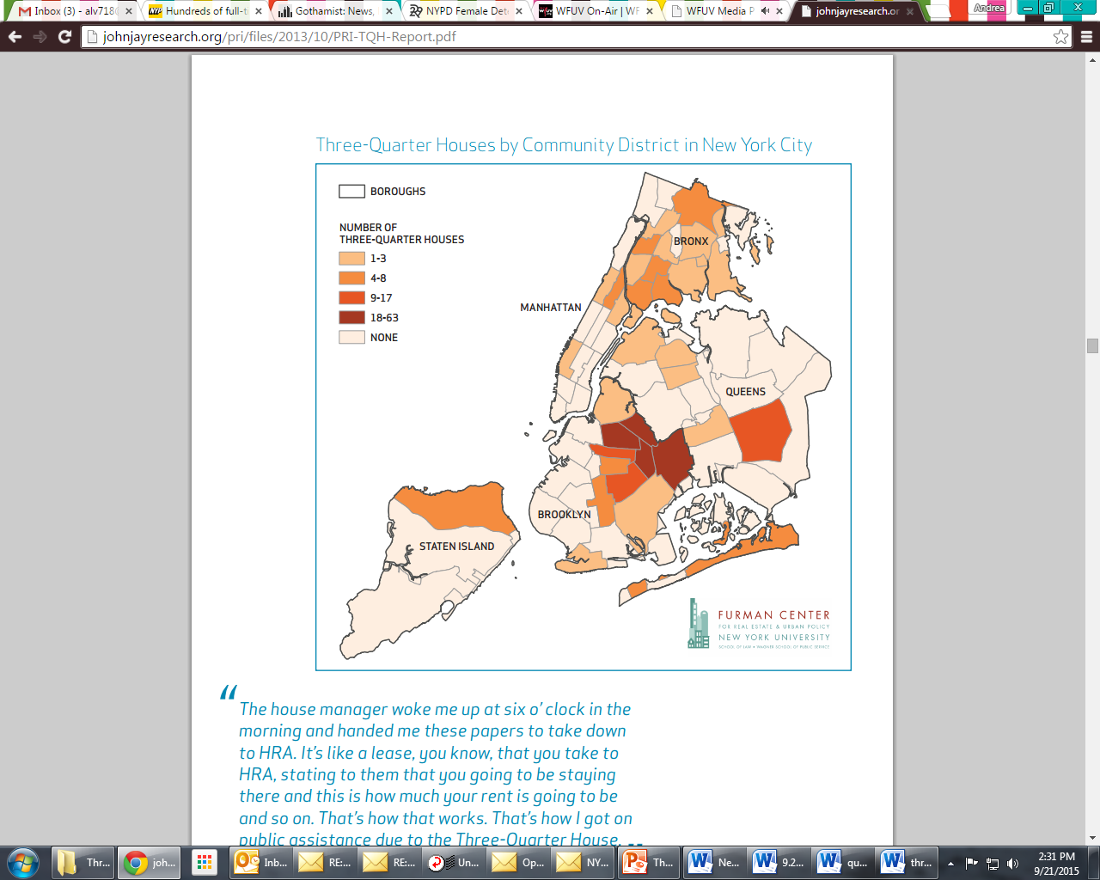
Three-quarters houses are financed almost entirely by public funds, and rents are typically tailored to a resident’s public assistance benefits. Those in receipt of only public assistance generally pay the $215 a month maximum shelter allowance for a single adult. Tenants who receive Social Security Disability (SSD) benefits, Social Security Income (SSI), unemployment insurance benefits, or are who are employed typically pay more than the $215/month which operators charge public assistance recipients. Operators of three-quarters housing also often charge other fees, generally between $30 and $50 a month, which tenants must pay the with their limited cash assistance. According to the PRI report, which surveyed tenants of three-quarters housing, 91% of the survey respondents’ rent was paid by HRA, and 47% of tenants were required to pay monthly fees with their public assistance cash benefits.
Who lives in three-quarters housing?
Three-quarters houses tenants are typically single adults who are returning from prison or jail, recovering from short-term hospital stays or residential substance abuse treatment, facing street homelessness, and/or dealing with unemployment, family crises or medical issues. Generally, three-quarters houses are the only alternative to the shelter system or the street for such individuals. According to the PRI report, 72% of the tenants who were surveyed were previously incarcerated, 60% had resided in a City shelter, 51% had been in a residential substance abuse treatment program, and 42% had experienced street homelessness. Individuals are often referred to three-quarters houses by State or City agencies, or by word of mouth. According to the PRI report, 31% were referred by a substance abuse program, 19% were referred through word of mouth, 14% were referred by parole, 14% were referred by a City shelter, 10% were referred by another three-quarters house, and 5% were referred by the courts.
Issues in three-quarters housing
Almost 90% of the three-quarter homes analyzed in the PRI report had Building Code complaints that resulted in at least one violation or stop-work order by the Department of Buildings (DOB). The violations included illegal conversions, lacking or violating certificates of occupancy, not having work permits, illegal SROs, blocked, locked or improper egress, illegal or defective gas hookups and failure to maintain the property. One of the most significant issues with three-quarter houses is overcrowding. Often, a single room has beds for between two and eight people, with bunk beds placed on all walls, and some place beds in hallways and closets.
Three-quarters houses operators also often violate tenants’ rights through unlawful evictions. Residents report that operators arbitrarily force people out without notice or court process. Additionally, there are reports that residents are required to attend a particular substance abuse treatment program, regardless of their need for such treatment. The evidence suggests that operators receive illegal kickbacks from substance abuse providers based on reports that tenants are forced to attend a particular program or face eviction, and are required to hand in daily “slips” to prove their attendance at such programs. Tenants are often illegally evicted upon successful completion of these programs. There are also reports of operators threatening tenants who are on parole or probation. According to the PRI report, 81% of the survey respondents’ houses required tenants to attend substance abuse treatment and submit proof of attendance. In 2015, prosecutors brought charges against Yury Baumblit, an operator of several known three-quarters houses, based on his unlawful evictions of tenants. In 2016, additional charges were brought against Mr. Baumblit and his wife by the New York State Attorney General’s office including grand larceny, money laundering, and violations of the law prohibiting Medicaid kickbacks. Mr. Baumblit and his business, Back on Track, was the subject of a New York Times profile in 2015 (discussed below).
Advantages of three-quarters housing
Despite the serious issues with three-quarters housing, many tenants report that there are benefits. The PRI report found that the tenants surveyed almost unanimously expressed their preference to live in a three-quarters home, as opposed to a shelter or the street. Some also reported an appreciation for the social support they received from housemates that have similar backgrounds or life experiences, and many reported that the homes struck the right balance between allocating them a degree of autonomy and providing the structure they need to recover, reenter society, and transition to more stable housing.
DHS Regulation
Based on advocacy and support from the Council, in 2010, the Department of Homeless Services (DHS) adopted a regulation prohibiting referrals of clients to buildings with vacate orders and with recorded violations typical of three-quarters houses. Although DHS has reduced its referrals to three-quarters houses since the implementation of the regulation, there continues to be reports that shelters make referrals to three-quarters houses. Further, these homes continue to proliferate due to referrals from other agencies and programs.
New York Times’ coverage and the de Blasio Administration’s response
In May 2015, the New York Times released A Choice for Recovering Addicts: Relapse or Homelessness, an in-depth report on one particularly problematic three-quarters house called Back on Track. The report detailed the poor living conditions typical of three-quarters homes and alleged that residents of this house were forced by the operator to relapse in order to continue attending the out-patient substance abuse treatment programs. The article also alleged that the operator would have staff members act as the Social Security payees for residents, and only provide them with $5-$10 a day from their disability checks.
Shortly after the article, Mayor Bill de Blasio announced an emergency task force to investigate three-quarters houses. The task force targeted known three-quarters houses based on a list compiled by the Human Resources Administration (HRA) of all addresses where ten or more HRA clients were receiving the State set shelter allowance of $215 a month. As of the May 2016 Executive Budget hearing of the Committee on General Welfare, the task force had inspected 72 sites and found 37 to be overcrowded. From those locations, 361 tenants were relocated voluntarily and 103 clients were connected to permanent housing with subsidized rents.
Relocation Services: HPD’s Emergency Housing Services Unit
The Department of Housing Preservation and Development’s (HPD) Emergency Housing Services (EHS) unit provides emergency relocation services and rehousing assistance to households who have been displaced from their homes as a result of fires or city-issued vacate orders. In the event of a building-wide emergency, such as a fire or city-issued vacate order, owners of residential buildings must provide the names and apartment numbers of all legal tenants in occupancy to EHS. After being assessed, displaced households may be temporarily placed in family centers or single-room-occupancy hotels in Manhattan, Bronx, Brooklyn, or Queens. Once a displaced household is relocated through EHS, they might be able to access additional support, including through HPD’s Section 8 Program, which accepts EHS referrals. According to advocates for individuals living of three-quarters houses, although such individuals are generally legal tenants of these houses, it is extremely difficult for them to access HPD’s services because they lack the documents, such as leases, that residents traditionally use to prove residency.

Legislative Analysis
Proposed Int. No. 1164-A – A Local Law to amend the administrative code of the city of New York, in relation to information regarding unlawful evictions

Proposed Int. No. 1164-A would require the Human Resources Administration (HRA) to provide any recipient of a rental subsidy a written statement explaining the protections of Section 26-521 of the Administrative Code, which prohibits unlawful evictions The notices would be provided to recipients upon initial receipt of the subsidy and at any point HRA determines to be appropriate. For the purposes of Proposed Int. No. 1164-A, the definition of rental subsidies means financial assistance provided by HRA for the purpose of paying a recipient’s rent on an ongoing basis, and would include the public assistance shelter allowance pursuant to Section 131-a of the State Social Services Law and the subsidies created by HRA including the Living in Communities rental assistance program, the City Family Eviction Prevention Supplement program, and the City Family Exit Plan Supplement program, the City Special Exit and Prevention Supplement, the Home Tenant-Based Rental Assistance Program, and any successor programs. The bill would also allow that if the applicant chooses, HRA may send the notice electronically. After introduction, Proposed Int. 1164-A was amended to clarify the definition of rental subsidy, to include a direct reference to Section 26-521 of the Administrative Code, and to allow for the option to receive the information electronically. Proposed Int. 1164-A would take effect 90 days after it becomes law
Proposed Int. No. 1166-A – A Local Law in relation to reporting on violations issued to three-quarter housing

Proposed Int. No. 1166-A would require HRA to produce a quarterly report that would be sent to the Council and posted on its website regarding the actions of the three-quarter housing task force. Proposed Int. No. 1166-A would define the three-quarter housing task force as the group of inspectors from HRA, the Department of Buildings (DOB), the Fire Department (FDNY), and the Department of Housing Preservation and Development (HPD) who are responsible for inspecting buildings where 10 or more unrelated adults are living. The reports required pursuant to Proposed Int. No. 1166-A would include: the number of violations issued by the three-quarters houses task force disaggregated by agency, identified in such a way that does not disclose the building’s address, and the number of people relocated from buildings inspected by the three-quarter housing task force, disaggregated by whether such individuals were given a rental assistance subsidy, what type of subsidy was provided, and the type of housing to which the individual was relocated, including but not limited to private apartments, single room occupancy dwellings or temporary housing. After introduction, Proposed Int. 1166-A was amended to track how the task force currently conducts its inspections, including by disaggregating violations by the administering agency, and by not reporting on the number of beds in each identified house to address privacy concerns. Proposed Int. 1166-A was also amended to make certain technical amendments to the due date and reporting period of the first report. The first report would cover data from June 1, 2015 through March 31, 2017. The bill would take effect immediately and would expire and be deemed repealed on January 1, 2019.

Proposed Int. No. 1164-A

By Council Members Johnson, Levin, Torres, Richards, Chin, Barron, Rose, Gentile, Koslowitz, Salamanca, Cornegy, Gibson, Espinal, Rosenthal, Rodriguez and the Public Advocate (Ms. James)

A LOCAL LAW

To amend the administrative code of the city of New York, in relation to information regarding unlawful evictions

Be it enacted by the Council as follows:

Section 1. Chapter 1 of title 21 of the administrative code of the city of New York is amended by adding a new section 21-138 to read as follows:
§ 21–138 Information regarding unlawful evictions. a. For the purposes of this section, the term “rental subsidy” means financial assistance provided by the department for the purpose of paying a recipient’s rent on an ongoing basis. The term “rental subsidy” includes but is not limited to the public assistance shelter allowance provided by the department as established by section 131-a of the social services law and defined in paragraph (1) of subdivision (a) of section 352.3 of title 18 of the New York codes, rules and regulations, as well as subsidies provided through the living in communities rental assistance program, the city family eviction prevention supplement program and the city family exit plan supplement, the city special exit and prevention supplement, the home tenant-based rental assistance program, and any successor program to the foregoing programs.
b. The department shall provide a written notice to each individual who applies for a rental subsidy for housing that is subject to section 26-521 of the code. The notice shall be provided upon the initial application or approval for such rental subsidy and at any time the department determines to be appropriate for such subsidy, except such notice may be provided in electronic form to any individual who registers electronic contact information with the department and elects to receive such notices in electronic form. Such notice shall inform individuals of the protections of section 26-521 of the code regarding eviction, and may include additional information as determined by the department.
c. Receipt of such notice shall not be construed to confer the protections set forth in section 26-521 of the code.
§ 2. This local law takes effect 90 days after it becomes law.

AV
LS #5501
1/17/17, 1:35PM

Proposed Int. No. 1166-A

By Council Members Richards, Torres, Johnson, Williams, Chin, Barron, Rose, Gentile, Koslowitz, Salamanca, Cornegy, Gibson, Espinal, Levin, Rosenthal, Rodriguez and the Public Advocate (Ms. James)

A LOCAL LAW

In relation to reporting on violations issued to three-quarter housing

Be it enacted by the Council as follows:

Section 1. Three-quarter housing task force report. a. For the purposes of this section, the term “three-quarter housing task force” means the group of representatives from the department of social services/human resources administration, department of buildings, the fire department, and the department of housing preservation and development responsible for inspecting certain dwellings identified by the task force where ten or more unrelated adults are living.
b. The mayor’s office of operations shall provide to the council and publish on its website quarterly reports on the findings of the three-quarter housing task force. The first such report shall be due 30 days following the calendar quarter ending March 31, 2017, and all subsequent reports shall be due 30 days following the last day of each succeeding calendar quarter. Such reports shall include, but need not be limited to, the following information:
1. For each building inspected by the three-quarter housing task force, the number of violations issued, disaggregated by agency, provided that each building shall be identified in such a way that does not disclose the building’s address; and
2. The number of individuals relocated from buildings inspected by the three-quarter housing task force, disaggregated by whether such individuals were given a rental assistance subsidy, the type of subsidy provided, and the type of housing to which the individual was relocated, including but not limited to private apartments, single room occupancy dwellings or temporary housing.
c. The first such report shall cover the period from June 1, 2015 to March 31, 2017.
§ 2. This local law takes effect immediately and expires and is deemed repealed on January 1, 2019.

AV
LS #5500/5712
1/24/17, 6:08pm

John Jay College of Criminal Justice, Prisoner Reentry Institute (PRI), Three Quarters Houses: The View from Inside (Oct. 2013) at v, available at http://johnjayresearch.org/pri/files/2013/10/PRI-TQH-Report.pdf (hereinafter PRI Report).
Barker, Kim, “A Choice for Recovering Addicts: Relapse or Homelessness,” the new York Times (May 30, 2015) (hereinafter NYT Article) available at http://www.nytimes.com/2015/05/31/nyregion/three-quarter-housing-a-choice-for-recovering-addicts-or-homelessness.html.
NYC Bldg. Code 310.2.
PRI Report, supra note 1.
Id.
Id. at vi.
Id. at 7.
18 NYCRR 352.3.
PRI Report supra, note 1.
Id. at 7.
Id.
Id.
Id.
Id. at 8.
Id. at 9.
Id. at vi.
Id. at 6.
Id. at vii.
Id.
Id. at viii.
Id.
Id.
Id. at 13.
Barker, Kim, “Landlord of ‘Three-Quarter’ Homes Faces Criminal Charges, The New York Times (Aug. 10, 2015) http://www.nytimes.com/2015/08/11/nyregion/landlord-of-three-quarter-homes-faces-criminal-charges.html.
Barker, Kim, “Flophouse Operator Is Arrested in a Scheme to Defraud Medicaid,” The New York Times (April 13, 2016) http://www.nytimes.com/2016/04/14/nyregion/flophouse-operator-is-arrested-in-a-scheme-to-defraud-medicaid.html.
PRI Report, supra, note 1 at ix.
Id.
Rules of the City of New York, Title 31 § 2-01.
Supra note 5.
PRI Report, supra, note 1 at 10.
NYT Article, supra note 2.
Id.
Id.
Barker, Kim, “New York City Task Force to Investigate ‘Three-Quarter’ Homes” The New York Times, (June 1, 2015) available at http://www.nytimes.com/2015/06/01/nyregion/new-york-city-task-force-to-investigate-three-quarter-homes.html.
Testimony of Steve Banks, HRA Commissioner, before the Committee on General Welfare, FY17 Executive Budget (May 12, 2016) p. 192.
Id.
Id.
See HPD’s Emergency Housing Services Office Description available at http://www1.nyc.gov/site/hpd/about/emergency-housing-services.page.
Id.
Id.
See HPD’s Section 8 Program Description available at http://www1.nyc.gov/nyc-resources/service/1872/hpd-section-8-program.

