THE COUNCIL OF THE CITY OF NEW YORK
RESOLUTION NO. 965

Resolution approving the decision of the City Planning Commission on Application No. N 150340 ZRR, for an amendment of the Zoning Resolution of the City of New York, to modify Appendix A of Article X, Chapter 7, concerning the boundaries of Designated Open Space, within the Special South Richmond Development District in Community District 3, Borough of Staten Island (L.U. No. 321).

By Council Members Greenfield and Richards

WHEREAS, the City Planning Commission filed with the Council on December 18, 2015 its decision dated December 16, 2015 (the "Decision"), pursuant to Section 201 of the New York City Charter, regarding an application submitted by BIRB Realty Inc., for an amendment of the text of the Zoning Resolution of the City of New York, to modify Appendix A of Article X, Chapter 7, concerning the boundaries of Designated Open Space along Durant Avenue and Ocean Road in the Great Kills neighborhood of Staten Island, within the Special South Richmond Development District, to facilitate development of three, two-family homes located at 521-529 Durant Avenue (Block 5120, Lot 62), (Application No. N 150340 ZRR), Community District 3, Borough of Staten Island (the "Application");

WHEREAS, the Decision is subject to review and action by the Council pursuant to Section 197-d(b)(1) of the City Charter;
WHEREAS, upon due notice, the Council held a public hearing on the Decision and Application on January 12, 2016;

WHEREAS, the Council has considered the land use implications and other policy issues relating to the Decision and Application; and

WHEREAS, the Council has considered the relevant environmental issues, including the conditional negative declaration (CEQR No. 15DCP154R) issued on December 14, 2015, which reflects the modified application (the “Conditional Negative Declaration”);

RESOLVED:

The Council finds that the action described herein will have no significant impact on the environment as set forth in the Conditional Negative Declaration.

Pursuant to Sections 197-d and 200 of the City Charter and on the basis of the Decision and Application, and based on the environmental determination and consideration described in the report, N 150340 ZRR, incorporated by reference herein, the Council approves the Decision.
The Zoning Resolution of the City of New York, effective as of December 15, 1961, and as subsequently amended, is further amended as follows:

ARTICLE X
SPECIAL PURPOSE DISTRICTS
Chapter 7
Special South Richmond Development District

* * *
Appendix A
Special South Richmond Development District Plan

* * *
Map 3: Open Space Network [Existing]
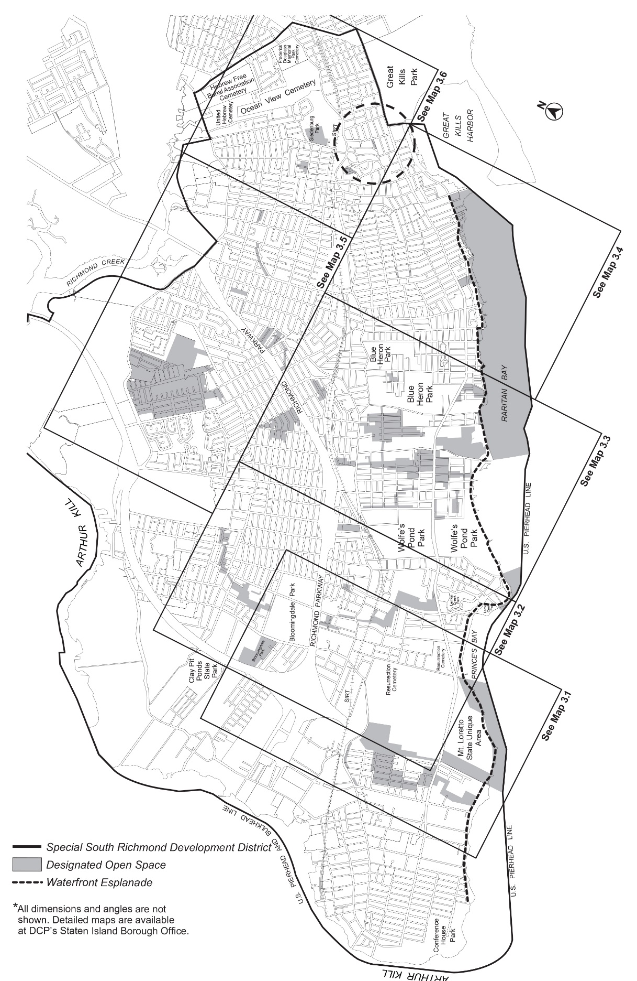
Map 3: Open Space Network [Proposed]

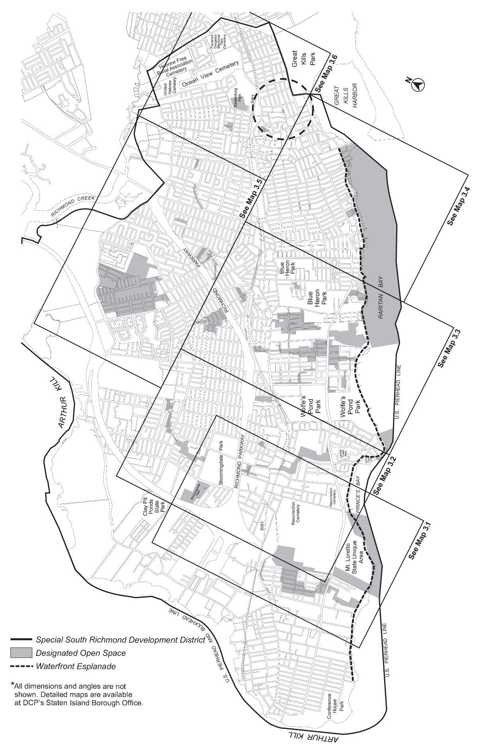

* * *
Map 3.6: Open Space Network [Existing]
──── Special South Richmond Development District
Designated Open Space

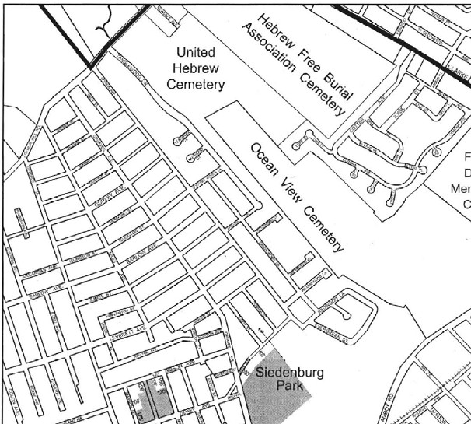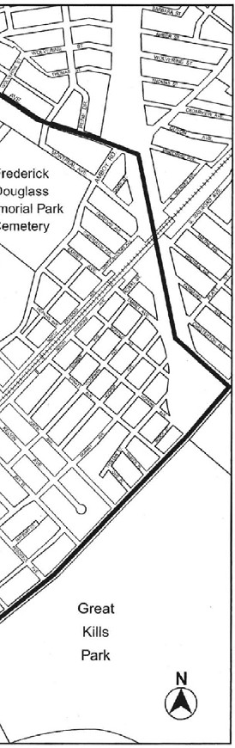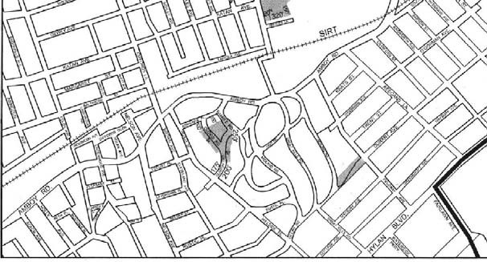

Map 3.6: Open Space Network [Proposed]
──── Special South Richmond Development District
Designated Open Space

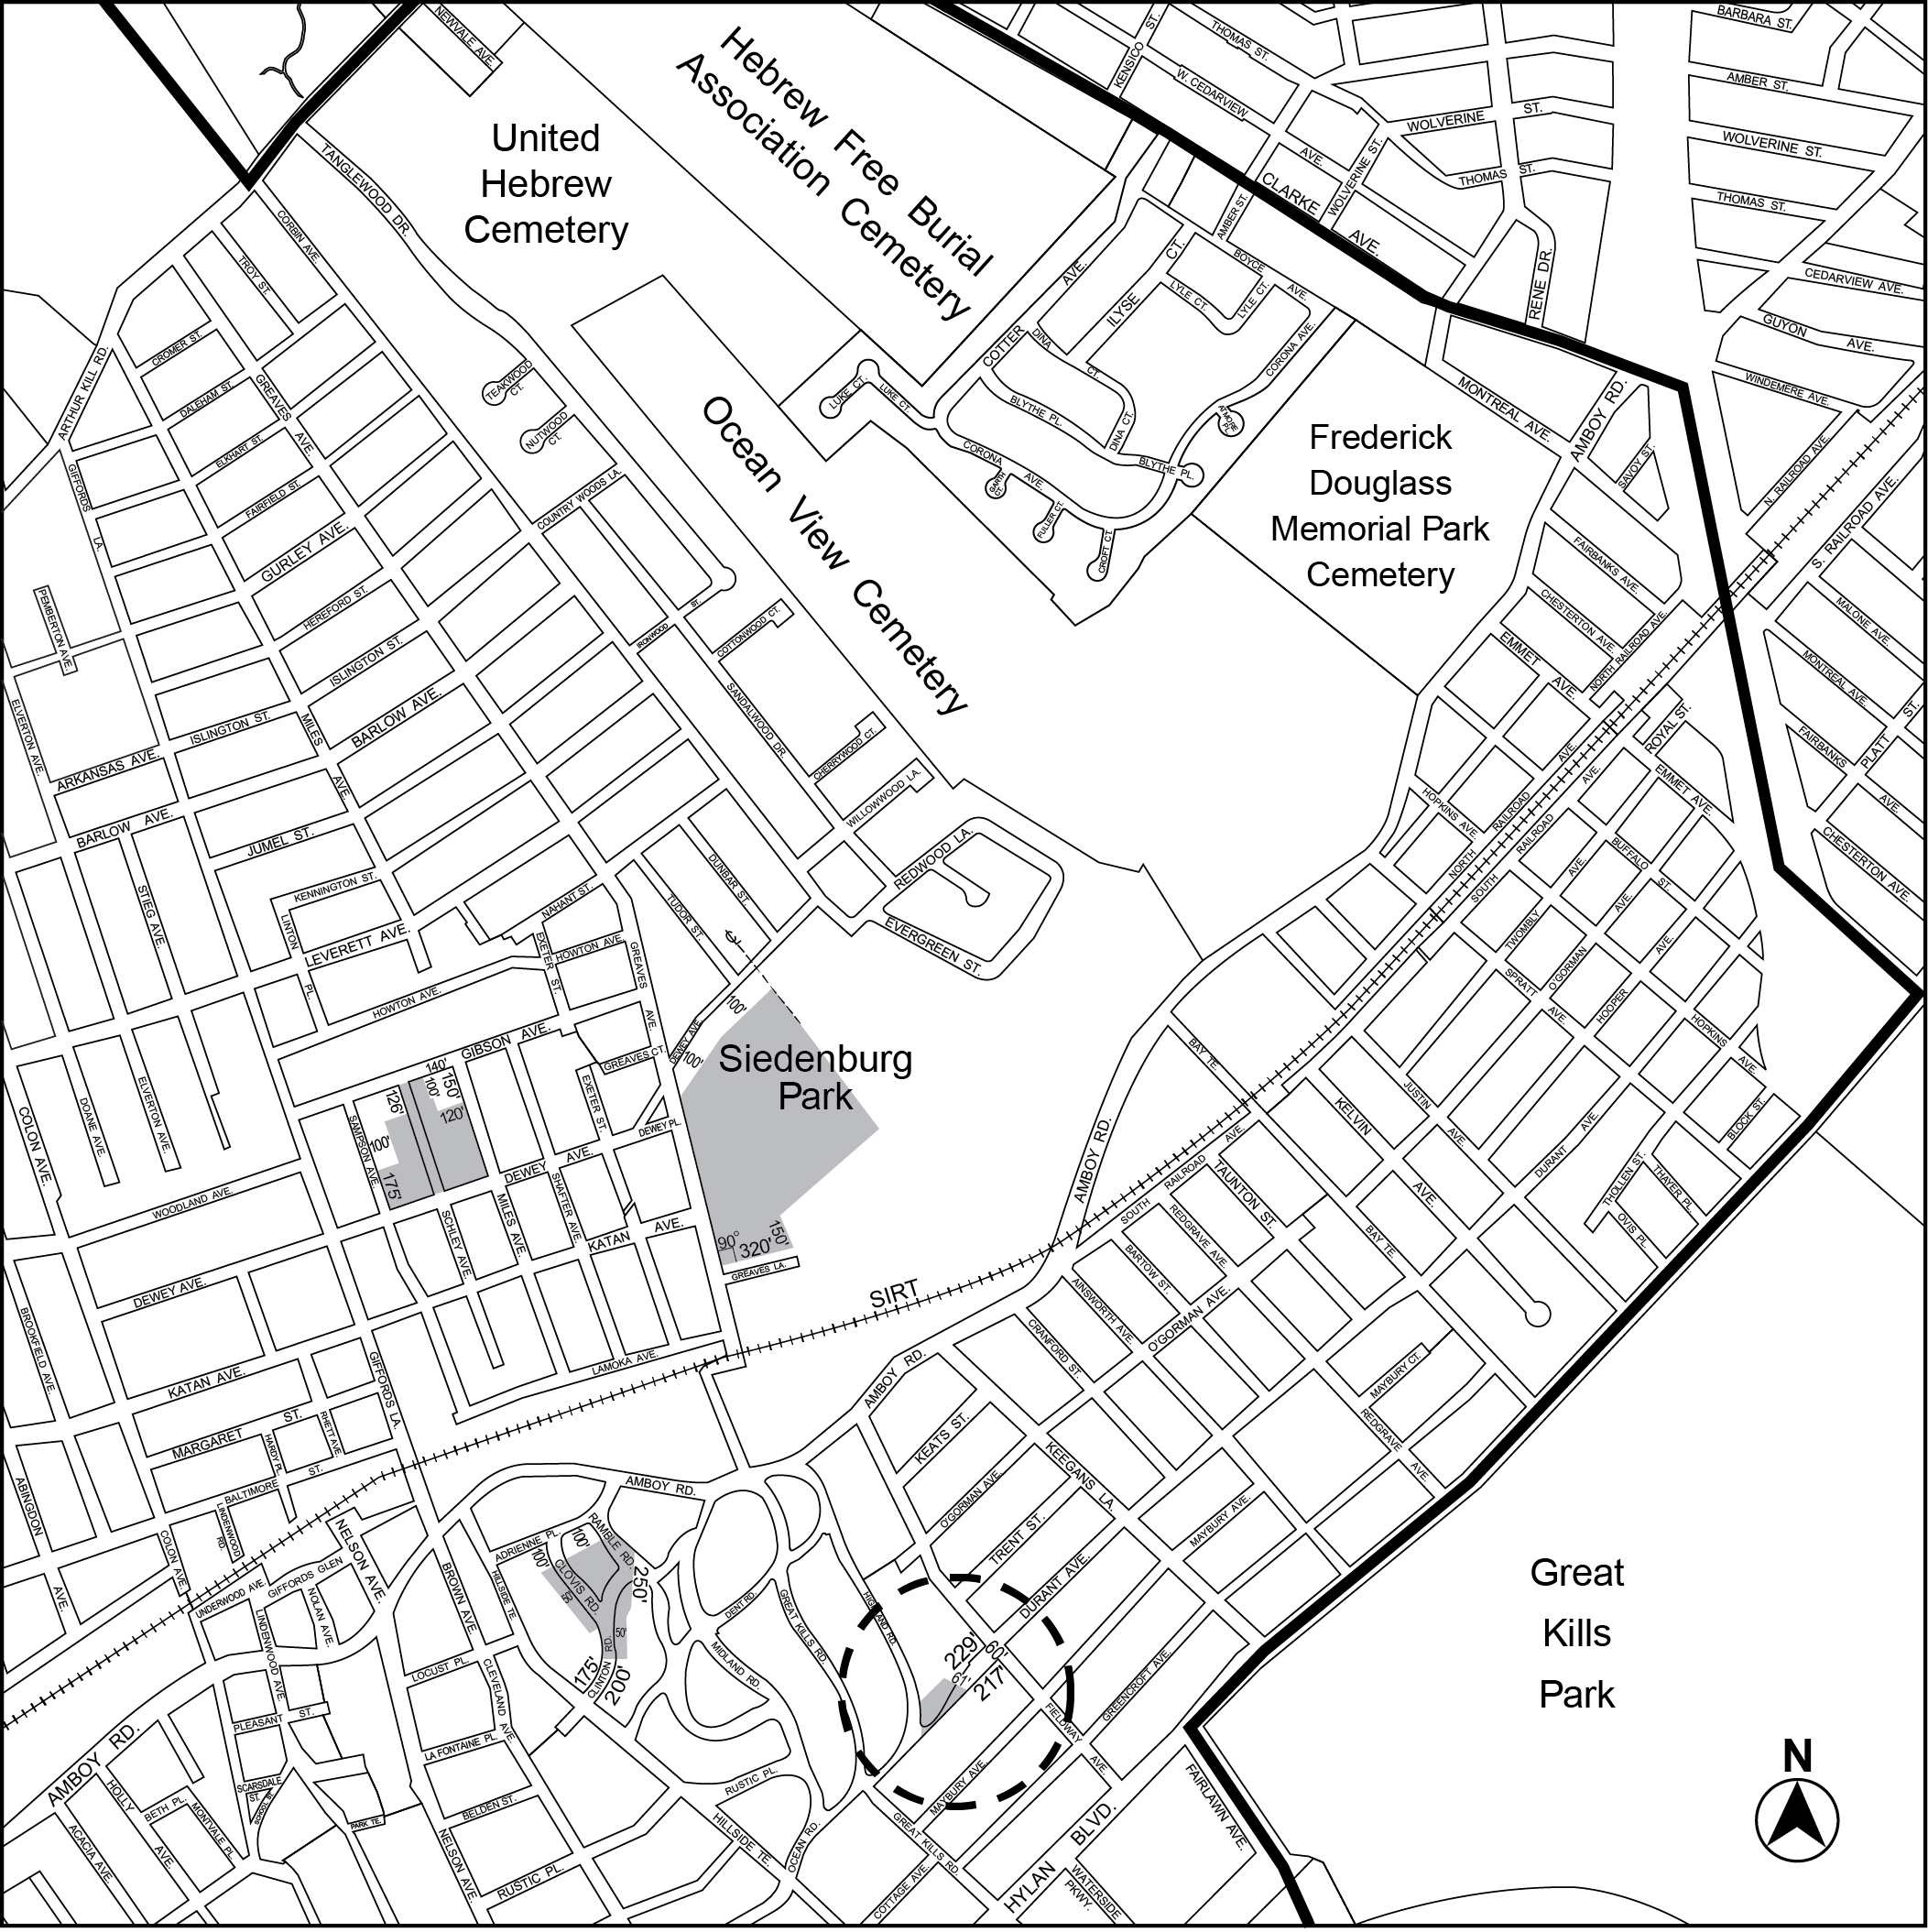

* * *

Adopted.
Office of the City Clerk, }
The City of New York, } ss.:

I hereby certify that the foregoing is a true copy of a Resolution passed by The Council of The City of New York on January 19, 2016, on file in this office.

.....…….........................................
City Clerk, Clerk of The Council

