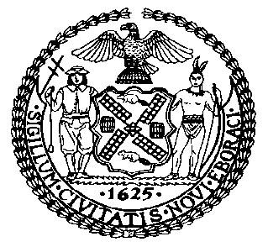 | The Council of the City of New York  Finance Division  Latonia McKinney, Director  Fiscal Impact Statement  Proposed Intro. No: 1149-B  Committee: Housing and Buildings
Title: A Local Law to amend the administrative code of the city of New York, in relation to documentation, submission and public availability of cooling tower inspections and certifications | Sponsors: Council Members Kallos, Yeger and Gibson
Summary of Legislation: Proposed Intro. No. 1149-B would require cooling tower inspectors to report to the New York City Department of Health and Mental Hygiene (DOHMH) within five days of the inspection when certain inspections occur, DOHMH to make that date of inspection available to the public and DOHMH to check the accuracy of the dates reported pursuant to this subdivision against the dates of inspection in the records of the property owner. This bill would also require building owners to make cooling tower inspection results available to the public upon request. Lastly, this bill would require DOHMH to send owners and operators of cooling towers an electronic reminder at least 30 days prior to the filing deadline for annual certifications with a link to where these certifications may be submitted.

Effective Date: This legislation would take effect 180 days after it becomes law, except that DOHMH would take such measures as are necessary for the implementation of this local law, including the promulgation of rules, before such date.
Fiscal Year In Which Full Fiscal Impact Anticipated: Fiscal 2021
Fiscal Impact Statement:

 | Effective FY20 | FY Succeeding Effective FY21 | Full Fiscal Impact FY21
Revenues | $0 | $0 | $0
Expenditures | $0 | $0 | $0
Net | $0 | $0 | $0

Impact on Revenues: It is estimated that there would be no impact on revenues resulting from the enactment of this legislation.

Impact on expenditures: It is estimated that there would be no impact on expenditures resulting from the enactment of this legislation because existing resources would be used by DOHMH and non-City entities to implement the provisions of this local law.
Source of Funds To Cover Estimated Costs: N/A.

Source of Information: New York City Council Finance Division

Estimate Prepared by: Sarah Gastelum, Principal Financial Analyst

Estimated Reviewed by: Noah Brick, Assistant Counsel
Chima Obichere, Unit Head

Legislative History: This legislation was introduced to the full Council on October 17, 2018 as Intro. No. 1149 and was referred to the Committee on Housing and Buildings. A joint hearing was held by the Committee on Housing and Buildings and the Committee on Health on October 23, 2018, and the bill was laid over. The legislation was subsequently amended, and then amended a second time, and this version, Proposed Intro. No. 1149-B will be considered by the Committee on March 25, 2019. Following a successful Committee vote, the bill will be submitted to the full Council for a vote on March 28, 2019.

Date Prepared: March 21, 2019

