General Welfare Committee Staff Aminta Kilawan, Senior Legislative Counsel David Romero, Legislative Counsel
Penina Rosenberg, Policy Analyst
Julia Haramis, Unit Head
Phariha Rahman, Financial Analyst
Rose Martinez, Assistant Deputy Director


THE COUNCIL OF THE CITY OF NEW YORK
BRIEFING PAPER AND COMMITTEE REPORT OF THE LEGISLATIVE DIVISION
Andrea Vazquez, Legislative Director
Smita Deshmukh, Deputy Director, Human Services

COMMITTEE ON GENERAL WELFARE

Hon. Diana Ayala, Chair March 1, 2024
Oversight: DSS Manipulation of Monthly Eligibility Rate Reporting
Int. No. 210-2024 By Council Members Hanif, Restler, Gutiérrez, De La Rosa, Hudson, Sanchez, Nurse, Won, Avilés, Rivera, Krishnan and Marte
Title: A Local Law to amend the administrative code of the city of New York, in relation to prohibiting the department of social services or any other city agency from imposing length of shelter stay restrictions in a shelter of any type
Int. No. 349-2024 By Council Member Nurse
Title: A Local Law to amend the administrative code of the city of New York, in relation to requiring monthly reports on removals of individuals experiencing homelessness and the outcomes for those individuals

INTRODUCTION

On March 1, 2024, the Committee on General Welfare, chaired by Deputy Speaker Diana Ayala, will hold an oversight hearing on a January 9, 2024, report (the DOI Report) published by the New York City (City) Department of Investigation (DOI) that contains findings and conclusions of DOI’s investigation into allegations that the City Department of Social Services (DSS) manipulated data concerning the rate of eligibility of shelter applicants. The Committee will also hear Int. No. 210-2024, sponsored by Council Member Shahana Hanif, in relation to prohibiting DSS or any other City agency from imposing a length of shelter stay restriction in a shelter of any type, and Int. No. 0349-2024, sponsored by Council Member Sandy Nurse, in relation to requiring reports on removals involving individuals experiencing homelessness and the outcomes for those individuals. Witnesses invited to testify include DSS, the City Office of Asylum Seeker Operations, service providers, and advocates.

BACKGROUND

New York City Department of Social Services and Department of Homeless Services
DSS is comprised of the Human Resources Administration (HRA), which administers major public benefits programs, and the Department of Homeless Services (DHS), which is responsible for transitional housing and services provided by the City for eligible homeless families and individuals.¹ DHS’s shelter system includes separate shelters for single adults, families with children, and adult families. Additional population specific housing support programs are administered for: youth (funded by the Department of Youth and Community Development (DYCD)); victims of domestic violence; relocation assistance for tenants displaced

¹ About DSS (n.d.) NYC Department of Social Services. Available at: https://www.nyc.gov/site/dss/about/about.page
due to disaster or catastrophe; drop-in centers that provide hot meals, clothing, and case management for unsheltered people; and housing for homeless people living with HIV/AIDS.²
DHS oversees over 300 shelters, which include commercial hotels and congregate shelters³. In Fiscal Year 2024, 50% of these shelters served families with children.⁴ Shelters may be operated directly by DHS, operated by non-contracted providers on a per diem basis, or formally contracted to one of a number of nonprofit providers⁵ including: Volunteers of America; Center for Urban Community Services; Women’s Prison Association; Henry Street Settlement; WIN; BronxWorks; Services for the UnderServed; CAMBA; and Bowery Residents Committee, among others.⁶
- Shelter Process

The process of accessing shelter and housing support is subject to State and local laws and regulations, and differs for different populations. The assessment process is dictated by the November 3, 2016, Administrative Directive published by the New York State Office of Temporary and Disability Assistance (OTDA).⁷ Families with children must apply for shelter at DHS’s Prevention Assistance and Temporary Housing (PATH) intake center located in the Bronx to undertake an eligibility assessment process for either services that may help prevent them from becoming homeless or to access emergency temporary shelter.⁸ Single adults seeking shelter must

2 Summary of the NYC Shelter System (n.d.) Community Service Society of New York. Available at: https://bplc.cssny.org/pbm/housing-programs-services/nyc-shelter-system/overview
³ Cluster sites were phased out in 2021
4 Review of the New York City Department of Homeless Services’ Programs and Services (Aug. 21, 2023). Office of the New York City Comptroller. Available at: https://comptroller.nyc.gov/reports/review-of-the-new-york-city-department-of-homeless- services-programs-and-services/
5 Review of the New York City Department of Homeless Services’ Programs and Services (Aug. 21, 2023). Office of the New York City Comptroller. Available at: https://comptroller.nyc.gov/reports/review-of-the-new-york-city-department-of-homeless- services-programs-and-services/
6 Providers (n.d.). DHS. Available At: https://www.nyc.gov/site/dhs/shelter/providers/providers.page
⁷ Office of Temporary and Disability Assistance. 16-ADM-11 (Nov. 3, 2016) Temporary Housing Assistance: Consolidation and Clarification of Policy, Available at: https://otda.ny.gov/policy/directives/2016/ADM/16-ADM-11.pdf
8Families with Children: Applying for Temporary Housing Assistance (n.d.). NYC Department of Homeless Services. Available at: https://www.nyc.gov/site/dhs/shelter/families/families-with-children-applying.page
report to either the male or female intake shelter located in midtown Manhattan and the Bronx respectively.⁹
After entering an intake center, applicants provide demographic information to DHS staff and undertake an assessment to identify whether a diversion or homelessness prevention program, such as HomeBase, a one-shot deal, family mediation, or Project Reconnect, may be appropriate.¹⁰ If diversion is not an option, applicants are assigned to assessment sites (or, for families with children, to a conditional placement for up to 15 days) for further assessment and eligibility checks.¹¹
Eligibility determinations include a review of two years' worth of previous living arrangements to assess other viable housing options.¹² Eligibility requirements are different for single adults, families with children, and adult families. Single adults do not have any eligibility requirements while families must meet family unit requirements and be experiencing an immediate housing crisis with no other viable housing options.¹³ Should applicants be found eligible for shelter within a DHS facility, they receive a placement in a temporary shelter and are connected with case management services including medical and mental health care, substance misuse support, and education and employment services.¹⁴ People in shelters are also supported in moving into permanent housing.¹⁵ Ineligible applicants may reapply for shelter at PATH.¹⁶

9Single Adults: Applying for Temporary Housing Assistance Assistance (n.d.). NYC Department of Homeless Services. Available at https://www.nyc.gov/site/dhs/shelter/singleadults/single-adults-applying.page. Per the NYC DHS Office of Policy, Procedures, and Training, intersex, transgender, and non-binary applicants my present at either intake center and will be assigned to an appropriate site based on their choice and taking into consideration concerns related to safety.
10 Review of the New York City Department of Homeless Services’ Programs and Services (Aug. 21, 2023). Office of the New York City Comptroller. Available at: https://comptroller.nyc.gov/reports/review-of-the-new-york-city-department-of-homeless- services-programs-and-services/
11 Id
12 Id
13 Id.
14 Id
15 Id.
16 Id.
In Fiscal Year 2023, the average length of stay in a shelter was over a year: single adults stayed for an average of 412 days; adult families stayed for an average of 750 days; and families with children stayed for an average of 437 days.¹⁷ This was a decrease from Fiscal Year 2022¹⁸, as illustrated in the chart below, but still totals over a year in shelters before exiting to stable housing.
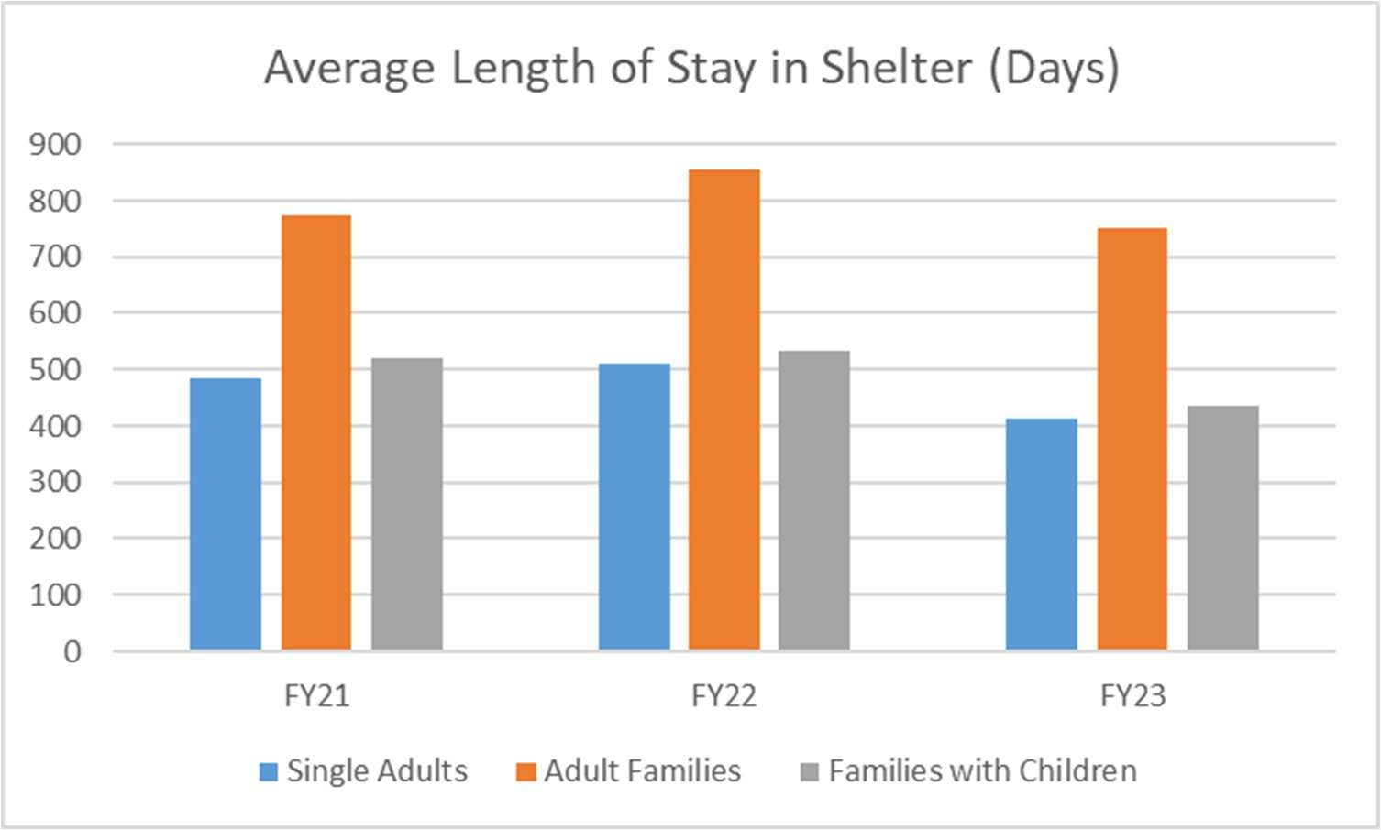
Source: Preliminary Mayor's Management Report FY2024

- Eligibility Rate

DHS’s process for determining eligibility for services involves collecting applicants’ housing history¹⁹, which includes undertaking field visits to verify information and rule out alternative shelter arrangements.²⁰ According to the DOI report, applicants are coded in DHS’s

17 Department of Homeless Services. (Jan 31, 2024). Preliminary Mayor’s Management Report FY 2024. Available at: https://www.nyc.gov/assets/operations/downloads/pdf/pmmr2024/dhs.pdf
¹⁸ These numbers are affected by asylum seeking families in DHS shelter and the 30/60 day rules which artificially lowered the length of shelter stays.
19 Families with Children: Applying for Temporary Housing Assistance (n.d.). NYC Department of Homeless Services. Available at: https://www.nyc.gov/site/dhs/shelter/families/families-with-children-applying.page
20 DHS Frequently Asked Questions (FAQ) (n.d.) NYC Department of Homeless Services. Available at: https://www.nyc.gov/site/dhs/about/frequently-asked-questions.page
Client Assistance and Rehousing Enterprise System (CARES) database according to their eligibility: “XA” (ineligible due to non-cooperation and not subject to supervisory review); “XX” (ineligible due to DHS identifying another available housing option, subject to one level of review), or “YY” (preliminarily eligible, subject to two levels of review).²¹ This data is used for DHS’s public reporting on PATH’s 30-day Eligibility Rate, the proportion of all families with children determined to be eligible for shelter during the reporting period.²²

The State of Homelessness in New York City
The federal government defines homelessness as “an individual of family who lacks a fixed, regular, and adequate nighttime residence”²³ and includes those sleeping in public or private places “not designed for or ordinarily used as a regular sleeping accommodation for human beings”; those sleeping in temporary shelters; and those at risk of losing their housing within 14 days.²⁴ Research has shown that lack of affordable housing is currently a main driver of homelessness, and that evictions, job loss, domestic violence, and lack of care for mental illness of substance misuse disorders can all trigger homelessness.²⁵
As of February 19, 2024, there were 87,857 individuals in shelters in New York City, 72% of whom were classified as members of families with children.²⁶²⁷ Since 2013, DHS has recorded

21 The City of New York Department of Investigation (Release #02-2024) “DOI ISSUES REPORT ON DISCLOSURE OF OVERNIGHT STAYS AT THE PATH INTAKE CENTER IN SUMMER 2022 AND THE MANIPULATION OF THE PUBLICLY-REPORTED PATH ELIGIBILITY RATE FROM 2017 TO EARLY TO MID-2022,” (Jan. 9, 2024) available at
www.nyc.gov/assets/doi/press-releases/2024/January/02DSSRelease.Rpt.01.09.2024.pdf, (hereinafter DOI Report).
22 Id.
23 42 U.S. Code § 11302
24 Id.
25 Basic Facts About Homelessness: New York City (December 2023). Coalition for the Homeless. Available at: https://www.coalitionforthehomeless.org/basic-facts-about-homelessness-new-york-city/
26DHS daily report (Feb. 19, 2024). Available from: https://data.cityofnewyork.us/Social-Services/DHS-Daily-Report/k46n-
sa2m/about_data
27 This dataset includes the daily number of families and individuals residing in the DHS shelter system and the daily number of families applying to the DHS shelter system.
an average of 55,000 individuals in City shelters at any given time,²⁸ however this does not account for the scope of homelessness in the city. DHS’s annual Homeless Outreach Population Estimate (HOPE) Survey, a "point-in-time" survey undertaken in the last week of January each year to count the number of unsheltered individuals in the city, estimated over 4,000 unsheltered individuals in 2023;²⁹ according to the Coalition for the Homeless, the HOPE survey likely significantly underestimates the number of unsheltered individuals citywide.³⁰ In addition to individuals in DHS shelters and unsheltered individuals, other New Yorkers lack stable housing, including individuals who “double-up” with family and friends.³¹ Because there is no official count of individuals in such situations, or people who may be temporarily sheltered and staying with friends or family with no guarantee of long-term, stable housing³² and who do not access DHS services, the total number of New Yorkers who would fit the federal definition of homelessness is unknown.
Inefficiencies and a heavy administrative burden on applicants create considerable difficulties in accessing shelter.³³ Reporting from The City found that, on average, only half of families who apply for shelter are accepted after their first application, and the percentage of families who are accepted after six or more applications jumped from 4% in March 2020 to 18% in March 2021.³⁴ The intensive application process includes the provision of two-year housing

28 DHS daily report (Feb. 19, 2024). Available from: https://data.cityofnewyork.us/Social-Services/DHS-Daily-Report/k46n- sa2m/about_data
29 Homeless Outreach Population Estimate 2023 results. (2023). NYC Department of Social Services. Available at: https://www.nyc.gov/assets/dhs/downloads/pdf/hope/hope-2023-results.pdf
30 Basic Facts About Homelessness: New York City (Dec. 2023). Coalition for the Homeless. Available at: https://www.coalitionforthehomeless.org/basic-facts-about-homelessness-new-york-city/
31 How many total people are homeless in NYC? (n.d.) Coalition for the Homeless. Available at: https://www.coalitionforthehomeless.org/facts-about-homelessness-dynamic/how-many-total-people-are-homeless-in-nyc/ 32 Did You Know There Are Four Types of Homelessness? (n.d.). CaringWorks. Available at: https://www.caringworksinc.org/did-you-know-there-are-four-types-of-homelessness/
33 Caroline Iosso and Max Rein. Long and Winding PATH: The Burden of Repeated Shelter Eligibility Denials on Families and Shelter Providers (Sept. 19, 2022). Institute for Children, Poverty, and Homelessness. Available at: https://www.icphusa.org/reports/long-and-winding-path-the-burden-of-repeated-shelter-eligibility-denials-on-families-and- shelter-providers/#introduction
34 Suhail Bhat and Josefa Velasquez. Three in Four Family Shelter Applications Rejected in 2021, Setting Record (January 30, 2022). The City. Available at: https://www.thecity.nyc/2022/01/30/family-shelter-applications-rejected/
history to assess available housing options. Previous stays with friends and family may count as a housing option, or ”resource” unless applicants can provide ”clear, convincing, and credible evidence”³⁵ that they do not have permission to reside there, and friends and family who previously housed an applicant can provide a ”reasonable justification to decline to allow the applicant to return to the residence.”³⁶ This requirement can challenge applicants to meet documentation standards or cause administrative or technical errors, leading to erroneous rejections.³⁷ State policy, which places the onus on applicants to prove they have no viable housing options and gives DHS more latitude for ineligibility determinations, was included in the 2016 Administrative Directive at the request of DSS, and has led to a drop in shelter acceptance rates.³⁸

THE DOI REPORT FINDINGS
On January 9, 2024, DOI issued a report detailing its findings and conclusions after conducting an investigation into allegations of unlawful overnight stays at the PATH intake center in summer 2022 and improper manipulation of the publicly reported PATH Eligibility Rate from 2017 to mid-2022.³⁹ DOI found not only weaknesses in policies and procedures at the PATH intake center with respect to tracking the entry and exit times of families seeking shelter, but also found a sustained and intentional “effort within DSS to manipulate the number of families eligible for shelter on a daily basis, ... in order to control the Monthly Eligibility Rate, a publicly reported figure.”⁴⁰

35 Office of Temporary and Disability Assistance. 16-ADM-11 (Nov. 3, 2016) Temporary Housing Assistance: Consolidation and Clarification of Policy, Available at: https://otda.ny.gov/policy/directives/2016/ADM/16-ADM-11.pdf
36 Id.
37 Id.
38 Suhail Bhat and Josefa Velasquez. Three in Four Family Shelter Applications Rejected in 2021, Setting Record (January 30, 2022). The City. Available at: https://www.thecity.nyc/2022/01/30/family-shelter-applications-rejected/
39 DOI Report
40 Id.
Specifically, DOI investigated DSS’s and DHS’s response to a report of multiple families remaining in the PATH building overnight after arriving the previous evening—a clear violation of longstanding DSS and DHS policy.⁴¹ This policy, known as the 10-to-4 rule, requires families who arrived at PATH prior to 10 p.m. to “be provided with a shelter placement and transported out of PATH by 4 a.m. the following morning.”⁴² The 10-to-4 rule is based on local law (Section 21-313), which requires any family with minor children “in the process of applying” for DHS services at 10 p.m. to be placed in a shelter that night.⁴³ DOI’s investigation revealed “a total of 11 violations of the 10-to-4 Rule that occurred on and prior to July 18—six more than the Administration was aware of as of August 2022”⁴⁴ when the former DSS Deputy Director of Press and Communications allegedly informed City Hall about the violations.⁴⁵
DOI found that communication and reporting lapses caused the violations, and were rooted in the absence of data documenting the times that families arrive and exit PATH.⁴⁶ DOI concluded that because “PATH lacks procedures to accurately record family arrival and departure times,” they could not properly identify and report families that arrive prior to 10 p.m. and are entitled to be transported to and placed in a shelter overnight.⁴⁷ DOI also found that DHS’s inadequate written policies regarding instructions for compliance with Section 21-313 and the 10-to-4 Rule “contributed to confusion among DSS leadership and PATH staff as to the requirements … and the significance of any potential violations.”⁴⁸

41 Id.
42 Id.
43 Administrative Code § 21-313.
44 DOI Report, supra note 1.
⁴⁵ Id.
46 Id.
47 Id.
48 Id.

9
DOI found that the lack of procedure regarding Section 21-313 and the 10-to-4 Rule, combined with incomplete documentation of the times that families arrive and exit PATH, led to the City’s deficient response to the violations that occurred.⁴⁹ DOI concluded “that DSS’s lack of formal procedures for managing violations of Section 21-313” caused a “lack of clarity” for the PATH manager, and thus, a failure to comply with the requirement to notify DHS and DSS leadership of any families remaining at PATH.⁵⁰ Further, DOI determined that DSS’s untimely identification and reporting of a fifth 10-to-4 Rule violation on July 19 could have been avoided “if DHS had in place the procedures to document family entry and exit times” that DOI recommends in the report.⁵¹
DOI also investigated a separate allegation that DHS had manipulated eligibility data from June 2017 to mid-2022.⁵² DOI uncovered no proof that former DSS Commissioner Steven Banks provided an official directive to “manage the eligibility rate”⁵³ and keep the number low, however, DOI was informed that the rate was “closely tracked at the highest levels of City Government.”⁵⁴ DOI reviewed documentary evidence which included email exchanges between Commissioner Banks and DHS Administrator Jocelyn Carter which can be understood to reference the manipulation of the eligibility rate, as well as an Excel file with a built-in formula that calculated the number of cases that should be found eligible each day.⁵⁵ The Excel file was accompanied by an instruction sheet, which included as the final step “play with the numbers.”⁵⁶ Administrator Carter told DOI that she “generally understood that a higher rate resulted in a negative ‘impact on

49 Id.
50 DOI Report
51 Id.
52 Id.
53 Id.
54 Id.
55 Id.
56 Id.
[shelter] capacity’ and ‘increased costs’ to the City”⁵⁷ and the resultant efforts to downplay the Eligibility Rate identified by DOI made the homelessness crisis appear less severe.⁵⁸
In light of its findings, DOI recommended policies and procedures to DSS.⁵⁹ First, DOI recommended that DSS create a process for documenting families’ arrival and departure times at PATH, including keeping a log of arrival times; departure times upon exit from the intake center; and tracking families who leave PATH intermittently.⁶⁰ Additionally, DOI recommended that DSS conduct audits on a consistent basis “to ensure that the process is functioning as intended and that the times of client movements into, within, and out of PATH are easily discernible.”⁶¹ Further, DOI recommended that DSS maintain structured written requirements for complying with Section 21-313 and the 10-to-4 Rule, including procedures for reporting violations.⁶² DOI also recommended that DHS should regularly train PATH staff and DHS/DSS leadership on the requirements of Section 21-313 and the 10-to-4 Rule.⁶³ Finally, DOI recommended that DSS implement an internal audit process to ensure that the data made public by DHS is accurate and truthful.⁶⁴

IMPLICATIONS
Per the DOI report, the City uses eligibility rate data to understand trends in homelessness, plan shelter capacity, and budget for City Family Homelessness and Eviction Prevention Supplement (CityFHEPS) rental assistance vouchers.⁶⁵ While DOI was not able to “assess the full

57 Id
58 Emma G. Fitzsimmons, New York City Hid Realities of Homelessness Crisis, Report Finds, NY TIMES (Jan. 9, 2024), https://www.nytimes.com/2024/01/09/nyregion/homeless-shelter-system-investigation.html.
59 DOI Report
60 Id.
61 Id.
62 Id.
63 Id.
64 Id.
65 Id.
impact of DHS’s manipulation of the Eligibility Rate[,]” it determined that data manipulation could have delayed the placement “of unhoused families from DHS shelter into permanent housing.”⁶⁶ According to DOI, DHS’s effort “to keep the Eligibility Rate roughly constant on a day-to-day basis” caused eligible families “to remain on hold pending managerial review for longer than necessary.”⁶⁷ Additionally, the City based shelter capacity plans on the manipulated Eligibility Rate.⁶⁸ DOI found no evidence of resulting harm, but determined that it is possible that the inaccurate data “caused the City to miscalculate its true shelter capacity needs.”⁶⁹
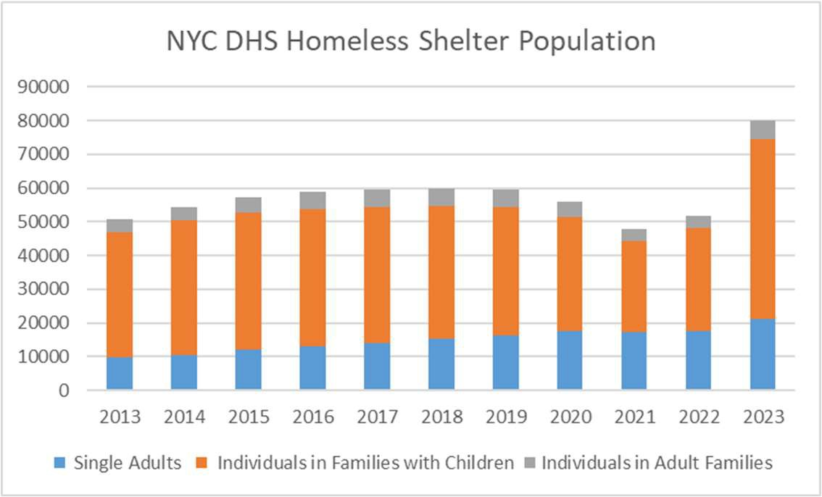
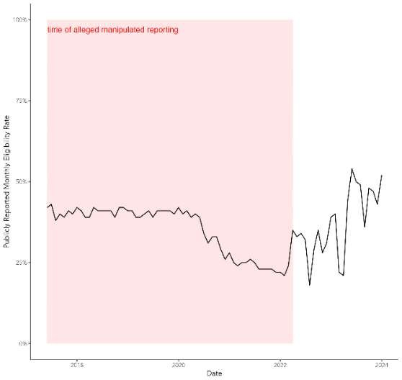
Source: DHS

CONCLUSION
At this hearing, the Committee intends to further explore and understand how City agency violations and the manipulation of data affects the City’s operation of the shelter system and the people it is intended to serve, as well as the potential for legislation and policy to safeguard against such manipulation and the harms it causes.

66 Id.
67 Id.
68 Id.
69 Id.

LEGISLATIVE ANALYSIS

Int No. 210-2024
This bill would prohibit any city agency from imposing limits on the length of time an individual or family may remain in shelter or emergency congregate housing, provided such individual or family is eligible for temporary housing assistance under State law, as applicable. If enacted, the bill would take effect immediately.

Int No. 349-2024
This bill would amend Local Law number 34 for the year 2024 to require the submission of reports relating to removals involving individuals experiencing homelessness on a quarterly basis.
Page left intentionally blank

Int. No. 210-2024
By Council Members Hanif, Restler, Gutiérrez, De La Rosa, Hudson, Sanchez, Nurse, Won, Avilés, Rivera, Krishnan and Marte
A Local Law to amend the administrative code of the city of New York, in relation to prohibiting the department of social services or any other city agency from imposing length of shelter stay restrictions in a shelter of any type
Be it enacted by the Council as follows:

Section 1. Chapter 1 of title 21 of the administrative code of the city of New York is amended by adding a new section 21-152 to read as follows:
§ 21-152 Prohibition on length of shelter stay limitations. a. Definitions. For purposes of

this section, the following terms have the following meanings:

Emergency congregate housing. The term “emergency congregate housing” means any

location operated by an agency or provider under contract or similar agreement with an agency,

except for any location operated by the department or by a provider under contract or similar

agreement with the department, where individuals and families reside for more than 96 hours and

where such individuals and families sleep in a congregate setting with shared facilities, including

but not limited to, sleeping quarters and bathrooms.

Homeless youth. The term “homeless youth” has the same meaning as provided in section

532-a of the executive law. For the purposes of this section, the term “homeless youth” shall also

include homeless young adults.

Homeless young adults. The term “homeless young adult” has the same meaning as

provided in section 531-a of the executive law.

Shelter. The term “shelter” means temporary housing assistance provided to homeless

adults, adult families, families with children, and runaway and homeless youth by the city or a

provider under contract or similar agreement with the city.
b. No agency shall impose limits on the length of time an individual or family may reside

in shelter or emergency congregate housing. To reside in shelter operated by the department or a

provider under contract or similar agreement with the department, an individual or family must

maintain eligibility for temporary housing assistance pursuant to section 352.35 of title 18 of the

New York codes, rules and regulations.

§ 2. This local law takes effect immediately.

Session 13 LS #14056 1/25/24

Session 12 DR
LS #14056 9/20/2023
Page intentionally left blank

Int. No. 349-2024

By Council Member Nurse

A Local Law to amend the administrative code of the city of New York, in relation to requiring quarterly reports on removals involving individuals experiencing homelessness and the outcomes for those individuals
Be it enacted by the Council as follows:

Section 1. The opening paragraphs of subdivisions b and c of section 21-152 of the administrative code of the city of New York, as added by local law number 34 for the year 2024, are amended to read as follows:
b. No later than 1 month after the effective date of the local law that added this section, and quarterly thereafter, the commissioner, in consultation with the police commissioner, the commissioner of sanitation, and the commissioner of parks and recreation, shall submit to the speaker of the council, the public advocate, and the mayor, and publish on the department’s website, in a machine readable format, a report on removals conducted during the prior [month] quarter. The report shall include a table in which each row references a unique occurrence of a
removal. Each such row shall include the following information and any additional information the commissioner deems appropriate, set forth in separate columns:
c. No later than 1 month after the effective date of the local law that added this section, and quarterly thereafter, the commissioner shall submit to the speaker of the council, the public advocate, and the mayor, and publish on the department’s website, in a machine readable format,
a report on the same-day outcomes for individuals experiencing homelessness involved in a removal during the prior [month] quarter. Such report shall include a table in which each row
references a unique occurrence of a removal. Each such row shall include the following
information, as well as any additional information the commissioner deems appropriate, set forth in separate columns:
§ 2. This local law takes effect immediately.

ACK LS #15489 1/24/2024

