Small Business Committee Staff
Jessica Boulet, Legislative Counsel
Rebecca Barilla, Legislative Policy Analyst
Glenn Martelloni, Principal Financial Analyst



THE COUNCIL OF THE CITY OF NEW YORK

briefing paper OF

THE GOVERNMENTAL AFFAIRS Division
Andrea Vazquez, Legislative Director
Rachel Cordero, Deputy Director, Governmental Affairs

COMMITTEE ON SMALL BUSINESS
Hon. Oswald Feliz, Chair

April 17, 2024

Oversight: Vital Corridors: Storefront Vacancy Rates and Trends

- INTRODUCTION
On April 17, 2024, the Committee on Small Business, chaired by Council Member Oswald Feliz, will hold an oversight hearing Vital Corridors: Storefront Vacancy Rates and Trends. Those invited to testify include the Department of Small Business Services (“SBS”), Department of Finance (“DOF”), representatives of BIDs throughout the City, Chambers of Commerce, advocacy organizations and members of the public.
- BACKGROUND
New York City’s neighborhood shopping corridors are essential hubs of activity, where locals and visitors alike can purchase goods and services, enjoy walkable public space, and get to know the City and one another. Retail corridors are often considered a “vital sign” of an area’s health—many thriving businesses on a well-lit street may be seen as a microcosm of a City’s well-being, while a high number of storefront vacancies or “Going Out of Business” signs may send the opposite signal. Some vacancies are inevitable in even the most robust retail corridors due to natural turnover as businesses move, leases are signed, or new space opens up: experts suggest that this rate should be anywhere from 5 to 10 percent. On the other hand, too many vacancies—and especially long-term vacancies—may indicate that something is out of balance. The Council has therefore taken steps to track and assess storefront vacancy rates over time as a means of monitoring the health of the City’s business environment for small businesses.
  - Pre-Pandemic
New York City can be a challenging place for small businesses to operate. In addition to adhering to complex regulatory schemes enforced by multiple City agencies, business owners must confront hurdles including high rents, taxation, and competition from chain stores and e-commerce retailers. Commercial vacancies have been rising in NYC for years. Former NYC Comptroller Scott Stringer released a report examining retail vacancy trends between 2007 and 2017. The report found that the citywide retail vacancy rate was 5.8 percent in 2017, up from 4.0 percent in 2007. Outside research reports confirm the upward trend across a similar timeframe. While it is difficult to definitively ascertain the reasons for the rise in retail vacancies, the Comptroller report suggested that the rise in City retail vacancies may be due to an increase in internet retail, rising rents, and regulatory burdens.
In August 2019, the City’s Department of City Planning (“DCP”) also released an assessment of storefront vacancies across 24 neighborhoods in the City. Their assessment contained comparisons between DCP surveys conducted in 2008/2009 and 2017/2018. Their assessment also pulled data from Live XYZ which “aggregates all the events happening at more than 140,000 local businesses around the city.” The report assessed vacancy rates based on data from DCP surveys, Live XYZ data and Real Estate Board of New York (“REBNY”) retail market reports. The report was limited to assess only 24 commercial corridors but shared three key findings of those areas.
DCP found that the retail industry is significantly changing due to the rise of e-commerce, changing real estate development trends, evolving technology and changing consumer preferences. The rise of e-commerce and shift to online retail may pose difficulties for local business owners. Nationwide, e-commerce accounted for approximately 14 percent of all retail sales in 2021, a significant increase from its share of less than one percent in 2000.
DCP also found that the vacancy rates are “volatile, vary from neighborhood to neighborhood and street to street, and cannot be explained by any single factor.” Storefronts were found to be vacant because of delays between leasing and occupying a space, expected redevelopment, business closures, undesirable space and location, or landlord’s charging high rent or seeking a specific tenant for their location. They found that in comparing corridors between 2008/9 and 2017/18 the vacancy rate did not increase significantly and there was no clear geographic pattern between vacancy rates. This latter finding required further investigation into local trends. However, their final finding indicated that vacancies were endemic in certain neighborhoods due to “local and citywide market forces and spending patterns.” Under this finding, DCP also noted that for certain commercial corridors, a lack of capital, limited building investments, and low foot traffic contributed to their higher vacancy rates.
Between 2006 and 2016, average Manhattan retail asking rents rose from $108 per square foot (psf) annually to $156, an increase of 44.4 percent. The most acute growth took place in Midtown South, where rents rose from $85 psf to $143 psf, an increase of 68.2 percent. However, rising prices were not limited to Manhattan. According to a 2017 report published by CPEX, a commercial real estate company, the number of major Brooklyn retail corridors where floor space costs are $100 or more psf increased from three in 2007 to 15 in 2017, an increase of 400 percent. This trend has spanned neighborhoods including Park Slope, Williamsburg, Cobble Hill, Downtown Brooklyn, Brooklyn Heights and Boerum Hill.
Taxation issues also pose difficulties for New York City retailers. Business owners and advocates frequently point to the burden imposed by the commercial rent tax (CRT), a 3.9 percent levy on annual rent applied to Manhattan businesses that pay an annualized base rent of $250,000 or more. In 2017, the CRT accounted for more than $800 million in revenue for the City. Opponents of the tax, such as the New York City Hospitality Alliance and the Manhattan Chamber of Commerce, argue for its abolition on the grounds that it places a geographically arbitrary burden on businesses that were already struggling to afford to stay in operation. In November 2017, the Council passed, and the Mayor signed, legislation that effectively raised the threshold for the tax to $500,000 in annual rent. As a consequence of this change, approximately 2,000 businesses are no longer subject to the tax.
  - Legislation on Storefront Vacancy Reporting
In July 2019, the Council enacted Local Law 157 (LL 157) in order to gain more insight into commercial vacancy rates in the City, the neighborhoods and industries affected by vacancies, and other key drivers of storefront vacancies. LL 157 requires property owners of ground floor or second floor commercial properties to submit information on their properties. The requirements vary by property class, but may include information on the property owner, the premises and its occupation or vacancy. For efficiency, this information is required to be submitted at the same time as the Real Property and Expense Statement (RPIE), once annually. LL 157 further required DOF to establish a public online searchable dataset containing certain data points received from property owners in accordance with the provisions of the law.
Following implementation, it became apparent that the datasets provided in accordance with the Local Law presented usability issues. The data was provided in a series of Open Data datasets separated by property class, filing years, and in the aggregate and disaggregate, making it difficult to combine and use the data. Some datasets did not clearly indicate the year the data was collected, and some data was incomplete, lacking information about location or the most recent business type. These lapses made it difficult to ascertain trends that may have triggered the commercial vacancies. Furthermore, when business types were indicated in the dataset, they were not expressed consistently, further undermining its usefulness.
In 2022, LL 157 of 2019 was amended by Local Law 95 (LL 95) to increase the frequency and timeliness of reporting. Under LL 95 of 2022, supplemental registration statements must be filed by August 15, for the period from January 1 through June 30, and by February 15, for the period from July 1 through December 31 each year. LL 95 of 2022 also required that DOF release the supplemental registration statement data within 60 days of the reporting deadline (updated from the previous timeframe of six months).
In 2019, additional legislation was passed to assess the state of storefronts in the City. LL 152 of 2019 requires SBS to report on storefront businesses in a minimum of 20 community districts every 3 years. SBS is tasked to work with DOF and DCP to include details such as the number of storefront businesses, the types of economic activities, a storefront’s number of employees, taxation information, storefront vacancies, and the demographic of a district. The most recent version of this report was released on January 19, 2024, and is examined in more detail in Section IV below.
  - Vacancy Rates Post-Pandemic
Over the past several years, small businesses across New York City have been recovering from the effects of the COVID-19 pandemic. In the first year of the pandemic, businesses were forced to shut down their stores to protect customers and employees from COVID-19. In 2022, the Association for Neighborhood and Housing Development (ANHD) released a report on “The State of Storefronts: Alarming Vacancy Rates and Rising Rents during the Pandemic” assessing the storefront registry data from the Department of Finance as of December 2020. The data pulled for the report provided information regarding the immediate impacts of the pandemic on storefronts by comparing the data from 2019 and 2020. Overall, the City’s vacancy rate changed from 7.9% to 10.6%, with the biggest increase in Manhattan from 9% to 14.2%, likely due to the decrease in tourist traffic. Of the 71,763 storefronts in 2020, over seven thousand were marked as vacant. According to SBS data from 2019, out of 69,654 total storefronts, 10,388 were not leased to tenants. However, it’s unclear from SBS’s data how many of these unleased storefronts were vacant. LL 152 data released in 2023 provides a clearer, albeit not improved picture, noting that out of 143,991 total storefronts citywide, over 16,000 were not operating, making the vacancy rate 11% citywide. However, when comparing to the DOF data, in the data collected for 2019-2020 out of 75,250 storefronts, 6,940 were reported vacant (around 9%). For 2020-2021, the vacancy rate was 11.3% and jumping ahead to 2022-2023 the vacancy rate for 64,092 storefronts was almost 10%. A deeper look at the DOF and SBS data is available under “Current Data Availability and Assessment.”
For the retail sector specifically, some real estate interest groups have reported that the City’s retail sector vacancy rate is now equal to both the City’s historical and United States’ average at 4.1%
- SBS RESOURCES
  - SBS Partnership with Live XYZ
Last fall, SBS introduced their Live NYC MAP. This map was created out of a partnership between Live XYZ and SBS and utilizes a comprehensive database to map out more than 150,000 small businesses and other public places across the five boroughs. According to the announcement, the map is updated daily and re-mapped every three months thanks to door-to-door street teams. The map appears to list every storefront across the City, both active and vacant, and includes details on a storefront’s occupancy since 2018. The announcement for the map also noted that the Live NYC Map is used by almost every BID and is helpful to “locate new storefronts and activate retail spaces within their neighborhoods.”
  - Storefront Concerns: Visual and Economic
Visually, storefronts can set the tone and character of a community. Even one or two vacant storefronts can undermine foot traffic for surrounding businesses. In San Francisco, for example, advocates have noted that a vacant storefront reduces foot traffic and economic activity for neighboring small businesses. San Francisco’s vacant storefronts’ negative effects on foot traffic have forced San Francisco to rethink how they handle vacant ground floor properties and they have moved to hire artists to paint over the vacant windows or use the space for pop-ups galleries and businesses.
In recognition of the importance of storefronts to the surrounding community, in 2017 SBS introduced a Storefront Improvement Program to help revitalize storefronts across the city and “give identity to New York City’s diverse network of commercial districts.” Funding for these storefront improvement programs is available through SBS’s Avenue NYC grants.
- CURRENT DATA AVAILABILITY AND ASSESSMENT
  - Identifying Trends in SBS’s Storefront Vacancy Data
SBS’s most recent report for Fiscal Year 2023 outlines storefront vacancy rates, average employee count, and average sales tax revenue by storefront for all 59 community districts in the City. It also provides demographic information by population, age, and ethnicity for each community district. The report pulls vacancy data from Live XYZ, while tax and labor information is taken from the DOF.
SBS data shows Manhattan with the highest overall vacancy rate at 15 percent; the second highest overall vacancy rate, at 12 percent, is in Brooklyn. Bronx and Queens are tied for lowest vacancy rates, at 8 percent. Notably, of the top 10 community districts with the highest vacancy rates—with almost all above 15 percent—8 are located in Manhattan. Two are in Brooklyn. Of the 10 districts with the lowest vacancy rates—all below 8 percent—7 are in Queens, with 2 in the Bronx and 1 in Staten Island.
Map 1 below visualizes the location of these vacancies across community districts. Mapping the data provides additional insights, such as that vacancies are most concentrated in lower Manhattan, followed by middle and upper Manhattan. High-vacancy districts correspond to districts zoned for higher concentrations of commercial use; the lowest vacancy rates in Manhattan and across the boroughs generally correspond to higher residential density.
Map 1. SBS/Live XYZ data on storefront vacancy rates by community district, FY’23
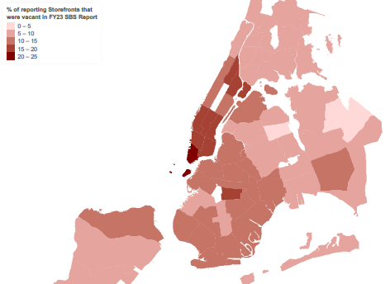

By employee count and sales tax revenue, Manhattan also averages the highest number of employees, with stores employing on average more than 9 staff, and largest sales tax revenue per storefront, at $35,007 annually. The Bronx has both the smallest average number of employees and average sales tax, at 4.72 and $14,690, respectively. Again, of the top 10 community districts by tax revenue, 9 of the 10 are in Manhattan with one from Brooklyn; the lowest tax revenues come from community districts in the Bronx and Brooklyn. By staff numbers, although 7 of the top 10 average employers are in Manhattan, community district 6 in Queens tops the list at more than 18 staff per store on average; the second-highest employment average is 12.44. This may reflect a higher availability of square footage per store outside of Manhattan. The 10 lowest per store employment averages are found variously in Brooklyn, the Bronx, and Queen, indicating a higher number of microbusinesses.
  - Identifying Trends in DOF’s Storefront Vacancy Data
An assessment of currently available data from both SBS and DOF suggests a number of trends as well as some questions. First, vacancy rates seem to be trending back to pre-pandemic levels, to about 9.6 percent down from 11.3 percent at the peak of the pandemic. However, the total number of storefronts reported in the data have decreased at the same time by about 10 thousand. It is not clear what may have caused this change. Notably, SBS’s Live XYZ map shows 59,380 ‘venues’ of which 11,838 are labeled as vacant; if venues are understood as storefronts, this would suggest a vacancy rate of 19.9%.
Existing data also allows for an additional layer of analysis, by property type. In the City, property is divided into four classes. Classes 1, 2 and 4 are relevant to tracking storefront vacancy rates. Class 1 encompasses most residential property of up to three units, including family homes and small stores or offices with one or two apartments attached. Approximately a third of properties in Class 1 are owner-occupied. Class 2 is defined as any property that is primarily residential but is not in Class 1. Class 4 covers all commercial and industrial properties. Classes 2 and 4 are reported together.
The overall citywide vacancy rate of 9.6 percent includes all three relevant classes of property. However, storefronts are not evenly distributed across classes: nearly all storefronts, 98 percent, are in Classes 2 and 4. Vacancy rates also differ significantly between classes, with Class 1 storefronts experiencing greater than 50 percent vacancy rates, compared to 9.5 percent of Class 2 and 4 properties. Trends in vacancy rates over the last five years are also very different across property types: whereas Class 1 storefronts reported about 6 percent lower vacancies in 2022 compared to 2019, Class 2 and 4 vacancy rates have increased since 2019, from 7.9 to 9.5 percent.
Data made available through DOF pursuant to LL 157 of 2019 and LL 95 of 2022 can also be organized by Council District to give a sense of where vacancies are concentrated. This is done in Map 2 below, as a snapshot from December 2023. However, vacancy rates based on other geographic demarcations, such as by commercial district, may be more relevant to a nuanced understanding and response to vacancies in any given area.
Map 2. DOF data snapshot: Storefront vacancy rates by Council District on Dec. 31, 2023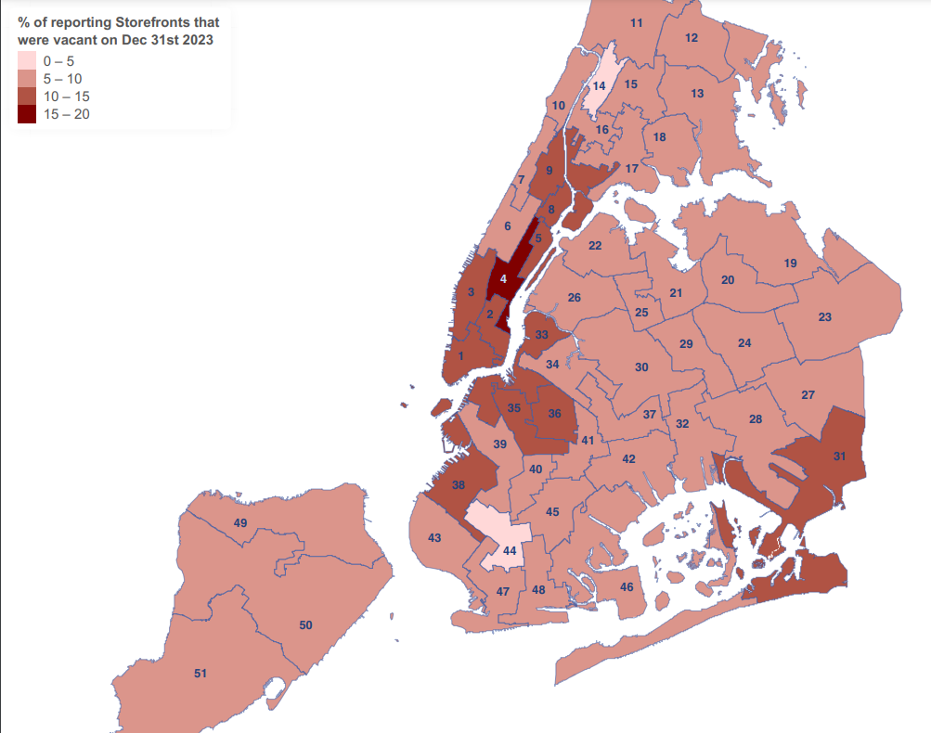
As indicated above, the highest vacancy rates are concentrated in Manhattan, with Council District 4 showing the highest vacancy rate, between 15 and 20 percent. The next highest vacancy rates, ranging from 10 to 15 percent, were also found mostly in Manhattan (Districts 1, 2, 3, 5, 8, and 9) as well as some in Brooklyn (Districts 33, 35, 36, and 38), and one in Queens (District 31).
  - DOF Storefront Vacancy Data—in Charts, since 2019
Chart A below shows the Citywide Overview of LL 157 Storefront Vacancy Reporting. From the DOF reporting there are four years of vacancy information, covering 2019 to 2022. For the year 2023, DOF listed only vacant properties in their dataset, yielding a vacancy rate 100% for 2023. The total number of reported vacancies is less than half those reported in the previous reporting period, however, suggesting that this may reflect a reduced reporting rate rather than a fundamental change in the numbers.
Chart A. DOF data: Storefront vacancies compared to total number of storefronts, 2019-2023*
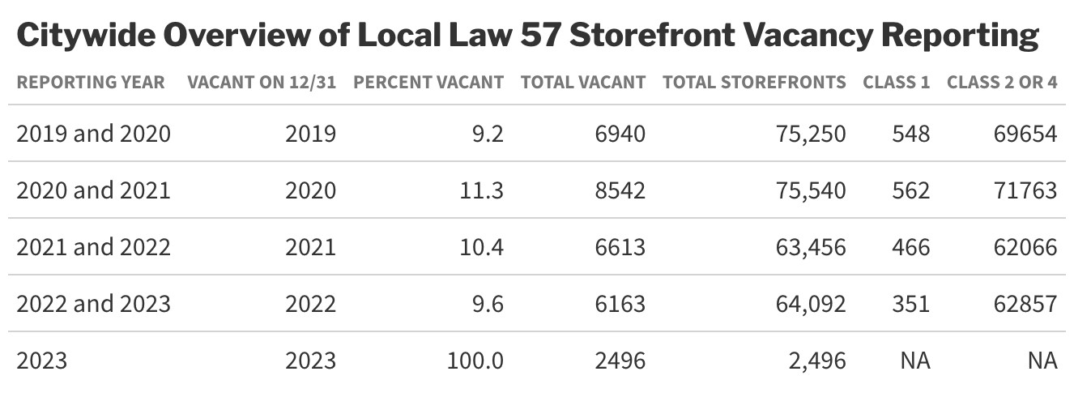
Charts B and C below provide a breakdown of Class 1 and Classes 2 and 4 storefronts citywide based on DOF’s reporting for the years 2019 to 2022.
Chart B. DOF data for Class 1 storefront vacancies, 2019-2022
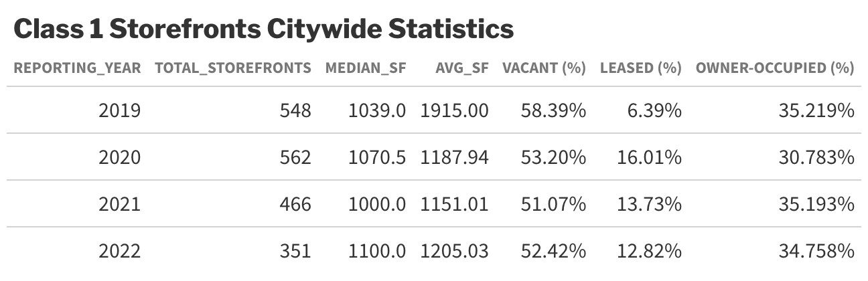

Chart C. DOF data for Classes 2 and 4 storefront vacancies, 2019-2022
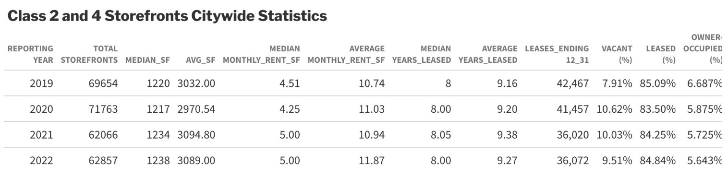

- CONCLUSION
It has been some time since the Council has discussed with SBS and relevant stakeholders the trends and rates of storefront vacancies across New York City. This hearing is an opportunity to assess post-pandemic storefront vacancy trends and hear about SBS’s work responding to the needs of business owners and workers in commercial corridors. The hearing will also provide an opportunity to hear from BIDs, merchants’ associations, and other small business representatives about their experiences with current storefront vacancies and general experiences in commercial corridors.

Abigail Savitch-Lew, Diagnosing NYC’s Vacant Storefront Problem, Dec. 5, 2017, https://citylimits.org/2017/12/05/diagnosing-nycs-vacant-storefront-problem/.
“Retail Vacancy in New York City: trends and causes, 2007-2017”, New York City Comptroller Scott M. Stringer, available at: https://comptroller.nyc.gov/wp-content/uploads/documents/Retail_Vacancy_in_NYC_2007-17.pdf
Abigail Savitch-Lew, Diagnosing NYC’s Vacant Storefront Problem, Dec. 5, 2017, https://citylimits.org/2017/12/05/diagnosing-nycs-vacant-storefront-problem/.
“Retail Vacancy in New York City: trends and causes, 2007-2017”, New York City Comptroller Scott M. Stringer, available at: https://comptroller.nyc.gov/wp-content/uploads/documents/Retail_Vacancy_in_NYC_2007-17.pdf
NYC Department of City Planning, Assessing Storefront Vacancy in NYC, Aug. 2019, available at: https://www.nyc.gov/assets/planning/download/pdf/planning-level/housing-economy/assessing-storefront-vacancy-nyc.pdf
Id.
Liz Warren, “Meet Live XYZ, the app that makes sure you’re always having fun,” June 8, 2018, Built In NYC, available at: https://www.builtinnyc.com/2018/06/08/live-xyz-app-nyc
https://www.nyc.gov/assets/planning/download/pdf/planning-level/housing-economy/assessing-storefront-vacancy-nyc.pdf.
“E-commerce as percentage of total retail sales in the United States from 2013 to 2025” Available at: https://www.statista.com/statistics/379112/e-commerce-share-of-retail-sales-in-us/
Planning for Retail Diversity: Supporting NYC’s Neighborhood Businesses, https://council.nyc.gov/land-use/wp-content/uploads/sites/53/2017/12/NYC-Council-Planning-For-Retail-Diversity.pdf.
https://www.nyc.gov/assets/planning/download/pdf/planning-level/housing-economy/assessing-storefront-vacancy-nyc.pdf
Id.
Id.
Id.
Id.
Id.
Planning for Retail Diversity: Supporting NYC’s Neighborhood Businesses, December 2017, https://council.nyc.gov/land-use/wp-content/uploads/sites/53/2017/12/NYC-Council-Planning-For-Retail-Diversity.pdf.
Id.
2017 Brooklyn Retail Report from CPEX, https://www.scribd.com/document/337456586/2017-Brooklyn-Retail-Report-from-CPEX#from_embed.
Id.
Changes to the New York City Commercial Rent Tax, CPA Journal, April 2018, https://www.cpajournal.com/2018/04/03/changes-new-york-city-commercial-rent-tax/.
Tom Corrie, Big Tax Changes for the Big Apple: How the Amended Commercial Rent Tax May Impact You, June 28, 2018, https://www.friedmanllp.com/insights/big-tax-changes-for-the-big-apple-how-the-amended-commercial-rent-tax-may-impact-you-.
Andrew Rigie, The tax that’s Killing Manhattan Businesses, NY Daily News, October 6, 2016, https://www.nydailynews.com/opinion/rigie-walker-tax-killing-manhattan-business-article-1.2818905.
Local Law 254 of 2017, available at: https://legistar.council.nyc.gov/LegislationDetail.aspx?ID=2324746&GUID=5F1CB761-B063-4E8F-B72E-328714C639AF&Options=ID|Text|&Search=799
Freedom! 2,000 Businesses to Escape Commercial Rent tax, The Real Deal, December 1, 2017, https://therealdeal.com/2017/12/01/freedom-2000-businesses-to-escape-commercial-rent-tax/.
Local Law 157 of 2019, available at: https://legistar.council.nyc.gov/LegislationDetail.aspx?ID=3877885&GUID=C0D2361D-766A-42E3-A5CD-F8DBB1C52E8B&Options=ID|Text|&Search=157
Id.
If leased during the covered period, the law requires certain property owners to include certain information on the lease terms; if vacant, the date and duration of the vacancy; if not leased to a tenant during the covered period, the monthly rent per square foot paid by the most recent tenant; and if the property has undergone construction during the covered period, the start and completion dates of the construction project.
Implementation of this law was delayed. Although Local Law 157 required commercial property owners to submit their first registration statements no later than November 2020 and the public dataset to be established by DOF no later than May 2021, DOF instead required the first statements to be provided by July 1, 2021.
Open Data is free public data published by New York City agencies and other partners. Available at https://opendata.cityofnewyork.us/
Local Law 95 of 2022, available at: https://nyc.legistar.com/LegislationDetail.aspx?ID=5656491&GUID=29BEF19D-6F19-48AA-A9BA-757D3D6F2182&G=2FD004F1-D85B-4588-A648-0A736C77D6E3&Options=Advanced&Search=
Id..
Id.
Local Law 152 of 2019, available at: https://nyc.legistar.com/LegislationDetail.aspx?ID=3557680&GUID=8828C697-B7CB-491A-BA8B-B24CB7C931C4&G=2FD004F1-D85B-4588-A648-0A736C77D6E3&Options=Advanced&Search=
Id.
Id.
LL 152 of 2019 Report on Storefront Business FY23, available at: https://a860-gpp.nyc.gov/catalog?utf8=%E2%9C%93&locale=en&agency=Small%20Business%20Services%2C%20Department%20of%20%28SBS%29&required_report_name=Report%20on%20Storefront%20Businesses&sort=date_published_ssi+desc&search_field=advanced
Gina Lee, Sarah Internicola, Karen Yao, “The State of Storefronts: Alarming Vacancy Rates and Rising Rents during the Pandemic,” Oct. 13, 2022, available at https://anhd.org/report/state-of-storefronts
Id.
Id.
Id.
NYC Department of Small Business Services, Required Notices: State of Storefront Businesses Assessment, 2019 Report, available at https://www.nyc.gov/site/sbs/about/required-notices.page. Accessed on April 11, 2024.
NYC Department of Small Business Services, Required Notices: State of Storefront Businesses Assessment, FY23 Report, available at https://www.nyc.gov/site/sbs/about/required-notices.page. Accessed on April 11, 2024.
NYC Open Data, Storefronts Reported Vacant or Not, available at https://data.cityofnewyork.us/City-Government/Storefronts-Reported-Vacant-or-Not/92iy-9c3n/data. Accessed on April 11, 2024.
Id.
Matthews Real Estate Investment Services, New York CRE Market Report, Apr. 24, 2023, available at https://www.matthews.com/all-sectors-market-report-new-york/.
NYC Department of Small Business Services, “SBS Rolls out ‘Live NYC Map’ Tool Featuring Real-Time Comprehensive Data on Small Businesses and Public Places Across NYC,” Nov. 22, 2023, available at https://www.nyc.gov/site/sbs/about/pr20231122-livenycmap.page.
Id.
Id.
Id.
Id.
Emily Badger, ”The Ground-Floor Window Into What’s Ailing Downtowns,” Sep. 4, 2023, available at https://www.nytimes.com/2023/09/04/upshot/cities-downtowns-vacant-storefronts.html.
Id.
NYC Department of Small Business Services, Storefront Improvement, available at https://www.nyc.gov/site/sbs/neighborhoods/storefront-improvement.page. Accessed on April 11, 2024.
Id.
LL 152 of 2019 Report on Storefront Business FY23, available at: https://a860-gpp.nyc.gov/catalog?utf8=%E2%9C%93&locale=en&agency=Small%20Business%20Services%2C%20Department%20of%20%28SBS%29&required_report_name=Report%20on%20Storefront%20Businesses&sort=date_published_ssi+desc&search_field=advanced
Id.
This can be seen by comparing Map 1, infra, to the zoning map available at https://zola.planning.nyc.gov/?selectedZoning=%5B%22C4%22%2C%22C5%22%2C%22C6%22%2C%22PA%22%2C%22R1%22%2C%22R10%22%2C%22R2%22%2C%22R3%22%2C%22R4%22%2C%22R5%22%2C%22R6%22%2C%22R7%22%2C%22R8%22%2C%22R9%22%5D. More information about zoning designations is available from the NYC Dept. of City Planning at https://www.nyc.gov/site/planning/zoning/districts-tools/residence-districts-r1-r10.page.
Community district numbers are omitted for legibility. A map of the City’s community districts is available at https://www.nyc.gov/assets/planning/download/pdf/about/publications/maps/nyc-community-districts-map.pdf.
Presumably this data is annual and per storefront; the report does not specify but the numbers suggest this to be the case.
The Bronx’s community district five has the lowest average sales tax revenue at $9,502.
Community district five in Manhattan brings in the highest average sales tax revenue at $47,238.
Brooklyn’s community district 16 has the lowest average number of employees among all community districts at 3.54.
The City generally considers businesses with under 9 employees to be microbusinesses. See Ad. Code § 22-1001.
As of April 1st 2024.
NYC Department of Finance, Definition of Property Assessment Terms. Category: Tax Class, available at https://www.nyc.gov/site/finance/property/definitions-of-property-assessment-terms.page. Accessed on April 12, 2024.
Id.
Id.
For example, DCP’s 2019 report analyzed vacancies by corridor across 24 neighborhoods, defined as “continuous, pedestrian-oriented corridors” that “excluded shopping malls or auto-oriented corridors.” NYC Department of City Planning, Assessing Storefront Vacancy in NYC, Aug. 2019, available at: https://www.nyc.gov/assets/planning/download/pdf/planning-level/housing-economy/assessing-storefront-vacancy-nyc.pdf

