THE COUNCIL OF THE CITY OF NEW YORK
RESOLUTION NO. 669

Resolution approving the decision of the City Planning Commission on Application No. N 230183 ZRK, for an amendment of the text of the Zoning Resolution (L.U. No. 165).

By Council Members Salamanca and Riley

WHEREAS, Brooklyn Yards Development, LLC, filed an application pursuant to Sections 197-c and 201 of the New York City Charter, for an amendment of the text of the Zoning Resolution of the City of New York, modifying Appendix F for the purpose of establishing a Mandatory Inclusionary Housing area and modifying Appendix I to expand the Transit Zone, which in conjunction with the related actions would facilitate a new 335,000 square-foot development including 272,000 square feet of residential space with 270 dwelling units and 64,000 square feet of commercial uses in the Borough Park neighborhood of Brooklyn, Community Districts 11 and 12 (ULURP No. N 230183 ZRK), (the “Application”);
WHEREAS, the City Planning Commission filed with the Council on September 26, 2024 its decision dated September 25, 2024 (the "Decision") on the Application;
WHEREAS, the Application is related to applications C 230182 ZMK (L.U. No. 164), a zoning map amendment to change M1-1 and R5 districts to C4-5, R6, and R6/C2-4 districts; C 230184 ZSK (L.U. No. 166), a special permit pursuant to Section 74-52 of the ZR to reduce the number of required accessory off-street parking spaces; C 230185 ZSK (L.U. No. 167), a special permit pursuant to Section 74-61 of the ZR to allow development over portions of a railroad or transit right-of-way which has been permanently discontinued or terminated to be included in the lot area; C 230188 ZSK (L.U. No. 168), a special permit pursuant to Section 74-745 of the ZR to allow required or permitted accessory off-street parking spaces to be located anywhere within a large-scale general development (LSGD) without regard for zoning lot lines, in connection with a proposed mixed-use development; C 230189 ZSK (L.U. No. 169), a special permit pursuant to Section 74-61 of the ZR to allow development over portions of a railroad or transit right-of-way which has been permanently discontinued or terminated to be included in the lot area; C 230190 ZSK (L.U. No. 170), a special permit pursuant to Section 74-61 of the ZR to allow development over portions of a railroad or transit right-of-way which has been permanently discontinued or terminated to be included in the lot area; and C 230191 ZSK (L.U. No. 171), a special permit pursuant to Section 74-52 of the ZR to reduce the number of required accessory off-street parking spaces; and C 230196 ZSK (L.U. No. 172), a special permit pursuant to sections 74-743(a)(1), 74-743(a)(2), and 74-743(a)(6) to establish a LSGD and modify bulk, yard, window, walls and lot line regulations;
WHEREAS, the Decision is subject to review and action by the Council pursuant to Section 197-d of the City Charter;
WHEREAS, upon due notice, the Council held a public hearing on the Decision and Application on October 8, 2024;
WHEREAS, the Council has considered the land use implications and other policy issues relating to the Decision and Application; and
WHEREAS, the Council has considered the land use and other policy issues relating to the Decision and Application; and
WHEREAS, the Council has considered the relevant environmental issues, including the Negative Declaration issued June 7th, 2024 (CEQR No. 23DCP039K), which includes an (E) designation to avoid the potential for significant adverse impacts related to hazardous materials, air quality, and noise (E-749). The application, as analyzed in the Environmental Assessment Statement, contained Project Components Related to the Environment (“PCREs”), including a commitment to conduct a Transportation Monitoring Program (“TMP”) to determine if an enhanced midblock crossing for 60th Street between 15th Avenue and 16th Avenue is warranted based on actual future traffic conditions and the PCREs are described in detail in the Environmental Assessment Statement Attachment A, “Project Description” and Attachment H, “Transportation”. To ensure the implementation of the PCREs, the applicant will enter into a Restrictive Declaration at the time of the approval of land use-related actions and prior to issuance of any permits; and with these measures in place, the Proposed Actions would not result in significant adverse impacts. The Council has also considered the Technical Memorandum dated [__________] (the “Technical Memorandum”).
RESOLVED:
The Council finds that the action described herein will have no significant impact on the environment as set forth in the (E) Designation (E-749) and Negative Declaration.
Pursuant to Sections 197-d and 200 of the City Charter and on the basis of the Decision and Application, and based on the environmental determination and consideration described in the report, C 230183 ZRK, incorporated by reference herein, and the record before the Council, the Council approves the Decision of the City Planning Commission.
Matter underlined is new, to be added;
Matter struck out is to be deleted;
Matter within # # is defined in Section 12-10;
* * * indicates where unchanged text appears in the Zoning Resolution.

* * *

APPENDIX F
Inclusionary Housing Designated Areas and Mandatory Inclusionary Housing Areas

* * *

BROOKLYN

* * *

Brooklyn Community District 12

* * *

Map 3 – [date of adoption]

[EXISTING MAP]

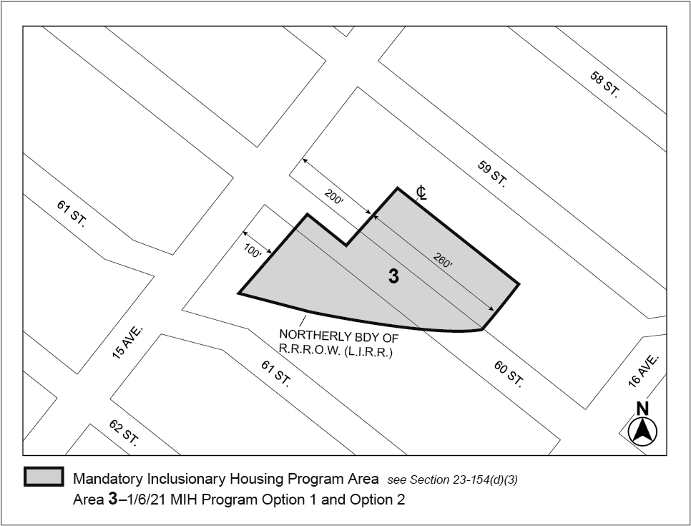

[PROPOSED MAP]

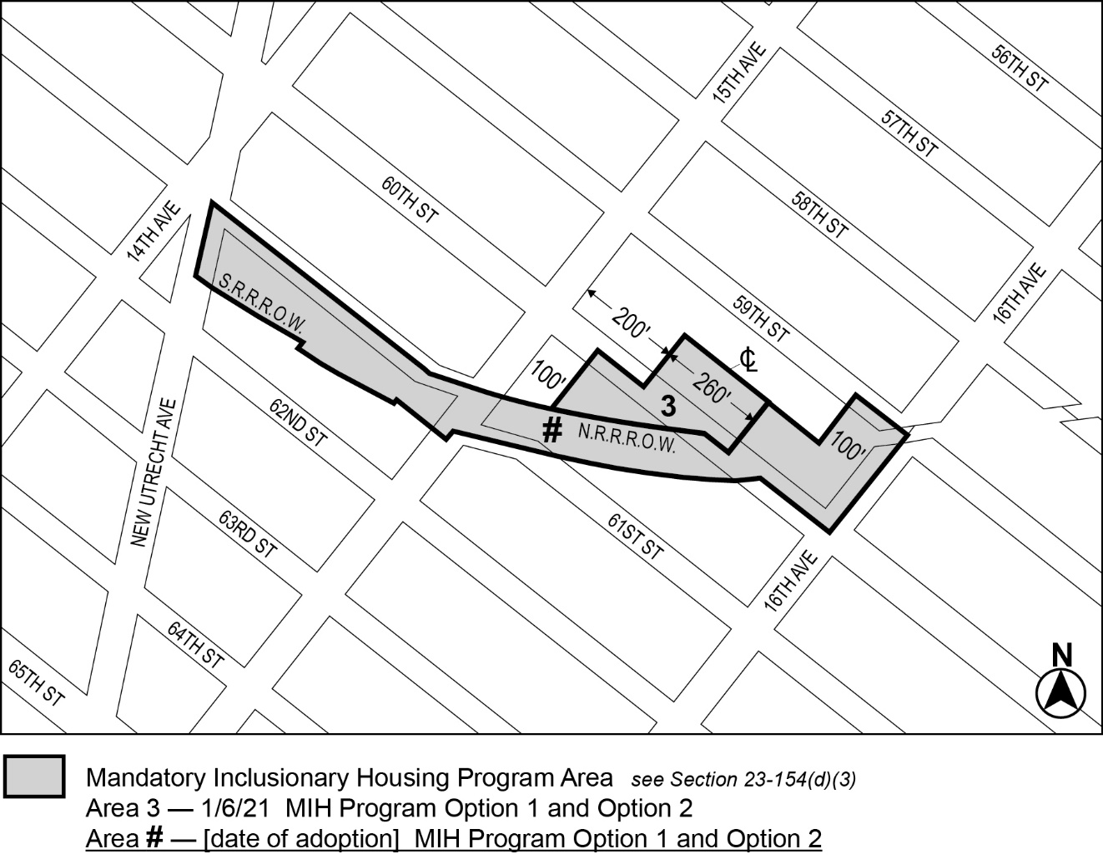

Portion of Community District 12, Brooklyn

* * *
APPENDIX I
Transit Zone

* * *

[EXISTING MAP]

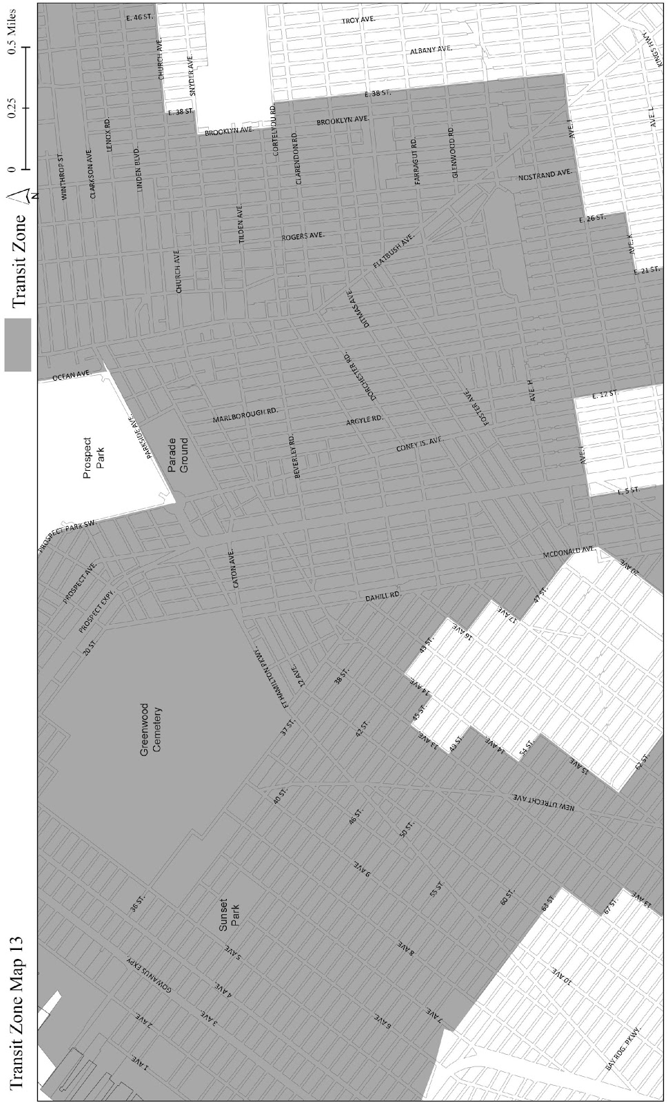
[PROPOSED MAP]

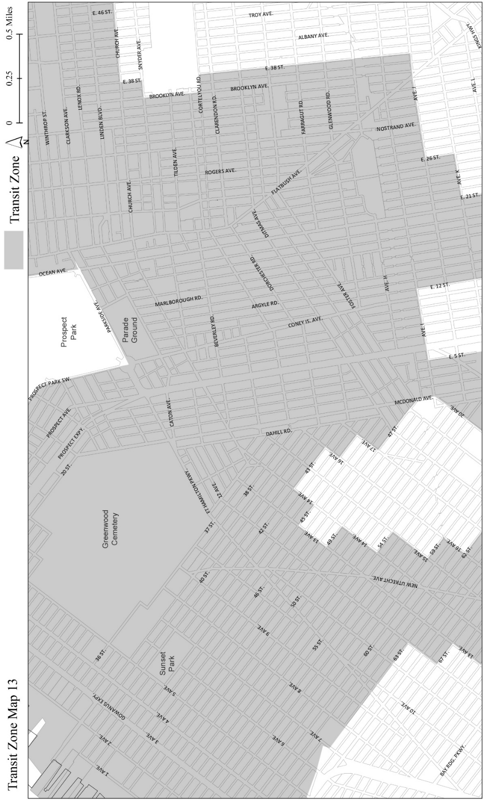
[EXISTING MAP]

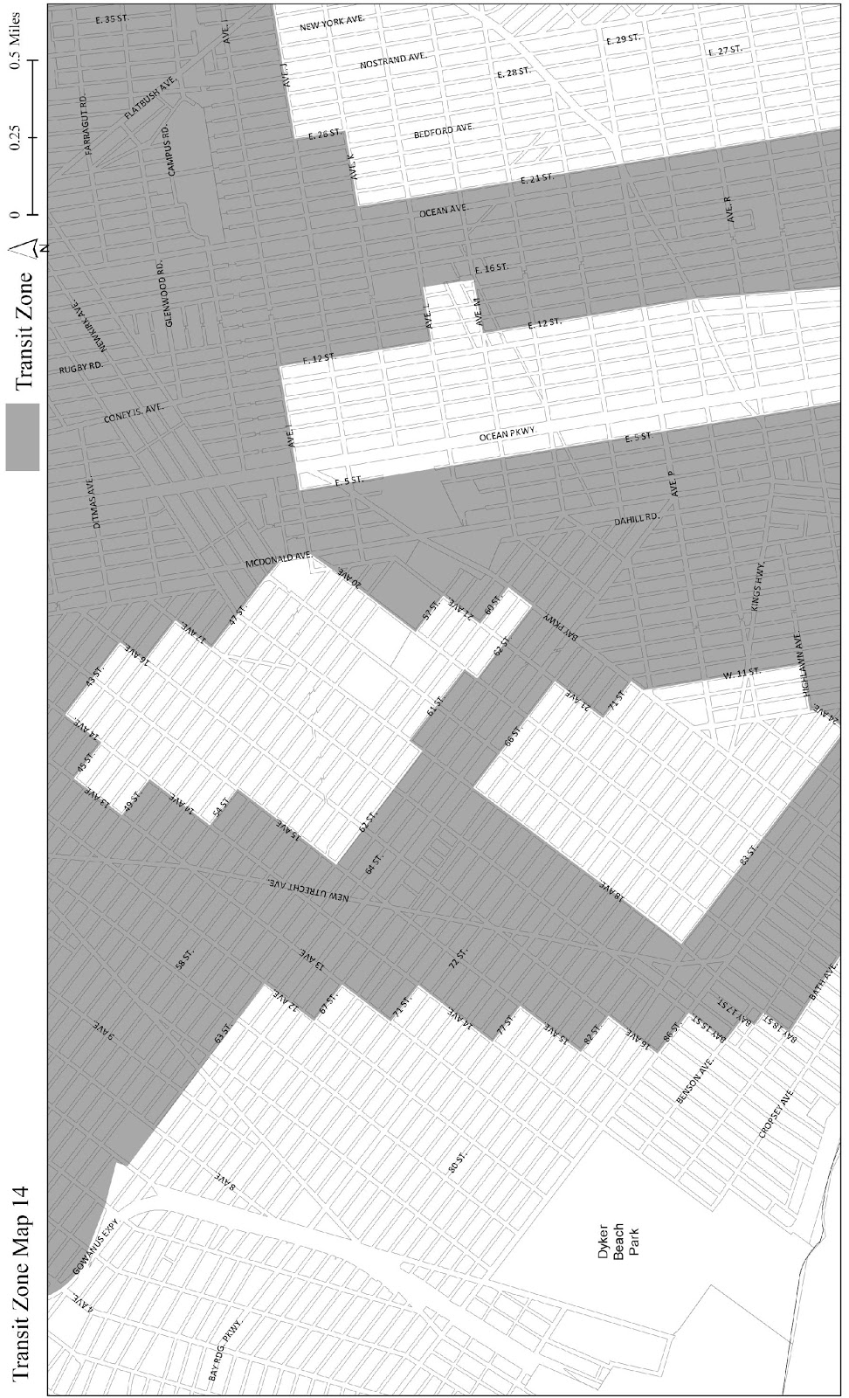
[PROPOSED MAP]

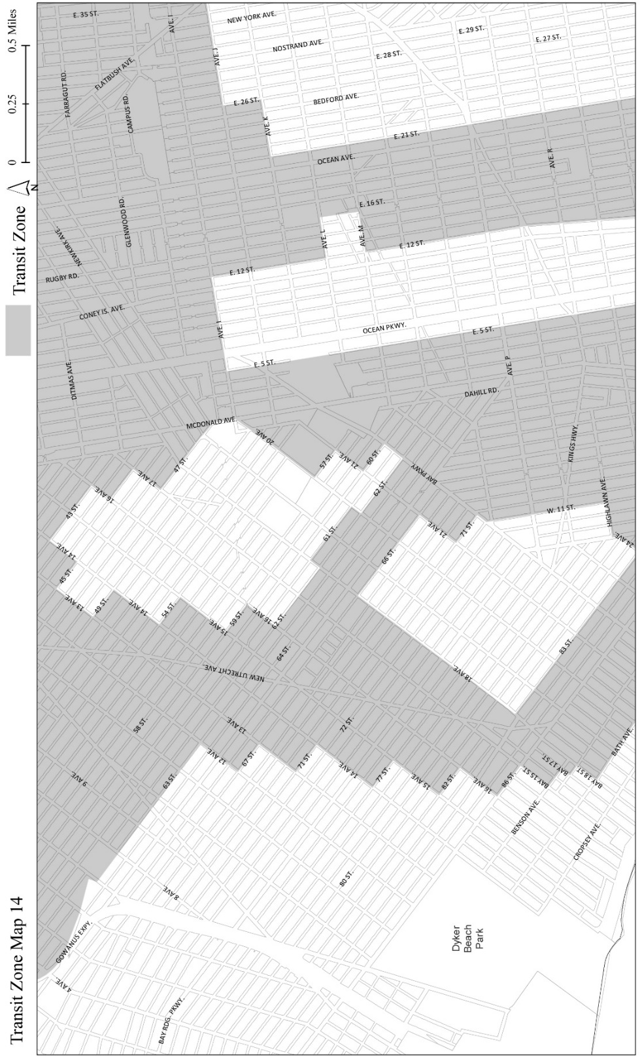

* * *
Adopted.

Office of the City Clerk,}
The City of New York, } ss.:

I hereby certify that the foregoing is a true copy of a Resolution passed by The Council of The City of New York on __________, 2024, on file in this office.

.....................................................
City Clerk, Clerk of The Council

