THE COUNCIL OF THE CITY OF NEW YORK
RESOLUTION NO. 271

Resolution approving with modifications the decision of the City Planning Commission on Application No. N 200229 ZRX, for an amendment of the text of the Zoning Resolution (L.U. No. 64).

By Council Members Salamanca and Riley

WHEREAS, Markland 4551, LLC, filed an application pursuant to Section 201 of the New York City Charter, for an amendment of the text of the Zoning Resolution of the City of New York, modifying Appendix F for the purpose of establishing a Mandatory Inclusionary Housing area and Appendix I for the purpose of modifying the existing Transit Zone, which in conjunction with the related action would facilitate a mixed-use development with approximately 148 units of affordable housing, approximately 7,150 square feet of retail use on the ground floor and approximately 11,100 square feet of community facility space located at 4541 Furman Avenue in the Wakefield neighborhood of the Bronx, Community District 12 (ULURP No. N 200229 ZRX) (the “Application”);

WHEREAS, the City Planning Commission filed with the Council on May 13, 2022, its decision dated May 11, 2022 (the “Decision”), on the Application;

WHEREAS, the Application is related to application C 200228 ZMX (L.U. No. 63), a zoning map amendment to change an M1-1 zoning district to an R7D/C2-4 zoning district;

WHEREAS, the Decision is subject to review and action by the Council pursuant to Section 197-d of the City Charter;

WHEREAS, upon due notice, the Council held a public hearing on the Decision and Application on May 31, 2022;

WHEREAS, the Council has considered the land use implications and other policy issues relating to the Decision and Application; and

WHEREAS, the Council has considered the relevant environmental issues, including the Negative Declaration issued January 3rd, 2022 (CEQR No. 20DCP159X) which includes an (E) designation to avoid the potential for significant adverse impacts related to hazardous materials, air quality, and noise impacts (E-656) (the “Negative Declaration”). The Council has also considered the Technical Memorandum dated June __, 2022;

RESOLVED:

The Council finds that the action described herein will have no significant impact on the environment as set forth in the (E) Designation (E-656), Negative Declaration and Technical Memorandum.

Pursuant to Sections 197-d and 200 of the City Charter and on the basis of the Decision and Application, and based on the environmental determination and consideration described in the report, N 200229 ZRX, incorporated by reference herein, and the record before the Council, the Council approves the Decision of the City Planning Commission with the following modifications:

Matter underlined is new, to be added;
Matter struck out is to be deleted;
Matter within # # is defined in Section 12-10;
* * * indicates where unchanged text appears in the Zoning Resolution
Matter double struck out is old, deleted by the City Council;
Matter double-underlined is new, added by the City Council

* * *

APPENDIX F
Inclusionary Housing Designated Areas and Mandatory Inclusionary Housing Areas

* * *

The Bronx
* * *

The Bronx Community District 12

* * *

Map 1 – [date of adoption]

[EXISTING MAP]

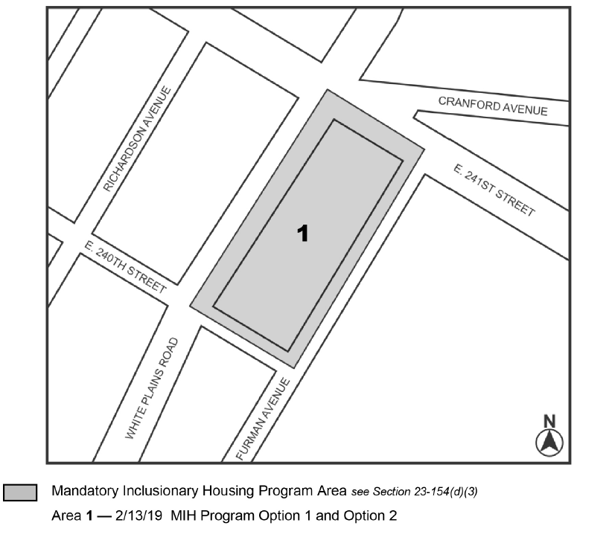

[PROPOSED MAP]

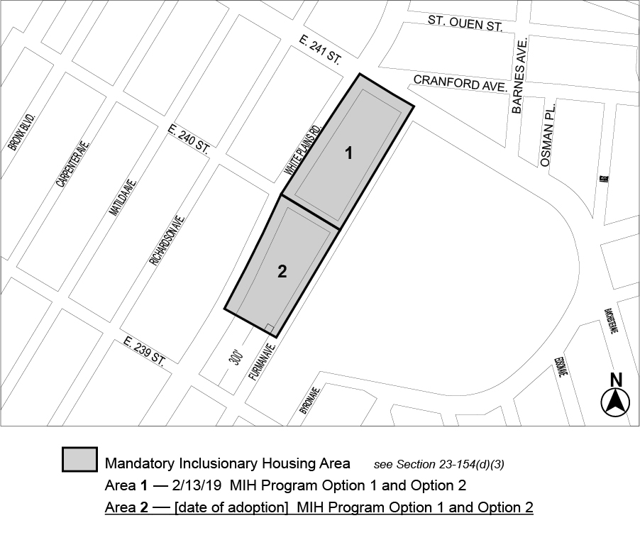

Portion of Community District 12, The Bronx
* * *

APPENDIX I
TRANSIT ZONE
[EXISTING MAP]

[PROPOSED MAP]

* * *

Adopted.

Office of the City Clerk, }
The City of New York, } ss.:

I hereby certify that the foregoing is a true copy of a Resolution passed by The Council of The City of New York on __________, 2022, on file in this office.

.....................................................
City Clerk, Clerk of The Council

