Governmental Operations, State and Federal Legislation Committee Staff
Jayasri Ganapathy, Senior Legislative Counsel
Erica Cohen, Policy Analyst
Hector German, Economist

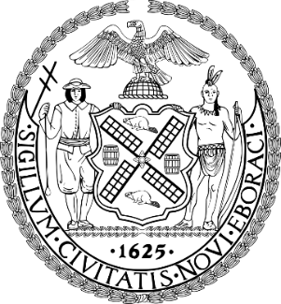
The Council Of The City Of New York

Committee Report of the Governmental Affairs Division
Andrea Vazquez, Director
Rachel Cordero, Deputy Director, Governmental Affairs

Committee on Governmental Operations, State & Federal Legislation
Hon. Lincoln Restler, Chair

June 11, 2025

 | By Council Member Restler
SLR #7: | S.3815-B (Rivera)  A.8810 (Dinowitz)
TITLE: | AN ACT to amend the general municipal law, in relation to allowing for certain child beneficiaries to receive accidental death benefits for the duration of their lifetime

- BACKGROUND
On June 11, 2025, the Committee on Governmental Operations, State and Federal Legislation, chaired by Council Member Lincoln Restler, held a vote on Preconsidered SLR 7, State Legislation Resolution requesting the New York State Legislature to pass bills introduced by Senator Rivera, 3815-B, and Assembly Member Dinowitz, A.8810, “AN ACT to amend the general municipal law, in relation to allowing for certain child beneficiaries to receive accidental death benefits for the duration of their lifetime.” Preconsidered SLR 7 passed with 9 votes in the affirmative, 0 votes in the negative, and 0 abstentions.
- PROPOSED STATE LEGISLATION
This bill would allow for certain child beneficiaries to receive accidental death benefits for the duration of their lifetime.
- FISCAL IMPLICATIONS
See Council Finance Division fiscal impact statement.
- EFFECTIVE DATE
This bill takes effect immediately; provided however, the amendments to section 208-f of the general municipal law made by section one of this act shall apply to members who die on or after such effective date.

.
Preconsidered State Legislation Resolution No. 7

State Legislation Resolution requesting the New York State Legislature to pass bills introduced by Senator Rivera, 3815-B, and Assembly Member Dinowitz, A.8810, “AN ACT to amend the general municipal law, in relation to allowing for certain child beneficiaries to receive accidental death benefits for the duration of their lifetime”.

By Council Member Restler

Whereas, Bills have been introduced in the New York State Legislature by Senator Rivera, S. 3815-B, and Assembly Member Dinowitz, A.8810, “AN ACT to amend the general municipal law, in relation to allowing for certain child beneficiaries to receive accidental death benefits for the duration of their lifetime”; and

Whereas, The enactment of the above State Legislation requires the concurrence of the Council of the City of New York as the local legislative body; now, therefore, be it

Resolved, That the Council of the City of New York, in accordance with the provisions of Section 2 of Article 9 of the Constitution of the State of New York, does hereby request the New York State Legislature to enact into law the aforesaid pending bills.

EC
06/10/25 2:10

