THE COUNCIL OF THE CITY OF NEW YORK
RESOLUTION NO. 777

Resolution approving the decision of the City Planning Commission on Application No. N 180394 ZRK, for an amendment of the text of the Zoning Resolution (L.U. No. 334).

By Council Members Salamanca and Moya

WHEREAS, the City Planning Commission filed with the Council on January 11, 2019 its decision dated January 9, 2019 (the "Decision"), on the application submitted by Caton Park Rehabilitation and Nursing Center, LLC, pursuant to Section 201 of the New York City Charter, for an amendment of the text of the Zoning Resolution of the City of New York, modifying APPENDIX F for the purpose of establishing a Mandatory Inclusionary Housing area on portions of two lots (Block 5074, Lots 4 and 14), which in conjunction with the related action would facilitate an enlargement of an existing nursing home in the Flatbush neighborhood of Community District 14, Brooklyn, (Application No. N 180394 ZRK), (the "Application");

WHEREAS, the Application is related to application C 180393 ZMK (L.U. No. 333), a zoning map amendment to change an R3X zoning district to an R6A zoning district;

WHEREAS, the Decision is subject to review and action by the Council pursuant to Section 197-d(b)(1) of the City Charter;

WHEREAS, upon due notice, the Council held a public hearing on the Decision and Application on January 31, 2019;

WHEREAS, the Council has considered the land use implications and other policy issues relating to the Decision and Application; and

WHEREAS, the Council has considered the relevant environmental issues, including the negative declaration issued August 20th, 2018 (CEQR No. 18DCP118K), which includes an (E) designation to avoid the potential for significant adverse impacts related to air quality and noise (E-492) (the “Negative Declaration”).

RESOLVED:

The Council finds that the action described herein will have no significant impact on the environment as set forth in the (E) Designation (E-492) and Negative Declaration.

Pursuant to Section 200 of the City Charter and on the basis of the Decision and Application, and based on the environmental determination and consideration described in the report, N 180394 ZRK, incorporated by reference herein, and the record before the Council, the Council approves the Decision of the City Planning Commission.

Matter underlined is new, to be added;
Matter struck out is to be deleted;
Matter within # # is defined in Section 12-10;
* * * indicates where unchanged text appears in the Zoning Resolution

* * *

APPENDIX F
Inclusionary Housing Designated Areas and Mandatory Inclusionary Housing Areas

* * *

Brooklyn

* * *

Brooklyn Community District 14
* * *

Map 4 - [date of adoption]

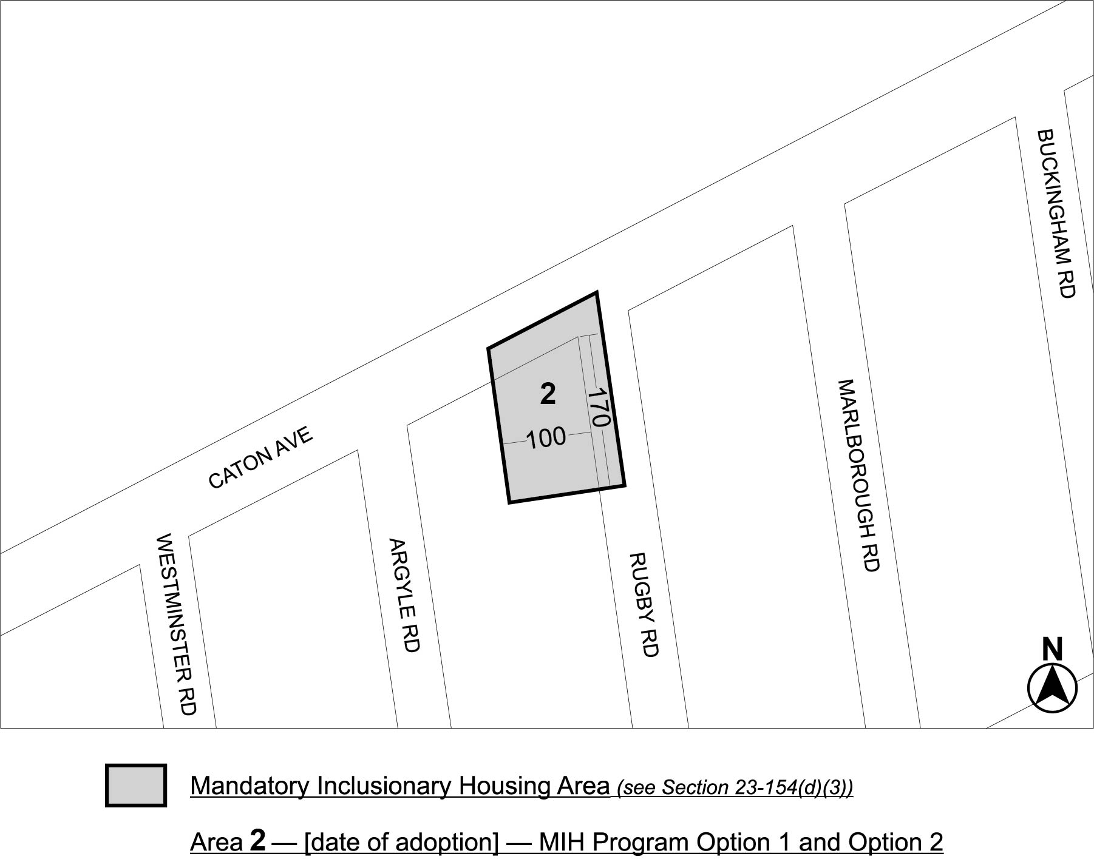

Portion of Community District 14, Brooklyn
* * *

Adopted.

Office of the City Clerk, }
The City of New York, } ss.:

I hereby certify that the foregoing is a true copy of a Resolution passed by The Council of The City of New York on February 28, 2019, on file in this office.

...........…....................................... City Clerk, Clerk of The Council

