THE COUNCIL OF THE CITY OF NEW YORK
RESOLUTION NO. 1752

Resolution approving with modifications the decision of the City Planning Commission on Application No. N 170026 ZRK, for an amendment of the Zoning Resolution of the City of New York, modifying Appendix F for the purpose of establishing a Mandatory Inclusionary Housing area in Community District 3, Borough of Brooklyn (L.U. No. 788).

By Council Members Greenfield and Richards

WHEREAS, the City Planning Commission filed with the Council on October 6, 2017 its decision dated October 4, 2017 (the "Decision"), pursuant to Section 201 of the New York City Charter, regarding an application submitted by JMS Realty Corp., for an amendment of the text of the Zoning Resolution of the City of New York, modifying Appendix F for the purpose of establishing a Mandatory Inclusionary Housing area. The amendment to the text of the Zoning Resolution, in conjunction with the related action would facilitate the development of a new eight-story mixed-use building containing approximately 75 dwelling units in the Bedford-Stuyvesant neighborhood of Brooklyn (Application No. N 170026 ZRK), Community District 3, Borough of Brooklyn (the "Application");

WHEREAS, the Application is related to application C 170025 ZMK (L.U. No. 787), a zoning map amendment to change an M1-1 and M1-2 zoning districts to R7D/C2-4 and R6A/C2-4 zoning districts;

WHEREAS, the Decision is subject to review and action by the Council pursuant to Section 197-d(b)(1) of the City Charter;
WHEREAS, upon due notice, the Council held a public hearing on the Decision and Application on October 24, 2017;

WHEREAS, the Council has considered the land use implications and other policy issues relating to the Decision and Application; and

WHEREAS, the Council has considered the relevant environmental issues, including the negative declaration issued June 5, 2017 (CEQR No. 16DCP177K), which included (E) designations to avoid the potential for significant adverse impacts related to hazardous materials, air quality and noise (E-433) (the “Negative Declaration”);

RESOLVED:

The Council finds that the action described herein will have no significant impact on the
environment as set forth in the Negative Declaration.
Pursuant to Sections 197-d and 200 of the City Charter and on the basis of the Decision and Application, and based on the environmental determination and consideration described in the report, N 170026 ZRK, incorporated by reference herein, the Council approves the Decision of the City Planning Commission with the following modifications:

Matter underlined is new, to be added;
Matter struck out is to be deleted;
Matter within # # is defined in Section 12-10;
Matter double struck-out is old, deleted by the City Council;
Matter double underlined is new, added by the City Council;
* * * indicates where unchanged text appears in the Zoning Resolution

* * *

APPENDIX F
Inclusionary Housing Designated Areas and Mandatory Housing Designated Areas

* * *

Brooklyn

* * *

Brooklyn Community District 3
In the R6AR6B, R7A and R7D Districts within the areas shown on the following Maps 1, 2, 3, 4, and 5:
* * *

Map 3 - [10/11/12]

[EXISTING MAP]
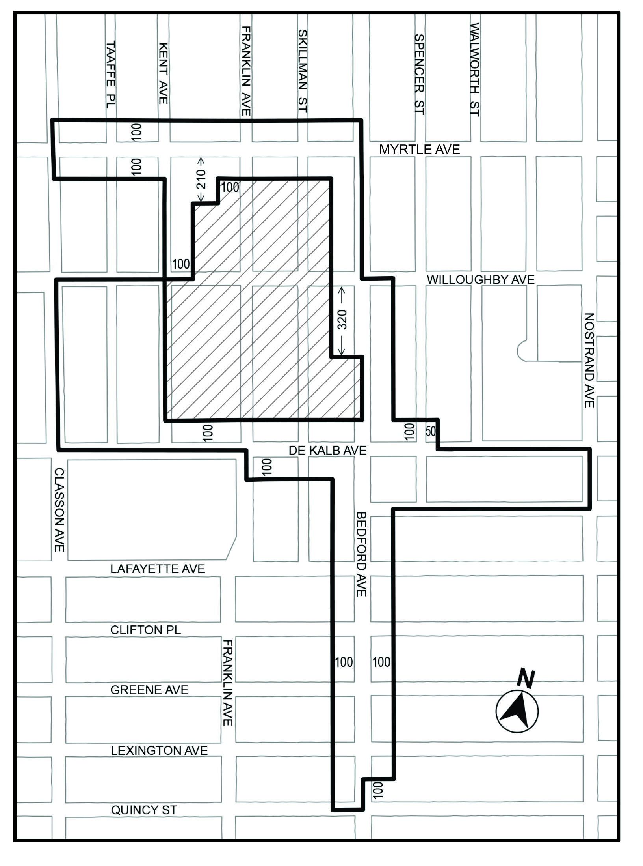
Inclusionary Housing Designated Area
Excluded Area
Map 3 - [date of adoption]
[City Planning Commission Proposed Map 3 as Modified by City Council]

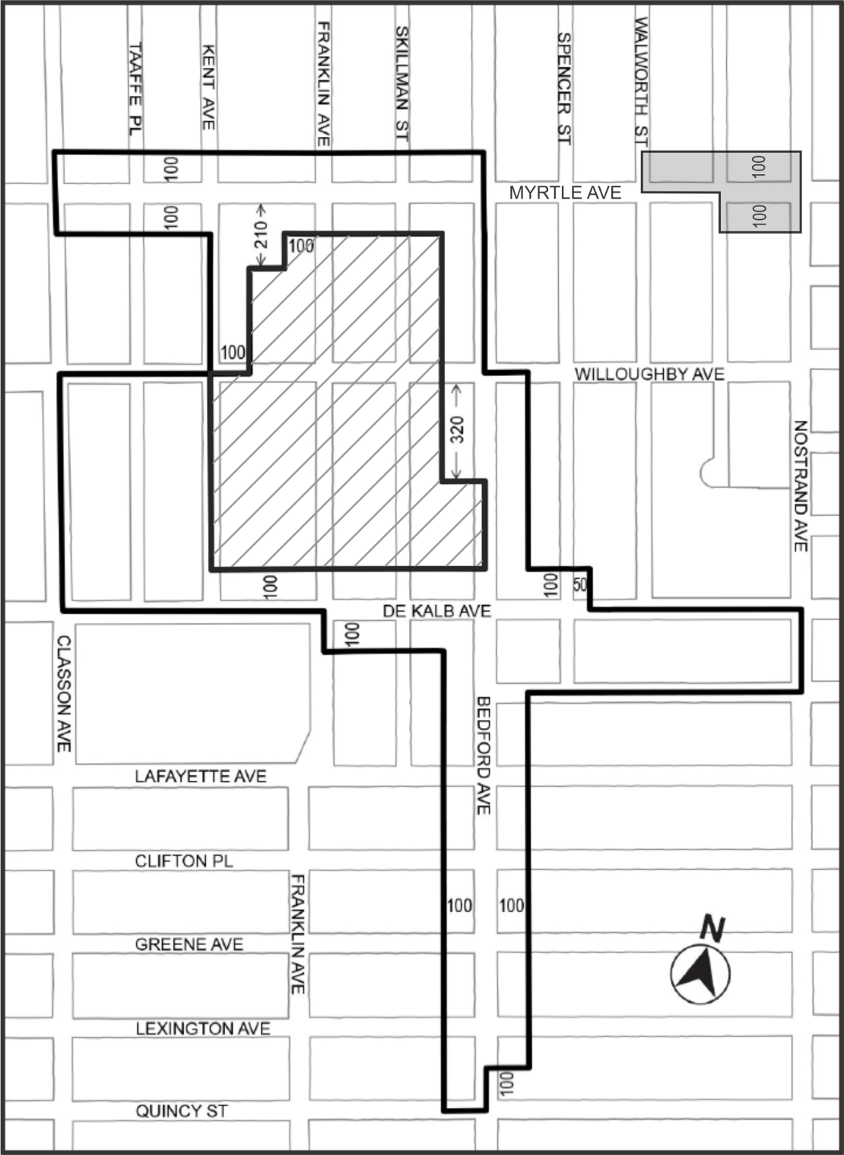
1

Inclusionary Housing Designated Area
Mandatory Inclusionary Housing area see Section 23-154(d)(3)
Area 1 — [date of adoption] — MIH Program Option 1 and Option 2

Excluded Area

Portion of Community District 3, Brooklyn

* * *

Adopted.

Office of the City Clerk, }
The City of New York, } ss.:

I hereby certify that the foregoing is a true copy of a Resolution passed by The Council of The City of New York on November 30, 2017, on file in this office.

.....…….........................................
City Clerk, Clerk of The Council

