March 29, 2007

Dear Colleague:

We are writing to ask for your support for Intro 541, a bill that will provide great relief to small businesses in each of our districts. Currently many small business owners are plagued by a discrepancy in city and state law relating to the definition of a commercial vehicle. Because of this small but important variation, parking tickets are unjustly given to small business owners.

While the NY State Department of Motor Vehicles issues commercial plates to a vehicle with rear seats, an outdated city law prohibits any vehicle parking in a commercial zone from having rear seats. In recent years auto manufacturers have released trucks with rear seats, allowing businesses to simultaneously transport goods and workers, while reducing fuel emissions and transportation costs. Our legislation would eliminate the discrepancy in city and state law, and allow commercial vehicles as designated by the state to park legally in commercial zones.

Thank you for your consideration of Intro 541. By passing this bill, the Council would be aiding small businesses and encouraging more efficient and environmentally friendly methods of transportation. If you wish to become a co-sponsor, please see the attached sign-on sheet and fax to William Martin in legislative documents at 212-788-9296. Feel free to call Kate Mikuliak, Community/Policy Aide to Councilwoman Rosie Mendez at (212) 677-1077 with any questions.

Thank you for your consideration.

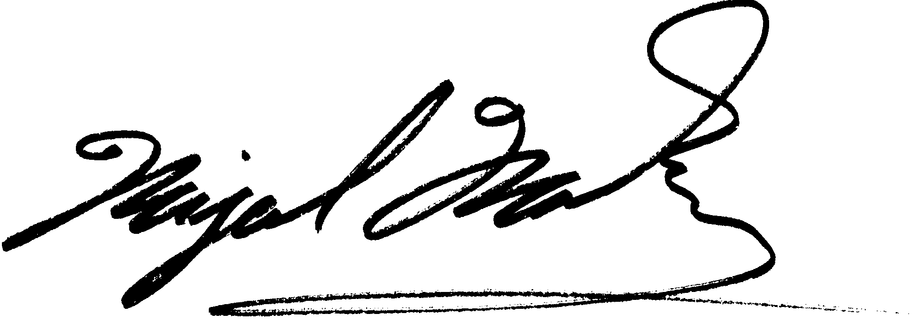
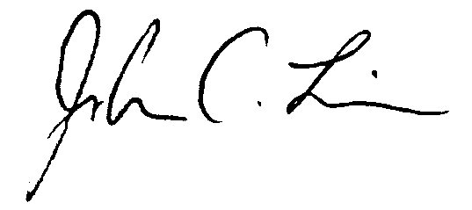
Sincerely,

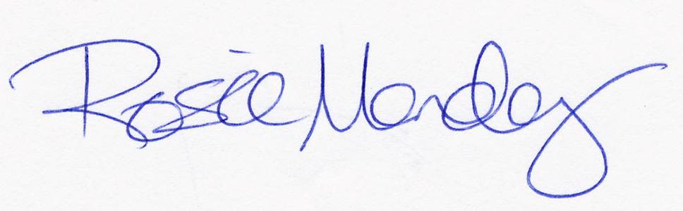
Rosie Mendez Miguel Martinez Sarah M. Gonzalez John C. Liu



THE COUNCIL

OF

THE CITY OF NEW YORK

Legislative Sponsorship Form

A local law to amend the administrative code of the city of New York, in relation to the parking, standing and stopping of commercial vehicles.

Please add my name as a sponsor of this legislation.

________________________ ____________________________ _____
Please Print Name of Council Member Date

_________________________
Signature of Council Member

