THE COUNCIL OF THE CITY OF NEW YORK
RESOLUTION NO. 436

Resolution approving with modifications the decision of the City Planning Commission on Application No. N 220430 ZRK, for an amendment of the text of the Zoning Resolution (Preconsidered L.U. No. 138).

By Council Members Salamanca and Louis

WHEREAS, New York City Department of Housing Preservation and Development, filed an application pursuant to Section 201 of the New York City Charter, for an amendment of the text of the Zoning Resolution of the City of New York, modifying Appendix F for the purpose of establishing a Mandatory Inclusionary Housing area, which in conjunction with the related actions would facilitate the development of four new 11-12 story mixed used buildings totaling approximately 430,284 square feet, with approximately 498 units of affordable housing including supportive and senior housing, as well as 14,313 square feet of commercial floor area, and 46,747 square feet of community facility space, Borough of Brooklyn, Community District 16 (ULURP No. N 220430 ZRK) (the “Application”);

WHEREAS, the City Planning Commission filed with the Council on October 14, 2022, its decision dated October 11, 2022 (the “Decision”), on the Application;

WHEREAS, the Application is related to application C 220427 HAK (Pre. L.U. No. 137), an Urban Development Action Area designation (UDAA), project approval (UDAAP), and disposition of City-owned property; C 220428 HUK (Pre. L.U. No. 138), Amendment to the Brownsville II Urban Renewal Plan (URP); and C 220429 ZMK (Pre. L.U. No. 135), a zoning map amendment to change R6/C2-4 and R6 districts, to an R7-2/C2-4 district;

WHEREAS, the Decision is subject to review and action by the Council pursuant to Section 197-d of the City Charter;

WHEREAS, upon due notice, the Council held a public hearing on the Decision and Application on October 19, 2022;

WHEREAS, the Council has considered the land use implications and other policy issues relating to the Decision and Application; and

WHEREAS, the Council has considered the relevant environmental issues, including the Negative Declaration issued May 19, 2022 (CEQR No. 20HPD054K) (the “Negative Declaration”).

RESOLVED:

The Council finds that the action described herein will have no significant impact on the environment as set forth in the Negative Declaration.

Pursuant to Sections 197-d and 200 of the City Charter and on the basis of the Decision and Application, and based on the environmental determination and consideration described in the report, N 220430 ZRK, incorporated by reference herein, and the record before the Council, the Council approves the Decision of the City Planning Commission with the following modifications:

Matter underlined is new, to be added;
Matter struck out is to be deleted;
Matter within # # is defined in Section 12-10;
Matter double struck out is old, deleted by the City Council;
Matter double-underlined is new, added by the City Council
* * * indicates where unchanged text appears in the Zoning Resolution.

APPENDIX F
Inclusionary Housing Designated Areas and Mandatory Inclusionary Housing Areas

* * *

BROOKLYN

* * *

Brooklyn Community District 16

Map 4 – (12/10/20) [date of adoption]

[EXISTING MAP]

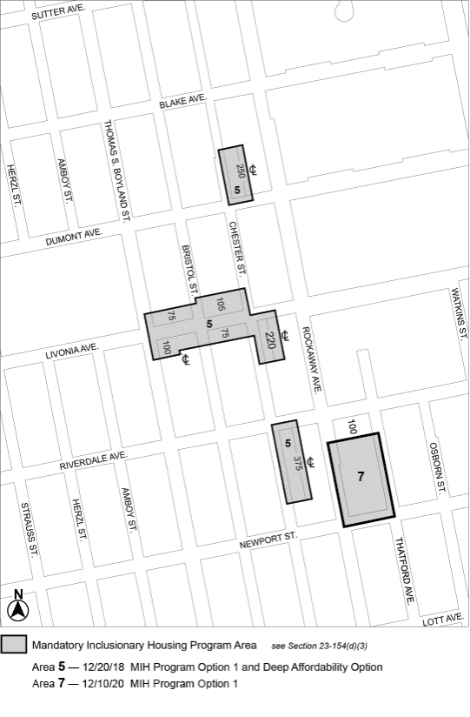

[PROPOSED MAP]
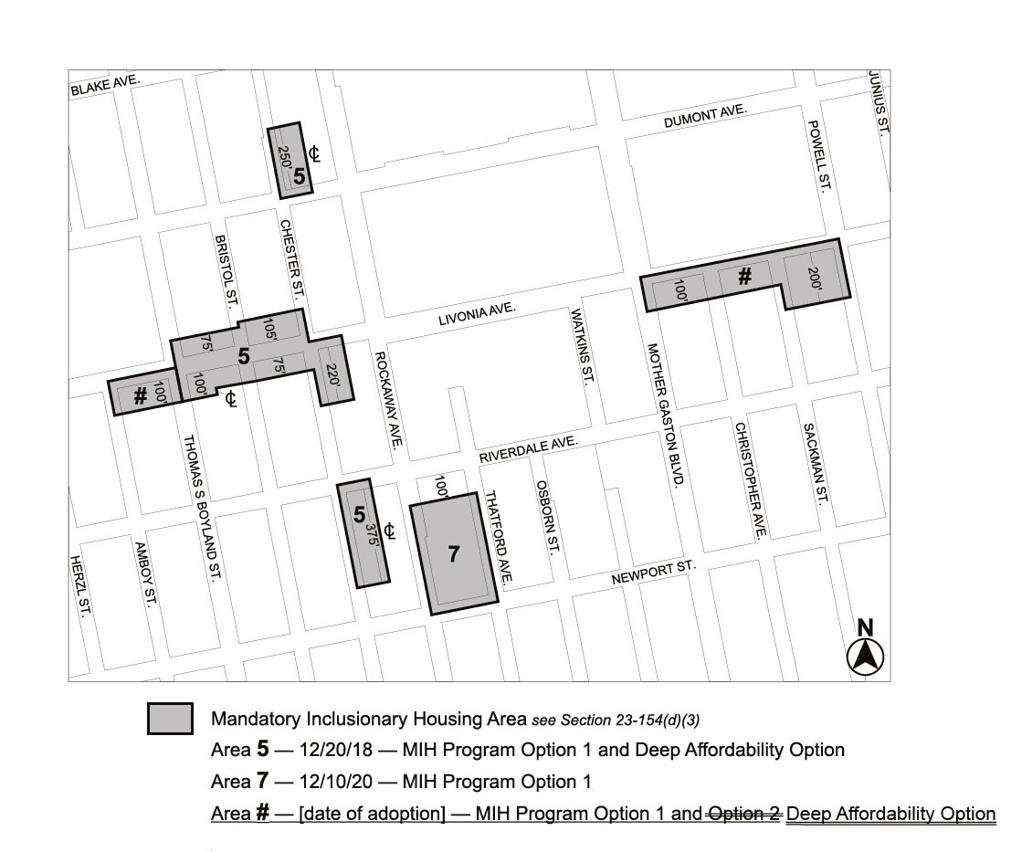
Portion of Community District 16, Brooklyn

* * *

Adopted.

Office of the City Clerk, }
The City of New York, } ss.:

I hereby certify that the foregoing is a true copy of a Resolution passed by The Council of The City of New York on __________, 2022, on file in this office.

.....................................................
City Clerk, Clerk of The Council

