THE COUNCIL OF THE CITY OF NEW YORK
RESOLUTION NO. 428

Resolution approving the decision of the City Planning Commission on Application No. N 230147 ZRK, for an amendment of the text of the Zoning Resolution (L.U. No. 65).

By Council Members Salamanca and Riley

WHEREAS, Omni New York, LLC, filed an application pursuant to Section 201 of the New York City Charter, for an amendment of the text of the Zoning Resolution of the City of New York, modifying APPENDIX F for the purpose of establishing a Mandatory Inclusionary Housing area, which in conjunction with the related actions would facilitate the development of two mixed-use buildings totaling approximately 141,000 square feet and consisting of 155 income-restricted housing units, ground floor commercial and community facility uses, and publicly accessible open space at 281 and 311 Marcus Garvey Boulevard in the Bedford-Stuyvesant neighborhood of Brooklyn, Community District 3 (ULURP No. N 230147 ZRK), (the “Application”);
WHEREAS, the City Planning Commission filed with the Council on April 8, 2024, its decision dated March 20, 2024 (the "Decision") on the Application;
WHEREAS, the Application is related to applications C 230146 ZMK (L.U. No. 64), a zoning map amendment to change R6A, R6A/C2-4, R6B, and R6B/C2-4 zoning districts to an R7A/C2-4 zoning district; C 230148 ZSK (L.U. No. 66), a special permit to establish a large-scale general development (LSGD) to modify height and setback requirements and to allow the distribution of total allowable floor area without regard for the zoning lot lines or district boundaries; and C 230152 ZSK (L.U. No. 67), a special permit to reduce the number of required accessory residential off-street parking spaces;
WHEREAS, the Decision is subject to review and action by the Council pursuant to Section 197-d of the City Charter;
WHEREAS, upon due notice, the Council held a public hearing on the Decision and Application on April 17, 2024;
WHEREAS, the Council has considered the land use implications and other policy issues relating to the Decision and Application; and
WHEREAS, the Council has considered the relevant environmental issues, including the Negative Declaration issued on October 30, 2023 (CEQR No. 23DCP012K), which includes an (E) designation to avoid the potential for significant adverse impacts related to hazardous materials, air quality, and noise (E-706) (the “Negative Declaration”).
RESOLVED:
The Council finds that the action described herein will have no significant impact on the environment as set forth in the (E) Designation (E-706) and Negative Declaration.
Pursuant to Sections 197-d and 200 of the City Charter and on the basis of the Decision and Application, and based on the environmental determination and consideration described in the report, N 230147 ZRK, incorporated by reference herein, and the record before the Council, the Council approves the Decision of the City Planning Commission.
Matter underlined is new, to be added;
Matter struck out is to be deleted;
Matter within # # is defined in Section 12-10;
* * * indicates where unchanged text appears in the Zoning Resolution

APPENDIX F
Inclusionary Housing Designated Areas and Mandatory Inclusionary Housing Areas

* * *

BROOKLYN

* * *

Brooklyn Community District 3

* * *

Map 8 - [date of adoption]

[PROPOSED MAP]
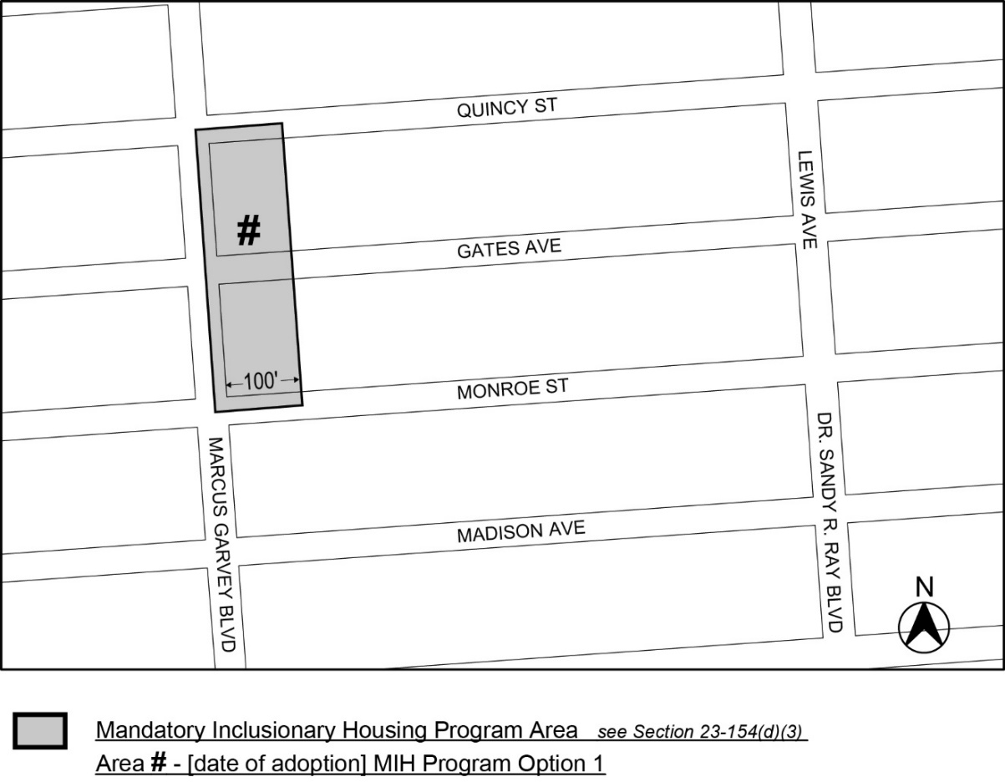
Portion of Community District 3, Brooklyn
* * *
Adopted.

Office of the City Clerk,}
The City of New York,} ss.:

I hereby certify that the foregoing is a true copy of a Resolution passed by The Council of The City of New York on _________, 2024, on file in this office.

.....................................................
City Clerk, Clerk of The Council

