THE COUNCIL OF THE CITY OF NEW YORK
RESOLUTION NO. 982

Resolution approving the decision of the City Planning Commission on Application No. N 190036 ZRQ, for an amendment of the text of the Zoning Resolution (L.U. No. 419).

By Council Members Salamanca and Moya

WHEREAS, Court Square 45th Avenue, LLC, filed an application pursuant to Section 201 of the New York City Charter, for an amendment of the text of the Zoning Resolution of the City of New York, modifying Article XI, Chapter 7 (Special Long Island City Mixed Use District), to facilitate the construction of a 45-story mixed-use building at 23-10 45th Avenue in the Court Square neighborhood of Long Island City, Queens, Community District 2 (Application No. N 190036 ZRQ), (the “Application”);
WHEREAS, the City Planning Commission filed with the Council on May 10, 2019 its decision dated May 8, 2019 on the Application (the “Decision”);
WHEREAS, the Decision is subject to review and action by the Council pursuant to Section 197-d of the City Charter;
WHEREAS, upon due notice, the Council held a public hearing on the Decision and Application on May 14, 2019;
WHEREAS, the Council has considered the land use implications and other policy issues relating to the Decision and Application; and
WHEREAS, the Council has considered the relevant environmental issues, including the negative declaration issued February 11th, 2019 (CEQR No. 19DCP038Q), which include an (E) designation related to hazardous materials, air quality, and noise would be established in connection with the proposed action (the “E” Designation (“E-523”)).
RESOLVED:

The Council finds that the action described herein will have no significant impact on the environment as set forth in the (E) Designation (E-523) and Negative Declaration.
Pursuant to Sections 197-d and 200 of the City Charter and on the basis of the Decision and Application, and based on the environmental determination and consideration described in the report, N 190036 ZRQ, incorporated by reference herein, and the record before the Council, the Council approves the Decision of the City Planning Commission.
Matter underlined is new, to be added;
Matter struck out is to be deleted;
Matter within # # is defined in Section 12-10;
* * * indicates where unchanged text appears in the Zoning Resolution.

ARTICLE XI
SPECIAL PURPOSE DISTRICTS

Chapter 7
Special Long Island City Mixed Use District

* * *
117-40
COURT SQUARE SUBDISTRICT

* * *

117-421
Special bulk regulations

* * *

(c) The height and setback regulations of the underlying C5-3 District shall apply, except that:

(1) no #building or other structure# shall exceed a height of 85 feet above the #base plane# within the area bounded by 23rd Street, 44th Road, a line 60 feet east of and parallel to 23rd Street, and a line 75 feet north of and parallel to 45th Road 45th Avenue; and
(2) on Blocks 1 and 3, the #street wall# of a #building or other structure# shall be located on the #street line# or sidewalk widening line, where applicable, and extend along the entire #street# frontage of the #zoning lot# up to at least a height of 60 feet and a maximum height of 85 feet before setback, except any portion of a #building# on Block 3 fronting upon 23rd Street may rise to a maximum height of 125 feet before setback. Recesses, not to exceed three feet in depth from the #street line#, shall be permitted on the ground floor where required to provide access to the #building#. Above the level of the second #story#, up to 30 percent of the #aggregate width of street walls# may be located beyond the #street line#, provided no such recesses are within 15 feet of an adjacent #building#.

Above a height of 85 feet the highest applicable maximum #street wall# height, the underlying height and setback regulations shall apply. However, the underlying tower regulations shall be modified:

(i) to permit portions of #buildings# that exceed a height of 85 feet to be set back at least five feet from a #wide street line#, provided no portion of such #building# that exceeds a height of 85 feet is located within 15 feet of a #side lot line#., and

(ii) so that the provisions of Section 33-451 (In certain specified Commercial Districts) regulating the aggregate area of a tower within 50 feet of a #narrow street# shall not apply to any #building# or portion of such #building# on Block 3 fronting upon 45th Avenue.

The provisions of this paragraph (c)(2) shall not apply to #enlargements# on #zoning lots# existing on June 30, 2009, where such #zoning lot# includes an existing #building# to remain with at least 300,000 square feet of #floor area#.

* * *

Appendix B
Court Square Subdistrict Plan Map and Description of Improvements

[EXISTING MAP]
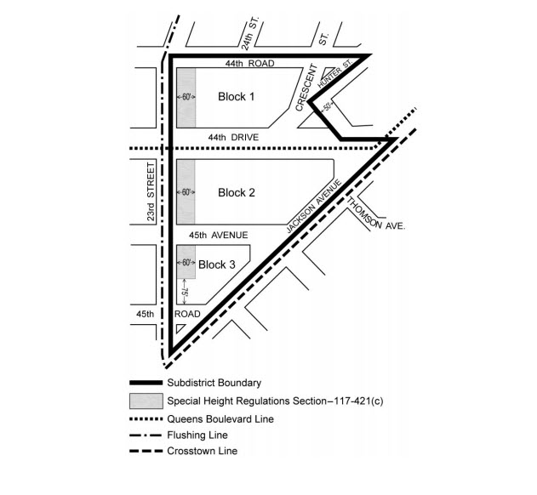

[PROPOSED MAP]
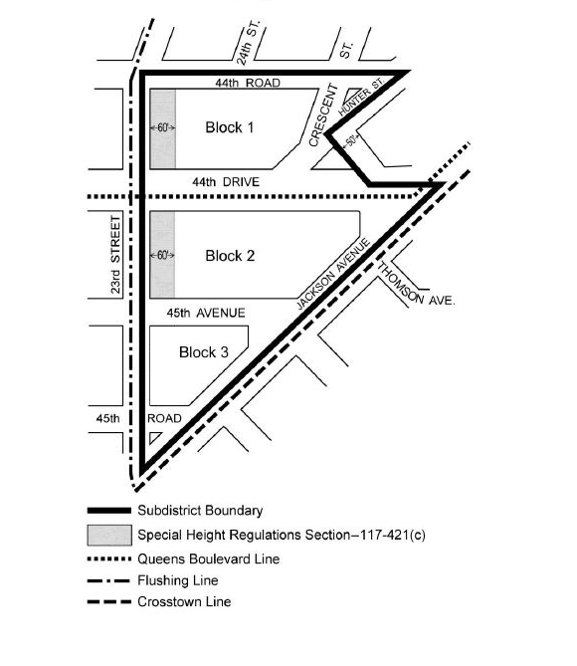
* * *

Adopted.

Office of the City Clerk, }
The City of New York, } ss.:

I hereby certify that the foregoing is a true copy of a Resolution passed by The Council of The City of New York on June 26, 2019, on file in this office.

.....................................................
City Clerk, Clerk of The Council

