Governmental Operations Committee Staff
CJ Murray, Senior Legislative Counsel
Erica Cohen, Legislative Policy Analyst



THE COUNCIL

BRIEFING PAPER OF THE GOVERNMENTAL AFFAIRS Division
Andrea Vazquez, Legislative Director
Rachel Cordero, Deputy Director, Governmental Affairs

COMMITTEE ON GOVERNMENTAL OPERATIONS
Hon. Sandra Ung, Chair

February 28, 2023

Oversight: Appointing and Supporting New York City’s Community Boards

Introduction

On February 28, 2023, the Committee on Governmental Operations, chaired by Council Member Sandra Ung, will hold an oversight hearing on appointing and supporting New York City’s Community Boards. Among those invited to testify are the Borough Presidents, the Civic Engagement Commission, the Office of Technology and Innovation, Community Board representatives, advocacy organizations, and other members of the public

Background

Community Board Basics
New York City’s Community Boards are “the level of government that is most intimately connected with the community.” They are designed to provide a mechanism for members of the public that reside, work, or have interests in a particular community to have a voice in what is going on in their local area. They provide a method for community members to provide feedback to city and state agencies and other government bodies about how their local areas might be affected by government decisions and how effectively public services are being provided. Although they lack decision making authority, Community Boards can make recommendations on issues that affect the community including on pending liquor licenses, zoning changes, development projects, sidewalk cafes, and newsstands.
There are currently 59 Community Boards, each composed of up to 50 volunteer members, although some have fewer. Each member must be at least 16 years old, reside in the City, and have a residence, business, professional, or other significant interest in the district. No more than one quarter of the members on any one board may be city employees, and none may be employees of the appointing Borough President or nominating Council Member. In addition, no board may have more than two members who are under the age of 18.
The Borough Presidents are responsible for appointing members to the Community Boards in their boroughs. At least half of those appointed to each board must come from nominations made by the Council Members who represent portions of the community district. Such Council Members are also non-voting members of the Community Board. Members are appointed to staggered two-year terms so that half of each board’s members are appointed in even years, and half are appointed in odd years. No member may serve more than four consecutive terms. A member who has reached their term limit may be reappointed in the future if more than one full term has passed since they last served.
Community Boards are required to hire a district manager whose duties include processing complaints, presiding at meetings of the district service cabinet, and other duties assigned by the Board. Boards may also hire additional staff and utilize the services of outside professionals, including urban planners and other experts, if appropriated sufficient funding to do so.
  - Community Board Responsibilities

Community Boards are responsible for opining and advising on government decisions that affect the welfare of their districts. Boards may hold public or private hearings on such matters, but can only take action at meetings open to the public. Each Community Board must meet and hold a public hearing at least once per month, except during July and August. With the assistance of the Office of Technology and Innovation, all Community Boards are required to maintain a website that includes notice of upcoming meetings, minutes from the past year’s meetings, and contact information for the Board.
One area where Community Boards play a particularly significant role is in the land use process. All zoning changes and other actions subject to the Uniform Land Use Review (ULURP) process must be submitted to the local Community Board for review. Once a Community Board receives a ULURP application, it has 60 days to hold a public hearing on the proposal and issue a recommendation to the City Planning Commission and applicable Borough President. Although such recommendations are merely advisory, they often influence other decision-makers and thereby affect the final outcome of the ULURP process.
Community Boards also play an important advisory role in preparing and administering the City’s budget. Among other duties, they consult with agencies on the capital and programmatic needs of their districts, review agency expenditure estimates, hold hearings on budgetary matters, and submit budget priorities to the Mayor. In addition, Community Boards make recommendations on the use of federal, state, and local funds earmarked for community development activities, assist in the planning and monitoring of capital projects, and evaluate the quantity and quality of services provided by city agencies.
Community Boards participate in other governmental processes as well, including the issuance of liquor licenses and the construction of bike lanes. Furthermore, Community Boards serve as a key line of communication between community members and government agencies by collecting and processing the complaints, requests, and inquiries of district residents.
  - Training and Support for Community Boards

    - The Role of Borough Presidents

In addition to appointing Community Board members, Borough Presidents are also required to provide training and technical assistance to Community Board members, including technical assistance on urban planning matters. The Borough President must also consult with Community Boards to inform the Mayor about significant long-term issues faced by the borough and propose solutions to such problems.
    - The Role of the Civic Engagement Commission

In November 2018, New York City voters approved a referendum establishing the Civic Engagement Commission (CEC). The CEC is responsible for identifying qualified professionals to assist Community Boards on land use matters. The Commission is also required to identify and provide language access services to Community Boards. Lastly, the CEC is required to develop “training and other assistance” for Community Boards. This training may include assistance in utilizing technology and “developing uniform meeting procedures.” Since its inception the CEC has held workshops on “uniform meeting procedures, language access best practices and community outreach.”
- Community Board Diversity and Inclusion

  - 2018 Charter Revisions Expanding Diversity and Inclusion Requirements
The Charter has long required Borough Presidents, in making Community Board appointments, to “assure adequate representation from the different geographic sections and neighborhoods within the community district” and “consider whether the aggregate of appointments fairly represents all segments of the community.” In 2018, New York City voters approved a set of Charter revisions that significantly expanded upon this mandate. Pursuant to these revisions, Borough Presidents have an affirmative obligation to seek out Community Board applicants from diverse backgrounds, “including with regard to race, ethnicity, gender, age, disability status, sexual orientation, language,” and other factors the Borough President deems relevant to “promoting diversity and inclusion of under-represented groups and communities within community boards.”
The 2018 revisions also made changes to the Community Board application process. Specifically, they required Borough Presidents to include applications on their websites where interested members of the public may apply to become Community Board members online. Notably, the application must give applicants the option to disclose certain demographic information, including the applicant’s age, gender, race, ethnicity, sexual orientation, disability status, and languages spoken, as well as any other demographic information the applicant chooses to disclose. The Office of Technology and Innovation is responsible for assisting the Borough Presidents in developing Community Board applications and making them readily accessible to the public online.
In addition, the 2018 Charter revisions added greater transparency around Community Board appointments. The revisions require Borough Presidents to produce an annual report on Community Board membership and demographics. The report must be submitted to the Mayor and the Council, and be posted on the Borough President’s website, by July 1 of each year. Each report is intended to provide a snapshot of Community Board membership during the preceding calendar year and is required to include, among other things, a demographic breakdown of each Community Board based on the information voluntarily provided in the online application. In addition, each report must describe the Borough President's recruitment plan for filling vacant Community Board member positions, including the Borough President’s efforts to publicize openings and the particular methods used to seek out candidates from diverse backgrounds.
Each annual report must also include the following information: (i) the name, length of service, and leadership positions, if any, of each Community Board member who served in the borough during the preceding calendar year; (ii) the number of vacant Community Board positions in the borough in the preceding calendar year; (iii) the number of applications received and interviews conducted during such year; (iv) a general description of the Borough President’s evaluation criteria; and (v) any particular tools employed by the Borough President in the selection process.
  - Review of Annual Reports on Community Board Demographics

The 2018 Charter revisions became effective on January 1, 2019. Since then, four deadlines have passed for the submission of annual reports on Community Board demographics. Compliance with these deadlines has been mixed. On multiple occasions, Borough Presidents have submitted their reports well after the July 1 deadline. In addition, there are several reports that Committee staff and the Council’s Correspondence Unit have no record of ever receiving and that are not available on the relevant Borough President’s website. In light of these missing reports, our understanding of Community Board demographics across the City, and how those demographics are changing over time, is incomplete.
Nevertheless, the reports that have been submitted provide numerous examples of Community Boards where representation is severely lacking. In addition, the reports suggest that underrepresentation is a problem, not just for select Community Boards, but for entire boroughs and for the City as a whole. For instance, a review of the first annual report for Brooklyn found that Latino residents were underrepresented on 16 of the borough’s 18 Community Boards, that Black residents were underrepresent on 12, that Community Board members across Brooklyn skewed older than the borough as a whole, and that 11 of the borough’s 18 boards skewed male. Similarly, a review of the second annual report for Queens found that male members outnumbered female members on 10 of the borough’s 14 boards (despite the fact that men and women each made up about half the borough’s population), that only two board members across the borough identified as transgender or gender non-conforming, that Latino residents, immigrants, and residents under the age of 46 were underrepresented on every board in the borough, and that Asian residents were underrepresented on 13 of 14 boards. In addition, a citywide review of the inaugural reports for The Bronx, Brooklyn, Queens, and Manhattan found that Community Board members in these four boroughs skewed male relative to the City’s overall population.
At the same time, representation across certain dimensions appears to have improved in recent years, at least in certain boroughs. For instance, in his most-recent annual report, Queens Borough President Donovan Richards highlights the progress his office has made in ensuring that younger New Yorkers are adequately represented on Community Boards. In addition, in 2022, women were appointed to more Community Board seats than men in both Brooklyn and Queens, and in 2021, women held the majority Community Board seats in The Bronx. The following charts show how well Community Boards in The Bronx, Brooklyn, Queens, and Staten Island reflected the gender demographics of their communities, based on each borough’s 2022 demographic report:
Figure 1: The Bronx
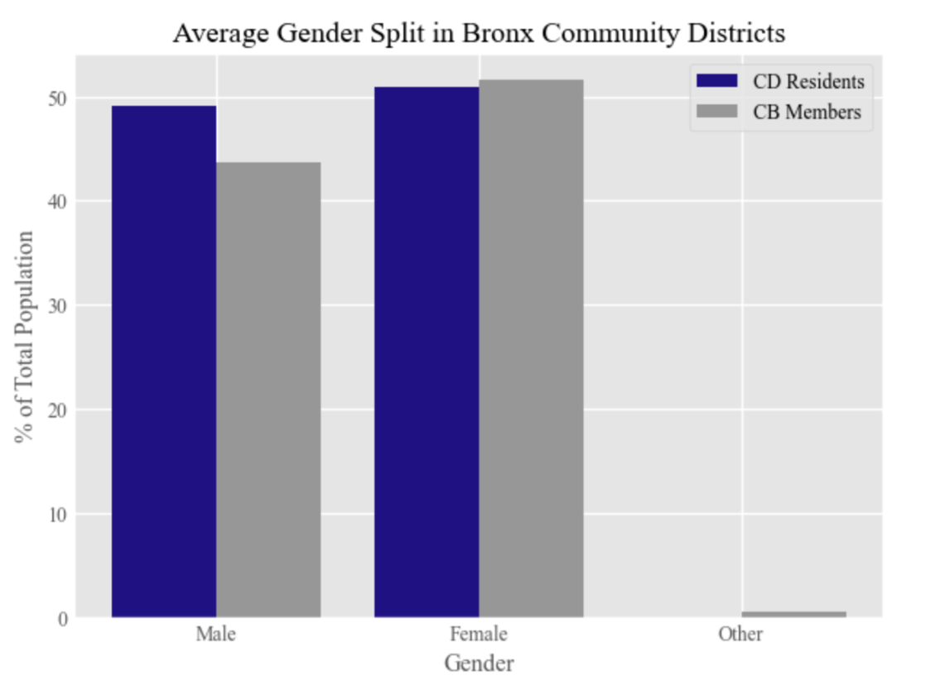
Figure 2: Queens
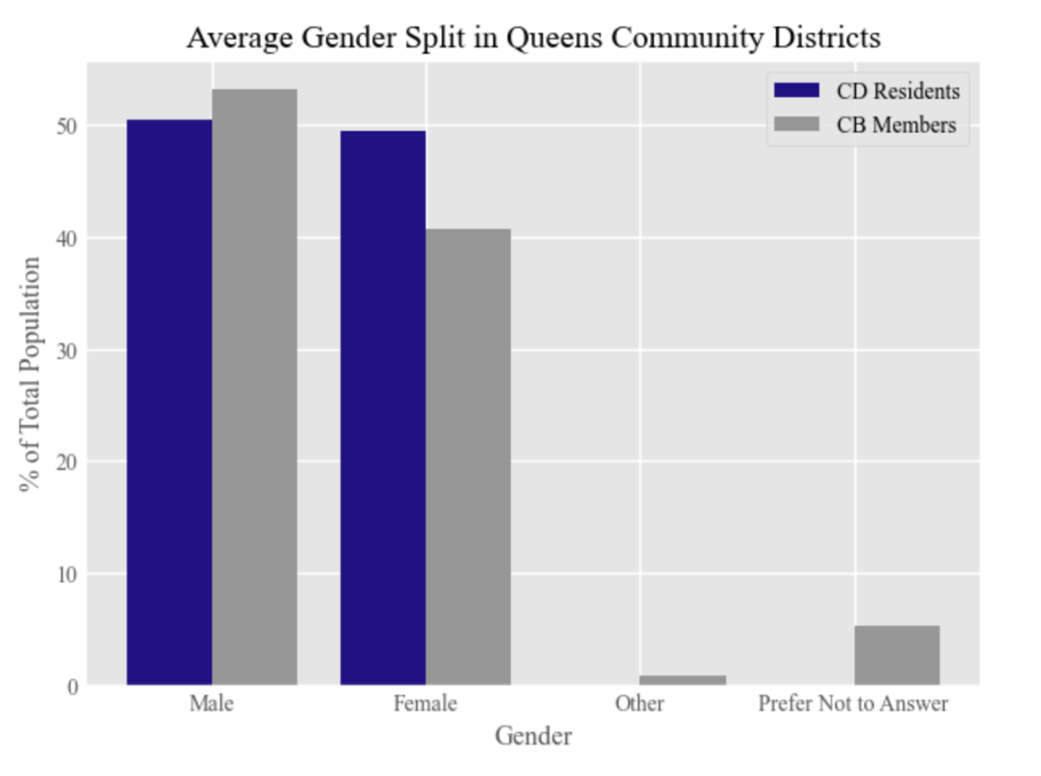
Figure 3: Staten Island
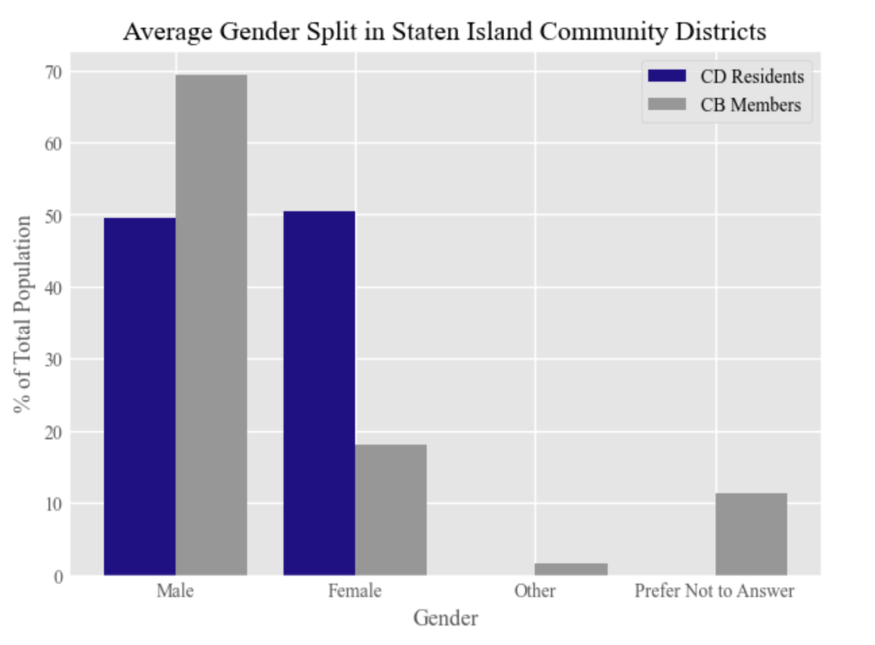
Figure 4: Brooklyn
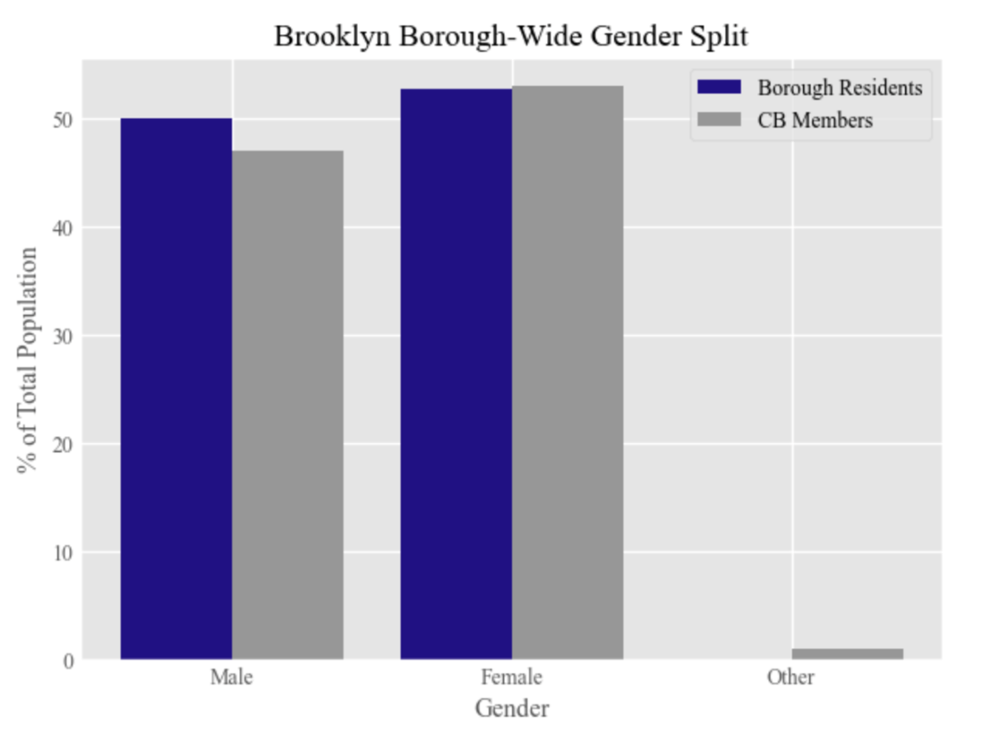
These charts indicate that while gender representation on Community Boards may be getting better, there remains significant room for improvement.
These points aside, it is difficult to ascertain whether the City’s Community Boards are becoming more representative on the whole, or whether certain boroughs are seeing more progress than others. The fact, mentioned above, that some annual reports are missing is one part of this problem. Another aspect, however, is that each Borough President reports its data differently. For instance, when it comes to race, the most-recent Bronx report uses 7 racial categories, the most-recent Queens report uses 9, the most-recent Brooklyn report uses 10, and the most-recent Staten Island report uses 11. In addition, even within the same Borough, reporting practices change from year to year. For example, whereas the first annual report for The Bronx split board members into two age groups, the two most-recent Bronx reports (which were issued under a different Borough President) split board members into five age cohorts. Reporting differences like these make it challenging to compare representation across boroughs or track how individual boroughs are doing over time. Adding further to this challenge is the fact that data is reported in pdf format, making it difficult to extract, combine, and analyze.
In the future, standardizing reporting practices across boroughs would allow the City and members of the public to better track the impact of 2018 Charter revisions on Community Board diversity and inclusion. In particular, developing a standardized self-identification survey that all Borough Presidents can include in their community board applications, and having all Borough Presidents post anonymized survey results on the City’s Open Data Portal, could significantly improve transparency around Community Board demographics.
- Conclusion
At today’s hearing, the Committee will conduct oversight on issues related to Community Board appointments. In particular, the Committee will attempt to gain a clearer understanding of how well Community Boards represent the diversity of their districts. The Committee will also review member recruitment strategies and data collection best practices. In addition, the Committee will discuss challenges Borough Presidents, the Civic Engagement Commission, the Office of Technology and Innovation, and other city entities have faced in providing Community Boards with the support they need in order to function effectively. Finally, the Committee will invite Community Board members and staff to share their experiences.

Testimony of Ken Brown, District Manager of Bronx Community Board 5, at the February 25, 2019 hearing of the Committee on Government Operations, available at https://legistar.council.nyc.gov/LegislationDetail.aspx?ID=3854412&GUID=1745372F-8FC1-4612-8F2A-DC224A9375CE&Options=&Search=.
See Charter §§ 2700 and 2800(a).
See Charter § 2800(d).
Id.
“About Community Boards” available at https://www.nyc.gov/site/cau/community-boards/about-commmunity-boards.page.
Charter § 2800(a).
NY Public Officers Law § 3(1).
Id.
Charter § 2800(a).
Charter § 2800(a).
Charter § 1135.
Charter § 2800(a).
Charter § 2800(a).
Id. Community groups, including Community Boards themselves, may recommend applicants as well. Id.
Id.
Id.
Id.
Id.
Charter § 2800(f).
Id.
See Charter §2800(d); .
Charter § 2800(d)(3).
Charter § 2800(h).
In 2022, Mayor Adams renamed the Department of Technology and Telecommunications Services the “Office of Technology and Innovation.” See Executive Order 3 (January 19, 2022), https://www.nyc.gov/office-of-the-mayor/news/003-002/executive-order-3.
Charter §2800(d)(22).
Charter § 197-c(e); see
Id.
See Rachel Holiday Smith, How to Join a Community Board, and What to Know Before You Apply, The CITY (February 16, 20230, https://www.thecity.nyc/civic-newsroom/2022/1/12/22880779/how-to-join-a-community-board-and-what-to-know-before-you-apply; Roshan Abraham, Do New York’s Community Boards Need Veto Power?, City Limits (August 24. 2016), https://citylimits.org/2016/08/24/do-new-yorks-community-boards-need-veto-power/.
Charter §2800(d)(11), (13).
Charter §2800(d)(12).
Charter §2800(d)(14), (15).
Charter §2800(d)(18).
See NY Alcoholic Beverage Control Law § 110-b.
Admin Code § 19-187.
Charter §2800(d)(20).
Charter §82(12).
Charter §82(9).
Charter §82(14).
Local Law 211 of 2018.
Charter §3203(a).
Id.
Id.
Id.
New York City Civic Engagement Commissions “Community Boards” Page available at https://www.nyc.gov/site/civicengagement/our-programs/community-boards.page (last visiting Feb 1, 2023)
Charter § 2800(a).
Local Law Local Law 211 of 2018. See generally Christine Billy and Matt Gewolb, Reflections on the 2018 Charter Revision Process, City Law (October 21, 2019), https://www.citylandnyc.org/reflections-on-the-2018-charter-revision-process/; Final Report of the 2018 New York City Charter Revision Commission (September 6, 2018), available at https://www.nyc.gov/assets/charter/downloads/pdf/final-report-20180904.pdf.
Id.
See Charter § 82(17)(b).
Charter § 82(17)(b)(1).
Charter § 82(17)(b)(2).
Charter § 82(17)(a).
Id.
Charter § 82(17)(a)(ii).
Charter § 82(17)(a)(iv).
Charter § 82(17)(a)(i).
Charter § 82(17)(a)(iii).
Charter § 82(17)(a)(v).
Charter § 82(17)(a)(vi).
Charter § 82(17)(a)(vii).
Charter § 82(17)(a)(viii).
Charter § 1152(l)(3).
See Rachel Holliday Smith and Ann Choi, Does Your Community Board Reflect You and Your Neighbors? Find Out., the CITY (January 29, 2020), https://www.thecity.nyc/government/2020/1/29/21210566/does-your-community-board-reflect-you-and-your-neighbors-find-out (noting that each of the inaugural reports was late).
See Rachel Holliday Smith and Ann Choi, Does Your Community Board Reflect You and Your Neighbors? Find Out., the CITY (January 29, 2020), https://www.thecity.nyc/government/2020/1/29/21210566/does-your-community-board-reflect-you-and-your-neighbors-find-out (discussing underrepresentation in Morris Park, The Bronx; Midtown, Manhattan; and Forest Hills and Rego Park, Queens).
Kelly Mena and Meaghan McGoldrick, How well does your community board represent the district? Not very., Brooklyn Eagle (November 26, 2019), https://brooklyneagle.com/articles/2019/11/26/community-board-diversity/.
David Brand, Racial, ethnic and gender disparities persist on every Queens community board. New applicants can change that, Queens Daily Eagle (January 27, 2021), https://queenseagle.com/all/racial-gender-ethnic-disparities-queens-community-boards.
Staten Island was not included in the analysis because the first annual report for Staten Island did not provide demographic information.
Rachel Holliday Smith and Ann Choi, Does Your Community Board Reflect You and Your Neighbors? Find Out., the CITY (January 29, 2020), https://www.thecity.nyc/government/2020/1/29/21210566/does-your-community-board-reflect-you-and-your-neighbors-find-out.
See 2022 Queens Community Board Demographic Report, available at https://queensbp.org/wp-content/uploads/2022/07/2022-Queens-Community-Board-Report-lo-res2.pdf.
See id.; 2022 Brooklyn Community Board Demographic Report, available at https://www.brooklyn-usa.org/brooklyn-community-board-demographics-report-2022/.
2022 Bronx Community Board Demographic Report, available at https://ukj187.p3cdn2.secureserver.net/wp-content/uploads/2022/07/2021-bxbp-cb-demographics-report.pdf.
As of February 2, 2022, Committee staff had not received the most-recent annual report for Manhattan and such report was not available on the Manhattan Borough President’s website.
Charts developed by Rachel Avram and Julia Fredenburg from the Council’s Data Operations Unit.
Community Board data is based on Community Board seats held in calendar year 2021. See 2022 Bronx Community Board Demographic Report, available at https://ukj187.p3cdn2.secureserver.net/wp-content/uploads/2022/07/2021-bxbp-cb-demographics-report.pdf.
Community Board data is based on Community Board seats held as of 2022. See Queens Community Board Demographic Report, available at https://queensbp.org/wp-content/uploads/2022/07/2022-Queens-Community-Board-Report-lo-res2.pdf.
Community Board data is based on Community Board seats held in calendar year 2021. See 2022 Staten Island Community Board Demographic Report, available at https://www.statenislandusa.com/uploads/8/9/8/7/89877849/community_board_annual_report_2021.pdf.
Community Board data is based on Community Board appointments made in 2022. In addition, because the Brooklyn report did not provide data broken down by Community Board, Figure 4 reflects the borough-wide gender split, rather than the average split in each community district. See 2022 Brooklyn Community Board Demographic Report, available at https://www.brooklyn-usa.org/brooklyn-community-board-demographics-report-2022/.
2022 Bronx Community Board Demographic Report, available at https://ukj187.p3cdn2.secureserver.net/wp-content/uploads/2022/07/2021-bxbp-cb-demographics-report.pdf.
2022 Queens Community Board Demographic Report, available at https://queensbp.org/wp-content/uploads/2022/07/2022-Queens-Community-Board-Report-lo-res2.pdf.
2022 Brooklyn Community Board Demographic Report, available at https://www.brooklyn-usa.org/brooklyn-community-board-demographics-report-2022/.
2022 Staten Island Community Board Demographic Report, available at https://www.statenislandusa.com/uploads/8/9/8/7/89877849/community_board_annual_report_2021.pdf.
2019 Bronx Community Board Demographic Report; see also Rachel Holliday Smith and Ann Choi, Does Your Community Board Reflect You and Your Neighbors? Find Out., the CITY (January 29, 2020), https://www.thecity.nyc/government/2020/1/29/21210566/does-your-community-board-reflect-you-and-your-neighbors-find-out.
2022 Bronx Community Board Demographic Report, available at https://ukj187.p3cdn2.secureserver.net/wp-content/uploads/2022/07/2021-bxbp-cb-demographics-report.pdf.

