THE COUNCIL OF THE CITY OF NEW YORK
RESOLUTION NO. 595

Resolution approving the decision of the City Planning Commission on Application No. N 210341 ZRK, for an amendment of the text of the Zoning Resolution (Preconsidered L.U. No. 157).

By Council Members Salamanca, Riley and Mealy

WHEREAS, MTL Realty, LLC, filed an application pursuant to Section 201 of the New York City Charter, for an amendment of the text of the Zoning Resolution of the City of New York, modifying APPENDIX F for the purpose of establishing a Mandatory Inclusionary Housing area, which in conjunction with the related action would facilitate the development of a new eight-story, approximately 91,500-square-foot mixed-use building containing approximately 73,900 square feet of residential space, or 80 dwelling units, approximately 20 to 24 of which would be permanently income-restricted, as well as approximately 17,600 square feet of ground floor commercial space located at 2390 McDonald Avenue in the Gravesend neighborhood of Brooklyn, Community District 15 (ULURP No. N 210341 ZRK), (the “Application”);

WHEREAS, the City Planning Commission filed with the Council on September 13, 2024, its decision dated September 11, 2024 (the “Decision”) on the Application;

WHEREAS, the Application is related to application C 210340 ZMK (Pre. L.U. No. ___), a zoning map amendment to change a C8-1 zoning district to a C4-4L zoning district;

WHEREAS, the Decision is subject to review and action by the Council pursuant to Section 197-d of the City Charter;

WHEREAS, upon due notice, the Council held a public hearing on the Decision and Application on September 17, 2024;

WHEREAS, the Council has considered the land use implications and other policy issues relating to the Decision and Application; and

WHEREAS, the Council has considered the relevant environmental issues, including the Negative Declaration issued on May 13, 2024 (CEQR No. 21DCP090K), which includes an (E) designation to avoid the potential for significant adverse impacts related to air quality and noise (E-747). In order to avoid the potential for significant adverse historic and cultural resource impacts, as part of the Proposed Actions, the Applicant entered into a Restrictive Declaration on April 16, 2024, and recorded on May 7, 2024, which commits the applicant to conduct archaeological identification, investigation, and mitigation in accordance with the CEQR Technical Manual and NYC Landmarks Preservation Commission (LPC) guidelines for archaeological work in New York City, in which no significant adverse impact to archaeological resources would result from the proposed actions.

RESOLVED:

The Council finds that the action described herein will have no significant impact on the environment as set forth in the (E) Designation (E-747) and Negative Declaration.

Pursuant to Sections 197-d and 200 of the City Charter and on the basis of the Decision and Application, and based on the environmental determination and consideration described in the report, N 210341 ZRK, incorporated by reference herein, and the record before the Council, the Council approves the Decision of the City Planning Commission.

Matter underlined is new, to be added;
Matter struck out is to be deleted;
Matter within # # is defined in Section 12-10;
* * * indicates where unchanged text appears in the Zoning Resolution.

* * *

APPENDIX F
Inclusionary Housing Designated Areas and Mandatory Inclusionary Housing Areas

* * *

BROOKLYN

* * *

Brooklyn Community District 15

* * *

Map 7 – [date of adoption]

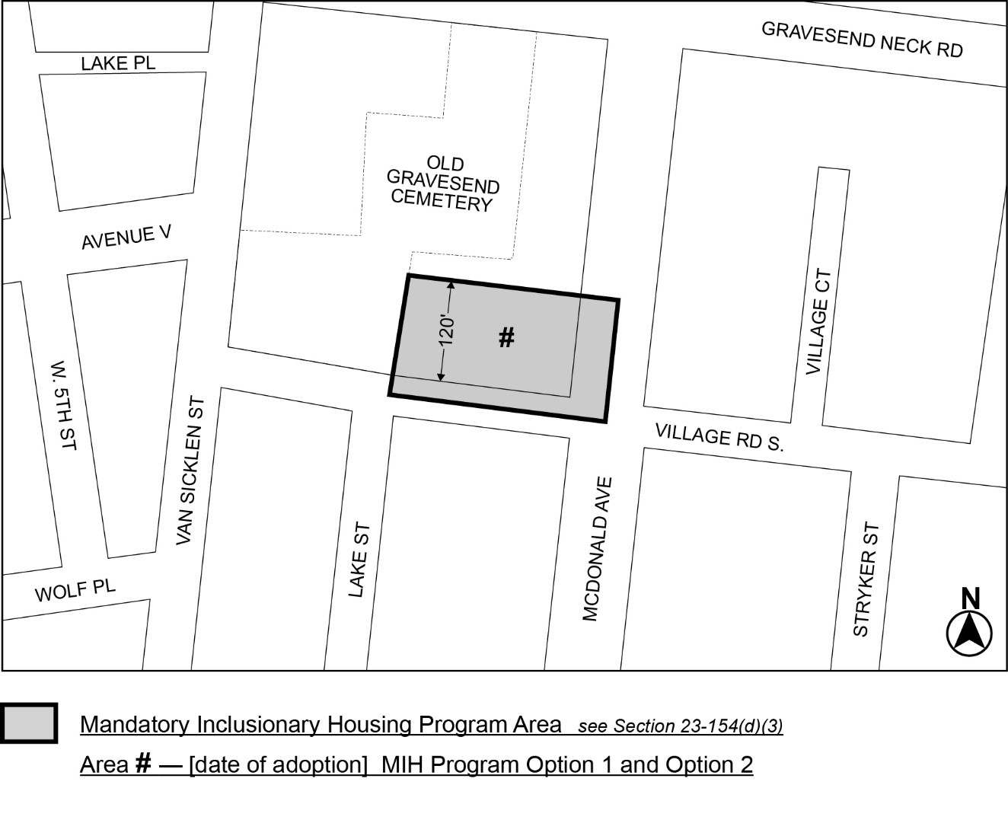

Portion of Community District 15, Brooklyn

* * *

Adopted.

Office of the City Clerk,}
The City of New York, } ss.:

I hereby certify that the foregoing is a true copy of a Resolution passed by The Council of The City of New York on ________, 2024, on file in this office.

.....................................................
City Clerk, Clerk of The Council

