Committee Staff
Samara Swanston, Legislative Counsel
Claire MacLachlan, Legislative Counsel
Ricky Chawla, Senior Legislative Policy Analyst
Andrew Bourne, Legislative Policy Analyst
Andrew Lane-Lawless, Financial Analyst
Nicholas Montalbano, Senior Data Scientist
Christopher Zawora, Data Scientist
Anne Driscoll, Data Scientist



The New York City Council
Andrea Vazquez, Legislative Director

Committee Report of the Infrastructure Division
Brad Reid, Deputy Director

Committee on Environmental Protection, Resiliency and Waterfronts
Hon. James F. Gennaro, Chair

October 16, 2023

Oversight – DEP’s Management of Noise Complaints

Int. No. 160: By Council Members Holden, Yeger, Ariola and Vernikov
Title: A Local Law to amend the administrative code of the city of New York, in relation to the noise standard for commercial establishments
Administrative Code: Amends sections 24-218 and 24-244

Int. No. 774: By Council Members Powers, Mealy, Restler, Menin, Yeger, Joseph, Holden, Schulman, Brewer, Hudson, Bottcher, Hanks, Riley and Abreu
Title: A Local Law to amend the administrative code of the city of New York, in relation to requiring the department of environmental protection to measure construction-related sound levels inside dwelling units upon request
Administrative Code: Amends sections 24-203 and adds a new section 24-224.1

Int. No. 775: By Council Members Powers, Restler, Menin, Yeger, Joseph, Holden, Schulman, Brewer, Hudson, Bottcher, Hanks, Riley, Abreu and Louis
Title: A Local Law to amend the administrative code of the city of New York, in relation to results of noise inspections
Administrative Code: Amends section 24-207

Int. No. 776: By Council Members Powers, Restler, Menin, Yeger, Joseph, Holden, Schulman, Brewer, Hudson, Bottcher, Hanks, Riley and Abreu
Title: A Local Law to amend the administrative code of the city of New York, in relation to providing noise inspection reports
Administrative Code: Adds a new section 24-217.2

Int. No. 777: By Council Members Powers, Restler, Menin, Holden, Schulman, Brewer, Hudson, Bottcher, Hanks, Riley and Abreu
Title: A Local Law to amend the administrative code of the city of New York, in relation to requiring an after hours variance for the removal of construction debris
Administrative Code: Amends section 24-222

Int. No. 778: By Council Members Power, Yeger, Holden, Restler, Menin, Joseph, Schulman, Brewer, Hudson, Bottcher, Hanks, Abreu, Ung, Dinowitz, Louis and Vernikov
Title: Local Law to amend the administrative code of the city of New York, in relation to establishing a photo noise violation monitoring device program for motor vehicles
Administrative Code: Adds a new section 24-236.1

Int. No. 1194: By Council Member Gennaro
Title: Local Law to amend the administrative code of the city of New York, in relation to citizen noise complaints
Administrative Code: Amends section 24-261

- Introduction

On October 16, 2023, the Committee on Environmental Protection, Resiliency, and Waterfronts (the Committee), chaired by Council Member James F. Gennaro, will hold an oversight hearing on citizen enforcement of the noise code, the Department of Environmental Protection’s (DEP or Department) response to noise complaints, and various sources of noise pollution. The Committee will also hear Int. No. 160, sponsored by Council Member Robert F. Holden, in relation to the noise standard for commercial establishments; Int. No. 774, sponsored by Council Member Keith Powers, in relation to requiring the department of environmental protection to measure construction-related sound levels inside dwelling units upon request; Int. No. 775, sponsored by Council Member Keith Powers, in relation to results of noise inspections; Int. No. 776, sponsored by Council Member Keith Powers, in relation to providing noise inspection reports; Int. No. 777, sponsored by Council Member Keith Powers, in relation to requiring an after-hours variance for the removal of construction debris; Int. No. 778, sponsored by Council Member Keith Powers, in relation to establishing a photo noise violation monitoring device program for motor vehicles; and Int. No. 1194, sponsored by Council Member James F. Gennaro, in relation to citizen noise complaints. The Committee expects to hear testimony from DEP, the Office of Administrative Trials and Hearings (OATH), the Department of Small Business Services (SBS), and interested members of the public.
- Background

Citizen’s Noise Complaint Program:

The New York City Administrative Code allows for citizens to file complaints against alleged violators of New York City’s noise code. Citizen complainants must first serve a complaint upon DEP. If, within 30 days of serving the complaint on DEP, DEP has failed to serve a notice of complaint upon the person allegedly responsible for the violation or has failed to serve a written notice upon the complainant that their complaint is frivolous or duplicitous, then the complainant may serve a notice of violation directly upon the person allegedly responsible and on the Environmental Control Board (ECB). Summonses that result from notices served upon ECB are adjudicated by the OATH Hearings Division, which has final say over its hearing decisions unless an appeal is filed and accepted. Citizen enforcers may collect 50% of any penalty assessed by OATH as compensation for any proceeding they successfully prosecute, and up to 25% of any penalty for any proceeding DEP prosecutes as a result of a complaint they filed. Violators are subject to a schedule of fines which increase upon a violator’s second and third violation. The ECB may remit, in whole or in part, the penalty imposed, if it determines that the violator is no longer in violation of the noise code at the time of the hearing.
Virtually all citizen noise complaints allege violations of Admin. Code § 24-244(b)(i), which prohibits the use of any sound reproduction device “for commercial or business advertising purposes or for the purpose of attracting attention to any performance, show, sale or display of merchandise, in connection with any commercial or business enterprise . . . outside or in front of any building, place or premises,” inter alia. The DEP Commissioner has decried these serial complaints as “not legitimate enforcement activity,” and called for changes to the law. Some civilian complainants have countered that they are only responding to DEP’s unwillingness to enforce its own laws.
On June 23, 2023, NBC New York published an article about the citizen’s noise complaint program, in which some local businesses reported a deluge of summonses alleging noise code violations, often complaining that they received multiple summonses at one time, without the opportunity to cure any defects. According to a representative of the NYC Hospitality Alliance, some businesses received up to 6 violation notices filed by the same individual, by the time they were notified of the initial violation. An employee of a Midtown Manhattan restaurant stated that the establishment was facing at minimum $8,000 in fines, and potentially up to $33,000 in fines. The owner of a restaurant in the Hell’s Kitchen neighborhood in Manhattan stated that the business was facing over $33,000 in fines stemming from 7 individual complaints that had all been filed by the same individual.
Concerns have also been raised about whether relying on a citizen-based enforcement model may be leading to inequitable outcomes due to uneven scrutiny on the part of participating complainants. Analysis of city administrative court records by the NBC News I-Team showed that one prolific participant in the citizen noise enforcement program had filed over 300 complaints in Corona and Jackson Heights, in the borough of Queens, issuing more summonses in these predominantly immigrant communities than they had in all other New York City zip codes combined. Of the 2,537 hearings concerning alleged violations of Admin. Code § 24-244(b) that OATH adjudicated in 2022, 424 involved businesses located on Roosevelt Avenue, a thoroughfare in Queens. The following map, Map A: Geographic Distribution of Alleged Violations of Admin. Code Section 24-244(b) (2018 – Present), shows that most alleged violations of § 24-244(b) occurred in lower Manhattan and in Queens.

Map A: Geographic Distribution of Alleged Violations of Admin. Code Section 24-244(b) (2018 – Aug 25, 2023)
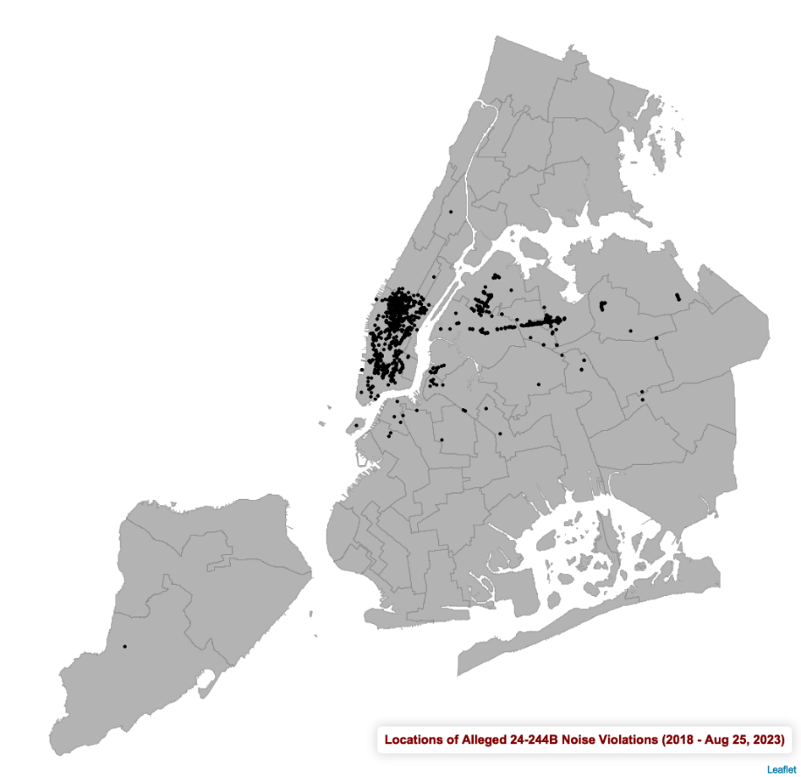
A map displaying the location of OATH summons issued for illegal use of a sound reproduction device by a commercial enterprise. The map shows that the geographic distribution of such summonses are uneven and are concentrated in lower Manhattan and in Queens, particularly along Roosevelt Avenue. (Source: NYC Open Data ‘OATH Hearing Division Case Status’)

The available OATH data does not specify whether a hearing occurred because of a noise complaint submitted by a citizen or a noise inspection conducted by DEP. However, anecdotal evidence from business owners suggests that most summonses for alleged violations of § 24-244(b) are issued on the basis of citizens’ noise complaints. Further, the number of summonses issued for violations of this section of the noise code has increased exponentially in recent years from 6 in 2021 to 2,537 in 2022. The annual sum of penalties levied against businesses for violating this section of the noise code also increased during these years, from $2,450 in 2021 to $3,134,590 in 2022. DEP has not acknowledged any change in their enforcement of § 24-244(b) since 2021. More information about the number of annual OATH hearings concerning alleged violations of § 24-244(b) is provided below in Table A: Alleged Violations of Section 24-244(b).

Table A: Alleged Violations of Section 24-244(b)
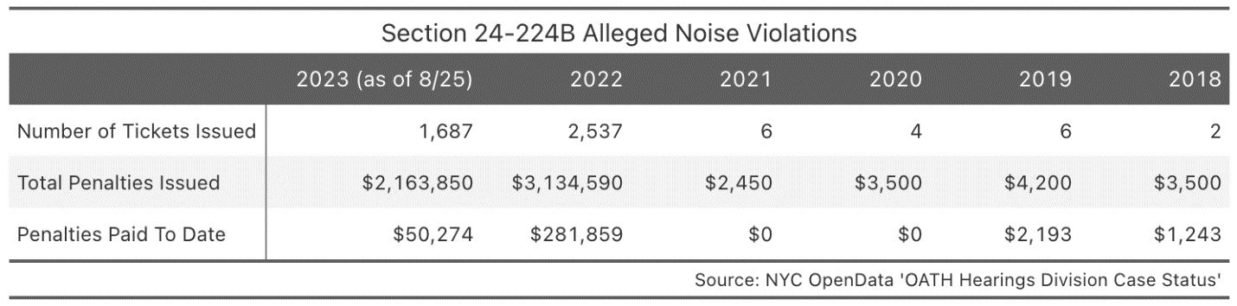
A table that displays the annual number of ECB hearings over alleged violations of § 24-244(b) from 2018 to 2023, year to date. The table shows that the number of violations and sum of penalties issued increased between 2021 and 2022.

OATH hearings for alleged violations of § 24-244(b) typically concern violations that occurred during daytime hours. From January 1, 2018 to August 25, 2023, 91% of such violations occurred between the hours of 7 a.m. and 6 p.m., and 99% of such violations occurred between the hours of 7 a.m. and 10 p.m. Further, OATH data corroborates the finding from the NBC New York I-Team that some businesses have received summonses for multiple violations of § 24-244(b) before having the opportunity to cure the source of the initial violation. In 2022, 348 businesses received summonses for alleged violations of § 24-244(b) that occurred within 30 days of each other, which is shorter than the minimum amount of time between when an alleged violation occurs and a when a summons may be issued to a business pursuant to a complaint that is filed directly unto OATH by a citizen.
On August 17, 2023, the ECB adopted a resolution to exercise the authority granted to it in the administrative code to remit the civil penalty in proceedings alleging a violation of a provision of the noise code, including § 24-244(b), upon a finding that the respondent is no longer in violation of such provision; upon such a finding, ECB will impose no penalty.

Noise Pollution from Construction:

DEP has the authority to inspect and issue violations for unreasonable construction noise and specific types of construction noise. Covered types of construction noise include noise produced by construction devices, noise produced by the transportation of construction materials, and noise produced by construction conducted pursuant to an after-hours variance, which is a permit that one must obtain in order to conduct certain construction work on a weekend or on a weekday before 7 a.m. or after 6 p.m. Specifically, construction devices may not emit either: an impulsive sound 15 decibels or louder than the ambient sound level when measured at 15 feet or from within a residential property; or a sound, other than an impulsive sound, louder than 85 decibels when measured at 50 feet. Noise from construction conducted pursuant to an after-hours variance may not exceed 7 decibels above ambient sound levels when measured within a receiving residential property with doors and windows shut, and such noise may not exceed 75 or 85 decibels when measured 50 or more feet from the source, depending on certain conditions. Violations of the noise code for after-hours construction carries a civil penalty of $875–$10,500, and violations of the code for excessive noise from construction devices carry a penalty of $440–$4,200. The exact amount of the penalties vary according to the number of offenses received and the discretion of the Administrative Law Judge who conducts the OATH hearing.
In 2022, DEP received 25,141 noise complaints concerning construction, which accounted for 52% of all noise complaints received by the Department in that year. Further, DEP issued 123 summonses for excessive noise related to after-hours construction, which accounted for about 21% of all summonses related to the noise code. These summonses for after-hours construction led to the payment of approximately $106,725.27 in civil penalties. The geographic distribution of construction noise complaints varies by City Council District. In 2022, Council Districts 10, 38 and 32 had the highest number of construction noise complaints to DEP submitted via 311.

Noise Pollution from Motor Vehicles:

In 2022, New Yorkers submitted 64,877 complaints to 311 about noise emanating from a vehicle. Some of these complaints are likely due to noise from a vehicle’s muffler or exhaust, while others may be due to music played from a speaker inside the vehicle. Certain community boards, including Manhattan 12, Bronx 5, Queens 8, and Bronx 4, receive significantly more 311 complaints concerning vehicle noise than the citywide average. The number of vehicle noise complaints follows a seasonal pattern, with the number of complaints increasing during summer months. The annual number of vehicle noise complaints has declined from its peak in 2020, although the number of vehicle noise complaints received in 2022 was still above pre-pandemic levels.
In February 2022, DEP announced a pilot noise camera program to detect vehicles with excessively loud mufflers and exhausts. The program uses a device that takes a photograph of any vehicle that creates a noise in excess of 85 decibels from over 50 feet away. According to DEP, the photograph contains no identifying information about the vehicle or its driver except for the vehicle’s license plate. On the basis of information gathered by the pilot program, DEP may cite a driver for violation of the noise code and instruct the driver to bring their vehicle to a DEP facility so that the department may inspect for a prohibited, aftermarket muffler or exhaust system. Citations issued pursuant to the pilot program result in civil penalties and do not add points to a driver’s record. The penalties for an excessively loud muffler or exhaust on a light-duty vehicle are: $150–$525 for a first offense; $300–$1,050 for a second offense; and $450–$1,575 for a third or subsequent offense. As of February 2023, the pilot consisted of one camera that has issued 71 citations and been moved across five different locations since the program’s launch.

Publication of Noise Complaint and Inspection Results:

New Yorkers may struggle to determine how their noise complaints are resolved by DEP. Such complaints may be submitted via 311 or DEP’s website, and most complaints are submitted via 311., The 311 dataset on NYC’s Open Data Portal may provide a description of a complaint’s resolution; however, such descriptions are rarely comprehensive, and may be inaccessible to those without a high degree of technical literacy. DEP does not publish how it resolves complaints submitted via the DEP website. Although DEP must report annually on its noise inspection process pursuant to Local Law 53 of 2018, the required report only includes high-level information and is unlikely to help a member of the public determine how a particular noise complaint was handled by the Department.
Between January 1, 2022 and August 25, 2023, New Yorkers submitted 80,694 noise complaints to 311 that were directed to DEP. Depending on the nature of the complaint, DEP may deploy an inspector to investigate the complaint. In most instances, DEP noise inspectors do not observe an ongoing violation of the noise code at the time of their inspection. Of the 80,694 noise complaints referenced above, 45,329 (56.2%) resulted in DEP conducting an inspection that did not identify a violation of the noise code. DEP noise inspectors are especially unlikely to observe an ongoing violation of the sections of the noise code that pertain to construction, as 72.5% of the 311 construction noise complaints directed to DEP between January 1, 2022 and August 25, 2023 resulted in an inspection that did not observe a violation of the code. The distribution of 311 noise complaints that are directed to DEP by complaint type is available in Table B: Distribution of 311 Noise Complaints Directed to DEP by Type.

Table B: Distribution of 311 Noise Complaint Directed to DEP by Type
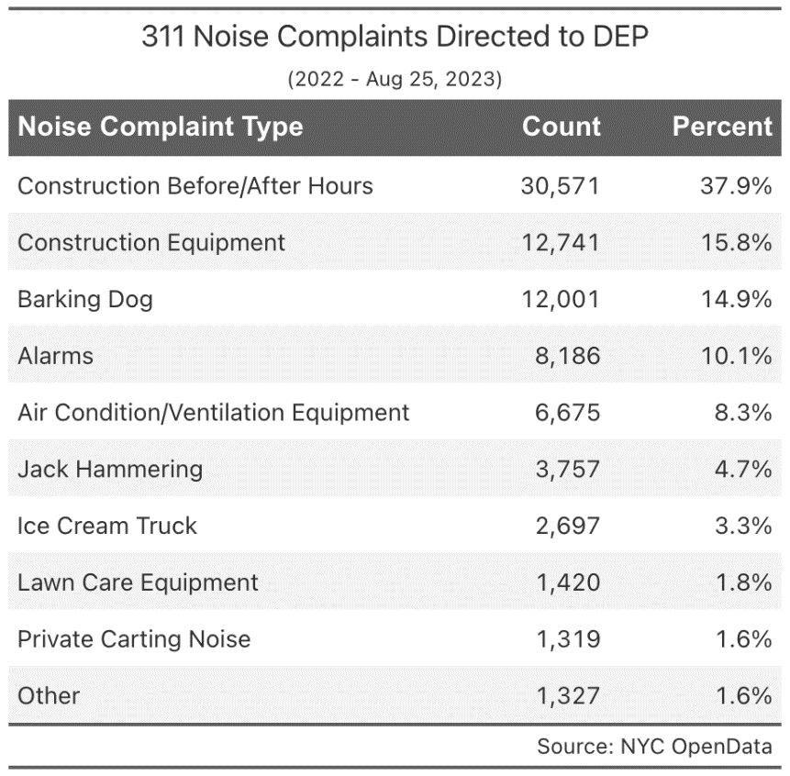
A table that provides the distribution of noise complaint types submitted to DEP via 311. The table shows that some of the most common types of complaint are: noise from construction that occurs before or after certain hours (37.9%); noise from construction equipment (15.8%); and dog barking (14.9%).

- Legislation
Int. No. 160 would amend the definition for “unreasonable noise” as applied to commercial establishments to be sound that exceeds specified prohibited noise levels. These noise levels vary by time of day, with sounds other than impulsive noise 7 dB(A) above ambient noise after 10:00 p.m. and before 7:00 a.m., or 10 dB(A) above ambient noise between 7:00 a.m. and 10:00 p.m. considered unreasonable, measured at any point within the property in question, or 15 feet or more from the source of the sound on the public right-of-way. Impulsive sound above 15 dB(A) measured at any point within the property in question, or 15 feet or more from the source of the sound on the public right-of-way, would be considered unreasonable. This bill would take effect immediately.
Int. No. 774 would require DEP to measure sound levels within dwelling units at the request of an owner, lessor, or occupant of a unit within a building located within a half-mile radius of a construction site, when the sound is caused by certain types of construction. The Department would be required to measure the sound level at any point within the unit with windows and doors that may affect the measurement closed. This bill would take effect 120 days after it becomes law.
Int. No. 775 would mandate that DEP publish the results of their noise inspections online within 24 hours after they have been completed. This bill would take effect immediately.
Int. No. 776 would require the DEP and NYPD to give a copy report created after a 311 noise complaint to anyone who requests the report and provides the 311 tracking number within 14 days of receipt of the request. The person requesting the noise inspection report would not be required to submit a Freedom of Information Law (FOIL) request to receive the report, and DEP and NYPD would not be allowed to deny or decline requests due to the lack of a FOIL request. This bill would take effect 120 days after it becomes law.
Int. No. 777 would amend the definition of “construction work” in Section 24-222 of the administrative code, which requires any person engaging in a construction project to obtain an after-hours variance when engaging in construction work before 7:00 a.m. on a weekday, after 6:00 p.m. on a weekday, or during the weekend, to include the removal of construction debris, construction related rubbish, waste, or broken down, demolished, and destroyed materials. This bill would take effect 120 days after it becomes law.
Int. No. 778 would establish a noise camera program involving the use of photo noise monitoring devices which pair decibel readers or other noise monitoring equipment with cameras capable of taking a series of photos, videos, or other recorded images to detect motor vehicles exceeding the noise limits under city law. Vehicles found to be in violation of motor vehicle sound limits would be issued a notice of violation and subject to the civil penalty as prescribed by the existing law. Photo noise monitoring devices would be required to undergo annual calibration, and notices of violation must be served to alleged violators within 14 business days for New York State residents, and 45 business days for non-residents. DEP would also be required to submit to the Mayor and the Speaker of the Council, and to post on its website, an annual report on the program including the locations of the noise cameras, the number of violations detected, and any revenue raised as a result of the program. This bill would take effect 60 days after it becomes law.
Int. No. 1194 would cap the compensation citizen complainants can receive when their complaint prompts proceedings under subdivision (b) of section 24-244 of the noise code. Compensation for proceedings brought by the Department of Environmental Protection would be capped at $5, and compensation for proceedings brought by a complainant would be capped at $10. This bill would take effect immediately.

- Conclusion

At this hearing, the Committee seeks to learn how the City should respond to citizen’s noise complaints and address various sources of noise pollution, including noise from construction and vehicles. The Committee expects to hear testimony from the public concerning the impact of noise pollution and the potential benefits of increased disclosure of noise inspection results by DEP. Furthermore, the Committee expects to hear testimony concerning the impact of citizen’s noise complaints on noise pollution, on commercial enterprises, and on DEP and ECB, which respectively process and adjudicate hearings that result from citizen’s noise complaints.
Int. No. 160

By Council Members Holden, Yeger, Ariola and Vernikov

A Local Law to amend the administrative code of the city of New York, in relation to the noise standard for commercial establishments

Be it enacted by the Council as follows:

Section 1. Subdivision b of section 24-218 of the administrative code of the city of New York, as amended by local law 72 for the year 2016, is amended to read as follows:
(b) [Unreasonable] For music originating from an interior space in connection with the operation of any commercial establishment or enterprise, unreasonable noise shall be defined as a sound that exceeds the prohibited noise levels set forth in this subdivision; and for all other sources of noise, unreasonable noise shall include but shall not be limited to sound, attributable to any device, that exceeds the [following] prohibited noise levels set forth in this subdivision:
(1) Sound, other than impulsive sound, attributable to the source, measured at a level of 7 dB(A) or more above the ambient sound level at or after 10:00 p.m. and before 7:00 a.m., as measured at any point within a receiving property or as measured at a distance of 15 feet or more from the source on a public right-of-way.
(2) Sound, other than impulsive sound, attributable to the source, measured at a level of 10 dB(A) or more above the ambient sound level at or after 7:00 a.m. and before 10:00 p.m., as measured at any point within a receiving property or as measured at a distance of 15 feet or more from the source on a public right-of-way.
(3) Impulsive sound, attributable to the source, measured at a level of 15 dB(A) or more above the ambient sound level, as measured at any point within a receiving property or as measured at a distance of 15 feet or more from the source on a public right-of-way. Impulsive sound levels shall be measured in the A-weighting network with the sound level meter set to fast response. The ambient sound level shall be taken in the A-weighting network with the sound level meter set to slow response.
§ 2. Section 24-244 of the administrative code of the city of New York is amended by adding a new subdivision c to read as follows:
(c) This section shall not apply to music originating from an interior space in connection with the operation of any commercial establishment or enterprise.
§ 3. This local law takes effect immediately.

Session 12
JSA
LS # 13
3/28/2022

Session 11
JB/MAJ
LS #116
12/19/17

Int. No. 774

By Council Members Powers, Mealy, Restler, Menin, Yeger, Joseph, Holden, Schulman, Brewer, Hudson, Bottcher, Hanks, Riley and Abreu

A Local Law to amend the administrative code of the city of New York, in relation to requiring the department of environmental protection to measure construction-related sound levels inside dwelling units upon request

Be it enacted by the Council as follows:

Section 1. Subdivision 11 of section 24-203 of the administrative code of the city of New York, as amended by local law 113 for the year 2005, is amended to read as follows:
(11) Building means a building as defined in section [27-232] 28-101.5 [of the administrative code].
§ 2. Subchapter 4 of chapter 2 of title 24 of the administrative code of the city of New York is amended by adding a new section 24-224.1 to read as follows:
§ 24-224.1 Measuring sound levels in dwelling units upon request. a. Upon the request of an owner, lessor or occupant of a residential receiving property dwelling unit within a building located within a half-mile radius of a construction site, in relation to department inspections pursuant to sections 24-223, 24-228 and 24-229, the department shall measure the sound level at any point within such dwelling unit with windows and doors that may affect the measurement closed.
b. The department may set forth the process of requesting measurement of sound levels within such dwelling units by rule.
§ 3. This local law takes effect 120 days after it becomes law, except that the department of environmental protection shall take such measures as are necessary for the implementation of this local law, including the promulgation of rules, before such date.

Session 12
NAB
LS #1237
1/25/22

Session 11
JJ
LS #6932
Int. #1043-2018

Int. No. 775

By Council Members Powers, Restler, Menin, Yeger, Joseph, Holden, Schulman, Brewer, Hudson, Bottcher, Hanks, Riley, Abreu and Louis

A Local Law to amend the administrative code of the city of New York, in relation to results of noise inspections

Be it enacted by the Council as follows:
Section 1. Section 24-207 of the administrative code of the city of New York, as amended by local law number 53 for the year 2018, is amended to read as follows:
(f) The commissioner shall publish on the city's website:
(i) the manner by which noise levels shall be measured during inspections conducted pursuant to this section and in accordance with section 24-217.1 which shall be available online[.] and
(ii) the results of each inspection, which shall be available online within 24 hours after such inspection has been completed.
[(f)](g) By no later than January 31 of each year, the department shall submit to the mayor and the council, and publicly post on its website, a report, containing, at a minimum, for the previous calendar year:
(i) the number of inspectors employed by the department;
(ii) the number of complaints regarding noise received by the department, disaggregated by the type of noise;
(iii) the number of after hours noise complaints responded to within the amount of time prescribed by rule as well as the number of duplicative after hours noise complaints;
(iv) the number of non-violation resolutions to complaints;
(v) the number of noise related violations issued;
(vi) the number of such violations which were dismissed;
(vii) the amount of civil penalties which were paid pursuant to such violations;
(viii) the number of alternative noise mitigation plans approved pursuant to section 24-221 of this code; and
(ix) the number of written stop work orders issued pursuant to section 24-223.1 of this code.
§ 2. This local law takes effect immediately.

Session 12
ARP
LS # 1241
4/14/2022

Session 11
NKA
LS # 6936
Int. No. 2180-2020

Int. No. 776

By Council Members Powers, Restler, Menin, Yeger, Joseph, Holden, Schulman, Brewer, Hudson, Bottcher, Hanks, Riley and Abreu

A Local Law to amend the administrative code of the city of New York, in relation to providing noise inspection reports

Be it enacted by the Council as follows:

Section 1. Subchapter 2 of chapter 2 of title 24 of the administrative code of the city of New York is amended by adding a new section 24-217.2 to read as follows:
§ 24-217.2 Noise inspection reports. a. Where the department generates a noise inspection report pursuant to a complaint submitted through 311, any person may request a copy of such report by providing the 311 tracking number on a form and in a manner to be specified by the department subject to subdivision d of this section.
b. Where the police department generates a noise inspection report pursuant to a complaint submitted through 311, any person may request a copy of such report by providing the 311 tracking number to the police department on a form and in a manner to be specified by such department subject to subdivision d of this section.
c. The department or police department shall provide a copy of a report requested under this section within 14 days of receiving such a request.
d. The department or police department shall not deny or decline to act on a request under this section on the ground that it fails to take the form of a freedom of information law request made pursuant to section 87 of the public officers law.
§ 2. This local law takes effect 120 days after it becomes law.

Session 12
MHL
LS #2760
01/13/22

Session 11
JSA
LS #11193
Int. 2190-2020

Int. No. 777

By Council Members Powers, Restler, Menin, Holden, Schulman, Brewer, Hudson, Bottcher, Hanks, Riley and Abreu

A Local Law to amend the administrative code of the city of New, in relation to requiring an after hours variance for the removal of construction debris

Be it enacted by the Council as follows:

Section 1. Section 24-222 of the administrative code of the city of New York, as added by local law number 113 for the year 2005, is amended to read as follows:
§ 24-222 After hours and weekend limits on construction work. Except as otherwise provided in this subchapter, it shall be unlawful to engage in or to cause or permit any person to engage in construction work other than on weekdays between the hours of 7 a.m. and 6 p.m. A person may however perform construction work in connection with the alteration or repair of an existing [one] 1- or [two family] 2-family owner-occupied dwelling classified in occupancy group J-3 or a convent or rectory on Saturdays and Sundays between the hours of 10 a.m. and 4 p.m. provided that such dwelling is located more than 300 feet from a house of worship. For the purposes of this section, the term construction work includes the removal of construction debris including rubbish, waste, discarded material, or the remains of something broken down, demolished, or destroyed.
§ 2. This local law takes effect 120 days after it becomes law.

Session 12
MHL
LS #3315
01/04/22

Session 11
AM
LS #12366

[This Page Intentionally Left Blank]

Int. No. 778

By Council Members Power, Yeger, Holden, Restler, Menin, Joseph, Schulman, Brewer, Hudson, Bottcher, Hanks, Abreu, Ung, Dinowitz, Louis and Vernikov

A Local Law to amend the administrative code of the city of New York, in relation to establishing a photo noise violation monitoring device program for motor vehicles

Be it enacted by the Council as follows:

Section 1. Subchapter 6 of chapter 2 of title 24 of the administrative code of the city of New York is amended by adding a new section 24-236.1 to read as follows:
§ 24-236.1 Owner liability for failure to comply with motor vehicle sound limits. a. Definitions. For the purposes of this section, the following terms have the following meanings:
Lessee. The term "lessee" has the meaning provided in section 239 of the vehicle and traffic law.
Lessor. The term "lessor" has the meaning provided in section 239 of the vehicle and traffic law.
Owner. The term "owner" has the meaning provided in section 239 of the vehicle and traffic law.
Photo noise violation monitoring device. The term "photo noise violation monitoring device" means one or more mobile or fixed vehicle sensors installed to work in conjunction with one or more noise measuring apparatuses such as a decibel reader which automatically produces two or more photographs, two or more microphotographs, a videotape or other recorded images of each motor vehicle at the time it is used or operated in violation of the motor vehicle noise limits prescribed in section 24-236 of this subchapter.
b. Photo noise violation monitoring device program established. 1. The department, in consultation with the police department and the department of transportation, shall establish a demonstration program of photo noise violation monitoring devices to monitor compliance with motor vehicle noise limits provided in section 24-236. Any motor vehicle found to be violating such provisions shall be issued a notice of violation and subject to the civil penalty prescribed in table I of paragraph 5 of subdivision b of section 24-257.
2. No photo noise violation monitoring device shall be used unless it has undergone an annual calibration check performed pursuant to paragraph 3 of this subdivision.
3. Each photo noise violation monitoring device shall undergo an annual calibration check performed by an independent calibration laboratory which shall issue a signed certificate of calibration. The department shall keep each such annual certificate of calibration on file until the final resolution of all cases involving a notice of violation issued during such year which were based on photographs, microphotographs, videotape or other recorded images produced by such photo noise violation monitoring device.
4. It shall be a defense to any prosecution for a violation issued pursuant to this section that such photo noise violation monitoring device was malfunctioning at the time of the alleged violation.
5. Such demonstration program shall utilize necessary technologies to ensure, to the extent practicable, that photographs, microphotographs, videotape or other recorded images produced by such photo noise violation monitoring devices shall not include images that identify the driver, the passengers, or the contents of the motor vehicle. Provided, however, that no notice of violation issued pursuant to this section shall be dismissed solely because such photograph, microphotograph, videotape or other recorded image allows for the identification of the driver, the passengers, or the contents of motor vehicles where the department shows that it made reasonable efforts to comply with the provisions of this paragraph in such case.
6. Any photograph, microphotograph, videotape or other recorded image from a photo noise violation monitoring device shall be for the exclusive use of the city for the purpose of the adjudication of liability imposed pursuant to subchapter 8 of this chapter and of the motor vehicle owner receiving a notice of violation, and shall be destroyed by the department upon the final resolution of the notice of violation to which such photograph, microphotograph, videotape or other recorded image relates, or one year following the date of issuance of such notice of violation, whichever is later. Notwithstanding the provisions of any other law, rule or regulation to the contrary, a photograph, microphotograph, videotape or other recorded image from a photo noise violation monitoring device shall not be available to the public, nor subject to civil or criminal process or discovery, nor used by any court or administrative or adjudicatory body in any action or proceeding therein except that which is necessary for the adjudication of a notice of violation, and no public entity or employee, officer or agent thereof shall disclose such information, except that a photograph, microphotograph, videotape or other recorded image from such devices:
(a) Shall be available for inspection and copying and use by the motor vehicle owner for so long as such photograph, microphotograph, videotape or other recorded image is required to be maintained or is maintained by such public entity, employee, officer or agent;
(b) Shall be furnished for use in a criminal action or proceeding when described in a search warrant issued by a court authorized to issue such a search warrant pursuant to article 690 of the criminal procedure law or a federal court authorized to issue such a search warrant under federal law, where such search warrant states that there is reasonable cause to believe such information constitutes evidence of, or tends to demonstrate that, a misdemeanor or felony offense was committed in this state or another state, or that a particular person participated in the commission of a misdemeanor or felony offense in this state or another state, provided, however, that if such offense was against the laws of another state, the court shall only issue a warrant if the conduct comprising such offense would, if occurring in this state, constitute a misdemeanor or felony against the laws of this state; and
(c) Shall be furnished for use in a criminal action or proceeding in response to a subpoena duces tecum signed by a judge of competent jurisdiction and issued pursuant to article 610 of the criminal procedure law or a judge or magistrate of a federal court authorized to issue such a subpoena duces tecum under federal law, where the judge finds and the subpoena states that there is reasonable cause to believe such information is relevant and material to the prosecution, or the defense, or the investigation by an authorized law enforcement official, of the alleged commission of a misdemeanor or felony in this state or another state, provided, however, that if such offense was against the laws of another state, such judge or magistrate shall only issue such subpoena if the conduct comprising such offense would, if occurring in this state, constitute a misdemeanor or felony in this state.
7. A certificate, sworn to or affirmed by a technician employed by the city, or a facsimile thereof, based upon inspection of photographs, microphotographs, videotapes or other recorded images produced by a photo noise violation monitoring device, shall be prima facie evidence of the facts contained therein. Any photographs, microphotographs, videotapes or other recorded images evidencing such a violation shall include at least two date and time stamped images of the rear of the motor vehicle that include the same stationary object near the motor vehicle and shall be available for inspection reasonably in advance of and at any proceeding to adjudicate the liability for such violation pursuant to subchapter 8 of this chapter.
8. A notice of violation shall be sent by first class mail to each person alleged to be liable as a motor vehicle owner for a violation of section 24-236, within 14 business days if such owner is a resident of this state and within 45 business days if such owner is a non-resident. Personal delivery on the owner shall not be required. A manual or automatic record of mailing prepared in the ordinary course of business shall be prima facie evidence of the facts contained therein.
9. A notice of violation shall contain the name and address of the person alleged to be liable as a motor vehicle owner for a violation of section 24-236, as documented by a photo noise violation monitoring device, the registration number of the motor vehicle involved in such violation, the location where such violation took place, the date and time of such violation, the identification number of the camera which recorded the violation or other document locator number, at least two date and time stamped images of the rear of the motor vehicle that include the same stationary object near the motor vehicle, and the certificate charging the violation, which shall be a statement within the notice of violation that an owner violated section 24-236 and is liable for penalties in accordance with this section.
10. The notice of violation shall contain information advising the person charged of the manner and the time in which the alleged violation may be contested in a hearing pursuant to section 24-263.
11. If a motor vehicle owner receives a notice of violation pursuant to this section for any time period during which the motor vehicle or the number plate or plates of such motor vehicle was reported to the police department as having been stolen, it shall be a valid defense to an allegation of liability for a violation of section 24-236 that the motor vehicle or the number plate or plates of such motor vehicle had been reported to the police as stolen prior to the time the violation occurred and had not been recovered by such time. For purposes of asserting the defense provided by this paragraph, it shall be sufficient that a certified copy of the police report on the stolen motor vehicle or number plate or plates of such motor vehicle be sent by first class mail to the body adjudicating the proceeding.
12. A motor vehicle owner who is a lessor of a motor vehicle to which a notice of violation is issued shall not be liable for a violation of section 24-236, provided that:
(a) Prior to the violation, the lessor has filed in accordance with the provisions of section 239 of the vehicle and traffic law; and
(b) Within 37 days after receiving notice of the date and time of the violation, together with the other information contained in the notice of violation, the lessor submits to the body adjudicating the proceeding the correct name and address of the lessee of the motor vehicle identified in the notice of violation at the time of such violation, together with such additional information contained in the rental, lease, or other contract document, as may be reasonably required by such adjudicating body pursuant to regulations promulgated for such purpose.
13. Failure to comply with the provisions of paragraph 12 of this subdivision shall render the motor vehicle owner liable for the penalty prescribed in table I of paragraph 5 of subdivision b of section 24-257.
14. Where the lessor complies with the provisions of paragraph 12 of this subdivision, the lessee of such vehicle on the date of such violation shall be deemed to be the owner of such vehicle for purposes of this section, shall be subject to liability for such violation pursuant to this section and shall be sent a notice of violation pursuant to paragraph 10 of this section.
15. If the motor vehicle owner liable for a violation of section 24-236 pursuant to this section was not the operator of the motor vehicle at the time of the violation, the owner may maintain an action for indemnification against the operator.
16. Notwithstanding any other provision of this section, no owner of a motor vehicle shall be subject to a monetary fine imposed pursuant to table I of paragraph 5 of subdivision b of section 24-257 if the operator of such motor vehicle was operating such motor vehicle without the consent of the owner at the time of the violation. For purposes of this paragraph there shall be a presumption that the operator of such motor vehicle was operating the motor vehicle with the consent of the owner at the time of such violation.
c. Placement of devices. The department shall select the locations for each photo noise violation monitoring device based on motor vehicle noise complaint data reported by the 311 customer service center within 30 days of the effective date of this law. To the extent practicable, the department shall take into consideration requests made by elected officials or community boards for placement of photo noise violation monitoring devices. Upon receipt of a request by an elected official or a community board for installation of a photo noise violation monitoring device at a particular location, the department shall assess the request and respond within 30 days with a determination as to whether the location requested is appropriate for inclusion in the program.
d. Warning signs. The department shall install signs giving notice to approaching motor vehicle operators where a photo noise violation monitoring device is in use, provided that the department shall not use dynamic display signs to display real time decibel readings of motor vehicles unless it determines that the use of such signs will be beneficial at specific locations.
e. Multiple technologies. The department shall trial different sound detection technologies within the photo noise violation monitoring devices as part of this program, including but not limited to:
1. Acoustic monitoring;
2. Beamforming devices; and
3. Artificial intelligence.
f. Reporting. No later than December 1, 2021, and annually on December 1 thereafter in each succeeding year in which the demonstration program is operable, the commissioner shall submit to the mayor and the speaker of the council, and post on the department’s website, a report on the use of photo noise violation monitoring devices. Such report shall include:
1. The locations where and dates when photo noise violation monitoring devices were used;
2. The total number of violations recorded by photo noise violation monitoring devices on a daily, weekly and monthly basis;
3. The total number of notices of violation issued for violations recorded by such devices;
4. The number of fines and total amount of fines paid after the first notice of violation issued for violations recorded by such devices;
5. The number of violations adjudicated in accordance with subchapter 8 of this chapter and the results of such adjudications disaggregated by dispositions made for violations recorded by such devices;
6. The total amount of revenue realized by the city in connection with the program;
7. Any expenses incurred by the city in connection with the program;
8. A cost-benefit analysis of the different types of technology trialed pursuant to subdivision e of this section; and
9. A description of the quality of the adjudication process and its results.
§ 2. This local law takes effect 60 days after it becomes law, except that the administering agency shall take such measures as are necessary for the implementation of this local law, including the promulgation of rules, before such date.

Session 12
XC
LS #8469
4/12/22 2:30pm

Session 11
NAW
LS #9201
8/5/2021 9:44 AM

[This Page Intentionally Left Blank]
Int. No. 1194

By Council Member Gennaro

A Local Law to amend the administrative code of the city of New York, in relation to citizen noise complaints

Be it enacted by the Council as follows:

Section 1. Subdivisions (d) and (e) of section 24-261 of the administrative code of the city of New York are amended to read as follows:
(d) In any proceeding brought by the department after receiving a complaint pursuant to subdivision (a) of this section, the board shall award the complainant, out of the proceeds collected, fair and reasonable compensation, which shall not exceed [twenty-five] 25 percent of the proceeds collected, for disclosure of information or evidence not in the possession of the department, which leads to the imposition of the civil penalty; provided that for any proceeding brought by the department after receiving a complaint pursuant to subdivision (b) of section 24-244, the board shall award the complainant, out of the proceeds collected, $5 as compensation.
(e) In any proceeding brought by a complainant, the board shall award, out of the proceeds collected, [fifty] 50 percent of any civil penalty as fair and reasonable compensation to such person; provided that for any proceeding brought by a complainant pursuant to subdivision (b) of section 24-244, the board shall award, out of the proceeds collected, $10 as compensation to such person.
§ 2. This local law takes effect immediately

CCM
LS #13915
8/29/2023

Adm. Code § 24-261(a).
Adm. Code § 24-261(b).
Id.
“About ECB,” Office of Administrative Trials and Hearings, https://www.nyc.gov/site/oath/hearings/about-ecb.page.
Adm. Code § 24-261(d)–(e)
Adm. Code § 24-257, Table I.
Adm. Code § 24-257(b)(5).
Chris Glorioso, “I-Team: Thousands of citizen-issued noise violations prompt NYC reform,” NBC New York, 6/29/2023, https://www.nbcnewyork.com/news/local/i-team-thousands-of-citizen-issued-noise-violations-prompt-nyc-reform/4462207/.
Chris Glorioso, Eduardo González Quintero, “I-Team: How one NYC resident makes a living writing thousands of noise tickets,” NBC New York, 6/23/2023, https://www.nbcnewyork.com/news/local/i-team-how-one-nyc-resident-makes-a-living-writing-thousands-of-noise-tickets/4448563/
Id.
Id.
Id.
Lisa Fickensher. NYC Residents make money off noise complaints targeting bars, restaurants. New York Post, 7/4/2023. https://nypost.com/2023/07/04/nyc-residents-make-money-off-noise-complaints-targeting-bars-restaurants/
Id at 6.
Id.
“OATH Hearing Division Case Status,” NYC Open Data Portal, 9/13/2023, https://data.cityofnewyork.us/City-Government/OATH-Hearings-Division-Case-Status/jz4z-kudi.
Id.
Chris Glorioso, “I-Team: Thousands of citizen-issued noise violations prompt NYC reform,” Id.
Id.
Id.
Id.
Id.
“Resolution Respecting The Environmental Control Board’s Exercise Of Its Authority To Remit A Civil Penalty In Code §24-244 (b) Matters,” Environmental Control Board, 8/17/2023, https://www.nyc.gov/assets/oath/downloads/pdf/resolution-re-board-remissn-of-Penalty-in-Citizen-Complainant-Noise-Summonses.pdf
Adm. Code § 24-223
Adm. Code § 24-228
Adm. Code § 24-223
Adm. Code § 24-257
“Local Law 53 of 2018 noise inspections and complaints report for calendar year 2022,” NYC Department of Environmental Protection, 3/10/2023, https://a860-gpp.nyc.gov/concern/nyc_government_publications/r494vp441.
Id.
Id.
“311 Service Requests from 2010 to Present,” NYC Open Data Portal, 9/6/2023, https://data.cityofnewyork.us/Social-Services/311-Service-Requests-from-2010-to-Present/erm2-nwe9.
Id.
“311 Service Requests from 2010 to Present,” NYC Open Data Portal, 9/6/2023, https://data.cityofnewyork.us/stories/s/7ahn-ypff.
“Roadside Sound Meter Camera that is Activated by Loud Mufflers Now Sending Notices to Vehicle Owners,” NYC Department of Environmental Protection, 2/22/2022, https://www.nyc.gov/site/dep/news/22-005/roadside-sound-meter-camera-is-activated-loud-mufflers-now-sending-notices-vehicle.
Id.
Id.
Adm. Code § 24-257
Dan Rosenbaum, “’Noise cameras’ aim to address vehicle nuisance complaints on city streets,” Smart Cities Dive, 2/13/2023, https://www.smartcitiesdive.com/news/noise-cameras-address-vehicle-nuisance-complaints-city-streets/642575/
“Noise Code,” NYC Department of Environmental Protection, https://www.nyc.gov/site/dep/environment/noise-code.page.
“311 Service Requests from 2010 to Present,” NYC Open Data Portal, 9/6/2023, https://data.cityofnewyork.us/stories/s/7ahn-ypff.
“Local Laws for 2018,” Legistar, https://legistar.council.nyc.gov/LegislationDetail.aspx?ID=3346815&GUID=856A05D9-2437-479C-91EC-217DA35B915D&Options=ID|Text|&Search=
“311 Service Requests from 2010 to Present,” NYC Open Data Portal, 9/6/2023, https://data.cityofnewyork.us/stories/s/7ahn-ypff.
Id.
Id.

