THE COUNCIL OF THE CITY OF NEW YORK
RESOLUTION NO. 2106

Resolution approving the decision of the City Planning Commission on Application No. N 140064 ZRK, for an amendment of the Zoning Resolution of the City of New York, concerning Section 113-00 (Special Coney Island District), 131-60 (Special Permit for Auditoriums), Appendix A (Coney Island District Plan) relating to the development of auditorium use in Community District 13, Borough of Brooklyn (L.U. No. 995).

By Council Members Comrie and Weprin

WHEREAS, the City Planning Commission filed with the Council on December 5, 2013 its decision dated December 4, 2013 (the "Decision"), pursuant to Section 201 of the New York City Charter, regarding an application submitted by the Department of City Planning for an amendment of the text of the Zoning Resolution of the City of New York, concerning Section 113-00 (Special Coney Island District), 131-60 (Special Permit for Auditoriums), Appendix A (Coney Island District Plan) relating to the development of auditorium use, (Application No. N 140064 ZRK), Community District 13, Borough of Brooklyn (the "Application");

WHEREAS, the Application is related to applications C 140063 ZSK (L.U. No. 994), a special permit pursuant to Section 131-60 to allow an open-air auditorium with a maximum of 5,099 seats for a term no greater than ten (10) years; C 140065 ZMK (L.U. No. 996), a proposed amendment to the Zoning Map, Section No. 28d, establishing a Special Coney Island District (CI) generally bounded by West 22nd Street, Riegelmann Boardwalk, West 23rd Street and a line 245 feet northerly of the boardwalk; C 140066 PPK (L.U. No. 997), a proposed Disposition of City Owned property to the Economic Development Corporation of the following lots on Block 7071: 27, 28, 30, 32, 34 76 79 81 130, 142, 226, and 231; C 140067 PQK (L.U. No. 998), a proposed acquisition of property by the City to allow the City to purchase the following lots on Block 7071, Lots 27, 28, 30, 32, 34 76 79 81 130, 226, and 231; and M 090107(B) MMK (L.U. No. 999), a proposed administrative modification to City Map Amendments approved by the City Planning Commission on December 3, 2010;

WHEREAS, the Decision is subject to review and action by the Council pursuant to Section 197-d(b)(1) of the City Charter;
WHEREAS, the City Planning Commission has made the findings required pursuant to Section 131-60 of the Zoning Resolution of the City of New York;

WHEREAS, upon due notice, the Council held a public hearing on the Decision and Application on December 17, 2013;

WHEREAS, the Council has considered the land use implications and other policy issues relating to the Decision and Application; and

WHEREAS, the Council has considered the relevant environmental issues and the Final Environmental Impact Statement (“FEIS”) for which a Notice of Completion was issued on October 25, 2013 (CEQR No. 13DME014K) and the CEQR Technical Memorandum dated December 18, 2013 (the “CEQR Technical Memorandum”).

RESOLVED:

Having considered the FEIS and the CEQR Technical Memorandum, with respect to the Decision and Application, the Council finds that:

- The FEIS meets the requirements of 6 N.Y.C.R.R. Part 617;

- Consistent with social, economic, and other essential considerations, from among the reasonable alternatives thereto, the Proposed Action adopted herein, as modified, is one that avoids or minimizes adverse environmental impacts to the maximum extent practicable; and

- The adverse environmental impacts disclosed in the FEIS and the CEQR Technical Memorandum will be minimized or avoided to the maximum extent practicable by incorporating as conditions to this approval, as modified, in accordance with environmental commitment letters, dated December 3, 2013, from the Deputy Mayor for Economic Development and November 26, 2013, from Coney Island Holdings, LLC, those, those project components related to the environment and mitigation measures that were identified as practicable; and

(4) The Decision together with the FEIS and the CEQR Technical Memorandum constitute the written statement of facts, and of social, economic and other factors and standards, that form the basis of the decision, pursuant to 6 N.Y.C.R.R. §617.11(d).

Pursuant to Sections 197-d and 200 of the City Charter and on the basis of the Decision and Application, and based on the environmental determination and consideration described in this report, N 140064 ZRK, incorporated by reference herein, the Council approves the Decision.

The Zoning Resolution of the City of New York, effective as of December 15, 1961, and as subsequently amended, is further amended as follows:

Matter in underline is new, to be added;
Matter in strikeout is old, to be deleted;
Matter within # # is defined in Section 12-10;
* * * indicates where unchanged text appears in the Zoning Resolution

Article XIII: Special Purpose Districts

* * *
Chapter 1
Special Coney Island District

* * *
131-60
Special Permit for Auditoriums

The special permit set forth in this Section is established to allow outdoor entertainment #uses# on a limited-term basis in a unique beachfront location within the #Special Coney Island District#. The #development# of such a #use# on a temporary basis pursuant to this special permit provides for the opportunity for a valuable public amenity to exist within an area that, while approved for future #residential development# pursuant to the #Special Coney Island District# plan, is currently underutilized and does not exhibit the characteristics of a well-developed #residential# neighborhood. Any special permit granted under this Section shall be subject to a term of years, in order to ensure that such #use# is consistent with and does not impede the goal of long-term revitalization of the surrounding area, pursuant to the #Special Coney Island District# plan.

In the Coney West Subdistrict, for Parcels B and G, the City Planning Commission may approve, by special permit, open-air auditoriums with greater than 2,000 seats, for a term no greater than ten years from the date a certificate of occupancy, including a temporary certificate of occupancy, has been issued, provided that the proposed auditorium meets the conditions of paragraph (a) and the findings of paragraph (b) of this Section, in addition to the #sign# and parking provisions of paragraphs (c) and (d) of this Section, respectively.

For any application for such special permit, the applicant shall provide plans to the Commission including but not limited to a site plan, signage plan, parking and loading plan, lighting plan and operations plan (the “Proposed Plans”).

(a) The Commission may permit open-air auditoriums with a maximum of 5,100 seats, provided the Proposed Plans demonstrate that:

- at all times when the Riegelmann Boardwalk is open to the public, all publically accessible space, as shown on the proposed plans, will remain accessible to the public, except that access may be restricted as necessary during scheduled events, for the setup and takedown for such events, and in connection with maintenance activities; any barriers erected for the purpose of restricting access or visibility during such events shall be completely removed at all other times;

- the height of all structures, temporary or fixed, does not exceed 70 feet in height, as measured from the level of the Riegelmann Boardwalk;

- any roof or structural canopy above the open-air auditorium seating area will be removed prior to the month of November and shall remain removed during the entire off-season period between November through April, as well as in advance of severe weather events;

(4) the signage plan and parking and loading plan comply with the provisions of paragraphs (c) and (d) of this Section, respectively; and

(5) the City and applicant will enter into an agreement under which Parcel G will be returned to the City as of the expiration of the term of the special permit in a condition set forth in such agreement appropriate for #use# as a #public park#.

(b) In granting such permit, the Commission shall find that:

(1) such open-air auditorium will not unduly impair the essential character or the future #use# or #development# of the surrounding area, pursuant to the goals and objectives of the #Special Coney Island District# plan;

(2) the outdoor lighting for such open-air auditorium is located and arranged so as to minimize any negative effects on nearby #residences# and #community facilities#, and that Proposed Plans include noise attenuation features and measures which serve to reduce the effect of noise from the open-air auditorium on the surrounding area, including nearby #residences# and #community facilities#;

(3) the construction of a stage as part of any #building# on Parcel B, for the purpose of accommodating an open-air auditorium #use#, will:

(i) enable the stage area to be closed to the outdoor portion of the open-air auditorium during the off-season when the open-air auditorium is not in use, so as to be operated for indoor entertainment #uses# with an eating and drinking establishment or other #use# permitted on Parcel B; and

(ii) allow for such #building# to be operated subsequent to the expiration of the special permit for #uses# permitted on Parcel B, such as eating or drinking establishments with entertainment;

(4) appropriate visual and pedestrian connections are maintained in the general area of the former street bed from the termination of West 22st Street to the Riegelmann Boardwalk;

(5) the portions of the site not dedicated to stage area or event seating are so designed to serve as a full time park-like resource for the public, and the portions of the site designed for open-air auditorium #use# serve as a high-quality open space resource when not in auditorium use;

(6) any roof or structural canopy above the open-air auditorium seating area will be visually unobtrusive, and maximize openness and visibility between the site and the Riegelmann Boardwalk,

(7) the operations plan, which shall include a protocol for queuing for concert-goers, demonstrates that there would be no interference with the public use and enjoyment of adjacent public facilities; and

(8) the site plan, signage plan and lighting plan incorporate good design, effectively integrate the site with surrounding streets and the Riegelmann Boardwalk, and are consistent with the purposes of the #Special Coney Island District#.

(c) The Commission may, through approval of the Proposed Plans, permit #signs# notwithstanding the applicable #sign# regulations, except that #flashing signs# shall not be permitted and only #advertising signs# that are oriented toward the interior of the open-air amphitheater and not visible from the Riegelmann Boardwalk or other public area shall be permitted.

In order to permit such #signs#, the Commission shall find that proposed signage is appropriate in connection with the permitted open-air auditorium #use#, is not unduly concentrated within one portion of the site, and will not negatively affect the surrounding area.

(d) The Commission may, through approval of the Proposed Plans, reduce or waive required parking or loading requirements, provided the Commission finds that the open-air auditorium will be adequately served by a combination of surrounding public parking facilities and mass transit. In addition, the Commission shall find that the proposed loading facilities on the site are located so as not to adversely affect the movement of pedestrians or vehicles on the #streets# surrounding the auditorium.

The City Planning Commission may prescribe appropriate conditions and safeguards to minimize adverse effects on the character of the surrounding area. Such conditions and safeguards may include, but are not limited to restrictions on signage or requirements for soundproofing of auditoriums, shielding of floodlights or screening of open #uses#.

Upon the first issuance of this permit for an open-air auditorium, the effective period of the permit shall be ten years from the date a certificate of occupancy, including a temporary certificate of occupancy, has been issued. To establish the term of years for subsequent applications for this special permit, the Commission shall, in determining whether the finding of paragraph (b)(1) of this Section is met, take into account the existing character of the surrounding area, as well as #residential# and #community facility development# proposed or under construction on surrounding #blocks#, and shall also consider whether continuation of such auditorium #use# within a proposed term of years would be compatible with or may hinder achievement of the goals and objectives of the #Special Coney Island District# plan. Subsequent applications for this special permit shall be filed no later than one year prior to expiration of the term of the permit then in effect.

Appendix A
Coney Island District Plan

Map 1 - Special Coney Island District and Subdistricts

[MAP TO BE DELETED]

[MAP TO BE INSERTED]

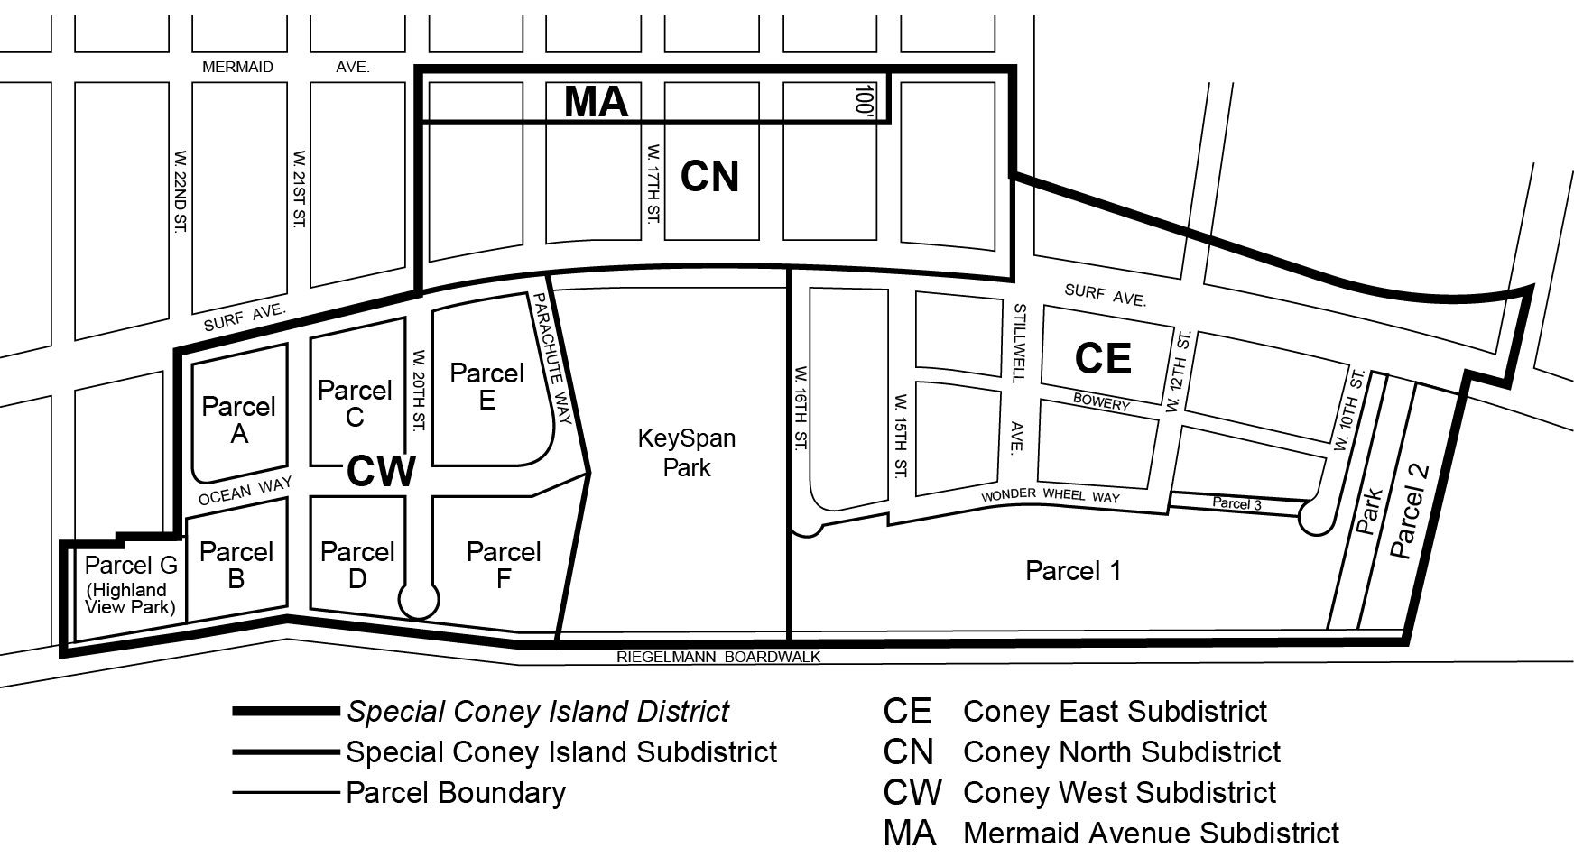

Map 2 - Mandatory Ground Floor Use Requirements

[EXISTING MAP TO BE UPDATED WITH REVISED DISTRICT BOUNDARY]

* * *

Map 4 - Street Wall Location

[EXISTING MAP TO BE UPDATED WITH REVISED DISTRICT BOUNDARY]

Map 5 - Minimum and Maximum Base Heights

[EXISTING MAP TO BE UPDATED WITH REVISED DISTRICT BOUNDARY]

Map 6 - Coney West Subdistrict Transition Heights

[MAP TO BE DELETED]

[MAP TO BE INSERTED]

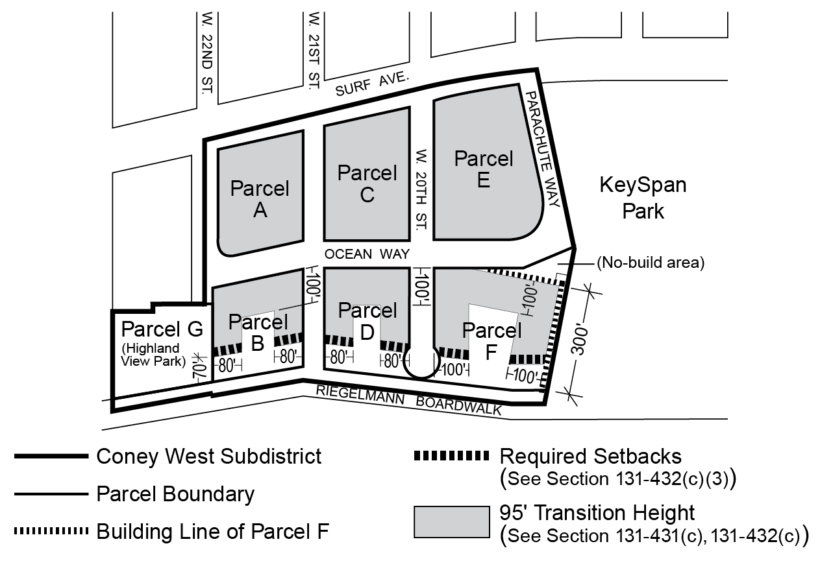

EXISTING
(TO BE DELETED)
Map 4 (12/21/09)
Portion of Community District 1, Brooklyn
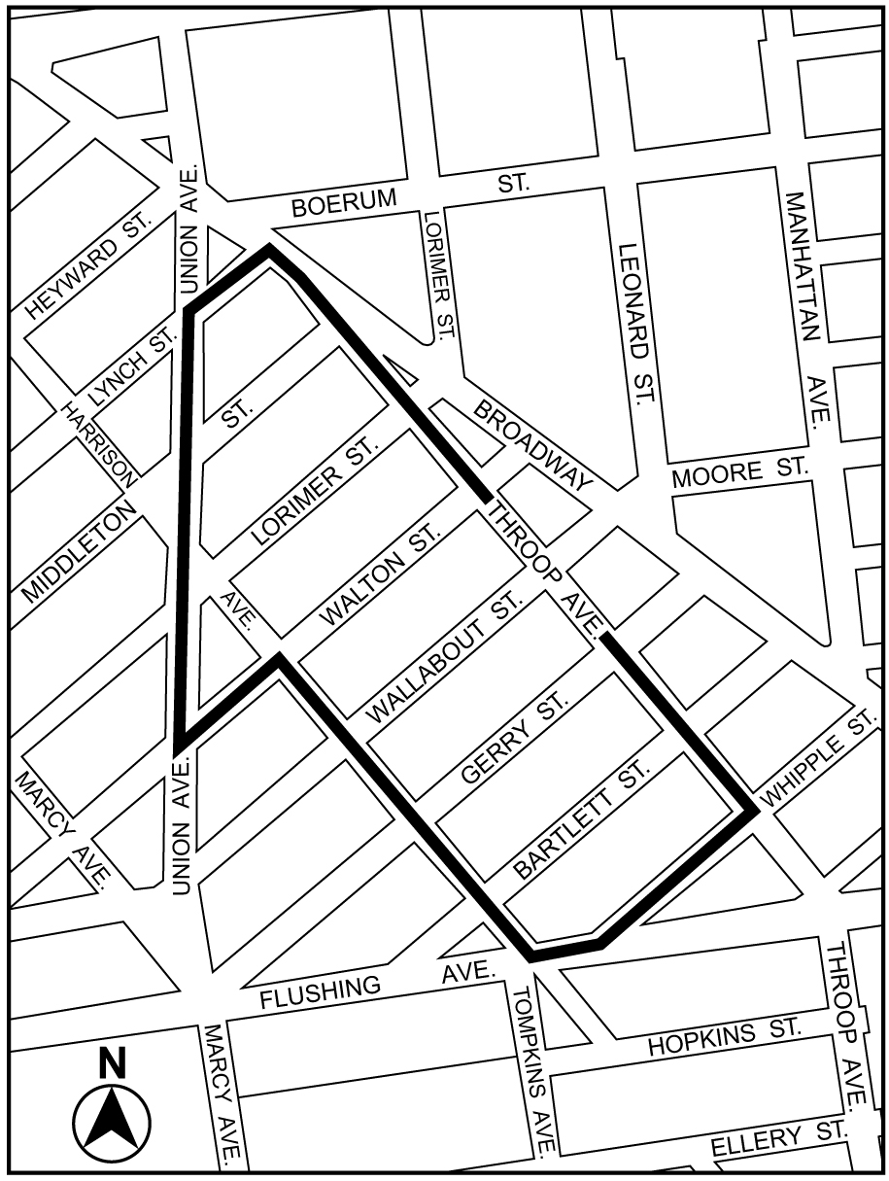

PROPOSED
(TO REPLACE EXISTING)

Map 4 (xx/xx/xx)
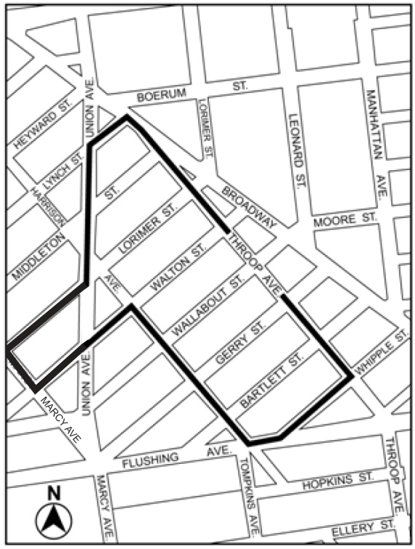

Portion of Community District 1, Brooklyn

* * *

Adopted.
Office of the City Clerk, }
The City of New York, } ss.:

I hereby certify that the foregoing is a true copy of a Resolution passed by The Council of The City of New York on December 19, 2013, on file in this office.

.....…….........................................
City Clerk, Clerk of The Council

