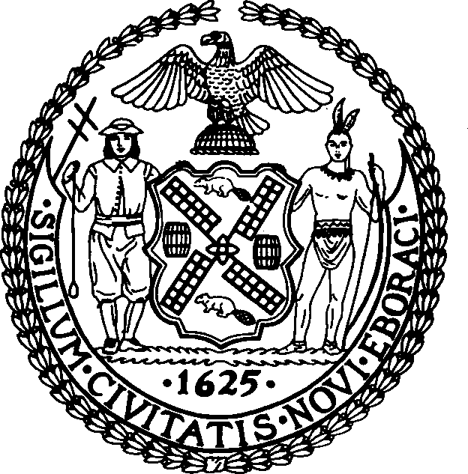

THE COUNCIL
THE CITY OF NEW YORK FINANCE DIVISION
250 BROADWAY, 15TH FLOOR
NEW YORK, N.Y. 10007-2594 (212) 788-6921

TO: Honorable Corey Johnson Speaker

Honorable Daniel Dromm
Chair, Finance Committee

FROM: Latonia McKinney, Director, Finance Division
Raymond Majewski, Deputy Director/Chief Economist, Finance Division
Rebecca Chasan, Senior Counsel
Paul Sturm, Supervising Economist
Nashia Roman, Economist

DATE: December 15, 2021

SUBJECT: A Budget Modification (MN-2) for Fiscal 2022 that will appropriate $895.0 million in new revenues.

INITIATION: By letter dated December 13, 2021, the Director of the Office of Management and Budget submitted to the Council, pursuant to section 107(e) of the New York City Charter, a request to appropriate $895.0 million in new revenues. These new revenues with an additional $69.7 million from General Reserve will be used for prepayments of $964.7 million to increase the Budget Stabilization Account.

BACKGROUND: This modification (MN-2) seeks to recognize $895.0 million in new revenues, implementing changes reflected since the June 2022 Adopted Budget. These funds will add $964.7 million to the Budget Stabilization Account to prepay debt service for Fiscal 2023 expenses, and downwardly adjust the General Reserve by $69.7 million.

FISCAL IMPACT: This modification represents a net increase in the Fiscal 2022 budget of $895.0 million.

