THE COUNCIL OF THE CITY OF NEW YORK
RESOLUTION NO. 1154

Resolution approving with modifications the decision of the City Planning Commission on Application No. N 160166 ZRM, for an amendment of the Zoning Resolution of the City of New York, relating to Article IX, Chapter I (Special Lower Manhattan District) and related sections concerning arcades, plazas, and urban plazas in Community District 1, Borough of Manhattan (L.U. No. 361).

By Council Members Greenfield and Richards

WHEREAS, the City Planning Commission filed with the Council on April 27, 2016 its decision dated April 25, 2016 (the "Decision"), pursuant to Section 201 of the New York City Charter, regarding an application submitted by the Alliance for Downtown New York, the New York City Economic Development Corporation, and the New York City Department of City Planning, for an amendment of the text of the Zoning Resolution of the City of New York, to modify the Special Lower Manhattan District, existing Section 91-80 of the Zoning Resolution (PUBLIC ACCESS AREAS) and related sections, to allow horizontal enlargements within existing arcades and the improvement of existing plazas and urban plazas by Chairman certification and City Planning Commission authorization; allow public events and the placement of publicly-accessible tables and chairs within arcades, plazas, and urban plazas as-of-right; and continue to allow cafes within arcades by Chairman certification. The text amendment would apply to all existing arcades, plazas, and urban plazas along and near Water Street in Lower Manhattan, (Application No. N 160166 ZRM), Community District 1, Borough of Manhattan (the "Application");

WHEREAS, the Decision is subject to review and action by the Council pursuant to Section 197-d(b)(1) of the City Charter;
WHEREAS, upon due notice, the Council held a public hearing on the Decision and Application on May 17, 2016;

WHEREAS, the Council has considered the land use implications and other policy issues relating to the Decision and Application; and

WHEREAS, the Council has considered the relevant environmental issues, including the revised negative declaration (CEQR No. 16DCP084M) issued on April 25, 2016, which reflects the modified application (the “Revised Negative Declaration”);

RESOLVED:

The Council finds that the action described herein will have no significant impact on the environment as set forth in the Revised Negative Declaration.
Pursuant to Sections 197-d and 200 of the City Charter and on the basis of the Decision and Application, and based on the environmental determination and consideration described in the report, N 160166 ZRM, incorporated by reference herein, the Council approves the Decision with the following modifications:

The Zoning Resolution of the City of New York, effective as of December 15, 1961, and as subsequently amended, is further amended as follows:

Matter in underline is new, to be added;
Matter in strikeout is to be deleted;
Matter in bold double-strikeout is old, deleted by the Council;
Matter in bold double-underline is new, added by the Council;
Matter within # # is defined in Section 12-10;
* * * indicates where unchanged text appears in the Zoning Resolution

* * *

Article III - Commercial District Regulations

Chapter 7
Special Urban Design Regulations

* * *
37-625
Design changes

Except as otherwise provided in Sections 74-41 (Arenas, Auditoriums, Stadiums or Trade Expositions), 91-83 (Retail Uses Within Existing Arcades) and 91-841 (Authorization for retail uses within existing arcades), design changes to existing #plazas#, #residential plazas# or #urban plazas# may be made only upon certification by the Chairperson of the City Planning Commission that such changes would result in a #plaza#, #residential plaza# or #urban plaza# that is in greater accordance with the standards set forth in Section 37-70 (PUBLIC PLAZAS), inclusive. The provisions of Section 37-78 (Compliance), other than paragraph (e) (Special regulations for an #urban plaza# in the #Special Lower Manhattan District#), shall be made applicable to such #plaza#, #residential plaza# or #urban plaza#.

* * *

37-73
Kiosks and Open Air Cafes

Kiosks and open air cafes may be placed within a #publicly accessible open area# upon certification, pursuant to this Section. Such features shall be treated as permitted obstructions. Only #uses# permitted by the applicable district regulations may occupy #publicly accessible open areas# or front on #publicly accessible open areas#.

* * *

(c) Certification

Kiosks and open air cafes may be placed within the area of a #publicly accessible open area# upon certification by the Chairperson of the City Planning Commission to the Commissioner of Buildings, that:

(1) such #use# promotes public use and enjoyment of the #publicly accessible open area#;

(2) such #use# complements desirable #uses# in the surrounding area;

(3) the owner of such #use# or the #building# owner shall be responsible for the maintenance of such kiosk or open air cafe, which shall be located within areas designated on building plans as available for occupancy by such #uses# and no encroachment by a kiosk or open air cafe outside an area so designated shall be permitted;

(4) such #use# does not adversely impact visual and physical access to and throughout the #publicly accessible open area#;

(5) such #use#, when located within a #public plaza#, is provided in accordance with all the requirements set forth in this Section;

(6) for kiosks and open air cafes located within an existing #publicly accessible open area#, such #use# is proposed as part of a general improvement of the #publicly accessible open area# where necessary, including as much landscaping and public seating as is feasible, in accordance with the standards for #public plazas#;

(7) a #sign# shall be provided in public view within the cafe area indicating the days and hours of operation of such cafe; and

(8) for kiosks that are in operation less than 225 days per year, an off-season plan has been submitted to the Chairperson showing that such kiosks will be completely removed from the #publicly accessible open area# when not in operation, that the area previously occupied by the kiosk is returned to public use and such area is in compliance with the applicable #publicly accessible open area# design standards.

* * *

(d) Process

An application for certification shall be filed with the Chairperson of the City Planning Commission, and the Chairperson shall furnish a copy of the application for such certification to the affected Community Board at the earliest possible stage. The Chairperson will give due consideration to the Community Board’s opinion as to the appropriateness of such a facility in the area and shall respond to such application for certification within 60 days of the application's receipt.

The Chairperson shall file any such certification with the City Council. The Council, within 20 days of such filing, may resolve by majority vote to review such certification. If the Council so resolves, within 50 days of the filing of the Chairperson's certification, the Council shall hold a public hearing and may approve or disapprove such certification. If, within the time periods provided for in this Section, the Council fails to act on the Chairperson's certification, the Council shall be deemed to have approved such certification.

Such certification shall be effective for a period of three years.

All applications for the placement of kiosks or open air cafes shall include a detailed site plan or plans indicating compliance with the provisions of this Section, including the layout and number of tables, chairs, restaurant equipment and heating lamps, as well as the storage location for periods when the kiosk or open air cafe is closed. Where a kiosk or open air cafe is to be located within an existing #publicly accessible open area#, each kiosk or open air cafe application must be accompanied by a compliance report in accordance with the requirements of Section 37-78, paragraph (c).

Where design changes to #publicly accessible open areas# are necessary in order to accommodate such kiosk or open air cafe, or to comply with paragraph (c)(6) of this Section, a certification pursuant to Section 37-625 (Design changes) shall be required., except that within the #Special Lower Manhattan District#, design changes to a #publicly accessible open area# pursuant to the provisions of Section 91-832 (Plaza improvements) as part of a certification pursuant to Section 91-83 (Retail Uses Within Existing Arcades), an authorization pursuant to Section 91-841 (Authorization for retail uses within existing arcades), or a certification pursuant to Section 91-837 (Additional Subsequent design changes) may satisfy the requirements in paragraph (c)(6) of this Section.

All such plans for kiosks or open air cafes, once certified, shall be filed and duly recorded in the Borough Office of the City Register of the City of New York, indexed against the property in the form of a legal instrument providing notice of the certification for the kiosk or open air cafe, pursuant to this Section. The form and contents of the legal instrument shall be satisfactory to the Chairperson, and the filing and recording of such instrument shall be a precondition for the placement of the kiosk or open air cafe within the #publicly accessible open area#.

* * *

Article IX - Special Purpose Districts

Chapter 1
Special Lower Manhattan District

* * *

91-00
GENERAL PURPOSES

The "Special Lower Manhattan District" established in this Resolution is designed to promote and protect public health, safety, general welfare and amenity. These general goals include, among others, the following specific purposes:

(a) encourage development of a 24-hour community through the conversion of older commercial buildings to residential use;

(b) facilitate maximum design flexibility of buildings and enhance the distinctive skyline and streetscape of Lower Manhattan;

(c) improve public use and enjoyment of the East River waterfront by creating a better physical and visual relationship between development along the East River and the waterfront area, public access areas and the adjoining upland community;

(d) enhance the pedestrian environment by relieving sidewalk congestion and providing pedestrian amenities;

(e) restore, preserve and assure the use of the South Street Seaport Subdistrict as an area of small historic and restored buildings, open to the waterfront and having a high proportion of public spaces and amenities, including a South Street Seaport Environmental Museum, with associated cultural, recreational and retail activities;

(f) establish the Historic and Commercial Core to protect the existing character of this landmarked area by promoting development that is harmonious with the existing scale and street configuration; and

(g) establish the Water Street Subdistrict to improve the urban design relationship between existing buildings and open areas by promoting retail activities and the enhancement of existing public spaces with new amenities in this area; and

(h) promote the most desirable use of land and thus conserve and enhance the value of land and buildings, and thereby protect the City's tax revenues.

* * *

91-03
District Maps

District maps are located in Appendix A of this Chapter and are hereby incorporated and made an integral part of this Resolution. They are incorporated for the purpose of specifying locations where special regulations and requirements, as set forth in the text of this Chapter, apply.

Map 1. Special Lower Manhattan District

Map 2. Street Wall Continuity Types 1, 2A, 2B & 3

Map 3. Street Wall Continuity Types 4 & 5

Map 4. Designated Retail Streets

Map 5. Curb Cut Prohibitions

Map 6. South Street Seaport Subdistrict (Section 91-63)

Map 7. Subway Station Improvement Areas

Map 8. Public Access Modification Areas.

Map 9. Water Street Subdistrict.

* * *

91-80
PUBLIC ACCESS AREAS

[ALL NEW TEXT (91-80 THROUGH 91-843) FOLLOWS –
DELETED TEXT (91-81 THROUGH 91-821)
IS LOCATED AFTER APPENDIX MAPS]

The following regulations shall apply to arcades and #publicly accessible open areas# existing on [effective date of amendment] located within the Water Street Subdistrict as shown on Map 8 in Appendix A of this Chapter except for the #plaza# that was the subject of special permit application CP-20518, approved by the City Planning Commission on November 27, 1968.

For the purposes of this Section, inclusive, “arcade” shall refer to an #arcade# or #through block arcade# provided in accordance with the provisions of Sections 12-10 (DEFINITIONS) and 37-80 (ARCADES), or any other arcade that generated a #floor area# bonus as evidenced by plans approved by the Department of Buildings.

A horizontal #enlargement# permitted by Section 91-83 (Retail Uses Within Existing Arcades), inclusive, or Section 91-841 (Authorization for retail uses within existing arcades) shall not be included as #floor area#, and such additional area shall not result in a reduction of the permitted #floor area#.

No arcade may be eliminated or reduced in size pursuant to paragraphs (a) or (d) of Section 33-124 (Existing public amenities for which floor area bonuses have been received). In lieu thereof, the following provisions shall apply: of Sections 91-83, and 91-841, and, as applicable, Section 91-85 shall apply. The provisions of paragraph (d) of Section 33-124 shall be modified to also permit the reduction or elimination of an arcade for which a #floor area# bonus has been utilized pursuant to the provisions of Sections 91-83 or 91-841.

For any #zoning lot# that was the subject of application C810325ZSM, C810506ZSM or C841070ZSM, a certification pursuant to Section 91-83 or an authorization pursuant to Section 91-841 shall not result in a departure from the findings and conditions specified in the applicable special permit, and such certification or authorization shall not require modification of the applicable special permit unless such a modification is required pursuant to a related restrictive declaration. For the #zoning lot# that was the subject of application C810325ZSM, the existing #through block arcade# shall not be eliminated, but may be modified in size and configuration provided that the standards for #through block arcades# set forth in Section 12-10 are met.

Public events may take place within a #publicly accessible open area# or arcade pursuant to the provisions of Section 91-81 (Events Within Public Access Areas). Publicly accessible tables, chairs, shade umbrellas and heating lamps may be located within a #publicly accessible open area# or arcade pursuant to the provisions of Section 91-82 (Amenities Within Public Access Areas). An outdoor cafe may be located within an arcade pursuant to Section 91-821 (Certification for outdoor cafes within arcades).

A horizontal #enlargement# of the ground floor and second floor levels may be permitted within arcades, or portions thereof, located within Area A in Map 9 of Appendix A of this Chapter pursuant to the provisions of Section 91-83, and within Area B pursuant to the provisions of Section 91-841. In addition, a horizontal #enlargement# of 7,500 square feet or greater shall also require a special permit pursuant to Section 91-85 (Special Permit for Enlargements of 7,500 Square Feet or Greater). For the purposes of calculating the total area of the horizontal #enlargement# that is subject to the special permit, the aggregate area of the horizontal #enlargement# permitted by prior certifications pursuant to Sections 91-83 and 91-837 (Subsequent design changes) and prior authorizations pursuant to Section 91-841 shall be included in such calculation, except the area of an indoor public space shall be excluded from such calculation. In no event shall an #enlargement# be permitted within arcades, or portions thereof, located within Area C on Map 9 in Appendix A of this Chapter.

91-81
Events Within Public Access Areas

The provisions of Article III, Chapter 7 restricting the temporary placement or storage of event-related amenities or equipment within a #publicly accessible open area# or arcade shall be modified by the provisions of this Section. The temporary placement or storage of event-related equipment or amenities in accordance with the provisions of this Section shall not constitute a design change pursuant to the provisions of Sections 37-625 (Design changes) or 91-837 (Subsequent Additional design changes).

Events including, but not limited to, farmers’ markets, holiday markets, concerts and performances, art and cultural exhibitions and festivals are permitted within all #publicly accessible open areas# and arcades. The utilization of a #publicly accessible open area# or arcade for the promotion of products or services shall not itself qualify as an event permitted under this Section.

Events shall be open to the public, provide free and unticketed admission and only be permitted to use amplified sound between the hours of 9:00 a.m. and 10:00 p.m. All #publicly accessible open areas# and arcades shall continue to be publicly accessible at all times. Event-related amenities and equipment shall be considered temporary permitted obstructions provided that sufficient circulation space connecting all #streets# and #building# entrances exists. All #publicly accessible open areas# and arcades shall be restored to their approved condition within 24 hours of the conclusion of an event.

The storage of equipment or materials outside of an event’s scheduled hours, excluding time required for set up and clean up, shall not be permitted within a #publicly accessible open area# or arcade, except that for events taking place over multiple days or weeks, large temporary equipment that requires assembly and will be actively used during the event, such as stages, kiosks and sound and video entertainment systems, may remain in the #publicly accessible open area# or arcade outside of the event’s scheduled hours.

At least 30 days prior to the scheduled date of an event, notification shall be given to the local Community Board, local Council Member and Borough President of the nature, size and duration of the event.

91-82
Amenities Within Public Access Areas

The provisions of Article III, Chapter 7 restricting the placement of tables, chairs, shade umbrellas and heating lamps within a #publicly accessible open area# or arcade shall be modified by the provisions of this Section. The placement of tables, chairs, shade umbrellas or heating lamps in accordance with the provisions of this Section, inclusive, shall not constitute a design change pursuant to the provisions of Sections 37-625 (Design changes) or 91-837 (Subsequent Additional design changes).

Publicly accessible tables and chairs, as well as shade umbrellas and heating lamps, shall be permitted obstructions within a #publicly accessible open area# or arcade, provided that such obstructions comply with the provisions of Section 91-822 (Requirements for furnishings), as applicable. Tables, chairs, shade umbrellas and heating lamps provided pursuant to this Section may be used by the public without restriction. Outdoor cafes may be placed within an arcade by certification pursuant to Section 91-821 (Certification for outdoor cafes within arcades).

91-821
Certification for outdoor cafes within arcades

An outdoor cafe may be permitted within an arcade upon certification by the Chairperson of the City Planning Commission to the Commissioner of Buildings that, in addition to the provisions of this Section, the provisions of Section 91-822 (Requirements for furnishings) are met. An outdoor cafe that is permitted by this Section shall be a permanently unenclosed restaurant or eating or drinking place, which may have waiter or table service.

No portion of an outdoor cafe that is permitted by this Section may extend into a #publicly accessible open area# except where an open air cafe has been permitted by a certification pursuant to Section 37-73 (Kiosks and Open Air Cafes).

In order to certify that the proposed modification to an existing arcade is consistent with the provisions of this Section, the applicant shall submit to the Chairperson a site plan and other detailed plans demonstrating that the proposed obstructions within the existing arcade and, where applicable, pursuant to paragraph (a)(2) of Section 91-822, the adjacent #publicly accessible open area#, will comply with the provisions of this Section. The placement of publicly accessible tables and chairs within a #publicly accessible open area# pursuant to paragraph (a)(2) of Section 91-822 shall not constitute a design change pursuant to the provisions of Section 37-625 (Design changes).

All plans for arcades or other #publicly accessible open areas# that are the subject of a certification pursuant to this Section shall be filed and duly recorded in the Office of the City Register of the City of New York, indexed against the property in the form of a legal instrument, in a form satisfactory to the Chairperson, providing notice of the certification of the arcade, pursuant to this Section. The filing and recording of such instrument shall be a precondition to certification. The filing and recording information shall be included on any temporary or final the certificate of occupancy for any #building#, or portion thereof, on the #zoning lot# issued after the recording date.

91-822
Requirements for furnishings

The following provisions shall apply to all furnishings, including tables, chairs, shade umbrellas and heating lamps, permitted by Section 91-82 (Amenities Within Public Access Areas) and Section 91-821 (Certification for outdoor cafes within arcades).

- Size, location and other requirements

  - Requirements for all furnishings

All furnishings shall be moveable. Permanent fixtures may be installed in the ground of a #publicly accessible open area# or arcade for the purposes of supporting shade umbrellas or heating lamps provided that such fixtures are flush-to-grade.

No furnishings shall be permitted within five feet of any #building# entrance, nor shall they be permitted within any required circulation paths.

  - Additional requirements for outdoor cafes located within arcades

Where an outdoor cafe is provided pursuant to Section 91-821, a minimum of four tables and 16 chairs shall be provided and made available to the public without restriction, which may be located within an arcade or within a #publicly accessible open area# and shall be outside of the permitted cafe boundary.

Outdoor cafes shall be located at the same elevation as the adjoining sidewalk area or #publicly accessible open area#, except that they may be located no more than six inches below or on a platform no more than six inches above such adjoining sidewalk area or #publicly accessible open area#. The border of the outdoor cafe shall be permanently marked in accordance with the applicable standards for open air cafes set forth in paragraph (b) of Section 37-73.

Fences, planters, walls, fabric dividers or other barriers that separate outdoor cafe areas from other portions of the arcade, adjacent sidewalks or #publicly accessible open areas# shall be prohibited. No kitchen equipment shall be installed within an outdoor cafe.

Litter receptacles shall be provided in accordance with the standards for #public plazas# set forth in Section 37-744 (Litter receptacles).

  - Circulation requirements for outdoor cafes located within arcades
For arcades with a depth of ten feet or less, as measured from the column face furthest from the #street line# or #publicly accessible open area# to the #building# wall fronting on such #street line# or #publicly accessible open area# , an unobstructed path not less than three feet wide shall be provided. For arcades with a depth greater than ten feet, as measured from the column face furthest from the #street line# or #publicly accessible open area# to the #building# wall fronting on such #street line# or #publicly accessible open area#, such unobstructed pedestrian way shall be increased to at least six feet. For #through block arcades#, an unobstructed pedestrian way, except for approved doorways, of at least eight feet shall be provided connecting each #street# on which the #through block arcade# fronts.

- Operation

  - Requirements for all tables and chairs

Except as otherwise provided in paragraph (b)(2) of this Section, tables, chairs, shade umbrellas and heating lamps may be stored or secured within an arcade between the hours of 9:00 p.m. and 7:00 a.m., but may not be stored or secured within a #publicly accessible open area#.

  - Additional requirements for outdoor cafes located within arcades

Publicly accessible tables and chairs that are required by paragraph (a)(2) of this Section may not be removed or secured while the cafe is in active use.

All furnishings within the boundary of an outdoor cafe, including tables, chairs, shade umbrellas, bussing stations and heating lamps, shall be completely removed from the arcade when the outdoor cafe is not in active use, except that tables and chairs may remain in such arcade if they are unsecured and may be used by the public without restriction.

91-83
Retail Uses Within Existing Arcades

A horizontal #enlargement# of the ground floor and second floor levels within an arcade located within Area A on Map 9 in Appendix A of this Chapter may be permitted upon certification by the Chairperson of the City Planning Commission to the Commissioner of Buildings that such #enlargement# complies with the provisions of this Section, and the following conditions are met:

- the horizontal #enlargement# meets the requirements of Section 91-831 (Ground floor requirements);
- a compensating amenity is provided pursuant to the provisions of Section 91-832 for plaza improvements, Section 91-834 for indoor public spaces, or Section 91-835 for alternative improvements; and
- the additional requirements of Section 91-836, as applicable.

For #zoning lots# with one or more #publicly accessible open area#, unless an alternative improvement has been identified in Section 91-835, an improvement to all #publicly accessible open areas# pursuant to the provisions of Section 91-832 shall be required as the compensating amenity required by condition (b) of this Section, and a certification for design changes pursuant to Section 37-625 (Design changes) shall not be required. Where a #publicly accessible open area# was improved and is fully compliant with a prior certification pursuant to Section 37-625 that was granted before January 19, 2016, the further improvement of such #publicly accessible open area# shall not be required.

The provision of a compensating amenity as part of a prior certification pursuant to this Section or a prior authorization pursuant to Section 91-841 (Authorization for retail uses within existing arcades) may satisfy the requirements of condition (b) of this Section for a compensating amenity.

As part of the certification, a horizontal #enlargement# of the ground floor level may be permitted within the area between a #street wall# and an arcade that did not generate a #floor area# bonus prior to [effective date of amendment]. The provisions of Section 91-831 (Ground floor requirements) shall not apply to such portion of the horizontal #enlargement#.

As part of the certification, a horizontal #enlargement# of the ground floor level may be permitted along existing #building# walls that do not face an arcade, but such #enlargement# shall not occupy any #publicly accessible open area#. The locational requirements of paragraph (a)(1) of Section 91-831 and the frontage prohibitions of paragraph (b)(1)(ii) of Section 91-831 shall apply to such #enlargement#. Where an #enlargement# is located adjacent to a #publicly accessible open area#, the #use# and transparency requirements of Section 91-831 for new #building# walls facing a #publicly accessible open area# shall apply.

For a horizontal #enlargement# of 7,500 square feet or greater, a special permit pursuant to Section 91-85 (Special Permit for Enlargements of 7,500 Square Feet or Greater) shall also be required. For the purposes of calculating the total area of the horizontal #enlargement# that is subject to the special permit, the aggregate area of the horizontal #enlargement# permitted by prior certifications pursuant to this Section and Section 91-837 (Subsequent design changes) and prior authorizations pursuant to Section 91-841 shall be included in such calculation, except the area of an indoor public space shall be excluded from such calculation.

Where any portion of the arcade remains open and accessible, such remaining arcade area shall maintain a minimum level of illumination of not less than five horizontal foot candles between sunset and sunrise. Any non-transparent portion of a #building# wall between columns that fronts on such arcade area shall be treated with artwork, planting or decorative material. Additional requirements for transparency in paragraph (c)(3) of Section 91-831 may apply.

91-831
Ground floor requirements

The provisions of this Section shall apply to the #street wall# of the ground floor and second floor level #enlargement#. For the purposes of this Section, a #building# wall that faces a #publicly accessible open area# or #through block arcade# shall also be considered a #street wall#, and the provisions of this Section for new #building# walls fronting on a #publicly accessible open area# shall also apply to new #building# walls fronting on a #through block arcade#, except as otherwise specified. The City Planning Commission may authorize a modification of the provisions of this Section pursuant to Section 91-842 (Authorization to modify design requirements).

- Location of #enlargement#

  - Location of new #building# walls

All new #building# walls shall extend to the full height of the arcade. New #building# walls may only be located between the column face closest to an existing #street wall# and the column face furthest from an existing #street wall# or the #street wall# location of the floor above, except that new #building# walls within an existing #through block arcade# that do not face a #street# may extend past the column face furthest from the existing #street wall# provided that the standards for #through block arcades# set forth in Section 12-10 (DEFINITIONS) and all other provisions of this Section are met. New #building# walls within an existing #through block arcade# that do not face a #street# shall not be required to extend for the full height of the #through block arcade#.

  - Length of new #building# walls

An #enlargement# shall extend for the full length of the #street wall#, except for the locations specified on Map 9 in Appendix A of this Chapter and except if a corner arcade that adjoins the Water Street #street line# and another #street line# or #publicly accessible open area# is provided in accordance with the provisions of paragraph (c) of Section 37-53 (Design Standards for Pedestrian Circulation Spaces) which may provide a clear path ten feet wide. However, an #enlargement# shall not be required along the length of the #street wall# occupied by an existing parking or loading entrance. Where an #enlargement# within an arcade extends along two or more #street walls#, the #enlargement# shall also include the area where the arcade areas intersect, except as otherwise provided in this Section, and the location of new #building# walls in such area shall be subject to the provisions of paragraph (a)(1) of this Section.

- Permitted #uses# within an #enlargement#

  - Requirements for all frontages

- Retail #uses#

The #street# frontage or frontage along a #publicly accessible open area# of the #enlarged# portion of the ground floor level shall be allocated exclusively to indoor public spaces that are provided in accordance with the provisions of Section 91-834 to or the #uses# permitted by Sections 91-111 (Additional uses in C5 Districts) and 91-12 (Uses on Designated Retail Streets), except that Use Groups 5A, 7A, 7B, 8B, 9A, 10A, 12A, 12B, or 12C shall not be permitted, or to indoor public spaces that are provided in accordance with the provisions of Section 91-834. However, bicycle rental or repair shops and studios for art, music, dancing or theater shall be permitted. #Residential uses# shall be limited to lobbies permitted by paragraph (c)(2) of this Section.

All #uses# permitted by this paragraph shall occupy a height no less than that of the ground floor level, and shall occupy a depth no less than that of the #enlargement#.

- Parking, loading and mechanical equipment

No garage entrances, driveways, parking spaces or loading berths shall be permitted within an #enlargement#. No exhaust vents or mechanical equipment shall be permitted on any new #building# wall unless such exhaust vents are more than 15 feet above the level of the curb.

(iii) Maximum #street wall# width
On the ground floor portion of an #enlargement# for the following Use Group 6 #uses#, the maximum #street wall# width of a bank or loan office shall not exceed 30 feet, and the maximum #street wall# width of a drug store shall not exceed 50 feet.

  - Additional #use# requirement for a #publicly accessible open area# or #through block arcade#

At least 50 percent of the total frontage of all new #building# walls fronting on a #publicly accessible open area# or #through block arcade#, excluding such frontage occupied by #building# lobbies, shall be occupied by retail or service establishments permitted by paragraph (b)(1) of this Section. As an alternative, the amount of frontage required by this paragraph for occupancy by retail or service establishments may be partially or fully located along existing #building# walls fronting on the #publicly accessible open area# or #through block arcade# and the transparency requirements of paragraph (c)(3) of this Section shall apply to such frontage.

Libraries, museums and art galleries are permitted #uses# that may front on a #publicly accessible open area#. Banks shall not be a permitted #use# on any #publicly accessible open area# or #through block arcade#. #Uses# required by this paragraph shall be directly accessible from the #publicly accessible open area# or #through block arcade#.

- Frontage

  - Number of establishments

Along the longest #street wall# of the ground floor level #enlargement#, at least two establishments permitted by paragraph (b) of this Section shall be provided on the ground floor level. Frontage that is solely dedicated to access a #use# on a level other than the ground floor level shall not constitute an establishment for the purposes of this paragraph.

  - Access, entrances and lobbies

The #street wall# frontage of an #enlarged# portion of the ground floor level may be occupied by the #primary entrance# for the principal #use# of the #building#, provided that such #primary entrance# shall not exceed a #street wall# width of 50 feet along Water Street, or, along other #streets#, a #street wall# width of 40 feet, or 25 percent of the #aggregate width of street wall# along such #street# frontage, whichever is less.

For a #primary entrance# that fronts on a #publicly accessible open area#, such entrance shall occupy a minimum frontage length of 20 feet or a length equal to the distance between the two closest columns adjacent to the #publicly accessible open area#, whichever is less. A #primary entrance# for the principal #use# of the #building# may be located along a #through block arcade# or indoor public space provided in accordance with Section 91-834 (Indoor public spaces), but may only occupy a maximum frontage length of 25 feet.

Where more than 50 percent of the length of the #enlargement# is occupied by a #primary entrance# permitted by this paragraph, retail or service establishments with an aggregate frontage length equal to at least 50 percent of the length of the #enlargement# shall be required along new or existing #building# walls along the same #street# frontage as the #enlargement#, and the transparency requirements of paragraph (c)(3) of this Section shall apply to such frontage along existing #building# walls.

  - Transparency and flood resilience

The ground floor level #street wall# between existing columns shall be glazed with transparent materials, which may include #show windows#, transom windows or glazed portions of doors, except for certain #uses# set forth in Section 37-31 (Applicability). Such transparent materials shall occupy at least 70 percent of the surface area of such ground floor level #street wall# between a height above grade of two feet and 14 feet or the height of the ground floor ceiling, whichever is lower.

Where the #use# located within the ground floor level #enlargement# fronts on an arcade that remains open and accessible, the length of such frontage shall be glazed with transparent materials in accordance with the provisions of this paragraph.

Permanent fixtures for temporary flood control devices and associated emergency egress systems that are assembled prior to a storm and removed thereafter and are affixed to a column may obstruct any transparent portion of a new #building# wall. Such permanent fixtures may be considered a transparent portion of a new #building# wall. Additionally, such permanent fixtures shall be encased in a decorative material. Temporary flood control devices and associated emergency egress systems shall be permitted in front of any new #building# wall for a reasonable period of time prior to and after a storm event, as determined by the Department of Buildings.

91-832
Plaza improvements

A #publicly accessible open area# shall be improved in full accordance with the provisions of Section 37-70 (PUBLIC PLAZAS) as modified by this Section, and as further modified by Section 91-833 (Special regulations for plazas less than 40 feet in depth) for #publicly accessible open areas# with a maximum depth of less than 40 feet, as measured perpendicular to any #street line#. Subsequent design changes to any #publicly accessible open area# improved pursuant to the provisions of such Sections may only be permitted pursuant to Section 91-837 (Additional Subsequent design changes). The City Planning Commission may authorize a modification of the provisions of this Section and Section 91-833 pursuant to Section 91-842 (Authorization to modify design requirements).

- For the purposes of applying the provisions of this Section, any portion of the #publicly accessible open area# occupied by a garage entrance, driveway, loading berth or gratings for electrical vaults may be excluded from the calculation of the total area or total #street# frontage of the #publicly accessible open area#. Such area shall remain open and accessible to the public at all times.

- The area dimension requirements of Section 37-712, the locational restrictions of Section 37-713, the orientation restrictions of Section 37-714 and the requirements for major and minor portions of #public plazas# set forth in Sections 37-715 and 37-716, respectively, shall not apply.
- The #through block public plaza# provisions of Section 37-717 that require a setback along any #building# wall or walls that adjoin a #through block public plaza# or through #block# portion of a #publicly accessible open area# shall not apply.

- The sidewalk frontage provisions of Section 37-721 shall be modified as follows:

  - The requirements of paragraph (a) may be reduced to the minimum extent necessary to allow existing walls or structures within such area to remain, provided that such walls or structures do not increase in height or length along the #street# frontage, and all portions of the #publicly accessible open area# are accessible from a #street#, arcade or other portion of the #publicly accessible open area#.

  - Paragraph (b) shall be modified to allow planters with bounding walls that exceed a height of two feet that are permitted by paragraph (g) of this Section to be located in such area.

  - For #corner public plazas#, where there is a change in elevation permitted by paragraph (e) of this Section 91-832 for the area within 15 feet of the intersection of any two or more #streets# on which the #publicly accessible open area# fronts, such area shall not be required to be at the same elevation as the adjoining public sidewalk, but must be free of obstructions except as may otherwise be provided in paragraph (d)(1) of this Section.

- The provisions of Section 37-722 (Level of plaza) shall be modified to permit any elevation of the #publicly accessible open area# existing on [effective date of amendment] to remain.

- The provisions of Section 37-726 (Permitted obstructions) shall be modified as follows:
  - Paragraph (c) shall allow awnings above retail and service establishments that do not project into the #publicly accessible open area# more than three feet when measured perpendicular to the #building# facade. There shall be no limitation on the area or height of an awning, but in no event shall an awning for a retail or service establishment contain vertical supports.

  - Paragraph (d) shall allow garage entrances, driveways or loading berths fronting on a #publicly accessible open area# and existing on [effective date of amendment] to remain, provided that they are separated from the remainder of the #publicly accessible open area# by a barrier sufficient to substantially conceal these facilities and any vehicles therein when viewed from any point in the #publicly accessible open area#. A #building# trash storage facility may be accessed or serviced through the portion of a #publicly accessible open area# that is occupied by a garage entrance, driveway or loading berth.

- The provisions of Section 37-742 (Planting and trees) may be modified where the Chairperson of the City Planning Commission has been furnished provided with materials documentation sufficient to establish that subsurface conditions do not allow the required soil depth for shrubs or trees to be provided below grade or within a planter with bounding walls no higher than 18 inches in height above an adjacent walking surface or the highest adjacent surface where the bounding wall of such planter adjoins two or more walking surfaces with different elevations. A raised planter may be provided with bounding walls up to three feet for shrubs, or three feet six inches for trees, provided that fixed seating with backs is integrated into the planter for at least 50 percent of the perimeter of the planter that is adjacent to a walking surface. If such planter, or any portion thereof, is located within ten feet of a #street line#, fixed seating with backs shall be integrated into at least 75 percent of the perimeter of the planter that is adjacent to a walking surface. Where it is demonstrated that no required trees can be planted flush-to-grade or planted at grade within planting beds with no raised curbs or railings, the Chairperson may allow all trees to be planted within raised planters.

- The calculation of the minimum number of entry plaques required by paragraph (a) of Section 37-751 (Public space signage systems) may be modified for #publicly accessible open areas# that occupy more than one #street# frontage to alternatively require a minimum of one entry plaque at each #street# frontage of the #publicly accessible open area#, and to further require one additional entry plaque at each #street# frontage that measures 80 feet or more in length.

- The provisions of paragraphs (a) and (d) of Section 37-753 (Accessory signs) shall not apply. Each establishment fronting on the #publicly accessible open area# shall be permitted to have one or more #signs# with an aggregate area not to exceed the product of 12 square feet and the length of the establishment along the #publicly accessible open area# in linear feet, divided by 40 linear feet. In no event shall a #sign# exceed 16 square feet in area. #Signs# may be affixed to the #building# wall or to awnings, or may project no more than 18 inches when measured perpendicular to the #building# façade, provided that such #sign# is located a minimum of ten feet above the level of the #publicly accessible open area#.

- The provisions of paragraphs (a) and (b) of Section 37-76 (Mandatory Allocation of Frontages for Permitted Uses) shall not apply. The provisions of Section 91-831 (Ground floor requirements) shall apply to all new #building# walls fronting on the #publicly accessible open area#, and the following shall also apply:

  - The #use# requirements of paragraph (b)(1) of Section 91-831 shall apply to all new establishments located along existing #building# walls fronting on a #publicly accessible open area#; and

  - The provisions of paragraph (c) of Section 37-76 for existing #building# walls that are non-transparent shall apply except for frontage occupied by active loading and parking entrances.

- The provisions of paragraphs (a) and (b) of Section 37-78 (Compliance) shall not apply be modified as follows:
  - Paragraph (a) shall be modified to provide that no permit shall be issued by the Department of Buildings for any change to a #publicly accessible open area# without certification by the Chairperson of the City Planning Commission of compliance with the provisions of this Section 91-832; and Section 91-833 or Section 91-837, as applicable; and
  - Paragraph (b) shall be modified to require that the periodic compliance report shall document compliance with the provisions of Section 37-70 as modified by this Section and, as applicable, Section 91-833, and that such report shall also be provided to the local Council Member.

91-833
Special regulations for plazas less than 40 feet in depth

A #publicly accessible open area# with a maximum depth less than 40 feet measured perpendicular to any #street line# shall be improved in full accordance with the provisions of Section 37-70 (PUBLIC PLAZAS) as modified by Section 91-832 (Plaza improvements) and as further modified by this Section. Where a #publicly accessible open area# may be considered a #corner public plaza#, the maximum depth shall be measured from a #street line# to a #street wall#. The City Planning Commission may authorize a modification of the provisions of this Section pursuant to Section 91-842 (Authorization to modify design requirements).

- The provisions of Section 37-721 (Sidewalk frontage) shall not apply. In lieu thereof, the provisions of this paragraph (a) shall apply to the area of the #publicly accessible open area# located within ten feet of a #street line# or sidewalk widening line:

- At least 40 percent of such area shall be free of obstructions, and, in addition:

- to facilitate pedestrian access at least 40 percent of the frontage along each #street line# or sidewalk widening line of the #publicly accessible open area# shall be free of obstructions; and

- such unobstructed access area shall extend to a depth of ten feet measured perpendicular to the #street line#. The width of such access area need not be contiguous provided that no portion of such area shall have a width of less than five feet measured parallel to the #street line#, and at least one portion of such area shall have a width of at least eight feet measured parallel to the #street line#.

The requirement of this paragraph for unobstructed access may be reduced to the minimum extent necessary to allow existing walls or structures within such area to remain provided that such walls or structures do not increase in height or length along the #street# frontage, and all portions of the #publicly accessible open area# are accessible from a #street#, arcade or other portion of the #publicly accessible open area#.

- In the remaining 60 percent or more of such area, the provisions of paragraph (b) of Section 37-721 shall apply, except that no more than 40 continuous linear feet of any #street# frontage occupied by a #publicly accessible open area# may be obstructed. Furthermore, planters with bounding walls that exceed a height of two feet that are permitted by paragraph (g) of Section 91-832 may be located in such area.

- For #corner public plazas#, the requirements of this paragraph (a) shall apply separately to each #street# frontage, and the area within ten feet of the intersection of any #street# and Water Street or Wall Street shall be at the same elevation as the adjoining public sidewalk, except where there is a change in elevation permitted by paragraph (e) of Section 91-832, and such area shall be free of obstructions except as may otherwise be provided in paragraph (a)(1) of this Section.

- The provisions of Section 37-723 (Circulation paths) shall be modified so that the required circulation path of at least eight feet clear width shall be located adjacent to the #street wall# and shall extend for at least 80 percent of the length of such #street wall#. Where there are multiple #street walls#, the provisions of this paragraph shall apply separately to each frontage. In addition to the obstructions that are permitted within circulation paths, moveable tables and chairs, fixed seating and planting beds not exceeding six inches above any adjacent walking surface shall also be considered permitted obstructions provided that an unobstructed path of at least five feet wide is provided.

Where an open air cafe pursuant to Section 37-73 (Kiosks and Open Air Cafes) is provided adjacent to a #building# wall, such open air cafe may occupy a portion of the required circulation path provided that there is an unobstructed clear path of at least six feet wide between the #building# wall and any furnishings of the open air cafe. The unobstructed path shall be included in the calculation of the area occupied by the open air cafe.

- The provisions of Section 37-741 (Seating) that require seating within 15 feet of the #street line# shall not apply to #street# frontages that measure less than 40 feet in length.

- The provisions of Section 37-742 (Planting and trees) shall be further modified as follows:

    - For #publicly accessible open areas# with an area less than 2,000 square feet, the number of required trees shall be reduced to two, and only one tree shall be required to be planted flush-to-grade or planted at grade within planting beds with no raised curbs or railings, except as may be modified by paragraph (g) of Section 91-832.

    - The total area of required planting beds may not be concentrated within one continuous planter or planting bed, except when a #publicly accessible open area# has an area of 1,000 square feet or less.

- The provisions of Section 37-746 (Drinking fountains) shall be modified to require only #publicly accessible open areas# containing an area of 2,000 square feet or more to provide a minimum of one drinking fountain.

91-834
Indoor public spaces

Indoor public spaces are enclosed, climate-controlled areas on a #zoning lot# intended for public use and enjoyment. The standards contained within this Section are intended to serve the same purposes outlined for #public plazas# in Section 37-70. The City Planning Commission may authorize a modification of the provisions of this Section pursuant to Section 91-842 (Authorization to modify design requirements).

- Indoor public spaces shall contain an area of not less than 2,000 square feet and have a minimum width and depth, at any point, of 20 feet. Indoor public spaces shall be located on the ground floor level, shall be directly accessible from all #streets# or #publicly accessible open areas# that the space fronts, and shall extend, at a minimum, for the full height of the ground floor level.

- Indoor public spaces shall be fully enclosed, and the transparency requirements of paragraph (c) of Section 91-831 (Ground floor requirements) shall apply to all #street walls# or #building# walls facing a #publicly accessible open area#. The space shall be heated or air-conditioned, and the standards for heating, ventilating and air-conditioning shall be at least equal to those of the lobby for the principal #use# of the #building#.

- Public access to the indoor public space shall be provided, at a minimum, between the hours of 6:00 a.m. to 12:00 a.m. The hours of access shall be included on all required entry plaques and information plaques in accordance with the provisions of Section 37-751 (Public space signage systems) and paragraph (i) of this Section.

- The provisions of Sections 37-718 (Paving), 37-722 (Level of plaza), 37-728 (Standards of accessibility for persons with disabilities), 37-744 (Litter receptacles), 37-745 (Bicycle parking), 37-746 (Drinking fountains), 37-748 (Additional amenities), 37-752 (Prohibition signs), 37-753 (Accessory signs) and 37-77 (Maintenance) shall apply.

- The provisions of Section 37-723 (Circulation paths) for #through block public plazas# shall apply to #through block arcades# except as otherwise provided in Section 91-821 (Certification for outdoor cafes within arcades) when a cafe is provided. Trees planted flush-to-grade that measure less than four caliper inches at the time of planting, as permitted by paragraph (h) of this Section, shall not be considered permitted obstructions within circulation paths.

- The provisions of paragraphs (a) and (b) of Section 37-726 (Permitted obstructions) shall apply. A kiosk shall be a permitted obstruction provided that the requirements of paragraph (a) of Section 37-73 (Kiosks and Open Air Cafes) are met. A certification pursuant to Section 37-73 shall not be required to locate a kiosk within an indoor public space. A cafe permitted by certification pursuant to Section 91-821 shall be considered a permitted obstruction within an indoor public space and may not occupy more than 20 percent of the indoor public space area.

- The provisions of Section 37-741 for seating shall apply, except as modified as follows:

  - The requirements for seating within 15 feet of a #street line# shall not apply.

  - All of the linear seating capacity may be in moveable seats. Any moveable seats that are provided must remain in the indoor public space during the hours of operation.

  - The requirement that seats that face walls must be a minimum of six feet from such wall shall only apply to fixed seating.

- The requirements of Section 37-742 for planting and trees shall apply, except that the surface area of any vertical planting may be included in the calculation of the total area of planting beds that are provided, and trees shall not be required.

- Public space signage shall be provided in accordance with the provisions of Section 37-751, except as modified as follows:

  - An information plaque shall be provided at each point of pedestrian entry to the indoor public space. Information plaques for #through block arcades# shall also include lettering stating "PUBLIC ACCESS TO ____ STREET" indicating the opposite #street# to which the through #block# connection passes and which lettering shall not be less than three inches in height and located not more than three inches away from the public space symbol. Furthermore, a minimum of one additional information plaque shall be provided within the indoor public space.

  - Paragraph (c) shall not apply.

- All indoor public spaces shall be illuminated with a minimum level of illumination of not less than five horizontal foot candles (lumens per foot) throughout the space. The requirements of Section 37-743 for a lighting schedule, a diagram of light level distribution and electrical power shall apply.

- The #use# requirements of paragraph (b) and the lobby requirements of paragraph (c)(2) of Section 91-831 shall apply to all #building# walls fronting on an indoor public space that do not face a #street# or #publicly accessible open area#. The provisions of paragraph (c) of Section 37-76 for new or existing #building# walls that are non-transparent shall apply.

- The provisions of paragraphs (a) and (b) of Section 37-78 (Compliance) shall not apply be modified as follows:
  - Paragraph (a) shall not apply; and
  - Paragraph (b) shall be modified to require that the periodic compliance report shall document compliance with the provisions of Section 37-70 as modified by this Section, and that such report shall also be provided to the local Council Member.
Subsequent design changes to any indoor public space that was subject to the provisions of this Section may only be permitted pursuant to Section 91-837 (Subsequent Additional design changes).

91-835
Alternative improvements

A permanent amenity other than the improvement of an existing #publicly accessible open area# pursuant to the provisions of Section 91-832 or the provision of an indoor public space pursuant to the provisions of Section 91-834 may be provided for the properties listed in this Section. The City Planning Commission may authorize an improvement not listed in this Section pursuant to Section 91-843 (Authorization to modify requirements for alternative improvements).

Building Address | Required Alternative Improvement
175 Water Street | Area C on Map 9 in Appendix A of this Chapter, the open area along John Street and the open area along Front Street with a minimum depth of 15 feet measured perpendicular to the Front Street #street line# shall be improved in accordance with the provisions of Sections 91-832 and 91-833. Such open area and remaining arcade area shall be considered one contiguous public space and shall be accessible to the public at all times.
100 Wall Street | Maintenance of Manahatta Park between Water Street and Front Street for the life of the #building#.
110 Wall Street | Maintenance of Manahatta Park between Front Street and South Street for the life of the #building#.

91-836
Additional requirements

- Legal requirements

All plans for arcades, #publicly accessible open areas#, required open areas, and indoor public spaces that are the subject of a certification pursuant to Section 91-83 (Retail Uses Within Existing Arcades) shall be filed and duly recorded in the New York County Office of the City Register of the City of New York, indexed against the property in the form of a legal instrument, in a form satisfactory to the Chairperson of the City Planning Commission, providing notice of the certification pursuant to Section 91-83. The filing and recording of such instrument shall be a precondition to certification. The recording information shall be included on the certificate of occupancy for any #building#, or portion thereof, on the #zoning lot# issued after the recording date. Where compensating amenity required by condition (b) of Section 91-83 is located on the same #zoning lot# as an #enlargement#, no temporary or final certificate of occupancy shall be issued for such #enlargement# until the compensating amenity has been substantially completed in accordance with the approved plans, as certified by the Department of City Planning to the Department of Buildings.

Where a compensating amenity is located within a #street# or #public park# pursuant to Section 91-835 (Alternative improvements), the commitment to provide or maintain such compensating amenity shall be duly recorded in the form of a signed declaration of restrictions, including a maintenance agreement with the Department of Parks and Recreation or other relevant agency, indexed against the #zoning lot#, binding the owners, successors and assigns. Such declaration or maintenance agreement may require security in the form of a bond or letter of credit to ensure that the compensating amenity is maintained in accordance with the declaration or maintenance agreement. The form and content of the legal instrument shall be satisfactory to the Chairperson, and the filing of such instrument in the New York County Office of the City Register shall be a precondition to certification. The recording information shall be included on the certificate of occupancy for any #building#, or portion thereof, on the #zoning lot# issued after the recording date. Modifications to the declaration required by this paragraph may only be allowed upon approval by the Chairperson.

- Existing approvals by the Board of Standards and Appeals

Where a #zoning lot# is subject to a variance or special permit that was granted by the Board of Standards and Appeals, the application pursuant to Section 91-83 shall be referred for thirty (30) days to the Board of Standards and Appeals who shall certify to the Department of City Planning whether such application would not result in a departure from the findings and conditions specified in the original approval.

- Community Board review

No earlier than the date on which the application for certification pursuant to Section 91-83 is filed, a copy of the application shall be submitted by the applicant to the affected Community Board and local Council Member for, which shall have 45 days to review said application. The Chairperson shall not issue a certification for an application during the Community Board review period, unless the Community Board has submitted to the Chairperson comments regarding such proposal or informed the Chairperson that the Community Board has no comments.

91-837
Subsequent Additional design changes

Design changes to any #publicly accessible open area#, required open area or indoor public space previously improved pursuant to the provisions of Sections 91-832 (Plaza improvements) or 91-834 (Indoor public spaces) may only be made upon certification by the Chairperson of the City Planning Commission that such changes would result in a #publicly accessible open area# or indoor public space that is compliant with the Section under which it was previously approved. As part of the certification, a horizontal #enlargement# on the ground floor level may be permitted along existing #building# walls that face the #publicly accessible open area# and do not face an arcade, but such #enlargement# shall not occupy any #publicly accessible open area#. The locational requirements of paragraph (a)(1) of Section 91-831 (Ground floor requirements) and the #use# and transparency requirements of Section 91-831 for new #building# walls facing a #publicly accessible open area# shall apply. The legal requirements of paragraph (a) of Section 91-836 shall apply.

91-84
Authorizations

91-841
Authorization for retail uses within existing arcades

The City Planning Commission may authorize a horizontal #enlargement# of the ground floor and second floor levels within an arcade located within Area B on Map 9 in Appendix A of this Chapter. In order to grant an authorization, the Commission shall find that:

- the requirements of Section 91-831 (Ground floor requirements) are met;

- a compensating amenity is provided pursuant to the provisions of Section 91-832 for plazas, Section 91-834 for indoor public spaces or Section 91-835 for alternative improvements;

- sufficient unobstructed space exists adjacent to the proposed #enlargement# to facilitate pedestrian circulation; and

- the #enlargement# will maintain a visual or physical connection to Water Street from another #street#, #public park# or #publicly accessible open area#.

As part of the authorization, the Commission may modify the requirements for the location of new #building# walls of paragraph (a) of Section 91-831 (Ground floor requirements).

For #zoning lots# with one or more #publicly accessible open area#, unless an alternative improvement has been identified in Section 91-835, an improvement to all #publicly accessible open areas# pursuant to the provisions of Section 91-832 shall be required as the compensating amenity required by finding (b) of this Section, and a certification for design changes pursuant to Section 37-625 (Design changes) shall not be required. Where a #publicly accessible open area# was improved and is fully compliant with a prior certification pursuant to Section 37-625 that was granted before January 19, 2016, the further improvement of such #publicly accessible open area# shall not be required.

The provision of a compensating amenity as part of a prior certification pursuant to Section 91-83 (Retail Uses Within Existing Arcades) or a prior authorization pursuant to this Section may satisfy the requirement of finding (b) of this Section for a compensating amenity.

As part of the authorization, a horizontal #enlargement# of the ground floor level may be permitted within the area between a #street wall# and an arcade that did not generate a #floor area# bonus prior to [effective date of amendment]. The provisions of Section 91-831 (Ground floor requirements) shall not apply to such portion of the horizontal #enlargement#.

As part of the authorization, a horizontal #enlargement# of the ground floor level may be permitted along existing #building# walls that do not face an arcade. The locational requirements of paragraph (a)(1) of Section 91-831 and the frontage prohibitions of paragraph (b)(1)(ii) of Section 91-831 shall apply to such #enlargement#. Where the #enlargement# is located adjacent to a #publicly accessible open area#, the #use# and transparency requirements of Section 91-831 for new #building# walls facing a #publicly accessible open area# shall apply.

For a horizontal #enlargement# of 7,500 square feet or greater, a special permit pursuant to Section 91-85 (Special Permit for Enlargements of 7,500 Square Feet or Greater) shall also be required. For the purposes of calculating the total area of the horizontal #enlargement# that is subject to the special permit, the aggregate area of the horizontal #enlargement# permitted by prior certifications pursuant to Sections 91-83 and 91-837 (Subsequent design changes) and prior authorizations pursuant to this Section shall be included in such calculation, except the area of an indoor public space shall be excluded from such calculation.

Where any portion of the arcade remains open and accessible, such remaining arcade area shall maintain a minimum level of illumination of not less than five horizontal foot candles between sunset and sunrise. Any non-transparent portion of a #building# wall between columns that fronts on such arcade area shall be treated with artwork, planting or decorative material. Additional requirements for transparency in paragraph (c)(3) of Section 91-831 may apply.

All plans for arcades, #publicly accessible open areas#, required open areas and indoor public spaces, once authorized, shall be filed and duly recorded in the Borough Office of the City Register of the City of New York, indexed against the property in the form of a legal instrument, in a form satisfactory to the Commission, providing notice of the authorization pursuant to this Section. The filing and recording of such instrument shall be a precondition to the issuance of a building permit. The recording information shall be included on the certificate of occupancy for any #building#, or portion thereof, on the #zoning lot# issued after the recording date. Where a compensating amenity required by condition (b) of Section 91-83 is located on the same #zoning lot# as an #enlargement#, no temporary or final certificate of occupancy shall be issued for any #enlargement# unless and until the compensating amenity has been substantially completed in accordance with the approved plans, as verified by the Department of City Planning to the Department of Buildings.

Where a compensating amenity is located within a #street# or #public park# pursuant to Section 91-835 (Alternative improvements), the applicable legal requirements of Section 91-836 (Additional requirements) shall apply.

Where a #zoning lot# is subject to a variance or special permit that was granted by the Board of Standards and Appeals, the requirements of paragraph (b) Section 91-836 shall apply.

The Commission may prescribe appropriate conditions and safeguards in connection with the grant of such authorization.

91-842
Authorization to modify design requirements

The City Planning Commission may authorize a modification of the requirements of Section 91-831 (Ground floor requirements), the provisions of Sections 91-832 (Plaza improvements) and 91-833 (Special regulations for plazas less than 40 feet in depth) for #publicly accessible open areas# and the provisions of Section 91-834 for indoor public spaces. In no event shall an #enlargement# be permitted within a #publicly accessible open area# or other required open area unless specified on Map 9 of Appendix A of this Chapter.

In order to grant such authorization, the Commission shall find:

    - the location, #use#, access, size, and treatment of the #enlargement# would result in a superior urban design relationship with the surrounding #streets#, #buildings# and open areas; and

    - the usefulness and attractiveness of the #publicly accessible open area#, required open area or indoor public space will be assured by the proposed layout and design, and that such modification will result in a superior urban design relationship with surrounding #streets#, #buildings# and public open areas.; and

- any waiver of required amenities and circulation paths is the minimum necessary to create a better site plan.

The Commission may prescribe appropriate conditions and controls to enhance the relationship between the #enlargement#, #publicly accessible open area#, required open area or indoor public space and the surrounding #streets#, #buildings# and open areas.

91-843
Authorization to modify requirements for alternative improvements

The City Planning Commission may authorize an alternative improvement not listed in Section 91-835 provided that the Commission finds that the new amenity will better serve the purpose of the Water Street Subdistrict described in Section 91-00 (GENERAL PURPOSES).

As a condition of the authorization, for a compensating amenity that is located within a #street# or #public park#, the commitment to provide or maintain such compensating amenity shall be duly recorded in the form of a signed declaration of restrictions, including a maintenance agreement with the Department of Parks and Recreation or other relevant agency, indexed against the #zoning lot#, binding the owners, successors and assigns. Such declaration or maintenance agreement may require security in the form of a bond or letter of credit to ensure that the compensating amenity is maintained in accordance with the declaration or maintenance agreement. The form and content of the legal instrument shall be satisfactory to the Commission, and the filing of such instrument in the New York County Office of the City Register shall be a precondition to the issuance of a building permit. The recording information shall be included on the certificate of occupancy for any #building#, or portion thereof, on the #zoning lot# issued after the recording date.

The Commission may prescribe appropriate conditions and safeguards in connection with the grant of such authorization.

91-85
Special Permit for Enlargements of 7,500 Square Feet or Greater

In addition to any certification pursuant to Section 91-83 (Retail Uses Within Existing Arcades), inclusive, or an authorization pursuant to Section 91-841 (Authorization for retail uses within existing arcades), the City Planning Commission may permit a horizontal #enlargement# of 7,500 square feet or greater within Areas A or B on Map 9 in Appendix A of this Chapter, provided that the Commission finds that the public amenity or improvement that is provided on the #zoning lot# is of equal or greater benefit to the public than the arcade to be eliminated or reduced.

For the purposes of calculating the total area of the horizontal #enlargement# that is subject to the special permit, the aggregate area of the horizontal #enlargement# permitted by any prior certification pursuant to Section 91-83, inclusive, and prior authorizations pursuant to Section 91-841 shall be included in such calculation, except the area of an indoor public space provided in accordance with the provision of Section 91-834 (Indoor public spaces) shall be excluded from such calculation.

As part of the special permit, the Commission may modify the requirements of Sections 91-831 (Ground floor requirements), the provisions of Sections 91-832 (Plaza improvements) and 91-833 (Special regulations for plazas less than 40 feet in depth) for #publicly accessible open areas# and the provisions of Section 91-834 for indoor public spaces. In no event shall an #enlargement# be permitted within a #publicly accessible open area# or other required open area unless specified on Map 9 in Appendix A of this Chapter.

The Commission may prescribe additional conditions and safeguards to enhance the relationship between the #enlargement# and the surrounding #streets#, #buildings# and public open areas.

* * *

Appendix A
Lower Manhattan District Plan Maps

* * *

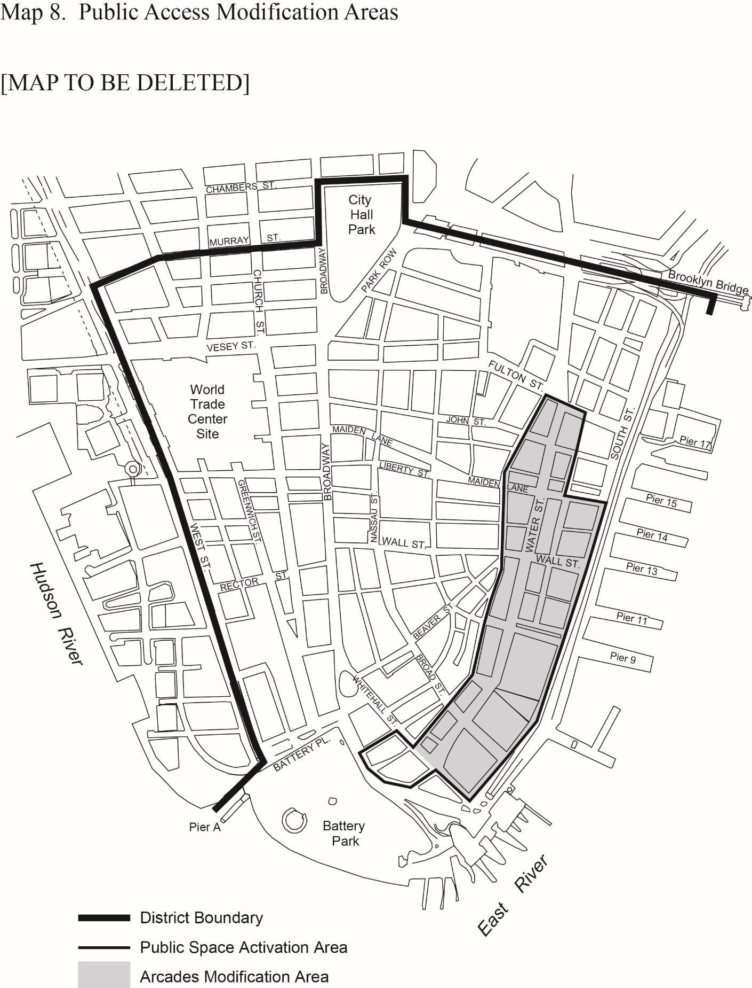

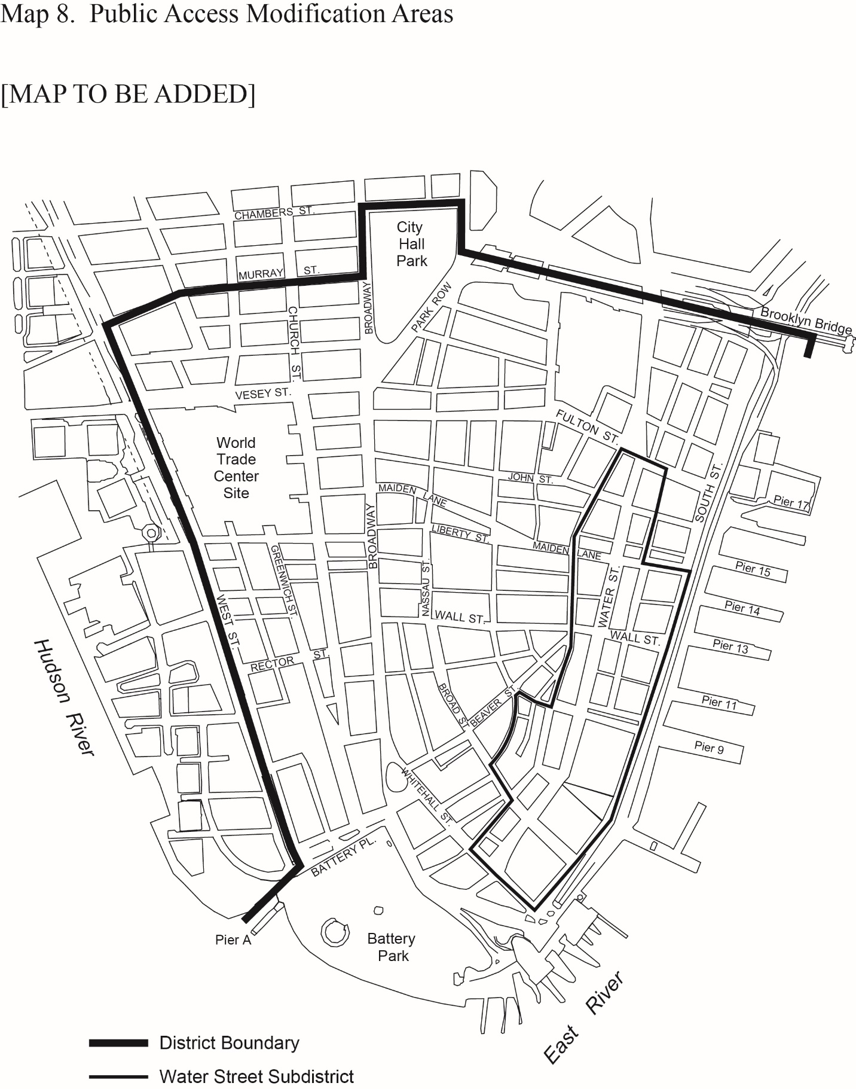

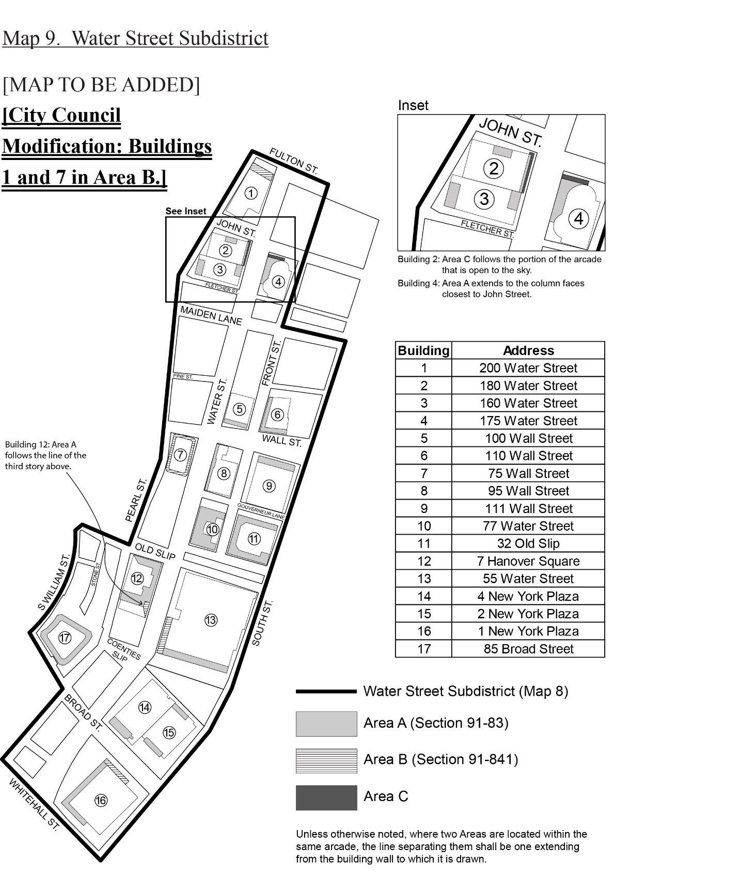

End Text

91-80
PUBLIC ACCESS AREAS

91-81
Certification to Modify Existing Arcades in Certain Areas

For the purposes of this Section, “arcade” shall refer to an #arcade# or #through block arcade# provided in accordance with the provisions of Sections 12-10 (DEFINITIONS) and 37-80 (ARCADES); or an arcade provided in accordance with paragraph (a) of Section 37-53 (Design Standards for Pedestrian Circulation Spaces); or an open space provided on a #zoning lot# between the #building street wall# and the #street line# where tables and chairs would otherwise not be allowed as permitted obstructions.

The provisions of this Section shall apply to existing #buildings# providing an arcade within the boundary designated by Map 8 in Appendix A of this Chapter.

Any underlying provisions restricting the placement of tables and chairs within such arcades may be modified where the Chairperson of the City Planning Commission certifies to the Commissioner of Buildings that such modifications are consistent with the provisions of this Section, as follows:

(a) Tables and chairs

Publicly accessible tables and chairs and outdoor cafes, as well as shade umbrellas and other furnishings, shall be permitted obstructions within an arcade, provided that such obstructions comply with the provisions listed in paragraphs (a) and (b) of this Section, as applicable.

Tables or chairs provided within an arcade shall be moveable and shall not contain any plastic material.

Where an outdoor cafe is provided, it shall be a permanently unenclosed establishment and may have waiter or table service.

(1) Number and size of tables and chairs

A minimum of four tables and sixteen chairs shall be provided within an arcade.

(i) Publicly accessible tables and chairs

Publicly accessible tables, and related chairs, shall constitute a minimum of 40 percent of the total number of tables provided within an arcade. Fractions equal to or greater than one-half resulting from such calculation shall result in one additional table. Every publicly accessible table required by such calculation shall be required to have four chairs.

All tables shall have a minimum diameter of two feet. All publicly accessible chairs shall have seat backs, and the seats shall have a minimum depth of 12 inches and a maximum depth of 20 inches.

(ii) Outdoor cafe

Outdoor cafe tables, and related chairs, shall constitute a maximum of 60 percent of the total number of tables provided within an arcade. Fractions equal to or greater than one-half resulting from such calculation shall result in one additional table.

(2) Location restrictions and other prohibitions

Tables or chairs shall not be permitted within five feet of any #building# entrance. For arcades with a depth of ten feet or less, as measured from the column face furthest from the #street line# to the #street wall#, a clear pedestrian circulation pathway not less than three feet shall be provided. For arcades with a depth greater than ten feet, such required clear pedestrian pathway shall be increased to at least six feet. In addition, for #through block arcades#, a continuous clear path of ten feet shall be provided, connecting each #street# on which the public access area fronts.

(i) Publicly accessible tables and chairs

For arcades located on a #zoning lot# with frontage along Water Street, at least half of all publicly accessible tables and chairs shall be located within 25 feet of the Water Street #street line#.

(ii) Outdoor cafe

Outdoor cafes shall be located at the same elevation as the adjoining sidewalk area or #publicly accessible open area#, except that platforms that do not exceed a height of six inches may be provided.

Fences, planters, walls, fabric dividers or other barriers that separate outdoor cafe areas from other portions of the arcade or adjacent sidewalks or #publicly accessible open areas# shall be prohibited. No kitchen equipment shall be installed within an outdoor cafe.

(3) Hours of operation

(i) Publicly accessible tables and chairs

Tables and chairs shall not be chained, fixed or otherwise secured during the hours of 7:00 am to 9:00 pm. However, during the hours of 9:00 pm to 7:00 am, such tables and chairs may be removed or secured within the arcade.

Where publicly accessible tables and chairs and outdoor cafes are provided within an arcade, such publicly accessible tables and chairs shall be subject to the hours of operation of an outdoor cafe, as set forth in paragraph (a)(3)(ii) of this Section.

(ii) Outdoor cafe

Outdoor cafes must be in operation and provide service a minimum of 225 days per year.

All furnishings of an outdoor cafe, including tables, chairs, bussing stations and heating lamps, shall be completely removed from the arcade when the outdoor cafe is not in active use, except that tables and chairs may remain in such arcade if they are unsecured and may be used by the public without restriction.

(4) Locating publicly accessible tables and chairs within an adjacent #publicly accessible open area#

Where tables and chairs are provided in an arcade located on the same #zoning lot# as an existing #publicly accessible open area# that fronts upon Water Street, the Chairperson of the City Planning Commission may certify that publicly accessible tables and chairs, provided pursuant to paragraph (a)(2)(i) of this Section, may be located within such a #publicly accessible open area#.

The area within such #publicly accessible open area# occupied by publicly accessible tables and chairs provided pursuant to this paragraph, (a)(4), shall not be included in calculating the maximum #lot coverage# which permitted obstructions may occupy within such #publicly accessible open area#, where applicable.

Such publicly accessible tables and chairs shall not constitute a design change pursuant to the provisions of Section 37-62 (Changes to Existing Publicly Accessible Open Areas), provided the Chairperson finds that:

(i) no more than 50 percent of the publicly accessible tables and chairs required to be within 25 feet of the Water Street #street line#, pursuant to paragraph (a)(2)(i), shall be located within such #publicly accessible open area#. However, where the entirety of an arcade is located beyond 25 feet of the Water Street #street line#, the entirety of the publicly accessible tables and chairs required to be within 25 feet of such #street line#, pursuant to paragraph (a)(2)(i), may be located within such #publicly accessible open area#;

(ii) such publicly accessible tables and chairs shall in no event constitute required seating for such existing #publicly accessible open area#; and

(iii) such publicly accessible tables and chairs comply with the hours of operation provisions of paragraph (a)(3) of this Section.

Any proposed design change to an existing #publicly accessible open area# beyond the findings permitted in this Section shall be subject to the requirements of Section 37-62.

(b) Litter receptacles

Litter receptacles shall be permitted obstructions within an arcade pursuant to the provisions set forth in Section 37-744.

In order to certify that the proposed modification to an existing arcade is consistent with the provisions of this Section, the applicant shall submit, to the Chairperson, a site plan demonstrating the proposed obstructions within the existing arcade and, where applicable, the adjacent #publicly accessible open area#, and a detailed seating plan illustrating compliance with paragraph (a) of this Section.

All plans for arcades or other #publicly accessible open areas# that are the subject of a certification pursuant to this Section shall be filed and duly recorded in the Office of the City Register of the City of New York, indexed against the property in the form of a legal instrument, in a form satisfactory to the Chairperson, providing notice of the certification of the arcade, pursuant to this Section. Such filing and recording of such instrument shall be a precondition to certification. The recording information shall be included on the certificate of occupancy for any #building#, or portion thereof, on the #zoning lot# issued after the recording date.

91-82
Existing Publicly Accessible Open Areas

The purpose of this Section is to facilitate temporary programmatic changes to existing public spaces to:

(a) help address the short-term challenges facing the Water Street corridor as a result of Hurricane Sandy by encouraging increased economic activity, reinforcing community connections, creating a lively and engaging experience and improving the corridor’s pedestrian environment; and

(b) explore new types of #uses# and amenities within public spaces intended to draw residents, workers and visitors, thereby increasing the utilization and activation of the existing public spaces.

This Section, inclusive, shall be effective until January 1, 2014, at which time the provisions of this Section shall automatically expire and all #publicly accessible open areas#, as defined in Section 91-821, shall be returned to their compliant state and all temporary obstructions shall be removed.

91-821
Special provisions for publicly accessible open areas

For the purposes of this Section, the definition of #publicly accessible open area# shall also include any #arcade#, #through block arcade#, or other public amenity, open or enclosed, for which a #floor area# bonus has been granted.

The provisions of this Section shall apply to all #publicly accessible open areas# existing on June 12, 2013, within the area designated as a public space activation area on Map 8 (Public Access Modification Areas) in Appendix A of this Chapter.

Any underlying provisions, including Section 91-81 of this Chapter, restricting the placement of obstructions within #publicly accessible open areas# or restricting their use for events may be modified, as follows:

(a) Temporary permitted obstructions

Amenities that shall be considered temporary permitted obstructions for cultural, entertainment and #commercial uses# including, but not limited to, tables, chairs, moveable planters, stages, kiosks, food trucks, artwork, and shade structures are allowed, provided that they:

(1) are not permanently affixed to the ground and do not cause damage to any surface of the #publicly accessible open area#;

(2) are not located within five feet of any #building# entrance; and

(3) do not, in combination, occupy more than 60 percent of the #publicly accessible open area#.

(b) Events

Events including, but not limited to, farmers markets, holiday markets, concerts and performances, art and cultural exhibitions, and festivals are permitted. Such events may be sponsored by non-profit or for-profit entities, without limitation, and may include the sale of food, refreshments and other event-related items, for the benefit or enjoyment of event participants. The use of a #publicly accessible open area# for the promotion of products or services shall not itself qualify as an event permitted under this Section. Such events shall:

(1) be open to the public; and

(2) only be permitted to use amplified sound between the hours of 9:00 am and 10:00 pm.

Nothing herein shall authorize the use of city #streets# or sidewalks in connection with an event permitted under this Section, and any such use shall be subject to all applicable provisions of law and regulation governing the use of city #streets# or sidewalks including, where applicable, the requirement to obtain a street activity permit from the Street Activity Permit Office of the Office of Citywide Events Coordination and Management. No event shall be permitted pursuant to this Section unless, no later than fourteen (14) days prior to the scheduled date, the sponsor notifies the Street Activity Permit Office of the nature, size and location of the event upon a form prescribed by the Street Activity Permit Office for such purpose.

Adopted.
Office of the City Clerk, }
The City of New York, } ss.:

I hereby certify that the foregoing is a true copy of a Resolution passed by The Council of The City of New York on June 21, 2016, on file in this office.

.....…….........................................
City Clerk, Clerk of The Council

