THE COUNCIL OF THE CITY OF NEW YORK
RESOLUTION NO. 570

Resolution approving the decision of the City Planning Commission on Application No. N 250249 ZRK for an amendment of the text of the Zoning Resolution (L.U. No. 101).

By Council Members Riley and Louis
WHEREAS, Ocean Towers Partners LLC, filed an application pursuant to Section 201 of the New York City Charter, for an amendment of the Zoning Resolution of the City of New York to amend APPENDIX F (Mandatory Inclusionary Housing Areas and former Inclusionary Housing Designated Areas) for the purpose of establishing a Mandatory Inclusionary Housing area, which in conjunction with the related applications would facilitate the development of an 18-story, approximately 334,300-square-foot mixed-use building with 408 income-restricted units, ground floor community facility and commercial uses, and open space at property located at 2950 West 24th Street in the Coney Island neighborhood of Brooklyn, Community District 13 (ULURP No. N 250249 ZRK) (the "Application");
WHEREAS, the City Planning Commission filed with the Council on June 24, 2026, its decision dated June 3, 2026 (the "Decision") on the Application;
WHEREAS, the Application is related to applications C 250248 ZMK (L.U. No. 100), a zoning map amendment to change R6 and R6/C1-2 to R6, R7-3, and R7-3/C2-4 zoning districts; C 250215 ZSK (L.U. No. 102), a zoning special permit to reduce the required parking at the development site from 167 spaces to 143 spaces; and C 250250 ZSK (L.U. No. 103), a zoning special permit to establish a Large-Scale General Development (LSGD) and modify regulations on height and setback, distribution of bulk, and minimum distances between walls and windows (collectively, the “Related Actions”);
WHEREAS, the Decision is subject to review and action by the Council pursuant to Section 197-d of the City Charter;
WHEREAS, upon due notice, the Council held a public hearing on the Decision and Application on July 1, 2026;
WHEREAS, the Council has considered the land use implications and other policy issues relating to the Decision and Application; and
WHEREAS, the Council has considered the relevant environmental issues, including the Negative Declaration issued on January 15, 2026 (CEQR No. 24DCP134K), which includes an (E) designation (E-868) related to hazardous materials, air quality, and noise to avoid the potential (the “E-designation”) for significant adverse impacts (the “Negative Declaration”); and to ensure the implementation of the Project Components Related to the Environment with respect to construction air quality and construction noise, the owners of the development site have entered into a restrictive declaration, which will be recorded against the site (the “Restrictive Declaration”, which together with the E-designation and the Negative Declaration, are collectively referred to as the Environmental Documentation”).

RESOLVED:

The Council finds that the action described herein will have no significant impact on the environment as set forth in the Environmental Documentation.

Pursuant to Section 197-d of the New York City Charter and based on the Decision and Application, the environmental determination and consideration described in the report, N 250249 ZRK, incorporated by reference herein, and the record before the Council, the Council approves the Decision, as follows:
Matter underlined is new, to be added;
Matter struck out is to be deleted;
Matter within # # is defined in Section 12-10;
* * * indicates where unchanged text appears in the Zoning Resolution.

* * *
APPENDIX F
Mandatory Inclusionary Housing Areas and former Inclusionary Housing Designated Areas

BROOKLYN

* * *
Brooklyn Community District 13

* * *
Map 1 – [date of adoption]
[EXISTING MAP]

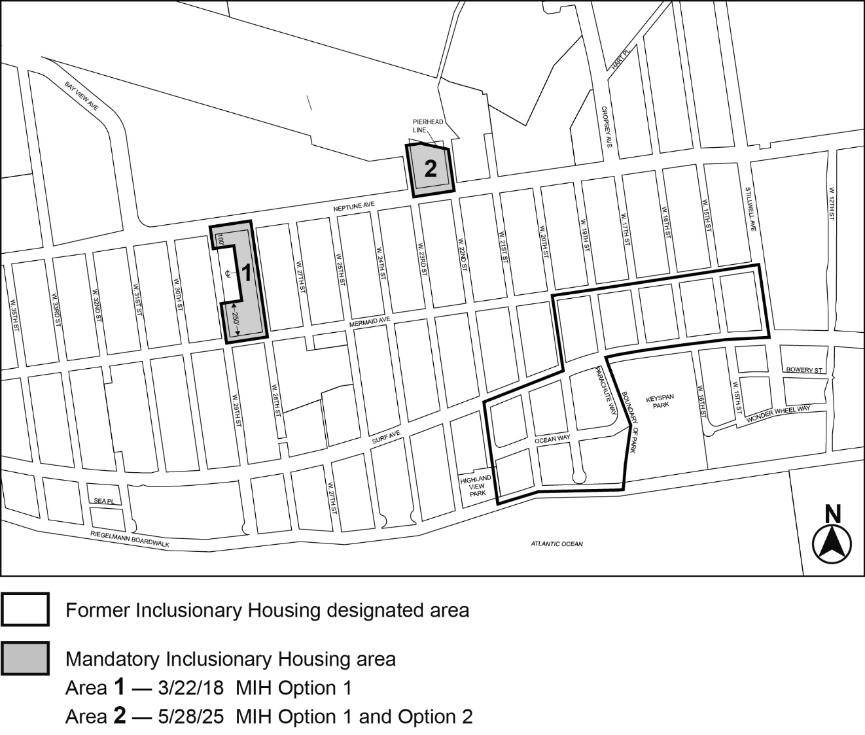

[PROPOSED MAP]

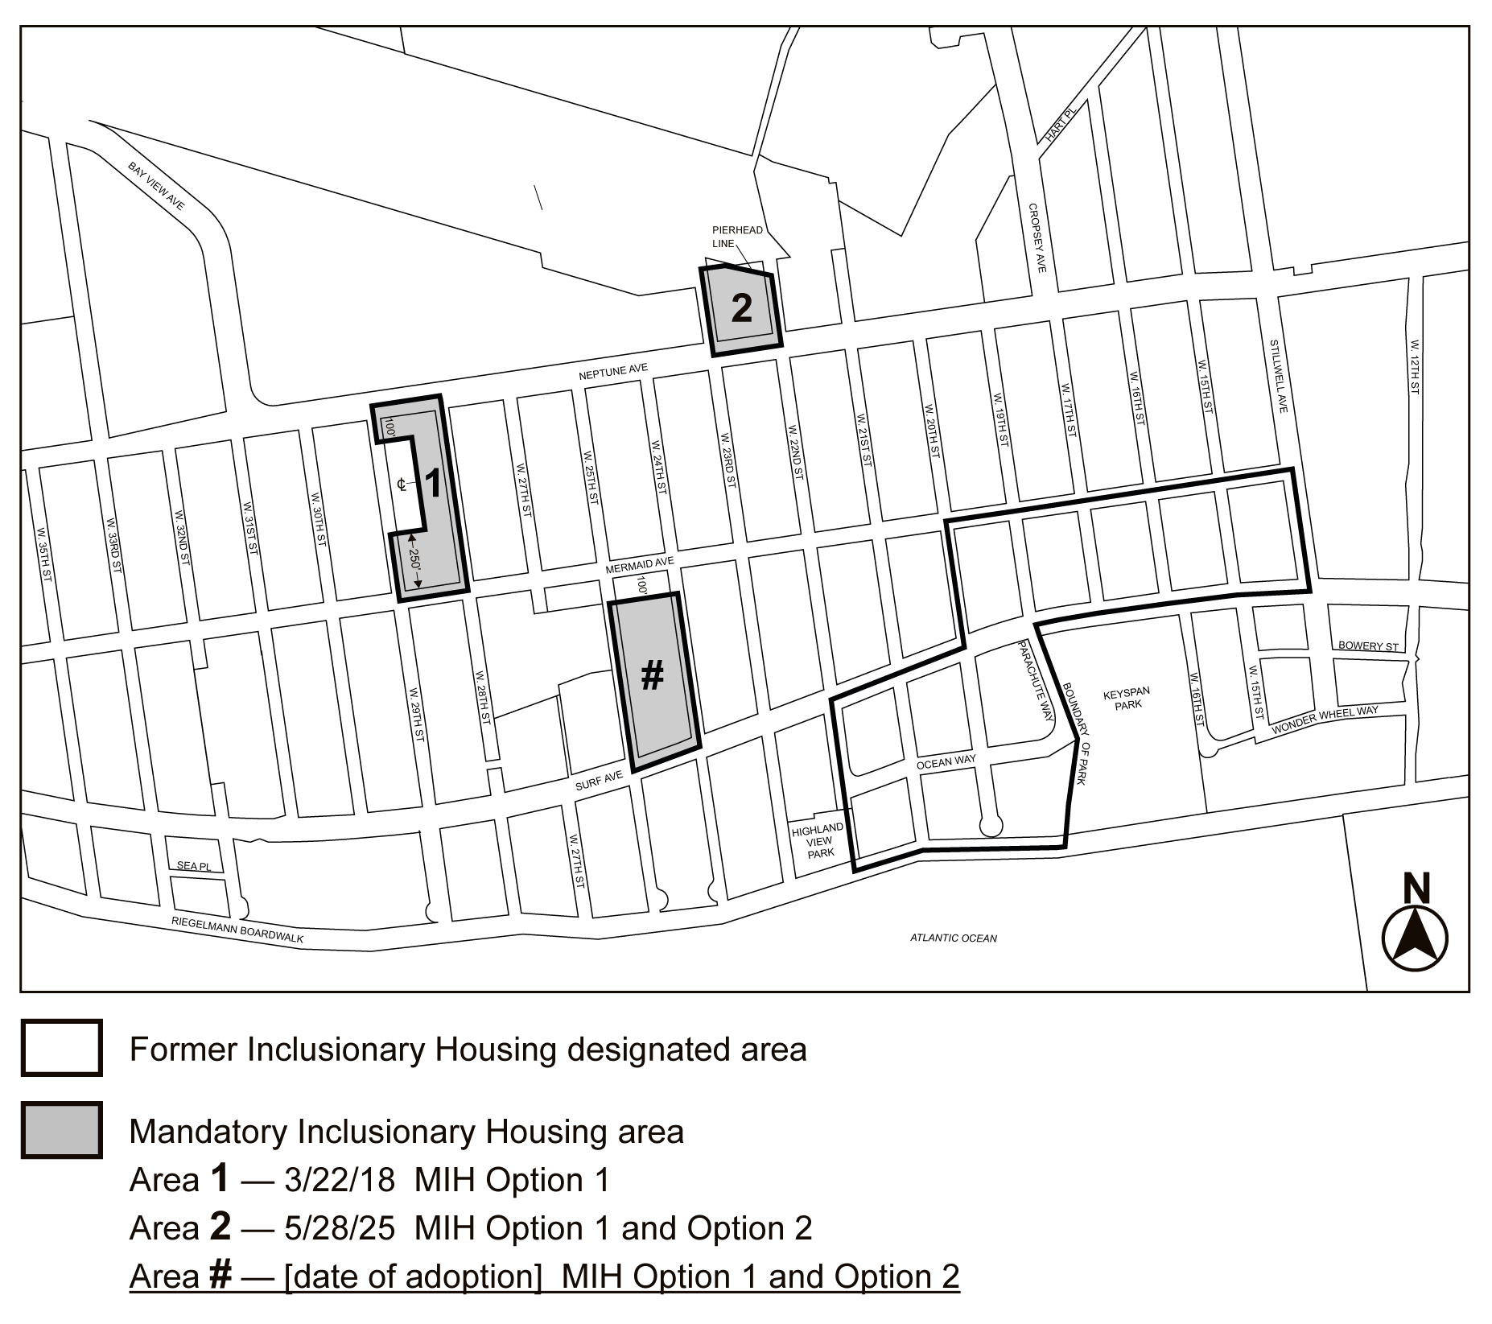
Portion of Community District 13, Brooklyn
* * *
Adopted.

Office of the City Clerk, }
The City of New York, } ss.:

I hereby certify that the foregoing is a true copy of a Resolution passed by The Council of The City of New York on ______________, on file in this office.

.....................................................
City Clerk, Clerk of The Council

