Committee on Veterans Staff
David Romero, Legislative Counsel
Anastassia Zimina, Policy Analyst
Ross Goldstein, Financial Analyst

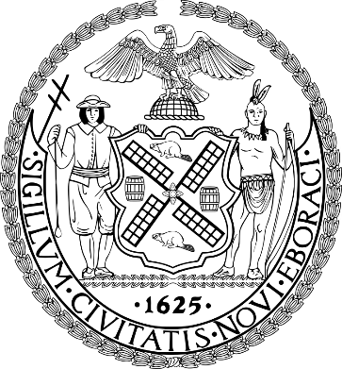

THE COUNCIL OF THE CITY OF NEW YORK

COMMITTEE REPORT OF THE HUMAN SERVICES DIVISION
Andrea Vazquez, Director
Smita Deshmukh, Deputy Director, Human Services

COMMITTEE ON VETERANS

Hon. Robert Holden, Chair

October 19, 2023

PROPOSED RESO. NO. 581-A: By Council Members Dinowitz, Louis, Yeger, Farías, Hanif, Brewer, Ung, Lee, Riley, Velázquez, Schulman, Nurse and Paladino (by request of the Bronx Borough President)

TITLE: Resolution to recognize November as Veteran Appreciation Month in New York City

INTRODUCTION
On October 19, 2023, the Committee on Veterans, chaired by Council Member Robert Holden, will consider Proposed Resolution Number (Reso. No.) 581-A, sponsored by Council Member Dinowitz. The Committee previously held a hearing on Proposed Reso. No. 581-A on September 15, 2023, where witnesses invited to testify included representatives from the New York City Department of Health and Mental Hygiene (DOHMH), the New York City Department of Veterans’ Services (DVS), and other interested stakeholders and members of the public.

Proposed Res. No. 581-A

Resolution to recognize November as Veteran Appreciation Month in New York City.

By Council Members Dinowitz, Louis, Yeger, Farías, Hanif, Brewer, Ung, Lee, Riley, Velázquez, Schulman, Nurse and Paladino (by request of the Bronx Borough President)

Whereas, For centuries, the armed forces have played a central role in American life, defending American values and interests from Bunker Hill to Baghdad; and
Whereas, The individuals who serve in the Army, the Navy, the Air Force, the Marines, and the Coast Guard come from all 50 states and embody the socioeconomic, racial, and religious diversity of our nation; and
Whereas, During the month of November, the United States celebrates Veterans Day, to recognize and honor the immeasurable sacrifices and indispensable contributions veterans have made to national security; and
Whereas, Every year since 1996, The President of the United States issues a proclamation to designate the month of November as National Veterans and Military Families Month to honor veterans, military families, caregivers, and survivors, who have served and continue to serve the nation; and
Whereas, Service to the nation also includes the immense patriotism, courage, and resilience of America’s military families; and
Whereas, New York City is home to roughly 200,000 veterans, and is the first city in the nation to establish a Department of Veterans Services; and
Whereas, The agency works to connect, mobilize, and empower New York City's veteran community in order to foster purpose-driven lives for New York City Service Members – past and present; and
Whereas, As a national leader on veterans’ issues, New York City should recognize November as Veteran Appreciation Month in the five boroughs; and
Whereas, This recognition would reaffirm New York City’s commitment to its veterans and create opportunities for civic engagement across New York City’s institutions; and
Whereas, In light of the significant contributions that veterans have made to American life, and New York City’s engagement with the veteran community, establishing this commemorative month is an important step toward becoming the most veteran-friendly city in the country; now, therefore, be it
Resolved, That the Council of the city of New York recognizes November as Veteran Appreciation Month in the city of New York.

EA/DR
LS 10668
10/17/2023

