Committee Staff:

Committee on Public Safety
Deepa Ambekar, Legislative Counsel
Beth Golub, Legislative Counsel
Laurie Wen, Legislative Policy Analyst
Ellen Eng, Legislative Financial Analyst

Legislative Counsel
Brian Crow

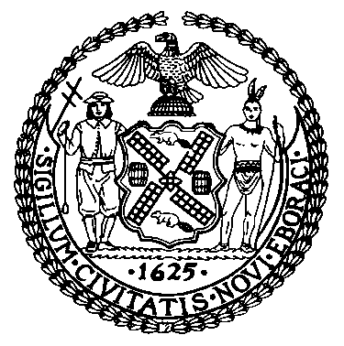

THE COUNCIL OF THE CITY OF NEW YORK

COMMITTEE REPORT OF THE GOVERNMENTAL AFFAIRS DIVISION
Matthew Gewolb, Legislative Director
Rachel Cordero, Deputy Director, Governmental Affairs

COMMITTEE ON PUBLIC SAFETY
Hon. Vanessa L. Gibson, Chair

January 25, 2016

PRECONSIDERED INT. NO. The Speaker (Council Member Mark-Viverito)
TITLE: A Local Law to amend the administrative code of the city of New York, in relation to the enforcement of criminal and civil offenses.
PRECONSIDERED INT. NO. Council Members Lancman and The Speaker (Council Member Mark-Viverito)
TITLE: A Local Law to amend the administrative code of the city of New York, in relation to the penalties for littering, and to repeal subdivision 5 of section 16-118 of the administrative code of the city of New York, relating to the distribution of advertising matter.
PRECONSIDERED INT. NO. The Speaker (Council Member Mark-Viverito)
TITLE: A Local Law to amend the administrative code of the city of New York, in relation to the penalties for excessive noise.
PRECONSIDERED INT. NO. Council Member Gibson and The Speaker (Council Member Mark-Viverito)
TITLE: A Local Law to amend the administrative code of the city of New York, in relation to the penalties for possessing an open container of alcohol.
PRECONSIDERED INT. NO. The Speaker (Council Member Mark-Viverito)
TITLE: A Local Law to amend the New York city charter and the administrative code of the city of New York, in relation to penalties for violating certain park rules.
PRECONSIDERED INT. NO. The Speaker (Council Member Mark-Viverito) and Council Members Gibson, Kallos, and Lancman
TITLE: A Local Law amend the New York city charter, in relation to permitting ECB to use community service as an alternative to fines.
PROPOSED INT. NO. 639-a Council Members Williams, Torres, Lancman, Johnson, Wills, Gibson, Chin, Mendez, Rose, Rodriguez, Rosenthal and Menchaca
TITLE: A Local Law to amend the administrative code of the city of New York, in relation to requiring the police department to submit quarterly reports relating to the issuance of summonses.
INT. NO. 662 Council Members Levine, Dromm, Chin, Cohen, Gibson, Rose, Williams, Wills, Rodriguez and Rosenthal
TITLE: A Local Law to amend the administrative code of the city of New York, in relation to requiring the police department to submit quarterly reports relating to the issuance of desk appearance tickets.
I. INTRODUCTION

On January 25, 2016, the Committee on Public Safety, chaired by Vanessa L. Gibson, will conduct a hearing on eight proposed bills regarding the equitable enforcement of criminal and civil offenses established in local laws. These bills amend laws governing behavior in five broad categories: the possession of an open container of alcohol in public, parks rules, public urination, unreasonable noise, and littering. Two of these bills require reporting related to the enforcement of these laws, one bill requires the New York City Police Department (“NYPD”) to create guidance regarding the enforcement of these laws, and one bill requires tribunals of the Office of Administrative Trials and Hearings (“OATH”) to offer community service as an alternative to paying civil penalties.
II. BACKGROUND
- Levels of Offenses
There are three basic levels of offenses in New York that are handled through the criminal court system: felonies, misdemeanors, and violations. Only felonies and misdemeanors are classified as crimes and carry the penalty of a permanent criminal record, but violations are processed exclusively in criminal courts. A misdemeanor carries a possible penalty of more than 15 days in jail, but a violation may involve a sentence of either a fine or jail.
The City may create misdemeanors or violations, but not felonies. The City may also create offenses that carry a civil penalty. Civil penalties are purely monetary. These penalties are imposed in an entirely different manner than those processed in criminal court. In fact, because civil penalties are independent from those imposed in criminal court, an individual may be liable simultaneously in civil and criminal courts without violating the principles of double jeopardy. Offenses that carry only the possibility of a civil penalty are typically handled in a civil adjudicative body such as the Environmental Control Board (“ECB”) of OATH.
- Methods of Enforcement for Local Laws
The enforcement of State and local laws differ in many respects, most notably in the use of criminal summonses, commonly known as “c-summonses.” A c-summons is a notice to appear in criminal court that charges an individual with either a violation or a misdemeanor. A police officer may issue a c-summons charging either a misdemeanor or violation defined in local law, but may not issue a c-summons charging a misdemeanor defined in the State Penal Law. For State Penal Law offenses, c-summonses may only be used to charge violations.
In 2014, 391,171 criminal summonses were issued in New York City, down from 458,095 in 2013, and 648,638 in 2005 - the highest number in the previous decade. As illustrated in the following graph, the use of c-summonses far outweighs felony and misdemeanor arrests. While the rate of c-summons has varied over the last decade, the felony rate has remained constant.
Arrests, Summonses, and Stops in New York City 2003-2014
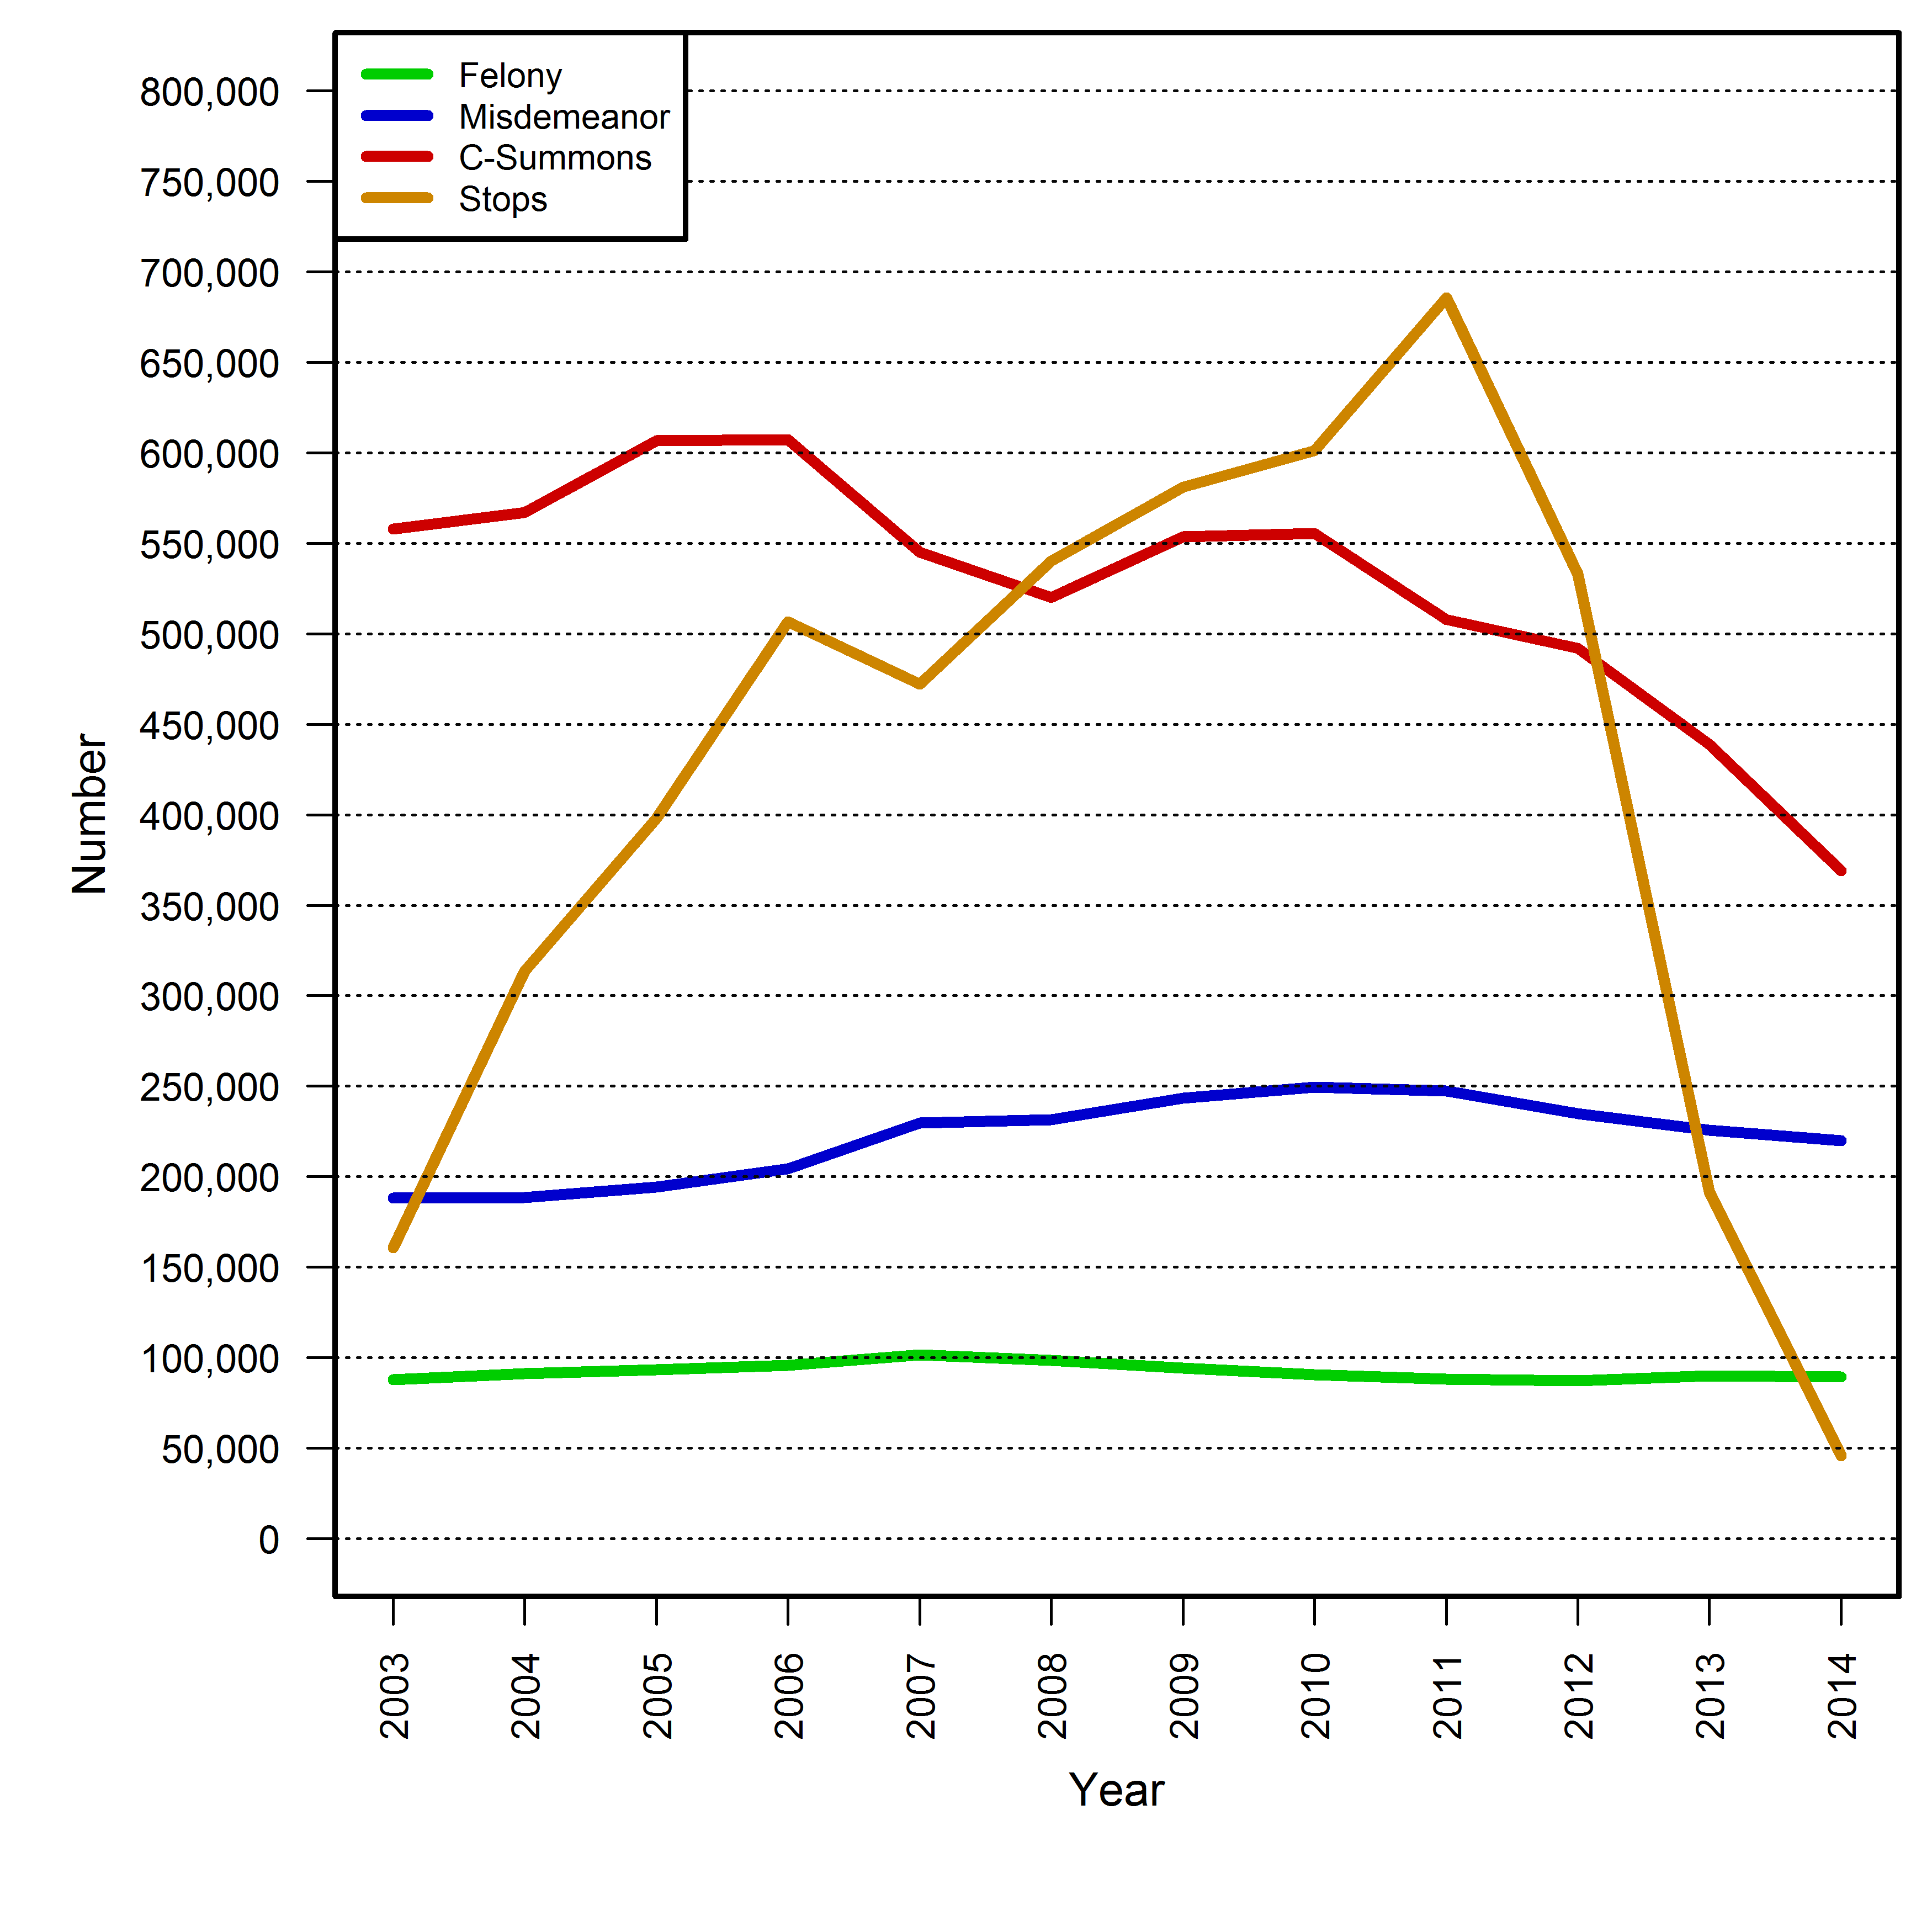
The most commonly charged offense for which a c-summons is issued is the consumption of alcohol in public. According to data provided to the Council by the Office of Court Administration (“OCA”), in 2013 approximately 116,000 c-summonses alleging the possession of an open container of alcohol were docketed. The second most frequently docketed local law offense was public urination, which had almost 30,000 c-summons. The following chart indicates common offenses for which c-summonses are issued for violations of local laws.

Criminal Summonses Issued by the NYPD in 2014
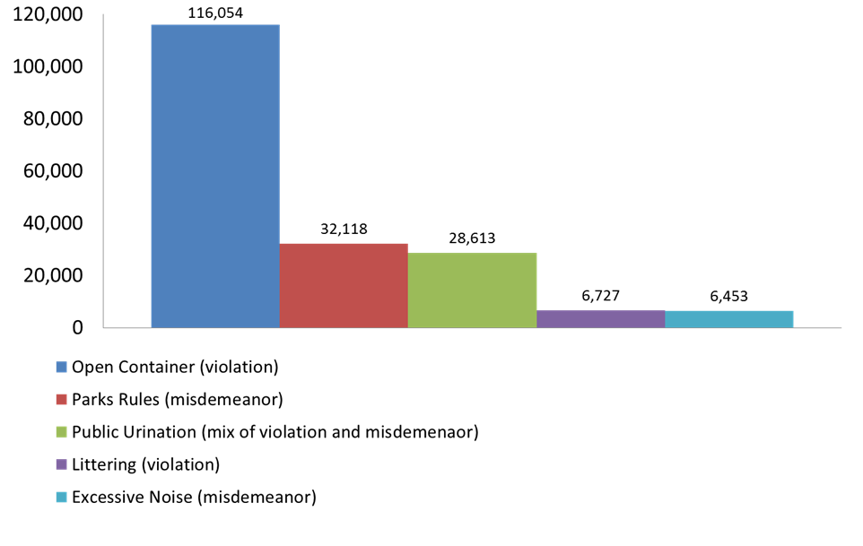
Of the commonly charged offenses listed above, the majority are misdemeanors: all parks rules are misdemeanors, as is unreasonable noise and many of the public urination charges. Advocates, criminal justice scholars and members of the community have long expressed concern that these penalties are disproportionate to the respective crime. For example, the refusal to obey any park sign carries the threat of a permanent criminal record, and even those offenses that do not carry the possibility of a permanent criminal record do carry the possibility of a warrant being ordered for failing to appear on any court date. It is widely believed that these outcomes disproportionately and adversely impact those charged, and erode the public trust in the just enforcement of local laws.
Another concern with how these low-level offenses are treated under local law is that many of these non-violent offenses, such as public urination, are covered by multiple local statutes that create overlapping and sometimes inconstant penalties for the same behavior. For example, public urination is punishable by a misdemeanor under the Health Code, but is a violation in the Administrative Code. As discussed in Section V, infra, the Council has endeavored to create consistency in the enforcement of such offenses going forward.
- Outcomes of C-Summons Enforcement
From 2003 to 2013, 65% of criminal summonses issued were either dismissed or adjourned in contemplation of dismissal. During the same period, defendants in 21% of the cases were convicted, and the overwhelming majority of those found guilty, 99.6%, were sentenced to fines. Summons courts may order bench warrants for the arrest of any person who does not appear in response to a summons, and at the end of this 11-year period, 14% of the total number of cases still had outstanding warrants. A chart summarizing the outcome of cases during this 11-year period follows.
Disposition of Criminal Summonses in New York City, 2003-2013
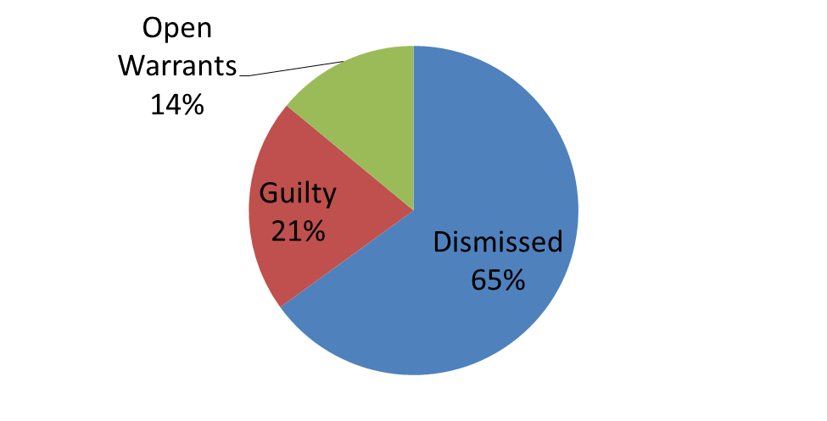

There is a concern that imposing an actual punishment on only 21% of those charged with an offense does not meaningfully hold offenders responsible for their behavior, nor does it meaningfully deter unwanted behavior. Furthermore, the fact that 99.6% of those convicted are sentenced to pay a fine suggests that there is little substantive difference between the monetary penalties imposed in criminal court and those imposed in civil adjudicative bureaus such as OATH’s ECB, which handles allegations of various offenses established under local laws, or the Transit Adjudication Bureau (“TAB”), which handles allegations of misconduct in transit facilities. Reports indicate that TAB collects 82% of those fines it imposes.
According to OCA data provided to the Council, as of December 2015, there were 1.5 million open summons warrants dating back to 1980 and approximately 1.1 million of those (75%) belong to unique individuals. Fifty thousand of these warrants were over 30 years old. While the number of outstanding summons warrants at the end of an 11-year period was only 14%, the rate of warrants per summons case is significantly higher: 38% in 2014. These rates vary dramatically because at the end of an 11-year period, numerous individuals have returned to court, either voluntarily or after being apprehended by the NYPD. The actual rate of warrants for some of the most commonly charged offenses was between 40% and 50% in 2013, as referenced in the chart below.

Warrant Rates in 2013
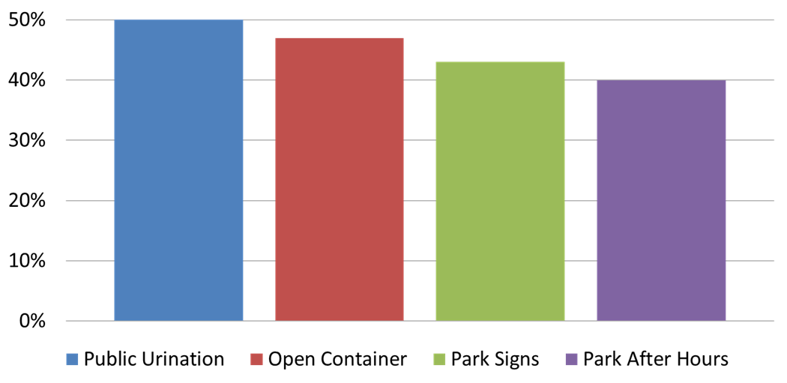

The Mayor’s Office of Criminal Justice has announced a series of reforms aimed at reducing the number of these warrants, and the Council has supported these efforts. However, given the sheer quantity of cases being sent to summons court, it has been argued that a more meaningful way to reduce the number of criminal court warrants is to reduce the number of cases being sent to these courts. Furthermore, reducing the summons caseload in criminal courts would potentially allow these courts to focus on more serious crimes.
- Consequences of a Warrant
The consequences of a warrant can be significant. According to information provided by the NYPD to the Council, the NYPD is required to arrest an individual with an open warrant at any point at which an officer determines that such a warrant exists. The arrestee then goes through a booking process that often takes up to 24 hours before the arrestee sees a judge, regardless of the seriousness of the offense for which the warrant was issued. In other words, summons warrants can have similar negative outcomes as warrants for felonies.
The consequences of warrants are broader than their direct effect. Under current NYPD policy, officers use discretion in deciding whether to arrest or issue a civil summons to an individual charged with Theft of Services related to not paying a subway or bus fare, commonly known as “turnstile jumping,” and in 2013, the NYPD issued civil summonses to the vast majority of these offenders. However, according to NYPD policy, any individual with an open warrant must be arrested for such conduct. It is notable that turnstile jumping was the second most commonly charged crime for which individuals were arrested in 2014. A similar policy applies to marijuana arrests: according to NYPD policy, a person charged with a certain low-level marijuana offense should be issued a c-summons charging a non-criminal offense, but if that person has any outstanding warrant, they must be arrested and charged with a misdemeanor.
- Consequences of a Criminal Conviction
Individuals found guilty of misdemeanors face consequences including a criminal record and negative impacts on employment, immigration status, and myriad other consequences. Much attention in recent years has focused on how the enforcement of low-level crimes disproportionately impacts low-income communities of color, burdening many young people of color with harsh consequences for the rest of their lives.
- Civil Enforcement
Though many of the local laws for which c-summonses are most commonly issued contain possible civil penalties, the NYPD has not enforced civil penalties for the vast majority of local law offenses, instead enforcing criminal penalties almost exclusively. However, the NYPD has enforced civil penalties extensively in the context of turnstile jumping, as described in Section II(D) above. The tribunal that enforces these penalties, TAB, reportedly collects 82% of the fines it imposes. In addition, in 2014, the NYPD began enforcing civil penalties for biking on a sidewalk in lieu of c-summonses. Notwithstanding these specific offenses, according to information provided by the NYPD to the Council, the NYPD does not have a general policy regarding when to enforce civil penalties, nor do such policies exist for the specific local laws being amended by the bills being heard at this hearing.
The differences between enforcing civil penalties and issuing c-summonses are significant. Among others, one important distinction is that a warrant for arrest is typically issued for a failure to appear in criminal court, but such warrants are not issued in civil tribunals such as those operated by OATH. Also, cases processed in criminal court carry a presumption of innocence and must be proven beyond a reasonable doubt, whereas OATH tribunals have no such presumption and cases must be proven by a preponderance of evidence. However, in other ways OATH tribunals and criminal courts are similar, most notably in that unpaid monetary penalties are handled identically: in both courts, civil judgments are entered for those with unpaid monetary penalties. Also, as noted in section II(C), supra, 99.6% of penalties imposed in criminal court are monetary, while 100% of penalties currently imposed in OATH are monetary.

III. PROPOSED INT. NO. 639-A

This bill would require the NYPD to issue a quarterly report on both criminal and civil summonses. The bill would require a basic report on the number of summonses issued for any offense for which more than 100 summonses were issued, and would require this information to be disaggregated by the offense charged. The bill would further require this information to be broken down by the precinct, and the age, race, and gender of the person to whom a summons was issued. Finally, the bill would require a separate comparison of the number of criminal and civil summonses issued for any offense for which either a criminal or civil summons could be issued. These reports would be permanently stored on the NYPD’s website and NYPD would make available a comparison between the current requisite data and data from previous quarters.

IV. Int. No. 662

This bill would require the NYPD to issue a quarterly report on the usage of desk appearance tickets. Desk appearance tickets are in many ways identical to summonses; both are technically referred to as “appearance tickets” in the Criminal Procedure Law. The key difference between a desk appearance ticket and a summons, as these terms are used by the NYPD and in the bills being heard, is that a desk appearance ticket is issued to a person only after their fingerprints are taken. Also, a desk appearance ticket, as that term is utilized by the NYPD and in these bills, is not an accusatory instrument, whereas a summons is.

This bill would require the NYPD to issue a quarterly report on the number of desk appearance tickets issued, disaggregated by the race, gender, and age of the person to whom it was issued. The report would also identify the offense charged.

V. PRECONSIDERED INT. NO. (RELATED TO THE POSSESSION OF AN OPEN CONATINER OF ALCOHOL)

As illustrated in Section II, supra, the NYPD issued over 116,000 c-summonses for the possession of an open container of alcohol in 2014. As the law presently stands, the only possible penalty for this offense is either a fine of up to $25 or five days in jail. This bill would add a possible civil penalty of up to $25 for any violation of this offense. This penalty would be returnable to and adjudicated by OATH.
VI. PRECONSIDERED INT. NO. (RELATED TO LITTERING)
Littering and dumping are prohibited in numerous areas of both state and local law, including within the seven subsections of section 16-118 of the Administrative Code, section 16-119 of the Administrative Code, New York Penal Law section 145.50, New York Vehicle and Traffic Law section 1219, and New York Railroad Law section 52-e. This bill addresses the very broad prohibition on littering in subdivision one of section 16-118 of the Administrative Code. This offense covers virtually any form of littering, including “rubbish and refuse of any kind whatsoever, in or upon any street or public place.” This provision is currently punishable by either a violation, with a penalty of up to 10 days in jail or a fine of between $50 and $250, or by a civil penalty of between $50 and $250, with escalating civil penalties for multiple convictions within one year. This bill would eliminate the possible penalty of a violation, leaving the possibility of a civil penalty, for this specific subdivision.
This bill would also repeal a different subdivision of section 16-118 that has been found unconstitutional. It would also eliminate references to civil penalties being returnable to ECB, and instead refer to OATH.
Many of the prohibitions in section 16-118 are presently duplicative of offenses in the Health Code promulgated by the New York City Board of Health. Most notably, the prohibition on “offensive animal matter” in section 16-118(6), which is commonly used to charge public urination, is very similar to the prohibition against “offensive animal matter” located in Health Code section 153.09. NYPD public reports indicate that thousands of c-summonses for violations of both section 16-118(6) and section 153.09 of the Health Code are issued every year. This has proved problematic, as all violations of the Health Code are misdemeanors, while violations of section 16-118 constitute violations. Therefore, in preparing this bill, the Council has discussed with the Board of Health the possibility of repealing five sections of its Code that are duplicated in the Administrative Code: sections 139.05, 139.07(a), 153.01, 153.11, and 181.03(a). If such sections are repealed, in order to maintain a local law that addresses the behavior covered by these sections, this bill adds a prohibition on spitting to the general prohibition on littering.
VII. PRECONSIDERED INT. NO. (RELATED OFFENSES IN PARKS)
Presently, the violation of any Department of Parks and Recreation (“DPR”) rule is punishable by a misdemeanor, with a penalty of up to 90 days in jail and a fine of up to $1,000, or by a civil penalty of up to $10,000. This means that any rule passed by the DPR automatically carries a criminal penalty. This bill would remove the misdemeanor penalty for DPR rules and replace it with a violation and a penalty of up to a $200 fine. As a result, any rule passed by the DPR would automatically carry a penalty that could be enforced in criminal court, but not one that would give an offender a permanent criminal record.
Numerous parks rules would be codified as misdemeanors in the Administrative Code, including offenses such as failing to comply with the lawful order of a police or peace officer, unlawful dumping, unlawful solicitation, and violating the exclusive use of children’s playgrounds. Further, all current DPR rules related to vending would be codified in the Administrative Code as misdemeanors.
VIII. PRECONSIDERED INT. NO. (RELATED TO UNREASONABLE NOISE)
The New York City Noise Control Code contains dozens of offenses, and the violation of any such offense is punishable by a misdemeanor with a penalty of up to 20 days in jail or a fine of between $50 and $500, with escalating fines for multiple convictions. Such violations are also punishable by a civil penalty and the exact penalties for each of the dozens of offenses are specifically enumerated in the Administrative Code.
The broadest prohibition in the Noise Control Code is contained in the subchapter entitled “general prohibitions,” which includes one section that contains a broad prohibition on unreasonable noise. Dozens of more specific offenses are enumerated later in the code; for example, prohibitions on commercial music, animal noise, motor vehicles, and sound reproductive devices. This bill would affect only the broad prohibition on unreasonable noise, and would eliminate the possible misdemeanor penalty and replace it with a violation carrying a maximum penalty of a $250 fine. Such cases could still be enforced in criminal court, but would not carry the possibility of a permanent criminal record. However, an individual could be charged with a misdemeanor for repeated violations of this statute; more specifically, an individual could be charged with a misdemeanor if he or she violated the broad prohibition on unreasonable noise, was issued a criminal or civil summons in response to such violation, and then violated the prohibition again within 24 hours of being issued such summons. The penalty for this repeated violation would be a misdemeanor with a penalty of up to 20 days in jail or a fine of up to $1,000. The civil penalties for all prohibitions in the noise control code would be unchanged.
IX. PRECONSIDERED INT. NO. (RELATED TO NYPD GUIDANCE)
Presently, according to information provided by the NYPD to the Council, the NYPD has no established policy or guidance for the enforcement of various local laws that have both criminal and civil penalty options, except for limited circumstances, such as turnstile jumping and riding a bicycle on a sidewalk. As illustrated in Section II, supra, the NYPD essentially never imposes civil penalties for such offenses.
This bill would require the NYPD to establish written, public guidance with respect to the enforcement of five offenses: possession of an open container of alcohol in public, the violation of all DPR rules, public urination, littering, and unreasonable noise. This guidance would detail when officers should issue criminal and civil summonses for these offenses, such as the guidance that currently exists regarding turnstile jumping. The “legislative findings and intent” section of this bill would state that the Council has “concluded that criminal enforcement of these offenses should be used only in limited circumstances and that, in the absence of such circumstances, civil enforcement should be utilized.”
X. PRECONSIDERED INT. NO. (RELATED TO COMMUNITY SERVICE)
Presently, violations returnable to and adjudicated by OATH, including those within ECB, are punishable only by civil penalties. To address the concern that moving adjudications out of criminal court and into civil will result in monetary fines being issued to individuals who do not have the means to pay them, this bill would require that OATH judges offer those without such means the opportunity to complete community service in lieu of paying civil penalties. Individuals who meet poverty guidelines and who are accused of violating the provisions of local laws related to the possession of an open container of alcohol, public urination, littering, the noise code, and violating parks rules, would be potentially eligible for community service. Anyone who availed themselves of the community service option but does not complete such service would have civil judgments entered against them.
Proposed Int. No. 639-A

By Council Members Williams, Torres, Lancman, Johnson, Wills, Gibson, Chin, Mendez, Rose, Rodriguez, Rosenthal and Menchaca

A Local Law to amend the administrative code of the city of New York, in relation to requiring the police department to submit quarterly reports relating to the issuance of summonses.

Be it enacted by the Council as follows:
Section 1. Title 14 of the administrative code of the city of New York is amended by adding a new section 14-155 to read as follows:
§14-155. Summons report. a. The commissioner shall submit to the council and the mayor, and post to the department’s website, within 20 days of the beginning of each quarter, a report containing the following information for the previous quarter: (i) the number of summonses to appear in criminal court that were issued, not including desk appearance tickets, (ii) the number of summonses to appear at an authorized tribunal of the office of administrative trials and hearings that were issued.
b. The data to be reported in subdivision a of this section shall be listed in total and disaggregated by the offense charged, for each offense for which at least 100 summonses were issued. For each offense for which the department may issue a summons to appear in either criminal court or at an authorized tribunal of the office of administrative trials and hearings, and for which at least either 100 summonses to appear in criminal court or 100 summonses to appear at an authorized tribunal of the office of administrative trials and hearings were issued, a separate report shall compare the number of summonses to appear in criminal court to the number of summonses to appear at an authorized tribunal of the office of administrative trials and hearings.
c. The data to be reported in subdivision a of this section shall be listed in total and disaggregated by the following factors for each person to whom a summons is issued: (i) race; (ii) gender; and (iii) age. The data to be reported in subdivision a of this section shall also be disaggregated by the borough in which the summons was issued, and by the each patrol precinct, housing police service area, or transit district in which the summons was issued.
d. The data requested in subdivisions a, b, and c for each quarter shall be stored permanently on the department’s website, and each quarterly report shall include a historical comparison to previous quarters.
§2. This local law shall take effect immediately, provided that the first quarterly report pursuant to section 1 is due within 20 days of the quarter beginning June 1, 2016.

BG/RC/BC
LS 2404/2014
1/19/2015

Int. No. 662

By Council Members Levine, Dromm, Chin, Cohen, Gibson, Rose, Williams, Wills, Rodriguez and Rosenthal

A Local Law to amend the administrative code of the city of New York, in relation to requiring the police department to submit quarterly reports relating to the issuance of desk appearance tickets.

Be it enacted by the Council as follows:
Section 1. Section 14-101 of title 14 of the administrative code of the city of New York is amended by adding a new subdivision c to read as follows:
c. "Desk appearance ticket" shall mean a written notice to appear in criminal court pursuant to article 150 of the penal law of the state of New York that is issued to an arrestee from a police precinct after a copy of the arrestee's fingerprints have been secured.
§ 2. Title 14 of the administrative code of the city of New York is amended by adding a new section 14-155 to read as follows:
§14-155. Desk appearance tickets. a. The commissioner shall submit to the council and the mayor on a quarterly basis, and post to the department's website on a quarterly basis, a report for each patrol precinct, housing police service area, transit district, street crime unit and narcotics division, of the number of desk appearance tickets issued broken down by: (i) race of suspect; (ii) gender of suspect; (iii) age of suspect; and (iv) the offense charged, including but not limited to marijuana violations.
§ 3. This local law shall take effect immediately.
BG/RC
LS 3409/2014
1/20/15, 1:00P

Preconsidered Int. No.

By Council Member Gibson and The Speaker (Council Member Mark-Viverito)

A Local Law to amend the administrative code of the city of New York, in relation to the penalties for possessing an open container of alcohol.

Be it enacted by the Council as follows:
Section 1. Subdivision e of section 10-125 of the administrative code of the city of New York, as amended by local law number 76 of 1995, is amended to read as follows:
e. [Any person who shall be found to have violated any of the provisions] The violation of subdivision b of this section, or any provision of any local law, rule, or regulation pertaining to the possession or consumption of alcoholic beverages in public, shall [be punished by] constitute a violation punishable by a fine of not more than twenty-five dollars ($25) [or imprisonment of up to five (5) days, or both,] or pursuant to the provisions of the family court act of the state of New York where applicable.
§ 2. Section 10-125 of the administrative code of the city of New York is amended by adding a new subdivision f to read as follows:
f. The violation of subdivision b of this section, or any provision of any local law, rule, or regulation pertaining to the possession or consumption of alcoholic beverages in public, constitutes a civil offense punishable by a civil penalty of up to 25 dollars, which may be recoverable in a proceeding before the office of administrative trials and hearings.
§ 3. This local law takes effect six months after it becomes law, and shall apply to proceedings for enforcement of section 10-125 of the administrative code commenced on and after such date.

BC
LS # 3417
1/20/2016
Preconsidered Int. No.

By Council Member Lancman and The Speaker (Council Member Mark-Viverito)

A Local Law to amend the administrative code of the city of New York, in relation to the penalties for littering, and to repeal subdivision 5 of section 16-118 of the administrative code of the city of New York, relating to the distribution of advertising matter.

Be it enacted by the Council as follows:
Section 1. Subdivisions 5 of section 16-118 of the administrative code of the city of New York is REPEALED.
§ 2. Subdivisions 1, 8, 9, 10, and 11 of section 16-118 of the administrative code of the city of New York, subdivisions 8 and 9 as amended by local law number 56 for the year 2013 and subdivision 11 as amended by local law number 1 for the year 2003, are amended to read as follows:
1. (a) No person shall litter, sweep, throw or cast, or direct, suffer or permit any servant, agent, employee, or other person under his or her control, to litter, sweep, throw or cast any ashes, garbage, paper, dust or other rubbish and refuse of any kind whatsoever, in or upon any street or public place, vacant lot, air shaft, areaway, backyard court, park, or alley
(b) No person shall spit upon a sidewalk of a street or public place, or on a floor, wall or stairway of any public or private building or premises used in common by the public, or in or on any public transportation facility.
8. The violation of subdivisions two, three, four, six, and seven [any provision] of this section shall constitute [an offense] a violation punishable by a fine of not less than fifty dollars nor more than two hundred fifty dollars[, or by imprisonment not to exceed ten days, or both].
9. Any person violating the provisions of this section, or any provision of any related local law, rule, or regulation, shall be liable for a civil penalty of not less than fifty dollars nor more than two hundred fifty dollars, except that for a second violation of subdivision one, three, or six of this section within any twelve-month period, such person shall be liable for a civil penalty of not [less than two hundred fifty dollars nor] more than three hundred fifty dollars and for a third or subsequent violation of subdivision one, three, four, or six of this section within any twelve-month period such person shall be liable for a civil penalty of not [less than three hundred fifty dollars nor] more than four hundred fifty dollars.
10. In the instance where the notice of violation, appearance ticket or summons is issued for breach of the provisions of this section and sets forth thereon civil penalties only, such process shall be returnable to the [environmental control board] office of administrative trials and hearings, which shall have the power to impose the civil penalties hereinabove provided in subdivision nine of this section.
11. In the event that a violator fails to answer such notice of violation, appearance ticket or summons within the time provided therefor by the rules and regulations of the [environmental control board] office of administrative trials and hearings, he or she shall become liable for additional penalties. The additional penalties shall not exceed four hundred fifty dollars for each violation.
§ 3. This local law takes effect six months after it becomes law, and shall apply to proceedings for enforcement of section 16-118 of the administrative code commenced on and after such date.

BC
LS # 3417
1/20/2015
Preconsidered Int. No.

By The Speaker (Council Member Mark-Viverito)

A Local Law to amend the New York city charter and the administrative code of the city of New York, in relation to penalties for violating certain park rules.

Be it enacted by the Council as follows:
Section 1. Subparagraphs (i) and (ii) of paragraph 9 of subdivision a of section 533 of the New York city charter are amended to read as follows:
(i) [Any violation of] Any person convicted of violating such rules or regulations, [except any violation of] notwithstanding subparagraph- (ii) of this paragraph, shall be punished by [a misdemeanor triable by a judge of the criminal court of the city of New York and punishable by not more than ninety days imprisonment or by a fine of not more than one thousand dollars or by both. Any violation of such rules or regulations shall also subject the violator to] a civil penalty of not more than [ten thousand] two hundred dollars for each violation which [may] shall be recovered in a proceeding before the [environmental control board] office of administrative trials and hearings. [Such proceeding shall be commenced by the service of a notice of violation returnable to the environmental control board.] Such person may be subject to a fine of not more than two hundred dollars.
(ii) [Any violation of a rule or regulation concerning the unlawful cutting, removal or destruction of any tree shall be a misdemeanor triable by a judge of the criminal court of the city of New York and punishable by not more than one year imprisonment or by a fine of not more than fifteen thousand dollars or by both. Any violation of a rule or regulation concerning the unlawful cutting, removal or destruction of any tree shall also subject the violator to a civil penalty of not more than ten thousand dollars for each violation which may be recovered in a proceeding before the environmental control board. Such proceeding shall be commenced by the service of a notice of violation returnable to the environmental control board. The environmental control board shall have the power to impose the civil penalties prescribed herein] Any action prohibited by a rule established by the department in accordance with this paragraph that is also a violation of the administrative code of the city of New York shall be punishable by the penalty provided by the administrative code, including but not limited to those actions defined in sections 18-146 and 18-147 of the administrative code;
§ 2. Title 18 of the administrative code of the city of New York is amended by adding new sections 18-146 and 18-147 to read as follows:
§18-146. Prohibitions in Parks. 1. The prohibitions in this section apply in any public park in the city of New York, recreational facilities and other property under the jurisdiction of the Hudson river park trust, the battery park city authority and the Brooklyn bridge park corporation provided that such trust, authority or corporation have entered into agreements with the commissioner to provide for the maintenance, protection and/or government of such property by the department, except to the extent that such rules and regulations are inconsistent with specific rules and regulations of the Hudson river park trust, the battery park city authority or the Brooklyn bridge park corporation.
a. Failure to comply with lawful order. No person shall fail, neglect or refuse to comply with the lawful direction or command of any member of the police force or peace officer.
b. Destruction or abuse of property. No person shall injure, deface, alter, write upon, destroy, remove or tamper with in any way, any real or personal property or equipment owned by or under the jurisdiction or control of the department.
c. Destruction or abuse of trees. No person shall deface, write upon, injure, sever, mutilate, kill or remove from the ground any trees under the jurisdiction of the department without permission of the commissioner.
d. Pollute waters. No person shall throw, drop, allow to fall, or discharge into or leave in the waters within any park, including pools and bathing areas, or any tributary, brook, stream, sewer or drain flowing into said waters, any substance, liquid or solid, which may or will result in the pollution of said waters.
e. Unlawful dumping. No person shall engage in unlawful dumping within any park including squares, public places, playgrounds or other recreational properties. For purposes of this subdivision “unlawful dumping” shall mean suffering or permitting any dirt, sand, gravel, clay, loam, stone, rocks, rubble, building rubbish, sawdust, shavings or trade or household waste, refuse, ashes, manure, garbage, rubbish or debris of any sort or any other organic or inorganic material or thing or other offensive matter being transported in a dump truck or other vehicle to be dumped, deposited or otherwise disposed of.
f. Aviation. No person shall voluntarily bring, land or cause to alight within or upon any park, any airplane, balloon, parachute, hang glider, or other aerial device, except that certain areas may be designated appropriate landing places for medical evacuation helicopters. For the purposes of this subdivision “voluntarily” shall mean anything other than a forced landing caused by mechanical or structural failure of the aircraft or other aerial device.
g. Explosives, firearms and weapons. No person, except a member of the police force or peace officer, shall bring into or have in his or her possession in any park, any firearms, slingshots, firecrackers, missile propelling instruments or explosives, including any substance, compound or mixture having properties of such a character that alone or in combination with other substances, compounds or mixtures, propel missiles, explode or decompose to produce flames, combustion, noise, or noxious or dangerous odors. Nothing in this subdivision shall be construed to prohibit the proper use of cigarette lighters, matches or of charcoal lighter fluid in proper containers in picnic grills where permissible pursuant to the rules promulgated by the commissioner.
h. Animal nests and eggs. No person shall within any park, including any zoo area, molest, chase, wound, trap, hunt, shoot, throw missiles at, kill or remove any animal, any nest, or the eggs of any amphibian, reptile or bird; or knowingly buy, receive, have in his or her possession, sell or give away any such animal or egg taken from or killed within any park including any zoo area.
i. Failure to control animals. No person owning, possessing or controlling any animal shall cause or allow such animal to be unleashed or unrestrained in any park unless permitted by the Commissioner in accordance with the rules of the department.
j. Trespass. No person shall knowingly enter or remain unlawfully in a building or upon real property which is fenced or otherwise enclosed in a manner designed to exclude intruders, or shall enter or leave any park except by designated entrance ways or exits.
k. Fee evasion. No person shall gain or attempt to gain admittance to the facilities in any park for the use of which charge is made without paying such charge.
l. Fortune telling. No person shall engage in fortune telling as defined by penal law section 165.35 or any successor statute, or the attempt to commit such crime under section 110 of the penal law. Notwithstanding any other provision of this section, the penalty for violating this subdivision shall be the penalty for such act as defined in the penal law.
m. Road obstruction. No person shall interfere with, encumber, obstruct, or render dangerous any part of a park or park road.
n. Assault. No person shall commit any act that would constitute assault in the third degree under section 120.00 of the penal law or any successor statute, or the attempt to commit such crime under section 110 of the penal law. Notwithstanding any other provision of this section, the penalty for violating this subdivision shall be the penalty for such act as defined in the penal law.
o. Harassment. No person shall intentionally and repeatedly harasses another person by following such person in or about a public place or places or by engaging in a course of conduct or by repeatedly committing acts which places such person in reasonable fear of physical injury.
p. Reckless endangerment. No person shall commit any act that would constitute reckless endangerment in the second degree under section 120.20 of the penal law or any successor statute, or the attempt to commit such crime under section 110 of the penal law. Notwithstanding any other provision of this section, the penalty for violating this subdivision shall be the penalty for such act as defined in the penal law.
q. Unlawful exposure. No person shall appear in public on property under the jurisdiction of the Department in such a manner that one's genitalia are unclothed or exposed.
r. Unlawful solicitation. i. No person shall engage in any commercial activity or commercial speech in any park, except pursuant to a permit issued by the commissioner.
ii. No person shall solicit money or other property from persons not known to such person in any park, unless such person possesses a permit for noncommercial solicitation issued by the commissioner.
s. Events without permits. No person shall erect any structure, stand, booth, platform, or exhibit in connection with any assembly, meeting, exhibition or other event without a permit issued by the commissioner.
t. Sound reproduction device. No person shall play or operate any sound reproduction device, as defined by the rules of the department, in any park without a permit issued by the commissioner and any other city agency or agencies with pertinent jurisdiction. This paragraph shall not apply to the regular and customary use of portable radios, record players, compact disc players, or television receivers, or tape recorders played or operated in full accordance with the rules of the department so as not unreasonably to disturb other persons in their permitted uses of the park, except that in areas designated by the commissioner as "quiet zones," such regular and customary use of sound reproduction devices shall be prohibited. Signs shall be posted in all quiet zones advising the public of such prohibition. Use of radios and other sound reproduction devices listened to solely by headphones or earphones, and inaudible to others, is permitted in all areas of the parks.
u. Music or advertising noise without a permit. No person shall play or operate any musical instrument or drum or cause any noise for advertising or commercial purposes except under the express terms of a permit issued by the Commissioner.
v. Unauthorized commercial cinematic production. Any person or entity engaged in filming or photography in a park, where such activity is subject to the permit requirements of the mayor's office of film, theatre and broadcasting may engage in such activity only upon obtaining such a permit from that office.
w. Unlawful fires. i. No person shall kindle, build, maintain, or use a fire in any place, portable receptacle, or grill except in places provided by the department and so designated by sign or by special permit. In no event shall open or ground camp fires be allowed in any park. Any fire authorized by this paragraph shall be contained in a portable receptacle grill or other similar device, and continuously under the care and direction of a competent person over eighteen years of age, from the time it is kindled until it is extinguished. No fire shall be within ten feet of any building, tree, or underbrush or beneath the branches of any tree.
ii. No person shall leave, throw away or toss any lighted match, cigar, or cigarette, hot coals, or other flammable material within, on, near, or against any tree, building, structure, boat, vehicle or enclosure, or in any open area.
x. Motor vehicles in parks. i. Motor vehicles may not be brought into or operated in any area of a park except on park roads or designated parking areas. Park roads may be closed to motor vehicles at such times and in such places designated by the commissioner.
ii. A person shall not park any motor vehicle in any park except in areas designated by the commissioner for parking, and only during the hours of operation of such park.
iii. No person shall use any area of a park, including designated parking areas, for the purpose of performing non-emergency automotive work, including, but not limited to, vehicle maintenance, repairs, or cleaning.
y. Unauthorized excavations. No person shall perform, cause, suffer or allow to be performed any excavations within or adjacent to any park property without a permit.
z. Exclusive Children’s Playgrounds. No person shall enter any playground designated an
exclusive children’s playground unless such person is accompanied by a child under the age of twelve. Such playgrounds shall be designated as such by department signage.
2. Penalties. Any person who violates the provisions of this section shall be guilty of a misdemeanor punishable by not more than 90 days imprisonment or by a fine of not more than one thousand dollars or by both, and shall be subject to a civil penalty of not more than one thousand dollars which shall be recoverable in a proceeding before the office of administrative trials and hearings, unless otherwise stated.
§18-147. Vending in Parks. a. Definitions. For purposes of this section, the following terms shall have the following meanings:
Display stand. “Display stand” shall mean a movable, portable or collapsible structure, framework, device, container or other contrivance used by a vendor in any property under the jurisdiction of the Department for the purpose of displaying, keeping or storing any goods, wares, merchandise, foodstuffs or expressive matter.
Expressive matter. “Expressive matter” means materials or objects with expressive content, such as newspapers, books, or writings, or visual art such as paintings, prints, photography, sculpture or entertainment.
Street furniture. “Street furniture” or “park furniture” shall mean any City-installed, maintained or approved structure, including but not limited to, benches, newspaper boxes, tree guards, fire hydrants, trash receptacles, telephone kiosks, newsstands, bus shelters, barricades, bollards, traffic signs, traffic lights, walls, water fountains, or fences located in any property under the jurisdiction of the Department.
Vend. “Vend” means to sell, offer for sale, hire, lease or let anything whatsoever, including, but not limited to goods, services, or entertainment, or provide or offer to provide services or items, or entertainment in exchange for a donation.
Vendor. “Vendor” or “vendors” mean persons who vend as defined herein.
b. No person shall vend in or on any property under the jurisdiction of the Department except under and within the terms of a permit, or except as otherwise provided by law.
c. Persons may vend expressive matter on property under jurisdiction of the Department without a permit, but must comply with all applicable rules and regulations. However, in the specific locations enumerated in paragraph (d) expressive matter vendors may only vend expressive matter at the specifically designated spots identified by the Commissioner in the accompanying maps and as marked by a Department decal, medallion, or other form of marking, on the specific location of the approved vending spot, unless they are only vending expressive matter without using a cart, display stand or other device and without occupying a specific location for longer than necessary to conduct a transaction and are otherwise in compliance with Department rules. These spots shall be allocated upon a first come, first serve basis except as otherwise provided by law and any expressive matter vendor may only vend expressive matter centered directly behind the Department decal, medallion, or other form of marking. Only one expressive matter vendor is authorized to vend directly behind the Department decal, medallion, or other form of marking as indicated by the Department decal, medallion, or other form of marking and if multiple expressive matter vendors attempt to vend expressive matter at any one Department decal, medallion, or other form of marking and if it cannot be otherwise determined which expressive matter vendor arrived first, then all such expressive matter vendors at such spot will be in violation of this section and may be directed to leave the area of that Department decal, medallion, or other form of marking immediately. Any such expressive matter vendor failing to leave the area of the Department decal, medallion, or other form of marking immediately upon direction as required under the preceding sentence will be in violation of this section. Expressive matter vendors can only occupy the designated spots for the purpose of vending expressive matter and only during posted times, which will be consistent with the hours of operation for the park where such designated spots are located in or adjacent to. The designated spots may deviate from the restrictions enumerated in subdivision l(i), l(iv), l(v), or l(vi), if such spots are determined to be appropriate by the Commissioner given the specific features of the park.
d. Expressive matter vendors may not vend in the following general areas unless they vend at the specifically designated spots for such vending on the accompanying maps and in compliance with all other applicable Department rules:
i. Central Park at the following locations: (A) the perimeter of the park between East 85th Street and East 60th Street, including all sidewalks and plazas (B) the perimeter of the park between West 86th Street and West 60th Street, including all sidewalks and plazas (C) all of Central Park South, including all sidewalks and plazas (D) Wien Walk and Wallach Walk, (E) pedestrian pathways parallel to East Drive between Grand Army Plaza and the Center Drive, (F) Grand Army Plaza, (G) Pulitzer Plaza, and (H) Columbus Circle.
ii. Battery Park, including all perimeter sidewalks.
iii. Union Square Park, including all perimeter sidewalks.
iv. Elevated portions of High Line Park.
e. No vendor in or on any property under the jurisdiction of the Department shall allow any item or items used or offered in conjunction with vending to touch, lean against or be affixed permanently or temporarily to any street or park furniture installed on public property or any rock formation, tree, shrub or other planting.
f. No vendor shall block any person from using any street or park furniture installed on public property by way of the vending activity.
g. No vendor shall vend anything in such a manner that would damage or otherwise injure Department property, including, but not limited to lawns, plants, animals or buildings.
h. No vendor shall vend anything that is placed immediately on a sidewalk or park path, or on a blanket or board placed immediately upon such surface or on the top of a trash receptacle or cardboard box.
i. No vendor shall vend anything over any ventilation grill, cellar door, manhole, transformer vault or subway access grating.
j. No vendor shall vend anything directly from any parked or double parked motor vehicle except for food vendors with appropriate Department and New York City Department of Heath and Mental Hygiene permits.
k. No vendor shall vend anything in an unsuitable location because the location is a specialized area including, but not limited to, a zoo, swimming pool, playground, athletic field or court, or skating rink;
l. No vendor shall vend anything whatsoever using a display stand that:
i. provides less than a twelve foot wide clear pedestrian path measured from the display on the sidewalk or park path to the opposite edge of the sidewalk or park path, except that when there is street or park furniture on the pedestrian path the measurement must be taken from the display to two feet from the street or park furniture in order to determine whether there is less than a twelve foot wide clear pedestrian path;
ii. is placed on any other part of a sidewalk under the Department’s jurisdiction other than that which abuts the curb, unless otherwise authorized;
iii. is within any bus stop, carriage horse stand, pedicab stand, or taxi stand, or is within ten feet of any subway entrance or exit;
iv. is within five feet from any street or park furniture, public telephone, disabled access ramp, tree, or from individuals or entities authorized by permit or license by the Commissioner to operate at a specific location;
v. is within ten feet from any crosswalk on any path or on any sidewalk under the jurisdiction of the Department;
vi. is placed within fifty feet from any monument or other public art installation, including, but not limited to ornamental fountains;
vii. occupies more than eight linear feet of public space parallel to the curb or park path;
viii. occupies more than three linear feet in depth;
ix. is more than five feet high or less than twenty-four inches above the sidewalk or park path where the display surface is parallel to the sidewalk or park path, and may not be less than twelve inches above the sidewalk or park path where the display surface is vertical;
x. where a rack or other display structure is placed on the top or above a table or other base, the size of the base is not less than the size of any rack or display structure placed thereon. Nothing shall be placed on the base so as to exceed the size limitations contained in this section;
xi. uses any areas other than that area immediately beneath the surface of the display stand for the storage of items for sale, unless permitted by Department license or permit for the use of a fixed location to store items for sale; or
xii. fails to use an opaque covering to shield any items stored beneath the surface of the display stand.
m. Where exigent circumstances exist and a Department employee or police officer gives notice to a vendor to move temporarily from any location such vendor shall not vend from such location. For the purposes of this section, exigent circumstances shall include, but not be limited to, unusually heavy pedestrian or vehicular traffic, the existence of any obstruction in the park, an accident, fire, or other emergency situation, a parade, special event, demonstration, construction project, maintenance operations, or other such event at or near such location, including periods of set up and take down for such exigent circumstances.
n. Penalties. Any person who violates the provisions of this section shall be guilty of a misdemeanor punishable by not more than 90 days imprisonment or by a fine of not more than one thousand dollars or by both, and shall be subject to a civil penalty of not more than one thousand dollars which shall be recoverable in a proceeding before the office of administrative trials and hearings, unless otherwise stated.
§ 3. This local law shall take effect immediately, and shall apply to proceedings for enforcement of section 533 of the charter commenced on and after such date.
BG/BC
1/19/16
LS 3417
Preconsidered Int. No.

By The Speaker (Council Member Mark-Viverito)

A Local Law to amend the administrative code of the city of New York, in relation to the penalties for excessive noise.

Be it enacted by the Council as follows:
Section 1. Subchapter 3 of chapter of title 24 of the of the Administrative Code of the City of New York is amended by adding a new section 24-218.2 to read as follows:
24-218.2. Aggravated unreasonable noise. A person is guilty of aggravated unreasonable noise when he or she violates section 24-218 within 24 hours of having violated section 24-218 and, pursuant to such violation, either (i) was charged with a violation pursuant to section 24-269(g); (ii) received a notice of violation pursuant to section 24-259; or (iii) was instructed by a police or peace officer to cease such unreasonable noise.
§ 2. Section 24-269 of the Administrative Code of the City of New York is amended by adding a new subdivision g to read as follows:
(g) Notwithstanding any other provision of this section, the violation of section 24-218 constitutes an offense punishable by a fine of up to 250 dollars, and the violation of section 24-218.2 constitutes a misdemeanor punishable by a fine of up to 1000 dollars, or imprisonment of up to 20 days, or both.
§ 3. This local law takes effect six months after it becomes law, and shall apply to proceedings for enforcement of section 24-218 of the administrative code commenced on and after such date.

BC
LS # 3417
1/20/2016
Preconsidered Int. No.

By The Speaker (Council Member Mark-Viverito)

A Local Law to amend the administrative code of the city of New York, in relation to the enforcement of criminal and civil offenses.

Be it enacted by the Council as follows:

Section 1. The administrative code of the city of New York is amended by adding a new section 14-155 to read as follows:
§14-155 Enforcement criteria.
a. Declaration of legislative findings and intent. The Council has analyzed the application of criminal and civil enforcement in numerous low-level offenses. Based upon this analysis, the Council has identified concerns with the use of criminal enforcement for many of these offenses and has concluded that criminal enforcement of these offenses should be used only in limited circumstances and that, in the absence of such circumstances, civil enforcement should be utilized. Therefore, the Council finds that it would be productive for the Police Department to communicate to its officers and to the public guidance regarding the important determination whether to utilize civil or criminal enforcement in particular instances.
b. Definitions. For the purposes of this section, the following terms have the following meanings:
Civil enforcement. The term “civil enforcement” means the issuance of a civil notice of violation.
Criminal enforcement. The term “criminal enforcement” means the charging of a misdemeanor or violation.
Specified unlawful act. The term “specified unlawful act” means an act that violates the any of the following provisions: subdivision b of section 10-125 of the code, subdivisions 1 and 6 of section 16-118 of the code, subdivision a of section 24-218 of the code, and rules and regulations of the department of parks and recreation described in paragraph 9 of subdivision a of section 533 of the charter, section 18-146 of the code, or section 18-147 of the code.
c. The department shall provide guidance to its uniformed officers with respect to determining whether to utilize civil enforcement or criminal enforcement, or both, for any individual who commits a specified unlawful act. Such guidance shall be made publicly available. Nothing contained in this subdivision or in the administration or application hereof shall be construed as creating:
1. a right to be subject to civil or criminal enforcement or prosecution in connection with any alleged specified unlawful act; or
2. a private right of action on the part of any persons or entity against the city of New York, the department, or any official or employee thereof.
§ 2. This local law takes effect 180 days after it becomes law.
BC
LS # 3417
1/20/2016
Preconsidered Int. No.

By The Speaker (Council Member Mark-Viverito) and Council Members Gibson, Kallos and Lancman

A Local Law to amend the New York city charter, in relation to permitting ECB to use community service as an alternative to fines.

Be it enacted by the Council as follows:
Section 1. Section 1049 of chapter 45-A of the New York city charter is amended by adding a new subsection 4 to read as follows:
4. Notwithstanding any other provision of law in the conduct of an adjudication, an administrative law judge shall, as an offer of settlement in accordance with paragraph (a) of subsection 3 of this section, for any person who meets the standards for poverty as determined by the center for employment opportunity, or any successor formula, offer such person the option of settling their case by completing community service. This subsection shall apply in a proceeding before the office of administrative trials and hearings for a violation of the following provisions of the administrative code: 10-125, 16-118, 18-142, 18-143, and 24-257. For the purposes of this subsection, one day of community service shall be offered to satisfy liability for a civil penalty of up to 250 dollars. The office of administrative trials and hearings shall take all necessary measures to ensure that the option of settlement by completing community service is communicated to and made available to any eligible person, and that compliance with such settlements is properly monitored. Should such person fail to comply with the terms of any such settlement, the administrative law judge may proceed with entering a judgment for civil penalties against such person, as authorized by law.
§2. This local law takes effect 6 months after it becomes law.
BC/SMD
LS # 3698, 5810
1/20/2016

See New York Penal Law § 10.00
New York Penal Law § 10.00(6)
See New York Criminal Procedure Law, Article 160
New York City Criminal Court Act, Article III; New York State Constitution, Article VI
New York Penal Law § 10.00(4)
New York Penal Law § 10.00(1)
New York Municipal Home Rule Act § 10
Id.
E.g., Rex Trailer Co. v. United States, 350 U.S. 148 (1956)
New York City Charter § 1049-a(c)
John Jay College of Criminal Justice, Trends in the Issuance and Disposition of Summonses in New York City, released April 27, 2015, p. 15, available at http://www.jjay.cuny.edu/sites/default/files/news/Summons_Report_DRAFT_4_24_2015_v8.pdf As noted in this report, from a strictly legal standpoint, a c-summons is actually an “appearance ticket” pursuant to Article 150 of the Criminal Procedure Law, as it “directs a designated person to appear in a designated local criminal court at a designated future time in connection with his alleged commission of a designated offense.” New York Criminal Procedure Law § 150.10. A c-summons is also an “accusatory instrument” pursuant to Article 100 of the Criminal Procedure Law, as it charges a person with an offense. New York Criminal Procedure Law Article 100. For the purposes of this committee report, however, criminal summonses will be referred to by their commonly known designation as “criminal summonses” or “c-summonses.”
See Id.
See New York Criminal Procedure Law § 160.10(1)
Id.
Criminal Court of the City of New York, Annual Report, 2014, p.9. Available at https://www.nycourts.gov/COURTS/nyc/criminal/cc_annl_rpt_2014.pdf
John Jay College, Tracking Enforcement Rates in New York City, 2003-2014, released December 11, 2015, available at http://www.jjay.cuny.edu/news/john-jay-college-report-tracks-police-enforcement-rates-new-york-city Note that in this chart, the use of “misdemeanor” and “felony” is in the custodial arrest context, and does not include c-summonses that charge misdemeanors.
NYPD, “Criminal Court Summonses 2007-2015 Year-to-Date,” available at http://www.nyc.gov/html/nypd/html/analysis_and_planning/reports.shtml
New York City Charter § 533
New York City Administrative Code § 24-269
Public urination is presently charged under two different offenses, and is a violation under Administrative Code § 16-118(6) and a misdemeanor under the Health Code § 153.09. For the purposes of this chart, these offenses were combined.
New York City Charter § 533; 56 R.C.N.Y. 1-03(c)(2)
E.g., Jeffrey Fagan and Garth Davies, Street Stops and Broken Windows: Terry, Race, and Disorder in New York City, 28 Fordham Urb. L.J. 457 (2000); David A. Harris, Across the Hudson: Taking the Stop and Frisk Debate Beyond New York City, 16 N.Y.U. J. Legis. & Pub. Pol'y 853, 854 (2013)
New York City Health Code 156.09
New York City Administrative Code § 16-118
Supra note 11. An adjournment in contemplation of dismissal involves a case being dismissed automatically after a specified period of time, typically six months, after the person to whom it was issued complies with certain conditions, typically not to be arrested within that time period. See New York Criminal Procedure Law § 170.55.
Id.
See CPL 530.70
Supra note 11.
Supra note 11.
New York City Charter, Chapter 45-A
New York City Charter § 1049-a(c)
New York Public Authorities Law § 1209-a
New York Daily News, New York's Metropolitan Transportation Authority has an 82% success rate in collecting fines, February 27, 2012, available at http://www.nydailynews.com/opinion/new-york-metropolitan-transportation-authority-82-success-rate-collecting-fines-article-1.1028969
Data provided to the Council by the Office of Court Research & Division of Technology, New York State Unified Court System, as of December 11, 2015.
New York City Mayor’s Office, press release, “Mayor de Blasio Announces Justice Reboot, an Initiative to Modernize the Criminal Justice System,” April 14, 2015. Available at http://www1.nyc.gov/office-of-the-mayor/news/235-15/mayor-de-blasio-chief-judge-lippman-justice-reboot-initiative-modernize-the
Data provided to the Council by the Office of Court Administration for the year 2013.
New York City Mayor’s Office of Criminal Justice, publicly available information available at http://www1.nyc.gov/site/criminaljustice/work/summons_reform.page
Supra note 35.
See People ex rel. Maxian on behalf of Damian Roundtree et al v. Brown et al, 164 A.D.2d 56 (App. Div. 1st Dept. 1990)
It should be noted that these policies apply only to those situations in which an officer is made aware of a warrant’s existence, and it is not the case that the NYPD actively seeks out those with warrants for c-summonses as they do those with warrants for felony cases. According to information provided by the NYPD to the Council, the NYPD does not actively seek out those with warrants for c-summonses.
Barry Paddock and Sarah Ryley, Fare evasion arrests surge in recent years, making it among city's top offenses leading to jail, New York Daily News, August 18, 2014, available at http://www.nydailynews.com/new-york/nyc-crime/fare-evasion-arrests-surge-years-article-1.1906667
Information provided by the NYPD to the Council.
See Supra note 15.
See Section II(A), supra
Among other impacts on employment, criminal convictions preclude employment in certain law enforcement and federal government agencies and in various other fields, including many health care jobs, e.g., NY Compilation of Codes, Rules, and Regulations title 10 § 402.7, as well as from obtaining many professional licenses. NY Correction Law §752[1]
See e.g., 8 U.S.C. § 1101
Baker, Al. Concerns in Criminal Justice System as New York City Eases Marijuana Policy. New York Times, November 10, 2014. Available at http://www.nytimes.com/2014/11/11/nyregion/concerns-in-criminal-justice-system-as-new-york-city-eases-marijuana-policy.html.
See New York City Administrative Code §§ 16-118, 24-259; New York City Charter § 533
Office of Administrative Trials and Hearings, Environmental Control Board Tribunal Data, available at http://www.nyc.gov/html/oath/html/ecb/ecb-tribunal-data.shtml. This report indicates that the NYPD enforces civil penalties for vending-related offenses, and the NYPD also informed the Council that it is not presently their practice to enforce the civil penalties in local laws.
New York Daily News, New York's Metropolitan Transportation Authority has an 82% success rate in collecting fines, February 27, 2012, available at http://www.nydailynews.com/opinion/new-york-metropolitan-transportation-authority-82-success-rate-collecting-fines-article-1.1028969
NYPD “Broken Windows and Quality of Life Policing in New York City” available at http://www.nyc.gov/html/nypd/downloads/pdf/analysis_and_planning/qol.pdf
See Section II(C), supra
New York Criminal Procedure Law § 300.10
48 R.C.N.Y. § 3-54
Information provided to the Council by the State’s Office of Court Administration and OATH.
See Section II(C), supra
See New York Criminal Procedure Law Article 150
See New York Criminal Procedure Law § 160.10
See New York Criminal Procedure Law §§ 150.10; see also New York Criminal Procedure Law Article 100
New York City Administrative Code § 16-118(1)
People v. Remeny, 40 N.Y.2d 527 (1976)
New York City Charter § 558(e)
New York City Administrative Code § 16-118(8)
See Section II, supra.
See New York City Administrative Code, Title 24, Chapter 2; see also New York City Administrative Code § 24-257
New York City Administrative Code § 24-269(e)
New York City Administrative Code § 24-257(a)(5)
New York City Administrative Code § 24-218
New York City Administrative Code § 24-231
New York City Administrative Code § 24-235
New York City Administrative Code § 24-236
New York City Administrative Code § 24-244
See Section II, supra.
See New York City Charter § 1049-a(d)

