THE COUNCIL OF THE CITY OF NEW YORK
RESOLUTION NO. 566

Resolution approving the decision of the City Planning Commission on Application No. N 250291 ZRQ for an amendment of the text of the Zoning Resolution (L.U. No. 95).

By Council Members Riley and Louis
WHEREAS, 88-66 Myrtle LLC, filed an application pursuant to Section 201 of the New York City Charter, for an amendment of the Zoning Resolution of the City of New York (“ZR”), modifying APPENDIX F for the purpose of establishing a Mandatory Inclusionary Housing area, which in conjunction with the related action would facilitate the development of a new six-story mixed-use building totaling approximately 91,000 square feet including community facility and residential space containing approximately 80 dwelling units, approximately 24 of which would be income restricted, at property located at 75-41 164th Street in the Hillcrest neighborhood of Queens, Community District 8 (ULURP No. N 250291 ZRQ) (the "Application");
WHEREAS, the City Planning Commission filed with the Council on June 9, 2026, its decision dated June 3, 2026 (the "Decision") on the Application;
WHEREAS, the Application is related to application C 250290 ZMQ (L.U. No. 94), a zoning map amendment to change an R3-2 zoning district to an R6A/C2-4 zoning district (the “Related Action”);
WHEREAS, the Decision is subject to review and action by the Council pursuant to Section 197-d of the City Charter;
WHEREAS, upon due notice, the Council held a public hearing on the Decision and Application on June 17, 2026;
WHEREAS, the Council has considered the land use implications and other policy issues relating to the Decision and Application; and
WHEREAS, the Council has considered the relevant environmental issues, including the Negative Declaration issued on January 2, 2026 (CEQR No. 25DCP053Q) which includes an (E) designation (E-880) related to hazardous materials, air quality, and noise to avoid the potential for significant adverse impacts (the “Negative Declaration”). The project also includes Project Components Related to the Environment, and the applicant will enter into a Restrictive Declaration to ensure the implementation of measure relating to open space, construction air quality, and construction noise measures.
RESOLVED:
The Council finds that the action described herein will have no significant impact on the environment as set forth in the Negative Declaration, the (E) Designation (E-880), and Restrictive Declaration.
Pursuant to Section 197-d of the New York City Charter and based on the Decision and Application, the environmental determination and consideration described in the report, N 250291 ZRQ, incorporated by reference herein, and the record before the Council, the Council approves the Decision, as follows:
Matter underlined is new, to be added;
Matter struck out is to be deleted;
Matter within # # is defined in Section 12-10;
* * * indicates where unchanged text appears in the Zoning Resolution.

* * *

APPENDIX F
Mandatory Inclusionary Housing Areas and former Inclusionary Housing Designated Areas

* * *

QUEENS

* * *

Queens Community District 8

* * *

Map 3 – [June 3, 2026]
[PROPOSED MAP]
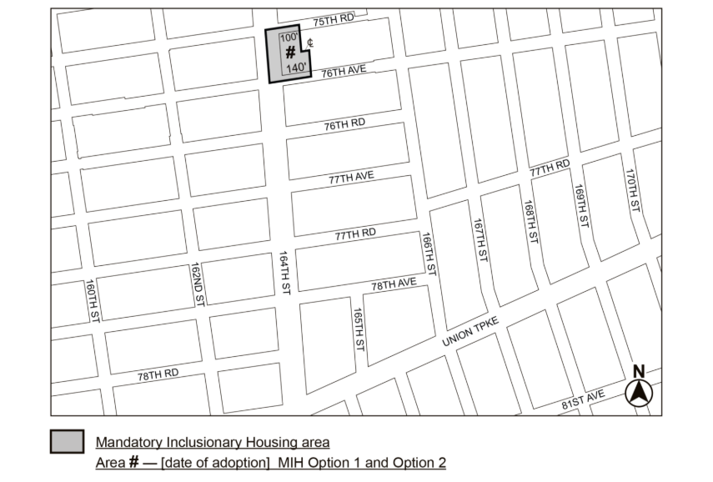
Portion of Community District 8, Queens

* * *
Adopted.

Office of the City Clerk, }
The City of New York, } ss.:

I hereby certify that the foregoing is a true copy of a Resolution passed by The Council of The City of New York on ______________, on file in this office.

.....................................................
City Clerk, Clerk of The Council

