THE COUNCIL OF THE CITY OF NEW YORK
RESOLUTION NO. 1704

Resolution approving the decision of the City Planning Commission on Application No. N 150277 ZRK, for an amendment of the Zoning Resolution of the City of New York, modifying Appendix F for the purpose of establishing a Mandatory Inclusionary Housing area in Community District 1, Borough of Brooklyn (L.U. No. 762).

By Council Members Greenfield and Richards

WHEREAS, the City Planning Commission filed with the Council on September 19, 2017 its decision dated September 19, 2017 (the "Decision"), pursuant to Section 201 of the New York City Charter, regarding an application submitted by Harrison Realty, LLC, for an amendment of the text of the Zoning Resolution of the City of New York, modifying Appendix F for the purpose of establishing a Mandatory Inclusionary Housing area. This amendment in conjunction with the related action would facilitate the development of eight mixed use buildings, containing approximately 1,146 dwelling units, of which 287 units, or 25 percent of the residential floor area, would be set aside for permanently affordable housing; 62,810 square feet of ground floor retail; 404 accessory parking spaces; and 26,000 square feet of public open space in the South Williamsburg neighborhood of Brooklyn, (Application No. N 150277 ZRK), Community District 1, Borough of Brooklyn (the "Application");

WHEREAS, the Application is related to application C 150278 ZMK (L.U. No. 761), a zoning map amendment to change from an M3-1 to R7A, R7D, R8A districts with C2-4 overlay;

WHEREAS, the Decision is subject to review and action by the Council pursuant to Section 197-d(b)(1) of the City Charter;
WHEREAS, upon due notice, the Council held a public hearing on the Decision and Application on October 10, 2017;

WHEREAS, the Council has considered the land use implications and other policy issues relating to the Decision and Application; and

WHEREAS, the Council has considered the relevant environmental issues, including the Final Environmental Impact Statement (FEIS) for which a Notice of Completion was issued on September 8, 2017 (CEQR No. 15DCP117K), which included an (E) designation to avoid the potential for significant adverse impacts related to hazardous materials, air quality and noise (E-427);

RESOLVED:

Having considered the FEIS with respect to the Decision and Application, the Council finds that:

(1) The FEIS meets the requirements of 6 N.Y.C.R.R. Part 617;

(2) Consistent with social, economic and other essential considerations, from among the reasonable alternatives thereto, the action is one which minimizes or avoids adverse environmental impacts to the maximum extent practicable; and

(3) The adverse environmental impacts disclosed in the FEIS will be minimized or avoided to the maximum extent practicable by incorporating as conditions to the approval, pursuant to the restrictive declaration dated September 14, 2017, those project components related to the environment and mitigation measures that were identified as practicable;

The Decision and the FEIS constitute the written statement of facts, and of social, economic and other factors and standards that form the basis of this determination, pursuant to 6 N.Y.C.R.R. §617.11(d).

Pursuant to Sections 197-d and 200 of the City Charter and on the basis of the Decision and Application, and based on the environmental determination and consideration described in the report, N 150277 ZRK, incorporated by reference herein, the Council approves the Decision of the City Planning Commission.

Matter underlined is new, to be added;
Matter struck out is to be deleted;
Matter within # # is defined in Section 12-10;
* * * indicates where unchanged text appears in the Zoning Resolution

* * *

APPENDIX F

Inclusionary Housing Designated Areas and Mandatory Inclusionary Housing Areas

* * *
BROOKLYN

Brooklyn Community District 1
In Waterfront Access Plan BK-1, and in the R6, R6A, R6B, R7A, R7D, R7-3, and R8 and R8A Districts within the areas shown on the following Maps 1, 2, 3 and 4:

* * *

Map 4. [date of adoption]

[EXISTING MAP]
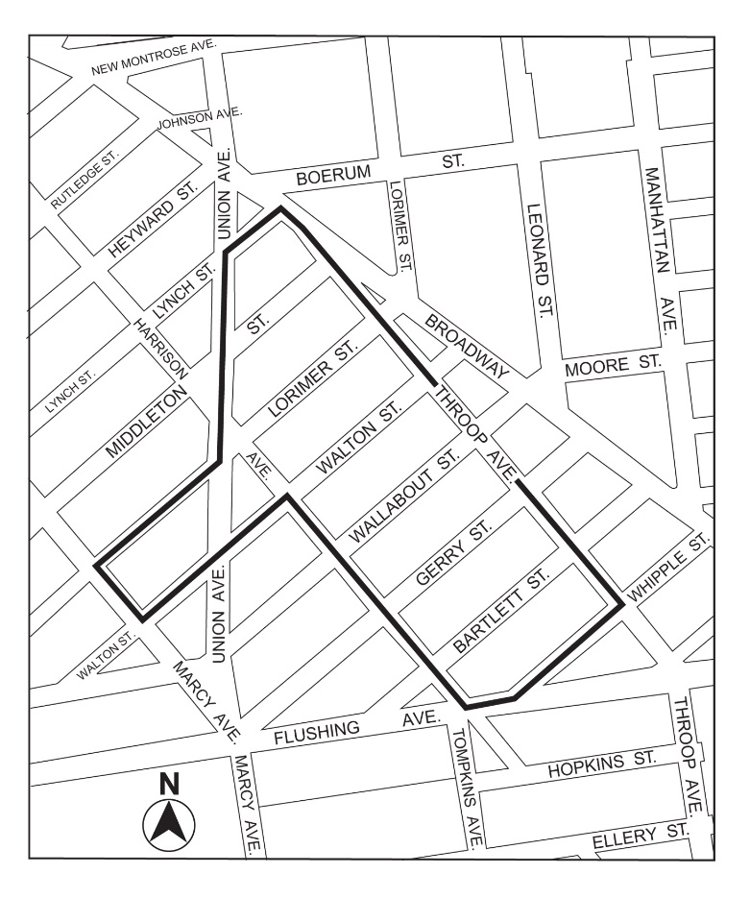

[PROPOSED MAP]

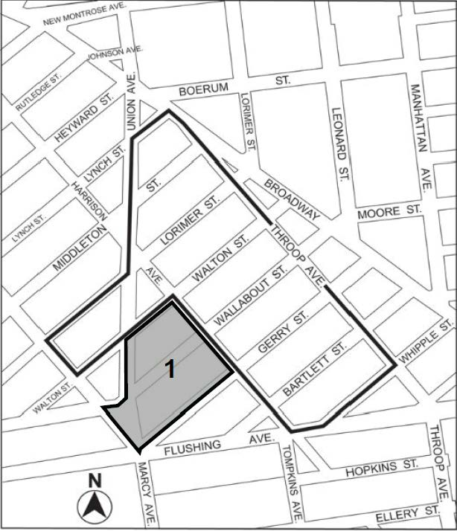

Inclusionary Housing designated area
Mandatory Inclusionary Housing area see Section 23-154(d)(3)
Area 1 [date of adoption] – MIH Program Option 1

Portion of Community District 1, Brooklyn

* * *
Adopted.

Office of the City Clerk, }
The City of New York, } ss.:

I hereby certify that the foregoing is a true copy of a Resolution passed by The Council of The City of New York on October 31, 2017, on file in this office.

.....…….........................................
City Clerk, Clerk of The Council

