THE COUNCIL OF THE CITY OF NEW YORK
RESOLUTION NO. 154

Resolution approving the decision of the City Planning Commission on Application No. N 140099 ZRK, for an amendment of the Zoning Resolution of the City of New York, pertaining to the regulations governing ferry and water taxi docking facilities in Community District 1 in the Borough of Brooklyn (L.U. No. 20).

By Council Members Greenfield and Weprin

WHEREAS, the City Planning Commission filed with the Council on February 7, 2014 its decision dated February 5, 2013 (the "Decision"), pursuant to Section 201 of the New York City Charter, regarding an application submitted by the New York City Economic Development Corporation, for an amendment of the text of the Zoning Resolution of the City of New York, establishing a non-discretionary Chairperson certification process to increase the capacity of ferry vessels permitted to dock in R6-R10 Residence Districts, as well as all Commercial and Manufacturing Districts along the Brooklyn Community District 1 waterfront. The proposed certification also would waive parking and drop-off/pick-up requirements, and would require that applicants meet site design standards to ensure harmonious interaction between ferry docks and waterfront public access areas (Application No. N 140099 ZRK), Community District 1, Borough of Brooklyn (the "Application");

WHEREAS, the Decision is subject to review and action by the Council pursuant to Section 197-d(b)(1) of the City Charter;
WHEREAS, upon due notice, the Council held a public hearing on the Decision and Application on March 4, 2014;

WHEREAS, the Council has considered the land use implications and other policy issues relating to the Decision and Application; and

WHEREAS, the Council has considered the relevant environmental issues, the negative declaration (CEQR No. 13DME009Y) issued on October 16, 2013 (the “Negative Declaration”);

RESOLVED:

The Council finds that the action described herein will have no significant impact on the environment as set forth in the Negative Declaration.

Pursuant to Sections 197-d and 200 of the City Charter and on the basis of the Decision and Application, and based on the environmental determination and consideration described in this report, N 140099 ZRK, incorporated by reference herein, the Council approves the Decision.

The Zoning Resolution of the City of New York, effective as of December 15, 1961, and as subsequently amended, is further amended as follows:

Matter in underline is new, to be added;
Matter in strikeout is to be deleted;
Matter with # # is defined in Section 12-10;
* * * indicates where unchanged text appears in the Zoning Resolution

Article II
Residence District Regulations

* * *

Chapter 2
Use Regulations

* * *

22-00
GENERAL PROVISIONS

In order to carry out the purposes and provisions of this Resolution, the #uses# of #buildings or other structures# and the open #uses# of #zoning lots#, or portions thereof, have been classified and combined into Use Groups. A brief statement is inserted at the start of each Use Group to describe and clarify the basic characteristics of that Use Group. Use Groups 1, 2, 3, and 4 and 6, including each #use# listed separately therein, are permitted in #Residence Districts# only as indicated in Sections 22-11 to 22-14 22-15, inclusive.

The following chart sets forth the Use Groups permitted in the #Residence Districts#.

* * *
Whenever a #use# is specifically listed in a Use Group and also could be construed to be incorporated within a more inclusive #use# listing, either in the same or another Use Group, the more specific listing shall control.

The #uses# listed in the various Use Groups set forth in Sections 22-11 to 22-1422-15, inclusive, are also listed in alphabetical order in the Index at the end of this Resolution for the convenience of those using this Resolution. Whenever there is any difference in meaning or implication between the text of these Use Groups and the text of the Index, the text of these Use Groups shall prevail.
* * *

22-10
USES PERMITTED AS-OF-RIGHT

* * *

22-15
Use Group 6C

R6 R7 R8 R9 R10

In the districts indicated, when located within Community District 1 in the Borough of Brooklyn, Use Group 6C, as set forth in Section 32-15 (Use Group 6), shall be limited to docks for ferries, other than #gambling vessels#, with a vessel capacity of up to 399 passengers, and docks for water taxis, with a vessel capacity of up to 99 passengers, provided that such docks are certified by the Chairperson of the City Planning Commission, pursuant to Section 62-813 (Docking facilities for ferries or water taxis in certain waterfront areas). Vessel capacity is the U.S. Coast Guard certified capacity of the largest vessel using a dock.

* * *

22-20
USES PERMITTED BY SPECIAL PERMIT

* * *

22-22
By the City Planning Commission

In the districts indicated, the following #uses# are permitted by special permit of the City Planning Commission, in accordance with standards set forth in Article VII, Chapter 4, or as otherwise indicated in this Section.

R3 R4 R5 R6 R7 R8 R9 R10

Docks for ferries or water taxis as listed in Use Group 6 pursuant to Section 62-832 (Docks for ferries or water taxis in Residence Districts), except in R6 through R10 Districts in Community District 1 in the Borough of Brooklyn.

* * *

Article III
Commercial District Regulations

* * *

Chapter 2
Use Regulations

* * *

32-10
USES PERMITTED AS-OF-RIGHT

* * *
32-15
Use Group 6
C1 C2 C4 C5 C6 C8

* * *

- Retail or Service Establishments

* * *

Clothing rental establishments, limited to 10,000 square feet of #floor area# per establishment [PRC-B]

Docks for ferries, other than #gambling vessels#, limited to an aggregate operational passenger load, per #zoning lot#, of 150 passengers per half hour. In Community District 1 in the Borough of Brooklyn, docks for ferries with a vessel capacity of up to 399 passengers shall be allowed, provided that such docks are certified by the Chairperson of the City Planning Commission pursuant to Section 62-813 (Docking facilities for ferries or water taxis in certain waterfront areas).The maximum dock capacity is the U.S. Coast Guard certified capacity of the largest vessel using the dock. [PRC-H]

Docks for water taxis, with a vessel capacity of up to 99 passengers. with vessel capacity limited to 99 passengers In Community District 1 in the Borough of Brooklyn, such docks shall be certified by the Chairperson of the City Planning Commission pursuant to Section 62-813 (Docking facilities for ferries or water taxis in certain waterfront areas). The maximum dock capacity is the U.S. Coast Guard certified capacity of the largest vessel using the dock.

Docks or mooring facilities for non-commercial pleasure boats [PRC-H]

* * *
32-19
Use Group 10

C4 C5 C6 C8

* * *

- Retail or Service Establishments

* * *

Depositories for storage of office records, microfilm or computer tapes, or for data processing [PRC-G]

Docks for ferries, other than #gambling vessels#, with no restriction on passenger load. In Community District 1 in the Borough of Brooklyn, such docks shall be certified by the Chairperson of the City Planning Commission, pursuant to Section 62-813 (Docking facilities for ferries or water taxis in certain waterfront areas). [PRC-H]

Dry goods or fabric stores, with no limitation on #floor area# per establishment [PRC-B]

* * *

32-23
Use Group 14

C2 C3 C7 C8
Use Group 14 consists of the special services and facilities required for boating and related activities.

- Retail or Service

* * *
Candy or ice cream stores [PRC-B]

Docks for ferries, other than #gambling vessels#, limited to an aggregate operational passenger load, per #zoning lot#, of 150 passengers per half hour. In Community District 1 in the Borough of Brooklyn, docks for ferries with a vessel capacity of up to 399 passengers shall be allowed, provided that such docks are certified by the Chairperson of the City Planning Commission pursuant to Section 62-813 (Docking facilities for ferries or water taxis in certain waterfront areas). [PRC-H]

Docks for sightseeing, excursion or sport fishing vessels, other than #gambling vessels#, limited to the following aggregate dock capacities per #zoning lot#:

200 in C2, C3 Districts; 500 in C7, C8-1, C8-2, C8-3 Districts; 2,500 in C8-4 Districts.

"Dock capacity" is the U.S. Coast Guard certified capacity of the largest vessel using a dock. "Aggregate dock capacity" is the sum of the dock capacities of all docks on the #zoning lot#.

Docks for water taxis, with a vessel capacity of up to 99 passengers. with vessel capacity limited to 99 passengers In Community District 1 in the Borough of Brooklyn, such docks shall be certified by the Chairperson of the City Planning Commission pursuant to Section 62-813 (Docking facilities for ferries or water taxis in certain waterfront areas). The maximum dock capacity is the U.S. Coast Guard certified capacity of the largest vessel using the dock.

Docks or mooring facilities for non-commercial pleasure boats [PRC-H]

* * *

Article VI
Special Regulations Applicable To Certain Areas

Chapter 2
Special Regulations Applying in the Waterfront Area

* * *

62-50
GENERAL REQUIREMENTS FOR VISUAL CORRIDORS AND WATERFRONT PUBLIC ACCESS AREAS

* * *

62-52
Applicability of Waterfront Public Access Area Requirements

Waterfront public access shall be provided for all #waterfront zoning lots# with a #lot area# of at least 10,000 square feet and a #shoreline# of at least 100 feet that are #developed#, and for all #developments# on #floating structures#, in accordance with the provisions of the following Sections:

* * *

- #Waterfront public access areas# required in conjunction with the following #developments# shall be subject to the minimum #waterfront public access area# set forth in the table in Section 62-57 and the requirements of Section 62-58 (Requirements for Water-Dependent Uses and Other Developments):

- #developments# comprised #predominantly# of the following WD #uses#: docks for non-commercial pleasure boats, ferries, sightseeing, excursion or sport fishing vessels, #boatels# or commercial beaches;

- #developments# on #piers# or #platforms# that involve existing #buildings or other structures# that are either New York City-designated landmarks or have been calendared for consideration, or are listed or eligible to be listed in the National or New York State Registers of Historic Places; or

(3) changes of #use# or #extensions# within #buildings# existing on October 25, 1993, which involve, in aggregate, an amount of #floor area# that is less than 30 percent of the maximum #floor area# permitted on the #zoning lot# for either #commercial# or #residential use#, whichever is greater.

In Community District 1 in the Borough of Brooklyn, on #zoning lots# with #developments# comprised exclusively of docks for ferries with a vessel capacity of up to 399 passengers, and #accessory# amenities for such docking facilities, such #zoning lots# shall be exempt from the waterfront public access requirements of this Section, provided that such docking facilities are certified by the Chairperson of the City Planning Commission, pursuant to Section 62-813 (Docking facilities for ferries or water taxis in certain waterfront areas). However, for any subsequent #development# on such #zoning lot# that is not comprised exclusively of docks for ferries, the public access requirements of this Section shall apply, and any public access exemptions for such docks for ferries shall no longer apply.

* * *
62-60
DESIGN REQUIREMENTS FOR WATERFRONT PUBLIC ACCESS AREAS

* * *

62-611
Permitted obstructions

#Waterfront public access areas# shall be unobstructed from their lowest level to the sky except that the obstructions listed in this Section shall be permitted, as applicable. However, no obstructions of any kind shall be permitted within a required circulation path.

(a) In all areas

* * *

(c) Beyond 20 feet of the #shoreline#

Tot-lots, playgrounds, dog runs, public telephones, toilets, bicycle racks.

- In Community District 1 in the Borough of Brooklyn

In Community District 1 in the Borough of Brooklyn, any amenity #accessory# to docking facilities for ferries or water taxis shall be considered a permitted obstruction only where such amenity is certified by the Chairperson of the City Planning Commission in conjunction with the docking facility, pursuant to Section 62-813 (Docking facilities for ferries or water taxis in certain waterfront areas).

* * *

62-63
Design Requirements for Public Access on Piers and Floating Structures

62-631
Design requirements for public access on piers

The design requirements of this Section shall apply to #waterfront public access areas# on #piers#, pursuant to Section 62-54.

(a) Circulation and access

At least one circulation path having a minimum clear width of ten feet shall be provided throughout the public access area required on the #pier#.

(b) Permitted obstructions

In addition to permitted obstructions pursuant to Section 62-611, #pier# public access areas may include one freestanding open or enclosed public pavilion, provided such structure does not exceed one #story#, is no taller than 30 feet and has an area no larger than 1,600 square feet. At least 50 percent of the perimeter wall area on all sides, up to a height of 15 feet, shall consist of clear or glazed materials which may include #show windows#, glazed transoms, glazed portions of doors or latticework. Such structures shall be exempt from #building# spacing requirements on #piers# provided they maintain a spacing of at least 12 feet from other #buildings# and from any water edge of the #pier#, except that when a #pier# is 30 feet or less in width, a pavilion may abut one water edge.

In Community District 1 in the Borough of Brooklyn, any amenity #accessory# to docking facilities for ferries or water taxis shall be considered a permitted obstruction only where such amenity is certified by the Chairperson of the City Planning Commission in conjunction with the docking facility, pursuant to Section 62-813 (Docking facilities for ferries or water taxis in certain waterfront areas).

(c) Seating

At least one linear foot of seating is required for every 100 square feet of #pier# public access area, subject to the provisions of paragraphs (a) through (d) of Section 62-652.

* * *

62-80
SPECIAL REVIEW PROVISIONS

* * *

62-81
Certifications by the Chairperson of the City Planning Commission

* * *

62-813
Docking facilities for ferries or water taxis in certain waterfront areas

In Community District 1 in the Borough of Brooklyn, docking facilities for ferries or water taxis set forth in paragraph (a) of this Section shall be permitted, provided that the Chairperson of the City Planning Commission certifies to the Commissioner of the Department of Buildings that such docking facilities comply with the standards for required amenities set forth in paragraph (b) of this Section and, where provided, the standards for permitted amenities set forth in paragraph (c) of this Section. In conjunction with such certification, parking and drop-off and pick-up area requirements for docking facilities with a vessel capacity of up to 399 passengers shall be waived, as applicable. Where such docking facilities are proposed within a #waterfront public access area#, such docking facilities shall also comply with the provisions of paragraph (d) of this Section. Where modifications to a docking facility certified pursuant this Section are made, including the amount or configuration of docking facility amenities, establishment of, or modification to, #waterfront public access areas# on the same #waterfront zoning lot#, or the cessation of ferry or water taxi service to such docking facility, the provisions of paragraph (e) of this Section shall apply.

The amount of amenities permitted or required pursuant to paragraphs (b) and (c) of this Section shall be calculated for each docking facility on the #waterfront zoning lot# and not according to the number of vessels a single docking facility can accommodate.

- Docking facilities

The following docking facilities are subject to the certification provisions of this Section:

- docks for water taxis, with a vessel capacity of up to 99 passengers, as listed in Use Group 6C, when located within R6 through R10 Districts, or C1, C2, C4, C5, C6 or C8 Districts, and as listed in Use Group 14A, when located in C2, C3, C7 or C8 Districts and #Manufacturing Districts#;

- docks for ferries, other than #gambling vessels#, with a vessel capacity of up to 399 passengers, as listed in Use Group 6C, when located within R6 through R10 Districts or C1, C2, C4, C5, C6 or C8 Districts, and as listed in Use Group 14A, when located in C2, C3, C7 or C8 Districts and #Manufacturing Districts#; and

- docks for ferries with an unlimited capacity, as listed in Use Group 10A, in C4, C5, C6, C8 Districts and #Manufacturing Districts#.

- Required amenities

Passenger queuing space, bicycle parking and a trash receptacle shall be provided in accordance with the applicable provisions of this paragraph, (b), inclusive. All applications shall include a site plan denoting the location of each required amenity, dimensioned plans and elevations of individual amenities, as applicable, as well as any other material required to demonstrate compliance with such provisions.

- Passenger queuing space

Passenger queuing space shall be provided in accordance with the provisions of this paragraph, (b)(1), inclusive.

- Amount

A minimum of four square feet of queuing space per passenger shall be provided on the #waterfront zoning lot# for 40 percent of the U.S. Coast Guard certified passenger capacity of the largest vessel proposed to dock at such facility. Queuing space may be either standing space or seating space, and may be either open to the sky or provided within a sheltered space for passengers in accordance with the provisions of paragraph (c)(1), inclusive, of this Section.

- Standing space

All standing queuing space shall be contiguous and clear of obstructions, except for any interruption by circulation paths required for access to docking facilities through a gangway, or pier access thereto. However, such standing queuing space may be non-contiguous and temporary dividers may be permitted as obstructions within such queuing space where the applicant signs an affidavit, or provides materials demonstrating in a manner that is satisfactory to the Chairperson, that an attendant will manage queues whenever such measures are implemented.

- Seating space

A minimum of ten percent of required queuing space shall be provided as seating, and up to 50 percent of required queuing space may be provided as seating. However, no seating shall be required within a previously approved #waterfront public access area#. For the purpose of applying seating towards the queuing requirement, one linear foot of seating shall equal one square foot of queuing space.

All seating provided for queuing space shall comply with the applicable dimensional criteria of Section 62-652 (Seating), but need not comply with the percentage requirements for different types of seating required pursuant to such Section. However, moveable chairs shall not constitute seating for queuing.

Any seating space provided pursuant to this Section within an existing or proposed #waterfront public access area# shall not count towards the maximum amount of seating permitted to be located seaward of the #shore public walkway# pursuant to paragraph (b) of Section 62-62 (Design Requirements for Shore Public Walkways and Supplemental Public Access Areas).

- Location

Queuing space shall be provided on the #waterfront zoning lot# within 150 feet of the landward terminus of the gangway leading to the docking facility.

- Bicycle parking

Bicycle racks sufficient to provide at least four bicycle parking spaces shall be provided on the #waterfront zoning lot#. Such bicycle racks shall comply with the standards of Section 62-657.

- Trash receptacle

One trash receptacle shall be provided on the #waterfront zoning lot# within 25 feet of the landward terminus of the gangway leading to the docking facility. Such trash receptacle shall comply with the standards of Section 62-658.

- Permitted amenities

Passenger queuing shelters and ticketing machines may be provided only in accordance with the applicable standards of this paragraph, (c), or, where applicable, the authorization provisions set forth in Section 62-824 (Modifications to passenger queuing shelters for ferry or water taxi docking facilities).

All applications shall include a site plan denoting the location of such amenities, dimensioned plans and elevations of individual amenities, as well as any other material required to demonstrate compliance with the following standards:

- Passenger queuing shelter

Where provided, passenger queuing shelters shall comply with the provisions of this paragraph, (c)(1), inclusive. All heights are measured from adjoining grade.

- Maximum dimensions and permitted enclosing walls

The maximum height of a shelter shall be ten feet. Below a height of seven feet, the maximum width shall be four feet, and above a height of seven feet, the maximum width shall be eight feet. The maximum length of a shelter shall not exceed 16 feet, except that where a ticketing machine provided pursuant to paragraph (c)(2) of this Section is located within such shelter, such maximum length may be increased to 20 feet.

Shelters shall be permitted a total of three enclosing walls, one along the long dimension of the shelter, and one along each narrow end.

- Support structures below the roof

A maximum of two vertical columns may support the enclosing walls and the roof of a shelter, except that where a ticketing machine provided pursuant to paragraph (c)(2) of this Section is located within such shelter, an additional column shall be permitted. The maximum width and depth of such columns shall not exceed twelve inches. All such columns shall be aligned so that when viewed in elevation view along the narrow end of the shelter, only one column shall be visible.

Below a height of 30 inches, one horizontal structural element shall be permitted along the long dimension of the shelter. The maximum depth and height of such structural element shall not exceed twelve inches. Between a height of 30 inches and seven feet no horizontal structural elements shall be permitted, and above a height of seven feet, horizontal structural elements shall be considered part of the roof structure.

Additional support structures needed to support glazing in the enclosing walls are permitted, provided that such structures are to the minimum amount necessary.

- Roof structure

The roof of the shelter, including all associated structural elements and materials, shall be located above a height of seven feet.

The maximum depth of the roof, including all associated structural elements and materials, shall not exceed twelve inches, as measured perpendicular to the roof surface. In addition, within six inches of the edge of any portion of the roof that cantilevers over passenger queuing space, as viewed in elevation along the narrow end of the shelter, the depth of the roof shall be limited to three inches.

No slopes or curves shall be permitted in the roof along the long dimension of the shelter. Along the narrow end of the shelter, slopes not to exceed fifteen degrees and curves with a radius of at least ten feet shall be permitted. Where two slopes are provided, in no event shall both portions of the roof angle downward from the same point.

- Materials, lighting and permitted signage

On each narrow end of the shelter, the enclosing wall or associated vertical support column may accommodate up to six square feet of way-finding ferry #signs#, with a width not to exceed twelve inches. In addition, the enclosing wall on the long end of the shelter or a face of a ticketing machine provided in accordance with paragraph (c)(2) of this Section may accommodate up to six square feet of materials related to ferry operations, including maps and schedules of ferry service. No #advertising signs# shall be permitted.

All structural elements shall be composed of unpainted, metallic materials. The entire surface area of all enclosing walls shall be composed of untinted, transparent materials, except for transparency distraction markers and any support structures or signage permitted pursuant to this paragraph, (c)(1). A minimum of 50 percent of the surface area of the roof shall be composed of translucent materials, except that any portion occupied by solar panels shall be excluded from such calculation. Benches provided within a shelter shall either match or complement such shelter materials.

Where lighting is provided within a shelter, the luminaire shall be shielded so the light source is not visible.

- Location and orientation

Shelters shall be provided on the #waterfront zoning lot# within 100 feet of the landward terminus of the gangway leading to the docking facility.

The long dimension of the shelter shall be oriented so as to be within 15 degrees of being perpendicular to the shoreline or, where located on a pier, within 15 degrees of being parallel to such pier.

Where a shelter is provided within a previously approved #waterfront public access area#, the Chairperson may modify the location and orientation provisions of this Section, to the minimum extent necessary, where site limitations would make compliance with such provisions infeasible.

- Ticketing machines

Ticketing machines provided in conjunction with a docking facility shall comply with the provisions of this paragraph, (c)(2).

- Maximum square footage

The maximum area of all ticket machines, as measured in plan around the furthest extent of such machines, shall not exceed 12 square feet.

- Location

Ticketing machines shall be provided on the #waterfront zoning lot# within 100 feet of the landward terminus of the gangway leading to the docking facility.

Where a passenger queuing shelter is provided in conjunction with the ferry or water taxi docking facility pursuant to paragraph (c)(1) of this Section, ticketing machines shall be located either within, or immediately adjacent to the upland portion of such shelter.

Any ticketing machine not placed within a passenger queuing shelter shall be placed in a location open to the sky.

Ticketing machines shall either front directly upon a required circulation path or shall be connected thereto by a walkway with an unobstructed minimum clear width of at least five feet.

Where a ticketing machine is provided within a previously approved #waterfront public access area#, the Chairperson may modify the location provisions of this Section, to the minimum extent necessary, where site limitations would make compliance with such provisions infeasible.

- Provisions for adding amenities for docking facilities to a #waterfront public access area#

Docking facilities proposed within a previously approved #waterfront public access area# or in conjunction with a certification for such approval, pursuant to Section 62-811 (Waterfront public access areas and visual corridors), shall comply with the applicable provisions of this paragraph, (d).

- Permitted obstructions

In no event shall amenities provided pursuant to paragraphs (b) or (c) of this Section be permitted to encroach upon the minimum circulation paths required pursuant to the applicable provisions of Sections 62-62 (Design Requirements for Shore Public Walkways and Supplemental Public Access Areas), 62-63 (Design Requirements for Public Access on Piers and Floating Structures), and 62-64 (Design Requirements for Upland Connections).

- Providing amenities in previously approved #waterfront public access areas#

All seating, bicycle parking and trash receptacles provided for docking facilities in accordance with the provisions of paragraph (b) of this Section, within a previously approved #waterfront public access area#, shall be provided in addition to the amount of seating, bicycle parking, or trash receptacles required for such #waterfront public access area# pursuant to the applicable provisions of Section 62-60 (DESIGN REQUIRMENTS FOR WATERFRONT PUBLIC ACCESS AREAS). Where excess seating, bicycle parking or trash receptacles have been provided within such previously approved #waterfront public access areas#, such additional amenities may be applied towards compliance with the provisions for docking facilities of this Section, provided that such amenities comply with the applicable provisions of paragraph (b) of this Section. Where previously approved #waterfront public access areas# are #non-complying# as to the provision of required amenities, in no event shall the minimum amount of amenity provided for docking facilities pursuant to paragraph (b) reduce the degree of #non-compliance# of such #waterfront public access area#.

All seating, bicycle parking and trash receptacles provided in accordance with the provisions of paragraph (b) of this Section in an existing #waterfront public access area# shall either match or shall be comparable with such existing amenities, with regard to quality, materials, finishes, and form.

Modifications to a previously approved #waterfront public access area# in order to accommodate amenities to be provided for a docking facility in accordance with paragraphs (b) or (c) of this Section shall not constitute a design change to such #waterfront public access area#, and shall not necessitate a new certification pursuant to Section 62-811, provided that the applicant demonstrates to the Chairperson of the City Planning Commission that such modifications are to the minimum extent necessary in order to accommodate the amenities being provided for such docking facility.

- Providing amenities in conjunction with a new #waterfront public access area#

All amenities provided for docking facilities in accordance with the provisions of paragraph (b) of this Section shall be provided in addition to all required seating, bicycle parking, or trash receptacles for a #waterfront public access area# being #developed# in conjunction with the provision of a docking facility. All such proposed amenities for the docking facility shall complement the proposed amenities for such #waterfront public access area#.

- Modifications of certified docking facilities

Any modification to a docking facility certified pursuant to this Section, shall comply with the applicable provisions of this paragraph, (e).

- Modification of amenities

Any modification of the required or permitted amenities for a docking facility certified pursuant to this Section, including the configuration of such amenities, shall be subject to a new certification pursuant to this Section.

Any ferry or water taxi service modification resulting in a reduction of passenger capacity of the largest vessel docking at such facility shall not be subject to a new certification provided that the amount of queuing space required at the time of approval, pursuant to paragraph (b) of this Section, is not diminished.

- Establishment of or modifications to #waterfront public access areas#

Any establishment of a #waterfront public access area# or modification to a previously approved #waterfront public access area# where a docking facility certified pursuant to this Section is located, shall require a new certification, pursuant to this Section, in conjunction with the certification set forth in Section 62-811 (Waterfront public access areas and visual corridors).

- Cessation of ferry or water taxi service

Where ferry or water taxi service ceases operations to a docking facility certified pursuant to this Section, and ferry docking infrastructure is removed from the #waterfront zoning lot# which would preclude further service, the following shall apply:

- Passenger queuing shelters and ticketing machines provided pursuant to paragraph (c) of this Section shall be removed from the #waterfront public access area#;

- Seating, bicycle racks, and litter receptacles provided pursuant to paragraph (b) of this Section need not be removed; and

- any breach in a guardrail along a #pier# or along the #shore public walkway# to accommodate a gangway to a docking facility shall be repaired and shall match the adjacent guardrail.

* * *

62-82
Authorizations by the City Planning Commission

62-821
Modification of requirements for ferries and sightseeing, excursion or sport fishing vessels

- In C1, C2, C3 and C7 Districts, the City Planning Commission may authorize modification of the #use# regulations of Section 32-10 (USES PERMITTED AS-OF-RIGHT) in order to allow docks for ferries with an operational passenger load greater than 150 passengers per half hour, or in Community District 1 in the Borough of Brooklyn, a vessel capacity larger than 399 passengers, provided the Commission finds that:

- such facility will not create serious pedestrian or vehicular traffic congestion that would adversely affect the surrounding area;

- the #streets# providing access to such facility will be adequate to handle the traffic generated thereby; and

- such #use# is so located as to draw a minimum of vehicular traffic to and through local #streets# in adjoining residential areas.

* * *

62-824
Modifications to passenger queuing shelters for ferry or water taxi docking facilities

In Community District 1 in the Borough of Brooklyn, the City Planning Commission may authorize a ferry passenger queuing shelter exceeding the dimensions set forth in paragraph (c)(1) of Section 62-813 (Docking facilities for ferries or water taxis in certain waterfront areas), provided that the Commission finds that:

- the public benefit derived from the proposed shelter merits the larger dimensions authorized;

- the proposed shelter utilizes the design standards set forth in paragraph (c)(1) of Section 62-813 regarding permitted support structures, materials, signage and roof construction to the greatest extent feasible;

- any modification to such provisions of Section 62-813 will not unduly limit views from the #waterfront public access area#; and

- the design of the proposed shelter will result in a quality structure that complements the #waterfront public access area# or the publicly accessible area of a #waterfront zoning lot# accommodating the ferry or water taxi docking facility.

62-83
Special Permits by the City Planning Commission

* * *

62-832
Docks for ferries or water taxis in Residence Districts

In all #Residence Districts#, except R1 and R2 Districts, and except within Community District 1 in the Borough of Brooklyn, where the certification provisions of Section 62-813 (Docking facilities for ferries or water taxis in certain waterfront areas) shall apply, the City Planning Commission may permit docks for ferries or water taxis as listed in Use Group 6., provided that:

As a condition for granting a special permit, the Commission shall find that:

- such facility will not create serious pedestrian or vehicular traffic congestion that would adversely affect surrounding residential #streets#;

- such #use# is so located as to draw a minimum of vehicular traffic to and through local #streets# in the adjoining residential area;

- there is appropriate landscaping along #lot lines# to enable such #use# to blend harmoniously with the adjoining residential area;

- #accessory# off-street parking spaces are provided in accordance with Section 62-43 (Parking Requirements for Commercial Docking Facilities) and the entrances and exits for such #accessory# parking facilities are so located as to not adversely affect #residential# properties fronting on the same #street#; and

- such #use# will not impair the character or the future use or development of the surrounding residential area.

The Commission may prescribe additional appropriate conditions and safeguards to minimize adverse effects on the character of the surrounding area and to protect #residential# properties which are adjoining or across the #street# from the facility. Such additional conditions and safeguards may include provisions for temporary parking of vehicles for passenger drop-off and pick-up, additional #accessory# off-street parking spaces and limitations on lighting and signage.

* * *

62-90
WATERFRONT ACCESS PLANS

* * *

62-93
Borough of Brooklyn

The following Waterfront Access Plans are hereby established within the Borough of Brooklyn. All applicable provisions of Article VI, Chapter 2, remain in effect within the areas delineated by such plans, except as expressly set forth otherwise in the plans:

BK-1: Greenpoint-Williamsburg, as set forth in Section 62-931.

62-931
Waterfront Access Plan BK-1: Greenpoint-Williamsburg

Maps BK-1a through BK-1c in paragraph (f) of this Section show the boundaries of the area comprising the Greenpoint-Williamsburg Waterfront Access Plan and the location of certain features mandated or permitted by the Plan. The plan area has been divided into parcels consisting of tax blocks and lots and other lands as established on May 11, 2005, as follows:

* * *

(c) Public access design reference standards

Section 62-65 is hereby modified by the following provisions.

(1) Guardrails

In addition to the provisions of paragraph (a) of Section 62-651 (Guardrails, gates and other protective barriers), guardrails shall comply with Illustration A1 of this Section.

[DELETE EXISTING ILLUSTRATION]

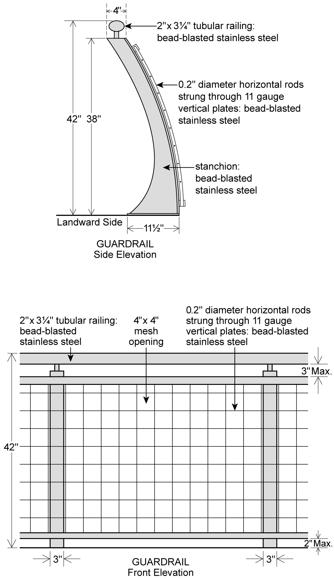

[REPLACE WITH THIS ILLUSTRATION]

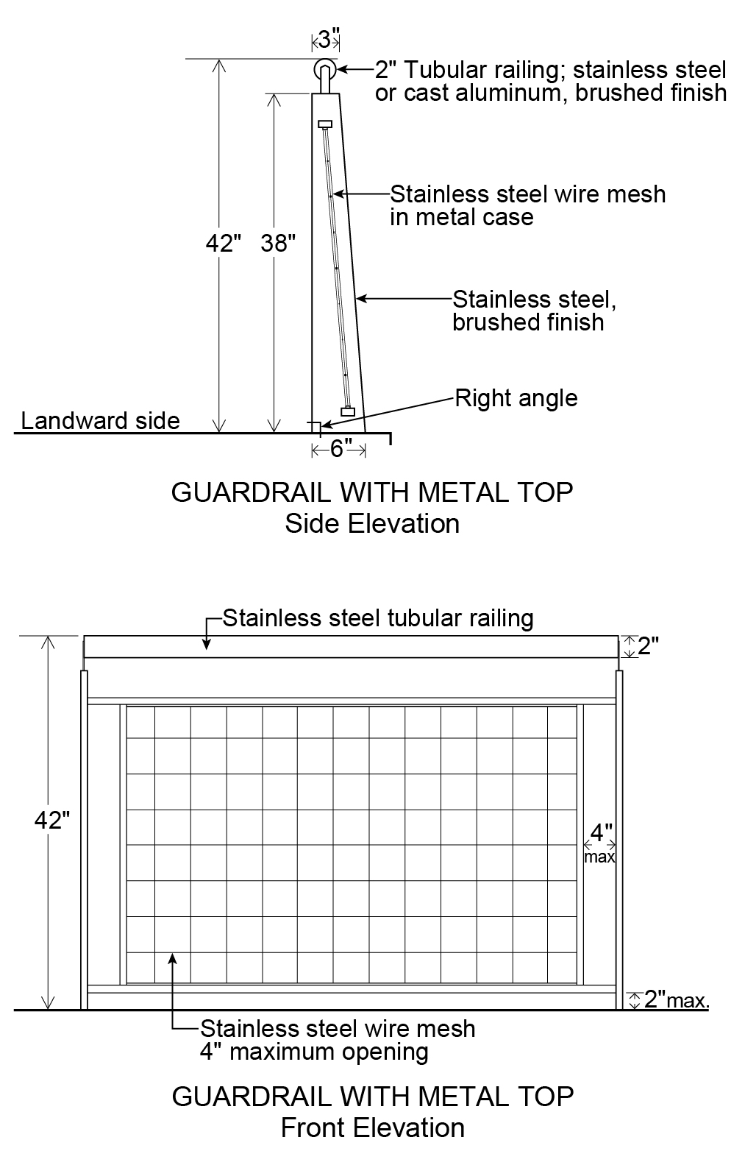

Illustration A1

All guardrail components and hardware shall be in No. 316 Stainless Steel, passivated and bead blasted.

(2) Seating

In addition to the provisions of Section 62-652, at least 50 percent of the required seating along any #shore public walkway# or #supplemental public access area# shall comply with Illustration B1 or B2 in this Section.

[DELETE EXISTING ILLUSTRATIONS]

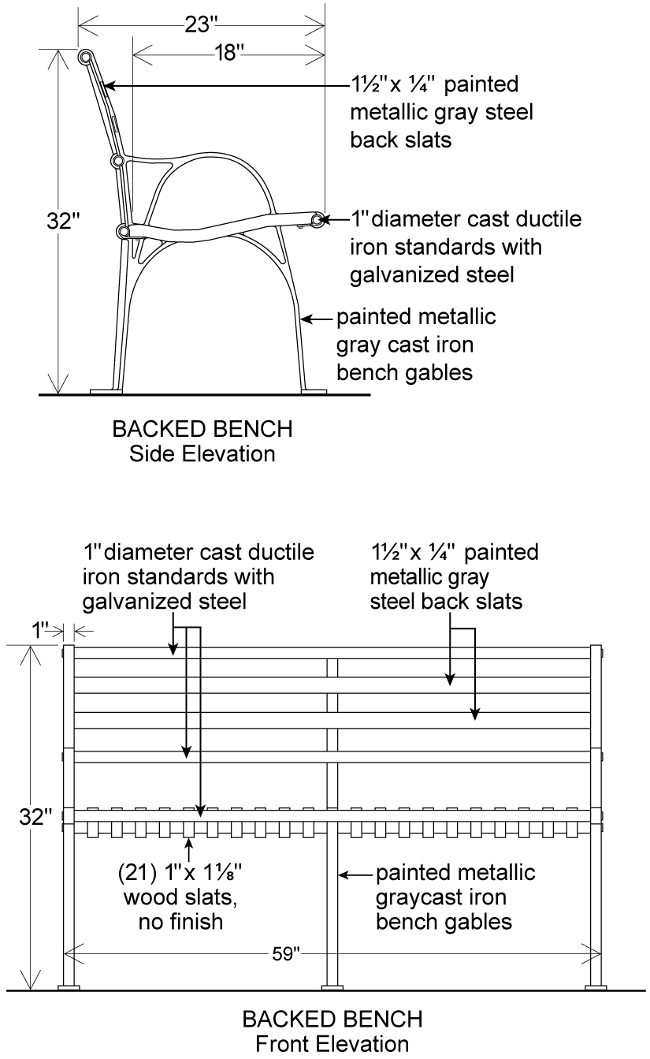

Illustration B1

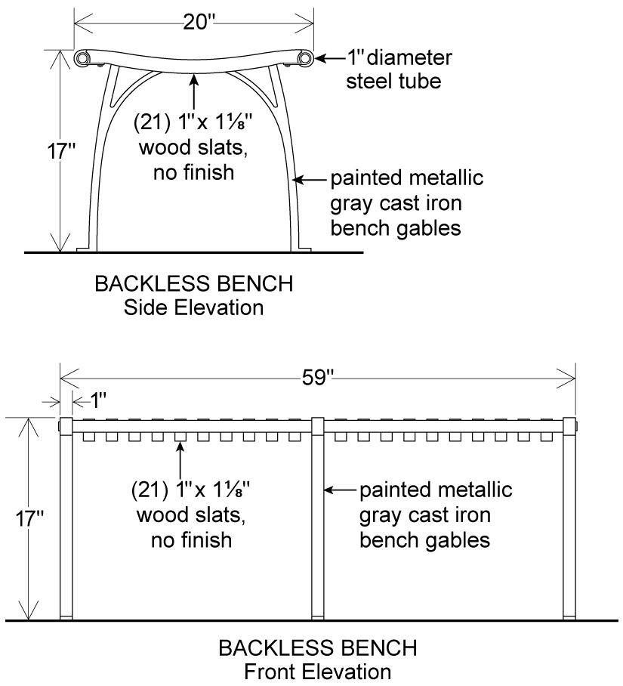

Illustration B2

All wood boards shall be made of domestically grown non-tropical hardwoods, such as American White Oak (Quercus alba), and be treated for external use without stain or varnish.

(3)(2) Lighting

In addition to the illumination provisions of Section 62-653, the required lighting along any public access area shall comply with Illustration C1 in this Section.

* * *

(4)(3) Paving

In addition to the provisions of Section 62-656, the paving for the required clear path within the #shore public walkway# shall be gray. At least 50 percent of all other paved areas within the #shore public walkway# and #supplemental public access areas# shall be paved in the same color range.

* * *

Adopted.
Office of the City Clerk, }
The City of New York, } ss.:

I hereby certify that the foregoing is a true copy of a Resolution passed by The Council of The City of New York on March 26, 2014, on file in this office.

.....…….........................................
City Clerk, Clerk of The Council

