THE COUNCIL OF THE CITY OF NEW YORK
RESOLUTION NO. 638

Resolution approving with modifications the decision of the City Planning Commission on Application No. N 230207 ZRM, for an amendment of the text of the Zoning Resolution (L.U. No. 150).

By Council Members Salamanca and Riley

WHEREAS, Crosscap Holdings, LLC, filed an application pursuant to Section 201 of the New York City Charter, for an amendment of the text of the Zoning Resolution of the City of New York, modifying special permit provisions of Article X, Chapter 4 (Special Manhattanville Mixed Use District) and modifying APPENDIX F for the purpose of establishing a Mandatory Inclusionary Housing area, which in conjunction with the related actions would facilitate the development of a seven-story mixed-use development with 60 residential units, including a Mandatory Inclusionary Housing requirement, at 701 West 135th Street (Block 2101, Lot 58) in the West Harlem neighborhood of Manhattan, Community District 9 (ULURP No. N 230207 ZRM), (the “Application”);
WHEREAS, the City Planning Commission filed with the Council on September 6, 2024 its decision dated August 21, 2024 (the "Decision") on the Application;
WHEREAS, the Application is related to applications C 230206 ZMM (L.U. No. 149), a zoning map amendment to change an M1-1 district to an R7-2 district with a C2-4 overlay and expand the Special Manhattanville Mixed Use District; C 230208 ZSM (L.U. No. 151), a zoning special permit pursuant to Section 74-61 of the Zoning Resolution to allow development over a portion of the railroad right-of-way; and C 230209 ZSM (L.U. No. 152), a zoning special permit pursuant to Section 104-60 of the Zoning Resolution to modify the rear yard and lot coverage requirements;
WHEREAS, the Decision is subject to review and action by the Council pursuant to Section 197-d of the City Charter;
WHEREAS, upon due notice, the Council held a public hearing on the Decision and Application on September 17, 2024 and September 24, 2024;
WHEREAS, the Council has considered the land use implications and other policy issues relating to the Decision and Application; and
WHEREAS, the Council has considered the relevant environmental issues, including the Negative Declaration issued March 29th, 2024 (CEQR No. 23DCP140M), which includes an (E) designation to avoid the potential for significant adverse impacts related to hazardous materials, air quality, and noise (E-761) (the “Negative Declaration”).

RESOLVED:

The Council finds that the action described herein will have no significant impact on the environment as set forth in the (E) Designation (E-761) and Negative Declaration.

Pursuant to Sections 197d and 200 of the City Charter and on the basis of- the Decision and Application, and based on the environmental determination and consideration described in the report, N 230207 ZRM, incorporated by reference herein, and the record before the Council, the Council approves the Decision of the City Planning Commission, with the following modifications.

Matter underlined is new, to be added;
Matter struck out is to be deleted;
Matter double-underlined is new, added by the City Council;
Matter double struck out is old, deleted by the City Council;
Matter within # # is defined in Section 12-10;
* * * indicates where unchanged text appears in the Zoning Resolution.

* * *

ARTICLE X
SPECIAL PURPOSE DISTRICTS

Chapter 4
Special Manhattanville Mixed Use District

* * *

104-30
SPECIAL HEIGHT AND SETBACK REQUIREMENTS

* * *

The City Planning Commission may modify, by special permit, the special height and setback requirements of this Section pursuant to Section 104-60 (MODIFICATION OF SPECIAL BULK REQUIREMENTS AND TRANSFER OF FLOOR AREA BY SPECIAL PERMIT).

* * *

104-50
PERMITTED TRANSFER OF FLOOR AREA

* * *

Floor area may be transferred as follows:

* * *

(c) by special permit, in accordance with the provisions of Section 104-60 (MODIFICATION OF SPECIAL BULK REQUIREMENTS AND TRANSFER OF FLOOR AREA BY SPECIAL PERMIT), where the proposed development or enlargement on the receiving site requires modification of the bulk regulations of Section 104-30 (SPECIAL HEIGHT AND SETBACK REQUIREMENTS).

* * *

104-60
MODIFICATION OF SPECIAL BULK REQUIREMENTS AND TRANSFER OF FLOOR AREA BY SPECIAL PERMIT

The City Planning Commission may, by special permit:

(a) modify the special height and setback requirements of Section 104-30 (SPECIAL HEIGHT AND SETBACK REQUIREMENTS), inclusive, provided the Commission finds that such modifications are necessary to:

* * *

(b) permit the transfer of #floor area# from any granting site to a receiving site for a #development# that requires modification of the special height and setback requirements of Section 104-30, inclusive, provided the Commission finds:

* * *

(c) modify the applicable #bulk# requirements for any #development# or #enlargement# that is subject to the provisions of Section 74-681 (Development within or over a railroad or transit right-of-way or yard), except #floor area ratio# provisions, provided that such #bulk# modifications will:

(1) not unduly obstruct access to light and air to surrounding #streets# and properties; and

(2) be compatible with the essential character of the surrounding area.

The Commission may prescribe additional conditions and safeguards to minimize adverse effects of the #development# or #enlargement# on the character of the surrounding area.

* * *

Appendix A
Special Manhattanville Mixed Use District Plan

Map 1 - Special Manhattanville Mixed Use District and Subdistricts

[EXISTING MAP]

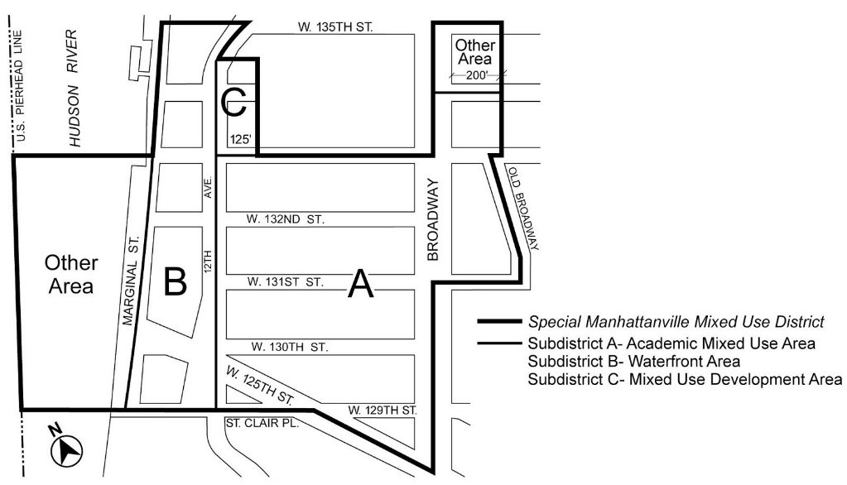

[PROPOSED MAP]

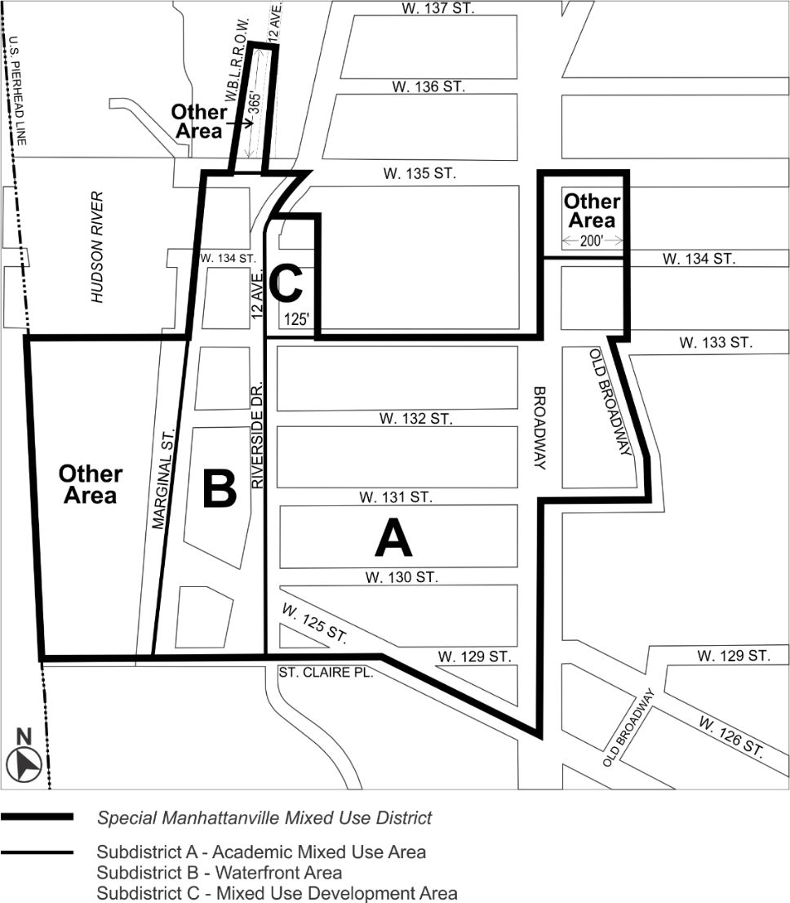

* * *

Map 4 - Street Wall Types and Locations

[EXISTING MAP]

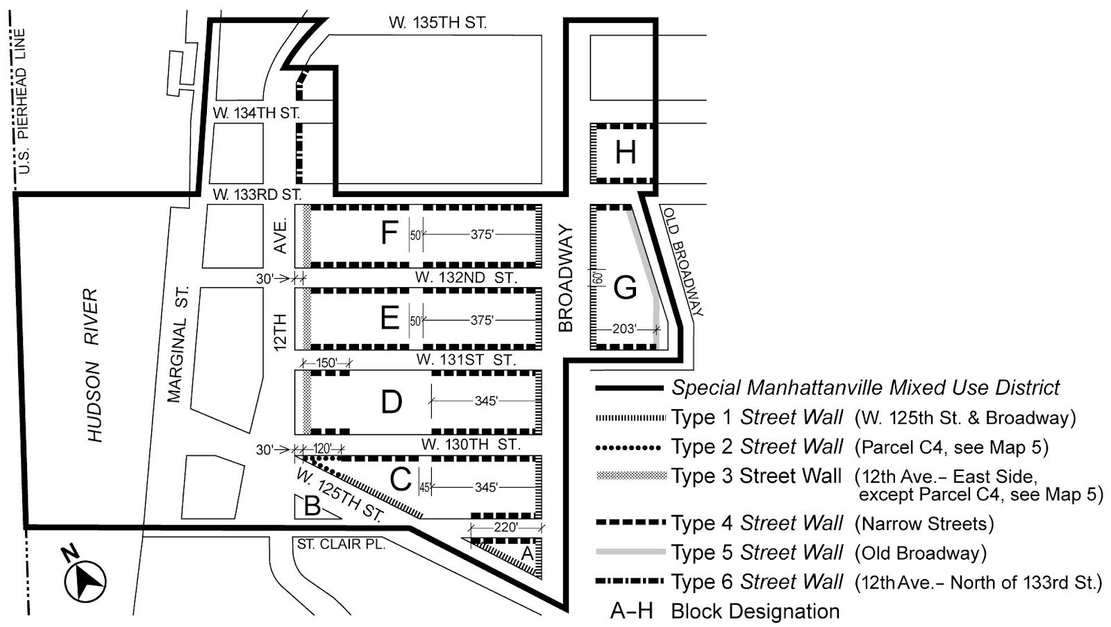

[PROPOSED MAP]

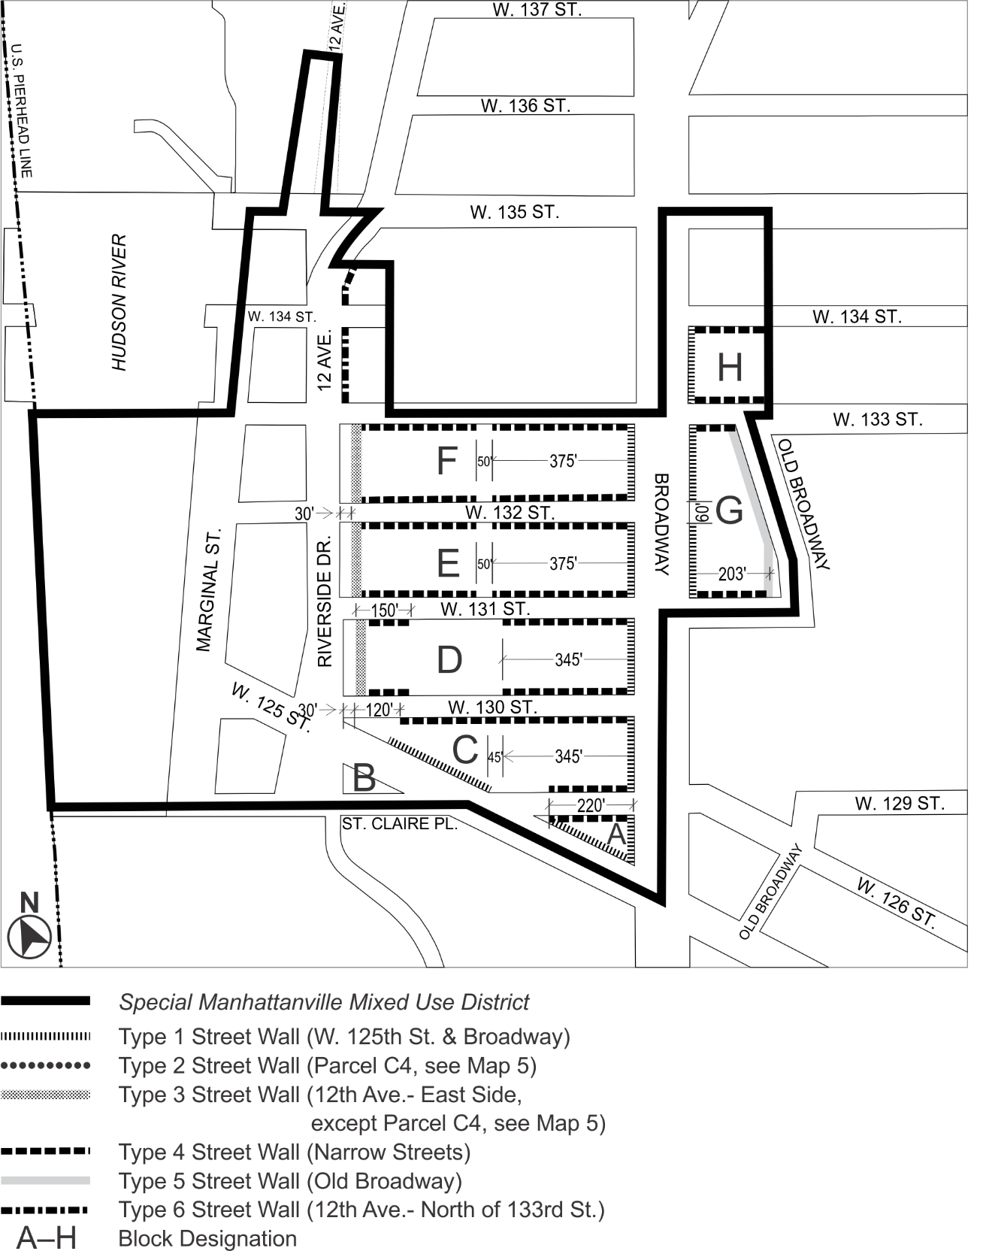
Map 5 - Parcel Designation and Maximum Building Heights

[EXISTING MAP]
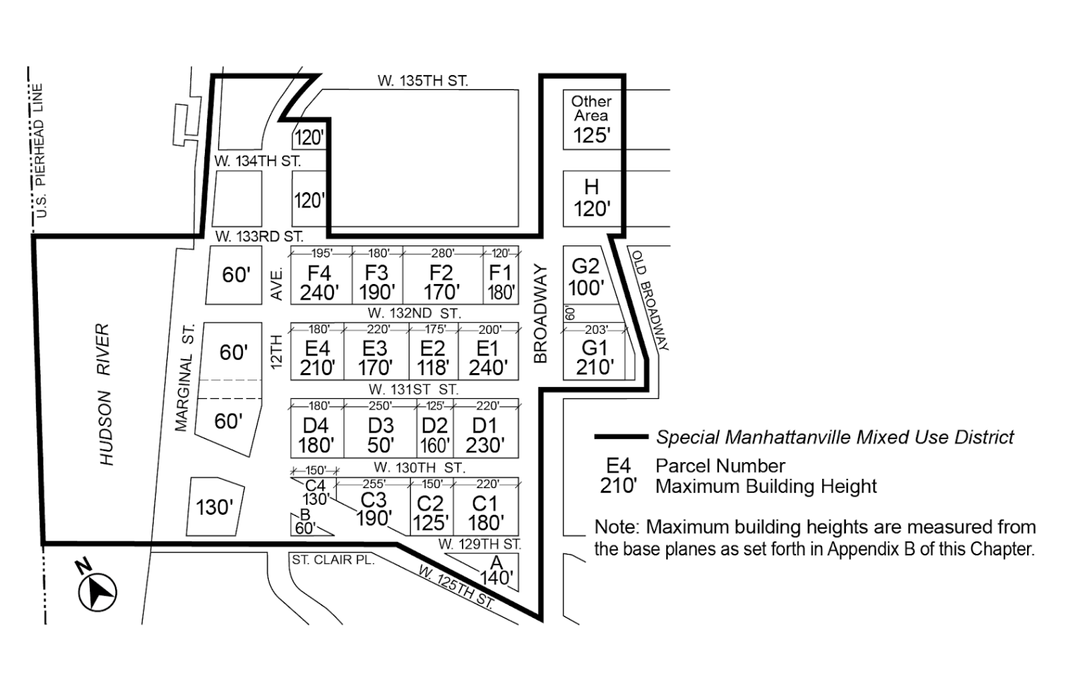

[PROPOSED MAP]

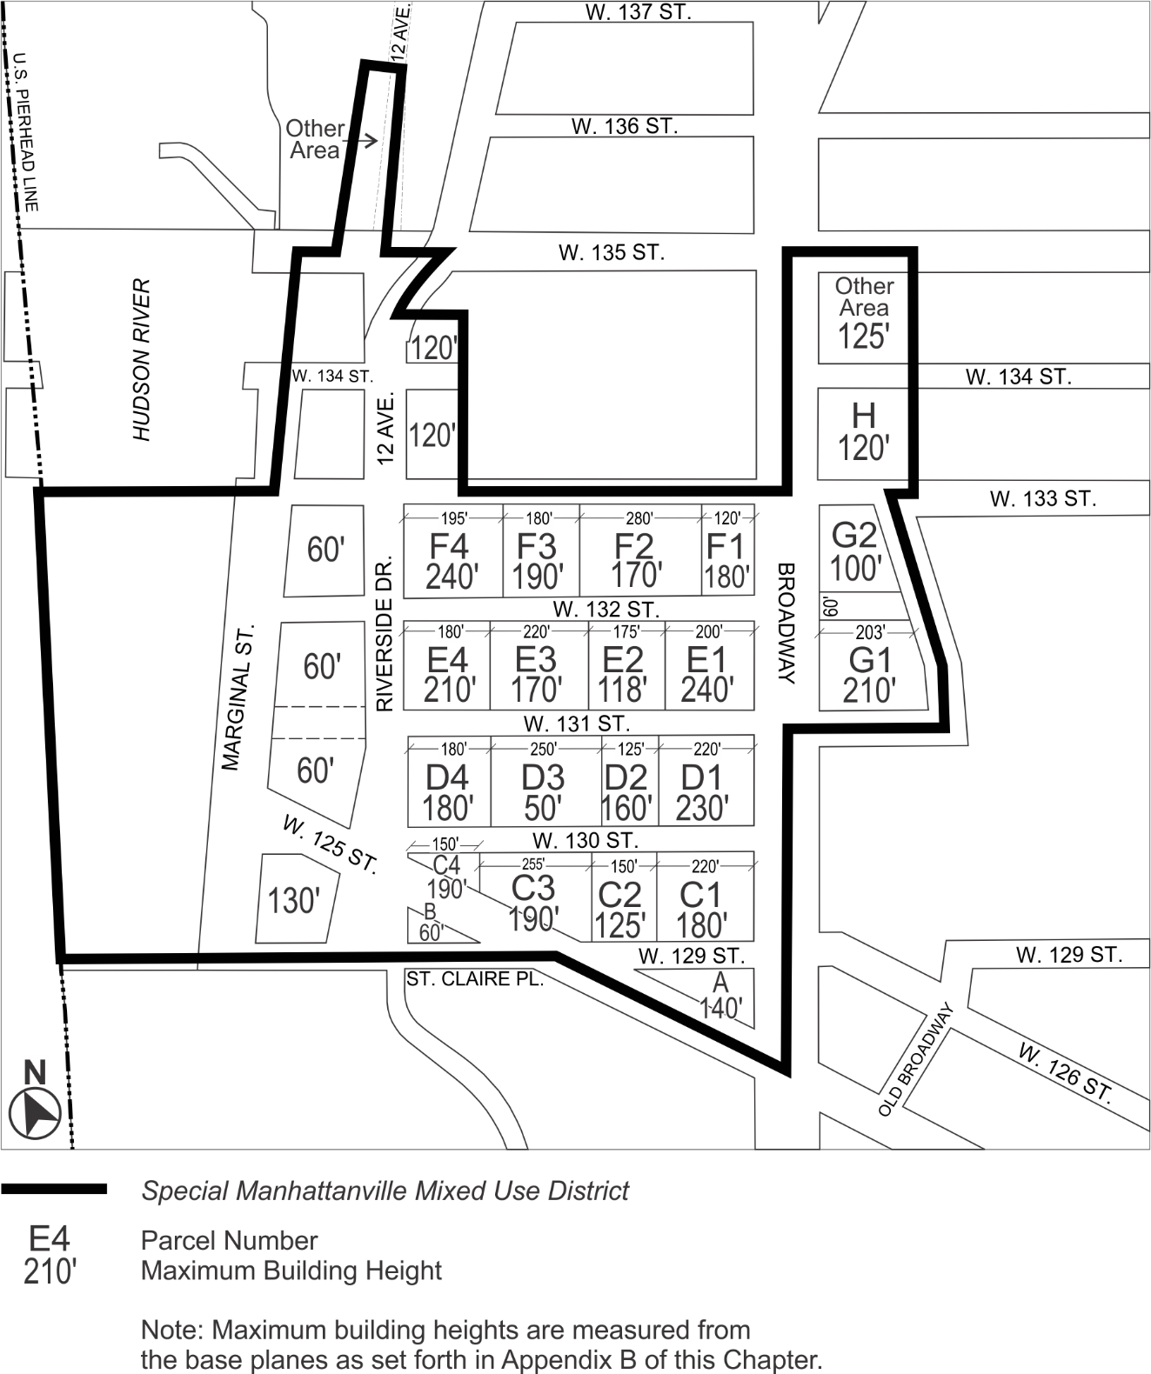

Map 6 - Ground Floor Use and Frontage

[EXISTING MAP]

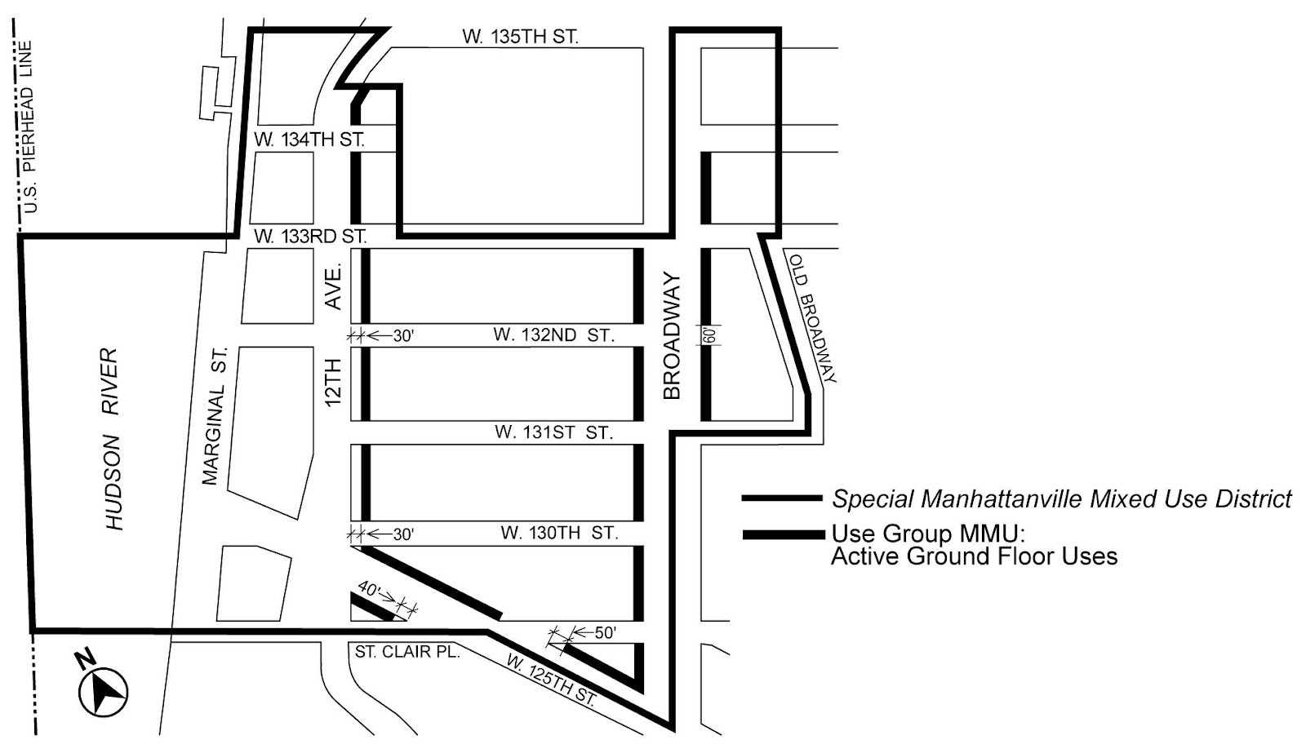

[PROPOSED MAP]

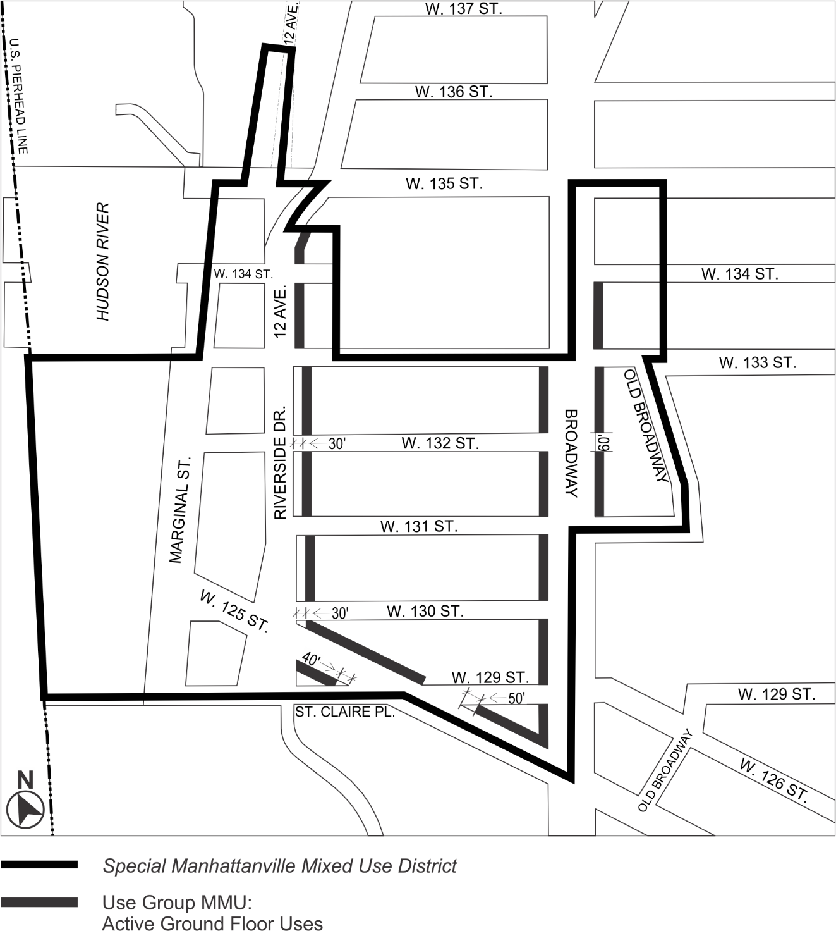

Map 7 – Mandatory Open Areas

[EXISTING MAP]

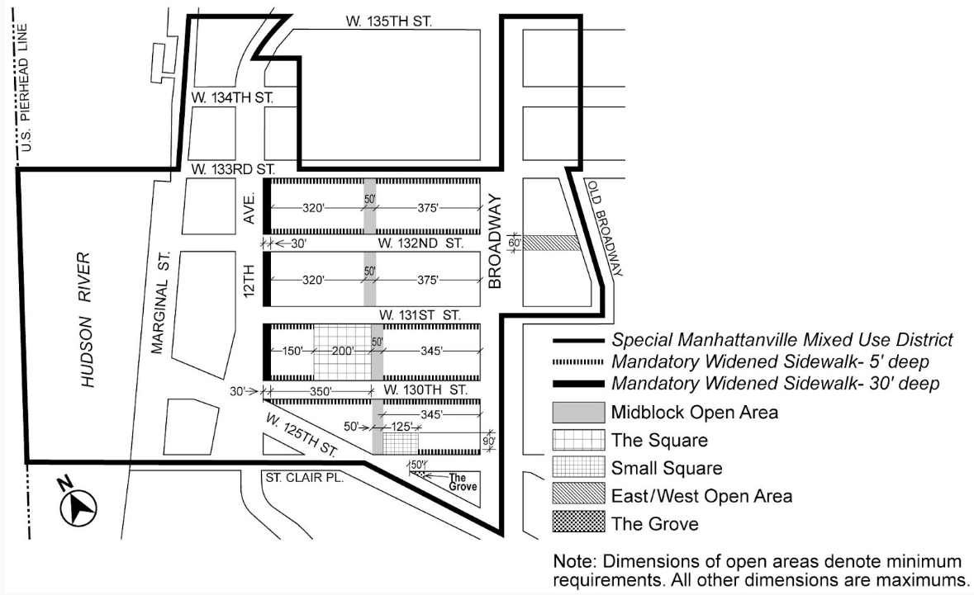

[PROPOSED MAP]

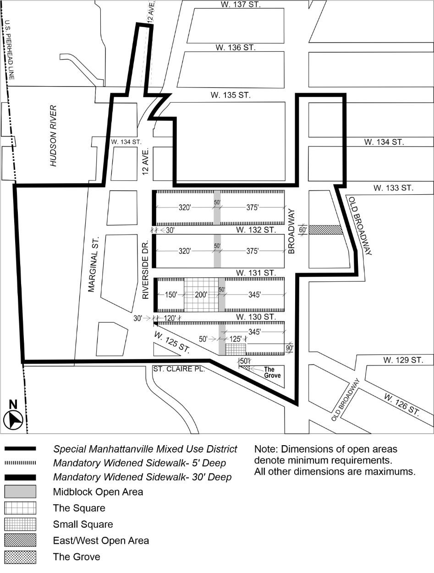

* * *

APPENDIX F
Inclusionary Housing Designated Areas and Mandatory Inclusionary Housing Areas
* * *

MANHATTAN
* * *
Manhattan Community District 9
* * *

Map 2 – [date of adoption]
[PROPOSED MAP]
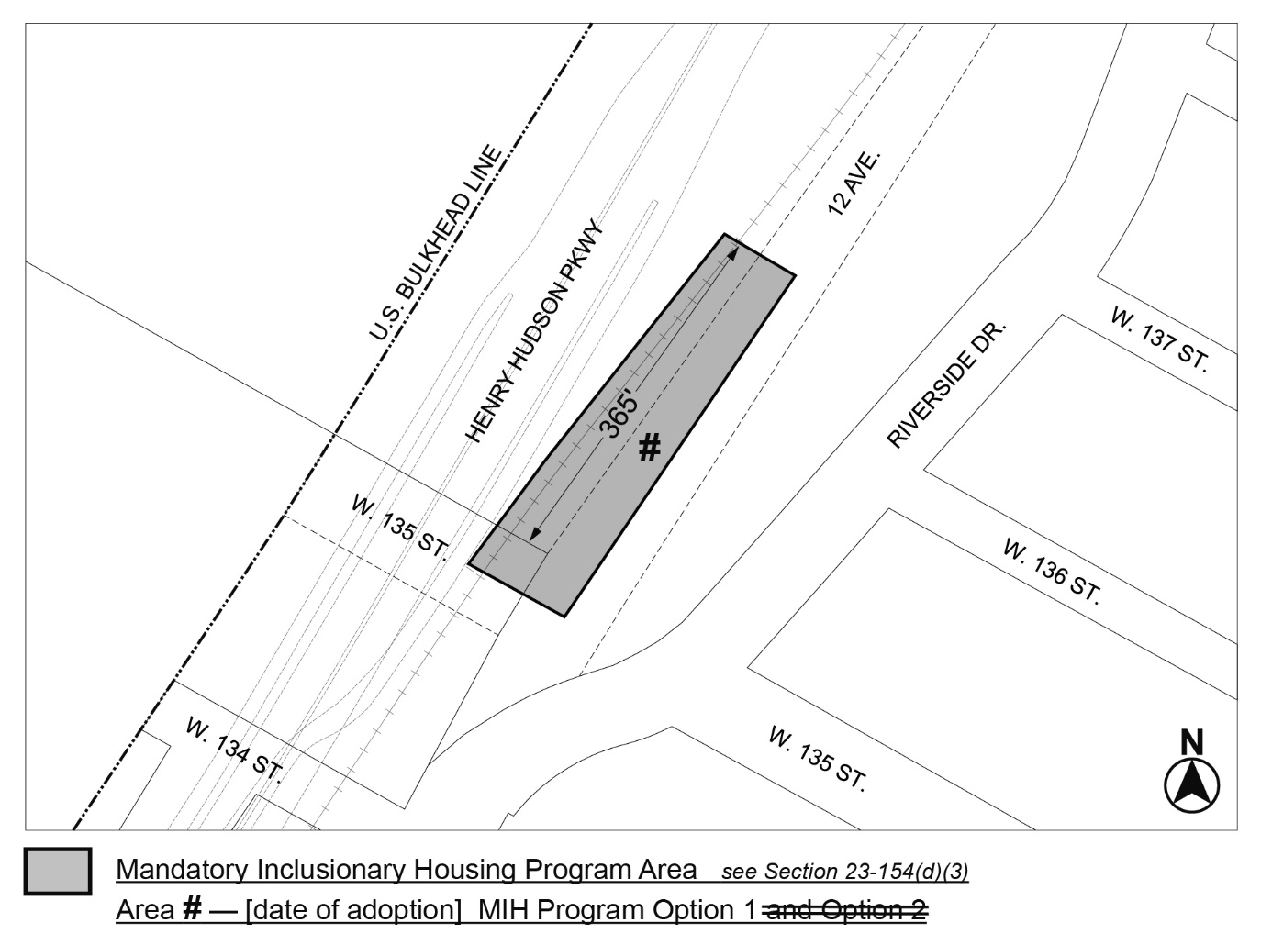
Portion of Community District 9, Manhattan
* * *
Adopted.

Office of the City Clerk,}
The City of New York, } ss.:

I hereby certify that the foregoing is a true copy of a Resolution passed by The Council of The City of New York on _________, 2024, on file in this office.

.....................................................
City Clerk, Clerk of The Council

