THE COUNCIL OF THE CITY OF NEW YORK
RESOLUTION NO. 536

Resolution approving with modifications the decision of the City Planning Commission on Application No. N 180149 ZRK (Preconsidered L.U. No. 165), for an amendment of the Zoning Resolution of the City of New York, modifying Appendix F for the purpose of establishing a Mandatory Inclusionary Housing area, Community District 4, Borough of Brooklyn.

By Council Members Salamanca and Moya

WHEREAS, the City Planning Commission filed with the Council on July 13, 2018 its decision dated July 11, 2018 (the "Decision"), pursuant to Section 201 of the New York City Charter, regarding an application submitted by 1601 DeKalb Avenue Owner, LLC, for an amendment of the text of the Zoning Resolution of the City of New York, modifying Appendix F for the purpose of establishing a Mandatory Inclusionary Housing (MIH) area on a portion of one block (Block 3237) fronting on Wyckoff Avenue, Hart Street, and DeKalb Avenue, which in conjunction with the related action would facilitate the development of two new nine-story residential buildings containing approximately 122 residential units, including 27 permanently affordable units, in the Bushwick neighborhood of Community District 4, Brooklyn, (Application No. N 180149 ZRK), Community District 4, Borough of Brooklyn (the "Application");

WHEREAS, the Application is related to application C 180148 ZMK (Pre. L.U. No. 164), a zoning map amendment to change M1-1 and R6 zoning districts to R7A, R7A/C2-4, and R6B zoning districts;

WHEREAS, the Decision is subject to review and action by the Council pursuant to Section 197-d(b)(1) of the City Charter;
WHEREAS, upon due notice, the Council held a public hearing on the Decision and Application on July 17, 2018;

WHEREAS, the Council has considered the land use implications and other policy issues relating to the Decision and Application; and

WHEREAS, the Council has considered the relevant environmental issues, including the negative declaration issued February 12, 2018 (CEQR No. 18DCP061K), which includes an (E) designations to avoid the potential for significant adverse impacts related to hazardous material, air quality and noise (E-465) (the “Negative Declaration”).

RESOLVED:

The Council finds that the action described herein will have no significant impact on the environment as set forth in the Negative Declaration.

Pursuant to Section 200 of the City Charter and on the basis of the Decision and Application, and based on the environmental determination and consideration described in the report, N 180149 ZRK, incorporated by reference herein, the Council approves the Decision of the City Planning Commission with the following modifications:

Matter underlined is new, to be added;
Matter struck out is to be deleted;
Matter within # # is defined in Section 12-10;
Matter double struck out is old, deleted by the City Council;
Matter double-underlined is new, added by the City Council;
* * * indicates where unchanged text appears in the Zoning Resolution.

* * *

APPENDIX F
Inclusionary Housing Designated Areas and Mandatory Inclusionary Housing Areas

* * *

Brooklyn

* * *

Brooklyn Community District 4

* * *

Map 2 - [date of adoption]

[PROPOSED MAP]

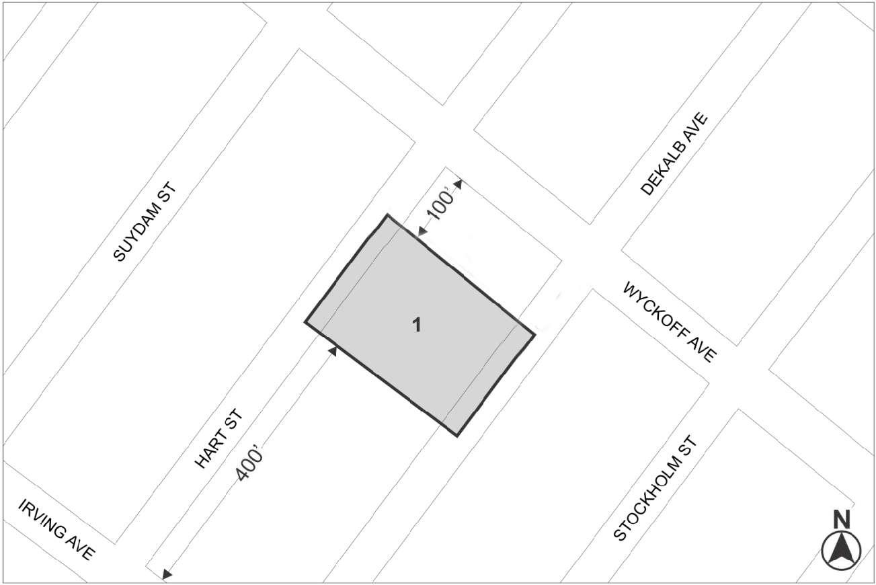

Mandatory Inclusionary Housing Program Area - see Section 23-154(d)(3)
Area 1 [date of adoption] — MIH Program Option 1 and Option 2 Deep Affordability Option

Portion of Community District 4, Brooklyn
* * *

Adopted.

Office of the City Clerk, }
The City of New York, } ss.:

I hereby certify that the foregoing is a true copy of a Resolution passed by The Council of The City of New York on September 12, 2018, on file in this office.

.....……......................................... City Clerk, Clerk of The Council

