THE COUNCIL OF THE CITY OF NEW YORK
RESOLUTION NO. 576

Resolution approving the decision of the City Planning Commission on Application No. N 260163 ZRK for an amendment of the text of the Zoning Resolution (L.U. No. 109).

By Council Members Riley and Louis

WHEREAS, Khalifah Residences LLC, filed an application pursuant to Section 201 of the New York City Charter, for an amendment of the Zoning Resolution of the City of New York, amending APPENDIX F (Mandatory Inclusionary Housing Areas and former Inclusionary Housing Designated Areas) for the purpose of establishing a Mandatory Inclusionary Housing area, which, in conjunction with the related action, would facilitate the development of a new 12-story mixed-use building with approximately 144 income-restricted dwelling units, 13,400 square feet of community facility use, and 4,800 square feet of ground floor commercial at 1166 Bedford Avenue, in the Bedford-Stuyvesant neighborhood of Brooklyn (ULURP No. C 260162 ZMK) (the "Application"),

WHEREAS, the City Planning Commission filed with the Council on June 24, 2026, its decision dated June 17, 2026 (the "Decision") on the Application;

WHEREAS, the Application is related to application C 260162 ZMK (L.U. No. 108), Zoning map amendment to change an R6A district to an R7X district;

WHEREAS, the Decision is subject to review and action by the Council pursuant to Section 197-d of the City Charter;

WHEREAS, upon due notice, the Council held a public hearing on the Decision and Application on July 1, 2026;

WHEREAS, the Council has considered the land use implications and other policy issues relating to the Decision and Application; and

WHEREAS, the Council has considered the relevant environmental issues, including the Type II Memorandum issued on January 15, 2026, pursuant to the City’s Green Fast Track for Housing Process (CEQR No. 26DCP082K), which includes an (E) designation (E-867) related to hazardous materials, air quality, and noise to avoid the potential for significant adverse impacts (the “Type II Memorandum”).

RESOLVED:

The Council finds that the action described herein will have no significant impact on the environment as set forth in the Type II Memorandum.
Pursuant to Section 197-d of the New York City Charter, the Decision and Application, the environmental determination and consideration described in report, N 260163 ZRK, incorporated by reference herein, and the record before the Council, the Council approves the Decision of the City Planning Commission, as follows:
The Zoning Resolution of the City of New York, effective as of December 15, 1961, and as subsequently amended, is further amended as follows:

Matter underlined is new, to be added;
Matter struck out is to be deleted;
Matter within # # is defined in Section 12-10;
* * * indicates where unchanged text appears in the Zoning Resolution.
* * *

APPENDIX F
Mandatory Inclusionary Housing Areas and former Inclusionary Housing Designated Areas

* * *

BROOKLYN

* * *
Brooklyn Community District 3

* * *

Map 1 – [date of adoption]
[PROPOSED MAP]
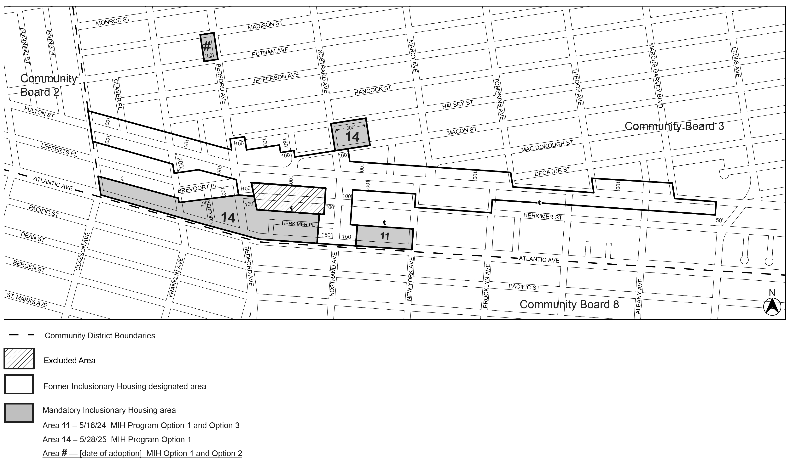

Portion of Community District 3, Brooklyn

* * *

Adopted.

Office of the City Clerk, }
The City of New York, } ss.:

I hereby certify that the foregoing is a true copy of a Resolution passed by The Council of The City of New York on ______________, on file in this office.

.....................................................
City Clerk, Clerk of The Council

