Committee Staff:
Charles Davis

THE COUNCIL OF THE CITY OF NEW YORK

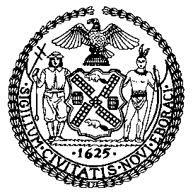

OFFICE OF THE GENERAL COUNSEL

Jason Adolfo Otaño, General Counsel

COMMITTEE REPORT OF THE
COMMITTEE ON RULES, PRIVILEGES AND ELECTIONS
Hon. Brad Lander, Chairperson

March 1, 2017

Council Chambers at City Hall

Preconsidered Res. No. 1391

SUBJECT:
Resolution approving changes in Membership to certain Standing Committees, Subcommittee and Chair.

ANALYSIS: Before the Committee for its consideration are proposed changes to the membership of certain Standing Committees, Subcommittee and Chair.

By Council Member Lander:
RESOLVED, That pursuant to Rules 7.00 and 7.20 of the Rules of the Council, the Council does hereby consent to the following changes in Membership to certain Standing Committees, Subcommittee and Chair:

STANDING COMMITTEES

AGING
Mendez
[Salamanca]

JUVENILE JUSTICE
Perkins
[Salamanca]

LAND USE
Salamanca

OVERSIGHT AND INVESTIGATIONS
Perkins

RECOVERY AND RESILIENCY
Perkins
[Mendez]

RULES, PRIVILEGES AND ELECTIONS
Rosenthal

SMALL BUSINESS
Perkins

STATE AND FEDERAL LEGISLATION
Perkins

SUBCOMMITTEE

PLANNING, DISPOSITIONS AND CONCESSIONS
Salamanca, Chair

