Committee on Contracts
Alex R. Paulenoff, Counsel
Leah Skrzypiec, Policy Analyst
Frank Sarno, Financial Analyst
John Russell, Finance Unit Head



THE COUNCIL OF THE CITY OF NEW YORK
Jeffrey Baker, Legislative Director

BRIEFING PAPER AND COMMITTEE REPORT OF THE GOVERNMENTAL

AFFAIRS DIVISION
Rachel Cordero, Deputy Director

COMMITTEE ON CONTRACTS
Hon. Ben Kallos, Chair

December 16, 2020

Oversight: PASSPort - The City's Procurement and Sourcing Solutions Portal

INT. NO. 1627: By Council Members Rosenthal and Kallos

TITLE: A Local Law to amend the administrative code of the city of New York, in relation to setting time limits for the procurement process, reporting on agency compliance and developing an online platform for managing procurement
- INTRODUCTION

On December 16, 2020, the Committee on Contracts, chaired by Council Member Ben Kallos, will hold a remote oversight hearing on PASSPort - The City's Procurement and Sourcing Solutions Portal. At this hearing the Committee will also hear testimony on Introductory Bill Number 1627-2019 (“Int. 1627-2019”), in relation to setting time limits for the procurement process, reporting on agency compliance and developing an online platform for managing procurement. Those invited to testify include the Mayor’s Office of Contract Services (“MOCS”) and interested members of the public.

- BACKGROUND
New York City has one of the largest contracting budgets in the country. In Fiscal Year 2020 (“FY2020”), the City purchased $22.5 billion worth of goods and services through almost 114,500 transactions. “This represents a 10% increase in total dollar value relative to Fiscal 2019 ($20.5 billion).” By contracting with businesses and nonprofit organizations, the City is able to provide human services to New Yorkers in need and help to maintain the City’s infrastructure and the operations of government.
There are several steps agencies and vendors must undergo before a contract can be finalized, depending on the method used. The Procurement Policy Board (“PPB”) issues rules and guidelines to “simplify, clarify, and modernize the law” governing the City’s procurement process and the different methods of purchasing goods and services that must be followed. In FY 2020, 86.9% of the total number of new contract awards were procured via contracts under the micro-purchase or small purchase thresholds.
In FY 2020, 106,768 of the total (114,458) number of contract awards were for $100,000 or less. Procuring goods and services through micro-purchases (less than $35,000 for construction services contracts, less than $20,000 for all other contracts) and small purchases (between the micro-purchase threshold and $100,000 or $500,000 for certified M/WBE vendors) typically allows government agencies more flexibility, and has less constraints compared to other methods of procurement. In the case of micro-purchases, agencies are not required to use competitive sealed bidding when selecting a vendor. In such cases, agencies need only demonstrate that such purchases are “reasonable” and “distributed appropriately among responsible vendors, including M/WBE vendors.” For procurements under the small purchase threshold, the rules require agencies to solicit vendors from a prequalified list. Contracts under these thresholds do not need to be awarded to the lowest responsible bidder, as is the case with general agency procurement contracts, pursuant to state law requirements.
In FY 2020, 18.7% of the total value of new contract awards ($3.1 billion), were procured via competitive sealed bidding and proposals. During the same fiscal year, the median time it took the City to complete the procurement process for competitive sealed bids was 183 days, a 18.1% increase from FY19. In FY 2020, Housing Preservation & Development had the longest median cycle time of 604 days, nearly two years, for the competitive bids issued by a City agency. The chart below illustrates the average cycle times for agencies that issued competitive bids in Fiscal Year 2020.

Citywide Median Cycle Time (Days) for Competitive Sealed Bids - FY2019 vs. FY2020
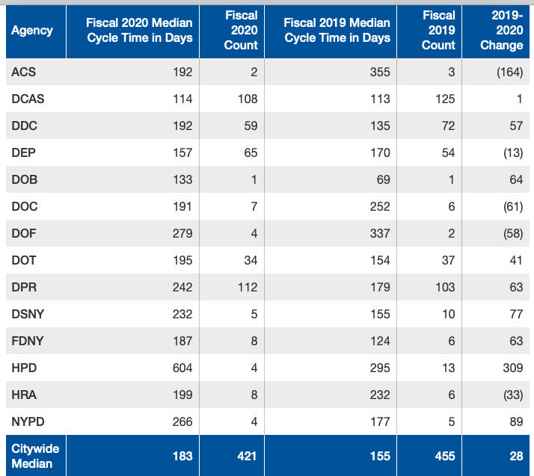
Source: Agency Procurement Indicators Report FY2020
Over the years, several stakeholders and industries have raised concerns about the City’s procurement process – mainly its reliance on paper processes, burdensome oversight, lack of standardized practices amongst agencies, and late payments. The City has sought to innovate and improve the procurement process through several methods, including the creation of the HHS Accelerator in 2013 for human service providers and the launch of the first phase of the Procurement and Sourcing Solutions Portal (“PASSPort”) in 2017.

- PROCUREMENT AND SOURCING SOLUTIONS PORTAL (PASSPort)
The Procurement and Sourcing Solutions Portal is a “technology solution designed to create visibility into the contracting process, enhance collaboration, and facilitate timely contract registration.” The new online portal aims to make procurement easier for vendors and agencies by making it the primary platform where business is done with the City. When building this platform, MOCS identified guiding principles and objectives to build a system that streamlined the process while also maintaining integrity and fairness. These principles and objects laid out the intentions of the system and were organized in the following areas: Process Improvement, Smart Use of Technology, Transparency & Accountability, and Planning & Management. Across these areas, MOCS identified several goals of PASSPort, including: shortening the procurement cycle times, creating a comprehensive vendor management system, internal and public-facing interfaces, business integrity controls, and the ability to manage risk.
In the summer of 2017, MOCS began rolling out the first phase of PASSPort, Release 1, which started with vendors creating and managing their online accounts, completing their vendor and principal questionnaires, enrolling in commodities reflecting their capability to do business, and allowing vendors to view and respond to performance evaluations based on their contracts with various city agencies. The goal of Release 1 was to begin integration for vendor profiles across city agencies, and to streamline both the vendor experience when contracting with the city, and the time between a contract award and registration.
Release 2 of PASSPort, “Requisition to Pay”, was launched in April 2019. This phase of the system allowed for electronic invoicing, and the creation of an online catalogue of vendor goods, which could be edited in real time. Using PASSPort, vendors could upload their inventory of goods available for City procurement, which agencies could then shop for online. Having an online database of goods meant that City agencies were able to easily search for needed items, and vendors could keep their product lists up-to-date, ensuring that agencies were not trying to procure items that were no longer available.
Release 3 of PASSPort was originally intended to be launched in the early part of 2020. With the outbreak of the COVID-19 pandemic, however, MOCS needed to redirect their focus to the procurement of personal protective equipment (“PPE”) and other lifesaving items to help the City weather the health emergency. Despite the new demands of the pandemic, MOCS was still able to forge ahead with the rollout of PASSPort Release 3. In the summer of 2020, MOCS began accepting electronic signatures, and dropped the notary requirement for contracts. This phase of PASSPort also allows vendors to track their contract registration process through a “milestone tracker”. Essentially, vendors are shown the list of steps required to be awarded a City contract, with check-boxes indicating where they are in the process. An example of this is shown below:

PASSPort Award Milestone Tracker Example
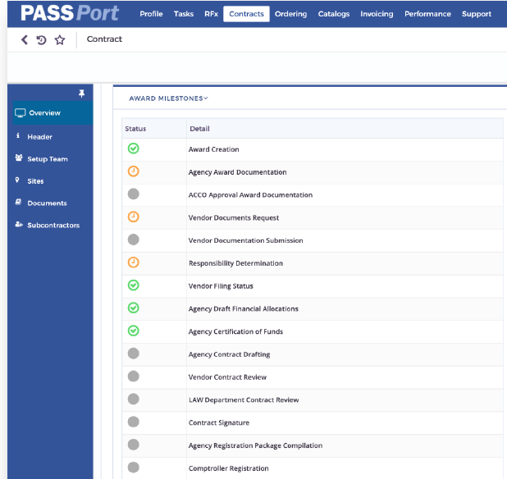
The green ticks indicate that a step has been successfully completed, while a yellow mark indicates that the step is still in process. The grey circles indicate required steps not yet begun. This process helps to communicate to vendors where they are in the award process, and where any delays could reside throughout the life-cycle of an award.
Lastly, Release 3 of PASSPort allows users to search through all of the City’s solicitations, which includes Requests for Information (“RFI”), Requests for Proposals (“RFP”), and Invitations to Bid (“ITB”).

- ISSUES & CONCERNS
Over the past several years, MOCS has refined the PASSPort system in order to provide a universal solution to various issues vendors have faced when engaging with the City’s contracting processes. PASSPort Release 3 attempts to solve many of the earlier issues facing vendors – particularly in the areas of communication with contracting agencies regarding their contracts, and the option to file contract applications and access awards electronically.
In Release 3, PASSPort has been updated to, among other things, offer real-time tracking of submissions, awards and contracts, develop digital signatures and provide access to available key data. While this amounts to a tremendous improvement over the earlier iterations of PASSPort as well as the paper-based VENDEX system, some outstanding issues do remain. Agencies still need to ensure that vendors are paid on time, and PASSPort does not address issues that may arise between prime contractors and subcontractors, which procurement advocates noted as a missed opportunity during the development of the PASSPort system. Nonetheless, the updated version of PASSPort, on the whole, provides considerable clarity to a previously complicated procurement system, and affords vendors doing business in New York City easier access to new contracting opportunities as well as information regarding their ongoing contracts.

- CONCLUSION
The committee looks forward to hearing testimony from the Mayor’s Office of Contract Services on the progress being made on the implementation of PASSPort, and anticipates that the final version is likely to address several of the issues raised by vendors and procurement advocates.

- BILL ANALYSIS
The proposed legislation would require the PPB to set time limits for agencies to complete each step of the procurement process. MOCS would be required to: assess whether each agency is complying with the time limits set by the PPB; analyze the difference between the time limits and the actual time required for each step of the procurement process; and recommend changes to the time limits set by the PPB. Every two years MOCS would be required to provide a report to the PPB, the Mayor and the Council outlining agency compliance with these rules and offer recommendations on changes to the time limits set by the PPB. The PPB would then be required to reevaluate and revise the timeframe goals based on the MOCS report.
The proposed legislation would also require MOCS to develop a publicly available online platform to be used for tracking contracts from the bid award to registration.
Int. No. 1627

By Council Members Rosenthal and Kallos

A Local Law to amend the administrative code of the city of New York, in relation to setting time limits for the procurement process, reporting on agency compliance and developing an online platform for managing procurement

Be it enacted by the Council as follows:

Section 1. Chapter 1 of title 6 of the administrative code of the city of New York is amended by adding new sections 6-102.1 and 6-143 to read as follows:
§ 6-102.1 Procurement process time limits. a. For any contract that exceeds the small purchase limit described in section 3-08 of title 9 of the rules of the city of New York, the procurement policy board shall establish the following, by rule:
1. The time limits within which the contracting agency must complete each step of the procurement process required by rules of such board; and
2. The time limits within which each mayoral agency charged with oversight of the contracting agency must complete its oversight review of the procurement contract.
b. No later than December 1, 2020, and every two years thereafter, the mayor’s office of contract services shall complete a study of the contracts affected by subdivision a and shall submit to the procurement policy board, the mayor and the council, and post on such office’s website, a report disclosing the following:
1. For each contract subject to this section, whether the agencies met the time limits set by the procurement policy board for each step of the procurement process and oversight review;
2. For each contract subject to this section, the difference between such time limits and the time actually required by the agencies for each step of the procurement process and oversight review; and
3. Recommendations for changes to the time limits set by the procurement policy board.
c. Upon receipt of such report, the procurement policy board may reevaluate and amend the time limits designated in subdivision a.
§ 6-143 Procurement process online platform. The mayor’s office of contract services shall develop an online platform to track all contracts through the procurement process from bid award to registration. Such online platform shall be publically available.
§ 2. This local law takes effect 120 days after it becomes law.

JG
LS # 8253
06/07/19 4:06 PM

See N.Y.C. Mayor’s Office of Contract Services, Agency Procurement Indicators Report Fiscal Year 2018, at 3, available at https://www1.nyc.gov/site/mocs/reporting/2018-agency-indicators-reports.page
See N.Y.C. Mayor’s Office of Contract Services, “How the City Spends its Money,” https://www1.nyc.gov/site/mocs/reporting/citywide-indicators/how-the-city-spends-its-money.page (last accessed December 14, 2020.
See id.
See N.Y.C. Mayor’s Office of Contract Services, “Procurement Policy Board Rules,” available at https://www1.nyc.gov/assets/mocs/downloads/pdf/ppb/UPDATE%20PPB%20RULES_FINAL_Effective%20November%202018%20Accepted%20TC.PDF
See N.Y.C. Mayor’s Office of Contract Services, “Procurement Methods” at 4 available at https://www1.nyc.gov/assets/mocs/downloads/pdf/MWBEReports/2017_AgencyProcurementIndicators.pdf
See N.Y.C. Mayor’s Office of Contract Services, “Procurement by Size,” https://www1.nyc.gov/site/mocs/reporting/citywide-indicators/procurement-by-size.page, (last accessed December 14, 2020).
N.Y. City Charter § 314; see also, N.Y. City Rules. Tit. 9 § 3-08
N.Y. City Rules. Tit. 9 § 3-08
See id.
See N.Y. Gen. Mun. § 103.
See N.Y.C. Mayor’s Office of Contract Services, “Procurement by Method” at 4 available at https://www1.nyc.gov/site/mocs/reporting/2018-agency-indicators-reports.page
See N.Y.C. Mayor’s Office of Contract Services, “Cycle Time,” https://www1.nyc.gov/site/mocs/reporting/citywide-indicators/cycle-time.page, (last accessed December 14, 2020).
See id.
See Citizens Budget Commission, No Small Change: Opportunities for Streamlining Procurement in New York City, (2002), available at https://cbcny.org/sites/default/files/report_procurement_02112002.pdf.
See N.Y.C. Mayor’s Office of Contract Services, “Notice of Adoption of Final Rule by the Procurement Policy Board,” November 8, 2013, available at http://www1.nyc.gov/assets/mocs/downloads/pdf/ppb/PPB_Amendments_HHS%20Accelerator_11082013.pdf.
See Jillian Jorgensen “More than 100 nonprofits Want Change to City Charter to Help Them Get Paid on Time,” NY Daily News, January 7, 2019 available at http://www.nydailynews.com/news/politics/ny-pol-nonprofits-contracts-deblasio-city-charter-20190104-story.html.
See N.Y.C. Mayor’s Office of Contract Services, “PASSPort,” https://www1.nyc.gov/site/mocs/systems/about-go-to-passport.page (last accessed December 14, 2020).
See id.
See N.Y. City Council Internal Staff Meetings with the Mayor’s Office of Contract Services.
See PASSPort, supra note 17.
See id.
Id.
See N.Y.C. Mayor’s Office of Contract Services, Presentation, “Catalog Import & Management: Vendors” at 4, available at https://www1.nyc.gov/assets/mocs/passport-downloads/pdf/R2-Launch-Materials/Vendor/PowerPoint_Vendor_Catalog_Import_Management.pdf.
See id. (Electronic invoicing is currently only in place for Requirements Contracts. MOCS expects to roll this feature out for all contracts in 2021); see also: N.Y.C. Mayor’s Office of Contract Services, “PASSPort Highlights,” https://www1.nyc.gov/site/mocs/systems/highlights-of-passport.page (last accessed December 14, 2020).
See Catalog Import & Management: Vendors, supra note 23 at 6.
See id at 9.
See City Council Internal Staff Meetings with the Mayor’s Office of Contract Services.
See N.Y.C. Mayor’s Office of Contract Services, Fact Sheet, “PASSPort Release 3: Making it Easier to Do Business with City of New York” (2020), available at https://www1.nyc.gov/assets/mocs/passport-downloads/pdf/resources-for-vendors/PASSPort_R3_VendorFactsheet.pdf.
See N.Y.C. Mayor’s Office of Contract Services, Fact Sheet, “Award Milestones Tracker,” (2020), available at https://www1.nyc.gov/assets/mocs/passport-downloads/pdf/resources-for-vendors/Award_MilestonesTracker_OnePager.pdf.
See id.
Id.
See Ethan Geringer-Sameth “City's $20 Billion in Contracting Takes Another Step into Modernity,” Gotham Gazette, January 7, 2019, available at: http://www.nydailynews.com/news/politics/ny-pol-nonprofits-contracts-deblasio-city-charter-20190104-story.html.
See PASSPort Release 3, supra note 28.
See Human Services Council, Testimony before the N.Y. City Council Committee on Contracts, November 15, 2018, available at https://legistar.council.nyc.gov/View.ashx?M=F&ID=6796528&GUID=137AF8A4-39FE-48AD-984D-6C0AC053FAF3.

