Consumer Affairs and Business Licensing Committee Staff:
Balqees Mihirig, Senior Counsel
Leah Skrzypiec, Policy Analyst
Andrew Wilber, Financial Analyst

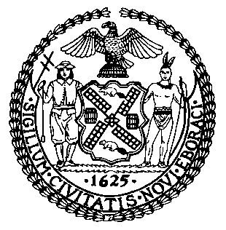

THE COUNCIL OF THE CITY OF NEW YORK

COMMITTEE REPORT OF THE GOVERNMENTAL AFFAIRS DIVISION

Jeffrey Baker, Legislative Director

Rachel Cordero, Deputy Director for Governmental Affairs

COMMITTEE ON CONSUMER AFFAIRS AND BUSINESS LICENSING

Hon. Rafael Espinal, Chair

May 15, 2019

PROPOSED INT. NO. 1476-A: By The Speaker (Council Member Johnson) and Council Members Levine, Cabrera, Brannan, Rosenthal, Holden, Lander, Dromm, Reynoso and Torres

TITLE: A Local Law to amend the administrative code of the city of New York, in relation to prohibiting the sale of fur apparel

- INTRODUCTION
On May 15, 2019, the Committee on Consumer Affairs and Business Licensing, chaired by Council Member Rafael Espinal, will hold a hearing on Proposed Introductory Bill Number 1476-A (Int. 1476-A), in relation to prohibiting the sale of fur apparel in New York City. The Committee has invited the Departments of Consumer Affairs, advocates, business owners, fashion retailers and other stakeholders to provide testimony on this bill.

- BACKGROUND
The Treatment of Animals by the Fur Industry
Advocates for the humane treatment of animals argue that killing an animal purely for its skin is inherently cruel, and assert that it is problematic that historic fashion trends have industrialized this killing. Many argue that although industry and business leaders have worked to improve and modernize the fur industry in order to use more ‘humane’ forms of killing, there remains very little oversight of the industry. Multiple investigations by different animal welfare groups from across the globe have documented incidents of inhumane treatment and conditions, even at locations that have been certified as being “humane.” The European Union (EU) passed regulations to guide the humane treatment of animals at the time of killing for fur, and it permits the electrocution of all species of animals. The EU regulations are the minimum standard for the region and member states can set their own specific polices. The Finnish Code of Good Practice for Human Killing in Foxes is one such example:
The position of the electrodes, shape of the electrodes and the pressure used to hold electrodes affect the efficiency of electrocution. It has been found, that when one electrode is placed properly inside the rectum and one is bitten by the fox, the current passes through the fox properly. The rod electrodes should be placed sufficiently deep in to the rectum and firmly in to the mouth. The current induces epileptic seizures in the brain and fibrillation or cardiac arrest of the heart. It should be checked that the restraining device or other materials in contact with the fox do not affect the path or effectiveness of the current flow. Many physiological properties affect the current flow, such as the body size. Therefore the voltage and amperage should be sufficiently high for the current to overcome the body resistance of even the largest of foxes.

In 2008, New York State was the first, and remains the only, state in the country to pass legislation that prohibits the anal and genital electrocution of animals for fur. However, there are currently no measures that prevent the sale of pelts and furs produced by electrocution that have been imported into New York.
Another common method of killing animals for their fur is gassing. Animal rights group Animal Equality conducted a two-year investigation of nearly all of the mink farms in Spain to examine the effects of this process. According to their findings, “[t]he death of these animals by inhalation of carbon monoxide or carbon dioxide is painful. Animals can suffer from seizures for more than 12 seconds, and then collapse. Carbon dioxide is irritating and, as with carbon monoxide, causes edema and bleeding in the lungs. This occurs whilst the animals are still conscious.” These investigators also obtained statements from a previous employee at one of the largest farms who confirmed “that many times, minks inside the gas chambers stay on top of other animals and do not die outright. Some remain unconscious but alive whilst they are skinned.” The animal rights group PETA uncovered similar occurrences at mink farms here in the United States.
There are also concerns by animal rights groups that prior to being killed, the conditions that farmed fur animals face are inhumane. Even when the cages meet the highest regulatory requirements, the space is small and does not permit the animal to roam. For example, in the most recent draft of the “Standard guidelines for the operation of mink farms in the United States” – guidelines developed and regularly updated by Fur Commission USA to advise on the ethical farming of mink – the recommended pen (cage) size for a female mink, without a litter, is 15 inches high and 7.5 inches wide. This is only a few inches higher than a shoe box, standing on its end.
For animals like minks, which are solitary creatures who like to roam and swim, confinement to a cage leads them to pace frantically in circles and self-mutilate, by biting their skin, tails and feet. Zoologists who studied captive minks at Oxford University have found that domestication, even after generations of being farmed, is not possible for these animals, and that they suffer greatly in captivity.
According to animal rights groups, breeding animals in unnatural conditions in order to preserve their skin provides incentives to farmers to seek out ways to maximize their profits, regardless of the harm caused to the animal. An investigation by a Finnish animal rights group called Oikeutta eläimille (Animal Justice), discovered a number of fur farms in their country were breeding deliberately obese foxes, up to five times their natural weight, to ensure a larger fur yield per animal. In disturbing video and photos (below) the group captured “grossly obese foxes with infected eyes, deformed feet, living in barren wire cages.”
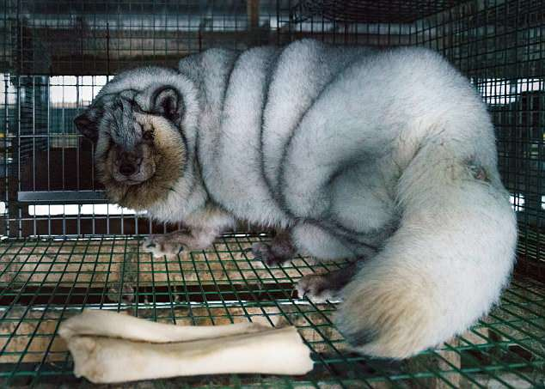
Images from Finnish fur farm captured by Animal Justice

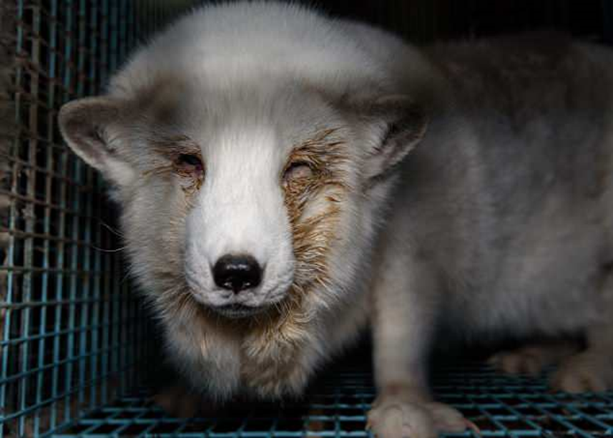

In the wild, female foxes weigh about 3.5 kilograms, while some of the foxes pictured by the animal rights group weighed over 19 kilograms. The extra weight causes the foxes to become too heavy to move around. According to animal rights advocates, the deliberate breeding of obese foxes causes painful conditions such as bent legs, skin inflammation, and swollen eyelids leading to red or pink eye infections, which are contagious.
Countries like the US, Canada and Russia also trade in wild-caught fur, which is obtained by trapping wild animals. A common style is the leg hold trap, where a steel-jaw quickly shuts on the animal’s leg, leaving them trapped until the fur trapper comes to collect it. There are 90 countries and at least six US states that have banned the steel-jaw traps, and the American Veterinary Medical Association also deems them to be inhumane.
Drowning traps were created to capture semi-aquatic animals such as beavers. This method also sets off a trap on the animal’s leg, but in this case, the animal slowly drowns due to the weight of the trap. Another type of trap used in the wild is the Conibear trap that aims to instantly break the neck of the caught animal.
In a 2011 investigation of fur trapping in the US, animal rights group Born Free USA found a number of serious issues with the use of wild traps. One common one was that the traps killed a number of non-targeted animals, including dogs, cats, bears and hawks. It is reported that approximately six million animals are trapped in the US, purely for their fur. However, it is also noted that this number does not account for the ‘collateral damage’ of other animals caught in the traps. All three of the trapping styles cause the animal to suffer a prolonged struggle until it finally dies or is killed by another method, including being crushed to death by the trapper. Even the Conibear trap, which is meant to kill the animal instantly, prolongs the trapped animal’s suffering because in 90% of cases, it takes up to three minutes for the animal to die.
According to data from 2014, there were 60 million mink, 13 million foxes, 14 million raccoon dogs bred and killed on fur farms in China and 42.6 million mink, 2.7 million foxes; 155,000 raccoon dogs; 206,000 chinchilla killed for fur in the EU.
Environmental and Health Concerns
The fur industry claims that fur from an animal is natural, able to biodegrade, and therefore better for the environment than synthetic materials developed to imitate animal fur. However, the World Bank ranked the fur dressing process as being one of the world’s five most toxic industries.
After animals have been skinned, their pelts are treated in order to protect from decay, and in some instances the pelts are also dyed or bleached. According to the Humane Society of the United States, the fur dressing process involves the use of formaldehyde and chromium, which are carcinogenic toxins. Other toxic chemicals used in the process include aluminum, ammonia, chlorine, chlorobenzene, copper, ethylene glycol, lead, methanol, naphthalene, sulfuric acid, toluene and zinc. Studies by the National Cancer Institute have linked exposure to formaldehyde to leukemia, while various agencies have concluded that chromium can cause cancer and other harmful health problems.
According to the Humane Society of the United States and PETA, the fur industry also creates a range of harmful pollutants during its production of fur. For instance, the gases created by the animals’ manure is comprised of high levels of nitrogen and phosphorus. Scientific studies estimate that each mink, for example, produces 44 pounds of feces. One side effect of this waste is phosphorus, which pollutes local water systems through run off and leaching.
It has been argued that producing fur is also incredibly energy intensive, especially compared to other available textiles. A detailed report produced by CE Delft, an independent research organization, examined the climate change impact of fur and a range of other textiles commonly used in the fashion industry. The evaluation considered 18 different factors, including climate change, toxic emissions and water pollution, and concluded that “[c]ompared with textiles, fur has a higher impact on 17 of the 18 environmental themes, including climate change, eutrophication and toxic emissions. In many cases fur scores markedly worse than textiles”. A comparison chart that shows the climate change impact of fur compared to other textiles is included below.

Climate change impact of 1 kg (2.2 pounds) material
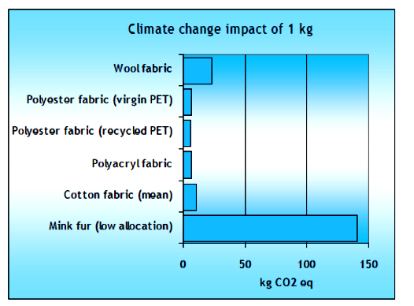
According to the FurFree Alliance, this means that the use of five faux fur coats would have less of an environmental impact than one mink fur coat. The CE Delft study reports that to produce a kilogram (2.2 pounds) of mink fur, more than 11 minks (1 pelt per animal) is required, and more than 1,200 pounds (563 kg) of feed. The noxious oxide that is present in the fecal matter of animals is also a major factor in the high carbon footprint calculated for fur farming. As a comparison, the carbon footprint created to produce a single fox or mink pelt is equivalent to that created by one to three days of average consumer activities.
Mislabeling and Consumer Protections
Fur trade groups have sought to position fur as a ‘green’ and ‘sustainable’ textile option. However, numerous advertising standards authorities issued rulings against such claims by the fur industry. For example, in France, the advertising standards authority, Jury de déontologie publicitaire (JDP), ruled against an advertisement for fur that made claims regarding the biodegradability of fur and its ‘earth friendliness.’ Ultimately JDP ruled that the advertisement was strongly misleading, especially to consumers who we trying to make eco-conscious purchases. The ruling authority also noted that the claims made in the pro-fur advertisement regarding biodegradability were unsupported by the data and in fact did not biodegrade. The Advertising Standards Authority (ASA) in the UK made a similar ruling against an advertisement from the European Fur Breeders’ Association. Their campaign claimed that it was “eco-friendly to wear fur” because “it lasts a lifetime: and “helps conservation.” The ASA banned the advertisement concluding that there was not enough evidence to support the claim that the product would not do any environmental harm, and they deemed the advertisement misleading.
Investigations across the world including in Canada, the UK, and the United States, have also turned up multiple incidents of cat and dog fur being labelled as faux-fur.
Fashion Trends and Banning Animal Products
The very nature of fashion means that it is an ever-changing set of trends and cultural norms that can become popular as quickly as they become passé. For example, during the 18th century, it was common for women, and even some men, to use lead powder to make their faces white, as was the trend at the time. Other fashion trends included rosy red cheeks, spurring people to create and put on their faces, rouge made from beetles, and grey eyebrows to match the pale faces. This trend meant that people would shave their eyebrows and replace them with false ones made from mouse hair. This trend began to subside by the end of the century.
As demand for certain animal products ebb and flow, legislators have acted to protect the welfare of animals. One such example was the New York State legislation to ban the slaughter of cats and dogs for human consumption (either as food or fur). In the legislation’s supporting memo, it was noted that, as a center for garment manufacturing, it was essential for New York to ban the use of dog and cat fur in these products. In the United States the import of dog, cat and seal fur has all been banned, and a near-total ban exists for has the commercial trade of African elephant ivory. Other restrictions in place to protect US wildlife include the interstate and international sale of rhino horns, Asian elephant ivory, and sea turtle shell and leather.
Fur farming has also been banned in numerous countries including the UK, Austria, the Netherlands, Northern Ireland, Serbia and Croatia. It is also being phased out in Denmark and Japan.
In New York City the Council has taken numerous steps to improve the regulation, oversight and general welfare of animals. For example, the Council enacted Local Law 118 in 2017 to prohibit the use of wild and exotic animals in circus performances.
Presently, the fashion industry appears to be moving away from fur. Major fashion houses such as Stella McCartney, Chanel, Coach, Burberry, Versace, Michael Kors, Jimmy Choo, Gucci, Yoox and Net-a-Porter, H&M and Zara, and Phillip Lim have all committed to not using fur in their collections. In 2018, the British Fashion Council declared that London Fashion Week would be totally fur free, and Laura Brown, editor for lead fashion magazine InStyle, has banned photographing fur and accepting advertisements from fur brands. Meanwhile, faux fur and lab-grown fur are two examples of existing and developing textiles that provide an alternative to farmed or trapped fur. Two faux fur fashion houses, House of Fluff, whose apparel has been featured in Vogue and Forbes, and Pelush, are both situated in New York City.

- ISSUES/CONCERNS
Job Losses
Although many designers and fashion houses located in the City have committed to stop selling fur products, there remain a number of traditional furriers located across the five boroughs, as well as major department stores that sell fur apparel. A fur industry report estimates that there are anywhere between 560 and 1,100 people employed in the fur sales industry. Those in the fur industry have expressed concern that a ban on the sale of fur will mean the loss of jobs and their businesses, and they anticipate that 150 small businesses would be forced to close within a year of a fur ban enactment.
Regulation
Consumer and constituent concerns regarding the harmful processes inherent in the production of animal fur have led to a range of industry produced ‘humane’ certifications and government regulations. These measures represent efforts to improve the lives of fur animals through industry practices. One such example, due to be rolled out in 2020, is FurMark, developed by the International Fur Federation (IFF). The goal of the FurMark program will be to create a global certification system where businesses are required to meet various environmental and animal welfare standards in order to be certified. IFF asserts that the verification of these standards will be conducted by impartial third parties.
Animal welfare advocates, however, remained concerned that the global nature of the fur trade and the general lack of meaningful oversight in the industry make it difficult to ensure a humane way of killing animals for their fur. For example, the UK was one of the first jurisdictions to ban fur farming in 2000. However, the British Parliament is currently undertaking an inquiry into the fur industry because it has been revealed that mislabeling of faux fur is rampant.
According to a Labor MP for Bristol East:
Fur farming was banned in England and Wales in the year 2000 and two years later in Scotland on the grounds of public morality, and the fact that fur produced in the same methods is allowed to be imported into the country is fundamentally illogical and surely it must be immoral too…A lot of our fur imports come from countries where animal welfare standards are even lower than the UK’s were before we introduced a fur farming ban. In some countries you could say the standards are simply non-existent. The idea of ethical fur farming even in countries which report to be high welfare, has been shown time and time again to be a complete fiction… The UK’s ban on fur farming was introduced only after our farm animal welfare council spent years gathering evidence eventually concluding that fur farms are simply unable to satisfy even the most basic needs of the wild animals kept in them. The council explicitly stated it was not possible to safeguard the welfare of animals kept on fur farms.

- INT. NO. 1476-A BILL ANALYSIS
Section one of Int. No. 1476-A creates a new Subchapter 13 in Chapter 4 of Title 20 of the Administrative Code. New section 20-699.10 contains definitions. It defines fur as “any animal skin, in whole or in part, with the hair, fleece or fur fibers attached.” It also defines fur apparel as, “any article of clothing or fashion accessory, to be worn on any part of the body, made of fur, in whole or in part.” Used fur apparel is also defined as “any fur apparel that a natural person has acquired for that person’s own use as an article of clothing or fashion accessory.”
Section 20-699.11 prohibits the sale of all fur apparel except fur apparel sourced from used fur apparel. For example, the bill would not ban used fur coats being re-styled into new fur clothing items or accessories. The bill also contains an exception for the sale of fur apparel that is worn as a matter of religious custom.
Subdivision a of section 20-699.12 creates penalties that are effective on the first day of May following the effective date of the bill. The bill imposes a civil penalty of not more than $500 for a first violation and each subsequent violation occurring on the same day. Any subsequent violations on subsequent days will incur a civil penalty of $1,500 for each violation. Violations shall accrue on a daily basis for each item of prohibited fur apparel that is sold or offered for sale. Subdivision b requires any fur apparel or any revenue generated from the sale of fur apparel to be forfeited to enforcement authorities.
Section 20-699.13 allows the commissioner of DCA to apply for injunctive relief pursuant to article 63 of the Civil Practice Law and Rules in a proceeding to enforce the provisions of this bill.
The bill takes effect 90 days after it becomes law.
Proposed Int. No. 1476-A

By The Speaker (Council Member Johnson) and Council Members Levine, Cabrera, Brannan, Rosenthal, Holden, Lander, Dromm, Reynoso and Torres

A Local Law to amend the administrative code of the city of New York, in relation to prohibiting the sale of fur apparel

Be it enacted by the Council as follows:

Section 1. Chapter 4 of title 20 of the administrative code of the city of New York is amended by adding a new subchapter 13 to read as follows:
SUBCHAPTER 13
FUR APPAREL
§ 20-699.10 Definitions
§ 20-699.11 Prohibited conduct
§ 20-699.12 Penalties
§ 20-699.13 Injunctive relief
§ 20-699.10 Definitions. For purposes of this subchapter, the following terms have the following meanings:
Commissioner. The term “commissioner” means the commissioner of consumer affairs.
Fur. The term “fur” means any animal skin, in whole or in part, with the hair, fleece or fur fibers attached.
Fur apparel. The term “fur apparel” means any article of clothing or fashion accessory, to be worn on any part of the body, made of fur, in whole or in part.
Used fur apparel. The term “used fur apparel” means any fur apparel that a natural person has acquired for that person’s own use as an article of clothing or fashion accessory.
§ 20-699.11 Prohibited conduct. No person may sell or offer for sale any fur apparel except:
1. Used fur apparel or fur apparel made from fur sourced exclusively from used fur apparel; or
2. Fur apparel that is worn as a matter of religious custom.
§ 20-699.12 Penalties. a. Any person that violates section 20-699.11 on or after the first day of May next succeeding the effective date of the local law that added this subchapter shall be subject to a civil penalty of not more than $500 for that person’s first violation and each additional violation occurring on the same day as the first violation, and not less than $500 nor more than $1,500 for each subsequent violation. Violations shall accrue on a daily basis for each item of prohibited fur apparel that is sold or offered for sale.
b. Any fur apparel offered for sale or any revenue generated from fur apparel sold in violation of section 20-699.11 shall be subject to forfeiture upon notice and judicial determination.
§ 20-699.13 Injunctive relief. In addition to any other relief available by law, the commissioner may seek any relief available under article 63 of the civil practice law and rules in a proceeding against any person alleged to be in violation of any provision of this subchapter.
§ 2. This local law takes effect 90 days after it becomes law, except that the commissioner of consumer affairs shall take such measures as are necessary for the implementation of this local law, including the promulgation of rules, before such date.

NC
LS #6888, 7184, 7773
4/22/19

See for example: Elisabeth Claire Alberts “Foxes and minks are trapped in barren cages at ‘haunting’ fur farm’, The Dodo, November 28, 2018, available at: https://www.thedodo.com/in-the-wild/fur-farm-finland-investigation; and PETA “Cruelty assured: The truth about ‘high-welfare’ fur”, available at: http://features.peta.org.uk/origin-assured-fur/.
Council Regulation (EC) No 1099/2009, available at: https://eur-lex.europa.eu/LexUriServ/LexUriServ.do?uri=OJ:L:2009:303:0001:0030:EN:PDF.
Id, p. 19.
Hannu T. Korhonen and Hanna Huuki “Code of good practice for human killing in foxes”, MTT Agrifood Research Finland, available at: http://fureurope.eu/wp-content/uploads/2015/02/Good-practice-foxes-15042013.pdf.
Id, p. 15.
Associate Press “New York bans grisly electrocution of animals for fur”, April 30, 2008, available at: https://www.newsday.com/long-island/new-york-bans-grisly-electrocution-of-animals-for-fur-1.880478.
Animal Equality “Animal Equality records the killing of minks in one of the biggest fur farms in Spain”, available at: https://www.animalequality.net/news/animal-equality-records-killing-minks-one-biggest-fur-farms-spain.
Id.
PETA “Before it was a fur coat, it was a someone: A PETA exposé”, July 17, 2017, available at: https://www.peta.org/blog/the-truth-about-fur-the-harsh-reality-of-mink-farming/.
Fur Commission USA “Standard guidelines for the operation of mink farms in the United States”, 2019 edition, book 1, available at: http://furcommission.com/wp-content/uploads/2019/04/Standard-Guidelines-for-the-Operation-of-Mink-Farms-in-the-US-2019-Book1.pdf, p. 8.
PETA “Inside the fur industry: Factory farms”, available at: https://www.peta.org/issues/animals-used-for-clothing/animals-used-clothing-factsheets/inside-fur-industry-factory-farms/.
Id.
Julian Robinson “Harrowing footage reveals plight of obese ‘monster foxes’ kept locked up in cages and bred to produce huge pelts on cruel fur farms in Finland’, Daily Mail, 19 April, 2018, available at: https://www.dailymail.co.uk/news/article-5624515/Harrowing-footage-reveals-plight-obese-monster-foxes.html.
The full video can be accessed at id.
Id.
Kati Pulli as quoted in Laura Forsyth “The pitiful Artic foxes that shame the fashion world: Beautiful creatures are cramped in tiny cages and deliberately bloated to produce two million fur pelts for Britain each year”, Daily Mail, May 31, 2018, available at: https://www.msn.com/en-gb/news/world/the-pitiful-arctic-foxes-that-shame-the-fashion-world-beautiful-creatures-are-cramped-in-tiny-cages-and-deliberately-bloated-to-produce-two-million-fur-pelts-for-britain-each-year/ar-AAy2PVA.
Last Chance for Animals “Fur trade facts”, available at: https://www.lcanimal.org/index.php/campaigns/fur/fur-trade-facts.
Id.
Born Free USA “Victims of vanity: U.S. trapping report”, 2011, available at: http://7a1eb59c2270eb1d8b3d-a9354ca433cea7ae96304b2a57fdc8a0.r60.cf1.rackcdn.com/Victims_of_Vanity-Report.pdf, p. 2.
Tara Zuardo “Reforms designed to make wildlife trapping less cruel”, The Journal of International Wildlife Law & Policy”, Vol. 20, Iss. 1, 2017, available at: https://www.tandfonline.com/doi/abs/10.1080/13880292.2017.1315278?journalCode=uwlp20.
Born Free USA, at note 19, p. 2.
Last Chance for Animals, at note 17.
Humane Society International “MPs call on UK Government to ban fur imports in passionate debate”, June 6, 2018, available at: https://www.hsi.org/news-media/fur-debate-060618/. Humane Society International “The fur trade”, February 22, 2019, available at: https://www.hsi.org/news-media/fur-trade/.
Tansy Hoskins “Is the fur trade sustainable”, The Guardian, October 29, 2013, available at: https://www.theguardian.com/sustainable-business/sustainable-fashion-blog/is-fur-trade-sustainable.
The Humane Society of the United States “Toxic fur: The impacts of fur production on the environment and the risks to human health”, January 29, 2009, available at: https://www.humanesociety.org/sites/default/files/docs/2009-toxic-fur-production-impact.pdf, p. 3.
National Cancer Institute “Formaldehyde and cancer risk”, June 10, 2011, available at: https://www.cancer.gov/about-cancer/causes-prevention/risk/substances/formaldehyde/formaldehyde-fact-sheet?redirect=true.
Agency for Toxic Substances & Disease Registry “Toxic substances portal – Chromium”, September 28, 2016, available at: https://www.atsdr.cdc.gov/toxfaqs/tf.asp?id=61&tid=17.
The Humane Society of the United States, at note 25; and PETA, at note 11.
PETA, at note 11.
The Humane Society of the United States, at note 25, p. 1; and PETA, at note 11.
Marijn Bijleveld, Marisa Korteland and Maartje Sevenster “The environmental impact of mink production”, Delft, January 2011, available at: https://www.cedelft.eu/en/publications/download/1047, p. 7.
FurFree Alliance “The environmental impact of fur farming”, available at: https://www.furfreealliance.com/wp-content/uploads/2017/09/Factsheet_Environmental-impact-of-fur-farming-1.pdf.
Id.
Marijn Bijleveld, et al, at note 31, p. 6.
F. Silvenius et al, “Life cycle assessment of mink and fox pelts produced in Finland”, in: Larsen P.F. et al. (eds) Proceedings of the Xth International Scientific Congress in fur animal production, Wageningen Academic Publishers, Wageningen (2012), available at: https://link.springer.com/chapter/10.3920/978-90-8686-760-8_15#citeas.
Faux Fur Institute “Pro fur/anti faux fur ad ruled misleading”, 5 December, 2018, available at: https://www.fauxfurinstitute.com/nouveau-blog/2018/12/5/pro-fur-anti-faux-fur-ad-natural-wonder-ruled-misleading.
Id.
Mark Sweney “’Eco-friendly’ fur ad banned”, The Guardian, March 21, 2012, available at: https://www.theguardian.com/media/2012/mar/21/eco-friendly-fur-ad-banned.
Id.
Erik Ryken “Flawed laws mean your faux fur could come from dogs and cats”, Huffington Post, September 22, 2016, available at: https://www.huffingtonpost.ca/get-leashed-magazine/faux-fur_b_12121648.html.
Ben Stevens “TK Maxx, Boohoo and Amazon found to be selling mislabeled real fur items”, Retail Gazette, December 22, 2017, available at: https://www.retailgazette.co.uk/blog/2017/12/tk-maxx-boohoo-and-amazon-found-to-be-selling-mislabelled-real-fur-items/; and Humane Society International “Fake faux fur scandal: Mislabeling of fur clothing and accessories in the UK”, October 9, 2015, available at: https://www.hsi.org/news-media/mis-labelled-fur-uk/.
Associated Press “Is your fur fake, or is it Fido?”, February 23, 2007, available at: http://www.nbcnews.com/id/17298301/ns/business-us_business/t/your-fur-fake-or-it-fido/#.XNHeXY5Kjcs.
Encyclopedia of fashion “Eighteenth-Century body decorations”, available at: http://www.fashionencyclopedia.com/fashion_costume_culture/European-Culture-18th-Century/Eighteenth-Century-Body-Decorations.html.
Assembly Mem. in Support, L.2002, ch. 573, available at: https://nyassembly.gov/leg/?default_fld=&leg_video=&bn=A04945&term=2001&Summary=Y&Memo=Y&Text=Y.
US Fish & Wildlife Service “Can I sell it? A guide to wildlife and plant protection laws”, August 2016, available at: https://www.fws.gov/international/pdf/factsheet-can-i-sell-it.pdf.
Id.
Humane Society International, at note 23.
NYC LL 118/2017.
Avery Matera “Every major fashion brand that has banned fur”, February 12, 2019, available at: https://www.teenvogue.com/gallery/every-major-fashion-brand-fur-ban.
Chelsea Ritschel “London Fashion Week 2008 will be totally fur-free, announces British Fashion Council”, The Independent, September 10, 2018, available at: https://www.independent.co.uk/life-style/fashion/london-fashion-week-2018-fur-free-ban-british-fashion-council-burberry-gucci-a8528061.html.
Taylor Harris “InStyle bans fur”, The Daily, April 3, 2018, available at: https://fashionweekdaily.com/instyle-bans-fur-laura-brown/.
For more information see: Faux Fur Institute “Fur grown in labs is becoming a reality”, November 5, 2018, available at: https://www.fauxfurinstitute.com/nouveau-blog/2018/11/5/fur-grown-in-labs-is-becoming-a-reality.
Kat Smith “This is how New York’s fur ban could change the fur industry”, Livekindly, April 30, 2019, available at: https://www.livekindly.co/ny-introduces-bill-ban-sale-fur/.
Ariel H. Collis “Impact report: A New York City ban on the sale of fur products”, Capital trade Inc., November 8, 2018.
FurNYC “Impact”, available at: https://furnyc.org/impact/.
International Fur Federation “Sustainable fur”, available at: https://www.wearefur.com/responsible-fur/fur-mark/.
International Fur Federation “FurMark: The international mark of responsible fur”, available at: https://www.wearefur.com/wp-content/uploads/2018/02/FurMark-Full-Brochure-final.pdf, p. 4.
World’s richest countries “Top fur clothing importers 2015”, available at: http://www.worldsrichestcountries.com/top-fur-clothing-importers.html.
Humane Society International “MPs call on UK Government to ban fur imports in passionate debate”, June 6, 2018, available at: https://www.hsi.org/news-media/fur-debate-060618/.

