THE COUNCIL OF THE CITY OF NEW YORK
RESOLUTION NO. 1602

Resolution approving with modifications the decision of the City Planning Commission on Application No. N 170071 ZRK, for an amendment of the Zoning Resolution of the City of New York, modifying Appendix F to establish a Mandatory Inclusionary Housing area in Community District 8, Borough of Brooklyn (L.U. No. 652).

By Council Members Greenfield and Richards

WHEREAS, the City Planning Commission filed with the Council on May 19, 2017 its decision and report dated May 10, 2017 (the "Decision"), pursuant to Section 201 of the New York City Charter, regarding an application submitted by Bedford Arms, LLC, for an amendment of the text of the Zoning Resolution of the City of New York, modifying Appendix F for the purpose of establishing a Mandatory Inclusionary Housing area on property located at Block 1205, Lot 28 on the west side of Bedford Avenue, which in conjunction with the related actions would facilitate the development of a new nine-story residential building, containing approximately 93 units of affordable housing in the Crown Heights neighborhood of Brooklyn, (Application No. N 170071 ZRK), Community District 8, Borough of Brooklyn (the "Application");

WHEREAS, the Application is related to application C 170070 ZMK (L.U. No. 651), an amendment to the Zoning Map to change an existing R6A district to an R7D district; and 20175520 HAK (L.U. 690), a real property tax exemption pursuant to Article XI of the Private Housing Finance Law for property located at Block 1205, Lot 28 (Tentative Lot 127);

WHEREAS, the Decision is subject to review and action by the Council pursuant to Section 197-d(b)(1) of the City Charter;
WHEREAS, upon due notice, the Council held a public hearing on the Decision and Application on May 30, 2017;

WHEREAS, the Council has considered the land use implications and other policy issues relating to the Decision and Application; and

WHEREAS, the Council has considered the relevant environmental issues, including the negative declaration issued January 17, 2017 (CEQR No. 17DCP071K), which includes an (E) designation to avoid the potential for significant adverse impacts related to hazardous materials, air quality, and noise (E-412), (the “Negative Declaration”);

RESOLVED:

The Council finds that the action described herein will have no significant impact on the environment as set forth in the Negative Declaration.

Pursuant to Sections 197-d and 200 of the City Charter and on the basis of the Decision and Application, and based on the environmental determination and consideration described in the Decision, incorporated by reference herein, the Council approves the Decision with the following modifications:

Matter underlined is new, to be added;
Matter struck out is to be deleted;
Matter within # # is defined in Section 12-10;
Matter in double-strikeout is old, deleted by the City Council;
Matter in double-underline is new, added by the City Council;
* * * indicates where unchanged text appears in the Zoning Resolution

APPENDIX F
Inclusionary Housing Designated Areas and Mandatory Inclusionary Housing Areas

⃰ ⃰ ⃰
Brooklyn

⃰ ⃰ ⃰

Brooklyn Community District 8

In the R7A and R7D Districts within the areas shown on the following Map 1:

Map 1. (9/24/13) [date of adoption]

[EXISTING MAP]

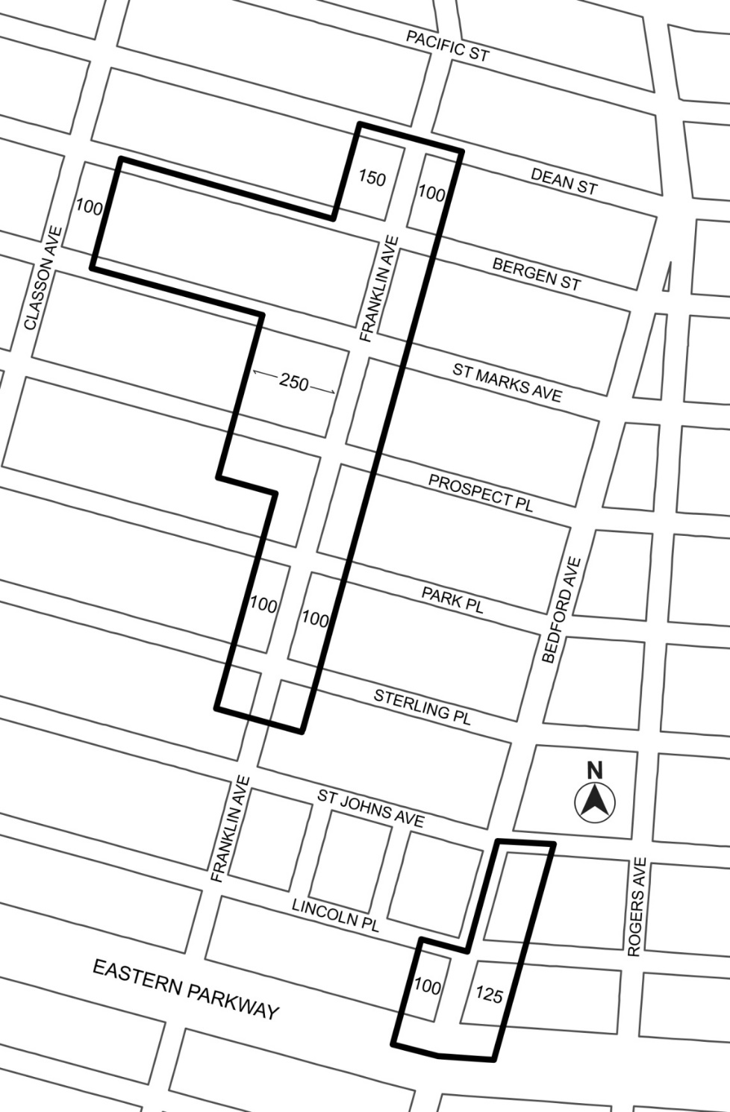

[PROPOSED MAP]

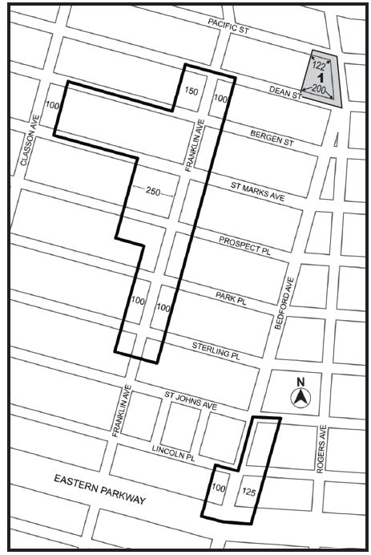

Inclusionary Housing Designated Area
Mandatory Inclusionary Housing Area (MIHA) see Section 23-154(d)(3)
Area 1 (date of adoption) ─ MIH Program Option 1 Option 2

Portion of Community District 8, Brooklyn

* * *

Adopted.

Office of the City Clerk, }
The City of New York, } ss.:

I hereby certify that the foregoing is a true copy of a Resolution passed by The Council of The City of New York on July 20, 2017, on file in this office.

.....…….........................................
City Clerk, Clerk of The Council

