THE COUNCIL OF THE CITY OF NEW YORK
RESOLUTION NO. 478

Resolution approving with modifications the decision of the City Planning Commission on Application No. N 250095 ZRK, for an amendment of the text of the Zoning Resolution (L.U. No. 55).

By Council Members Riley and Louis

WHEREAS, 46 Nelson LLC, pursuant to Section 201 of the New York City Charter, for an amendment of the Zoning Resolution of the City of New York, amending APPENDIX F (Mandatory Inclusionary Housing Areas and former Inclusionary Housing Designated Areas) for the purpose of establishing a Mandatory Inclusionary Housing area. This action would facilitate the development of a new seven-story, 100,000 square foot mixed-use building containing 108 dwelling units, of which approximately 27 would be permanently income-restricted, as well as 17,000 square feet of ground floor commercial use, located at 46 Nelson Street in the Red Hook neighborhood Borough of Brooklyn, Community District 6. (ULURP No. N 250095 ZRK) (the "Application");
WHEREAS, the City Planning Commission filed with the Council on April 10, 2026, its decision dated April 1, 2026 (the "Decision") on the Application;
WHEREAS, the Application is related to application C 250094 ZMK (L.U. No. 54), a zoning map amendment to change a M1-1 zoning district to an M1-2A/R6A (MX-22) zoning district;
WHEREAS, the Decision is subject to review and action by the Council pursuant to Section 197-d of the City Charter;

WHEREAS, upon due notice, the Council held a public hearing on the Decision and Application on April 14, 2026;

WHEREAS, the Council has considered the land use implications and other policy issues relating to the Decision and Application; and

WHEREAS, the Council has considered the relevant environmental issues, including the Negative Declaration issued on November 14, 2025 (CEQR No. 25DCP059K), (the “Negative Declaration”). The Negative Declaration includes an (E) designation (E-855) related to hazardous materials, air quality, and noise to avoid the potential for significant adverse impacts.

RESOLVED:
The Council finds that the action described herein will have no significant impact on the environment as set forth in the (E) Designation (E-855) and the Negative Declaration.

Pursuant to Sections 197-d and 200 of the New York City Charter and the Decision and Application, the environmental determination and consideration described in this report and the record before the Council, the Council approves the Decision of the City Planning Commission, with the following modifications:

Matter underlined is new, to be added;
Matter struck out is to be deleted;
Matter double-underlined is new, added by Council;
Matter double-struck out is old, deleted by Council;
Matter within # # is defined in Section 12-10 or 101-01;
* * * indicates where unchanged text appears in the Zoning Resolution.

* * *

APPENDIX F
Mandatory Inclusionary Housing Areas and former Inclusionary Housing Designated Areas

* * *

BROOKLYN

* * *

Brooklyn Community District 6

* * *

Map 3 – [date of adoption]

[PROPOSED MAP]

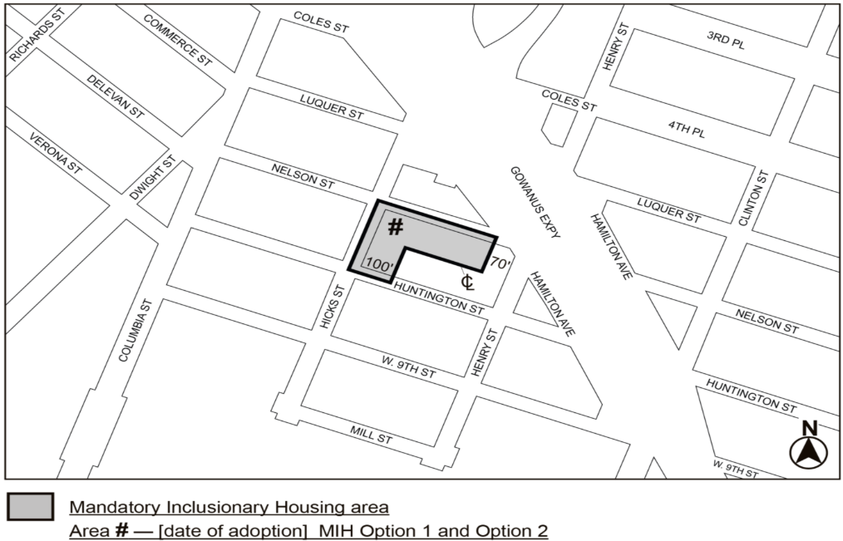
[PROPOSED MAP – MODIFIED BY CITY COUNCIL]
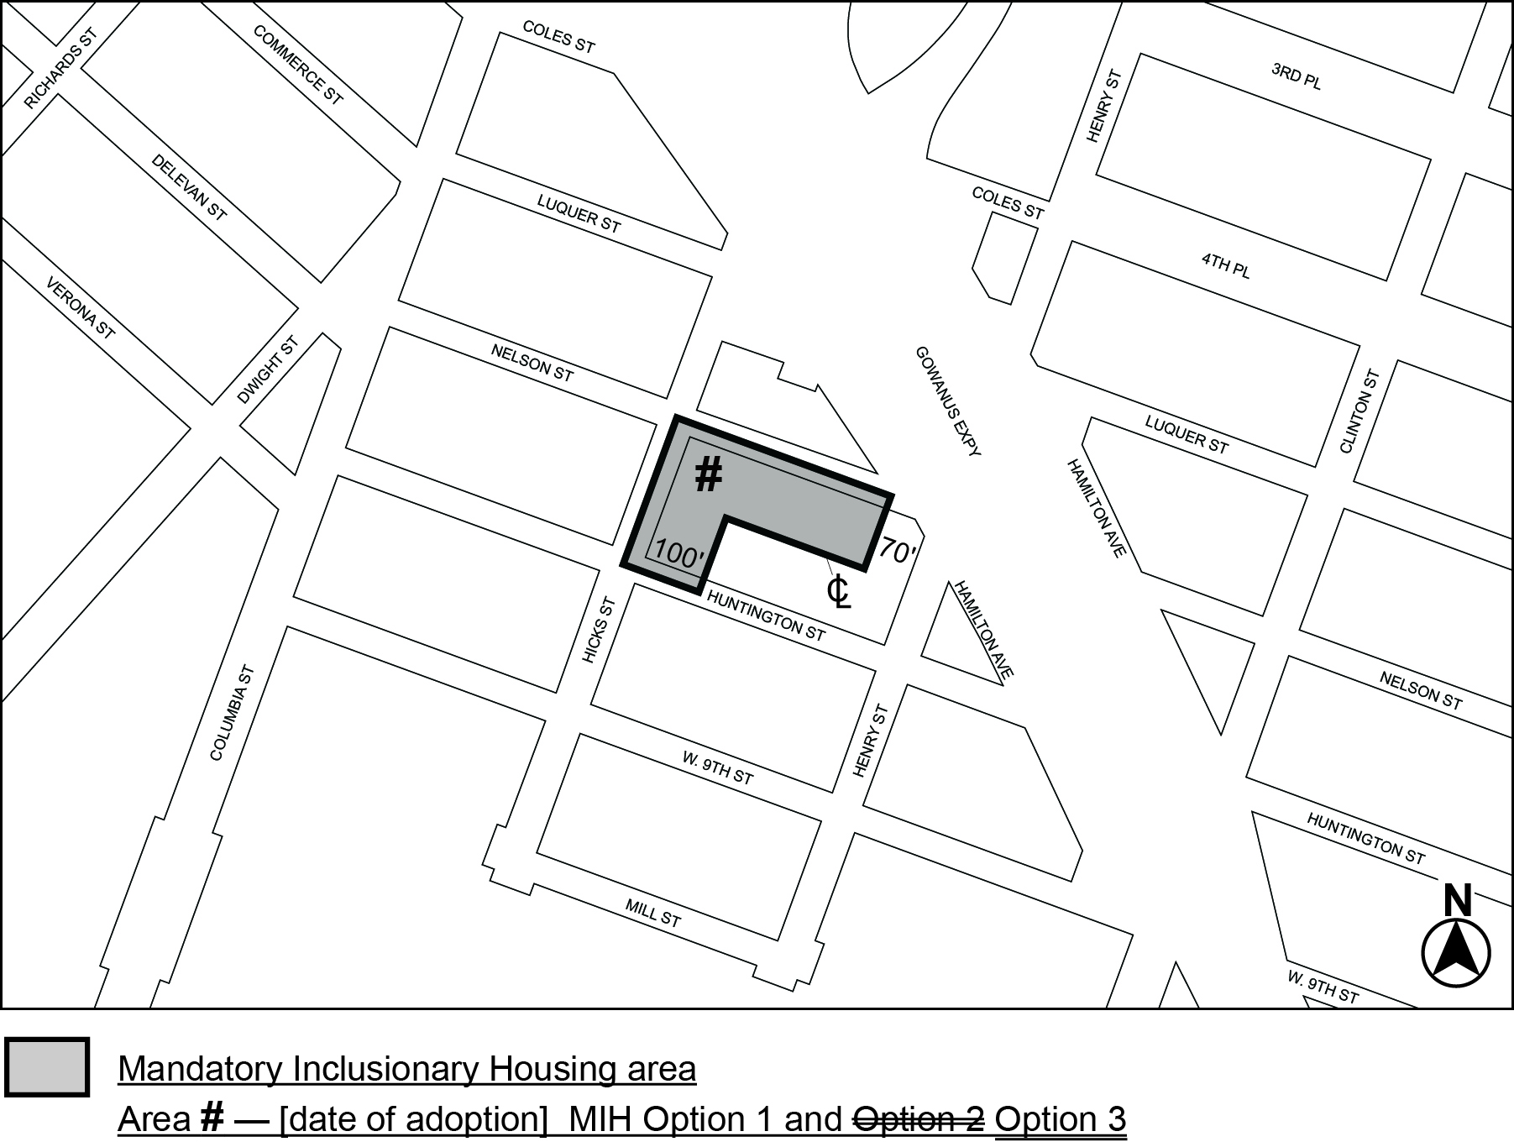

Portion of Community District 6, Brooklyn

* * *

Adopted.

Office of the City Clerk,}
The City of New York,} ss.:

I hereby certify that the foregoing is a true copy of a Resolution passed by The Council of The City of New York on _________, 2026, on file in this office.

.....................................................
City Clerk, Clerk of The Council

