THE COUNCIL OF THE CITY OF NEW YORK
RESOLUTION NO. 833

Resolution approving with modifications the decision of the City Planning Commission on Application No. N 240404 ZRK, for an amendment of the text of the Zoning Resolution (L.U. No. 236).

By Council Members Salamanca and Hanks

WHEREAS, the New York City Department of Housing Preservation and Development, filed an application pursuant to Section 201 of the New York City Charter, for an amendment of the text of the Zoning Resolution of the City of New York, modifying APPENDIX F (Mandatory Inclusionary Housing Areas and former Inclusionary Housing Designated Areas) for the purpose of establishing a Mandatory Inclusionary Housing Area, which in conjunction with the related actions would facilitate the development of a new seven story, approximately 144,000 square feet including 135,200 square feet of residential (173 units), 8,800 square feet of ground floor community facility space, and 37,315 square feet of private and public open space in the Borough of Brooklyn, Community District 5 (ULURP No. N 240404 ZRK), (the “Application”);
WHEREAS, the City Planning Commission filed with the Council on January 24, 2025, its decision dated January 22, 2025 (the "Decision") on the Application;
WHEREAS, the Application is related to applications C 240402 HAK (L.U. No. 234), an Urban Development Action Area designation (UDAA), project approval (UDAAP), and disposition of City-owned property; and C 240403 ZMK (L.U. No. 235), a zoning map amendment to change an R5 zoning district to an R6 zoning district;
WHEREAS, the Decision is subject to review and action by the Council pursuant to Section 197-d of the City Charter;
WHEREAS, upon due notice, the Council held a public hearing on the Decision and Application on February 5, 2025;
WHEREAS, the Council has considered the land use implications and other policy issues relating to the Decision and Application; and
WHEREAS, the Council has considered the relevant environmental issues, including the Negative Declaration issued August 15th, 2024 (CEQR No. 21HPD001K), which included measures to avoid the potential for significant adverse impacts related to hazardous materials. These measures are described in the Environmental Assessment Statement and Negative Declaration. The Council has also considered the Technical Memorandum dated March 18, 2025 (“Technical Memorandum”).
RESOLVED:
The Council finds that the action described herein will have no significant impact on the environment as set forth in the Negative Declaration and the Technical Memorandum.
Pursuant to Sections 197-d and 200 of the City Charter and on the basis of the Decision and Application, and based on the environmental determination and consideration described in the report, N 240404 ZRK, incorporated by reference herein, and the record before the Council, the Council approves the Decision of the City Planning Commission, with the following modifications.
Matter underlined is new, to be added;
Matter struck out is to be deleted;
Matter double struck out is old, deleted by the City Council;
Matter double-underlined is new, added by the City Council;
Matter within # # is defined in Section 12-10;
* * * indicates where unchanged text appears in the Zoning Resolution.

APPENDIX F
Mandatory Inclusionary Housing Areas and former Inclusionary Housing Designated Areas

* * *

BROOKLYN

* * *

Brooklyn Community District 5

* * *

Map 7 – [date of adoption]

[PROPOSED MAP]

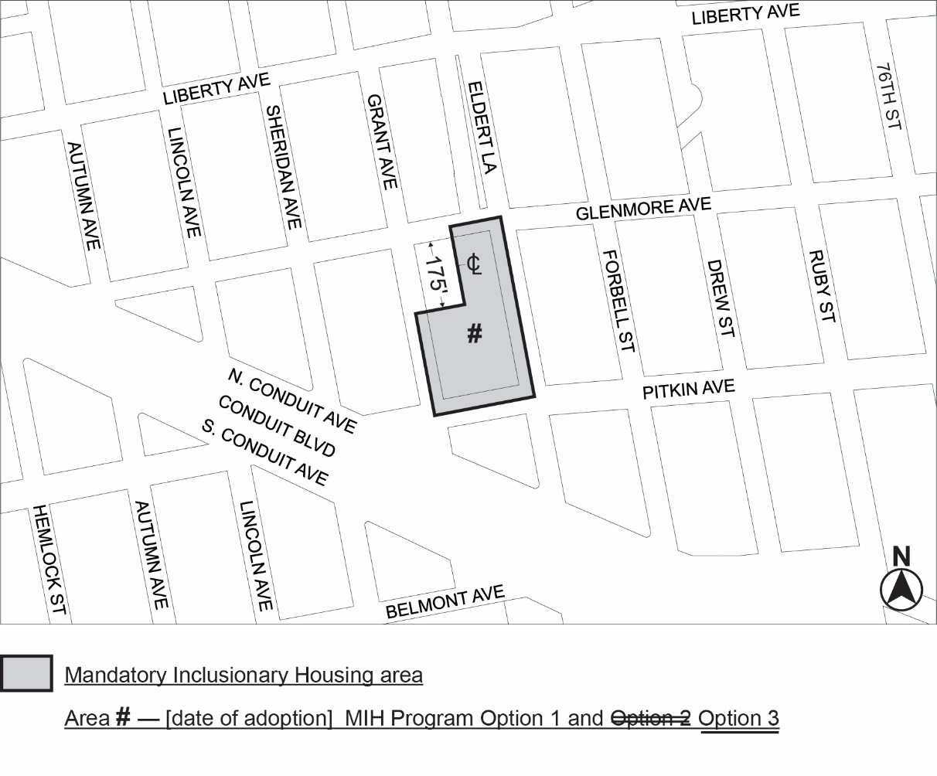
Portion of Community District 5, Brooklyn

* * *
Adopted.

Office of the City Clerk,}
The City of New York,} ss.:

I hereby certify that the foregoing is a true copy of a Resolution passed by The Council of The City of New York on _________, 2025, on file in this office.

.....................................................
City Clerk, Clerk of The Council

