DECLARATION OF LARGE-SCALE GENERAL DEVELOPMENT

KINGS COUNTY

Dated as of [_____], 2024

Block 5727, Lot [upper part of Lot 14]
Block 5516, [upper parts of Lots 1 and 33]
Block 5509, Lots [upper part of Lot 41] and 57

RECORD AND RETURN TO:
Cozen O’Connor P.C.
3 WTC, 175 Greenwich Street, 55th Floor
New York, New York 10007
Attention: Rachel Scall, Esq.

Matter double-underlined is new, added by the City Council;
Matter double struck out is old, deleted by the City Council

DECLARATION OF LARGE-SCALE GENERAL DEVELOPMENT
THIS DECLARATION OF LARGE-SCALE GENERAL DEVELOPMENT (“Declaration”), is made as of the [____] day of [___________________], 2024, by BROOKLYN YARDS DEVELOPMENT LLC (“BKY”), a New York limited liability company, having an address at 543 Bedford Avenue, Unit 264, Brooklyn, New York 11211; Joshua Dembitzber (“Dembitzer”) an individual residing at 1834 49th Street, Brooklyn, New York 11234; and SOLOMON WULLIGER (“Wulliger”), a deceased individual with an address of 1864 52nd Street, Brooklyn, New York 11204 (BKY, Dembitzer, and Wulliger, collectively, “Declarant”).
W I T N E S S E T H:
WHEREAS, BKY is the fee owner of certain real property located in the Borough of Brooklyn, Kings County, City and State of New York, identified on the Tax Map of the City of New York, Kings County ("Tax Map") as Block 5727, Lot [upper part of Lot 14] (“Parcel 1”), which real property is more particularly described in Exhibit A-1 annexed hereto and made a part hereof; Block 5516, Lot [upper part of Lots 1 and 33] (“Parcel 2”), which real property is more particularly described in Exhibit A-2 annexed hereto and made a part hereof; and Block 5509, Lot [upper part of Lot 41] (“Lot [upper part of Lot 41]”; and together with Parcel 1 and Parcel 2, the “Existing BKY Parcels”), which real property is more particularly described in Exhibit A-3 annexed hereto and made a part hereof; and
WHEREAS, The Long Island Rail Road Company (“LIRR”), a subsidiary of the Metropolitan Transportation Authority (“MTA”; together with LIRR, the “MTA Parties” and, individually, an “MTA Party”), is the fee owner of certain real property located in the Borough of Brooklyn, Kings County, City and State of New York, located below Parcel 1, Parcel 2 and Lot [upper part of Lot 41] and identified on the Tax Map as Block 5727, Lot [lower part of Lot 14]; Block 5516, Lot [lower parts of Lots 1 and 33]; and Block 5509, Lot [lower part of Lot 41]; which real property (collectively, the “LIRR Parcels”) is more particularly described in Exhibit B annexed hereto and made a part hereof; and
WHEREAS, the Existing BKY Parcels are subject to certain rights, restrictions, rights-of-way and interests in favor of LIRR (including without limitation in connection with the installation, maintenance, repair and operation of ventilation, lighting and other utility facilities and equipment for the benefit of the LIRR Parcels, the attachment of appurtenances, the operation of transportation corridors in the LIRR Parcels, the installation, restoration and maintenance of fencing, the proper construction, removal, maintenance, repair, renewal, operation and use of structures and improvements, LIRR’s approval of work, plans and specifications, the stationing of protective forces, and the protection of LIRR and its facilities, traffic and operations from losses, damage and interference), which may be modified, supplemented, amended and/or restated from time to time (such rights, restrictions, rights-of-way and interests, as the same may be so modified, supplemented, amended and/or restated, the “LIRR Rights”); and
WHEREAS, Dembitzer and Wulliger are the fee owners, as tenants in common, of certain real property located in the Borough of Brooklyn, Kings County, City and State of New York, identified on the Tax Map as Block 5509, Lot 57 ( “Lot 57”), which real property is more particularly described in Exhibit A-4 annexed hereto and made a part hereof (Lot 57 and the Lot [upper part of Lot 41], together, “Parcel 3”; Parcel 1, Parcel 2 and Parcel 3, collectively, the “BKY Parcels”; the BKY Parcels, excluding the LIRR Rights, any and all Future LIRR Portions (defined herein), and (for the avoidance of doubt) the LIRR Parcels, the “Subject Property”); and
WHEREAS, each of the BKY Parcels is part of a single zoning lot with the portion of the LIRR Parcels located in the same respective Block on the Tax Map; and
WHEREAS, Declarant desires to improve the Subject Property as a "large-scale general development" meeting the requirements of the definition of “large-scale general development” set forth in Section 12-10 of the Zoning Resolution of the City of New York, effective December 15, 1961, as amended to date and as same may hereafter be amended (the “Zoning Resolution” or “ZR”) (such proposed improvement of the Subject Property, the “Proposed Development”); and
WHEREAS, in connection with the Proposed Development, Declarant has filed applications with the New York City Department of City Planning (hereinafter “DCP”) for approval by the New York City Planning Commission (the “Commission”) of: (i) a Zoning Map Amendment to change the Subject Property from an M1-1 district and an R5 district to a mix of C4-5, R6 and R6/C2-4 districts (ULURP No. 230182ZMK) (the “Zoning Map Amendment”); (ii) a Zoning Text Amendment to Appendix F of the Zoning Resolution to establish a Mandatory Inclusionary Housing Area and to Appendix I of the Zoning Resolution to establish Brooklyn Blocks 5509, 5516, and 5523 as part of the Transit Zone (ULURP No. N230183ZRK) (the “Text Amendment”); (iii) a Special Permit, pursuant to ZR Section 74-743, to modify certain bulk regulations applicable to the development of the Subject Property (ULURP No. 230196ZSK) (the “Large-Scale Bulk Special Permit”); (iv) a Special Permit, pursuant to ZR Section 74-745(a), to modify parking location requirements within the Proposed Development (ULURP No. 230188ZSK) (the “Large-Scale Parking Special Permit,” together with the Large-Scale Bulk Special Permit and the Large-Scale Use Special Permit, the “Large-Scale Special Permits”); (v) two Special Permits, pursuant to ZR Section 74-533, to reduce the number of required off-street accessory parking spaces to facilitate affordable housing (ULURP Nos. 230191ZSK and 230184ZSK) (the “Parking Reduction Special Permits”); (vi) three Special Permits, pursuant to ZR Section 74-681, to permit development over a railroad right-of-way (ULURP Nos. 230189ZSK, 230190ZSK and 230185ZSK) (the “Railroad Special Permits”); (vii) three authorizations, pursuant to ZR Section 25-82, to waive required enclosed accessory residential bicycle parking spaces (ULURP Nos. N230193ZAK, N230186ZAK and N230187ZAK) (the “Residential Bicycle Authorizations”); and (viii) an authorization, pursuant to ZR Section 36-72, to waive required enclosed accessory commercial bicycle parking spaces (ULURP No. N230192ZAK) (the “Commercial Bicycle Authorization”) (items (i) through (viii), collectively, the "Land Use Applications"); and
WHEREAS the development of the Subject Property is consistent with the analyses set forth in the Environmental Assessment Statement for City Environmental Quality Review Application No. 23DCP039K (the “EAS”), pursuant to Executive Order No. 91 of 1977, as amended, and the regulations promulgated thereunder at 62 RCNY § 5-01 et seq. (“CEQR”) and the State Environmental Quality Review Act, New York State Environmental Conservation Law § 8-0101 et seq. and the regulations promulgated thereunder at 6 NYCRR Part 617 (“SEQRA”) and incorporates certain project components related to the environment which were materials to the analysis of environmental impacts in the EAS (“PCREs”); and
WHEREAS, such PCREs have been memorialized in that certain CEQR Restrictive Declaration, made by Declarant as of July 23, 2024 and recorded in the Office of the City Register (the “Register’s Office”) on August 9, 2024 at City Register File Number (“CRFN”) 2024000207079; and
WHEREAS, by letter dated June 6, 2024, attached hereto as Exhibit C, the MTA Parties determined that the Proposed Development would not interfere with current or future rail operations; and
WHEREAS, as of the date hereof, BKY is the contract vendee with respect to Lot 57 and intends to purchase from Dembitzer, and Dembitzer intends to sell to BKY, Lot 57 upon Final Approval (defined herein) of the Land Use Applications; and
WHEREAS, Section 74-743(b)(10) of the Zoning Resolution requires that a declaration with regard to ownership requirements in paragraph (b) of the large-scale general development definition in Section 12-10 be filed with the Commission; and
WHEREAS, all parties in interest (as such term is defined in the definition of “zoning lot” in ZR Section 12-10) to the Subject Property as shown on the Certification of Parties in Interest prepared by [TITLE COMPANY], dated [______________________], 2024, and attached hereto as Exhibit D, have joined in this Declaration or have waived their respective rights to execute this Declaration by written instrument, a form of which is annexed hereto as Exhibit E (which instruments are intended to be recorded in the Register’s Office simultaneously with the recordation of this Declaration), or have previously waived their right to do so; and
WHEREAS, Declarant desires to restrict the manner in which the Subject Property may be developed, redeveloped, maintained and operated in the future, and intends these restrictions to benefit all the land on the Subject Property;
NOW, THEREFORE, Declarant does hereby declare and agree that the Subject Property shall be held, sold, transferred, conveyed and occupied subject to the restrictions, covenants, obligations, easements, and agreements of this Declaration, which shall run with the Subject Property and which shall be binding on the Declarant, its successors and assigns as follows:
1. Definitions.
(a) “Affordable Housing Unit” shall mean (i) any residential unit of housing within any building at the Proposed Development that is rented to “low income households” (as such term is defined in Section 23-911 of the Zoning Resolution) or “middle income households” (as such term is defined in Section 23-911 of the Zoning Resolution); or (ii) a superintendent unit; provided, however, that there shall not be more than one (1) superintendent unit in each building located in the Proposed Development.
(b) “AG” shall mean the Attorney General of the State of New York.
(c) “Board” shall mean the duly elected or appointed Board of Directors or Board of Managers of a Coop/Condominium (defined herein).
(d) “Business Day” shall mean any day other than (i) a Saturday and a Sunday and (ii) a day on which federally insured depository institutions in the State of New York are authorized or obligated by law, governmental decree or executive order to be closed.
(e) “Coop/Condominium” shall mean any part of the Proposed Development subject to a condominium declaration or owned or otherwise held by a cooperative corporation in accordance with the provisions of the laws of the State of New York.
(f) “Effective Date” shall mean the date upon which the Final Approval (defined herein) becomes effective.
(g) “Final Approval” shall mean approval of those Land Use Applications by the Commission which are pursuant to New York City Charter Section 197-c, which shall be effective on the date that the City Council’s period of review has expired, unless (a) pursuant to New York City Charter Section 197-d(b), the City Council reviews the decision of the Commission approving the Land Use Applications and takes final action pursuant to New York City Charter Section 197-d approving the Land Use Applications, in which event “Final Approval” shall mean such approval of the Land Use Applications by the City Council or (b) the City Council disapproves the decision of the Commission and the Office of the Mayor files a written disapproval of the City Council’s action pursuant to New York City Charter Section 197-d(e), and the City Council does not override the Office of the Mayor’s disapproval, in which event “Final Approval” shall mean the Office of the Mayor’s written disapproval pursuant to such New York City Charter Section 197-d(e). Notwithstanding anything to the contrary contained in this Declaration, “Final Approval” shall not be deemed to have occurred for any purpose of this Declaration if the final action taken pursuant to New York City Charter Section 197-d is disapproval of the Land Use Applications.
(h) “Final Completion” or “Finally Complete” shall mean the completion of all relevant items of work, including any Punch List (defined herein) or other items that remained to be completed after Substantial Completion (defined herein).
(i) “Future LIRR Portions” shall mean any portion of the Existing BKY Parcels located below the limiting plane(s) separating the Existing BKY Parcels from the LIRR Parcels (as any such limiting planes may be modified so that such limiting plans are located at or below the lower face of a platform to be constructed within the Existing BKY Parcels and above the LIRR Parcels (after giving effect to such modification)), that is conveyed to an MTA Party.
(j) “Governmental Authority” shall mean the United States of America, the State of New York, the City of New York, and any agency, department, commission, board, bureau, instrumentality or political subdivision of any of the foregoing, now existing or hereafter created, having jurisdiction over the Subject Property.
(k) “Individual Assessment Interest” shall mean the Unit Interested Party’s (defined herein) percentage interest in the common elements of the condominium in which such condominium unit is located, applied to the assessment imposed by the Association (defined herein) on the condominium in which such condominium unit is located.
(l) “Legal Requirements” shall mean all applicable laws, statutes and ordinances, and all orders, rules, regulations, interpretations, directives and requirements, of any Governmental Authority having jurisdiction over the Subject Property.
(m) “LIRR Property” shall mean Future LIRR Portions, together with the LIRR Parcels and the LIRR Rights.
(n) “Offering Plan” shall mean an offering plan or “red herring” issued in connection with the marketing and sale of securities appurtenant to units in a Coop/Condominium constructed or otherwise included in the Proposed Development.
(o) “PCO” shall mean a permanent certificate of occupancy.
(p) “Publicly Accessible Areas” shall mean those areas labeled “Publicly Accessible Area” or “PAA” on the Plans (defined herein).
(q) “Substantial Completion,” or “Substantially Complete,” with respect to the Publicly Accessible Areas, shall be mean that the Publicly Accessible Areas have been constructed substantially in conformance with the Plans, as same may be amended from time to time in accordance herewith, and have been completed to such an extent that all portions of the improvements may be operated and made available for public use. The Publicly Accessible Areas shall be deemed Substantially Complete notwithstanding that (a) minor or insubstantial items of construction, decoration or mechanical adjustment remain to be performed, or (b) Declarant has not completed any relevant planting or vegetation or tasks that must occur seasonally.
(r) “Successor Declarant” shall mean any successor entity to the balance and entirety of Declarant’s fee interest in the Subject Property.
(s) “TCO” shall mean a temporary certificate of occupancy.
(t) “Uncontrollable Circumstance” shall mean an occurrence beyond the reasonable control of Declarant which delays the performance of Declarant’s obligations hereunder, provided that Declarant has taken all reasonable steps reasonably necessary to control or to minimize such delay, and which occurrences shall include, but not be limited to: (i) a strike, lockout or labor dispute; (ii) the inability to obtain labor or materials or reasonable substitutes therefor; (iii) acts of God; (iv) restrictions, regulations, orders, controls or judgments of any Governmental Authority; (v) undue material delay in the issuance of approvals by any Governmental Authority, provided that such delay is not caused by any act or omission of Declarant; (vi) enemy or hostile government action, civil commotion, insurrection, terrorism, revolution or sabotage; (vii) fire or other casualty; (viii) a taking of the whole or any portion of the Subject Property by condemnation or eminent domain; (ix) inclement weather substantially delaying construction of any relevant portion of the Subject Property; (x) unforeseen below-grade, underground or soil conditions, provided that Declarant did not and could not reasonably have anticipated the existence thereof as of the date hereof; (xi) the denial of access to adjoining real property, notwithstanding the existence of a right of access to such real property in favor of Declarant arising by contract, this Declaration, or Legal Requirements; (xii) failure or inability of a public utility to provide adequate power, heat or light or any other utility service; or (xiii) orders of any court of competent jurisdiction, including, without limitation, any litigation which results in an injunction or restraining order prohibiting or otherwise delaying the construction of any portion of the Proposed Development.
(u) “Unit Interested Party” shall mean all owners (other than a fee owner), lessees, or occupants of any individual residential or commercial condominium unit, and all holders of a mortgage or other lien encumbering any such residential or commercial condominium unit on the Subject Property.
2. Designation of Large-Scale General Development. Declarant hereby declares and agrees that, following the Effective Date, the Subject Property, if developed pursuant to the Large-Scale Special Permits, shall be treated and developed as a “large-scale general development,” as such term is defined in the Zoning Resolution in effect on the Effective Date, and shall be developed and enlarged as a single unit.
3. Development and Use of the Subject Property.
(a) Plans. If the Subject Property is developed in whole or part in accordance with the Large-Scale Special Permits, Declarant covenants and agrees that the Proposed Development on the Subject Property shall be constructed substantially in conformance with the following plans prepared by STUDIO V Architecture, and annexed hereto as Exhibit F and made a part hereof (collectively, the “Plans”):
Drawing No. | Title | Date
Z-010.00 | Zoning Analysis | 07/09/2024 [__/__/____]
Z-011.00 | Zoning Diagrams | 07/09/2024 [__/__/____]
Z-012.00 | LSGD Site Plan | 07/09/2024 [__/__/____]
Z-110.00 | Zoning Site Plan Lot 1 | 07/09/2024 [__/__/____]
Z-111.00 | Platform Diagram Lot 1 | 07/09/2024 [__/__/____]
Z-114.00 | Waiver Plan Lot 1 | 07/09/2024 [__/__/____]
Z-115.00 | Waiver Sections Lot 1 | 07/09/2024 [__/__/____]
Z-116.00 | Waiver Sections Lot 1 | 07/09/2024 [__/__/____]
Z-210.00 | Zoning Site Plan Lot 2 | 07/09/2024 [__/__/____]
Z-211.00 | Platform Diagram Lot 2 | 07/09/2024 [__/__/____]
Z-214.00 | Waiver Plan Lot 2 | 07/09/2024 [__/__/____]
Z-215.00 | Waiver Sections Lot 2 | 07/09/2024 [__/__/____]
Z-216.00 | Waiver Sections Lot 2 | 07/09/2024 [__/__/____]
Z-310.00 | Zoning Site Plan Lot 3 | 07/09/2024 [__/__/____]
Z-311.00 | Platform Diagram Lot 3 | 07/09/2024 [__/__/____]
Z-314.00 | Waiver Plan Lot 3 | 07/09/2024 [__/__/____]
Z-315.00 | Waiver Sections Lot 3 | 07/09/2024 [__/__/____]
L-100.00 | Landscape Zoning Lot Site Plan | 12/22/2023 [__/__/____]
L-110.00 | Layout Plans PAA – 1 & 2 | 12/22/2023 [__/__/____]
L-111.00 | Layout Plan – PAA 3 | 12/22/2023 [__/__/____]
L-120.00 | Furniture & Amenities Plans – PAA 1 & 2 | 12/22/2023 [__/__/____]
L-121.00 | Furniture & Amenities Plans – PAA 3 | 12/22/2023 [__/__/____]
L-130.00 | Planting Plans PAA 1 & 2 | 12/22/2023 [__/__/____]
L-200.00 | Sections and Elevations | 12/22/2023 [__/__/____]
L-201.00 | Sections and Elevations | 12/22/2023 [__/__/____]
L-300.00 | PAA Paving and Furnishing Details | 12/22/2023 [__/__/____]
L-301.00 | PAA Signage Details | 12/22/2023 [__/__/____]
LC-100 | Arch 1 Lighting Plan | 12/22/2023 [__/__/____]
LC-101 | Arch 2 Lighting Plan | 12/22/2023 [__/__/____]
LC-102 | Arch 3 Lighting Plan | 12/22/2023 [__/__/____]

(b) Representation. Declarant hereby represents and warrants that as of the Effective Date, except for the LIRR Rights, there will be no restriction of record on the development, enlargement, or use of the Subject Property, nor any then-existing estate or interest in the Subject Property, nor any lien, obligation, covenant, easement, limitation or encumbrance of any kind that shall preclude the restriction and obligation to develop and enlarge the Subject Property as a large-scale general development as set forth herein.
(c) LIRR Property; Limitations.
(i) In no event shall any MTA Party or any agency or affiliate thereof have, whether by virtue of any right, title or interest in the LIRR Property or otherwise, any liability whatsoever for the obligations or agreements of, or the restrictions on, Declarant hereunder or be subject to levy, execution or other enforcement procedure in connection with any exercise of remedies by the City of New York (the “City”) or any other party under or with respect to this Declaration.
(ii) In the event that any MTA Party acquires any Future LIRR Portion(s), Declarant shall amend the Declaration to reflect said acquisition. Such amendment shall be considered an amendment of this Declaration and must comply with all provisions of this Declaration, including Section 10. No failure by Declarant to effect, or delay by Declarant in effecting, such amendment shall derogate from the provisions of Section 3(d)(iii), which shall be self-operative and shall apply to any Future LIRR Portion automatically upon the acquisition of such Future LIRR Portion.
(iii) The MTA Parties shall have all rights in and to the LIRR Property (including without limitation LIRR’s right to use, enjoy, develop and occupy the LIRR Property), and this Declaration shall in no way encumber or restrict the LIRR Property or any interest therein, or be binding upon the holder of any interest in the LIRR Property.
4. Publicly Accessible Areas. Declarant shall construct and complete the Publicly Accessible Areas, as delineated on the Plans, of the Proposed Development, in accordance with the provisions set forth in this Section 4.
(a) Construction of the Publicly Accessible Areas. Declarant shall construct the Publicly Accessible Areas in substantial conformance with the Plans.
(b) Completion of the Publicly Accessible Areas.
(i) Substantial Completion. Declarant (i) shall not accept a TCO from the DOB for the seventh and final building of the Proposed Development on Parcel 1 until the Chair of the Commission (the “Chair”) certifies to Declarant and DOB that the Publicly Accessible Area labeled “PAA 1” on the Plans is Substantially Complete, and (ii) shall not accept a TCO from DOB for the fifth and final building of the Proposed Development on Parcel 2 until the Chair certifies to Declarant and DOB that the Publicly Accessible Areas labeled “PAA 2” and “PAA 3” on the Plans are Substantially Complete, each in accordance with the following provisions:
a. Notification. Declarant shall notify the Chair at such time as it believes that one or more of the Publicly Accessible Areas are Substantially Complete and shall request that the Chair issue a certification, in the form of Exhibit G annexed hereto (the “Notice of Substantial Completion”), to Declarant and DOB certifying the Substantial Completion of the subject Publicly Accessible Area(s) in accordance with the Plans.
b. Initial Review. Not later than twenty (20) business days of its receipt of the notification set forth in Section 4(b)(i)(a) hereof (the “Substantial Completion Initial Review Period”), the Chair shall either (A) issue the Notice of Substantial Completion, or (B) deliver to Declarant written notice setting forth in detail the reasons why the subject Publicly Accessible Area(s) are not Substantially Complete and the items which need to be completed in order to determine that the Publicly Accessible Area(s) are Substantially Complete. If the Chair notifies the Declarant that the subject Publicly Accessible Area(s) are not Substantially Complete in accordance with the Plans, such notice shall contain a detailed statement of the reasons for withholding the Notice of Substantial Completion in the form of a “punch list” of items remaining to be completed or to be satisfactorily performed (the “Punch List”). The Punch List shall not include items which, pursuant to the definition of Substantial Completion, are not required to be completed to achieve Substantial Completion.
c. Subsequent Review. Upon performing the work specified in the Punch List, Declarant shall notify the Chair of such completion. Not later than ten (10) business days of receipt of such notice (the “Substantial Completion Subsequent Review Period”) the Chair shall either (A) issue the Notice of Substantial Completion, or (B) notify Declarant in writing of any Punch List items that have not been completed or satisfactorily performed. This process shall continue until the Chair has issued a Notice of Substantial Completion for each Publicly Accessible Area.
d. Notwithstanding anything to the contrary set forth in Section 4 hereof, if, within the Substantial Completion Initial Review Period, or the Substantial Completion Subsequent Review Period, as applicable, the Chair fails to provide the Notice of Substantial Completion, or fails to notify the Declarant in writing of any Punch List items that have not been completed or satisfactorily performed, then the Chair shall be deemed to have issued the Notice of Substantial Completion for the subject Publicly Accessible Area(s), and Declarant may accept a TCO from DOB for the seventh and final building on Parcel 1 or the fifth and final building on Parcel 2, as applicable.
(ii) Final Completion. Declarant shall not accept a PCO from DOB for the fourteenth and final building of the Proposed Development constructed on the Subject Property pursuant to the Large-Scale Special Permits until the Chair certifies to Declarant and DOB that the Publicly Accessible Areas are Finally Complete, in accordance with the following provisions:
a. Notification. Declarant shall notify the Chair at such time as it believes that the Publicly Accessible Areas are Finally Complete and shall request that the Chair issue a certification, in the form of Exhibit H annexed hereto (the “Notice of Final Completion”), to Declarant and DOB certifying the Final Completion of the Publicly Accessible Areas in accordance with the Plans.
b. Initial Review. Not later than twenty (20) business days of its receipt of the notification set forth in Section 4(b)(ii)(a) hereof (the “Final Completion Initial Review Period”), the Chair shall either (A) issue the Notice of Final Completion, or (B) deliver to Declarant written notice setting forth in detail the reasons why the Publicly Accessible Areas are not Finally Complete and the items which need to be completed in order to determine that the Publicly Accessible Areas are Finally Complete. If the Chair notifies the Declarant that the Publicly Accessible Areas are not Finally Complete in accordance with the Plans, such notice shall contain a detailed statement of the reasons for withholding the Notice of Final Completion in the form of a Punch List.
c. Subsequent Review. Upon performing the work specified in the Punch List, Declarant shall notify the Chair of such completion. Not later than ten (10) business days of receipt of such notice (the “Final Completion Subsequent Review Period”) the Chair shall either (A) issue the Notice of Final Completion, or (B) notify Declarant in writing of any Punch List items that have not been completed or satisfactory performed. This process shall continue until the Chair has issued the Notice of Final Completion.
d. Notwithstanding anything to the contrary set forth in Section 4 hereof, if, within the Final Completion Initial Review Period, or the Final Completion Subsequent Review Period, as applicable, the Chair fails to provide the Notice of Final Completion, or fails to notify the Declarant in writing of any Punch List items which have not been completed or satisfactory performed, then the Chair shall be deemed to have issued the Notice of Final Completion, and Declarant may accept a PCO from DOB for the fourteenth and final building.
(c) Publicly Accessible Easement.
(i) Declarant covenants that, immediately upon the issuance of the Notice of Substantial Completion, it (as the burdened party) shall grant, convey and transfer to the City, for the benefit of the general public (as the benefited party), a permanent, perpetual, non-exclusive public access easement over and encompassing the Publicly Accessible Areas, unobstructed from the surface thereof to the sky, except where portions of a building are located above the Publicly Accessible Areas in accordance with the Plans, in which case the public access easement shall terminate at a height of 10 feet above base plane, as established on the Plans (the “Publicly Accessible Easement”). The Publicly Accessible Easement shall be for the purpose of (A) passive recreational use by the general public and (B) access for fire, police and other emergency services. Such easement (x) shall be effectuated without the necessity for recording a separate instrument and (y) upon such issuance of a Notice of Substantial Completion, shall be prior in interest to any property interest on the Subject Property or any portion thereof that is recorded after the date of this Declaration. The Publicly Accessible Easement shall be subject to the following conditions:
(ii) No member of the general public shall use any portion of the Publicly Accessible Areas for any activity or in a manner which injures, endangers or unreasonably disturbs the comfort, peace, health or safety of any person, or disturbs or causes injury to plant or animal life, or causes damage to the Subject Property or any person.
(iii) The Publicly Accessible Areas shall be open to the public between the hours of 6AM to 1AM, daily.
(iv) Declarant shall have the right, but not the obligation, to establish rules and regulations governing public use of, and behavior in, the Publicly Accessible Areas, which rules and regulations shall not conflict with Department of Parks and Recreation Rules and Regulations (56 RCNY §1-01 et seq.) unless Declarant has sought and received the consent of the Chair. Declarant shall operate the Publicly Accessible Areas in conformity with the Department of Parks and Recreation Rules and Regulations unless and until it promulgates rules and regulations of its own for use of the Publicly Accessible Areas.
(v) Declarant may close the Publicly Accessible Areas or portions thereof for periods as may be necessary (i) to accomplish maintenance and repairs or replacements, (ii) for safety and security, logistics and public safety during construction or maintenance of buildings surrounding the Publicly Accessible Areas, (iii) to make emergency repairs to mitigate hazardous conditions; and (iv) to address other emergency conditions.
(vi) Notwithstanding the foregoing, Declarant may close the Publicly Accessible Areas one day in each calendar year for private events to avoid public dedication.
(d) Maintenance and Operation.
(i) Declarant shall provide or, in Declarant’s sole discretion, cause to be provided, all services required for the maintenance and repair of the Publicly Accessible Areas, and any paving, landscaping, equipment or furniture provided therein, as and when reasonably needed to preserve the Publicly Accessible Areas and the amenities contained therein in neat, clean and good working order and condition as set forth in this Section.
(ii) Cleaning.
a. Trash shall be collected regularly. Litter and other obstructions shall be removed as needed.
b. Walkways and paths shall be cleaned and cleared as needed and maintained in good condition.
c. Appropriate measures shall be taken to control rodents and pigeons.
d. Graffiti shall be promptly removed or painted over.
e. Drains, sewers and catch basins shall be cleaned regularly to prevent clogging.
f. Snow shall be promptly removed from walkways, and fallen branches and trees shall be removed promptly.
(ii) Landscape and Feature Maintenance.
a. Appropriate maintenance for planted areas shall be undertaken, including pruning, trimming, and weeding; removal and replacement of plants, branches and trees that are dead or blighted; wrapping of trees, shrubs, and other plants as necessary to ensure adequate winter protection, and subsequent removal come springtime; replanting, reseeding and fertilizing as needed; mowing of grass and watering of plantings as needed.
b. Adequate lighting levels shall be maintained, and lighting equipment shall be repaired or replaced as necessary.
(ii) Repairs and Replacements. Repairs and replacements of features in the Publicly Accessible Areas shall occur as needed to maintain the Publicly Accessible Areas in a state of good repair. All repairs and replacements shall occur promptly and in substantial conformance with the Plans. Repairs shall include, but are not limited to, the following items:
a. Seating. All seating shall be repaired and repainted as necessary, including replacement of any moveable seating that has been removed.
b. Walls or Other Barriers. Any broken or cracked walls, fences or other barriers shall be repaired or replaced.
c. Paving. All paved surfaces shall be maintained in a safe and attractive condition.
d. Painting. All painted items shall be repainted and rust or other extraneous matter removed as needed.
e. Signage. All signs shall be maintained in good condition and cleaned or replaced if vandalized.
f. Construction Defects and Hazardous Conditions. The Publicly Accessible Areas shall be periodically inspected for construction defects and hazardous conditions, and any portion or feature that exhibits defects or hazardous conditions shall be promptly repaired or replaced.
(e) Property Owners’ Association.
(i) Applicability. The provisions of this Section 4(e) shall only apply if Declarant forms an Association (defined herein) with respect to the Subject Property.
(ii) Declarant shall cause a property owner’s association to be organized, pursuant to the provisions of 13 NYCRR Article 22 (the “Association”) or join a previously created Association, created for the purposes set forth in Section 4(e) herein, upon the earliest to occur of the following occurrences: (I) the issuance of a TCO for any portion of the Proposed Development (A) governed by a condominium regime, (B) conveyed to a housing corporation to be governed by a cooperative regime, or (C) governed by such other legal regime which shall require the organization of a not-for-profit membership organization comprising homeowners; and (ii) the subdivision and conveyance of the Subject Property to multiple fee owners and/or ground lessees.
(ii) The obligations of the Association under this Declaration shall commence on the date that a Declaration of Covenants, Restrictions, and Easements establishing the Association (the “DCRE”) is recorded in the Register’s Office (the “Association Obligation Date”), at which time the Association shall be deemed a Declarant. There may be only one Association for the Subject Property.
(iii) Filing Requirements. The Association shall be organized in accordance with the terms of this Declaration and in accordance with the New York State Not-for-Profit Corporation Law. Declarant shall certify in writing to the Chair, or any individual succeeding to their jurisdiction, that the certificate of incorporation of the Association has been filed with the New York Secretary of State and that the certificate of incorporation and all other governing documents of the Association are in full compliance with the requirements of this Declaration and shall provide the Chair with copies of such certificate of incorporation and the other governing documents of the Association. If Declarant fail to comply with the provisions of this Section, the City may proceed with any available enforcement measures.
(ii) Obligations. The Association shall be established for, among other things, the purposes of assuming the Declarant’s performance of the maintenance and operations obligations set forth in Section 4(d) hereof. The initial Declarant or any Successor Declarant, along with the Association and any party that constitutes a Declarant under this Section 4(e), shall be jointly and severally responsible for the construction and Final Completion of the Publicly Accessible Areas.
(iii) Members. The members of the Association (the “Association Members”) shall consist of (A) the fee owners and/or ground lessees of any portion of the Subject Property that has not been developed as or converted to a Coop/Condominium, and (B) the Boards of any portion of the Subject Property which is developed as or converted to a Coop/Condominium. In no event shall the Association Members include a Unit Interested Party.
- Each Association Member hereby (x) irrevocably consents to any amendment, modification, cancellation, revision or other change in this Declaration by the Association; (y) waives and subordinates any rights it may have to enter into an amended Declaration or other instrument amending, modifying, canceling, revising or otherwise changing this Declaration; and (z) nominates, constitutes and appoints the Association its true and lawful attorney-in-fact, coupled with an interest, to execute any documents or instruments that may be required in order to amend, modify, cancel, revise or otherwise change this Declaration and Exhibits hereto.

- Each Association Member, by acceptance of a deed or lease for a portion of the Subject Property shall, whether or not the covenant is expressed in such deed or lease (or, if the Association Member is the Board of a Coop/Condominium, in the declaration, bylaws and/or proprietary leases of such Coop/Condominium) be deemed to have consented to pay all assessments which may be imposed by the Association on the parcel owned or leased by such Association Member, as set forth herein.
(iv) Powers. Declarant shall cause the Association to be established with the power and authority to:
- Maintain repair, and operate the Publicly Accessible Areas to the extent required by this Declaration;

- Impose fees or assessments against the Association Members, for the purpose of collecting funds necessary to satisfy the obligations of the Association pursuant to this Declaration;

- Collect, receive, administer, protect, invest and dispose of funds related to the subject matter hereof;

- Bring and defend actions and negotiate and settle claims to recover fees or assessments owed to the Association pursuant to this Section 4(e);

- Exercise any of its duties or obligations pursuant to this Declaration without seeking the consent of any Unit Interested Parties; and

- Exercise any and all of such powers as may be necessary or appropriate for purposes of this Declaration and as may be granted to the Association in furtherance of the Association’s purposes pursuant to the New York Not-for-Profit Corporation Law or New York State Business Corporation Law, or the rules and regulations promulgated by the Department of Law for the regulation of homeowners’ (property owner’s) associations, as the case may be.
(v) Assessments; Association Member Obligations.
a. The Association shall assess real property constituting each Coop/Condominium or fee parcel within the Subject Property, other than Affordable Housing Units, (the “Assessment Property”) for its proportionate share of the obligations contained in Section 4(d) as provided in the DCRE, in order to obtain funds for the performance of the obligations of Declarant pursuant to this Declaration. The Assessment Property shall be assessed on a reasonable prorated basis as initially determined by Declarant, in compliance with Legal Requirements. For Association Members who are Boards, a reasonable basis for such proration shall be conclusively established if the AG accepts for filing an offering plan for the sale of interests in such Association and the Coop/Condominium, as applicable, which plan describes such proration. The Boards of each Coop/Condominium shall collect such assessments from the owners of individual residential or commercial units, other than the Affordable Housing Units, for delivery to the Association in accordance with the DCRE and the governing documents of each Coop/Condominium.
b. Each periodic assessment by the Association, together with such interest, costs and reasonable attorney’s fees as may be assessed in accordance with the provisions of this Declaration, shall be the obligation of the Association Members against whom the assessment is charged at the time such assessment falls due and may not be waived by such Association Member. The Association may bring an action to recover any delinquent assessment, including interest, costs and reasonable attorney’s fees of any such action, at law or at equity, against the Association Member obligated to pay the same. In the event an Association Member has not paid its assessment to the Association within ninety (90) calendar days of the date such payment was due, the Association shall take all reasonable measures as may be required in order to collect such unpaid assessment.
c. The periodic assessments shall be a charge on the land and a continuing lien upon the property owned by the Association Member against which each such assessment is made, except that if the Association Member is a Board, such lien shall be subordinate to the lien of any prior recorded mortgage in respect of such property given to a bank or other institutional lender (including but not limited to a Governmental Agency), the lien of any real property taxes, and the lien of the Board for unpaid maintenance or common charges. The periodic assessments charged to an Association Member that is a Board shall be included within the common charges of the Condominium. The Association may bring an action to foreclose the Association’s lien against the property owned by such Association Member, or a Unit Interested Party (other than the owner of an Affordable Housing Unit), as the case may be, to recover such delinquent assessment(s), including interest and costs and reasonable attorneys’ fees of any such action. Any Unit Interested Party, other than the owner of an Affordable Housing Unit, by acceptance of a deed or a lease to a portion of the Subject Property, thereby agrees to the provisions of this Section 5(e). Any unit owner may eliminate the Association’s lien described above on his or her unit by payment to the Coop/Condominium of such unit owner’s prorated share of the periodic assessment by the Association to the Condominium in which such unit is located. No Association Member may waive or otherwise escape liability for the assessments provided for herein by non-use of the Publicly Accessible Areas or abandonment of the Association’s property, or by renunciation of membership in the Association, provided, however, that an Association Member’s liability with respect to future assessments shall end upon the valid sale or transfer of such Association Member’s interest in the Subject Property.

d. Notwithstanding any contrary term set forth in this Declaration, the Association Members who may be assessed for obligations hereunder shall not include the holder of a mortgage or other lien encumbering (i) the fee estate in the Subject Property or any portion thereof, (ii) the lessee’s estate in a ground lease of all or substantially all of the Subject Property or all or substantially all of any parcel or portion thereof, or (iii) any single building to be built on the Subject Property, unless and until any such mortgagee succeeds to either (x) a fee interest in the Subject Property or any portion thereof or (y) the lessee’s estate in a ground Lease of all or substantially all the Subject Property or all or substantially all of any parcel or portion thereof (the interests described in sub-clauses (x) or (y) immediately preceding being each referred to as a “Possessory Interest”) by foreclosure of the lien of the mortgage or other lien or acceptance of a deed or other transfer in lieu of foreclosure or exercise of an option to convert an interest as mortgagee into a Possessory Interest in any such fee or ground leasehold estate in the Subject Property or by other means permitted under Legal Requirements from time to time and no such mortgagee or lien holder shall be liable for any assessment imposed by the Association pursuant to this Section 4(e) until the mortgagee or lien holder succeeds to such Possessory Interest.
e. Upon acceptance for filing of an Offering Plan by the AG allowing the sale or transfer of membership interests in the Association, the Association shall certify in writing to the Chairperson and the Commission, or to any individual succeeding to their positions, that all governing documents of the Association are in full compliance with the requirements of this Declaration and shall provide the Chairperson with a copy of such governing documents. If Declarant fails to comply with the provisions of this Section 4(e), the City may proceed with any available enforcement measures.
f. Association Members shall be considered Declarants. Notwithstanding the foregoing, upon Final Completion of the Publicly Accessible Areas, the liability of any Association Member shall be limited to such Association Member’s proportionate share of the obligations hereunder assessed by the Association pursuant to Section 4(e)(v). In the event of a default by the Association, the City shall, prior to enforcing any rights against any Association Members, seek enforcement against the Association and, if applicable, the initial Declarant or a Successor Declarant, pursuant to the notice and cure provisions of Section 9(d).
5. Binding Effect. The restrictions, covenants, rights and agreements set forth in this Declaration shall be binding upon Declarant, or Declarant's successor or assign thereof, and any party acquiring an interest in any portion of the Subject Property (which party shall become a Declarant); provided that the Declaration shall be binding on any Declarant, or Declarant's successor or assign thereof, only for the period during which such Declarant, or Declarant's successor or assign thereof, is the holder of an interest in the Subject Property and only to the extent of such Declarant's, or Declarant's successor or assign thereof, interest in the Subject Property. At such time as a Declarant, or Declarant's successor or assign, no longer holds an interest in the Subject Property, such Declarant's, or Declarant's successor’s or assign’s, obligations and liability under this Declaration shall wholly cease and terminate and the party succeeding such Declarant, or Declarant's successor or assign, shall assume the obligations and liability of Declarant, or Declarant's successor or assign, pursuant to this Declaration with respect to actions or matters occurring subsequent to the date such party assumes an interest in the Subject Property to the extent of such party's interest in the Subject Property. For purposes of this Declaration, any successor to a Declarant shall be deemed a Declarant for such time as such successor holds all or any portion of any interest in the Subject Property. The provisions of this Section 5 are subject to the provisions of Section 3(c).
6. Recordation.
(a) Effective Date. This Declaration and the provisions and covenants hereof shall become effective only upon the Effective Date, provided, that in the event that any administrative, judicial, or other action or enforcement proceeding is brought challenging the validity of the Large Scale Special Permits or the approval of any of the Land Use Applications, the conveyance of any portion of the Subject Property to the Declarant or any action undertaken in connection with or related thereto, then the Effective Date shall be deferred to the date of final resolution of such action or proceeding, including any appeals, upholding in all respects the validity of the Large Scale Special Permits and/or the approval of the Land Use Applications, the conveyance of any portion of the Subject Property, or such related action(s), as the case may be.
(b) Recordation. Within ten (10) Business Days of the date hereof, Declarant shall endeavor to file and record this Declaration (together with all of the exhibits hereto) in the Register’s Office, indexing this Declaration against the BKY Parcels. Declarant shall deliver to the Commission a copy of all such documents, as recorded, certified by the Register’s Office, promptly upon receipt of such documents from the Register’s Office. If Declarant fails to so record such documents, then the City may record duplicate originals of such documents. However, all fees paid or payable for the purpose of recording such documents, whether undertaken by Declarant, or by the City (as permitted in accordance with this Section), shall be borne by Declarant.
7. Limitation of Liability and Indemnification.
(a) Limitation of Liability.
(i) The City shall look solely to the fee estate and interest of Declarant and any and all of its successors and assigns in the Subject Property, on an in rem basis only, for the collection of any money judgment recovered against Declarant or its successors and assigns, and no other property of Declarant or its principals, partners, shareholders, directors, members, officers or employees or successors and assigns shall be subject to levy, execution or other enforcement procedure for the satisfaction of the remedies of the City or any other person or entity with respect to this Declaration, and Declarant shall have no personal liability under this Declaration. In the event that any building in the Proposed Development is converted to condominium form of ownership, every condominium unit (other than an Affordable Housing Unit) shall, as successor in interest to Declarant, be subject to levy or execution for the satisfaction of any monetary remedies of the City, to the extent of each Unit Interested Party’s Individual Assessment Interest, and provided that such enforcement procedures shall be taken simultaneously against all the condominium units in the Projected Development and not against selected individual units only. In the event of a default in the obligations of the Association as set forth herein, the City shall have a lien upon the property owned by each Unit Interested Party solely to the extent of each such Unit Interested Party’s unpaid Individual Assessment Interest, which lien shall include such Unit Interested Party’s obligation for the costs of collection of such Unit Interested Party’s unpaid Individual Assessment Interest. Such lien shall be subordinate to the lien of any mortgage, the lien of any real property taxes, the lien of the Board of any such condominium for unpaid common charges of the condominium, and the lien of the Association pursuant to the provisions of this Declaration. The City agrees that, prior to enforcing its rights against a Unit Interested Party, the City shall first attempt to enforce its rights under this Declaration against Declarant, the Association and the Boards of any condominium association. In the event that the Association shall default in its obligations under this Declaration, the City shall have the right to obtain from the Association and/or Boards of any condominium association, the names of the Unit Interested Parties who have not paid their Individual Assessment Interests. Notwithstanding the foregoing, nothing in this Section shall be deemed to preclude, qualify, limit or prevent any of the City’s governmental rights, powers or remedies, including without limitation, with respect to the satisfaction of the remedies of the City, under any laws, statutes, codes or ordinances.
(ii) The restrictions, covenants and agreements set forth in this Declaration shall bind Declarant and any successor-in-interest only for the period during which Declarant and any such successor-in-interest is the holder of a fee interest in, or is a party in interest of, the Subject Property and only to the extent of such fee interest or the interest rendering Declarant a party in interest. At such time as the named Declarant has no further fee interest in the Subject Property and is no longer a party in interest of the Subject Property, such Declarant’s obligations and liability with respect to this Declaration shall wholly cease and terminate from and after the conveyance of Declarant’s interest and Declarant’s successors-in-interest in the Subject Property by acceptance of such conveyance automatically shall be deemed to assume Declarant’s obligations and liabilities here-under to the extent of such successor-in interest’s interest.
(b) Indemnification.
(i) If Declarant is found by a court of competent jurisdiction to have been in default in the performance of its obligations under this Declaration and such finding is upheld on final appeal, or the time for further review of such finding on appeal or by other proceeding has lapsed, Declarant shall indemnify and hold harmless the City from and against all of its reasonable legal and administrative expenses arising out of or in connection with the enforcement of said judgment and Declarant’s obligations under this Declaration, provided, however, that nothing in this Section shall impose on the Association any indemnification obligations other than the reasonable legal and administrative expenses incurred by the City arising out of or in connection with the enforcement of such obligations. . If any judgment is obtained against Declarant from a court of competent jurisdiction in connection with this Declaration and such judgment is upheld on final appeal or the time for further review of such judgment or appeal by other proceeding has lapsed, Declarant shall indemnify and hold harmless the City from and against all of its reasonable legal and administrative expenses arising out of or in connection with the enforcement of said judgment.
(ii) Declarant shall indemnify and hold harmless the City and its respective officers, employees and agents from and against any and all claims, actions or judgments for loss, damage or injury, including death or personal or property damage of whatsoever kind or nature, arising from Declarant’s default under this Declaration (including, without limitation, if Declarant is found by a court of competent jurisdiction to have been in default in the performance of its obligations under this Declaration and such finding is upheld on final appeal, or the time for further review of such finding on appeal or by other proceeding has lapsed), or the negligence of Declarant, its agents or employees in undertaking its obligations under this Agreement unless such claims, actions or judgments arose out of the negligence, recklessness or willful acts of the City, its agents or its employees; provided, however, that should any such claim be made or action brought, Declarant shall have the right to defend such claim or action with attorneys reasonably acceptable to the City. No such claim or action shall be settled without the written consent of City, unless (i) the City is indemnified fully pursuant to this Section, and (ii) the City has no obligation under the settlement, financial or otherwise.
(iii) The City shall indemnify and hold harmless Declarant and their respective officers, employees and agents from and against any and all claims, actions or judgments for loss, damage or injury, including death or personal or property damage of whatsoever kind or nature, arising from the City’s default under this Declaration (provided that the City is found by a court of competent jurisdiction to have been in default in the performance of its obligations under this Declaration and such finding is upheld on final appeal, or the time for further review of such finding on appeal or by other proceeding has lapsed), or the negligence of the City, its agents, servants or employees in undertaking its obligations under this Declaration unless such claims, actions or judgments arose out of the negligence, recklessness or willful acts of Declarant, its agents or their employees.
8. Notice. All notices, demands, requests, consents, approvals, and other communications (each, a “Notice”) which may be or are permitted, desirable, or required to be given under this Declaration shall be in writing and shall be sent or delivered as follows:
- if to BKY:
Brooklyn Yards Development LLC
543 Bedford Avenue, Unit 263
Brooklyn, New York 11211
Attention: David Tabak

With a copy to:
Cozen O’Connor
175 Greenwich Street
3 WTC, 55th Floor
New York, New York 10007
Attention: Rachel Scall

- if to Dembitzer:
Joshua Dembitzer
1834 49th Street
Brooklyn, New York 11234

With a copy to:
[______________________]

If to Wulliger:
[_______________________]

With a copy to:
[_______________________]

- if to the Commission:

New York City Planning Commission
120 Broadway, 31st Floor
New York, New York 10271
Attention: Chairperson

with a copy to:
The general counsel of Commission at the same address.

- if to a Party-in-Interest other than Declarant:

at the address provided in writing to the Commission in accordance with this Section 8.

- if to a mortgagee of all or any portion of the Subject Property (a “Mortgagee”):

at the address provided in writing to the Commission in accordance with this Section 8.

Declarant or the Commission may, by notice provided in accordance with this Section 8, change any name or address for purposes of this Declaration. In order to be deemed effective, any Notice shall be sent or delivered in at least one of the following manners: (i) sent by registered or certified mail, postage pre-paid, return receipt requested, in which case the Notice shall be deemed delivered for all purposes hereunder five (5) calendar days after being actually mailed; (ii) sent by overnight courier service, in which case the Notice shall be deemed delivered for all purposes hereunder on the date the Notice was actually received or was refused; or (iii) delivered by hand, in which case the Notice will be deemed delivered for all purposes hereunder on the date the Notice was actually received. All Notices from the Commission to the Declarant shall also be sent to every mortgagee of whom Commission has notice, and no Notice shall be deemed properly given to a Declarant without such notice to such mortgagee(s). In the event that there is more than one Declarant at any time, any Notice from the City or the Commission shall be provided to all Declarants of whom Commission has notice.
9. Enforcement, Defaults and Remedies.
(a) Declarant acknowledges that the restrictions, covenants, and obligations of this Declaration will protect the value and desirability of the Subject Property, as well as benefit the City. If Declarant fails to perform any of Declarant’s obligations under this Declaration, the City shall have the right to enforce this Declaration against Declarant and exercise any administrative, legal, or equitable remedy available to the City, and Declarant hereby consents to same; provided that this Declaration shall not be deemed to diminish Declarant’s or any other party in interest’s right to exercise any and all administrative, legal, or equitable remedies otherwise available to it, and provided further, that the City’s rights of enforcement under this Declaration shall be subject to the cure provisions and periods set forth in this Declaration. Declarant also acknowledges that the remedies set forth in this Declaration are not exclusive and that the City and any agency thereof may pursue other remedies not specifically set forth herein including, but not limited to, a mandatory injunction compelling Declarant to comply with the terms of this Declaration and a revocation by the City of any certificate of occupancy, temporary or permanent, for any portion of the Proposed Development on the Subject Property subject to the Large-Scale Special Permits.
(b) Denial of Public Access. If the City has reason to believe that the use and enjoyment of the Publicly Accessible Areas by any member of the public has, without reasonable cause, been denied by Declarant, and the City determines that such denial of access with respect to the right of public access under the Publicly Accessible Easement is in violation of the provisions of this Declaration, the City shall have, after (a) notice to Declarant and (b) an opportunity for Declarant to present evidence disputing such alleged denial of access, in addition to such other rights as may be available at law or equity, the right to seek civil penalties at the New York City Environmental Control Board for a violation relating to privately owned public space.
(c) No Enforcement by Third Parties. Notwithstanding any provision of this Declaration to the contrary, only Declarant, Declarant’s successors and assigns, Mortgagees and the City shall be entitled to enforce or assert any claim arising out of or in connection with this Declaration. Nothing contained herein should be construed or deemed to allow any other person or entity to have any interest in or right of enforcement of any provision of this Declaration or any document or instrument executed or delivered in connection with the Large-Scale Special Permits. In any proceedings brought by the City against Declarant seeking to deny or revoke building permits or certificates of occupancy with respect to the Proposed Development on the Subject Property, or to revoke any Large-Scale Special Permits approved as part of the Land Use Applications, or to impose a lien, fine or other penalty, or to pursue any other remedy available to the City, if the event or occurrence which is the basis of an allegation of a failure to comply by a Declarant is associated with a particular lot or portion(s) of lots developed as part of the Proposed Development on the Subject Property, then the City shall only deny or seek the revocation of building permits or certificates of occupany for such lot(s) or portion(s) of lots, and only seek to impose a fine, lien or other penalty on such lot(s) or portion(s) of a lot, and any such event or occurrence shall not provide the basis for denial or revocation of the Large-Scale Special Permits approved as part of the Land Use Applications or building permits or certificates of occupancy, or the imposition of any fine, lien or other penalty, with respect to other lot(s) or portion(s) of a lot comprising a portion of the Proposed Development for which no such failure to comply has occurred.
(d) Notice and Cure.
(i) Prior to the City instituting any proceeding to enforce the terms or conditions of this Declaration due to any alleged violation hereof, the City shall give Declarant, every mortgagee and every party in interest, thirty (30) Business Days written notice of such alleged violation, during which period the Declarant, any party in interest and any mortgagee shall have the opportunity to effect a cure of such alleged violation or to demonstrate to the City why the alleged violation has not occurred. If a mortgagee or party in interest performs any obligation or effects any cure Declarant is required to perform or cure pursuant to this Declaration, such performance or cure shall be deemed performance on behalf of Declarant and shall be accepted by any person or entity benefited hereunder, including the Commission and City, as if performed by Declarant. If Declarant, any party in interest or mortgagee commences to effect such cure within a thirty (30) Business Day period of the City’s written notice of the alleged violation (or if cure is not capable of being commenced within such thirty (30) day period, Declarant, any party in interest or mortgagee commences to effect such cure when such commencement is reasonably possible), and thereafter proceeds diligently toward the effectuation of such cure, the aforesaid thirty (30) day period (as such may be extended or shortened in accordance with the preceding clause) shall be extended for so long as Declarant, any party in interest or mortgagee continues to proceed diligently with the effectuation of such cure, as determined by the City. In the event ownership of any of the lots comprising the Subject Property is held by multiple Declarants, notice shall be provided to all Declarants holding such lots from of the City has received notice in accordance with Section 8 hereof.
(ii) If, after due notice and opportunity to cure as set forth in this Declaration, Declarant fails to observe any of the terms or conditions of this Declaration, and Declarant fails to cure such violation within the applicable grace period provided herein, then, upon the expiration of such cure period, prior to institution by the City of any action or proceeding against Declarant, every mortgagee and party in interest shall be given thirty (30) Business Days written notice of such alleged violation by the City, during which period each mortgagee and party in interest shall have the opportunity to effect such cure. If any mortgagee or party in interest commences to effect a cure within thirty (30) Business Days of receipt of such notice and thereafter proceeds diligently to complete the effectuation of such cure, such cure period shall be extended for so long as any mortgagee or party in interest continues to proceed diligently toward such cure. If a mortgagee or party in interest performs any obligation or effects any cure Declarant is required to perform or cure pursuant to this Declaration, such performance or cure shall be deemed performance on behalf of Declarant and shall be accepted by any person or entity benefited hereunder, including the Commission and the City, as if performed by Declarant.
(iii) If, after due notice and opportunity to cure as set forth in this Section 9, Declarant, mortgagee or a party in interest shall fail to cure the alleged breach or other violation under this Declaration within the applicable grace period provided herein, the City may exercise any and all of its rights, including, without limitation, those delineated herein, and may disapprove any amendment, modification or cancellation of this Declaration on the sole ground that Declarant is in default of a material obligation hereunder. The time period for curing any violation by a Declarant, mortgagee, and/or party in interest shall be subject to extension for Uncontrollable Circumstances pursuant to Section 9(f) hereof.
(f) Uncontrollable Circumstances.
(i) In the event that, as the result of an Uncontrollable Circumstance, Declarant is unable to perform or complete any obligation (including but not limited to Substantially Completing or Finally Completing the Publicly Accessible Areas) (A) at the time or times required by this Declaration; (B) at the date set forth in this Declaration for such action, if a specific date for such requirement is set forth herein; or (C) prior to submitting an application for a building permit or other permit or certificate of occupancy which is conditioned on the completion of such requirement, where applicable, Declarant may, upon notice to the Chair (a “Delay Notice”) within forty-eight (48) hours after the occurrence of such Uncontrollable Circumstance becomes apparent, request that the Chair certify the existence of such Uncontrollable Circumstance. Any Delay Notice shall include a description of the Uncontrollable Circumstance and its probable duration and impact on the work in question (as reasonably determined by Declarant). In the exercise of his or her reasonable judgment, the Chair shall, within ten (10) business days of receipt of the Delay Notice, (x) certify in writing that the Uncontrollable Circumstance has occurred, or (y) notify Declarant that he or she does not reasonably believe that the Uncontrollable Circumstance has occurred, and set forth with reasonable specificity the reasons therefor. Failure to respond within such ten (10) business day period shall be deemed a determination by the Chair that an Uncontrollable Circumstance has occurred. If the Chair certifies that an Uncontrollable Circumstance exists, the Chair shall grant Declarant appropriate relief, including notifying DOB that a building permit, TCO or a PCO (as applicable) may be issued for any portion of the Proposed Development. Upon cessation of the Uncontrollable Circumstance, Declarant shall promptly recommence its obligations under this Declaration subject to the Uncontrollable Circumstance.
(ii) As a condition to granting relief pursuant to this Section 9(f), the Chair may require that Declarant post a letter of credit or other security, in a form reasonably acceptable to the Chair and naming the City as beneficiary, to secure Declarant’s obligation to Finally Complete the Publicly Accessible Areas upon the cessation of the Uncontrollable Circumstance. Such security shall be in a sum equal to 175% of the estimated cost of the remaining work required to Finally Complete the Publicly Accessible Areas, as certified by Declarant’s architect or landscape architect.
(iii) Declarant shall be obligated to re-commence construction of the Publicly Accessible Areas to Substantially Complete or Finally Complete same at the end of the Uncontrollable Circumstance specified in the Delay Notice, or such lesser period of time as the Chair reasonably determines the Uncontrollable Circumstance shall continue; provided, however, that any delay arising by reason of an Uncontrollable Circumstance shall be deemed to continue so long as the Uncontrollable Circumstance continues. If Declarant fails to resume performance of the Publicly Accessible Areas work within ninety (90) calendar days after the cessation of the Uncontrollable Circumstance (as reasonably determined by the Chair), the City may undertake performance of the Publicly Accessible Areas work, and draw upon the aforesaid security, to the extent required to Finally Complete the Publicly Accessible Areas. Upon Final Completion of the Publicly Accessible Areas (either by Declarant or the City), the City shall return the aforesaid security (or the undrawn balance thereof) to Declarant.
(iv) Declarant hereby grants to the City a license to enter upon such portions of the Subject Property as shall be required to exercise the self-help rights conferred upon the City by this Section 9(f). The City hereby agrees to indemnify, defend and hold Declarant, its officers, agents, employees, successors, and assigns (the “Indemnified Parties”) harmless from and against any claims arising by reason of its exercise of the self-help rights set forth in this Section 9(f), except to the extent such claim is caused by or contributed to by the negligence of the Indemnified Parties.
10. Applications.
(a) Declarant and/or Declarant’s successors or assigns shall include a copy of this Declaration with any application made to DOB for a foundation, new building, alteration, or other permit for any portion of the Proposed Development subject to the Land Use Applications Nothing in this Declaration, including but not limited to the declaration and covenant made in Section 2 hereof to develop and enlarge the Subject Property as a single unit, shall be construed to prohibit or preclude Declarant from filing for, or DOB from issuing, any permit for all or any portion of the Proposed Development, in such phase or order as the Declarant sees fit in the Declarant’s sole discretion.
(b) Subject to the requirements of Section 11 hereof, nothing in this Declaration shall be construed to prevent Declarant or any of Declarant’s successors or assigns from making any application of any sort to any Governmental Agency in connection with the development of the Subject Property; provided, that Declarant shall include a copy of this Declaration in connection with any application for any such discretionary approval, and provided that nothing in this Section 10(b) shall be construed as superseding the requirements, restrictions, or approvals that may be required under agreements with any other Governmental Agency or the City.
11. Amendment, Modification and Cancellation.
(a) This Declaration may be amended, cancelled, or modified upon application by Declarant and upon the express written approval of the Commission or an agency succeeding to the Commission’s jurisdiction. Without limiting Section 11(f), no other approval by any other public body, private person, or legal entity of any kind shall be required for such modification, amendment or cancellation.
(b) Notwithstanding anything to the contrary contained in this Declaration (but without limiting Section 11(f)), any change to this Declaration proposed by Declarant and submitted to the Chair, which the Chair deems to be a minor modification of this Declaration, may, by express written consent, be approved administratively by the Chair and no other approval or consent shall be required from the Commission, any public body, private person or legal entity of any kind.
(c) Notwithstanding anything to the contrary contained in this Declaration, for so long as Declarant (including any Successor Declarant, other than a Unit Interested Party) shall hold any fee interest in the Subject Property, or any portion thereof, (i) all Unit Interested Parties, (ii) all Boards, and (iii) the Association, hereby (x) irrevocably consent to any amendment, modification, cancellation, revision or other change in this Declaration by Declarant; (y) waive and subordinate any rights they may have to enter into an amended Declaration or other instrument amending, modifying, canceling, revising or otherwise changing this Declaration, and (z) nominate, constitute and appoint Declarant, their true and lawful attorney-in-fact, coupled with an interest, to execute any document or instruments that may be required in order to amend, modify, cancel, revise or otherwise change this Declaration.
(d) Notwithstanding anything to the contrary contained in this Declaration, if the Land Use Applications, as approved or modified by the City Council, are declared invalid or otherwise voided by a final judgment of any court of competent jurisdiction from which no appeal can be taken or for which no appeal has been taken within the applicable statutory period provided for such appeal, then, upon entry of said judgment or the expiration of the applicable statutory period for such appeal, this Declaration shall be cancelled and shall be of no further force or effect and an instrument discharging it may be recorded. Prior to the recordation of such instrument, Declarant shall notify the Chair of Declarant’s intent to discharge this Declaration and request the Chair’s approval, which approval shall be limited to insuring that such discharge and termination is in proper form and provides that the proper provisions that are not discharged survive such termination. Upon recordation of such instrument, Declarant shall provide a copy thereof to the Commission so certified by the Register’s Office. If one or more of the Land Use Applications are declared invalid, then Declarant may apply for modification, amendment or cancellation of this Declaration in accordance with this Section 11.
(e) From and after the date that no Declarant holds any fee interest in the Subject Property or any portion thereof (other than one or more individual residential or commercial condominium units), and provided the Association shall have been organized as provided in this Declaration, the Association shall be deemed to be the sole Declarant and party in interest under this Declaration for that portion of the Proposed Development upon that portion of the Subject Property for which the Association was formed. In such event, the Association shall (as the sole Declarant) be the sole party with any right to amend, modify, cancel, revise or otherwise change this Declaration for such portion, or make any application therefor, and each and every Unit Interested Party hereby (x) irrevocably consents to any amendment, modification, cancellation, revision or other change in this Declaration by the Association; (y) waives and subordinates any rights it may have to enter into an amended Declaration or other instrument amending, modifying, canceling, revising or otherwise changing this Declaration, and (z) nominates, constitutes and appoints the Association its true and lawful attorney-in-fact, coupled with an interest to execute any documents or instruments that may be required in order to amend, modify, cancel, revise or otherwise change this Declaration.
(f) Prior to submission of any amendment, modification or change to this Declaration pursuant to this Section 11, Declarant shall obtain written confirmation from LIRR that such proposed amendment, modification or change would not adversely affect any MTA Party or any agency or affiliate thereof, or, in the event LIRR determines such proposed amendment, modification or change would adversely affect any MTA Party or any agency or affiliate thereof, that LIRR nevertheless finds such amendment, modification or change to be acceptable. Any purported amendment, modification or change to this Declaration in violation of the foregoing provisions of this Section 11(f) shall be null and void ab initio.
12. Severability. In the event that any provision of this Declaration shall be deemed, decreed, adjudged or determined to be invalid or unlawful by a court of competent jurisdiction and the judgment of such court shall be upheld on final appeal, or the time for further review of such judgment on appeal or by other proceeding has lapsed, such provision shall be severable, and the remainder of this Declaration shall continue to be of full force and effect.
13. Governing Law. This Declaration shall be governed by and construed in accordance with the laws of the State of New York.
14. Exhibits. Any and all exhibits, appendices, or attachments referred to herein are hereby incorporated fully and made an integral part of this Declaration by reference.
15. Approvals. Wherever in this Declaration the certification, consent or approval of Declarant, the Chair, or the Commissioner is required or permitted to be given, it is understood that time is of the essence and such certification, consent or approval will not be unreasonably withheld or delayed.
16. Further Assurances. Declarant and the City each agree to execute, acknowledge and deliver such further instruments, and take such other or further actions as may be reasonably required in order to carry out and effectuate the intent and purpose of this Declaration or to confirm or perfect any right to be created or transferred hereunder, all at the sole cost and expense of the party requesting such further assurances.
17. Estoppel Certificates. Whenever requested by a party, the Chair shall within ten (10) Business Days thereafter furnish to the requesting party a written certificate setting forth: (i) that this Declaration is in full force and effect and has not been modified (or, if this Declaration has been modified, that this Declaration is in full force and effect, as modified) and (ii) whether or not, to the best of its knowledge, the requesting party is in default under any provisions of this Declaration and if such a default exists, the nature of such default.
18. Counterparts. This Declaration may be executed in one or more counterparts, each of which shall be an original and all of which, together, shall constitute one agreement.
19. Right to Sue. Nothing contained herein shall prevent Declarant from asserting any claim or action against the City, or any of its agencies or any of its officials, arising out of the performance by the City, or agency thereof, or failure of the City or agency thereof, to perform, any the obligations of the City, or agency thereof, under this Declaration or the exercise, by the City, or any agency thereof, of any of its rights under this Declaration. Nothing contained herein shall prevent the City of New York or any of its officials from asserting any claim or action against Declarant arising out of Declarant’s performance of, or failure to perform, any of its obligations under this Declaration, or the exercise by Declarant of any of their rights under this Declaration.

[Signature page follows]
IN WITNESS WHEREOF, the undersigned have executed this Declaration as of the date first written above.

BROOKLYN YARDS DEVELOPMENT LLC,
a New York limited liability company

By: ___________________________
Name:
Title:

STATE OF_______________)
) SS.:
COUNTY OF ____________)

On the ____ day of _________________, 20___, before me, the undersigned, personally appeared_____________________________________, personally known to me or proved to me on the basis of satisfactory evidence to be the individual whose name is subscribed to the within instrument and acknowledged to me that he/she executed the same in his/her capacity, and that his/her signature on the instrument, the individual, or the person upon behalf of which the individual acted, executed the instrument.

_______________________________
Notary Public

Joshua Dembitzber

By: ___________________________
Name:

STATE OF_______________)
) SS.:
COUNTY OF ____________)

On the ____ day of _________________, 20___, before me, the undersigned, personally appeared_____________________________________, personally known to me or proved to me on the basis of satisfactory evidence to be the individual whose name is subscribed to the within instrument and acknowledged to me that he/she executed the same in his/her capacity, and that his/her signature on the instrument, the individual, or the person upon behalf of which the individual acted, executed the instrument.

_______________________________
Notary Public
SOLOMON WULLIGER

By: ___________________________
Name: Beverley Wulliger, as nominated executor of the Estate of Solomon Wulliger

STATE OF_______________)
) SS.:
COUNTY OF ____________)

On the ____ day of _________________, 20___, before me, the undersigned, personally appeared_____________________________________, personally known to me or proved to me on the basis of satisfactory evidence to be the individual whose name is subscribed to the within instrument and acknowledged to me that he/she executed the same in his/her capacity, and that his/her signature on the instrument, the individual, or the person upon behalf of which the individual acted, executed the instrument.

_______________________________
Notary Public

EXHIBIT A-1
DESCRIPTION OF PARCEL 1
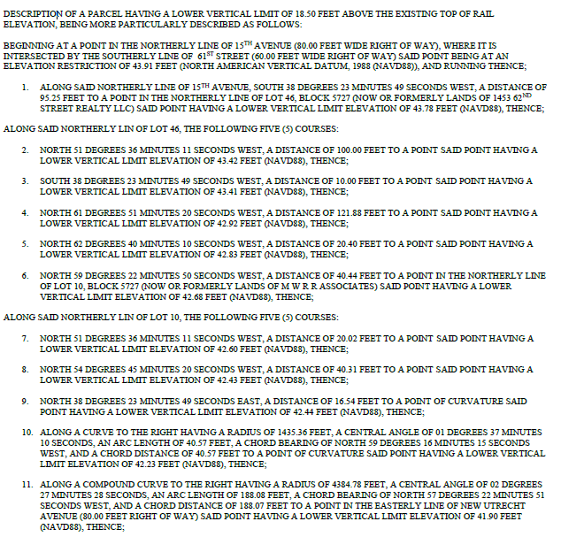
[continued on following page]
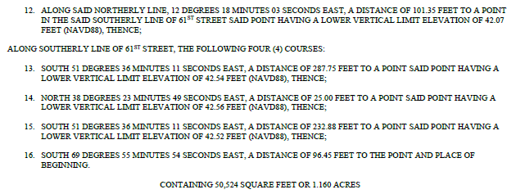

EXHIBIT A-2
DESCRIPTION OF PARCEL 2
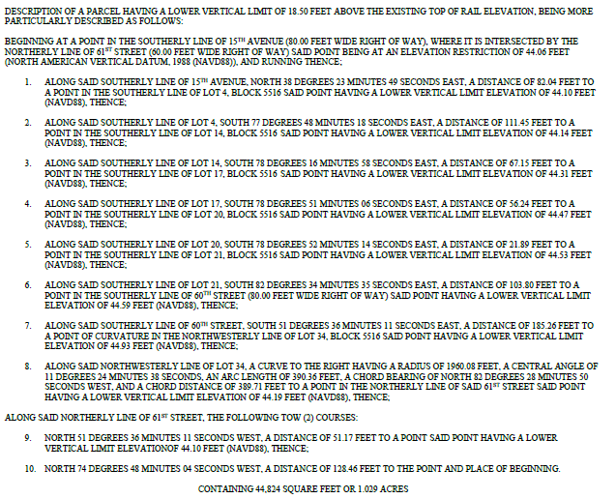

EXHIBIT A-3
DESCRIPTION OF LOT [UPPER PART OF LOT 41]
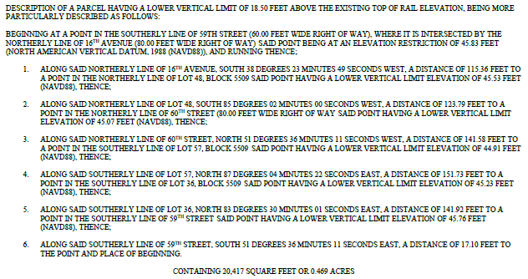
EXHIBIT A-4
DESCRIPTION OF BLOCK 5509, LOT 57
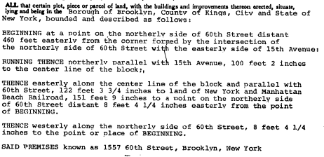
EXHIBIT B
DESCRIPTION OF THE LIRR PROPERTY
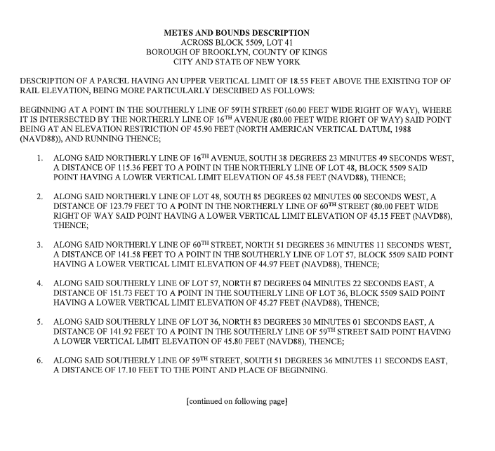

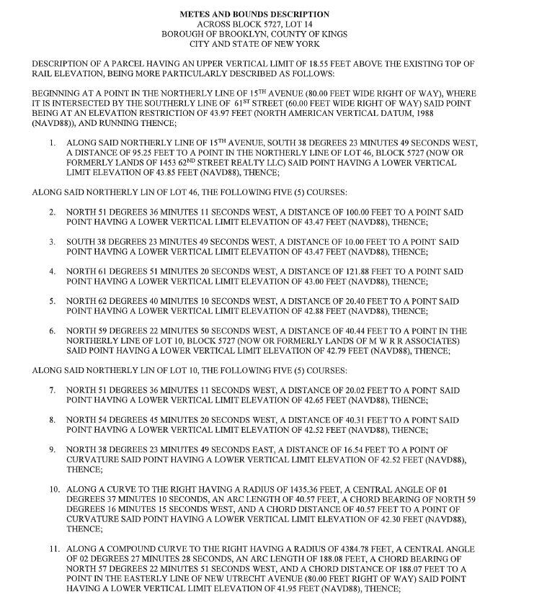

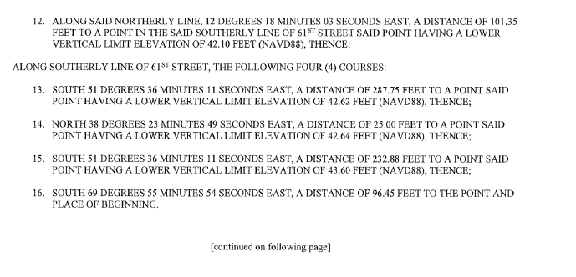

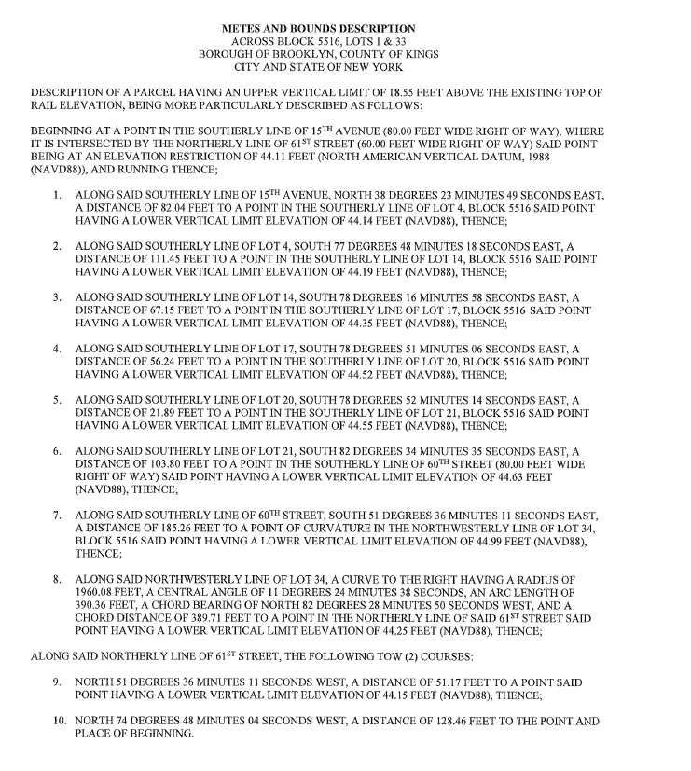
EXHIBIT C
MTA LETTER
[Attached behind]

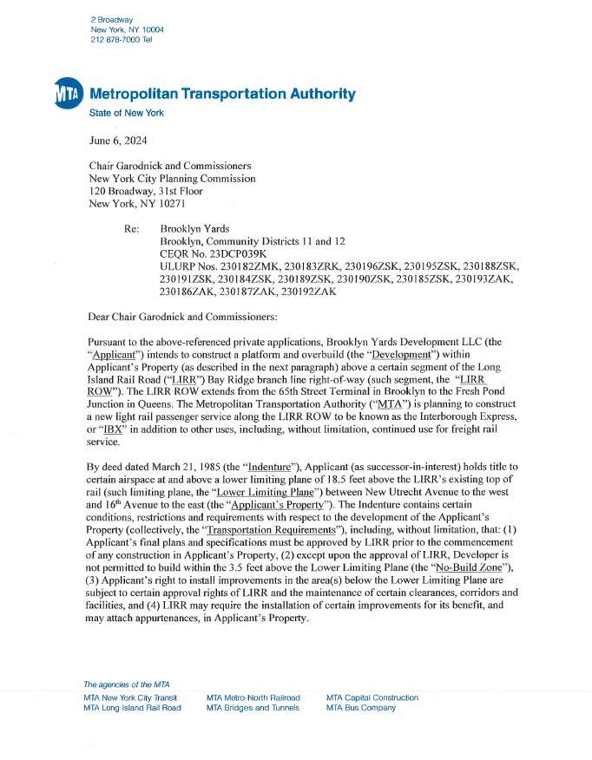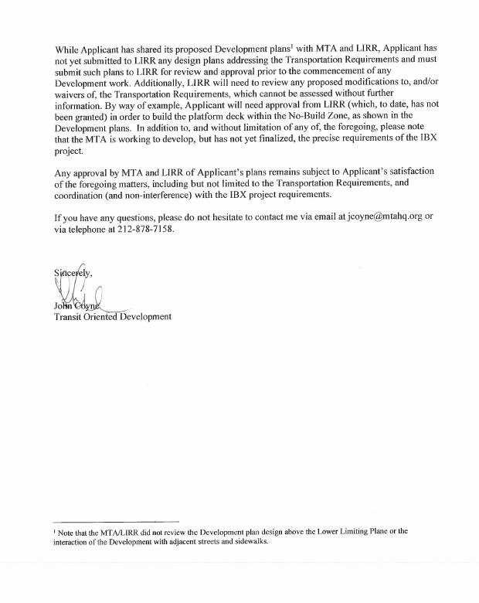
EXHIBIT D
CERTIFICATION OF PARTIES-IN-INTEREST
(Attached behind.)

EXHIBIT E
FORM OF WAIVER AND SUBORDINATION
(Attached behind.)
WAIVER OF EXECUTION OF RESTRICTIVE DECLARATION AND CONSENT AND SUBORDINATION OF MORTGAGE

WAIVER OF EXECUTION OF RESTRICTIVE DECLARATION, CONSENT AND SUBORDINATION OF MORTGAGE, made as of this [___] day of [__________], 2024 by [_________________], a [_____________] company, having an address at [________________] (the “Mortgagee”).

WITNESSETH:
WHERAS, the Mortgagee is the lawful holder of that certain [mortgage], dated [___________] made by and between [_______________] (the “Mortgagor”), and Mortgagee, recorded in the Office of the City Register of the City of New York, Kings County (the “Register’s Office”), on [___________] at CRFN [______________] and more particularly described on Schedule A attached hereto (as amended, modified, extended, renewed or restated from time to time, the “Mortgage”); and

WHERAS, the Mortgage encumbers the property (the “Premises”) known as Block [________], Lot[s] [____________] on the Tax Map of the City of New York, Kings County, and more particularly described in Schedule B attached hereto and made a part hereof, and any improvements thereon (such improvements and the Premises are collectively referred to herein as the “Subject Property”), which Subject Property is the subject of a Declaration of Restrictions dated as of even date herewith (the “Declaration”) made by Mortgagor; and

WHEREAS, the Declaration, which is intended to be recorded in the Register’s Office simultaneously with the recording hereof, shall subject the Subject Property and the sale, conveyance, transfer, assignment, lease, occupancy, mortgage, and encumbrance thereof to certain restrictions, cotenants, obligations, easements, and agreements contained in the Declaration; and

WHEREAS, the Mortgagee agrees, at the request of the Mortgagor, to waive its right, if any, to execute the Declaration and to subordinate the Mortgage to the Declaration.

NOW, THEREFORE, the Mortgagee (i) hereby waives any rights it has to execute, and consents to the execution by the Mortgagor of, the Declaration and (ii) hereby agrees that the Mortgage, any liens, operations and effects thereof, and any extensions, renewals, modifications and consolidations of the Mortgage, shall in all respects be subject and subordinate to the terms and provisions of the Declaration.

This Waiver of Execution of Restrictive Declaration and Consent and Subordination of Mortgage shall be binding upon the Mortgagee and its heirs, legal representatives, successors, and assigns.

[Signature Page Follows]
IN WITNESS WHEREOF, the undersigned has executed this instrument as of the date first written above.

MORTGAGEE:

[__________________]

By: _______________________________
Name:
Title:

STATE OF ______________)
) ss.:
COUNTY OF ____________)

On the [_____] day of [_______] in the year 2023, before me, the undersigned, personally appeared [_________________], personally known to me or proved to me on the basis of satisfactory evidence to be the individual(s) whose name(s) is (are) subscribed to the within instrument and acknowledged to me that he/she/they executed the same in his/her/their capacity(ies), and that by his/her/their signature(s) on the instrument, the individual(s), or the person upon behalf of which the individual(s) acted, executed the instrument.
Notary Public

Schedule A

Mortgage Schedule
Schedule B

Legal Description of the Premises

EXHIBIT F
PLANS
(Attached behind.)

EXHIBIT G
FORM NOTICE OF SUBSTANTIAL COMPLETION
[Letterhead of the Chair of the City Planning Commission]
[Date]
NOTICE OF SUBSTANTIAL COMPLETION
Re: Block _____, Lot _____, New York, New York

Dear ___________________:

This letter constitutes the Notice of Substantial Completion of the Publicly Accessible Areas pursuant to Section 4 of the Restrictive Declaration made by Brooklyn Yards Development LLC dated as of ______________, 2024 (the “Declaration”).

By this notice, the undersigned, for the City Planning Commission, confirms that the Publicly Accessible Areas (as defined in the Declaration) have been Substantially Completed (as defined in the Declaration) in accordance with all requirements of the Declaration.

Yours very truly,

__________________________

[THIS LETTER SHALL BE MODIFIED AS APPROPRIATE TO THE CERTIFICATION BEING ISSUED]

EXHIBIT H
FORM NOTICE OF FINAL COMPLETION
[Letterhead of the Chair of the City Planning Commission]
[Date]
NOTICE OF FINAL COMPLETION

Re: Block _____, Lot _____, New York, New York

Dear ___________________:

This letter constitutes the Notice of Final Completion of the Publicly Accessible Areas pursuant to Section 4 of the Restrictive Declaration made by Brooklyn Yards Development LLC dated as of ______________, 2024 (the “Declaration”).

By this notice, the undersigned, for the City Planning Commission, confirms that the Publicly Accessible Areas (as defined in the Declaration) have been Finally Completed (as defined in the Declaration) in accordance with all requirements of the Declaration.

Yours very truly,

__________________________

[THIS LETTER SHALL BE MODIFIED AS APPROPRIATE TO THE CERTIFICATION BEING ISSUED]

These tax lots will be subdivided before this RD is executed. Tax lot numbers to be updated accordingly.
These tax lots will be subdivided before this RD is executed. Tax lot numbers to be updated accordingly.
These tax lots will be subdivided before this RD is executed. Tax lot numbers to be updated accordingly.
This language to mirror the language in the MTA’s letter, including any conditions agreed to by Declarant.
These tax lots will be subdivided before this Memorandum is executed. Tax lot numbers to be updated accordingly.
When this certification is prepared prior to recordation, it should cover the “Subject Property” only, and not the “LIRR Property”
Form to be adapted for other parties in interest, as applicable.

