Committee on Public Safety:
Joshua Kingsley, Senior Legislative Counsel
Chad Benjamin, Legislative Policy Analyst
Jack Storey, Senior Finance Analyst
Owen Kotowski, Finance Analyst
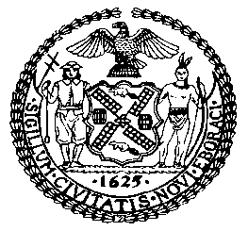

THE COUNCIL OF THE CITY OF NEW YORK
COMMITTEE REPORT OF THE GOVERNMENTAL AFFAIRS DIVISION
Andrea Vazquez, Legislative Director
Rachel Cordero, Deputy Director, Governmental Affairs Division

COMMITTEE ON PUBLIC SAFETY
Hon. Kamillah Hanks, Chair

December 7, 2022

PROP. INT. NO. 759-B: By Council Members Lee, Holden, Hanks, Brooks-Powers, Velázquez, Mealy, Restler, Farías, Schulman, Won, Hanif, Riley, Abreu and Ariola

TITLE: A Local Law to amend the administrative code of the city of New York, in relation to a catalytic converter etching program

ADMINISTRATIVE CODE: Adds §10-185

- INTRODUCTION

On December 7, 2022, the Committee on Public Safety, chaired by Council Member Kamillah Hanks, voted on Introduction Number 759-B (“Prop. Int. No. 759-B”), in relation to a catalytic converter etching program. The measure passed by a vote of 10 to 0. On October 20, 2022, the Committee heard a previous version of this legislation and received testimony from the Department of Consumer and Worker Protection (DCWP), the New York City Police Department (NYPD), and other interested parties.
- BACKGROUND
  - Motor Vehicle Ownership and Theft in New York City
There were nearly two million passenger cars registered to New York City residents in 2018. In 2020, the number of registered passenger cars surged as city residents felt safer relying on private modes of transportation during the pandemic. New York City saw an 18 percent increase in car registrations in June and July of 2020. The result was 62,507 more car registrations in those months than the previous year. In 2021, vehicle registration rose by 579,811, and as of July of 2022, another 421,758 vehicles were already registered in the city. Given that residential properties throughout the five boroughs often lack personal garages, and the high cost of municipal and private parking garages, most car owners in the City are forced to park on the street, and therefore contend with a greater opportunity for theft.
Decreasing crime trends for certain crimes in New York exclude motor vehicle theft, which is on the rise. The volume of motor vehicle theft increased significantly in 2020. By the end of the year, New York saw a 54.3% increase in motor vehicle theft statewide, and a 67.7% increase in New York City. A significant share of this increase is attributable to New York City as motor vehicle theft outside the City rose to a lesser extent – 44%. Motor vehicle thefts continue to escalate, and remain substantially higher than pre-pandemic levels throughout the city.
b. Catalytic Converter Theft
Catalytic converters are a part of a vehicle’s exhaust system located between the engine and muffler, and a key component of the emissions control system, reducing the amount of pollution exuding from the tailpipe. All modern vehicles with internal combustion engines have a catalytic converter, as they have been required on new cars since 1975. New York State also requires yearly emission testing; if a car does not have a catalytic converter, it will fail the test, making it illegal to drive a vehicle in New York without a catalytic converter. To decrease the amount of smog that would otherwise release from the tailpipe, catalytic converters contain precious metals such as rhodium, palladium and platinum, which can be salvaged and sold at a high price. As such, individuals can sell a stolen catalytic converter for up to $300, or up to $1,400 if the part comes from a hybrid vehicle.
According to NYPD data, catalytic converter theft in New York City has risen exponentially this past year. Citywide, as of mid-August 2022, catalytic converter theft had increased by 269% as compared to figures from the same period last year.
Reported Catalytic Converter Theft in NYC
 | 2021 | 2022 | Percent Increase
Citywide | 1505 | 5548 | 269%
Brooklyn | 403 | 1534 | 281%
Manhattan | 195 | 584 | 199%
Queens | 574 | 2092 | 264%
Bronx | 286 | 976 | 241%
Staten Island | 47 | 362 | 670%
*Year-to-Date: 8/14/2021; 8/14/2022
A challenging aspect of preventing catalytic converter theft is that it takes little over a minute to remove such device from a vehicle, requiring readily available equipment such as a common jack lift and a saw. Thefts are rather simple endeavors, but reports show elaborate tactics employed to make theft more prevalent and widespread, such as arriving and exiting the scene in a getaway vehicle, and deploying lookouts along neighborhood blocks to observe parked vehicles.
The NYPD introduced an etching program that allows individuals to inscribe a code/number to their vehicle’s catalytic converter, and link that code to a website where it can be tracked. If NYPD or a potential buyer later comes across such catalytic converter, the number will be visible and can be tracked to the original vehicle, which permits an easy determination regarding the chain of custody of the catalytic converter and whether the part might have been stolen. Without such labeling, individuals may sell stolen catalytic converters to unknowing buyers, claiming the removed part was retrieved from a willing vehicle owner. The NYPD is also attempting to deter catalytic converter theft by expanding undercover investigations and inspections of auto body shops.
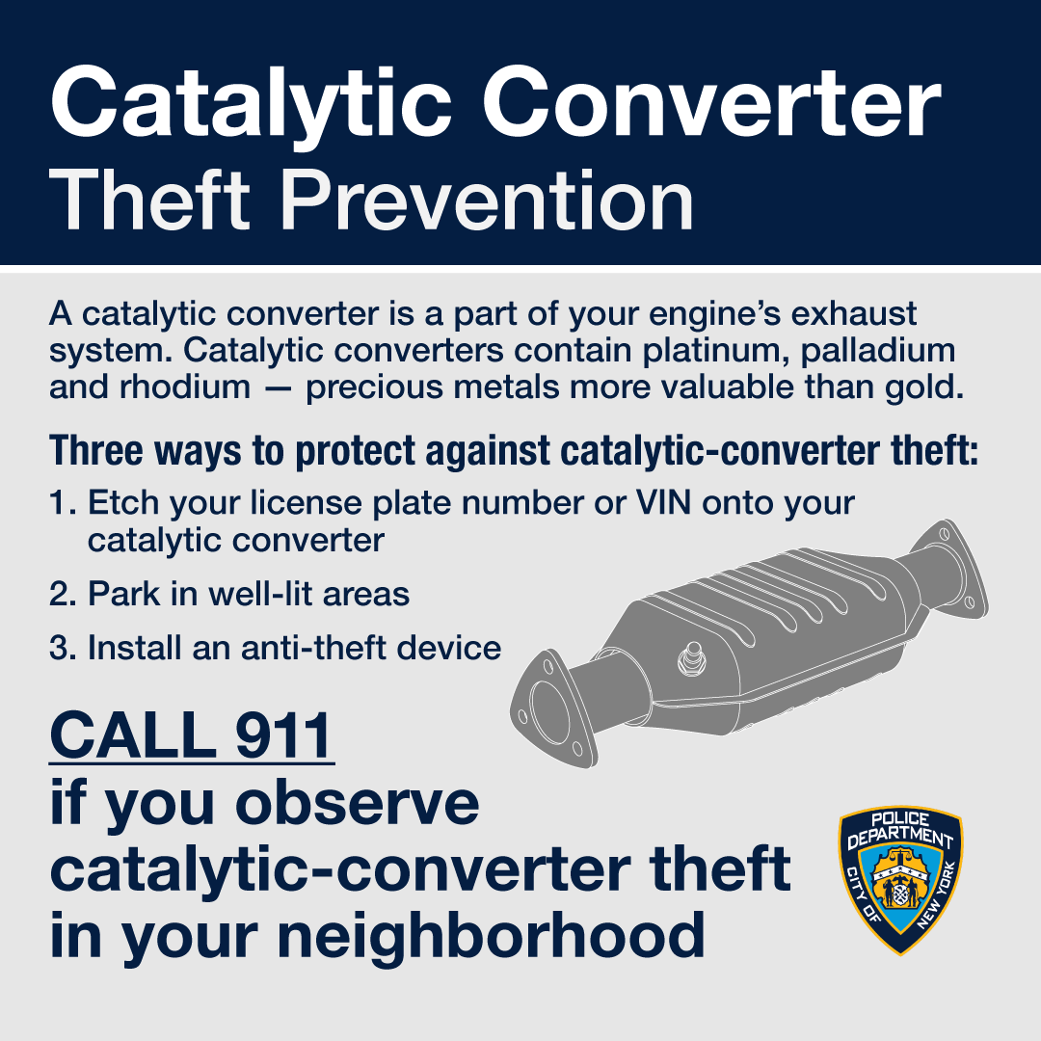
New York State responded to the growing concern over catalytic converter theft by passing legislation enhancing reporting requirements for sales of these parts by certain industries. On October 18, 2022, Governor Kathy Hochul signed State legislation that aims to impede the theft of catalytic converters by imposing restrictions on the purchase, sale and possession of catalytic converters by vehicle dismantlers, scrap processors and others. In addition to the maintenance of catalytic convertor ownership records, the law will require that all new motor vehicle dealers and qualified dealers offer kits to any consumer purchasing a new motor vehicle.
The Council is considering legislation to address the issue more directly at the local level. Specifically, Int. No. 525-B would expand record keeping requirements related to used catalytic converter purchases for dealers in second-hand articles. These additional requirements aim to address consumers’ particular vulnerability to catalytic converter theft in the City.
- INT. 759-B
This bill would require the NYPD to establish a program to provide the public with etchings that affix or engrave identifying numbers into catalytic converters of vehicles for the purpose of assisting law enforcement investigations and deterring theft of such parts
Since introduction, the bill has been amended as follows. First, to align with recently enacted State law that requires car dealerships to provide customers with catalytic converter etchings, provisions were removed that required NYPD to distribute etching kits to such dealerships. Additionally, provisions were amended to provide the NYPD with flexibility to utilize different methods of affixing identification numbers to catalytic converters, such as laser etching, in addition to current process of using etching kits.
.

Proposed Int. No. 759-B

By Council Members Lee, Holden, Hanks, Brooks-Powers, Velázquez, Mealy, Restler, Farías, Schulman, Won, Hanif, Riley, Abreu, Louis, Joseph, Brannan, Williams, Dinowitz and Ariola

A Local Law to amend the administrative code of the city of New York, in relation to a catalytic converter etching program

Be it enacted by the Council as follows:
Section 1. Chapter 1 of title 10 of the administrative code of the city of New York is amended by adding a new section 10-185 to read as follows:
§ 10-185 Catalytic converter etching program. a. Definitions. For purposes of this section, the term “etching” means the affixing or engraving of a unique identifying number onto a catalytic converter of a motor vehicle by the police department or with a kit provided by the police department.
b. Etching program for the public. Subject to appropriation, the police department shall establish a program to:
1. Provide etching to the public; and
2. Engage in an outreach campaign to inform the public about the etching program and the means by which etching may prevent theft of catalytic converters.
§ 2. This local law takes effect 90 days after it becomes law.

NAB/RMC/JDK
LS #9954/10082
11/29/2022

Warren, Tamara, “What Will New Yorkers Do With the Cars They Purchased During the Pandemic?” Car and Driver, 15 Aug. 2021; available at: https://www.caranddriver.com/features/a37293032/what-will-new-york-do-with-the-cars-they-purchased-during-the-pandemic/#
Ibid.
Kamer, Foster, “The Great Gotham Vroom Boom of 2020,” The New York Times, 12 Aug. 2020; available at: Buying Cars — and Parking Cars — in New York City - The New York Times (nytimes.com)
Sheinerman, Marie-Rose, “Car Owners Say It’s ‘Virtually Impossible’ to Find Street Parking in New York City,” Bloomberg, 16 Aug. 2022; available at: https://www.bloomberg.com/news/articles/2022-08-16/where-to-park-in-nyc-rise-in-new-cars-outdoor-dining-deepen-nightmare#:~:text=With%20some%20New%20Yorkers%20shunning,to%20eat%20up%20street%20space
Ibid.
“Crime in New York State 2020 Final Data,” Division of Criminal Justice Services, Dec. 2021; available at: https://www.criminaljustice.ny.gov/crimnet/ojsa/Crime-in-NYS-2020.pdf
Ibid.
Ibid.
Parascandola, Rocco, “NYPD Reports 51% Surge in Stolen Cars this Year,” Daily News, 12 June 2022; available at: https://www.nydailynews.com/new-york/nyc-crime/ny-car-vehicle-theft-surge-careless-motorists-nypd-20220612-eojbb2hhx5a3tn34vzhilc2fdq-story.html
Popely, Rick. “What Is a Catalytic Converter? - CARFAX.” CARFAX, 22 Sept. 2022, www.carfax.com/blog/catalytic-converters.
Id.
Sam, S. (2022, September 1). Know Everything about New York Catalytic Converter Laws. Way Blog. Retrieved October 14, 2022; available at: https://www.way.com/blog/new-york-catalytic-converter-laws/.
“What’s a Catalytic Converter and Why Do People Steal Them? | News | Cars.com.” Cars.com, 13 Feb. 2022; available at: www.cars.com/articles/whats-a-catalytic-converter-and-why-do-people-steal-them-446861.
“More Than 5000 Catalytic Converter Thefts Reported in NYC.” New York Post, 20 Aug. 2022; available at: www.nypost.com/2022/08/20/more-than-5000-catalytic-converter-thefts-reported-in-nyc.
Ibid.
Ibid.
“Catalytic-converter Thieves Work in Queens Robbery Video.” New York Post, 3 Sept. 2022; available at: www.nypost.com/2022/09/03/catalytic-converter-thieves-work-in-queens-robbery-video.
Ibid.
“NYPD Distributes New Tracking Device at Combat Catalytic Converter Theft Event - silive.com.” Silive, 15 July 2022, www.silive.com/news/2022/07/nypd-distributes-new-tracking-device-at-combat-catalytic-converter-theft-event.html.
Ibid.
Moses, Dean. “NYPD Is Cutting off Catalytic Converter Thieves With Anti-theft Label Enrollment | amNewYork.” amNewYork, 19 July 2022; available at: www.amny.com/news/nypd-is-cutting-off-catalytic-converter-thieves-with-anti-theft-label-enrollment .
Tremayne-Pengelly, Alexandra. “Thefts of Catalytic Converters Have Quadrupled in New York City This Year | Observer.” Observer, 20 July 2022; available at: www.observer.com/2022/07/thefts-of-catalytic-converters-have-quadrupled-in-new-york-city-this-year.
“NY State Senate Bill S9428.” NY State Senate, 26 May 2022; available at: www.nysenate.gov/legislation/bills/2021/S9428.

