Committee on Civil Service and Labor
Malcom M. Butehorn, Legislative Counsel
Kevin Kotowski, Policy Analyst
Kendall Stephenson, Finance Analyst

Committee on Governmental Operations
Brad J. Reid, Senior Legislative Counsel
Elizabeth Kronk, Legislative Policy Analyst
Zachary Harris, Finance Analyst

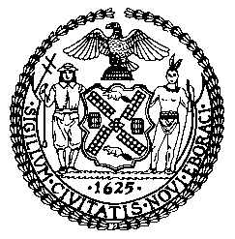

The Council of the City of New York

COMMITTEE REPORT OF THE HUMAN SERVICES DIVISION
Jeffrey Baker, Legislative Director
Andrea Vazquez, Deputy Director for Human Services

COMMITTEE ON CIVIL SERVICE AND LABOR

Hon. I. Daneek Miller, Chair

COMMITTEE ON GOVERNMENTAL OPERATIONS
Hon. Fernando Cabrera

Oversight: Examining the Civil Service System (Focus on the Provisional Employee Reduction Plan)

November 27, 2018

INTRODUCTION NO. 1235: By Council Members Miller, Cabrera, and Kallos

TITLE: A Local Law in relation to the department of citywide administrative services provisional employee reduction plan

RESOLUTION NO. 566: By Council Members Miller, Dromm, and Rosenthal

TITLE: Resolution calling on the state legislature to pass and the
Governor to sign, A.10935-A and S.8844-A, which would amend the education law to automatically enroll “optional employees” in the New York City Board of Education Retirement System (BERS) after 90 days of employment unless the employee affirmatively opts in or out of the program in advance

INTRODUCTION

On November 27, 2018, the Committee on Civil Service and Labor, chaired by Council Member I. Daneek Miller, and the Committee on Governmental Operations, chaired by Council Member Fernando Cabrera, will hold a joint oversight hearing entitled “Examining the Civil Service System (focus on the Provisional Employee Reduction Plan).” In addition to this oversight hearing, the Committee on Civil Service and Labor will hear two pieces of legislation, both sponsored by Council Member Miller: Introduction No. 1235, which relates to the Department of Citywide Administrative Services (DCAS) provisional employee reduction plan, and Resolution No. 566, which relates to calling on the state to amend the state Education Law to automatically enroll “optional employees” in the New York City Board of Education Retirement System (BERS). Witnesses invited to testify include DCAS, the New York City Central Labor Council, labor unions, advocates, and others.
This hearing will generally address the Civil Service System, with a focus on the issue of provisional employees. On October 22, 2008, the DCAS Provisional Reduction Plan (the Plan) was approved by the State Civil Service Commission (SCSC) in efforts to reduce the number of provisional employees within five years and achieve “substantial compliance.” At the time the Plan was approved, the City employed 36,855 provisional employees (19.31% of the City workforce under the jurisdiction of DCAS in a civil service competitive class title). To achieve substantial compliance the City would have had to reduce the number of provisional employees to fewer than 9,500 (no more than 5% of those serving in competitive class titles). While progress had initially been made by the City, it was clear more time was needed because as of May 1, 2014, the number of provisional employees in the employ of DCAS was below 23,000, “a substantial reduction of almost 15,000 from the number in May 2008.” An extension was granted by the State in 2014 (Chapter 284 of the Laws of 2014) and 2016 (Chapter 467 of the Laws of 2016).
The Civil Service & Labor Committee has previously held hearings on the Civil Service System and the Provisionals Reduction Plan. The first hearing was June 11, 2008, shortly after the proposed plan was released on March 28, 2008. The Committee received an update from DCAS representatives on its progress with implementing the plan at a hearing on June 15, 2010. The Committee received additional updates on:
- March 16, 2012 (provisional count 22,779);
- October 29, 2013 (provisional count 22,479);
- November 9, 2014 (provisional count 21,454) joint with the Committee on Governmental Operations; and
- March 30, 2016 (provisional count 23,052).
The latter three hearings held after the five-year plan should have been completed; however, the State had granted the City more time.
There is currently a state bill (A.11241/S.8837-A), awaiting signature by the Governor, which would provide even more time for the City to implement appropriate actions to further reduce the number of provisional appointments that have continued beyond the time periods permitted by state Civil Service Law. Int. No. 1235 would be a bill related to this state bill.

DCAS Human Capital Division
The Human Capital Division of DCAS is responsible for City personnel. According to the DCAS website, the division is:
- Responsible for maintaining the municipal civil service system and providing personnel-related shared services for City agencies.
- Responsible for working to satisfy the Provisional Reduction Plan regarding provisional appointments.
- Recruits and identifies the best-qualified candidates for City employment in a manner consistent with the State Constitution, Civil Service Law, and laws governing equal opportunity employment.
- Establishes qualifications for positions; develops, validates, administers, and rates competitive civil service examinations and certifies lists of eligible applicants; audits all appointments and promotions, tracks citywide vacancies and, when necessary, oversees layoffs; evaluates and administers citywide personnel policies and programs.
- Conducts professional development and employee training programs; and
- Oversees the expansion and maintenance of the New York City Automated Personnel System (NYCAPS), a centralized state-of-the-art automated personnel system for managers and employees to access and manage personnel and benefits information including Employee Self-Service.

New York City’s Civil Service System
Like municipalities across America, New York City fills most of its employee positions through a civil service process. For New York City, that process is guided by the New York State Civil Service Law. While most positions require an examination, there are some positions available that do not. The majority of City jobs are part of what is called the competitive class. To be permanently appointed to one of these positions, an applicant must take and pass a competitive civil service examination. Such exams are administered by DCAS at computer-based testing & applications centers (CTACs). There are CTACs in all boroughs except the Bronx. DCAS plans to open its fifth CTAC in the Bronx in Fiscal Year 2019.
When City agencies need to hire people and no eligible lists for the title (lists of candidates who have passed an exam) exists, City agencies may “consider and appoint qualified individuals who apply directly to vacant positions to ensure that essential agency functions are executed. Qualified individuals may be provisionally appointed to a competitive position while awaiting an exam for their title or for a similar title.” [emphasis added]
Appointments and Provisionals
New York State Civil Service Law contains requirements with respect to filling vacancies, holding civil service examinations and the use of, and time limitations on, provisional appointments. Civil service titles fall into one of four jurisdictional classifications: (1) competitive; (2) non-competitive; (3) labor; and (4) exempt. Under the New York State Constitution, competitive titles must be filled by competitive exams, which are used to create lists of eligible candidates for competitive civil service jobs. Lists are developed based on score. The lists expire after certain periods of time and on occasion do not have enough eligible candidates to fill existing vacancies.
When a dearth of eligible candidates exists, Section 5.5.1 of the Personnel Rules and Regulations for the City of New York provides for the appointment of provisional employees, who may serve for up to nine months, while a new civil service list is promulgated. For the most recent quarter (period ending August 31, 2018), the City had 17,455 provisional employees, the vast majority of which have served beyond the nine-month provisional service period, in many cases for numerous years. Provisionals without a permanent title (“pure” provisionals) represent 70 percent of the total and provisionals with a permanent title (“step-up” provisionals) represent 30 percent of the total.
Long Beach Court of Appeals Decision
In May 2007, the Court of Appeals of New York issued a decision addressing the legality of provisional employees serving beyond the nine-month period. In the Matter of Long Beach v. Civil Service Employees, (hereinafter “Long Beach”), the Court refused to extend arbitration rights to provisional employees and held that the continued employment of certain provisional employees violated Civil Service Law § 65 and applicable regulations. The Court emphasized the need for compliance with the time limitations imposed by Civil Service Law § 65 with respect to filling vacancies, holding examinations and removing provisional employees from positions in titles for which examinations should be held.
In March 2004, the New York State Civil Service Commission issued a “Report on Merit System Administration for the City of Long Beach Civil Service Commission” that admonished the City of Long Beach for its poor control over provisional appointments. In particular, the report noted that a number of competitive class positions had been improperly filled with, and retained by, provisional employees. Following an investigation, the City of Long Beach determined that the continued employment of the provisional employees violated the Civil Service Law and terminated the employees. The Civil Service Employees Association filed grievances on behalf of the terminated provisional employees, alleging that pursuant to the terms of a Collective Bargaining Agreement between the parties, the employees were “tenured” and entitled to be rehired to another position.
The Court disagreed, holding that the relief sought on behalf of the provisional employees under the “tenured” provisions of the Agreement would violate the Civil Service Law and public policy. The Court stated:
Policy considerations warrant strict compliance by employers with the time limitations imposed under the Civil Service Law. Such limitations are necessary to insure adherence to the constitutional preference for merit selection. The failure to administer timely examinations prevents the identification and hiring of qualified candidates from eligible lists, as required by the Civil Service Law, and misleads provisional appointees into having expectations of continued employment beyond that permitted by law.

New York State Civil Service Law
Following the decision in Long Beach, the State Legislature passed a law in 2008 requiring DCAS to submit a five-year plan to the SCSC to reduce the number of provisional employees employed by the City, at the time in the tens of thousands.
Having received approval in 2008 from the SCSC to implement an orderly and expeditious plan to reduce the number of provisional employees, the City made substantial progress toward its goal through various means authorized by the 2008 law. As of August 31, 2018, the number of provisional employees on the payrolls of DCAS employers was approximately 17,455, a substantial reduction of almost 19,400 from the number in December 2007, and the pace of provisional reduction has increased markedly. More than 12 percent of the total reduction in provisional appointments since 2008 was achieved during the period of January 1, 2017 to March 31, 2018. By increasing its capacity to administer competitive examinations through the use of automated examination development systems and other measures, during this 15-month period the City reduced the number of newly appointed provisional employees by more than 14 percent, and in addition, the administration of qualified incumbent examinations and other competitive civil service examinations led to a reduction of 15.5 percent in the number of long-term provisional appointees. The City is thus steadily approaching the objective of achieving substantial compliance with the length of provisional appointments permitted by section 65 of the Civil Service Law.
The State Legislature passed a bill on June 20, 2018 (A.11241/S.8837A) to allow the City to update and continue to implement the plan, with appropriate revisions to timeframes and plan strategies. The bill requires DCAS to provide a report to the SCSC by the end of 2020 on the implementation of the provisional reduction plan, and the prospects for substantial compliance to be achieved by the end of 2021. The bill awaits the signature of the Governor for enactment, but two two-year extensions for City compliance and its associated reporting requirements have been enacted before and it is anticipated the Governor will also sign this extension before December 31, 2018, when sections of the Civil Service Law expire with respect to DCAS’ required plans for provisional employee reductions. Today’s hearing will be an opportunity for DCAS to share with the Committee steps and benchmarks identified that will allow the City to finally realize its original, Court mandated and State enacted objective—full compliance with Civil Service Law § 65 and ultimately no longer use provisional employees for a period longer than allowed by law.
Quarterly Reports from DCAS
Pursuant to the New York City Charter § 814(e), DCAS is required to submit a quarterly report regarding its Plan to the Mayor, the Council, the Civil Service Commission and the Equal Employment Practices Commission. These reports specify, by agency and by title, including temporary titles:
- The number of provisional employees at the end of the second month of the quarter;
- The length of time such provisional employees have served in their positions; and
- The actions taken by the City to reduce the number of such provisional employees and the length of their service in such positions.
The latest such report was received by the Council on September 28, 2018 (for the quarter ending August 31, 2018). In the summary of the report, DCAS stated:
- Since the previous quarterly report the number of provisionals had decreased by 1,898 from 19,353 to 17,455;
- The number of provisionals without a permanent title decreased by 716 and those with a permanent title decreased by 1,182;
- The net decrease occurred primarily in the titles of Computer Systems Manager, Computer Associate (Operations), Administrative Contract Specialist, Administrative Public Information Specialist, and Administrative Job Opportunity Specialist;’
- During the last reporting period, 41 exams were conducted, including those for the titles: Administrative Project Manager, Computer Associate (Operations), Administrative Education Analyst, Accountant, and Special Consultant (Mental Health Standards and Services); and
- Finally, also during this time, 40 Civil Service lists were established and 429 certifications issued for 165 titles with provisionals serving.
The following two graphs compare which agencies have the highest rate of provisional appointees from the enactment of the Provisional Reduction Plan approved by the State in 2008 to the filing of the most recent quarterly report.

Figure 1
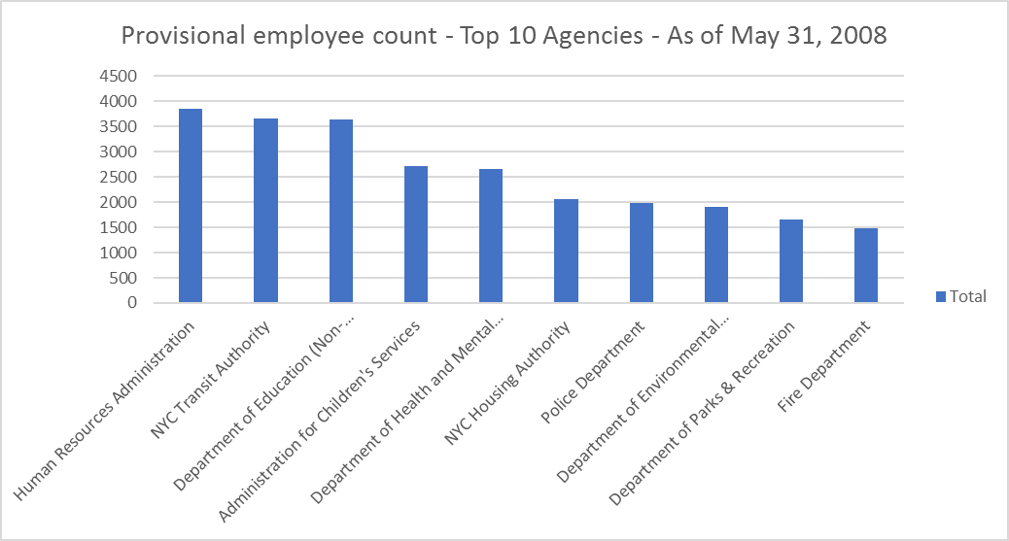
Source: DCAS Charter Mandated Quarterly Report – May 31, 2018
Figure 2
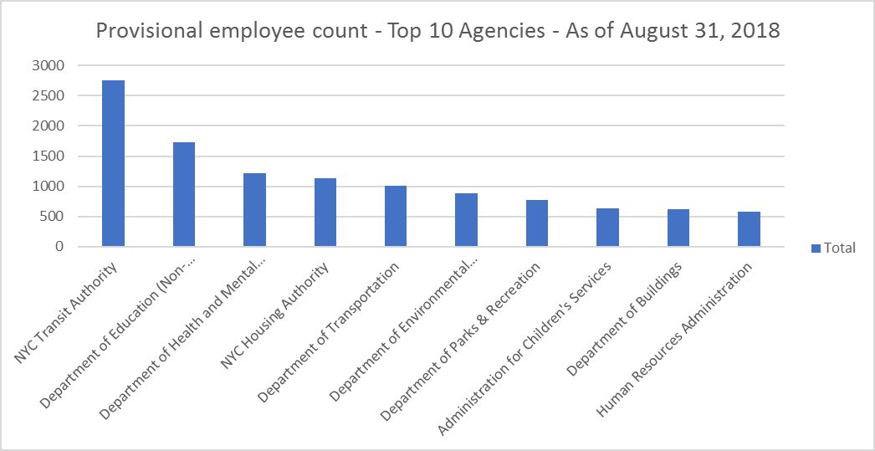
Source: DCAS Charter Mandated Quarterly Report – August 31, 2018
Decreased Numbers of Provisionals since 2017
Progress continues to be made by DCAS in reducing the number of provisional employees employed by the City. Systems and policies put in place by DCAS continue to work, such as administering examinations for titles with large numbers of provisional appointments (affecting approximately 7,000 provisional employees) and targeted reclassification of titles and positions outside of the competitive class (affecting approximately 1,600 provisional employees) (which requires approval from the State Civil Service Commission), but more must be done as the City is not on target to meet its State imposed deadline, therefore requiring another extension of the timelines set in the State Civil Service Law—leading to the passage of A.11241/S.8837-A. From the final quarter report in 2017 to the most recent, the total count of provisionals has decreased from 21,341 to 17,455 which represents an 18 percent decrease. A.11241/S.8837-A would allow the City to update and continue to implement its provisional reduction plan. It would ensure the City’s continued quality and effectiveness of governmental operations while the revised plan is being developed and implemented. It would require DCAS to provide a report to the SCSC by the end of 2020 on the implementation of the provisional reduction plan, and the prospects for substantial compliance to be achieved by the end of 2021.
Moreover, if the report does not reflect substantial compliance when submitted, the state bill would provide for the establishment of an advisory workgroup for provisional appointments in the City comprised of members appointed by the Governor, Legislature and Mayor. The workgroup would be charged with preparing a recommended plan for substantial compliance, to be adopted by or pursuant to state legislation.
Timely Administration of Civil Service Exams
According to the 2018 New York City Mayor’s Management Report, DCAS administered 254 civil service examinations in Fiscal Year 2018, all of which were on schedule. In Fiscal Year 2018, the median time from exam administration to completed exam results was 78 days, a 68 percent decrease compared to Fiscal Year 2017. The decrease is attributable to the administration of more single-part exams and, most notably, the administration of 133 qualified incumbent exams, which are automatically rated and are targeted specifically to provisional employees who have served two or more years in certain titles. Also, DCAS administered 156 civil service information sessions in Fiscal 2018. According to its most recent quarterly report on provisionals, the City established 40 civil services lists and issued 492 certifications for 1,654 titles with provisionals serving in order to further decrease the total count of provisionals.
Finally, it was noted at this committee’s last hearing in 2016 that the length of time involved with the civil service system from exam to eligible list generation can be very frustrating for potential employees to wait. The 2018 Mayor’s Management Report acknowledges DCAS is actively working to overhaul the current system to bring greater transparency and user-friendliness to applying for and taking certain civil service exam.

ANALYSIS OF INT. NO. 1235-2018
The New York State Legislature passed legislation earlier this year that would allow New York City to update and continue to implement its Provisional Employee Reduction Plan. The City has made substantial progress in approaching the objective of achieving substantial compliance with the length of provisional appointments permitted by section 65 of the Civil Service Law. The state legislation, which is currently awaiting the Governor’s signature, requires DCAS to produce a single comprehensive revised reduction plan and submit it to the State for approval. Int. No. 1235 would require DCAS to send a copy of that revised plan to the City Council.
CONCLUSION
Today’s hearing will review the current status of the Provisionals Reduction Plan, including the pending extension to be signed into law requiring a comprehensive revised plan to be submitted by DCAS to SCSC, with implementation by December 31, 2021, to further reduce the number of provisional appointments that have continued beyond the periods permitted by state statute. DCAS has taken significant steps toward reducing the number of provisionals since the initial formulation of the Provisional Reduction Plan and today’s hearing will allow DCAS to share lessons learned in the steps taken so far, where there is room for improvement and how DCAS will prepare to meet the new state extension which is pending signing by the Governor.

(page left intentionally blank)

Int. No. 1235

By Council Members Miller, Cabrera and Kallos

A Local Law in relation to the department of citywide administrative services provisional employee reduction plan

Be it enacted by the Council as follows:

Section 1. On or before April 1, 2019, the department of citywide administrative services shall submit to the speaker of the council its comprehensive plan revision for provisional employees required pursuant to paragraph c-4 of subdivision 5 of section 65 of the civil service law.
§ 2. This local law takes effect on the same date as an act to amend the civil service law, in relation to provisional employees of certain public employers; to amend chapter 5 of the laws of 2008 amending the civil service law relating to provisional employees of certain public employers, in relation to extensions of certain negotiated agreements and extending the provisions of such chapter; and to amend part I of chapter 56 of the laws of 2008 amending the civil service law relating to excess provisional employees of a city having a population of one million or more, in relation to extending the provisions thereof, as proposed in A11241 and S8837A, takes effect, and is deemed repealed if A11241 and S8837A do not take effect by January 1, 2019.

MMB
LS # 8066
9/19/18; 11:48 a.m.

(page left intentionally blank)

Res. No. 566

Resolution calling on the state legislature to pass and the Governor to sign, A.10935-A and S.8844-A, which would amend the education law to automatically enroll “optional employees” in the New York City Board of Education Retirement System (BERS) after 90 days of employment unless the employee affirmatively opts in or out of the program in advance.

By Council Members Miller, Dromm and Rosenthal
Whereas, Public-sector employees comprise a significant portion of New York City’s workforce; and
Whereas, According to a report from the Department of Citywide Administrative Services (DCAS), the City of New York employs approximately 363,000 people, or 8.2 percent of the city’s total workforce, as estimated by the Bureau of Labor Statistics; and
Whereas, DCAS also found that roughly 37,000, or 10 percent of city government employees, are part-time or temporary employees, and that 29 percent of all City employees, or roughly 105,000 people, are eligible to retire within the next five years; and
Whereas, Currently, part-time and temporary employees, as well as those who are not required to take civil service exams, are allowed optional enrollment in the Board of Education Retirement System (BERS), which, according to the office of the Comptroller, holds over $4 billion in assets; and
Whereas, Part-time City employees have been eligible for pension benefits since 1988, when the State Court of Appeals ruled in their favor in a 7-0 decision; and
Whereas, Pension enrollment is optional; and
Whereas, According to the Chief Actuary for the New York City Retirement Systems and Pension Funds, only 73 percent of eligible employees join BERS; and
Whereas, Furthermore, the Chief Actuary has reported that 64 percent of those who have not elected to enroll are women, with an average salary of approximately $22,410; and
Whereas, A simple lack of awareness can mean that a committed City employee can lose access to years of benefits to which he or she is entitled; and
Whereas, There is currently legislation in both the New York State Assembly and the New York State Senate that would address this issue; and
Whereas, A.10935-A and its companion, S.8844-A, would amend the education law by automatically enrolling new employees in the pension system 90 days after beginning employment; and
Whereas, The proposed legislation would also allow employees to either opt-in immediately or opt-out in accordance with their wishes; and
Whereas, These bills have won the support of District Council 37, New York City’s largest public employee union, which represents 125,000 members and 50,000 retirees, and
Whereas, Most importantly, however this measure would ensure that City employees can obtain the pension benefits that they have earned; now, therefore, be it
Resolved, That the Council of the City of New York calls on the state legislature to pass and the Governor to sign, A.10935-A and S.8844-A, which would amend the education law to automatically enroll “optional employees” in to the New York City Board of Education Retirement System (BERS) after 90 days of employment unless the employee affirmatively opts in or out of the program in advance.

LS#6393
10/2/18
MK

Department of Citywide Administrative Services, 2008 DCAS 5-Year Plan, March 28, 2008, page 3. Available at: https://www.cs.ny.gov/commission/DCAS/EntirePlan.pdf
Id.
Id.
A.9970. Assemb. Reg. Sess. 2013-2014, Sponsors Memo (N.Y. 2014).
See N.Y. Civil Service Law § 65(2)- “No provisional appointment shall continue for a period in excess of nine months.”
NYC DCAS Civil Service Commission website, http://www.nyc.gov/html/dcas/html/about/service.shtml.
DCAS Civil Service Commission Civil Service Jobs website http://www.nyc.gov/html/dcas/html/work/work.shtml.
Id.
DCAS Civil Service Commission Civil Service Jobs website, http://www.nyc.gov/html/dcas/html/work/civilservice_2.shtml.
NYC Mayor’s Management Report, Department of Citywide Administrative Services. Available at: https://www1.nyc.gov/assets/operations/downloads/pdf/mmr2018/dcas.pdf.
DCAS Civil Service Commission Civil Service Jobs website,http://www.nyc.gov/html/dcas/html/work/work.shtml.
Competitive Jurisdictional Class (Competitive Class) - The Jurisdictional Class under the Classified Civil Service (Classified Service) composed of positions for which it is practicable to determine the merit and fitness of applicants by competitive examination.
Non-competitive Jurisdictional Class (Non-Competitive Class) - The Jurisdictional Class under the Classified Civil Service (Classified Service) designating positions not in the Exempt or Labor Classes and for which it is found by the Civil Service Commission to be not practicable to ascertain the merit and fitness of applicants by competitive examination, but meet specific minimum qualifications.
Labor Jurisdictional Class (Labor Class) - The Jurisdictional Class under the Classified Civil Service (Classified Service) designated for positions for which competitive tests are impracticable because of the unskilled nature of the duties. Minimum qualifications for Labor Class positions other than the physical ability to perform the duties of the position are generally not established.
Exempt Jurisdictional Class (Exempt Class) - The Jurisdictional Class under the Classified Civil Service (Classified Service) of positions deemed impracticable to fill by tests of any kind. No minimum training and experience requirements are established for exempt positions.
DCAS Provisional Reduction Plan (“DCASPRP”), Commissioner Martha K. Hirst, March 28, 2008.
Id.
Id.
NYC DCAS Quarterly Report, September 28, 2018.
Id.
835 N.Y.S.2d 538 (2007).
Id.
Long Beach at 468.
Id. at 469.
Id. at 472.
Chapter 5 of the Laws of 2008.
New York City Department of Citywide Administrative Services 2008 DCAS 5-Year Plan. Available at: https://www.cs.ny.gov/commission/DCAS/EntirePlan.pdf
A.11241/S.8837-A Sponsors Memo
Chapter 284 of the Laws of 2014 and Chapter 467 of the Laws of 2016.
These reports significantly predate the Long Beach decision, as this requirement was added to the Charter during the major charter revision approved by voters in 1989. Summary of Final Proposals of the New York City Charter Revision Commission, Aug. 1989, http://www.nyc.gov/html/charter/downloads/pdf/1989_final_report.pdf.
Memorandum from DCAS Commissioner Lisette Camilo to Hon. Corey Johnson, Sept. 28, 2018.
Id.
Id.
Id.
Id.
Department of Citywide Administrative Services, 2014 Provisional Reduction Plan Extension, October 13, 2014, page 4. Available at: http://www.nyc.gov/html/dcas/downloads/pdf/misc/Provisional_Plan.pdf.
A.11241/S.8837-A
Id.
Id.
NYC Mayor’s Management Report, Department of Citywide Administrative Services. Available at: https://www1.nyc.gov/assets/operations/downloads/pdf/mmr2018/dcas.pdf.
Id.
Id.
Memorandum from DCAS Commissioner Lisette Camilo to Hon. Corey Johnson, Sept. 28, 2018.

