THE COUNCIL OF THE CITY OF NEW YORK
RESOLUTION NO. 182

Resolution approving the decision of the City Planning Commission on Application No. N 220051 ZRQ, for an amendment of the text of the Zoning Resolution (Preconsidered L.U. No. 49).

By Council Members Salamanca and Riley

WHEREAS, Agayev Holding, LLC, filed an application pursuant to Section 201 of the New York City Charter, for an amendment of the text of the Zoning Resolution of the City of New York, modifying APPENDIX F for the purpose of establishing a Mandatory Inclusionary Housing Area, which in conjunction with the related action would facilitate the construction of a new nine-story mixed-use building with residential, commercial and light industrial uses on the property located at 35-01 Vernon Boulevard in the Ravenswood neighborhood of Queens, Community District 1 (ULURP No. N 220051 ZRQ) (the “Application”);

WHEREAS, the City Planning Commission filed with the Council on April 15, 2022, its decision dated April 13, 2022 (the “Decision”) on the Application;

WHEREAS, the Application is related to application C 220050 ZMQ (Pre. L.U. No. 48), a zoning map amendment to change an R5 district to an MX-23 Special Mixed Use District (M1-4/R7A);

WHEREAS, the Decision is subject to review and action by the Council pursuant to Section 197-d of the City Charter;

WHEREAS, upon due notice, the Council held a public hearing on the Decision and Application on April 26, 2022;

WHEREAS, the Council has considered the land use implications and other policy issues relating to the Decision and Application; and

WHEREAS, the Council has considered the relevant environmental issues, including the Negative Declaration issued January 3rd, 2022 (CEQR No. 21DCP114Q) which includes an (E) designation to avoid the potential for significant adverse impacts related to hazardous materials, air quality, and noise (E-645) (the “Negative Declaration”).

RESOLVED:

The Council finds that the action described herein will have no significant impact on the environment as set forth in the (E) Designation (E-645) and Negative Declaration.

Pursuant to Sections 197-d and 200 of the City Charter and on the basis of the Decision and Application, and based on the environmental determination and consideration described in the report, N 220051 ZRQ, incorporated by reference herein, and the record before the Council, the Council approves the Decision of the City Planning Commission.

Matter underlined is new, to be added;
Matter struck out is to be deleted;
Matter within # # is defined in Section 12-10;
* * * indicates where unchanged text appears in the Zoning Resolution.

* * *
APPENDIX F
Inclusionary Housing Designated Areas and Mandatory Inclusionary Housing Areas

* * *

QUEENS

Queens Community District 1

* * *

Map 4 – [date of adoption]

[EXISTING MAP]

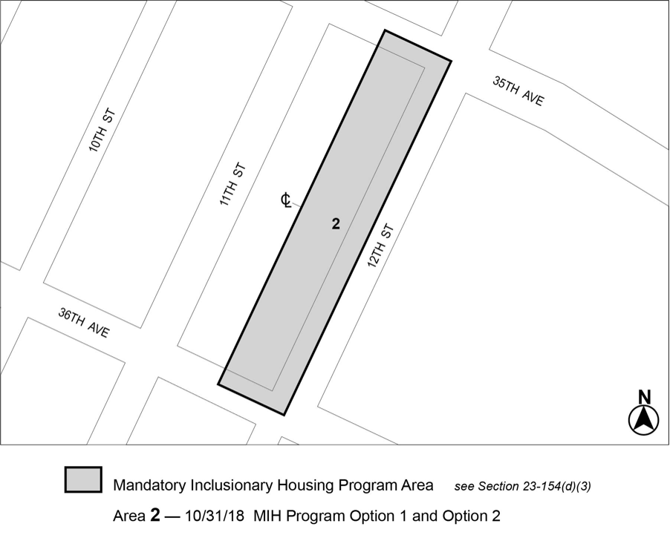

[PROPOSED MAP]

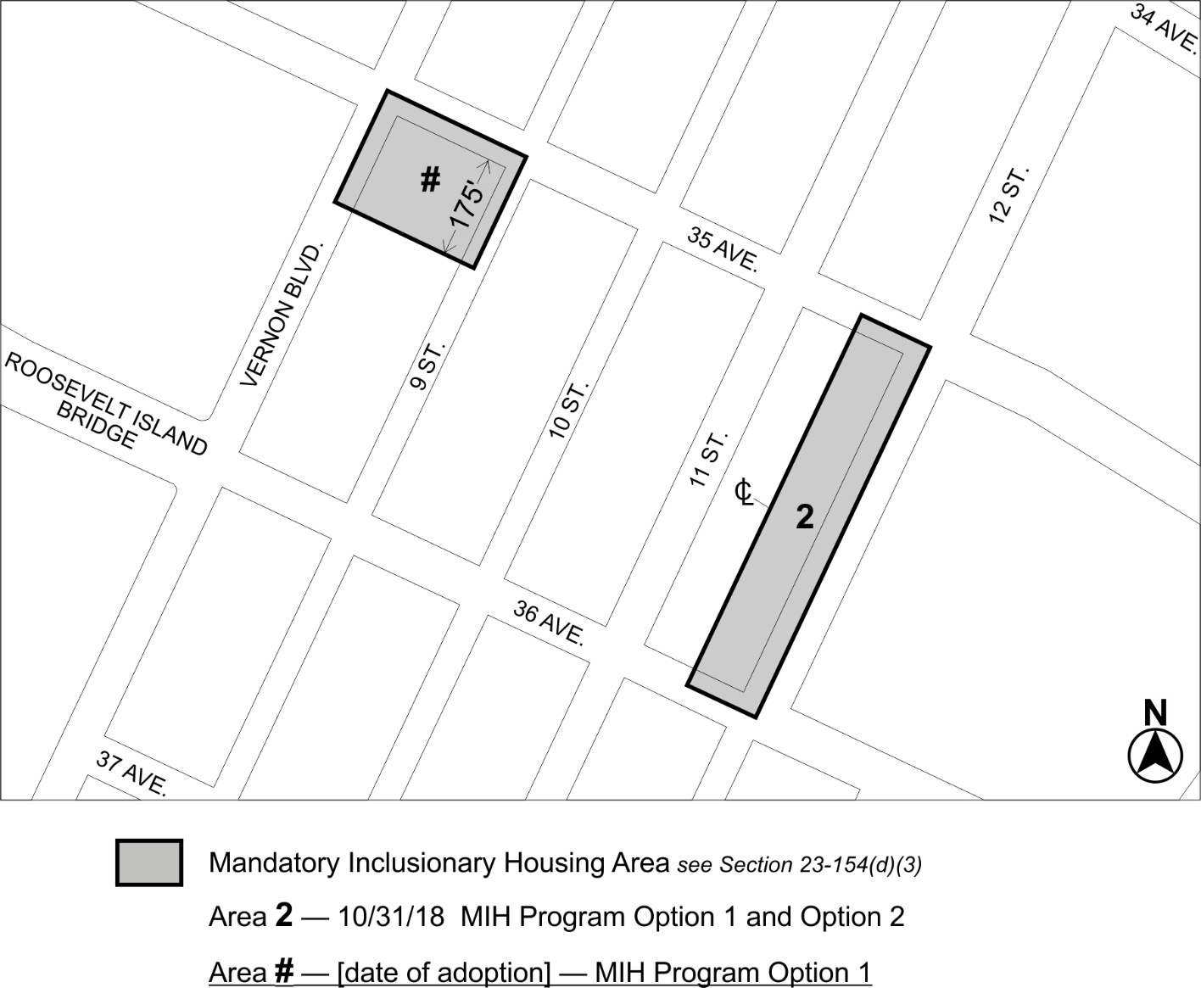

Portion of Community District 1, Queens

* * *

Adopted.

Office of the City Clerk, }
The City of New York, } ss.:

I hereby certify that the foregoing is a true copy of a Resolution passed by The Council of The City of New York on __________, 2022, on file in this office.

.....................................................
City Clerk, Clerk of The Council

