Committee on Recovery and Resiliency
Malaika Jabali, Counsel
Bill Murray, Senior Policy Analyst
Jonathan Seltzer, Finance Analyst



The New York City Council

Briefing Paper of the Infrastructure Division
Matthew Gewolb, Legislative Director

Committee on Recovery and resiliency
Hon. Mark Treyger, Chair

January 19, 2017

INT. NO. 1155: By Council Members Treyger, Chin, Cohen, Koslowitz and Ulrich

TITLE: A Local Law to amend the New York city charter, in relation to maintaining a voluntary registry of people who may need evacuation assistance in the event of an emergency

CITY CHARTER: Amends section 497 of the city charter by renumbering existing subdivisions and adding a new subdivision

Oversight: Assisting vulnerable populations in emergency evacuations
- Introduction
On January 19, 2017, the Committee on Recovery and Resiliency, chaired by Council Member Mark Treyger, will hold a hearing on Int. No. 1155, in relation to maintaining a voluntary registry of people who may need evacuation assistance in the event of an emergency, as well as oversight on how the city assists vulnerable populations in emergency evacuations.

- Background
Superstorm Sandy began on October 22, 2012, as a tropical depression cyclone in the southern Caribbean Sea with wind speeds around 40 mph. On October 29th, Superstorm Sandy made a sharp turn to the northwest, on a path toward the coast of New Jersey. The storm gained energy as it interacted with other weather systems and by 7:30 p.m., Sandy’s center made landfall in Brigantine, New Jersey with 80 mph winds. The impacts Sandy had on New York were unprecedented in the City’s history. The storm caused 51 square miles of the City to be flooded, or about 17% of the City’s total land area. The flooded zone was home to 443,000 New Yorkers, 300,000 homes and 23,400 businesses.
Superstorm Sandy caused 43 New Yorkers to lose their lives, the vast majority of whom perished by drowning in areas where waters rose rapidly due to storm surge. The storm took an especially high toll on the young and the old, with victims ranging in age from a 2 year old boy to a man and women aged 90. Additionally, 6,500 patients had to be evacuated from hospitals and nursing homes.
- Additional risk to vulnerable populations during emergency situations
The City’s population of 8.2 million includes people with a wide range of health conditions and needs. Over 1 million New Yorkers are in poor health, which includes chronic conditions such as diabetes and high blood pressure, and these individuals depend on regular, ongoing medical care. Additionally, there are 800,000 New Yorkers under the age of 5 or over the age of 80 who are more vulnerable to illness and injury. Sandy underscored the fact that a significant number of vulnerable individuals in the City experience greater risk during emergency situations. There were an estimated 75,000 people in poor health living in areas that were inundated by floodwaters and an estimated 54,000 more in communities that lost power. These people faced additional dangers during the storm, as they were less capable of gaining access to needed care.
Prior to Superstorm Sandy’s arrival in the City, representatives of the City’s Human Resources Administration, the Department for the Aging, and the Administration for Children’s Services made efforts with their partner service providers to contact clients and advise them of safety protocols. However, after the storm, these and other City agencies found it difficult to confirm that known, vulnerable clients were well because of displacement, telecommunications failures and other reasons. And although certain City agencies had access to databases with information about vulnerable individuals, in some cases, legal and technical barriers prevented the sharing of lists across agencies.
According to the New York City Special Initiative for Rebuilding and Resiliency final report, “the lack of a consolidated and accessible information source made [the task of locating and serving vulnerable individuals] both slower and more difficult than it should have been.” In recognition of this issue, the City’s Hurricane Sandy After Action Report, released in May 2013, called for “better integration of the City’s data across all platforms and agencies to increase situation awareness and allow for more targeted, efficient response and recovery operations.”
In 2013, the New York City Department of Health and Mental Hygiene (DOHMH) published a paper, “Vulnerable Populations: A Function-Based Vulnerability Measure for the New York City Region,” which provides analysis and a variety of definitions for the terms “disability” and “vulnerability,” as well as data regarding sections of the City that have the densest concentration of vulnerable populations. For instance, the DOHMH paper, citing work by the Census Bureau, mentions the following attributes that may help define disability: self-care difficulty (difficulty dressing or bathing); hearing difficulty; vision difficulty; independent living difficulty (difficulty doing errands alone such as visiting a doctor’s office or shopping); ambulatory difficulty (serious difficulty walking or climbing stairs); cognitive difficulty (serious difficulty concentrating, remembering, or making decisions). The DOHMH paper notes that when defining “vulnerability,” those in the emergency management profession have recently made a shift such that rather than focusing on population level characteristic like age, gender or income, there is now greater emphasis on the individual’s ability to perform key functions necessary to maintain health and safety before, during and after an emergency. The DOHMH paper goes on to note that the definition of “vulnerability” might include consideration of the individual’s age, disability, inability to speak English, income, access to an automobile, soundness of living structure, and the level of social capital and emergency response infrastructure in the individual’s community.
According to DOHMH’s methodology, sections of the city with the highest densities of vulnerable populations include the south Bronx, Chinatown and the Lower East Side in southern Manhattan, with elevated densities also existing in northern Manhattan, peaking in West Harlem, Central Brooklyn, South Brooklyn, Coney Island and in northwestern Queens.
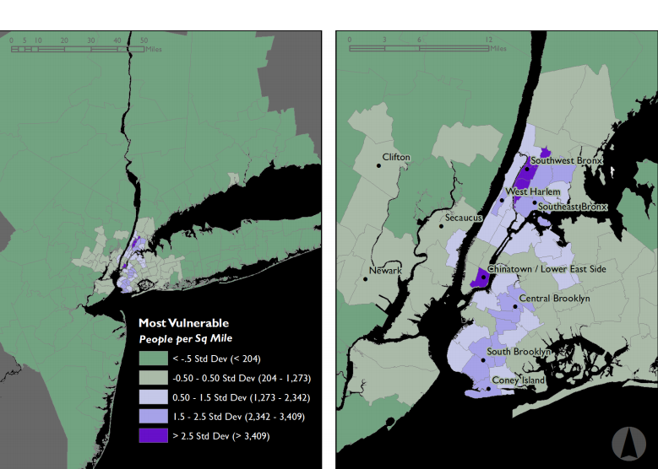
(above) Figure 1: A map showing areas of the City with the most vulnerable people per square mile.

(below) Figure 1: A map showing areas of the City with the most vulnerable people per 1,000 people.
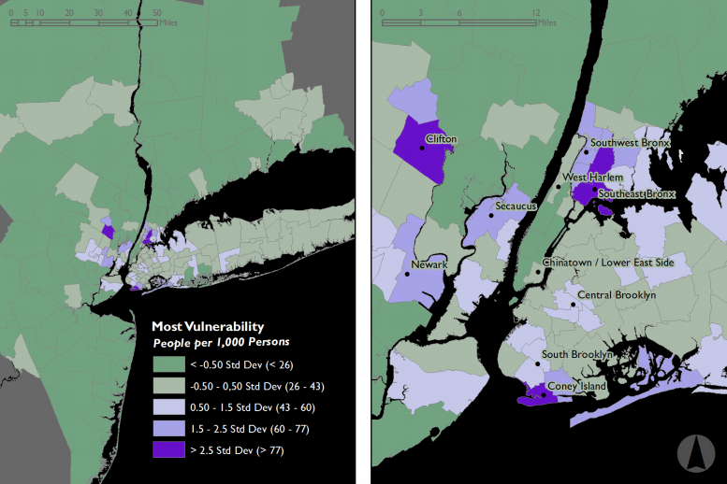
- City measures to assist vulnerable populations in emergency evacuations

- Emergency planning and notification services
The New York City Emergency Management website includes a webpage containing information regarding “Disabilities, Access & Functional Needs.” The webpage includes link to “Ready New York: My Emergency Plan” which is a workbook designed to assist New Yorkers with disabilities or access and functional needs to create an emergency plan. Additionally, the City provides the Notify NYC service whereby New Yorkers can register to receive email, text message, telephone and other alerts from the City concerning emergency events and important, urgent information. The City also provides a Ready NYC App service which allows users to download an application from Apple and Android, which can then be used to create and store an emergency plan on your mobile device, and share the plan with other users.
The City’s Emergency Management also maintains the Advance Warning System, which is designed to disseminate hazard and emergency information to agencies and organizations that serve people with disabilities or others with access and functional needs throughout New York City. The City’s Emergency Management website also provides useful tools including a Hurricane Evacuation Zone Finder, the ability to register with electric utilities to receive information concerning service, sheltering considerations, and information about evacuation transportation for people with disabilities and others with access or functional needs. Emergency Management’s website notes that when the Mayor has issued an evacuation order due to an emergency, people with disabilities or other access or functional needs can request transportation assistance by contacting 311.

- Settlement agreement following Brooklyn Center for Independence of the Disabled v. City of New York
On September 26, 2011, the Brooklyn Center for Independence of the Disabled (BCID) filed a lawsuit against Mayor Michael Bloomberg and the City of New York alleging that the City’s emergency preparedness program violated the Americans with Disabilities Act and State and City law by failing to account for the needs of persons with disabilities. BCID alleged, and the court agreed in their holding, that the City failed to accommodate the needs of people with disabilities by, among other things, “inadequately planning for the evacuation of people with disabilities, from multi-story buildings and generally; failing to provide a shelter system that is accessible within the meaning of the ADA; ignoring the unique needs of people with disabilities in the event of a power outage; failing to communicate adequately with people with special needs during an emergency; and failing to account for the needs of people with disabilities in recovery operations following a disaster.”
Following the court’s order, the City agreed to commitments in 7 Memoranda of
Understanding (MOUs) with BCID. These include MOUs for Sheltering, Canvassing, Accessible Transportation, Emergency Communications, Power Outages, High Rise Evacuations, and Coordinator/Panel. Among other commitments required in the MOUs, the City must:
- Have a minimum of 60 accessible emergency shelter facilities by the end of September 2017
- Provide transportation for people with disabilities from an Evacuation Center to an accessible facility in the event that they initially arrive at a facility that is full, unable to support their needs, or both.
- Rapidly survey populations after a disaster to determine critical needs and refer those needs to appropriate partners for resolution, which includes the creation of a post-emergency canvassing operation plan and providing canvassing services for people with disabilities.
- Develop an inventory of accessible vehicles and conduct a needs analysis
- Train city personnel in transporting people with disabilities.
- Communicate with people with disabilities about accessible transportation options and make best efforts to ensure 311 conveys accurate information regarding evacuation.
- Revise its emergency plans to reflect certain procedures relating to accessible communication at Disaster Assistance Service Centers (DASCs).
- Give people with disabilities priority to charge equipment at DASCs.
- Work with Con Edison during an Emergency Operations Center activation to maintain situational awareness concerning ConEd’s Life Sustaining Equipment and Medical Hardship program, facilitate ConEd’s messages regarding power usage, and assess the power related needs of critical facilities.
- Create a High Rise Building Evacuation Task Force.
- Hire a Disability and Access and Function Needs Coordinator.
- Create a Disability Community Panel.
In addition, the settlement includes monitoring procedures. Under the settlement
agreement, which became effective October 15, 2014, every 6 months the City must produce written reports on the current status of the progress of implementing the MOUs. The first report was due to BDIC six months after the effective date. Three years after the effective date, the City is required to submit a final report regarding the implementation of 5 of its 7 MOUs. Four years after the effective date, the City must provide BDIC and the court with a final report regarding implementation of the High Rise Evacuation MOU and the Coordinator/Panel MOU.

- Int. No. 83-2010
In the last legislative session, Int. 83-2010 was introduced requiring the commissioner of
the City’s Office of Emergency Management to develop and maintain a registry of people who may need evacuation assistance—whether due to age, disability, or some other reason—in the event of a citywide emergency and to create a plan for conducting such an evacuation. Advocates were concerned that such a registry maintained by the government could infringe on their privacy. Int. No. 1155-2016 helps to address these concerns by making the registry voluntary.

- Int. No. 1155 Summary
Int. No. 1155-2016 amends the New York City Charter §497 to require that the Commissioner of Emergency Management develop and maintain a voluntary registry of people who may need evacuation assistance in the event of an emergency, and to plan for such an evacuation. The law becomes effective one year after enactment.

PAGE INTENTIONALLY LEFT BLANK

Int. No. 1155
By Council Members Treyger, Chin, Cohen, Koslowitz and Ulrich

A Local Law to amend the New York city charter, in relation to maintaining a voluntary registry of people who may need evacuation assistance in the event of an emergency

Be it enacted by the Council as follows:
Section 1. Section 497 of the New York city charter is amended by renumbering existing subdivisions n and o as subdivisions o and p, respectively, and adding a new subdivision n to read as follows:
n. develop and maintain a voluntary registry of persons with a disability, as defined by rules promulgated by the commissioner in conjunction with the department of health and mental hygiene and the mayor’s office for people with disabilities, who may need evacuation assistance in the event of an emergency, and a plan for conducting such evacuations;
§ 2. This local law shall take effect one year after it becomes law, except that the commissioner of emergency management shall take all actions necessary for its implementation, including the promulgation of rules, prior to such effective date.

BJR
LS 7062
4/1/16 4:30PM

See Posting of Willie Drye to National Geographic Newswatch, A Timeline of Hurricane Sandy’s Path of Destruction, Nov. 2, 2012, available at: http://newswatch.nationalgeographic.com/2012/11/02/a-timeline-of-hurricane-sandys-path-of-destruction/; see also Hurricane Sandy Advisory Archive, NOAA National Hurricane Center, available at: http://www.nhc.noaa.gov/archive/2012/SANDY.shtml.
Id.
NYC Special Initiative for Rebuilding and Resiliency Report, A Stronger, More Resilient New York: Sandy and Its Impacts, available at http://www.nyc.gov/html/sirr/downloads/pdf/final_report/Ch_1_SandyImpacts_FINAL_singles.pdf
Id.
NYC Special Initiative for Rebuilding and Resiliency, 2013 final report, “A Stronger More Resilient New York” pages 13 and 14, available at http://s-media.nyc.gov/agencies/sirr/SIRR_singles_Lo_res.pdf
Id. Page 11
Id. Page 145
Id.
Id.
Id. Page 157
Id.
Id.
Id.
New York City Hurricane Sandy After Action Report – May 2013, page 5, available at http://www.nyc.gov/html/recovery/downloads/pdf/sandy_aar_5.2.13.pdf
New York City Department of Health and Mental Hygiene, 2013, “Vulnerable Populations: A Function-Based Vulnerability Measure for the New York City Region” available at https://www1.nyc.gov/assets/doh/downloads/pdf/em/regional_hazards_vulnerability_measures.pdf
Id. Page 12
Id. Page 11
Source: New York City Department of Health and Mental Hygiene, 2013, “Vulnerable Populations: A Function-Based Vulnerability Measure for the New York City Region” page 22, available at: https://www1.nyc.gov/assets/doh/downloads/pdf/em/regional_hazards_vulnerability_measures.pdf
Source: Id. Page 23
New York City Emergency Management website available at https://www1.nyc.gov/site/em/ready/disabilities-access-functional-needs.page
New York City Emergency Management, “My Emergency Plan” webpage at http://www1.nyc.gov/site/em/ready/guides-resources.page#myemergencyplan
Notify NYC available at https://a858-nycnotify.nyc.gov/notifynyc/
Link to Ready NYC: https://itunes.apple.com/us/app/ready-nyc/id633614907?mt=8
Link to NYC’s Advance Warning System: https://advancewarningsystemnyc.org/
NYC Emergency Management’s webpage on “Disabilities, Access & Functional Needs” available at https://www1.nyc.gov/site/em/ready/disabilities-access-functional-needs.page
42. U.S. §12102
BROOKLYN CENTER FOR INDEPENDENCE OF THE DISABLED v. Michael R. BLOOMBERG and the City of New York, 2011 WL 4445718 (S.D.N.Y.)
Brooklyn Ctr. for Indep. of Disabled v. Bloomberg, 980 F. Supp. 2d 588, 596 (S.D.N.Y. 2013)

