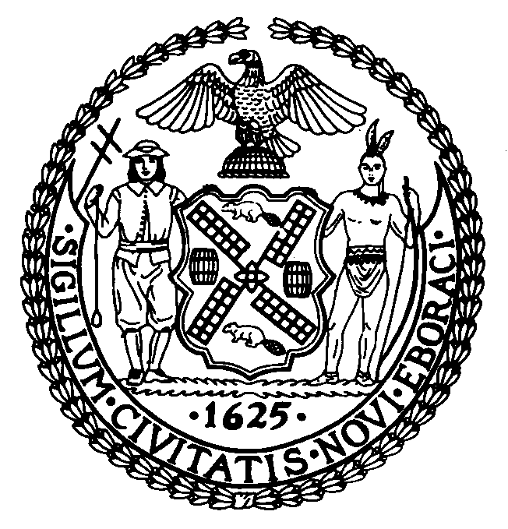 | The Council of the City of New York  Finance Division  Larian Angelo, Director  Fiscal Impact Statement  Intro. No: 724  Committee: Mental Health, Mental Retardation, Alcoholism, Drug Abuse & Disability Services
Title: A Local Law to amend the administrative code of the city of New York, in relation to rent increase exemptions for persons with disabilities. | Sponsors: Council Members Lopez and The Speaker (Council Member Miller), Baez, Barron, Brewer, Clarke, Comrie, Fidler, Gerson, Gonzalez, James, Koppell, Liu, McMahon, Monserrate, Nelson, Recchia, Seabrook, Sears, Stewart, Weprin and Gentile.
Summary of Legislation: This legislation would amend subparagraph (iii) of paragraph (2) of subdivision m of section 26-405 of the administrative code of the city of New York to exempt the following items from consideration of a person’s “aggregate disposable income” for purposes of qualifying for the Disabled Rent Increase Exemption (DRIE) Program: gifts or inheritances, payments made to individuals because of their status as victims of Nazi persecution, as defined in P.L. 103-286, or a public or private pension paid to any member of the household which increase, in any given year, does not exceed the consumer price index for such year.

Current law allows disabled persons currently receiving social security disability insurance (SSDI) or supplemental security insurance (SSI) benefits under the federal social security act or disability pension or disability compensation benefits provided by the United States Department of Veterans Affairs, or previously eligible by virtue of receiving disability benefits under the supplemental security income program or the social security disability program and currently receiving medical assistance benefits based on determination of disability as provided in section three hundred sixty-six of the social services law, to participate in a Disabled Rent Increase Exemption (DRIE) Program similar to the Senior Citizen Rent Increase Exemption (SCRIE) Program.

The DRIE program exempts renters from increases in rent above one-third of total household income. Landlords receive a real estate tax abatement equal to the amount of rent forgiven. If the total rent increase exemption exceeds the taxes due, a real estate tax refund is granted. To be eligible for DRIE, a disabled renter must live in a rent controlled, rent stabilized or rent-regulated (such as Mitchell-Lama housing) unit. The income cap for disabled renters qualifying for the program is not the same as the income cap for seniors eligible for the SCRIE program, which is $24,000 in Fiscal 2005. Under DRIE, the total household income of all members of a disabled individual’s household cannot exceed the maximum income at which such individual would not be eligible to receive cash SSI benefits under federal law.

Effective Date: This local law shall take effect immediately.

Fiscal Year In Which Full Fiscal Impact Anticipated: Fiscal 2006.

Fiscal Impact Statement:

 | Effective FY06 | FY Succeeding  Effective FY06 | Full Fiscal  Impact FY06
Revenues (+) | $0 | $0 | $0
Expenditures (-) | $0 | $0 | $0
Net | $0 | $0 | $0

Impact on Revenues: It is estimated that this legislation will have no impact on revenues.

Impact on Expenditures: It is estimated that this legislation will have no impact on expenses.

Source of Funds To Cover Estimated Costs: Not applicable.

Source of Information: New York City Council Finance Division
New York City Office of Management and Budget

Estimate Prepared By: Nadine Felton, Assistant Director, Revenue
Andrew Wallace, Legislative Financial Analyst
New York City Council Finance Division

History: To be considered by the Committee on October 20, 2005.
Date Submitted to the Council: September 28, 2005.

