THE COUNCIL OF THE CITY OF NEW YORK
RESOLUTION NO. 1711

Resolution approving with modifications the decision of the City Planning Commission on Application No. N 170431 ZRK, for an amendment of the Zoning Resolution of the City of New York, modifying Appendix F for the purpose of establishing a Mandatory Inclusionary Housing area in Community District 5, Borough of Brooklyn (L.U. No. 769).

By Council Members Greenfield and Richards

WHEREAS, the City Planning Commission filed with the Council on October 2, 2017 its decision dated September 19, 2017 (the "Decision"), pursuant to Section 201 of the New York City Charter, regarding an application submitted by Canyon Sterling Emerald, LLC, for an amendment of the text of the Zoning Resolution of the City of New York, modifying Appendix F for the purpose of establishing a Mandatory Inclusionary Housing area, which in conjunction with the related action would facilitate the development of four new buildings, ranging in height from eight to twelve stories and containing approximately 521 affordable dwelling units as well as retail and community facility uses, in the East New York neighborhood of Brooklyn, (Application No. N 170431 ZRK), Community District 5, Borough of Brooklyn (the "Application");

WHEREAS, the Application is related to application C 170430 ZMK (L.U. No. 768), an amendment to the Zoning Map, changing from R4 and R4/C1-2 to R8A/C2-4, R7A, and R6A zoning districts; and Non-ULURP No. 20185103 HAK (Preconsidered L.U.), a real property tax exemption pursuant to Section 577 of the Private Housing Finance Law:

WHEREAS, the Decision is subject to review and action by the Council pursuant to Section 197-d(b)(1) of the City Charter;
WHEREAS, upon due notice, the Council held a public hearing on the Decision and Application on October 10, 2017;

WHEREAS, the Council has considered the land use implications and other policy issues relating to the Decision and Application; and

WHEREAS, the Council has considered the relevant environmental issues, including the negative declaration issued June 19, 2017 (CEQR No. 17DCP155K), which included an (E) designation to avoid the potential for significant adverse impacts related to hazardous materials, air quality and noise (E-432) (the “Negative Declaration”);

RESOLVED:

The Council finds that the action described herein will have no significant impact on the
environment as set forth in the Negative Declaration.

Pursuant to Sections 197-d and 200 of the City Charter and on the basis of the Decision and Application, and based on the environmental determination and consideration described in the report, N 170431 ZRK, incorporated by reference herein, the Council approves the Decision with the following modifications:

Matter underlined is new, to be added;
Matter struck out is to be deleted;
Matter within # # is defined in Section 12-10;
Matter in double strike-out is old, deleted by the City Council;
Matter in double underline is new, added by the City Council;
* * * indicates where unchanged text appears in the Zoning Resolution

* * *

APPENDIX F
Inclusionary Housing Designated Areas and Mandatory Housing Designated Areas

* * *

BROOKLYN

* * *

Brooklyn Community District 5

* * *

In the R6A, R6B, R7, R7A and R8A Districts within the areas shown on the following Maps 1 and 2:

Map 2 – [date of adoption]

[PROPOSED MAP]

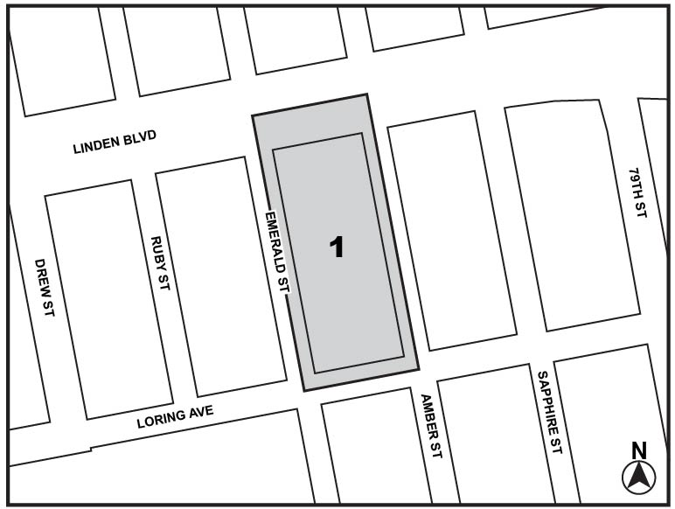
Mandatory Inclusionary Housing Area see Section 23-154(d)(3)
Area 1 — [date of adoption] MIH Program Option 1 and Option 2

Portion of Community District 5, Brooklyn

* * *

Adopted.

Office of the City Clerk, }
The City of New York, } ss.:

I hereby certify that the foregoing is a true copy of a Resolution passed by The Council of The City of New York on October 31, 2017, on file in this office.

.....…….........................................
City Clerk, Clerk of The Council

