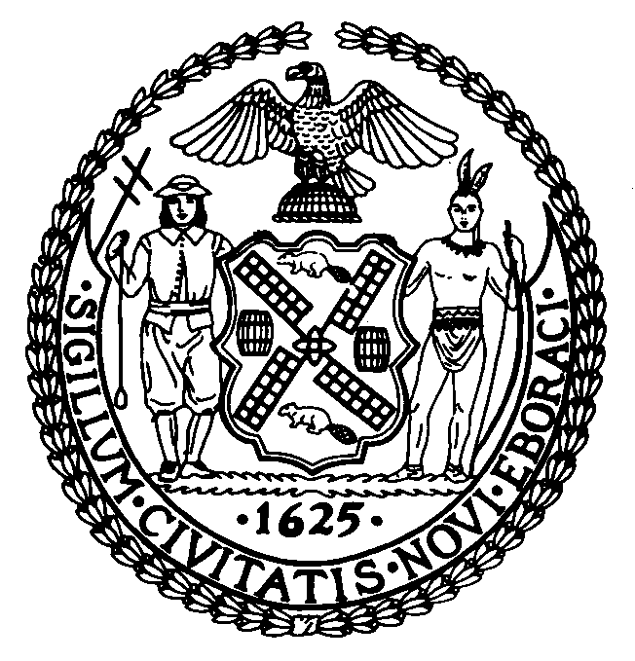

The Council of the City of New York

Finance Division
Preston Niblack, Director
Fiscal Impact Statement

Proposed Intro. No: 896-A

Committee: Parks and Recreation

Title: A Local Law to amend the administrative code of the city of New York, in relation to requiring signage warning of heat dangers of playground equipment including safety surfacing.

Sponsor: Council Members de Blasio, Lappin, Barron, Brewer, Gerson, Gonzalez, James, White, Jr. and Mark-Viverito

Summary of Legislation: This legislation would require signage warning of heat dangers of all playground equipment. This legislation requires the Parks Department to place at the entrances to all playgrounds operated by or under its jurisdiction, including those for which the department has an agreement with a conservancy or other not-for-profit organization with respect to operation of any aspect of a playground a sign reading, “Warning: Some surfaces may become hot. Please take precautions with exposed skin” if no such sign exists.

Effective Date: This local law would take effect forty-five days after enactment, except that the commissioner of parks and recreation shall take all steps necessary to implement this local law prior to such effective date.

Fiscal Year in which Full Fiscal Impact Anticipated: Fiscal 2009

Fiscal Impact Statement:
 | Effective FY09 | FY Succeeding  Effective FY10 | Full Fiscal  Impact FY09
Revenues (+) | $0 | $0 | $0
Expenditures (-) | ( $93,600) | $0 | ( $93,600)
Net | ( $93,600) | $0 | ( $93,600)

Impact on Revenues: There would be no impact on revenues resulting from the enactment of this legislation.

Impact on Expenditures: This legislation would cost $93,600 for the acquisition and installation of three warning signs costing $26 each at approximately 1,200 parks under the jurisdiction of the Parks Department.

Source of Funds To Cover Estimated Costs: General Fund

Source of Information: Mayor’s Office of Legislative Affairs

Estimate Prepared By: Jonathan Rosenberg, Deputy Director
Walter Pitts, Legislative Financial Analyst

History: This legislation was introduced by Council and referred to the Committee on Parks and Recreation on December 18, 2008. The Committee on Parks and Recreation held a hearing on Intro. 896 on February 9, 2009 and the legislation was laid. The legislation has been amended and will be considered by the Committee on April 22, 2009 as Proposed Intro. 896-A.

