THE COUNCIL OF THE CITY OF NEW YORK
RESOLUTION NO. 268

Resolution approving with modifications the decision of the City Planning Commission on Application No. N 230288 ZRK, for an amendment of the text of the Zoning Resolution (L.U. No. 11).

By Council Members Salamanca and Riley

WHEREAS, Kent Riverview, LLC, filed an application pursuant to Section 201 of the New York City Charter, for an amendment of the text of the Zoning Resolution of the City of New York, modifying provisions of Article XII, Chapter 3 (Special Mixed Use District) and APPENDIX F for the purpose of establishing a Mandatory Inclusionary Housing area, which in conjunction with the related action would facilitate the development of an eight-story, 32,847-square-foot mixed-use building containing 40 dwelling units, approximately 12 of which would be designated as permanently income-restricted, as well as 3,000 square feet of commercial ground-floor area at 230 Kent Avenue in the Northside neighborhood of Brooklyn, Community District 1 (ULURP No. N 230288 ZRK), (the “Application”);

WHEREAS, the City Planning Commission filed with the Council on January 12, 2024, its decision dated December 13, 2023 (the "Decision") on the Application;

WHEREAS, the Application is related to application C 230289 ZMK (L.U. No. 12), a zoning map amendment to change an M1-4 zoning district to a M1-4/R7X (MX-8) zoning district;

WHEREAS, the Decision is subject to review and action by the Council pursuant to Section 197-d of the City Charter;

WHEREAS, upon due notice, the Council held a public hearing on the Decision and Application on January 23, 2024;

WHEREAS, the Council has considered the land use implications and other policy issues relating to the Decision and Application; and

WHEREAS, the Council has considered the relevant environmental issues, including the Negative Declaration issued August 18th, 2023 (CEQR No. 23DCP075K), which includes an (E) designation to avoid the potential for significant adverse impacts related to hazardous materials and air quality (E-723) (the “Negative Declaration”).

RESOLVED:

The Council finds that the action described herein will have no significant impact on the environment as set forth in the Negative Declaration.

Pursuant to Sections 197-d and 200 of the City Charter and on the basis of the Decision, Application, the environmental determination, considerations described in the report, N 230288 ZRK, incorporated by reference herein, and the record before the Council, the Council approves the Decision of the City Planning Commission, with the following modifications.

Matter underlined is new, to be added;
Matter struck out is to be deleted;
Matter within # # is defined in Section 12-10;
* * * indicates where unchanged text appears in the Zoning Resolution.
Matter double struck out is old, deleted by the City Council;
Matter double-underlined is new, added by the City Council

* * *
ARTICLE XII
SPECIAL PURPOSE DISTRICTS
* * *
Chapter 3
Special Mixed-Use District (MX)

* * *
123-60
SPECIAL BULK REGULATIONS
* * *
123-63
Maximum Floor Area Ratio and Lot Coverage Requirements for Zoning Lots Containing Only Residential Buildings in R6, R7, R8 and R9 Districts
* * *
Special Mixed Use District | Designated Residence District
*** | ***
MX 8 – Community District 1, Brooklyn | R6 R6A R6B R7A R7D R7X
*** | ***

* * *
APPENDIX F
Inclusionary Housing Designated Areas and Mandatory Inclusionary Housing Areas

* * *
BROOKLYN

* * *
Brooklyn Community District 1
* * *
Map 2 – [date of adoption]

[EXISTING MAP]
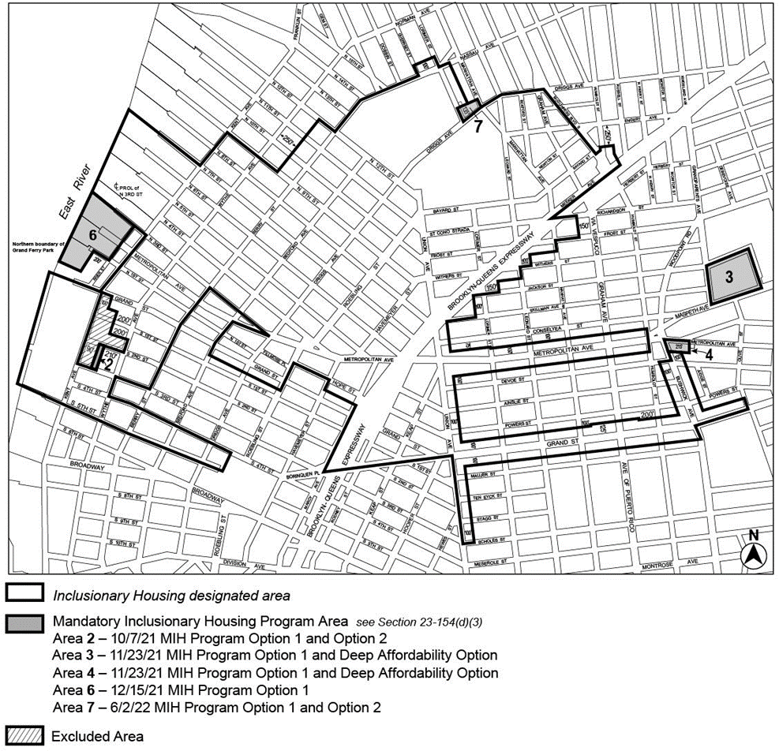

[PROPOSED MAP – as modified by Council]
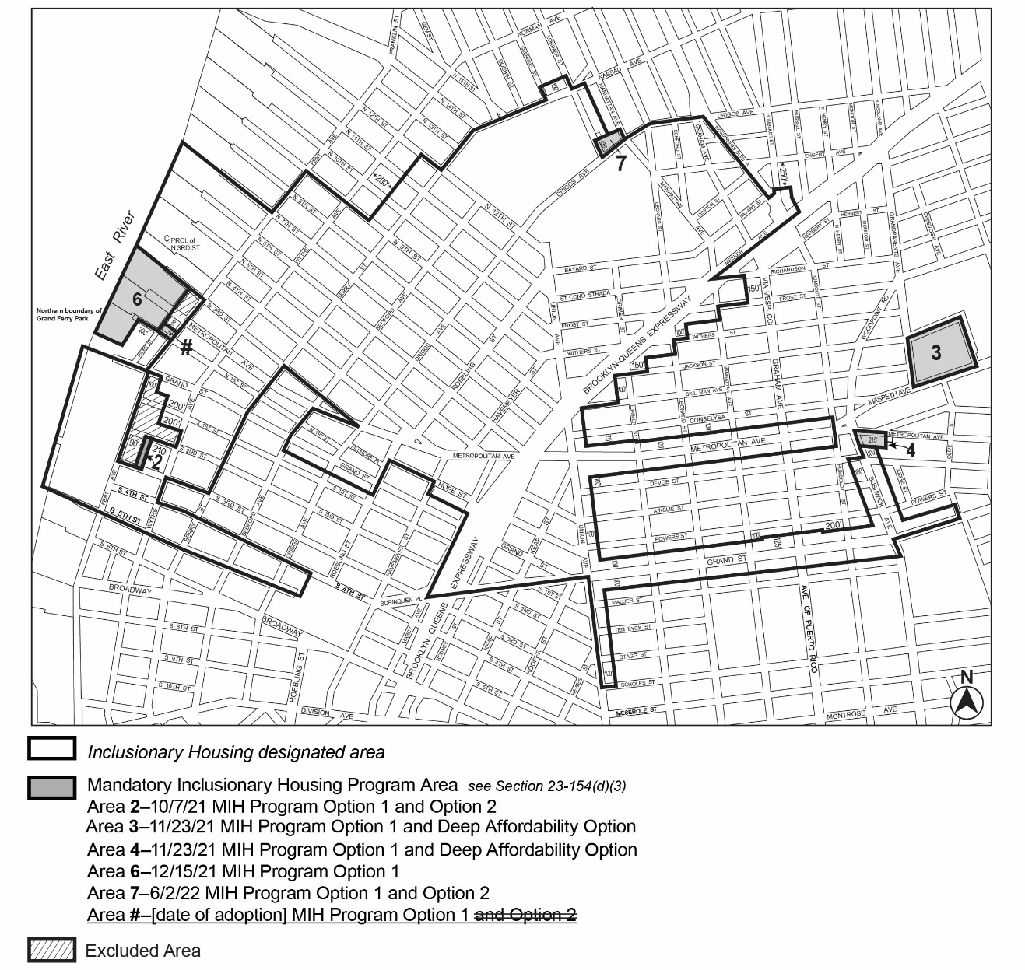
Portion of Community District 1, Brooklyn
* * *

Adopted.
Office of the City Clerk,}
The City of New York,} ss.:
I hereby certify that the foregoing is a true copy of a Resolution passed by The Council of The City of New York on _________, 2024, on file in this office.

.....................................................
City Clerk, Clerk of The Council

