THE COUNCIL OF THE CITY OF NEW YORK
RESOLUTION NO. ___

Resolution approving with modifications the decision of the City Planning Commission on ULURP No. N 260156 ZRQ, for a Zoning Text amendment (L.U. No. 105).

By Council Members Riley and Louis

WHEREAS, 63-02 Fresh Pond Road Realty LLC, filed an application pursuant to Section 201 of the New York City Charter for an amendment of the Zoning Resolution of the City of New York, amending APPENDIX F (Mandatory Inclusionary Housing Areas and former Inclusionary Housing Designated Areas) for the purpose of establishing a Mandatory Inclusionary Housing area, which in connection with the related action would facilitate the development of a new seven-story mixed-use residential building in the neighborhood of Ridgewood, Community District 5, Queens. (ULURP No. N 260156 ZRQ) (the "Application");
WHEREAS, the City Planning Commission filed with the Council on June 24, 2026 its decision dated June 3, 2026 (the "Decision") on the Application;

WHEREAS, the Application is related to application C 260155 ZMQ (L.U. No. 104), a zoning map amendment to change R5B and R5B/C1-4 zoning districts to R6A and R6A/C2-4 zoning districts;
WHEREAS, the Decision is subject to review and action by the Council pursuant to Section 197-d of the City Charter;
WHEREAS, upon due notice, the Council held a public hearing on the Decision and Application on July 1, 2026;

WHEREAS, the Council has considered the land use and other policy issues relating to the Decision and Application; and

WHEREAS, the Council has considered the relevant environmental issues, including the Type II Memorandum issued on January 15, 2025, pursuant to the City’s Green Fast Track for Housing process (CEQR 26DCP074Q), which includes an (E) designation to avoid the potential for significant adverse impacts related to hazardous materials, air quality, and noise (E-859) (the “Type II Memorandum”);

RESOLVED:

The Council finds that the action described herein will have no significant impact on the environment, as set forth in the Type II Memorandum.

Pursuant to Section 197-d of the New York City Charter and based on the Decision and Application, the environmental determination and consideration described in the report, N 260156 ZRQ, incorporated by reference herein, and the record before the Council, the Council approves the Decision of the City Planning Commission, with the following modification:

The Zoning Resolution of the City of New York, effective as of December 15, 1961, and as subsequently amended, is further amended as follows:

Matter underlined is new, to be added;
Matter struck out is to be deleted;
Matter double-underlined is new, added by Council;
Matter double-struck out is old, deleted by Council;
Matter within # # is defined in Section 12-10 or 101-01;
* * * indicates where unchanged text appears in the Zoning Resolution.

* * *

APPENDIX F
Mandatory Inclusionary Housing Areas and former Inclusionary Housing Designated Areas

* * *

Queens Community District 5

* * *

Map 1 – [date of adoption]

[PROPOSED MAP – APPROVED BY CPC]
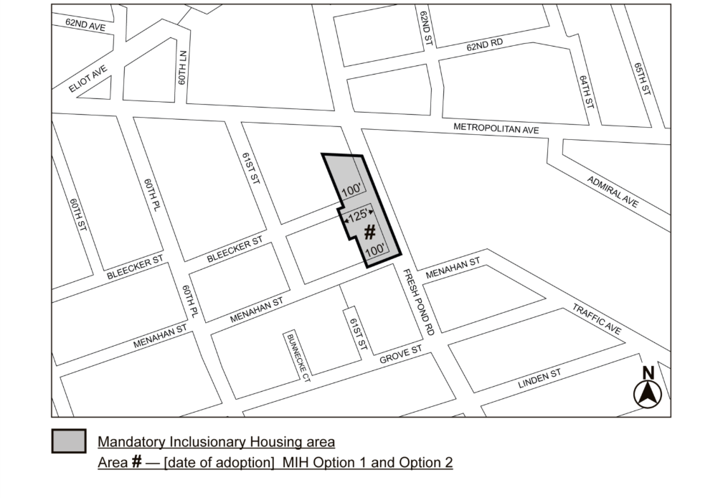

[PROPOSED MAP – MODIFIED BY CITY COUNCIL]
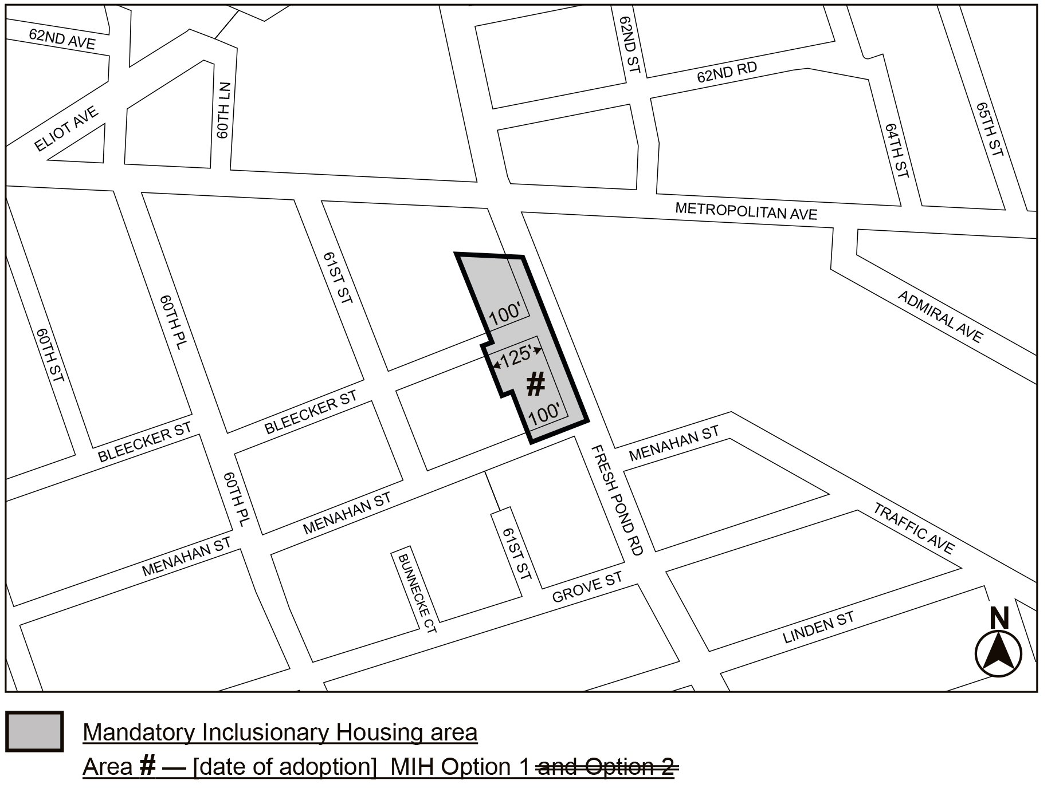

Portion of Community District 5, Queens

* * *

Adopted.

Office of the City Clerk, }
The City of New York, } ss.:

I hereby certify that the foregoing is a true copy of a Resolution passed by The Council of The City of New York on _______, 2026, on file in this office.

.....................................................
City Clerk, Clerk of The Council

