Staff:

Tanisha Edwards
Chief Counsel

Rebecca Chasan
Assistant Counsel



THE COUNCIL
REPORT OF THE FINANCE DIVISION
LATONIA MCKINNEY, DIRECTOR

COMMITTEE ON FINANCE

HON. JULISSA FERRERAS, CHAIR

March 11, 2015

INT. NO. 681 By: Council Members Ferreras, Johnson and Rose (by request of the Mayor)

TITLE: To amend the administrative code of the city of New York, in relation to the establishment of the Meatpacking Area business improvement district.

ADMINISTRATIVE CODE: Amends chapter five of title 25 of the administrative code of the city of New York by adding a new section 25-488.

ANALYSIS:
Under Local Law 82 of 1990, the City Council assumed responsibility for adopting the legislation that would establish individual business improvement districts (“BIDs”).
BIDs are specifically defined areas of designated properties. They use the City’s real property tax collection mechanism to collect a special tax assessment that the BID District Management Association uses to pay for additional services beyond those that the City provides. The additional services would be designed to enhance the area and to improve local business. Normally, a BID's additional services would be in the areas of security, sanitation, physical/capital improvements (lighting, landscaping, sidewalks etc.), seasonal activities (Christmas lighting) and related business services (marketing and advertising).
Under the process established by Chapter 4 of Title 25 of the Administrative Code, the City Council has already adopted Resolution 591, which set the hearing date for the Meatpacking Area BID plan and its enacting legislation for Wednesday, March 11, 2015.
Prior to the Council’s action, the Community Boards for the district in which the proposed BID is located -- Community Boards 2 and 4 of Manhattan -- voted to approve the plan on November 21, 2014 and December 8, 2014, respectively. The City Planning Commission (“CPC”) reviewed the plan and held a public hearing on the plan on December 17, 2014. The CPC approved a resolution on January 21, 2015 (Calendar No. 12), which certified the CPC’s unqualified approval of the plan.
Resolution 591, approved by the Finance Committee and adopted by the Council on February 26, 2015, set the date for this hearing and directed that all notice provisions contained in the law be complied with. Therefore, the Department of Small Business Services was directed to publish the Resolution or its summary in the City Record not less than ten nor more than thirty days before the public hearing and the Meatpacking Area BID Steering Committee was directed to mail the Resolution or its summary to each owner of real property within the BID, to such other persons as are registered with the City to receive tax bills for property within the BID and to occupants of each building within the BID, also not less than 10 nor more than 30 days before the public hearing.
The public hearing to consider both the plan itself and the enacting legislation, according to the provisions of the law, is to be closed without a vote. The Committee then must wait at least 30 days before it can again consider and possibly vote to approve this legislation. The 30-day period immediately after this public hearing serves as an objection period. Any property owner may, during this time period, formally object to the plan by filing such objection in the Office of the City Clerk, on forms provided by the City Clerk. In the event that either at least 51 percent of the total number of property owners or owners with at least 51 percent of the assessed valuation of all the benefited real property within the district object to the plan, then the City Council is prohibited, by law, from approving such plan.
When the Committee considers this legislation after the conclusion of the objection period, it must answer the following four questions:
1. Were all notices of hearing for all hearings required to be held published and mailed as so required?;
2. Does all the real property within the district's boundaries benefit from the establishment of the district, except as otherwise provided by the law?;
3. Is all real property benefited by the district included within the district?; and
4. Is the establishment of the district in the best interests of the public?
If the Committee finds in the affirmative on these four questions and the number of objections required to prevent the creation of such district are not filed, then the legislation can be adopted.
This local law takes effect after all requirements contained in chapter four of title 25 are complied with.
MEATPACKING AREA BID DETAILS
The proposed Meatpacking Area BID (hereinafter the “District”) is located in the borough of Manhattan in the northernmost part of the West Village and the southernmost part of lower Chelsea. It is generally bounded by Horatio Street to the South, West 17th Street to the North, 10th Avenue to the West, and 8th Avenue to the East. The majority of the District’s land use is commercial, but there are also hotels, residences, government or not-for-profit properties, and public plazas.
The District is comprised of 649 parcels, which include 154 commercial lots, 472 residential lots (primarily individual condominiums), 5 vacant lots, 1 parking lot and 17 government or not-for-profit properties and is located in Manhattan Community Boards 2 and 4.
The District will be managed by the Meatpacking Area District Management Association, Inc. Services to be provided within the District include: sanitation, landscape maintenance, beautification, public safety, economic development initiatives, business and community advocacy, and general administration. The budget for the first year of operation is $1.6 million. In subsequent years the District’s budget may rise to $3.2 million as additional development occurs in the district.
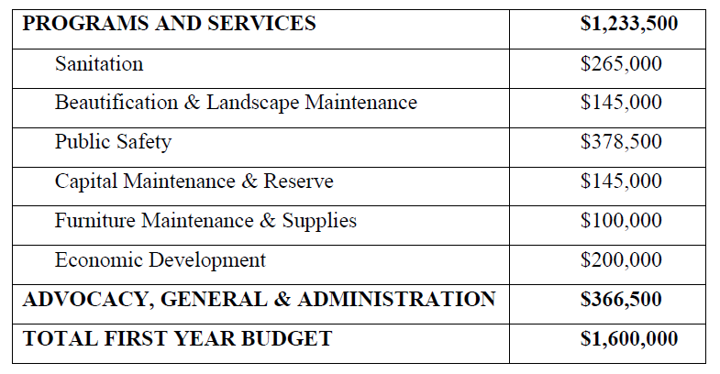
All properties within the District in whole or in part devoted to commercial use, including vacant parcels and parking lots, will be assessed at a rate of no more than $0.24 per commercial square foot. At a rate of $0.24 per commercial square foot, the median annual assessment would be approximately $1,920, the minimum assessment would be approximately $120, and the highest assessment would be $518,878. Government and not-for-profit owned property are exempt from assessment. Residential properties will be assessed $1 per year.
Int. No. 681

A Local Law to amend the administrative code of the city of New York, in relation to the establishment of the Meatpacking Area business improvement district.

By Council Members Ferreras, Johnson and Rose (by request of the Mayor)

Be it enacted by the Council as follows:

Section 1. Chapter 5 of title 25 of the administrative code of the city of New York is amended by adding a new section 25-488 to read as follows:
§ 25-488 Meatpacking Area business improvement district. a. The city council having determined, pursuant to section 25-407 of chapter four of this title: that notice of hearing for all hearings required to be held was published and mailed as required by law and was otherwise sufficient; that, except as otherwise provided in section 25-403 of chapter four of this title, all the real property within the boundaries of the district will benefit from the establishment of the district; that all the real property benefited is included within the limits of the district; and that the establishment of the district is in the public interest; and the council having determined further that the requisite number of owners have not objected as provided in section 25-406 of chapter four of this title, there is hereby established in the borough of Manhattan, the Meatpacking Area business improvement district. Such district is established in accordance with the district plan required to be filed with the city clerk pursuant to subdivision b of this section.
b. Immediately upon adoption of this local law by the council, the council shall file with the city clerk the district plan upon which the Meatpacking Area business improvement district is based.
c. The district plan shall not be amended except in accordance with chapter four of this title.
§ 2. This local law shall take effect upon compliance with section 25-408 of chapter 4 of title 25 of the administrative code of the city of New York.

