Committee Staff:
Committee on Fire and Criminal Justice Services
Brian Crow, Counsel
William Hongach, Senior Policy Analyst
Steve Riester, Finance Analyst



THE COUNCIL OF THE CITY OF NEW YORK

Briefing Paper of the Governmental Affairs
Matthew Gewolb, Legislative Director
Rachel Cordero, Deputy Director, Governmental Affairs Division

COMMITTEE ON FIRE AND CRIMINAL JUSTICE SERVICES
Hon. Elizabeth S. Crowley, Chair

May 4, 2016

Int. No. 1026: By Council Members Crowley, Mealy, Mendez, Rodriguez and Rose

Title: A Local Law to amend the administrative code of the city of New York, in relation to requiring the department of probation to evaluate the effectiveness of programs it utilizes
Administrative Code: Adds Section 9-203

Int. No. 1142: By Council Members Crowley, Rose and Cohen

Title: A Local Law to amend the administrative code of the city of New York, in relation to requiring the department of probation to report on recidivism and related statistics
Administrative Code: Adds Section 9-203

I. INTRODUCTION
On May 4, 2016, the Committee on Fire and Criminal Justice Services, chaired by Council Member Elizabeth S. Crowley, will hear Introductory Bill Number 1026 (“Int. 1026”), a local law to amend the administrative code of the city of New York, in relation to requiring the Department of Probation to evaluate the effectiveness of programs it utilizes, and Introductory Bill Number 1142 (Int. 1142), a Local Law to amend the administrative code of the city of New York, in relation to requiring the Department of Probation to report on recidivism and related statistics. The Committee expects testimony from the Department of Probation (“DOP” or “Department”), various stakeholders, and other interested parties.
II. BACKGROUND
- The Department of Probation
The Department has a total of 945 staff members who provide services to those individuals involved in the criminal and juvenile justice systems. Each year the DOP provides intake services and investigation and/or probation supervision for more than 55,000 adults and juveniles and supervises approximately 22,000 adults and 1,100 juveniles on any given day. According to its mission statement, the DOP seeks to protect the community by intervening in the lives of offenders, holding them accountable and serving as a catalyst for positive change.
- DOP’s Role in Juvenile Delinquency Cases
Youth under the age of sixteen who are arrested for crimes enter the juvenile justice system. Defendants are classified differently depending on the crime they are accused of committing. A "Juvenile Delinquent" is a youth who is at least seven years old but less than sixteen years old who commits an act that would be a crime if he or she were an adult. Juvenile delinquency cases are heard in Family Court and are prosecuted by attorneys from the Law Department. A “Juvenile Offender” is a youth thirteen to fifteen years of age who is charged and tried as an adult for committing one or more serious or violent enumerated crimes, including all designated felonies. Juvenile offender cases are heard in Criminal or Supreme Court and are prosecuted by the District Attorney’s offices. Juvenile offenders may be sentenced as adults, and if so they must be sentenced to a period of prison and are not eligible for probation, unless they are sentenced as “youthful offenders.” A “youthful offender” is eligible for a sentence of probation, and such cases are handled in the same way as adult cases, as addressed in Section II(c), below.
When a juvenile is arrested by the police for allegedly committing a crime that would classify him or her as a juvenile delinquent, one of three things can occur: (i) the police may release the juvenile to a parent or guardian with or without a Family Court appearance ticket; (ii) the police may bring the youth directly to Family Court, for an interview with an officer from the DOP; or (iii) if the Family Court is closed, the youth may be detained in a secure juvenile detention facility administered by ACS until the court re-opens the next morning, when a probation officer conducts the interview. In addition to interviewing the accused, probation officers also interview parents, police, and the victim to determine whether to refer the case to formal court proceedings or to “adjust” the case instead. “Adjusting” diverts cases from the court system and, as an alternative, provides services which can include “restitution, community service, referral for community based services, letter of apology and/or mediation.” Adjusted cases are monitored by the DOP for up to four months.
If a case proceeds in Family Court, assuming a judge issues a finding against a juvenile, the disposition stage is akin to the sentencing phase of a criminal trial. During disposition hearings, DOP issues one of the following disposition recommendations to the court: (i) discharge; (ii) probation; (iii) participation in an Alternative to Placement program (“ATP”); or (iv) placement in a correctional facility administered by the New York State Office of Children and Family Services (“OCFS”) or an entity that contracts with OCFS. The judge may consider DOP’s recommendation but ultimately issues the final disposition. If a judge determines that probation supervision would best suit a juvenile, the youth is assigned to a DOP Probation Officer who sets up a reporting schedule and a treatment plan based on the needs of the individual and his or her family. Probation Officers can refer adolescents to a program or treatment provider and are also responsible for monitoring the probationer’s adjustment at home, at school and in the community to ensure compliance with the conditions of probation. Juvenile delinquents can be placed on probation supervision for up to two years.
If a juvenile delinquent violates the terms and conditions of their probation, the DOP may file a “petition of violation” with the Family Court. Either the DOP or the Law Department must specify the nature of the violation, and the time and place at which it allegedly occurred. A Family Court may issue a warrant or summons for the defendant to appear for a hearing regarding any such violation. Defendants are entitled to counsel at violation hearings, and to present evidence on their behalf. If a court finds the defendant violated the terms of their probation, the court may revoke the order of probation and impose any sentence that would have been originally authorized for the delinquency conviction.
- DOP’s Role in Adult Criminal Cases
Any individual aged 16 years or older who is charged with a crime is prosecuted by the District Attorney’s office in Criminal or Supreme Court. Unlike in juvenile delinquency cases, in adult criminal cases the DOP has no role in “diverting” cases from the criminal court system. However, the DOP’s other roles are similar: the DOP prepares pre-sentencing reports, and monitors those individuals who are sentenced to a term of probation. A court may sentence an adult to probation if the judge finds that a sentence of incarceration would not necessarily protect public safety and that the defendant is in need of guidance and supervision. Most sentences of probation for felony convictions are for between three and five years, though there are exceptions for sex abuse and other more serious charges. Most sentences for misdemeanor convictions are for between one and three years, though again there are exceptions for sex abuse charges. Unlike Family Court sentences of probation, any adult probationer is entitled to apply for early termination of probation if a judge finds that the probationer is no longer in need of guidance, has complied with the terms of probation, and such early termination would not adversely impact public safety.
During the course of a sentence of probation, a probationer may violate the terms and conditions of their probation, and in such cases a court may issue a “declaration of delinquency,” which permits the arrest of the probationer. A probationer is entitled to a “prompt” hearing regarding any alleged violation, and is entitled to counsel for any such hearing. If a court finds that a probationer did violate the terms of their probation, the court may either place the probationer back on probation, possibly with modifications to the terms of the probation, or revoke the sentence of probation and re-sentence the defendant to a period of incarceration.
III. VIOLATION AND RECIDIVISM RATES
Over the past five years, it appears that successful probation completion rates have varied to some extent for the adult population, but have trended notably downwards for the juvenile population. Data from the Mayor’s Management Report for 2015 track successful yearly completion rates for the past five years.

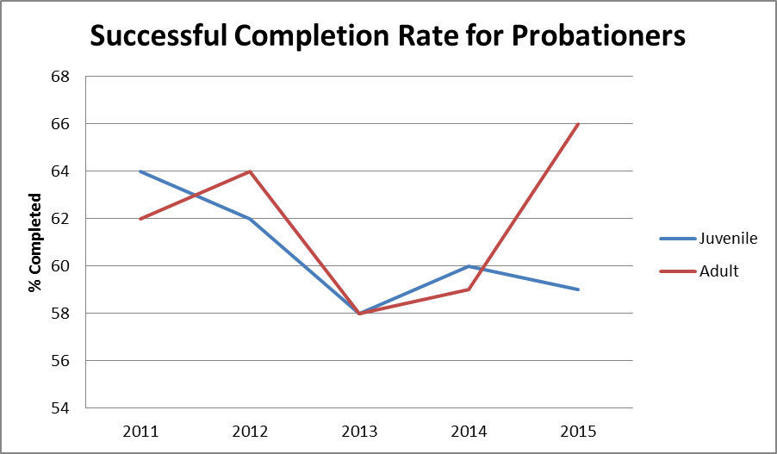
A court may find that a probationer violated their sentence of probation if that probationer violated any term of their probation, including but not limited to being re-arrested. Violations of probation may generally be categorized as either a re-arrest or a technical violation. As that term is used here, a “technical” violation may based on violating any term of probation other than avoiding re-arrest, but often is based on a failure to report to a probation officer or failure to obey the directives of a probation officer, such as attending a treatment or educational program. In the past five years, data provided by the DOP to the Council indicates that the clear majority of yearly probation violations have been based on re-arrests, and the number of technical violations has steadily declined.
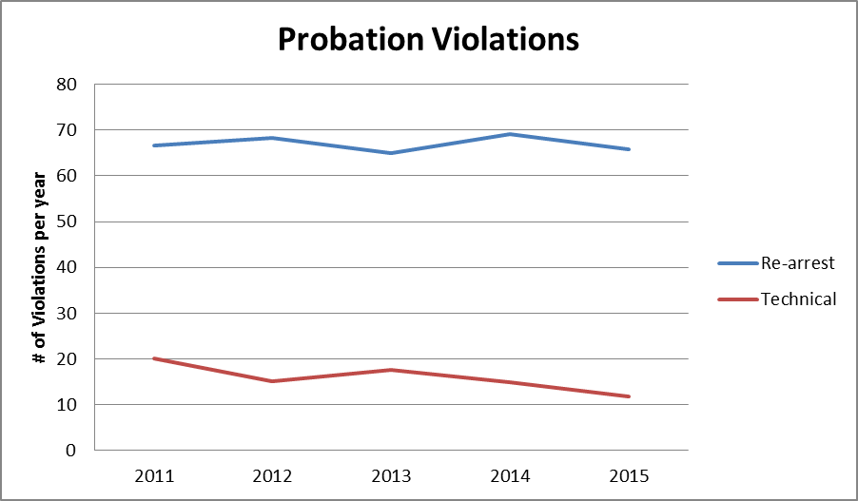
Regardless of whether a violation was based on a re-arrest or technical violation, if a court finds that a probationer violated the terms of their probation, the court can either place that probationer back on probation, possibly with modifications to the terms of the probation, or revoke the sentence of probation and re-sentence the defendant to a period of incarceration. Data from the 2015 Mayor’s Management report indicates that only roughly half of violation proceedings result in the revocation of probation and a sentence of incarceration, and the percentage of juvenile violation proceedings resulting in revocation has been steadily declining on a yearly basis for the past 5 years.
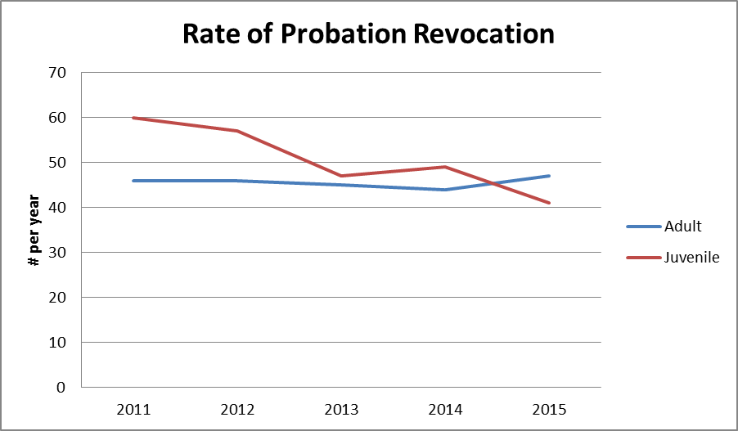
A probationer being re-arrested does not necessarily mean that their probation will be revoked. The DOP may choose not to pursue a violation of probation based on a re-arrest for a non-criminal offense, for example. Even if the DOP pursues a violation for a re-arrest, a court may either find that the probationer did not in fact commit the alleged violation, or may find that the probation did commit the alleged violation but place the probationer back on probation. Therefore, re-arrest rates may vary significantly from rates of successful completion of probation. Information provided to the Council by the DOP illustrate that in the fiscal year of 2015, roughly one third of probationers were re-arrested, though the slight majority of re-arrests were for misdemeanors or non-criminal offenses.
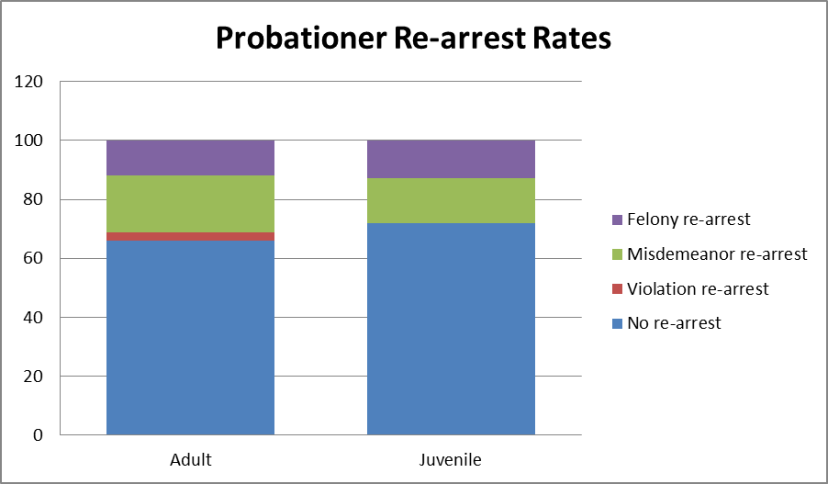

Over the past 5 years, information from the 2015 Mayor’s Management Report indicates that while re-arrest rates for adult probationers has remained relatively steady, re-arrest rates for juvenile probationers has risen.
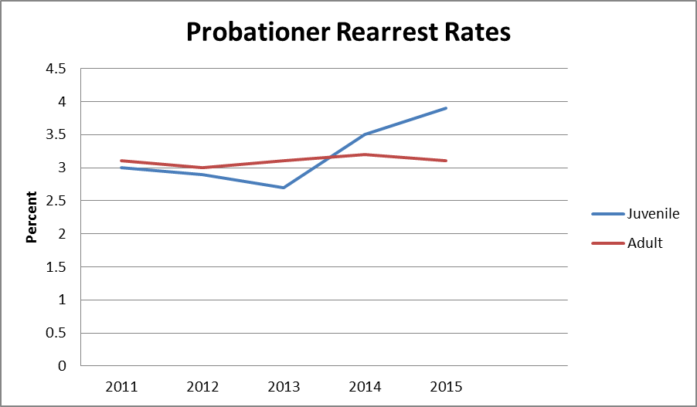
IV. INT. NO. 1026
This bill would require the DOP to issue an annual report on the effectiveness of the programs it utilizes in delivering services to probationers. This report would include data on the amount of funding each such program receives, the numbers of individuals served, a description of the services it provides, and data related to recidivism and compliance where applicable.
V. INT. NO. 1142
This bill would require yearly reporting on rates of recidivism and compliance for probationers. As illustrated in Sections II and III, supra, the length a sentence of probation can vary, both in terms of what length of period is imposed by a judge and by the possibility of early termination, either through a successful application for early termination or through a probationer’s being violated and sentenced to imprisonment. Therefore, this bill examines recidivism and compliance through multiple perspectives; the bill first requires reporting of all probationers’ recidivism and compliance in the previous year, regardless of when such probationer was sentenced. The bill then requires reporting outcomes for all probationers whose original sentences to probation would have expired during the previous year, barring any early termination. For example, the 2015 report would include statistics for those persons under the DOP’s supervision in 2015, and also include statistics for those sentenced to a 3-year period of probation in 2012, those sentenced to a 5-year period of probation in 2010, and those sentenced to a 10-year period in 2005. Within these categories, the report would include statistics related to recidivism, such as the number and percentage of probationers arrested, in total and broken down by the seriousness of the arrest, as well as the number and percentage of probationers convicted of crimes, also in total and broken down by the seriousness of the conviction. For those probationers arrested, the report would include the length of time they were supervised by the DOP prior to their arrest. Also, the report would include the number and percentage of probationers for whom the DOP filed a notice of violation or related legal document, and including the basis of this violation. Finally, the report would include statistics relating to the use of juvenile adjustment, and the rates of successful completion of probation. All of this information would be reported in total and disaggregated by probationers’ ages, risk level, and the seriousness of their underlying conviction. These reports would be kept permanently on the DOP’s website, and each year would be compared to previous years.

Int. No. 1026

By Council Members Crowley, Mealy, Mendez, Rodriguez and Rose

A LOCAL LAW

To amend the administrative code of the city of New York, in relation to requiring the department of probation to evaluate the effectiveness of programs it utilizes.

Be it enacted by the Council as follows:

Section 1. Chapter 2 of title 9 of the administrative code of the city of New York is amended by adding a new section 9-203 to read as follows:
§ 9-203 Probation programming report. The department of probation shall evaluate the effectiveness of each program through which the department provides any structured service directly to probation clients. Beginning on March 1, 2016 and annually thereafter, the department shall submit a summary of each evaluation to the Mayor and the Council. This summary shall include criteria determined by the department, which shall include, but not be limited to, information related to the following for each such program: (i) the amount of funding received; (ii) the number of individuals served; (iii) a brief description of the services provided; and (iv) recidivism and compliance rates, if applicable.
§ 2. This local law takes effect immediately.
LS #6667
BC
12/2/15

Int. No. 1142

By Council Members Crowley, Rose and Cohen

A LOCAL LAW

To amend the administrative code of the city of New York, in relation to requiring the department of probation to report on recidivism and related statistics

Be it enacted by the Council as follows:
Section 1. Chapter 2 of title 9 of the administrative code of the city of New York is amended by adding a new section 9-203 to read as follows:
§ 9-203 Probation recidivism report. a. Definitions. For the purposes of this section, the following terms have the following meanings:
Adjust. The term “adjust” has the same meaning as that in section 308.1 of the New York family court act, or any successor statute.
Department. The term “department” means the New York city department of probation.
Eligible year. The term “eligible year” means any year during which a court ordered the department to supervise a probationer that pursuant to such court order would have terminated during the reporting period.
Probationer. The term “probationer” means a person the department has been ordered to supervise.
b. No later than 20 days from January 1 of each year, the department shall provide to the Council and publish on its website an annual report regarding recidivism. Such report shall include the information in paragraphs 2 through 6 of this subdivision for every eligible year regarding probationers sentenced to probation during such eligible year. Such report shall include the following information for probationers who were under the supervision of the department during the previous year:
1. The number of probationers, the average daily number of probationers, and the number of probationers whose period of supervision began;
2. The number and percentage of probationers who were: (a) arrested for a non-criminal offense, (b) arrested for any crime; (c) arrested for a misdemeanor, (d) arrested for a felony, disaggregated by whether such felony is defined as violent by section 70.02 of the penal law or any successor statute or whether such felony is defined as a felony drug offense by section 70.70 of the penal law or any successor statute, (e) convicted of any crime, (f) convicted of a misdemeanor, or (g) convicted of a felony, disaggregated by whether such felony is defined as violent by section 70.02 of the penal law or any successor statute or whether such felony is defined as a felony drug offense by section 70.70 of the penal law or any successor statute;
3. For those probationers who were arrested, the mean and median length of time between the date on which they were sentenced to probation and their subsequent arrest, in total and disaggregated by whether such arrest was for: (a) any crime, (b) a felony, or (c) a misdemeanor;
4. The number and percentage of probationers who were arrested and for whom a related declaration of delinquency, petition of violation, or similar court filing, was filed at any time, in total and disaggregated by whether such arrest was for: (a) a non-criminal offense, (b) a misdemeanor, or (c) a felony, disaggregated by whether such felony is defined as violent by section 70.02 of the penal law or any successor statute or whether such felony is defined as a felony drug offense by section 70.70 of the penal law or any successor statute;
5. The number and percentage of probationers who were: (a) in full compliance with the terms of their probation, (b) violated the terms of their probation, in total and disaggregated by whether such violation was based on an arrest or another ground, or (c) violated the terms of their probation and a related declaration of delinquency, petition of violation, or similar court filing, was filed, in total and disaggregated by whether such declaration was based on an arrest or another ground;
6. The number and percentage of probationers whose period of probation was successfully completed during the reporting period, and the mean and median length of their period of probation; and
7. The number of adjusted cases monitored by the department, and the number and percentage of such cases in which those being monitored violated the terms of their monitoring.
c. The information in subdivisions b of this section shall be reported in total and disaggregated by the following criteria:
1. The age of the probationer, in the following categories: (a) up to age 12, (b) 13-15, (c) 16-17, (d) 18-21, and (e) 21 and older. For the purposes of subdivision b of this section, such age shall be calculated by using the probationer’s age at the end of the reporting period, and for the purposes of subdivision c of this section such age shall be calculated by using the probationer’s age at the time at which their period of supervision began;
2. Whether the underlying case for which the probationer was ordered to be monitored by the department was classified by state law, or by equivalent laws of another state, as a: (a) juvenile delinquency, (b) juvenile offender, (c) youthful offender, or (d) adult criminal case;
3. For those probationers for whom the underlying case for which the probationer was ordered to be monitored was an adult criminal case, or the equivalent in another state, whether such case was a misdemeanor or felony; and
4. The risk level of the probationer, as defined by section 351.6 of title 9 of the compilation of codes, rules and regulations of the state of New York, or any successor statute.
d. The information in subdivisions b and c of this section shall be compared to previous reporting periods, and shall be permanently stored on the department’s website.
§ 2. This local law takes effect immediately, provided that the first report pursuant to section 1 is due within 20 days of January 1, 2017.
LS #6388
BC
3/29/2016

Fiscal 2015 Mayor’s Management Report, p.91 available at: http://www1.nyc.gov/assets/operations/downloads/pdf/mmr2015/dop.pdf (Last Accessed 9/25/15)
Id. at p.90
N.Y. Family Court Act § 301.2
N.Y. Penal Law § 10.00(18)
N.Y. Penal Law§ 60.10(1)
See N.Y. Penal Law § 60.02
See Citizen’s Crime Commission of New York City, Guide to Juvenile Justice in New York City, May 2010, at pages 19-20, available at: http://www.nycrimecommission.org/pdfs/GuideToJuvenileJusticeInNYC.pdf. (Last accessed 9/25/15). See also NYS Family Court Act. §305.2.
N.Y. Family Court Act §308.1 and §320.6
NYC Department of Probation Programs and Services, available at: http://www.nyc.gov/html/prob/html/programs/programs.shtml (Last accessed 9/25/15).
NYS Family Court Act §308.1(9).
NYS Family Court Act §§352.1—352.3; §§353.1—353.4.
Id.
N.Y. Fam. Ct. Act § 360.2(1)
N.Y. Fam. Ct. Act § 360.2(2)
N.Y. Fam. Ct. Act § 360.2(3)
N.Y. Fam. Ct. Act § 360.3
N.Y. Fam. Ct. Act § 360.3(5)
See, e.g., New York State Penal law § 30.00(1)
See New York State Criminal Procedure Law § 390.20
See New York State Penal Law § 65.00
Id.
Id.
Id.
N.Y. Crim. Proc. Law § 410.90
N.Y. Crim. Proc. Law § 410.30
N.Y. Crim. Proc. Law §§ 410.40, 410.50(4)
N.Y. Crim. Proc. Law § 410.70
N.Y. Crim. Proc. Law § 410.70(5); Penal Law § 60.01(4)
2015 Mayor’s Management Report, p. 90, available at: http://www1.nyc.gov/assets/operations/downloads/pdf/mmr2015/dop.pdf
See N.Y. Crim. Proc. Law § 410.30; N.Y. Fam. Ct. Act § 360.2(2)
Materials provided by the DOP to the Council draw this distinction.
Id.
N.Y. Crim. Proc. Law § 410.70(5); Penal Law § 60.01(4)
2015 Mayor’s Management Report, p. 90, available at: http://www1.nyc.gov/assets/operations/downloads/pdf/mmr2015/dop.pdf
See Section II(A), supra
Id.
2015 Mayor’s Management Report, at p. 90, available at: http://www1.nyc.gov/assets/operations/downloads/pdf/mmr2015/dop.pdf

