THE COUNCIL OF THE CITY OF NEW YORK
RESOLUTION NO. 1255

Resolution approving the decision of the City Planning Commission on Application No. N 160220 ZRQ, for an amendment of the Zoning Resolution of the City of New York, modifying Appendix F for the purpose of establishing a Mandatory Inclusionary Housing area, in Community District 14, Borough of Queens (L.U. No. 481).

By Council Members Greenfield and Richards

WHEREAS, the City Planning Commission filed with the Council on September 9, 2016 its decision dated August 24, 2016 (the "Decision"), pursuant to Section 201 of the New York City Charter, regarding an application submitted by Rockaway Beach Hotel, LLC, for an amendment of the text of the Zoning Resolution of the City of New York, to modify Appendix F for the purpose of establishing a Mandatory Inclusionary Housing area which along with the other related action would facilitate the development of an approximately 24,000 square foot transient hotel in the Rockaway Park neighborhood of Queens, (Application No. N 160220 ZRQ), Community District 14, Borough of Queens (the "Application");

WHEREAS, the Application is related to application C 160219 ZSM (L.U. No. 480), an amendment to the Zoning Map to rezone property from R5B/C1-3 to R6A/C2-5;

WHEREAS, the Decision is subject to review and action by the Council pursuant to Section 197-d(b)(1) of the City Charter;
WHEREAS, upon due notice, the Council held a public hearing on the Decision and Application on October 5, 2016;

WHEREAS, the Council has considered the land use implications and other policy issues relating to the Decision and Application; and

WHEREAS, the Council has considered the relevant environmental issues, including the negative declaration (CEQR No. 15DCP145Q) issued on May 23, 2016, which includes an (E) Designation (E-387) related to air quality, noise, and hazardous materials to avoid the potential for significant adverse impacts (the “Negative Declaration”);

RESOLVED:

The Council finds that the action described herein will have no significant impact on the environment as set forth in the Negative Declaration.

Pursuant to Sections 197-d and 200 of the City Charter and on the basis of the Decision and Application, and based on the environmental determination and consideration described in the report, N 160377 ZRK, incorporated by reference herein, the Council approves the Decision as follows:

Matter in underline is new, to be added;
Matter in strikeout is to be deleted;
Matter within # # is defined in Section 12-10;
* * * indicates where unchanged text appears in the Zoning Resolution

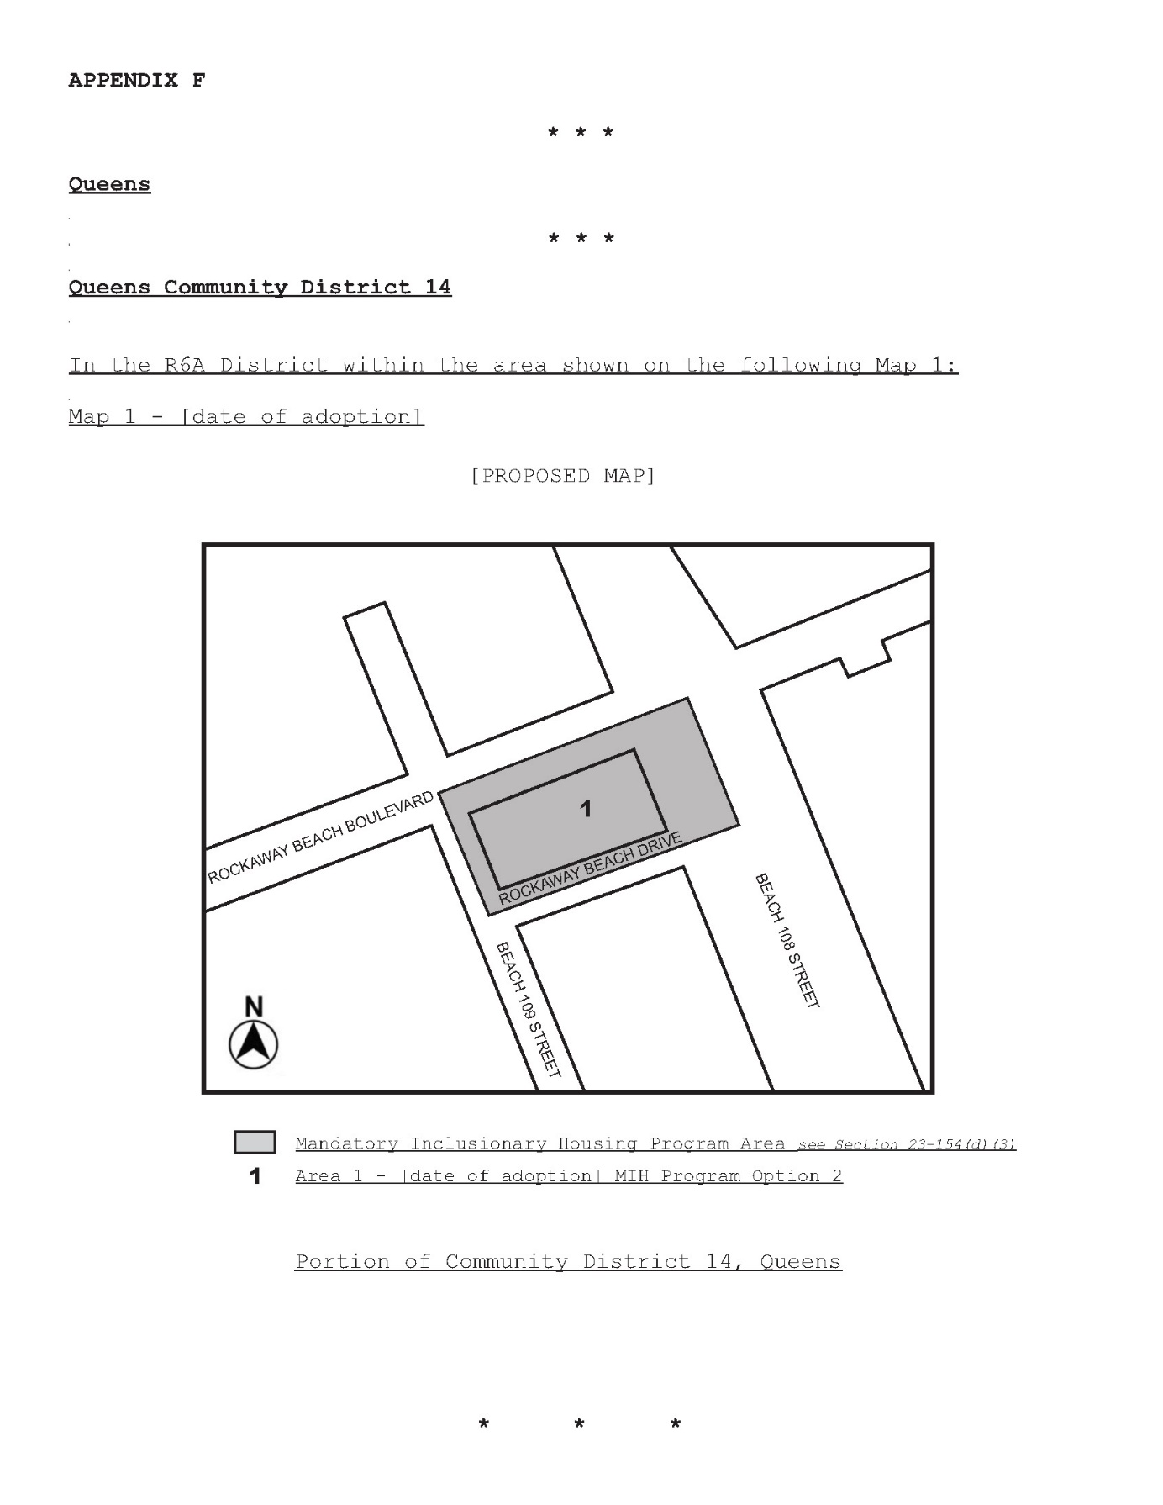
Adopted.

Office of the City Clerk, }
The City of New York, } ss.:

I hereby certify that the foregoing is a true copy of a Resolution passed by The Council of The City of New York on October 13, 2016, on file in this office.

.....…….........................................
City Clerk, Clerk of The Council

